#### PROCESSING BODY FLUID SPECIMENS AT 4867 LABORATORY

|  |  |
| --- | --- |
| Purpose | To establish a guideline in processing body fluid specimens in a timely manner. |

**Definition Core Lab MICRO Area –** Single drop off point andprocessing bench for body fluids in the main laboratory. All body fluid specimens are to be hand delivered by courier and other staff and should never be transported through the pneumatic tube.

_________________________________________________________________

|  |  |
| --- | --- |
| StatementResponsibilities | * All specimens dropped off at the laboratory must be given/taken to the MICRO Area (MICRO area will be the single drop off point). This is regardless of the priority of the test orders, STAT vs. Routine. * All specimens must be logged into the Micro Body Fluid Log Book. There must be a warm hand-off of specimens by the person dropping off the specimen and the lab staff in MICRO Area. The log entry must be complete before the person dropping off leaves the lab**. NUID** of lab employee receiving the samples must be entered in the log. * The laboratory employees in the MICRO Area of the CORE Lab are responsible for checking and processing all active orders in KPHC, KRMS and Cerner.   _______________________________________________________________   * Pull all active orders in KRMS(Ambulatory), KPHC and Cerner including Flow Cytometry test. Orders for Flow Cytometry in KPHC are “Hold for Flow Cytometry” for CSF and Surgical Pathology order with hold for Flowcytometry for all other body fluids. * Print Cerner labels for Flow Cytometry CSF samples from Cerner and complete accessioning log in to confirm receipt. * Flow Cytometry body fluids will require an order print out of a ‘Surgical Pathology Order with Hold for Flowcytometry comment’, print test order as needed. * Accession Orders for Cytology through Co-Path application.   **Note: “Total volume must be documented in the Micro Body Fluid Log”.**   * MIX ALL specimens very well prior to aliquoting. When specimens are submitted in very large bottles or containers, MIX EACH BOTTLE VERY WELL prior to aliquoting |

Continued on next page

PROCESSING BODY FLUID SPECIMENS AT 4867 LABORATORY, Continued __________________________________________________________

Responsibilities,

cont’d

ALIQUOTS FOR ORDERS OTHER THAN NON-GYN CYTOLOGY:

* + - **Specimen aliquots for Local Testing**:
    - Distribute aliquots to the appropriate local testing area of the main lab (Warm Hand-Off is required)
    - **Specimen aliquots for Regional Reference Lab Testing**:
    - Scan the specimens for Regional Laboratories, put into transfer list and place in the tub for packing. Ensure that all specimens are sent with the next scheduled courier
    - **Specimens aliquots for Outside Laboratories Testing:**
    - Hand off specimens for outside laboratories to staff assigned to send out bench

**SPECIMENS FOR NON-GYN CYTOLOGY ORDER:**

* + - **When specimens are received in very large bottles or containers, SUBMIT ALL bottles or containers. DO NOT SEND ALIQUOTS.**

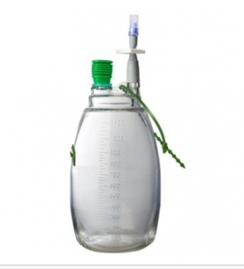

* + - Save/retain an aliquot of at least 90 ml of well mixed specimens (use sterile urine cups) in the MICRO refrigerator for seven days, then move to the freezer located in the specimen processing send out area for three months storage.
* If sample appears to be insufficient for all tests ordered, hand off the specimen (s) and all orders to CLS in Manual Hematology. Document on Body Fluid SpecimenS Received Log.
* Consult Manager or Supervisor for any problems encountered

**NOTE: PRIORITIZE ALL STAT ORDERS**

**________________________________________________________________**

PROCESSING BODY FLUID SPECIMENS AT 4867 LABORATORY, Continued

|  |  |
| --- | --- |
| Responsibilities, cont’d | * Assigned CLS/MLT/Lab Assistant will receive the specimens via warm hand-off in the MICRO Area. * Specimens will be logged in the Body Fluids log; all required information must be recorded. * Assigned CLS/MLT/Lab Assistant in the MICRO Area of the CORE Lab are responsible for checking and processing all active orders in KPHC, KRMS and Cerner. This includes Non-Gyn Cytology orders. * All specimens for in-house testing are distributed to its respective testing area/s and the performing technical staff is notified * All Non-Gyn Cytology specimens must be processed and put in the CoPath tracking/in-transit list during the shift * Any Non-Gyn Cytology specimens that were not processed during the shift are kept in the MICRO Area section and a warm hand-off will be made to the next shift MICRO staff. * All specimens endorsed are included in the shift to shift endorsement sheet. * Any body fluids sent via the p-tube system must be recorded as such in the log and manager must be notified for proper follow up and generation of a UOR |

Continued on next page

PROCESSING BODY FLUID SPECIMENS AT 4867 LABORATORY, Continued

|  |  |
| --- | --- |
| Process | The flowcharts illustrate the processing of body fluid specimens in the CORE and STAT sections of the laboratory. |



Continued on next page

PROCESSING BODY FLUID SPECIMENS AT 4867 LABORATORY, Continued

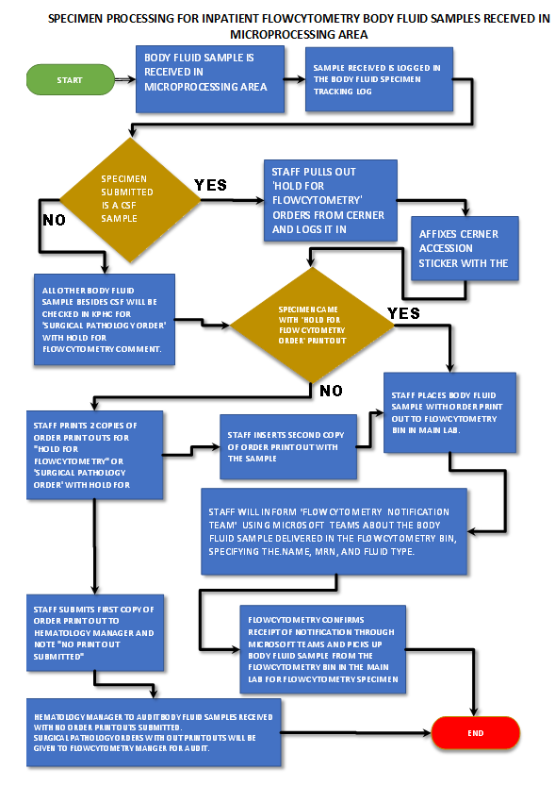

PROCESSING BODY FLUID SPECIMENS AT 4867 LABORATORY, Continued

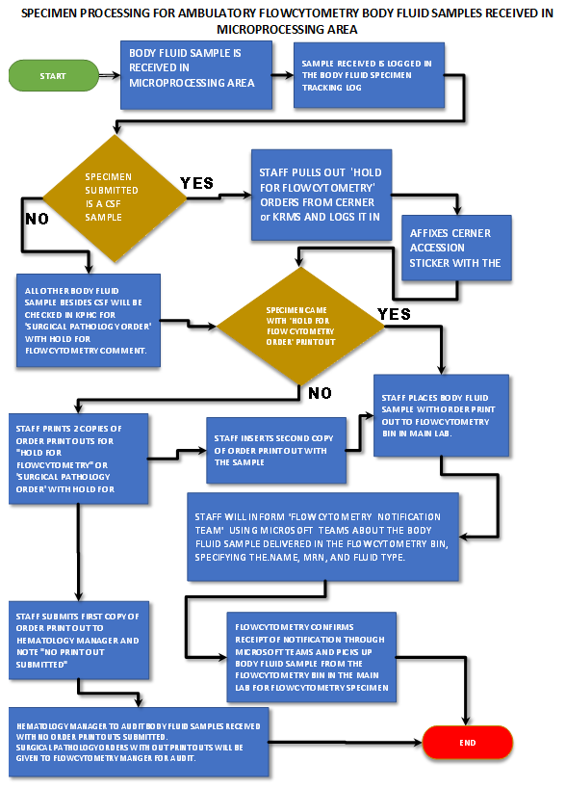

PROCESSING BODY FLUID SPECIMENS AT 4867 LABORATORY, Continued

Reference Chart for Body Fluid Tests:

|  |  |  |  |  |
| --- | --- | --- | --- | --- |
| Test Name | Reference Guide Look-Up | Collection Container | Collection Label Code -Aliquot Container | Transport Temperature – Performing Location |
| A/G Ratio Fluid | Lab Net | SC 99 | A/G-F - 6 ML Red Top | Ambient – LAMC Chemistry |
| Albumin Peritoneal Fluid | Lab Net | SC 99 | Alb PRF - 6 ML Red Top | Ambient – LAMC Chemistry |
| Albumin Pleural Fluid | Lab Net | SC 99 | Alb PLF - 6 ML Red Top | Ambient – LAMC Chemistry Area |
| Bilirubin Body Fluid | Lab Net | AF 10 | Bil, BF - AF 10 Protect from light | Ambient – LAMC Chemistry |
| Cell Count W/Diff CSF | Lab Net | SF 10 | CelCnt CSF - SF 10 | Ambient – LAMC Hematology |
| Cell Count W/Diff Body Fluid | Lab Net | SC 99 | CelCnt BF - 4 ML EDTA | Ambient – LAMC Hematology |
| Cell Count W/Diff Synovial Fluid | Lab Net | SC 99 | CelCnt SF - 4 ML EDTA | Ambient – LAMC Hematology |
| Creatinine Peritoneal Fluid | Lab Net | SC 99 | Creat PRF - 6 ML Red Top | Ambient – LAMC Chemistry |
| Crystals Synovial Fluid | Lab Net | SC 99 | 6 ML Red Top | Ambient – LAMC Hematology |
| Glucose - CSF | Lab Net | SF 10 | Gluc CSF - SF 10 | Ambient – LAMC Chemistry |
| Glucose Pleural Fluid | Lab Net | SC 99 | Gluc PLF - 6 ML Red Top | Ambient – LAMC Chemistry |
| Glucose,Protein - CSF | Lab Net | SF 10 | G P CSF - SF 10 | Ambient – LAMC Chemistry |
| Lactic Acid - CSF | Lab Net | SF 10 | Lact CSF - SF 10 | Ambient – LAMC Chemistry |
| Lamellar Body Count | Lab Net | SF 10 | LBC – SF 10 | Ambient – LAMC Hematology |
| LDH Peritoneal Fluid | Lab Net | SC 99 | LDH PRF - 6 ML Red Top | Ambient – LAMC Chemistry |
| LDH Pleural Fluid | Lab Net | SC 99 | LDH PLF - 6 ML Red Top | Ambient – LAMC Chemistry |
| Occult Blood Qualitative Gastric Fluid | Lab Net | SC 99 | OC BL – SC 99 | Ambient or Ref LAMC Micro |

Continued on next page

PROCESSING BODY FLUID SPECIMENS AT 4867 LABORATORY, Continued

Reference Chart for Body Fluid Tests:

|  |  |  |  |  |
| --- | --- | --- | --- | --- |
| Test Name | Reference Guide Look-Up | Collection Container | Collection Label Code -Aliquot Container | Transport Temperature – Performing Location |
| Spinal Fluid Total Protein | Lab Net | SF 10 | TP - SF 10 | Ambient – LAMC Chemistry Chemistry |
| Total Protein Pleural Fluid | Lab Net | SC 99 | TP PLF - 6 ML Red Top | Ambient – LAMC Chemistry |
| Hold for Flow Cytometry | Lab Net | Conical Tube | Hold for Flow Cytometry | Ambient – LAMC Flow Cytometry |
| 14-3-3 Antigen Detection Elisa CSF | Lab Net | SF 10 | SF 10 – Order Manually | Frozen – SWRL (See special instruction) |
| Amino Acid Quantitative CSF | Lab Net | SF 10 | AA CSF – SF 10 | Frozen – SWRL |
| Amniotic Fluid AFP | Lab Net | AF 10 | AFAFP– AF 10 | Ambient - SWRL |
| Amniotic Fluid Spectral Scan, Liley Analysis OD 450 | Lab Net | AF 10 | Amnio OD – AF 10 | Refrigerate – SWRL (See special instruction) |
| Amylase Peritoneal Fluid | Lab Net | SC 99 | Amy PRF - 6 ML Red Top | Refrigerate - SWRL |
| Amylase Pleurall Fluid | Lab Net | SC 99 | Amy PLF - 6 ML Red Top | Refrigerate - SWRL |
| Cholesterol Peritoneal Fluid Spectrophotometry | Lab Net | SC 99 | Chol PRF – 6 ML Red Top | Refrigerate - SWRL |
| Cholesterol Pleural Fluid | Lab Net | SC 99 | Chol PLF - 6 ML Red Top | Refrigerate - SWRL |
| Chromosome Analysis Amniotic Fluid | Lab Net | SF 10 or SC 99 | C-AMN - SF 10 or Conical Bottom Tube | Refrigerate - SWRL |
| Creatinine Peritoneal Dialysis Fluid | Lab Net | SC 99 | Creat PDF – 6 ML Red Top | Refrigerate - SWRL |
| Coccidiodes Immitis AB IGG and IGM CSF | Lab Net | SF 10 | Cocci CSF – SF 10 | Refrigerate - SWRL |
| Cryptococcus AG CSF | Lab Net | SF 10 | Crypto CSF – SF 10 | Refrigerate - SWRL |
| Culture CSF | Lab Net | SF 10 | CSFCU – SF 10 | Ambient (See special instruction and Pre-Analytical instruction) |

Continued on next page

PROCESSING BODY FLUID SPECIMENS AT 4867 LABORATORY, Continued

Reference Chart for Body Fluid Tests:

|  |  |  |  |  |
| --- | --- | --- | --- | --- |
| Test Name | Reference Guide Look-Up | Collection Container | Collection Label Code -Aliquot Container | Transport Temperature – Performing Location |
| Culture Sterile Site | Lab Net | Varies | STRL - Varies | Ambient (See special instruction and Pre-Analytical instruction |
| Glucose Peritoneal Dialysis Fluid | Lab Net | SC 99 | Gluc PDF – 6 ML Red Top | Refrigerate - SWRL |
| Glucose Peritoneal Fluid | Lab Net | SC 99 | Gluc PRF – 6 ML Red Top | Refrigerate - SWRL |
| Glucose Peritoneal Dialysis Fluid | Lab Net | SC 99 | Gluc PDF – 6 ML Red Top | Refrigerate - SWRL |
| Glucose Peritoneal Fluid | Lab Net | SC 99 | Gluc PRF – 6 ML Red Top | Refrigerate - SWRL |
| Herpes Simplex PCR, CSF | Lab Net | SF 10 | HSVSF – SF 10 | Refrigerate or Frozen SWRL |
| LSPG Amniotic Fluid | Lab Net | SAF 10 or SF 10 | L S and PG – AF 10(Amniotic Fluid) or SF 10(CSF) | Refrigerate or Frozen SWRL |
| Total Protein Peritoneal Fluid | Lab Net | SC 99 | TP PRF -6 ML Red Top | Refrigerate - SWRL |
| Triglyceride Peritoneal Fluid | Lab Net | SC 99 | Trig PRF -6 ML Red Top | Refrigerate - SWRL |
| Triglyceride Pleural Fluid | Lab Net | SC 99 | Trig PLF -6 ML Red Top | Refrigerate - SWRL |
| Urea Nitrogen Peritoneal Dialysis Fluid | Lab Net | SC 99 | UN PDF -6 ML Red Top | Refrigerate - SWRL |
| VDRL CSF, Qualitative | Lab Net | SF 10 | VDRL CSF | Refrigerate - SWRL |
| Cytopathology, Non-Genital Source Smear W Interpretation | Lab Net | Varies | Varies | Ambient (See specimen collection information and Specimen Requirements) |
| NON-GYN CYTOLOGY | Lab Net | Varies | All Body Fluids | Ambient - SWRL |

Continued on next page

PROCESSING BODY FLUID SPECIMENS AT 4867 LABORATORY, Continued

Reference Chart for Body Fluid Tests:

|  |  |  |  |  |
| --- | --- | --- | --- | --- |
| Test Name | Reference Guide Look-Up | Collection Container | Collection Label Code -Aliquot Container | Transport Temperature – Performing Location |
| Adenosine Deaminase Pericardial Fluid | LabNet or Quest | SF 10 | Manual Order SF 10 | Frozen – ARUP via Quest Diagnostics |
| Adenosine Deaminase Peritoneal Fluid | LabNet or Quest | SC 99 | ADPER – 6 ML Red Top | Frozen Quest Diagnostics |
| Adenosine Deaminase Pleural Fluid | LabNet or Quest | SC 99 | ADPLE – 6 ML Red Top | Frozen Quest Diagnostics |
| Angiotensin Converting Enzyme | LabNet or Quest | SF 10 | ACE - SF 10 | Frozen Quest Diagnostics |
| Beta-2 Transferrin | LabNet or Quest | SC 99 | B2TRF – 6 ML Red Top | Frozen Quest Diagnostics |
| BK Virus DNA, Quantitative Real-Time PCR, CSF | LabNet or Quest | SC 99 | BKCSF – 6 ML Red Top | Frozen Quest Diagnostics |
| Cysticercus Ab, CSF | LabNet or Quest | SF 10 | CYSSF - 6 ML Red Top | Refrigerate Quest Diagnostics |
| Cytomegalovirus IGM, CSF | LabNet or Quest | SF 10 | CMVSF – 7 ML Red Top | Refrigerate Quest Diagnostics |
| Cytomegalovirus DNA Qualitative Real Time PCR, Amniotic Fluid | LabNet or Quest | AF 10 | Manual Order AF 10 | Ambient Quest Diagnostics via Genetics Lab (see processing instructions) |
| Epstein Barr Virus DNA, Quantitative | LabNet or Quest | SF 10 or PPT Tube | EBVQN - SF 10 or 1 ML Plasma | Frozen Quest Diagnostics |
| IGG Synthesis Rate/Index | LabNet or Quest | SF 10 and 7 ML Red Top | IGGRI- SF 10 and 2 ML Serum | Refrigerate Quest Diagnostics |
| IGG, CSF | LabNet or Quest | SF 10 | IGGSF – SF 10 | Refrigerate Quest Diagnostics |
| JC Polyoma Virus DNA, Qualitative Real-Time, PCR, CSF | LabNet or Quest | SF 10 | JCCSF – SF 10 | Frozen Quest Diagnostics |

Continued on next page

PROCESSING BODY FLUID SPECIMENS AT 4867 LABORATORY, Continued

Reference Chart for Body Fluid Tests:

|  |  |  |  |  |
| --- | --- | --- | --- | --- |
| Test Name | Reference Guide Look-Up | Collection Container | Collection Label Code -Aliquot Container | Transport Temperature – Performing Location |
| Lyme Disease Antibodies (IGG,IGM), IFA CSF | LabNet or Quest | SF 10 | LYMAB - SF 10 | Refrigerate Quest Diagnostics |
| Meningoencephalitis Comprehensive Panel, CSF | LabNet or Quest | SF 10 | Manual Order SF 10 | Refrigerate Quest Diagnostics |
| Multiple Sclerosis Panel CSF, Serum | LabNet or Quest | SF 10 and 7 ML Red Top x2 | MS-P1- SF 10 and 2 ML Serum | Frozen Quest Diagnostics |
| Myelin Basic Protein | LabNet or Quest | SF 10 | MYEBP- SF 10 | Refrigerate Quest Diagnostics |
| N-Methyl-D-Aspartate Receptor Antibody IGG, CSF with Reflex to Titer | LabNet | SF 10 | Manual Order SF 10 | Refrigerate ARUP |
| Oligoclonal Bands, Cerebrospinal Fluid | LabNet or Quest | SF 10 and 7 ML Red Top | OLIGO - SF 10 and 1 ML Serum | Frozen Quest Diagnostics |
| Rheumatoid Factor, Synovial Fluid | LabNet or Quest | SC 99 | RFSYN -6 ML Red Top | Refrigerate or Frozen Quest Diagnostics |
| West Nile Virus IGM, CSF | LabNet or Quest | SF 10 | WNVSF - SF 10 | Refrigerate Quest Diagnostics |

Continued on next page

PROCESSING BODY FLUID SPECIMENS AT 4867 LABORATORY, Continued

|  |  |
| --- | --- |
|  | Below is illustration of aliquot tubes/containers being used. |

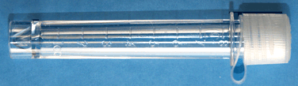

**SF 10** - Clear CSF Collection Tube (can be used for other fluids)

**AF 10** - Amber Amniotic Fluid Collection Tube (can be used for other fluids)

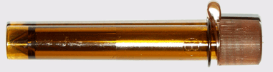

6 mL Red Top (Plastic, can be used to aliquot fluids for transport)

(Contains no Anticoagulant)

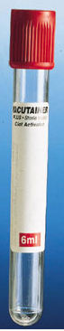

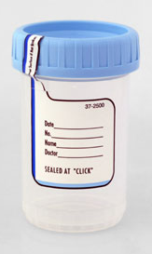

**SC 99** - Sterile Screw-Cap Container sometime used for collecting fluids and can be used to transport sample.

Conical Tube sometime used for collecting fluids and can be used to transport sample. Flow Cytometry

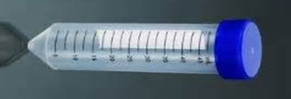

Evacuated jar container sometime used for collecting fluids. Aliquot fluid base on specific orders and requirements. (Save/Retain an aliquot using the sterile cup container for storage) ***Disposed jar after aliquoting all required containers if there is no Cytology order.***

**IMPORTANT Note: Entire and all jar/s must be submitted to SWL if there is Cytology order**



End of page