Policy | Most commercial controls have expected recovery ranges for each parameter, provided by the manufacturer. The mean of such ranges may not be the exact target value in a given laboratory. Each laboratory must assign its own initial target value, based on initial analysis of the material; this target value should fall within the recovery range supplied by the manufacturer, but need not exactly match the package insert mean. The laboratory must establish specific recovery ranges that accommodate known changes in product attributes, assuming that calibration status has not changed.

Workplace Safety | All laboratory employees are expected to maintain a safe working environment and an injury-free workplace. Laboratory employees are responsible for their own safety, the safety of others and adhering to all departmental and medical center safety policies and procedures.  - For standard precautions and safety practices in the laboratory; see Safety Practices, specifically, but not limited to, equipment safety, proper body mechanics, sharps exposure and proper use of personal protective equipment (PPE).  - For Universal Body Substance precautions, see Universal Body Substance Precautions, specifically, but not limited to, exposure to body fluids.  - For proper handwashing, see Hand washing Policy, specifically, not limited to, proper handwashing.  - For proper infection control, see Infection Control, specifically, but not limited to, proper use of gloves.  - For proper handling of regular and infectious waste, see Handling of Regular and Infectious Waste, specifically, but not limited to, proper disposal of regular and biohazardous waste.  - For proper cleaning of work area, see Cleaning Work Areas.  - For proper handling of chemicals and reagents, see the Chemical Hygiene Plan.  - For proper storage and disposal of chemical hazardous waste, see Storage & Disposal of Chemical Hazardous Waste.  All laboratory employees are expected to maintain a safe working environment and an injury-free workplace. Laboratory employees are responsible for their own safety, the safety of others and adhering to all departmental and medical center safety policies and procedures.

Materials | Sysmex XN-L CHECK Controls  Sysmex XN 550 analyzer

Procedure | New QC lot crossover or parallel studies  At least a week prior to the expiration of the current lot number of assayed control cells, the new lot is analyzed in conjunction with the current QC lot. The BeyondCare Quality Monitor program establishes the target and limit values for the new QC lot once it has accumulated 10 data points.  Registering a New Lot of QC- Manual Mode
 | Step | Action
 | 1 | Ensure Analyzer is in Manual Mode
 | 2 | Touch the manual icon to program the manual icon
 | 3 | Use the barcode scanner to read the barcode on the QC vial. The lot number will be automatically registered in the next available QC file
 | 4 | Verify the QC registration in the QC File list
 | 5 | Follow analyzer procedure for processing the new lot of QC material.
 | 7 | Repeat for each level of XN CHECK to be registered

 | Registering a New Lot of QC- Sampler Mode
 | Step | Action
 | 1 | Ensure Analyzer is in Sampler Mode
 | 2 | Place the well mixed-vials of QC in a sample rack and start processing on the analyzer
 | 3 | Upon reading the barcodes, the QC levels will automatically register in the next available QC files. Verify QC registration and results in the QC File list.
Note: The analyzer must have an active SNCS connection.

Run the NEW QC
Refer to Hematology Policy & Procedures, XN 550 Quality Control Procedure for detailed instructions on performing QC.

 |  | Auto Set Target Values
 |  | Step | Action
 |  | 1 | Select QC Chart.
 |  | 2 | Select [Range] and drag the flag so that every data point is included.
 |  | 3 | Select [Modify] button on the toolbar; the ‘Input Lot Information’ dialog box displays.
 |  | 4 | Select [Target/Limit Settings]
 |  | 5 | Select [Auto Settings]
 |  | 6 | 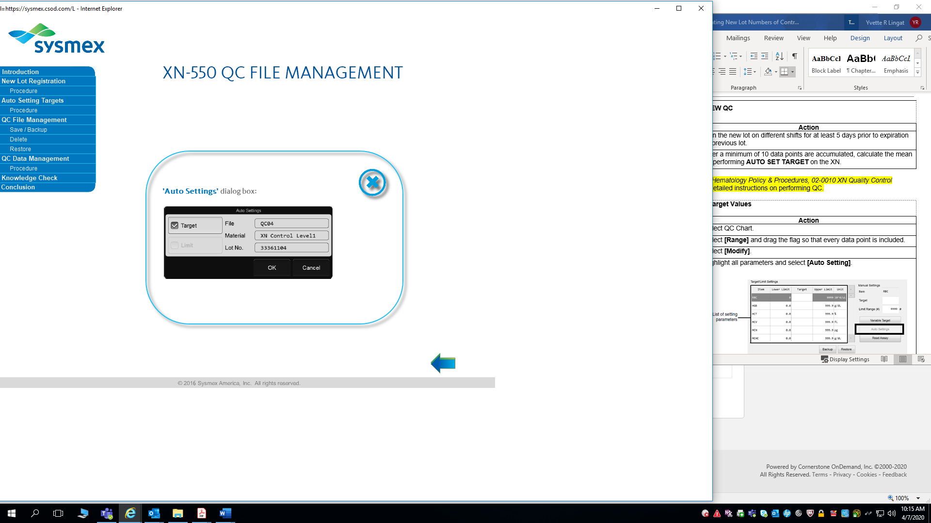  In the dialogue box that opens, check the box for target values to be automatically set, the touch [ok]  Note: This procedure only applies to laboratories who do NOT utilize the BeyondCare Quality Monitor for Hematology Application.
References |  | The following documents support this procedure.
 | Reference
 | Sysmex XN-550 Instructions for Use (North American Edition), Sysmex Corporation, Kobe, Japan.
 | Sysmex XN series Administrator’s Guide (North American Edition), Sysmex Corporation, Kobe, Japan
 | Sysmex America Inc., Lincolnshire, IL. XN CHECK Hematology Control for Sysmex XN-Series Analyzers package insert

Controlled Documents | The following controlled documents support this procedure.  Document Number Document Name  LAMC-PPP-0123 Safety Practices  LAMC-PPP-0127 Infection Control  LAMC-PPP-0128 Universal Body Substance Precaution  LAMC-PPP-0129 Handling of Regular and Infectious Waste  LAMC-PPP-0130 Cleaning Work Areas  LAMC-PPP-0132 Hand-washing Policy  LAMC-PPP-0134 Storage and Disposal of Chemical Hazardous Waste  Sysmex XN550 QC Procedure

Author(s) | Yvette Lingat, CLS
Updated by | Alvin Castillo, CLS

