Principle |  | The presence of cold agglutinins, lipemia, icterus, platelet clumping, hemolysis in the sample can cause erroneous results. These results must be corrected before being released.
Workplace Safety | All laboratory employees are expected to maintain a safe working environment and an injury-free workplace. Laboratory employees are responsible for their own safety, the safety of others and adhering to all departmental and medical center safety policies and procedures.  - For standard precautions and safety practices in the laboratory; see Safety Practices, specifically, but not limited to, equipment safety, proper body mechanics, sharps exposure and proper use of personal protective equipment (PPE).  - For Universal Body Substance precautions, see Universal Body Substance Precautions, specifically, but not limited to, exposure to body fluids.  - For proper hand-washing, see Hand washing Policy, specifically, not limited to, proper hand-washing.  - For proper infection control, see Infection Control, specifically, but not limited to, proper use of gloves.  - For proper handling of regular and infectious waste, see Handling of Regular and Infectious Waste, specifically, but not limited to, proper disposal of regular and biohazardous waste.  - For proper cleaning of work area, see Cleaning Work Areas.  - For proper handling of chemicals and reagents, see the Chemical Hygiene Plan.  For proper storage and disposal of chemical hazardous waste, see Storage & Disposal of Chemical Hazardous Waste. All laboratory employees are expected to maintain a safe working environment and an injury-free workplace. Laboratory employees are responsible for their own safety, the safety of others and adhering to all departmental and medical center safety policies and procedures.
Materials and Reagents | 37 ° C Dry bath and timer 12X75 Tubes  CELLPACK DCL MLA tips
 | MLA pipette, 500 uL/300 uL Sysmex Analyzer
Procedure | - Cold Agglutinin: The presence cold agglutinin can adversely affect the results of the CBC, i.e. inaccurate results. The parameters affected are RBC, HCT, MCV, MCH and MCHC.  XN & WAM will have an alert message of RBC Agglutination?  And asterisks (*) appear next to RBC and its indices.  Step Action  1 Incubate the CBC sample by putting it in a 37 ° C Dry bath for at least 15 minutes.  2 Mix well and rerun the specimen immediately after pre-warming.  3 If MCHC is corrected (≤ 37.5g/dL and no asterisk present), then the other indices have been corrected for cold agglutinin. Proceed to result the corrected values.  4 In cases of very strong cold agglutinins where the MCHC does not correct after warming the sample for more than 1 hour, manually prepare a 1:5 dilution with a prewarmed CELLPACK DCL and run CBC on XN in Manual Analysis mode. Follow steps below: - Order a rerun in WAM. - Scan the sample accession in the XN IPU. - Mix the sample by gentle inversion at least 10 times. - Run the sample in Manual Analysis mode.  5 If results are valid (see #3 above), enter the dilution factor in WAM. Follow steps below: - In the Rerun screen, enter the dilution factor (in whole numbers) in the Dilution Field under the appropriate run column.
- Click on the [CALC] button to apply the dilution factor into the results.
- Choose the appropriate run column for the rerun group.
- Replace WBC and PLT results from the original run, then validate in WAM.
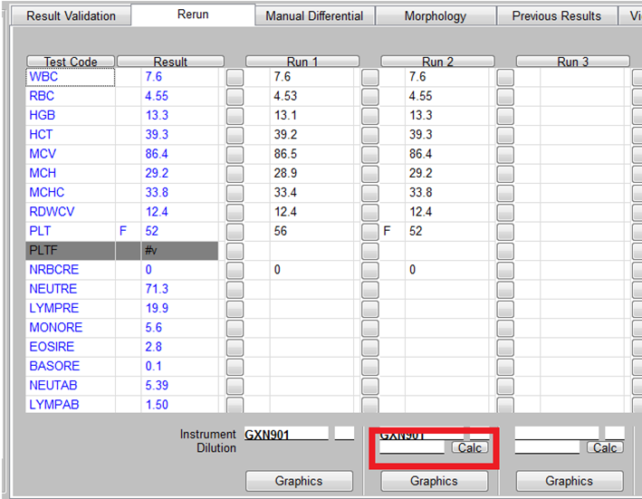

NOTE: RBC Indices results are unaffected by dilution and do not require correction.
6 | If dilution does not correct problem, then perform plasma replacement procedure.
7 | If a manual differential is needed, prewarm several slides in the drybath for 15-30 minutes and make a new peripheral smear from the warmed sample.

  - Severe Cold Agglutinin: In cases with high cold agglutinin titers, a plasma replacement using warm CELLPACK DCL may be necessary to reduce the interference from the antibody.
Step | Action
1 | Pre-Warm CELLPACK DCL at 37° C dry bath for at least 15 minutes
2 | Aliquot 1 mL of well mixed pre-warmed sample of specimen in a 12 mm tube

3 | Centrifuge the 1 mL aliquot for 2000 RPM for 10 minutes to separate plasma from red cells.
4 | Using an MLA pipette, carefully remove plasma without disturbing the buffy coat.
5 | Change tip on MLA pipette and add back the same amount of removed plasma with Pre-warmed CELLPACK DCL diluent.
6 | Simultaneously mix and warm the sample for at least five (5) minutes, order a rerun and cycle through the analyzer in manual mode.
7 | Use the original WBC and PLT results obtained as a guide to verify proper re-dilution of the specimen. WBC/PLT results should be within ±5% from the original run
8 | If plasma replacement corrected the symptom, replace the WBC and Platelet with the original values since centrifugation will alter these parameters. Document on WAM “Severe Cold Agglutinin, RBC and indices corrected by Plasma Replacement.”
9 | If plasma replacement does not correct the symptom, request for a redraw where sample is kept at 37° C at all time.

  - Lipemic/Icteric/Hemolyzed Samples: Lipemia and Icterus falsely elevates HGB and/or MCHC. Result will have a low or normal MCV with MCHC of
≥ 37.5 g/dL.

XN & WAM will have an alert message of Turbidity/HGB Interference?
And asterisks (*) appear next to HGB, MCH and MCHC.

Step | Action
1. | Order a rerun in WAM. Then manually prepare a 1:5 dilution with CellPack DCL and run on XN in Manual Analysis mode. If results are valid then validate in WAM. If dilution does not correct problem, then perform plasma replacement. Proceed to next step.
2. | Take a portion of the specimen and transfer into another tube.
3. | Centrifuge the aliquot at 2000 RPM for 10 minutes to thoroughly separate the cells from the plasma.
4. | Using an MLA pipette, carefully remove the plasma without disturbing the buffy coat.
5. | Change tip on MLA pipette and replace removed plasma with equal amount of CellPack DCL diluent.
6. | Mix the sample, order a rerun and run through the analyzer.

7. | Use the WBC and PLT results obtained in step 1 as a guide to verify proper re-dilution of the specimen.
8. | If the WBC/PLT results are within ±5% of results in step 1, report the Hgb, MCH and MCHC from the re-diluted sample. The other results are resulted from the results from step 1.
9. | Document in report that specimen was grossly lipemic/icteric, and that hemoglobin was corrected for lipemia/icterus.

For Hemolyzed Samples: follow steps below

Step | Action
1. | Take a portion of the specimen and transfer into another tube.  Centrifuge the aliquot at 2000 RPM for 10 minutes. Observe plasma for the presence of hemolysis. If hemolyzed, obtain a second sample if possible and check for hemolysis. If the second sample is also hemolyzed, do not perform CBC anymore.
2. | Do not report out any CBC result. Cancel test due to hemolysis.

- Platelet Clumping: Follow procedure below to process the specimen.

XN & WAM will have an alert message of PLT Clumps? or PLT ABN Distribution

And asterisks (*) appear next to PLT, MPV and IPF results.

Please follow the workflow below for any platelet issues
OP Alert (1st run): PLT Clumps? – Rerun for PLTF or PLT ABN Distribution
XN will automatically RERUN the PLTF

Depending on your sample you may or may not get any OP Alert on the PLTF (this is your 2nd run).

- IF the PLTF result is good, i.e., there’s no asterisk (*) and no PLT IP message, then you can release this result.
- IF the PLTF result has an asterisk (*) and/or there’s a PLT IP message, then proceed to the vortex procedure below.

VORTEX specimen for a minimum of 1 minute and PREPARE a smear for review

RERUN sample manually as PLTF (this is your 3rd run)
- IF the PLTF result is good, i.e., there’s no asterisk (*) and no PLT IP message, then you can release this result from the 3rd run.
- IF the PLTF result has an asterisk (*) and/or there’s a PLT IP message, then proceed to the smear review and PLT Estimate procedure below.

REVIEW smear manually (not Cellavision) for PLT CLUMPS and PERFORM a PLT Estimate
Note: see LAMC-PPP-0303 Hematology Scan Differential and Reporting Criteria Procedure, Platelet Scan section to perform PLT Estimate
If smear review was not reflexed in WAM, ADD SMEAR through the ACTION button and ADD ‘SMEAR5’ to document smear review performed.
YES PLT CLUMPS seen NO

- Delete the platelet count in WAM/Cerner.
- On the PLT result area, free test as CLUMPING. Click SAVE,
- Then double click on the Comment section, ADD a comment on the Free Text box of:
“Plt estimate appears decreased/adequate/increased (whatever applies). Suggest Citrated Plt Count order.”
- Do platelet count on citrate (if there’s an order).
NOTE: Presence of small occasional clumping is fine.

COMPARE PLT count result from 3rd run with your PLT Estimate count, if it correlates THEN release PLT count result from the 3rd run.
Controlled Documents | The following controlled documents support this procedure.

Reference
- Sysmex XN-9000 Instructions for Use (North American Edition), Sysmex Corporation, Kobe, Japan.
- Sysmex XN-Series Automated Hematology Systems. Flagging Interpretation Guide, Sysmex Corporation, Kobe, Japan.
- Koepke, John. Practical Laboratory Hematology. Churchill Livingstone Inc. 1991. p. 24-25, 36-39.
- Cornbleet J., Spurious results from automated hematology cell counters. Lab Medicine. 1983;8:509-514.
- Stewart, Charles and Koepke, John. Basic Quality Assurance Practices for Clinical Laboratories, Van Nostrand Reinhold, 1989, p 189.
- Gulati GL, Asselta A, Chen C. Using vortex to disaggregate platelet clumps, Laboratory Medicine, 28:665, 1997.

