Purpose | To serve as a guide for handling bacteriology specimens.

Principle | - The initial handling of specimens for Bacteriology is a multifaceted procedure. The specimens must be matched to the requisition to make sure there are no discrepancies. The determination also has to be made as to what type of category the specimen falls into to determine whether to plate or sent directly to Sherman Way to be processed. If plating is required refer to plating chart. Determine if specimen requires pretreatment (i.e. centrifugation or grinding).  - A biological safety cabinet should be used during the processing of all specimens.  - All specimens should be plated as soon as possible after receipt if plating is required.

Workplace Safety | All laboratory employees are expected to maintain a safe working environment and an injury-free workplace. Laboratory employees are responsible for their own safety, the safety of others and adhering to all departmental and medical center safety policies and procedures.  - For standard precautions and safety practices in the laboratory; see Safety Practices, specifically, but not limited to, equipment safety, proper body mechanics, sharps exposure and proper use of personal protective equipment (PPE).  - For Universal Body Substance precautions, see Universal Body Substance Precautions, specifically, but not limited to, exposure to body fluids.  - For proper hand-washing, see Hand washing Policy, specifically, not limited to, proper hand-washing.  - For proper infection control, see Infection Control, specifically, but not limited to, proper use of gloves.  - For proper handling of regular and infectious waste, see Handling of Regular and Infectious Waste, specifically, but not limited to, proper disposal of regular and biohazardous waste.  - For proper cleaning of work area, see Cleaning Work Areas.  - For proper handling of chemicals and reagents, see the Chemical Hygiene Plan.  - For proper storage and disposal of chemical hazardous waste, see Storage & Disposal of Chemical Hazardous Waste.  All laboratory employees are expected to maintain a safe working environment and an injury-free workplace. Laboratory employees are responsible for their own safety, the safety of others and adhering to all departmental and medical center safety policies and procedures.

Specimen | - All primary bacteriology specimens should be processed, inoculated, and incubated according to the techniques described in this procedure.  - Each specimen received must be accompanied by the appropriate requisition.  - All specimens must be labeled with the patient’s name and medical record number.  - Unlabeled specimens will not be processed.  - The source of each specimen should be specified either on the requisition slip or the computer accession along with the date and time of collection.  - Current antibiotic therapy, if any, should be listed.  NOTE: Consult a supervisor if there are any questions regarding specimen plating.

Materials | The necessary equipment and reagents are listed below.
 |  | Reagents | Culture media
 |  | Supplies | - Sterile Pasteur pipettes  - Sterile tubes  - Inoculating metal loops  - eSwabs | - Calibrated disposable loops 1:1000  - Calibrated disposable loops 1:100(urine samples only, check Urine section below)
 |  | Equipment | - Biological safety cabinet  - Centrifuge  - Bacticinerator | - Microscope slides  - Incubator (35-37°C; CO2)

Procedure –  Smear Preparation | Follow the steps below when preparing smears from fluids.

 |  |  | Step |  |  | Action
 |  |  | SMEARS FROM FLUIDS
 |  |  | 1 |  | - Cytocentrifuge specimen onto slide  - Refer to the Cytocentrifuge procedure LAMC-PPP-0310.
NOTE:
- After making smears heat fix for a few seconds
- Refer to the Gram stain procedure for staining.
Procedure – Pretreatment | - When preparing specimens for culture analysis, observe universal precautions at all times  - Whenever possible, all steps required in the processing of specimens should be done in a laminar-flow biological safety hood.
 |  | Step |  | Action
 |  | CENTRIFUGATION
 |  | 1 |  | Centrifuge all sterile body fluids for 15 min. at 2,500 to 3,000 rpm.
 |  | 2 |  | Decant supernatant.  Note that if there is no visible sediment, use a sterile transfer pipette to remove most of the fluid and discard it. Leave approximately 1 ml of fluid. Mix and use to inoculate the required plates.
 |  | 3 |  | Use the sediment to plate culture.

Procedure –  Specimen Inoculation | - Refer to the Medical Center Media Plating Chart –Summary for proper media to inoculate

Plating techniques | - Four Quadrant Streaking Method – perform this plating technique on all your plating except for Urine cultures and Quantitative Respiratory cultures.  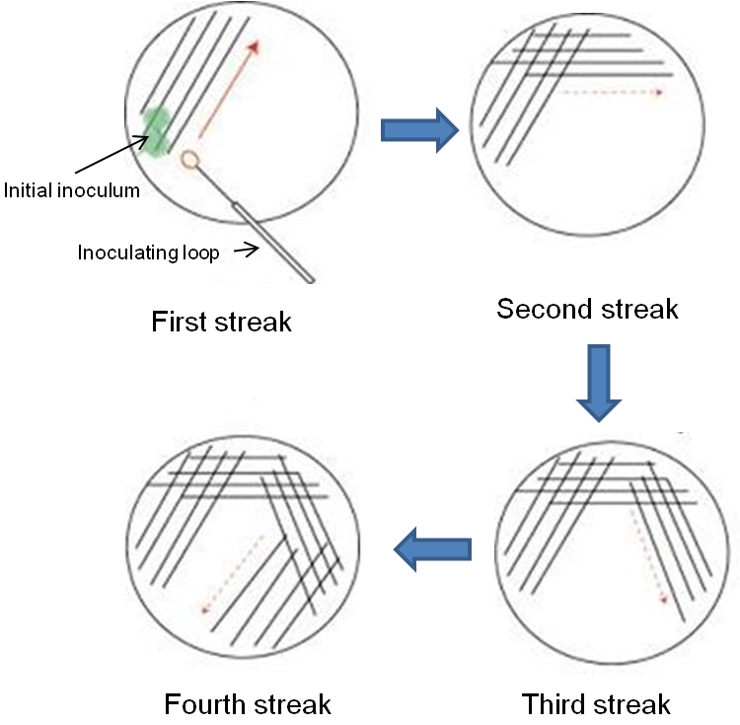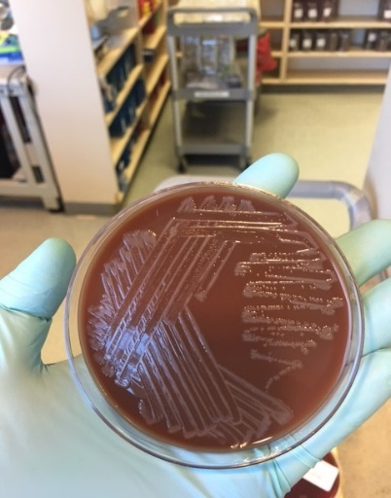

- Semi-Quantitative Streaking Method- perform this plating technique for Urine cultures and Quantitative Respiratory cultures only.
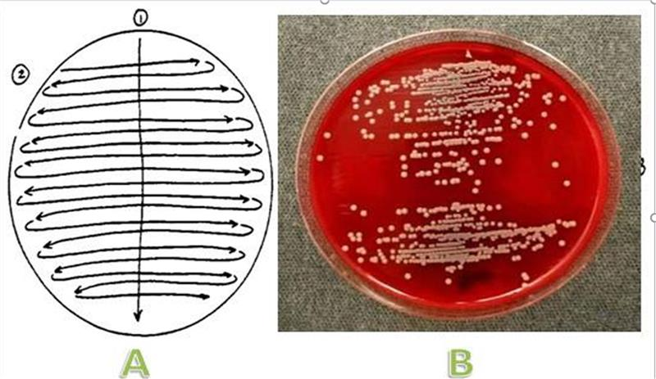

Catheter tips | Follow the steps below when plating catheter tips.

Step | Action
1 | Using sterile forceps, remove catheter tip from transport container.
2 | Lay catheter onto BAP plate.
3 | Using sterile forceps roll tip over entire plate surface.
4 | Leave catheter tip on plate.

Syringes | - Follow the steps below when plating specimens received in syringes  - If needle received DO NOT process specimen – consult supervisor immediately.

Step | Action
1 | Directly inoculate solid media with fluid by placing 2-3 drops on one quadrant of the plate.
2 | Streak plates for isolation.
3 | Inoculate a broth medium (THIO).
4 | - If large quantity of fluid is receive in a syringe transfer to a Falcon tube (large blue top) and centrifuge  - Inoculate sediment to plates  - If no visible sediment, use a sterile transfer pipette to remove most of the fluid and discard it. Leave approximately 1 ml of fluid. Mix and use to inoculate the required plates.
5 | If smear is needed for Gram stain cytocentrifuge the specimen onto a slide.

Swabs | Follow the steps below when plating specimens received on swabs.

Step | Action
1 | - Inoculate agar plates rolling swab across one quadrant of each plate  - Inoculate non-selective media first.
2 | - Streak plate for isolation  - Incubate appropriately.
3 | Prepare smear for Gram stain (if needed).

eSwabs© | The sample should be sent to the regional reference laboratory for plating. Extra labels should be included with the sample.

MRSA Select | The sample should be sent to the regional reference laboratory for plating. Extra labels should be included with the sample.

Urine | - Transfer urine into urine culture tube(Boric Acid tube) using transfer straw if at least 3-4 ml specimen is available.  - If not follow the steps below when plating urine specimens onto a blood/MacConkey agar biplate(<3ml not suitable for Boric acid transportation tube). Use Semi-Quantitative Streaking Method.

Step | Action
1 | Mix specimen thoroughly by swirling urine cup or inverting BD urine tube.
2a | For Routine Urine Culture:  - Plate 1:1000 dilution on bi plate using 1:1000 disposable loop
2b | For 1:100 dilution urine culture:  - Plate BOTH 1:100 and 1:1000 dilution on separate bi plates using 1:100 and 1:1000 disposable loops accordingly.  - Label respective dilution on inoculated bi plates.
3 | Guide in plating urine sample on bi-plate  - Streak down the center of the other side of the biplate  - Then streak the entire surface with perpendicular lines. (Refer to Figure 1.)
 | Figure 1.

Transfer list when using boric acid urine culture tube(grey top) for Urine culture 1:100
Step | Action
1 | Affix one of the labels to the grey top tube. Discard 2nd label.
2 | Scan the tube onto the transfer list
3 | Pop-up window will open indicating both labels (A&B)
4 | Hit Shift and select both A&B. Click OK  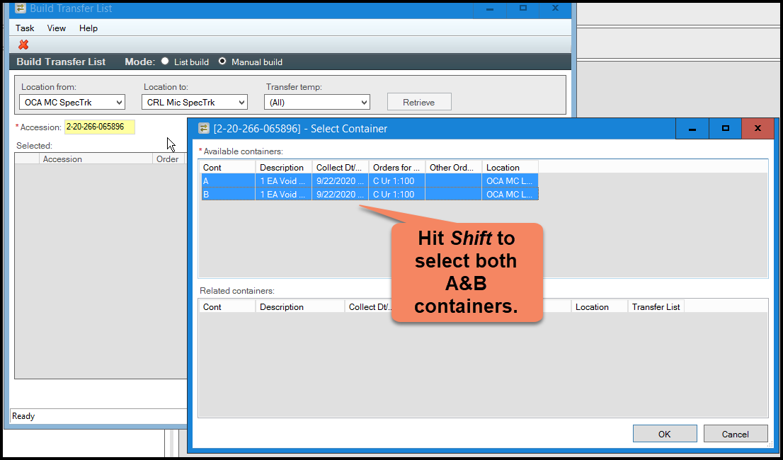

Procedure –  Inoculation by Source | - Use the guidelines detailed below to inoculate the appropriate media according to the specimen source  - Refer to Medical Center Media Plating Chart

Urine | - If enough urine available transfer into urine culture tube (minimum 3-4 ml) if not plate to Blood/MacConkey Agar biplate.  - Cystoscopic, Bladder, Supra-pubic tap, and straight catherization specimens are plated using the 0.01 ml loop (1:100 dilution).  - All other urines are plated using the 0.001ml loop (1;1000 dilution).  - Incubate at 35-37°C in CO₂.

Throat | The sample should be sent to the regional reference laboratory for plating. Extra labels should be included with the sample.

Respiratory | - Includes Sputum, Bronchial, Nasopharyngeal, etc.  - Select part of the specimen that is purulent and use that area for plating. If there are no purulent areas mix specimen well before plating.  - BAP  MAC  CHOC  - Gram Stain – Q Score on all Respiratory specimens except Nasopharyngeal.  - Incubate at 35-37°C in CO₂.

GC | The sample should be sent to the regional reference laboratory for plating. Extra labels should be included with the sample.

Genital | The sample should be sent to the regional reference laboratory for plating. Extra labels should be included with the sample.

Group B Strep Screen | - The sample should be sent to the regional reference laboratory for plating.  - Extra labels should be included with the sample.

Stool | - Transfer the stool sample into Total Fix Vial(black top).  - The sample should be sent to the regional reference laboratory for plating.  - Extra labels should be included with the sample.

CSF | - Centrifuge CSF if > 1.0 mL  - BAP  CNA  MAC  CHOC  THIO(setup from shunt sample only)  - Gram stain (cytospin)  - Incubate at 35-37°C in CO₂.  - Sample can also be sent to regional reference laboratory for plating, include all labels.

Sterile Site/Fluid | - Centrifuge fluids  - BAP  CNA  MAC  CHOC  THIO(only required on CAPD fluids and Tissues if plated at Med. Centers, check Medical Center Media Plating Chart for more information about CAPD Fluids and Tissues)  - Gram stain (cytospin)  - Incubate at 35-37°C in CO₂.  - Sample can also be sent to regional reference laboratory for plating, include all labels.

Miscellaneous | - Includes: Foot, eye, ear, skin, wounds, abscess, etc.  - The sample should be sent to the regional reference laboratory for plating.  - Extra labels should be included with the sample.

Environmental | Environmental cultures are accessioned and sent to regional reference laboratory for plating.

Hickman Catheter tip | - BAP  - Roll on plate (leave tip on plate inserted into blood agar)  - Incubate at 35-37°C in CO₂.

Anaerobic Culture | - Anaerobic culture is collected either using e swab or Port-A-Cul tube for swabs or tissue or Port-A-Cul vial for fluids. Samples are accessioned and sent to the regional reference laboratory for processing. Send all labels with the specimen.

Listeria Culture | - The sample should be accessioned as a blood culture and sent to the regional reference laboratory for plating.  - Extra labels should be included with the sample.

H. pylori | - The sample should be sent to the regional reference laboratory for plating.  - Extra labels should be included with the sample.  - Refer to Labnet for special instructions: "Collection, Handling and Transport of Biopsy Samples for H. pylori Culture"

H. ducreyi | - eSwab regular  - refer to Labnet for special instructions  - Sample required to be refrigerated when transport.

Leptospira | - Flectchers medium  - Inoculate one to two ml of specimen into the Flectchers medium - wrap tube with foil send to the regional reference laboratory, or accession specimen and send to the regional reference laboratory for processing at room temperature with all labels.

Bordetella pertussis | - Bordetella Pertussis PCR collection kit  - Bordetella Pertussis PCR collection kit is accessioned and sent to regional reference laboratory for PCR testing  - Note: Bodetella Pertussis cultures have been discontinued

Diphtheria | - The sample should be sent to the regional reference laboratory for plating.  - Extra labels should be included with the sample.

Sterility | - The sample should be sent to the regional reference laboratory for plating.  - Extra labels should be included with the sample.

Legionella Culture | - Accession and send to the regional reference laboratory for processing.  - Send all labels with the specimen.

Fungus Cultures | - The sample should be sent to the regional reference laboratory for plating.  - Extra labels should be included with the sample.

AFB Cultures | - The sample should be sent to the regional reference laboratory for plating.  - Extra labels should be included with the sample.

Ova and Parasites | - Place stool sample in Total Fix Vial (black top)..  - The sample should be sent to the regional reference laboratory.  - Extra labels should be included with the sample.

Controlled Documents | Document Number Document Name  LAMC-PPP-0123 Safety Practices  LAMC-PPP-0127 Infection Control  LAMC-PPP-0128 Universal Body Substance Precaution  LAMC-PPP-0129 Handling of Regular and Infectious Waste  LAMC-PPP-0130 Cleaning Work Areas  LAMC-PPP-0132 Hand-washing Policy  LAMC-PPP-0134 Storage and Disposal of Chemical Hazardous Waste  LAMC-PPP-0310 Cytospin Smear Preparation using Thermo Scientific Cytospin  Medical Center Media Plating Chart(Lab Net)  See below the list of controlled documents
Author(s) | Alvin Castillo

