|  |  |
| --- | --- |
| **Step** | **Action** |
| **Note** | **For MOB Lab staff & Managers** |
| **1** | * Call the Main Lab (323-783-4961) ask for any available Manager. * If a Manager is not available, ask for a Lead CLS.   **3**  **3**  **2**  **3**  **7**  **8**  **4**  **9**  **6**  **1**  **Tie Line: 8 - 363 – 4961**   * Main Lab Manager or Lead CLS will escalate communication and follow the Downtime Communication Plan. |
| **2** | If downtime is ongoing by the end of your shift, notify your MOB manager if you are available to stay to provide downtime support before clocking out. |
| **3** | Keep all routine specimens collected at the MOBs until instructed by a manager.  Send only specimens that have been prepared for shipment prior to downtime.  Ensure seamless operations by ensuring break and meal coverage has been coordinated and taken as assigned.  Prepare for printing HC demographics labels  Prepare manual logs and file systems  Prepare for sorters, supplies, stamps.  Determine storage, supplies, totes. |



|  |  |
| --- | --- |
| **Step** | **Action** |
| **Note** | **For Service Representatives** |
| **4** | Normal check-in process. |

|  |  |
| --- | --- |
| **Step** | **Action** |
| **Note** | **For Laboratory Staff** |
| **5** | Check-in patient and collect copayment as applicable in KPHC. |

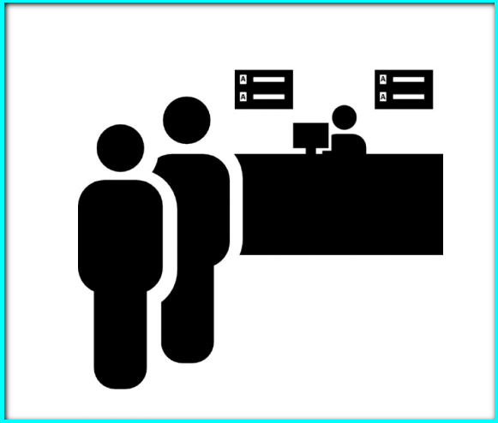

|  |  |
| --- | --- |
| **Step** | **Action** |
| **Note** | **Lab Assistant: Phlebotomist** |
| **6** | Log on to KRMS. Print the SO screen only. Do NOT accession. |
| **7** | Stamp the SO printout with the “MOB Phleb Collection” stamp. Write all required information.    MOB  Phleb Collection  Collected by, NUID: _________________  Coll’n date/time: ____________________  Indicate # tubes Collected BLDCult:______    BLU5 _______ PST4: _________   GLD6: _______ LAV5:_________   Other: _______                                             (Specify tube type) Special Instructions if any________________ _____________________________________ |
| **8** | Log on to KPHC. Print KPHC demographics labels. Select the option highlighted below. Place one label per specimen container and one extra for the ‘MOB Downtime Specimen Log’. |
| **9** | Collect the specimens from the patient based on the SO printout (KRMS). |
| **10** | If possible, do not share specimens (example: BNP and CBC) |
| **11** | Refer to LabNet for collection information. |
| **12** | Affix a KPHC demographic label on each of the primary specimen containers. |
| **13** | Use one specimen biohazard bag per patient. |
| **14** | Place the SO printout (KRMS) in the bag’s side pocket. |

|  |  |
| --- | --- |
| **Step** | **Action** |
| Note | Lab Assistants: Processing |
| **15** | Process the blood tubes as appropriate  (Refer to laminated Downtime Specific Specimen Requirements) |
| **16** | |  |  | | --- | --- | | **IF** | **THEN** | | **Downtime ETA < 4 hours**   * ROUTINE | Centrifuge specimens as needed.  Refrigerate specimens if required. | | **Downtime ETA >4 hours or the estimation of <4 hours has exceeded**   * Routine * Sendouts   (SWL, Quest or ARUP) | Prepare all specimens and accompanying printouts for transport to LAMC Lab.  Samples maybe sent through KP courier or third party. | |  | | |

|  |  |
| --- | --- |
| **Step** | **Action** |
| **Note** | **Lab Assistants: Specimen Distribution** |
| **17** | Complete a “MOB Downtime Specimen Log” prior to specimen transfer to LAMC Main Lab. Use the extra KPHC label for the log. |
| **18** | Keep a copy of all “MOB Downtime Specimen Log” in your area for tracking purposes. |
| **19** | Print a SmartShip (KPCourier only) printout for each tote. |
| **20** | Indicate on the SmartShip printout the total patient count per tote. |
| **21** | Staple together the original copy of the “MOB Downtime Specimen Log” and the SmartShip printout to go along with the tote. |

|  |  |
| --- | --- |
| Step | Action |
| **Note** | **Lab Assistants: Recovery** |
| **22** | Accession the orders in the KRMS and complete the orders with one of the following:   |  |  | | --- | --- | | **If the orders are:** | **Then use:** | | Laboratory and patient collect | SO function | | Clinic Collect Orders | OE function | |
| **23** | Print the labels. |
| **24** | Validate that all collection labels are printed (Cerner &/or RMS labels). |
| **25** | Affix appropriate label to each specimen container. |
| **26** | Perform Specimen Log-In on Cerner following established protocol. |
| **27** | Prepare specimens for transfer and send outs as usual. |
| **28** | Retain all downtime documents on site for 3 months (LAMC-PPP-0015) |

