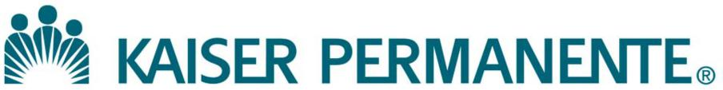

**LOCATION: VERSION:**

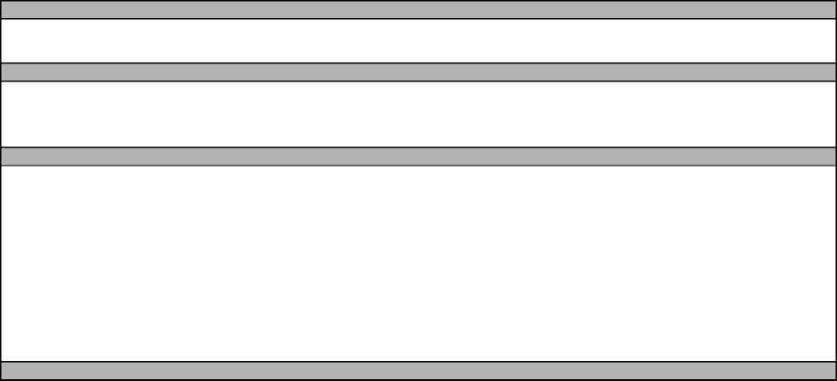

**DOCUMENT NUMBER:**

**DOCUMENT TITLE:**

**DOCUMENT NOTES:**

**DOC TYPE: STATUS:**

**EFFECTIVE DATE: NEXT REVIEW DATE:**

**RELEASE DATE: EXPIRATION DATE:**

**AUTHOR: PREVIOUS NUMBER:**

**OWNER: CHANGE NUMBER:**

|  |  |
| --- | --- |
|  | **WAM Connection Resolution Guide**  (User Level) |

1. What is the message or indication of WAM connection issue?

|  |  |  |
| --- | --- | --- |
| Situation/Observations | Possible Cause | Action |
| * All specimens will be Unregistered. | Communication between host (LIS) | 1. Contact KP ServiceNow at 8-395-1143, or |
| * Specimens will not have | and Sysmex WAM for orders and | 1-844-563-4357. |
| demographics   * Orders are not recognized | results (interface connection) is interrupted. | * Provide location WAM site (site A, B,  etc) and instrument serial number |
| * Message "Has lost connection. TCP/IP |  | * Mention the message/s observed. Be |
| unable to establish connection" visible |  | specific as possible. |
| on the instruments. |  | * Communicate what is not working, as |
| * Rules are not working |  | applicable (XN ? WAM? Slidemaker?) |
| * Are slides being made? |  | * Mention that it is a patient care issue. |
| * Note if issue is isolated to Sysmex and |  | * KP HelpDesk will ask a number of |
| the following are working as expected: |  | troubleshooting steps, possibly |
| Cerner, other middleware (i.e., UA, Remisol, DI, etc) |  | including restarting the analyzer.   * Ask ticket to be assigned to: ASG CDAS |
|  |  | LAB SPECIALTY APPS |
| Upon loading specimen, message saying | Communication between host (LIS) | Log off user at inactive workstations. |
| "License is expired" came up on WAM | and Sysmex WAM for orders and | If logging off inactive workstations, doesn’t |
| and/or instrument | results (interface connection) is | resolve the issue, call ServiceNow, and mention |
|  | interrupted. | the message |
|  | Number of active licenses have exceeded limit of 47. |  |

1. After ServiceNow ticket assignee calls Sysmex TAC, TAC will work with ASG CDAS LAB SPECIALTY APPS for determination of issue extent and start resolution and recovery:
2. What is Sysmex WAM’s finding?
3. Sysmex WAM First level and/or Second level support will call back lab user.
4. Based on Sysmex WAM’s initial finding, TAC will call lab user with the info received and resolution and recovery steps.

Page 1 of 1 Version No.: 01

|  |  |
| --- | --- |
|  | **WAM Connection Resolution Guide**  (User Level) |

|  |  |  |
| --- | --- | --- |
| Suspected Cause | Possible Owner/Attribution | Action |
| WAM Server Issue on Sysmex WAM side | WAM Support | Work with WAM TAC Support to fulfill the incident ticket resolution |
| WAM Server Issue on KP  Cerner LIS issue | WAM Support + TCS (+ASG CDAS LAB SPECIALTY APPS if needed) | Relay information to SN; ask ticket to be assigned to possible owner group. |
| WAM Support + TCS (+ASG CDAS LAB SPECIALTY APPS if needed + Cerner NonIT | Relay information to SN; ask ticket to be assigned to possible owner group. |
|  |  |

4. Continue to work with Sysmex TAC to bring the analyzer system up. On notification of issue resolution, re-logged in samples for download to WAM. Keep INC# and REF# on record for possible follow up.

*Regional Parent Document Reference Number: SCPMG-PPP-0565 Rev: 01*

Page 2 of 2 Version No.: 01