Procedure for Creating a STAT Alert Request

Procedure | Follow the steps below to create a STAT Alert request with documentation required by CAP, JCAHO, and other regulatory agencies.

Medical Center Procedure for Filling Out STAT Alert
Step | Action
1 | Create a STAT Alert.  - Access Stat Alert Request website: https://sp-cloud.kp.org/sites/STATAlertRequests/Lists/Stat%20Alert%20Requests/AllItems.aspx  - Note: For Medical Centers, only pages 1, 2, 3, 4, & 6 are applicable.
2 | Click on New and then Item.  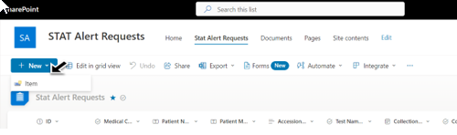
Continued next page

Procedure for Creating a STAT Alert Request, Continued

Medical Center Procedure for Filling Out STAT Alert, continued
Step | Action
3 | A window will pop up. Fill out the appropriate areas applicable to the specific Medical Center where the sample is originating and the location of where the lab sample will be tested.  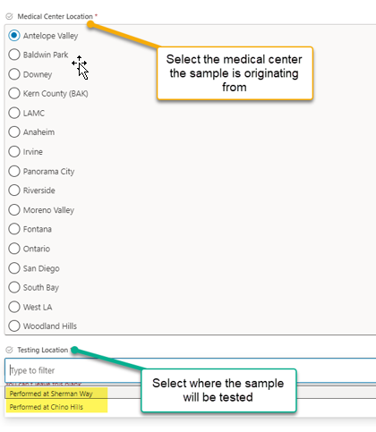  Note: Specify the Regional Laboratory that is associated with your service area.  Chino Hills services – Baldwin Park, Downey, Riverside, Moreno Valley, San Diego, Fontana, Ontario, Anaheim, & Irvine  Sherman Way services – LAMC, Woodland Hills, Pan City, South Bay, Antelope Valley/Lancaster, Bakersfield, West LA

Continued next page

Procedure for Creating a STAT Alert Request, Continued

Medical Center Procedure for Filling Out STAT Alert, continued
Step | Action
4 | Fill in the Patient Information, Collection Date & Time, and Test Name.  - If multiple samples of the same test are being sent in the same tote/courier, add all patient information (Name, MR #, Accession #, Collection date/time).  - If multiple samples of different tests are being sent in the same tote/courier, another request must be made.  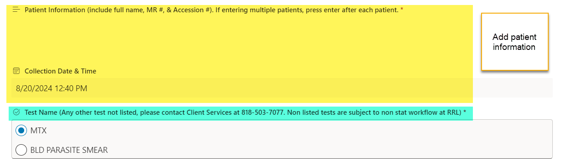  Note: ONLY two options are available for Stat Alerts:  - MTX  - Blood Parasite smear (BLD PARASITE SMEAR).  - If choosing Blood Parasite Smear, be sure to include number of slides and EDTA tubes being sent.  - Other tests must follow the previous workflow.  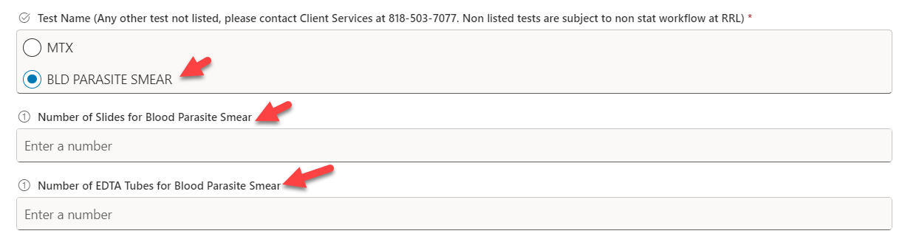
5 | Include type of courier used and add applicable information  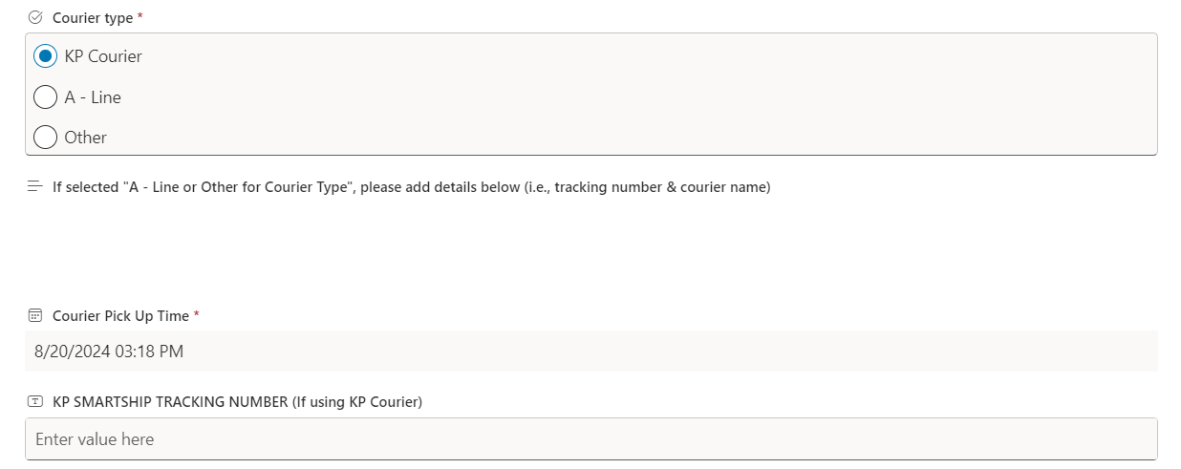
6. | When all patient and sample information has been added, click Save at the bottom of the form.  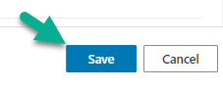

Continued next page

Procedure for Creating a STAT Alert Request, Continued

Regional Reference Laboratories Ancillary and Client Service Center Procedure for STAT Alert
Step | Action
1 | When the sample is received at SWL or CRL, the Ancillary staff will fill out the following:  - Date/time received at SWL or CRL  - Dept the sample was delivered to  - Date/time of delivery to testing dept.  - NUID of testing dept. employee receiving the sample  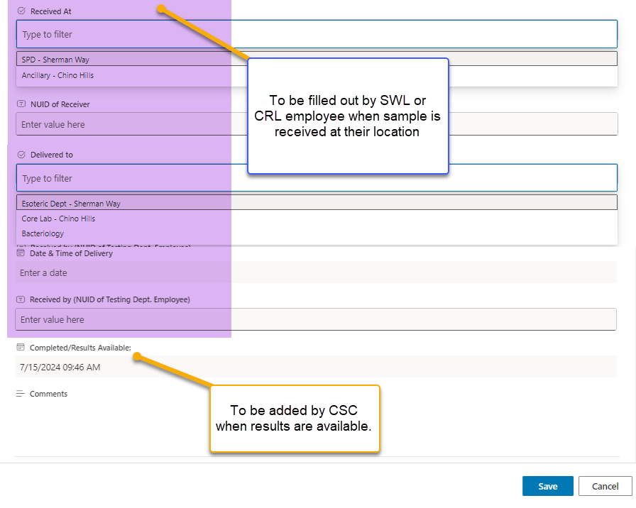

Continued next page

Procedure for Creating a STAT Alert Request, Continued

Regional Laboratory Ancillary and Client Service Center Procedure for STAT Alert, continued
Step | Action
2 | The Client Service Center will fill in the Completed/Results Available section.  Note: In case of problems, follow the contingency process outlined below:  