FETAL HEMOGLOBIN (APT TEST)

METHOD | APT - Downey

PRINCIPLE | The test is based on the alkali resistance of fetal hemoglobin found in feces and gastric contents of bleeding newborn infants and serves to differentiate  it from maternal blood.

SAFETY | All reagents and controls should be handled as though capable of transmitting infectious diseases. Wear appropriate personal protective equipment when running patient samples or performing scheduled maintenance.  Refer to Laboratory Policy and Procedure Manual Safety Section (11).

REAGENTS | 1% sodium hydroxide.

CONTROLS | Positive Control: Baby’s blood (fetal hemoglobin) remains pink.  Negative Control: Mother’s (adult hemoglobin) blood will change from  pink to light brown.

PROCEDURE

Step | Action
1. | Mix the material to be tested with water about 1:10 to lyse the red cells. If the specimen appears like whole blood, use a higher dilution (approx. 1:20) to ensure detection of color change after step 4.
2. | Centrifuge the mixture. Separate the pink supernatant, and filter.
3. | Mix 1 ml 1% sodium hydroxide with 5 ml hemoglobin solution.
4. | After 2 minutes incubation at room temperature, examine.
5. | Controls of mothers and infants blood specimens should be run. Make a 1:20 dilution of whole blood with water to lyse the red cells. Procede with step 2.
Continued on next page

RESULT INTERPRETATION AND REPORTING | - Adult hemoglobin changes from pink to light brown. Report as NEGATIVE: No fetal hemoglobin not detected.  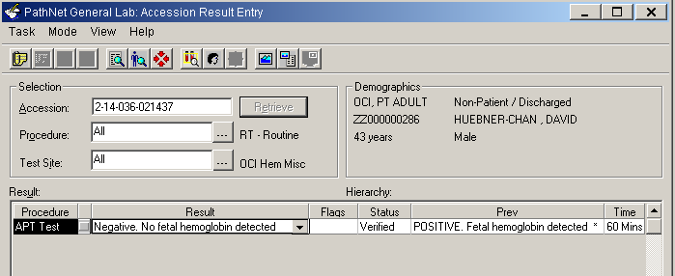  - Fetal hemoglobin remains pink. Report as POSITIVE: Fetal hemoglobin detected.  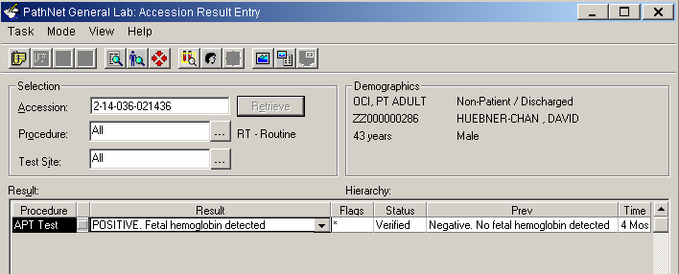  - Results are manually entered in Cerner under the Accession Result Entry (ARE) mode.  For detailed instructions of entering results, please refer to Laboratory Informatics – Cerner Genlab Policies & Procedures Manual, “Resulting in Cerner GenLab: Manual Entry Module” LIS.SCPMG.041 document.

REFERENCE | Bray's Clinical Laboratory Methods, 7th Ed., p. 170.

Document History Page

Change type: New, Major, Minor etc. | Changes Made to SOP – describe | Name of responsible person/date | Med. Dir. Reviewed/ Date | Lab Manager reviewed/ date | Date change Imp.
Minor | Added additional information regarding Positive and Negative | Charlie Park  11/13/12 |  |  | 11/13/12
Major | Updated resulting section to reflect the changes for new LIS, Cerner. | Julius Salomon 04/15/14
Imp. =Implemented

