NASAL SMEARS FOR EOSINOPHILS

PRINCIPLE | Nasal smear is stained with Wright Stain and observed microscopically for the presence of eosinophils. Allergic and atopic conditions such as bronchial asthma and seasonal rhinitis (hay fever) are characterized by eosinophilia.

MATERIALS & REAGENTS | Microscope  Cover slip  Glass microscope slides  Hema-tek Slide Stainer  Hema-tek Stain Pak

SAFETY | All specimens, reagents and controls should be handled as though capable of transmitting infectious diseases. Wear appropriate personal protective equipment when running patient samples or performing scheduled maintenance.  Refer to: Policy and Procedures Safety Manual Infection Control and Procedures 11-030-01

SPECIMEN | Nasal swab/smear.

PROCEDURE
Step | Action
1. | Stain slide with Wright Stain on Hema-Tek slide stainer.
2. | Examine for the presence of eosinophils under oil immersion.
3. | View the slide under oil immersion lens (100X) and report any eosinophils seen as follows:  - 0/HPF = NONE SEEN  - 0-5/HPF = 0-5 cells/oil immersion field  - 5-10/HPF = 5-10 cells/oil immersion field  - 10-25/HPF = 10-25 cells/oil immersion field  - >25/HPF = >25 cells/oil immersion field  Note: See attached picture

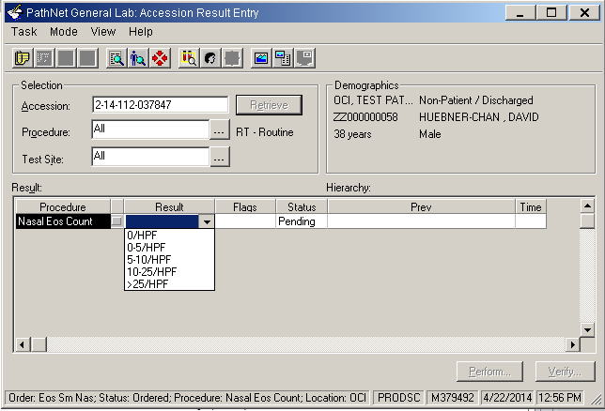

NOTE: Cell and parasite identification can be difficult. If you have any doubt of the correct identification, you may consult your co-worker, supervisor, or pathologist for assistance.

RESULT REPORTING | Results are manually entered in Cerner under the Accession Result Entry (ARE) mode.  For detailed instructions of entering results, please refer to Laboratory Informatics – Cerner Genlab Policies & Procedures Manual, “Resulting in Cerner GenLab: Manual Entry” LIS.SCPMG.041 document.

REFERENCE RANGE | None seen

REFERENCE | John Bernhard Henry, M.D. Clinical Diagnosis & Management by Laboratory Methods, 18th Edition.

Document History Page

Change type: New, Major, Minor etc. | Changes Made to SOP – describe | Name of responsible person/date | Med. Dir. Reviewed/ Date | Lab Manager reviewed/ date | Date change Imp.
Major | Updated format and procedure, added the materials/reagents, safety, specimen and result reporting section to reflect the changes for new LIS, Cerner. | Julius Salomon  04/14
Imp. =Implemented

