SYNOVIAL (JOINT) FLUID CRYSTAL EXAMINATION

METHOD | Manual

PRINCIPLE | Microscopic examination of synovial fluid for the presence of crystals is used in the diagnosis of crystal-induced arthritis. The primary crystals seen in synovial fluid are monosodium urate, which is found in cases of gout, and calcium pyrophosphate, which is associated with cases of pseudogout. Cholesterol crystals, crystals of apatite (the major mineral found in cartilage), and corticosteroid crystals resulting from drug injections also may be seen.  In this procedure, fluid is examined unstained, under both direct and compensated polarized light. By examining the refractive properties of the crystals under compensated polarized light, it is possible to differentiate between the two different crystals, monosodium urate and calcium pyrophosphate.

MATERIALS | - Reference slide of known monosodium urate crystal.  - Polarizer with first-order red tint plate.  - This accessory is to be used with Nikon Eclipse 50i microscope located in the area of the laboratory where body fluid analysis is performed.  - This microscope has been fitted with the C-IA intermediate tube with analyzer located directly below the eyepiece tube.

SPECIMEN | Synovial fluid submitted in a liquid EDTA tube is the preferred specimen.  Specimens with or without anticoagulants may be used. However, powdered EDTA, oxalate, lithium heparin should NOT be used as an anticoagulant, since each may be associated with crystal formation. If the specimen is received in a specimen cup, transfer the fluid to a red top tube with no anti-coagulant or an EDTA tube and centrifuge.
Continued on next page

SAFETY | All specimens should be handled as though capable of transmitting infectious diseases. Wear appropriate personal protective equipment when running patient samples or performing scheduled maintenance.  Refer to: Policy and Procedures Safety Manual Infection Control and Procedures 11-030-01

PROCEDURE

Step | Action
1. | Centrifuge specimen for 10 minutes at 3000 rpm.
2. | Using a disposable pipette, remove and discard about 90 – 95% of the supernatant.
3. | If there is a pellet of sediment, re-suspend it in the remaining fluid.
4. | Place a small droplet of the remaining fluid or re-suspended sediment on a glass microscope slide. Float a coverslip on the drop.
5. | Perform microscopic exam under routine light and polarized light. See following section for instructions on use of polarizing filter.
6. | Evaluate for the presence of typical uric acid or calcium pyrophosphate crystals at low and high power.
7. | YOU MUST SCAN THE ENTIRE SLIDE FROM ONE END OF THE COVERSLIP TO THE OTHER INCLUDING STUFF THAT SQUIRTS OUT FROM UNDER THE COVERSLIP EDGE!
8. | View the reference slide that is positive for MSU crystals to ensure proper functioning of the polarizer. Resolve any discrepancies and document before releasing patient results.

Continued on next page
SET UP AND USE OF POLARIZER

Step | Action
1. | Select microscope IR 052129 located in the area where body fluids are analyzed.
2. | Remove the polarizer from the storage box and place the polarizer over the illuminator. It will be necessary to remove the IR cut filter.
3. | Orient the polarizer so that the words Nikon C-TP are at 6 o’clock.
4. | Although there is a small hexagonal clamp screw it is not necessary to tighten it as long as you keep the polarizer in the aforementioned orientation.
5. | Place the slide with the prepared specimen on the stage.
6. | Swing the orientation handle to the far left. The background of the field should be rose colored.
7. | Find at least 1 crystal oriented North-South and another oriented East-West.
8. | With the orientation handle in the left position, MSU crystals (gout) with their long dimension in the N-S direction should appear yellow.
9. | Move the orientation handle to the extreme right position. Now the N-S crystals should be blue and E-W yellow if they are MSU.
10. | Be sure to test the crystals with the orientation handle in both positions.
11. | Use a reference slide containing known MSU crystals to familiarize yourself with the procedure and ensure the microscope and polarizer are functioning correctly.
12. | The color change in calcium pyrophosphate is the reverse of monosodium urate.
13. | Refer to the supplemental guide entitled “Crystal Analysis” for further photomicrographs and instructions.

For detailed instructions of entering results, please refer to Laboratory Informatics – Cerner Genlab Policies & Procedures Manual, “Result Entry in the Microbiology Module” LIS.SCPMG.005 document.

RESULT REPORTING
 | Step | Action
 | 1. | In Cerner go to Microbiology Result Entry
 | 2. | Scan or type specimen barcode
 | 3. | Click the Entry field
 | 4. | Type fin and press Enter
 | 4. | Type the Response Value and press Enter. If needed, type additional Response Values and press Enter after each.  Response Value:  - Press F2  - Click the radio button to select one of the following filters  - Under Filter; click Report Responses  - Response List will pop-up  - Select appropriate response for number  Few = ≤ 2 cells / HPF  Mod = 3-9 / HPF  Many = ≥ 10 cells / HPF  Select appropriate response for location  Intra C = intra-cellular crystals  Extra C = Extra-cellular crystals  In and Ex = Both Intra and Extra  Select appropriate type  CHO = Cholesterol  CPPD = Calcium Pyrophosphate Dehydrate  MSU = Monosodium Urate
 | 5. | To save result, click Perform or the release click Verify

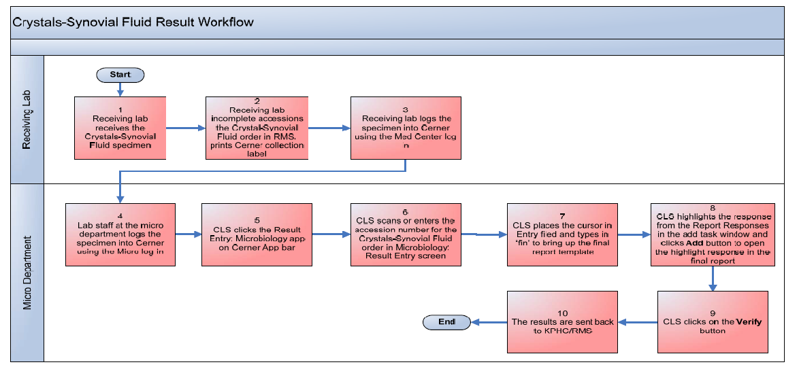

RESULT REPORTING,  continued | Note: if crystals appear to be present but you are unable to identify, enter  “unable to classify, specimen submitted to pathology for identification.”  When submitting a specimen to pathology for identification please send the following:  - The specimen  - A printout of the result from Cerner  - The transmittal from ED if the specimen is submitted from the Emergency Department.  - If the patient is an outpatient and no transmittal is available, please print out the original order for “Crystal Analysis, Body Fluid” from Health Connect and submit it to pathology.

EXPECTED RESULTS | Crystals are not present in normal synovial fluid.

PROCEDURAL NOTES | - Crystal examination should be performed as soon as possible after collection, because changes in temperature and pH in the fluid can affect crystal solubility, producing erroneous results.  - Crystals tend to have sharp, clearly defined edges and straight sides, in contrast to the indistinct forms of many artifacts.  - Talcum powder from surgical gloves may sometimes be seen in the synovial fluid as bright Maltese crosses when the fluid is polarized.

REFERENCE | Kjeldsberg, Carl R., Knight, Joseph A., Body Fluids: Laboratory Examination of Amniotic, Cerebrospinal, Seminal, Serous & Synovial Fluids, 3rd Edition, ASCP Press, Chicago, Il, 1993.

Document History Page

Change type: New, Major, Minor etc. | Changes Made to SOP – describe | Name of responsible person/date | Med. Dir. Reviewed/ Date | Lab Manager reviewed/ date | Date change Imp.
Major | 1) Updated the procedure format. 2) Updated result reporting section to reflect the changes for new LIS, Cerner. And added Cerner workflow diagram. | Julius Salomon  04/14
Imp. =Implemented

