Purpose | This procedure will describe how to document the daily monitoring of the temperatures and how to document corrective actions using the automated temperature monitoring system (ATMS) that has the ability to continuously monitor and record temperature of Laboratory equipments

Policy | - There must be a mechanism to ensure monitoring of appropriate temperatures, responding to alerts and documentation of corrective action steps.  - ATMS monitors and maintains accurate logs for temperature monitoring of all equipments.  - ATMS sends real-time alerts for out-of-range situations to protect critical temperatures of laboratory reagents, blood supplies, specimens and other supplies.  - Centralized online documentation allows access to corrective actions & automated data. Security, Engineer, CLS, and Supervisor/designee will work in collaboration to ensure the proper monitoring, responding to alert, handling and documenting for all equipment with ATMS.  - Security, Facilities, Communications and Department Administrator or Designee will work in collaboration to ensure proper monitoring, response to alerts, handling and documentation for each automated temperature monitoring units.  - Facilities Services Department will work in collaboration with the Awarepoint vendor to perform & document annual Preventive Maintenance to ensure the life span of the battery and proper functioning of the automated temperature monitoring tag.  - The daily logging of temperatures consists of checking temperatures daily and documentation all equipment temperatures that are in compliance, out of compliance, and also of the corrective actions taken for all equipments that are out of compliance:  - Harbor Mac CLS will document for the equipment in HBM, TRM, IMO & HB MOB Laboratory  - Mission Viejo MOB CLS will document for the equipment in MVJ, AVO, FHR & SJC MOB Laboratory  - The IMC CLS assigned to Blood Bank will document for the equipment in IMC BB, Laboratory & SCN MOB Laboratory

List of Laboratory Equipment Types, Temperature Ranges & Alert Times

Equipment Type | Reference Temperature  Ranges | Time to 1st alert (min)
Lab Reagent Refrigerator | 2°C to 8°C | 30
Lab Specimen Refrigerator | 2°C to 8°C | 60
Lab Reagent Freezer | < -18°C | 30
Lab Freezer | < -10°C | 60
Lab Glucola Refrigerator | 2°C to 8°C | No alert
Laboratory Cryopak Freezer | < -10C | No Alert
Blood Bank Refrigerator | 1.0°C to 6.0°C | 20
Blood Bank Refrigerator Blood/Reagent | 2.0° to 6.0°C | 20
Blood Bank Freezer | <-18°C | 20
Platelet Incubator | 20°C to 24°C | 20
Bacti Incubators | 33°C to 38°C | 30
Chemistry Reagent Freezer | <-20°C | 30
Chemistry Calibrator Freezer | -15C to -20C | 30

Daily Logging of Equipment Temperature | Step | Action
Daily Logging of Equipment Temperature | 1. | Launch the awarepoint program.  - https://aps.awarepoint.com/sso/login  - (save it under your favorites)  - Enter users name: your complete KP email address  e.g., john.x.doe@kp.org)  - Enter your password.  - Password can be reset by clicking on “Forgot your password?”

 | 2. | Select the Temperature/Humidity Tab at the top of the screen.  - Temperature/ Humidity Dashboard will appear  - From the drop down box on the top left, select “Show My Assets”.  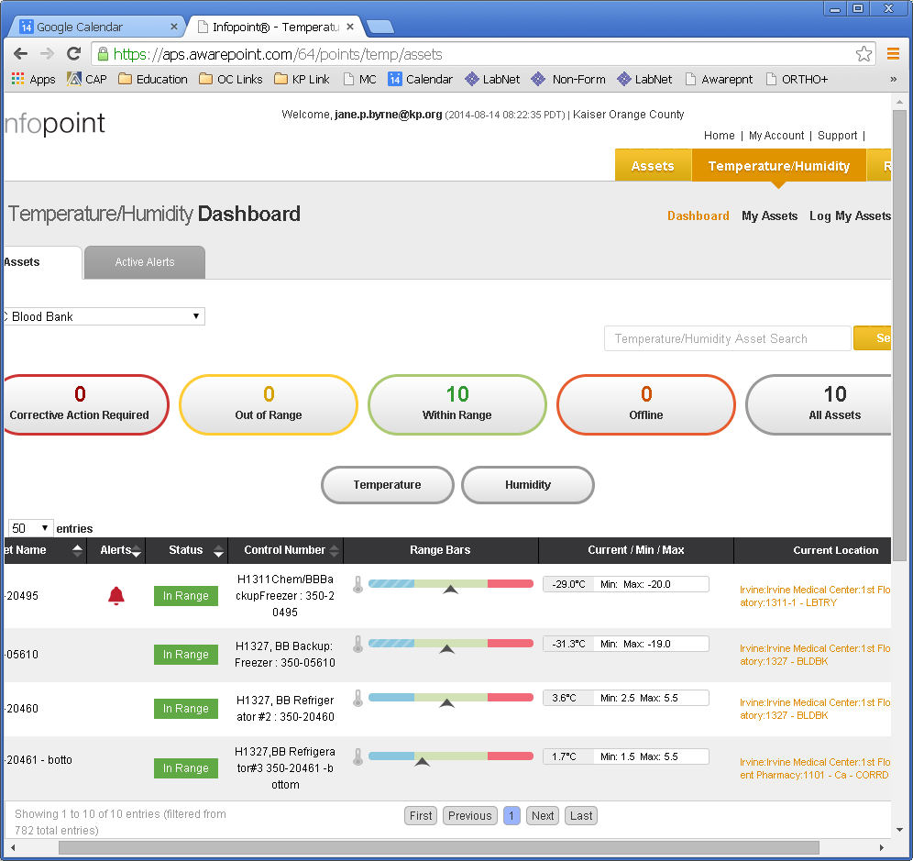
 | 3. | Displayed Status are:  - Red Corrective Action Required: display equipment that have been out of the temperature range longer than the set alert time & requiring corrective action steps.  - Yellow Out of Range: displays equipment with temperature out of range but still within the alert time range & requiring corrective action steps.  - Green Within Range: displays equipment that are within the temperature range  - Orange Off Line: displays equipment when awarepoint tag is not responding or communicating

 | 4. | - Select “Log My Assets” on the top right.  - Select “Show My Assets” from the drop down window on the left  - Temperature/Humidity Assets Logging Dashboard will appear, ensure that “Show All Assets” is selected, do not select “Show Out of Compliance Assets”  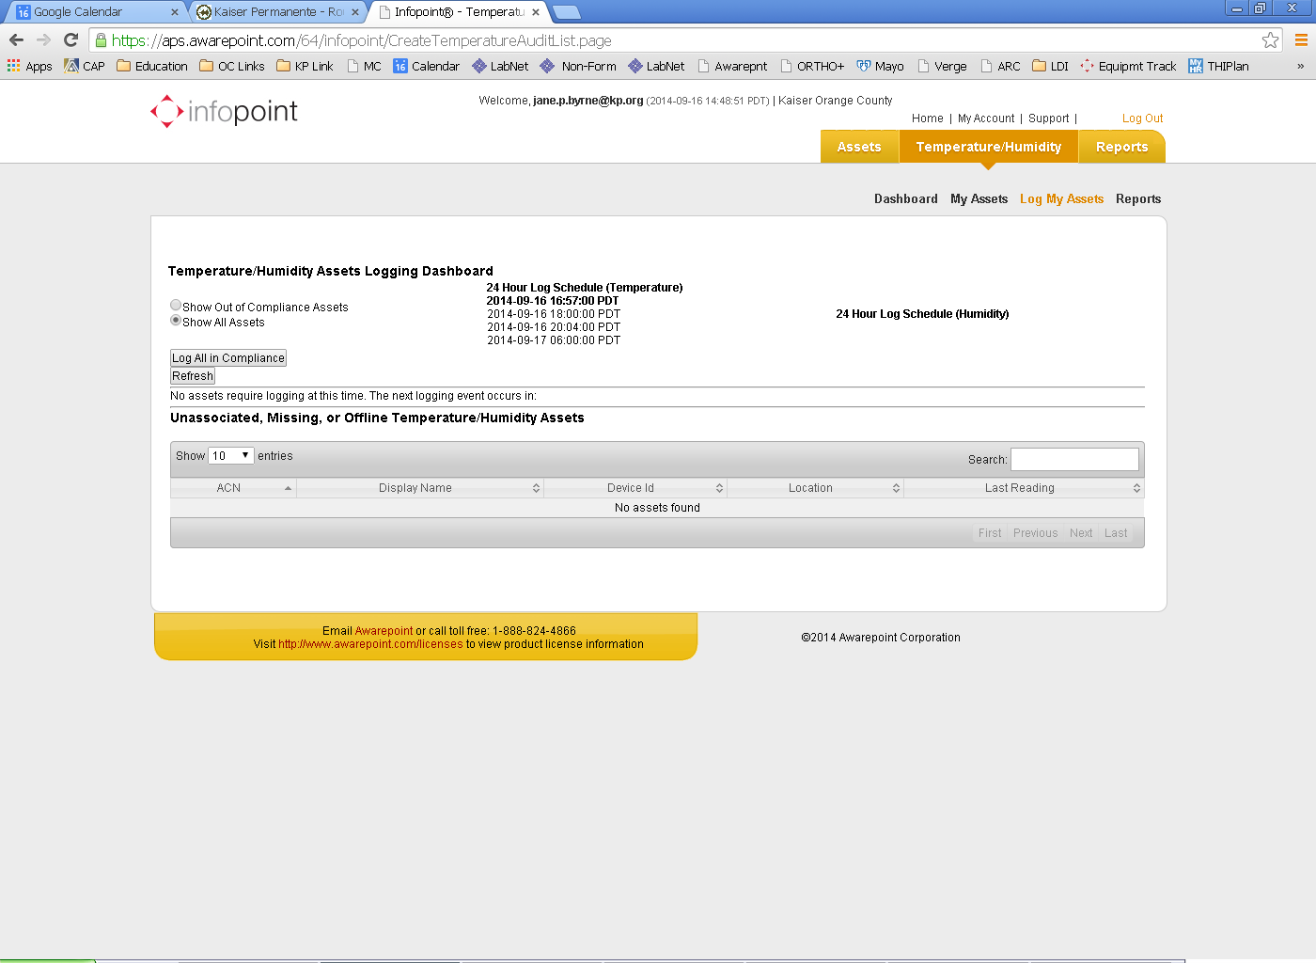

 | 5. | Click on “Log All In Compliance”  - This will remove all equipments that are in compliance (in green box) from the screen display  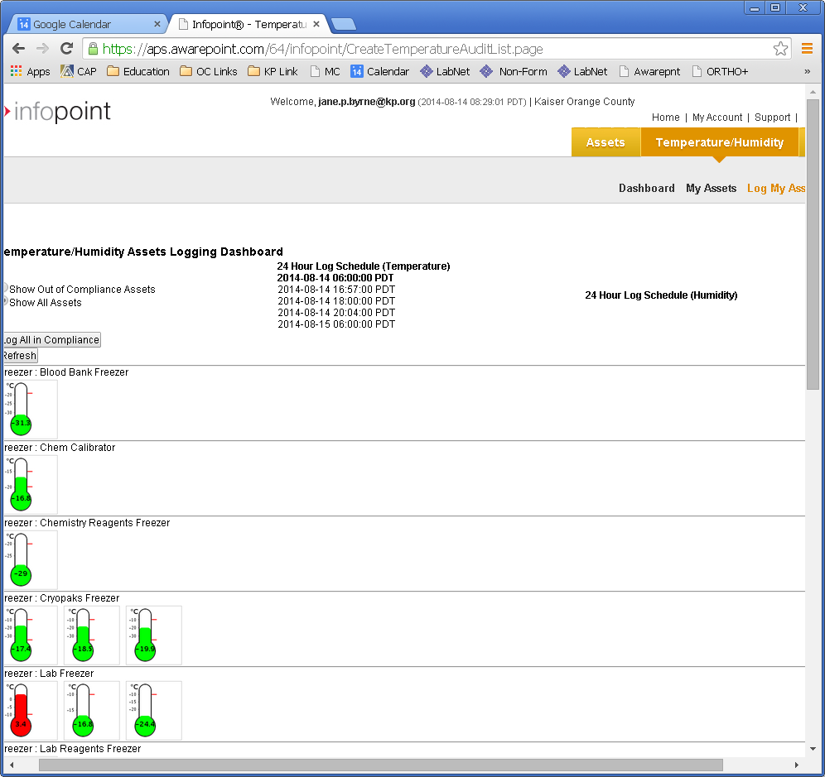

Any equipment that is in Yellow box will remain on the screen requiring documentation of the corrective action steps. Click on the thermometer & documentation box will appear
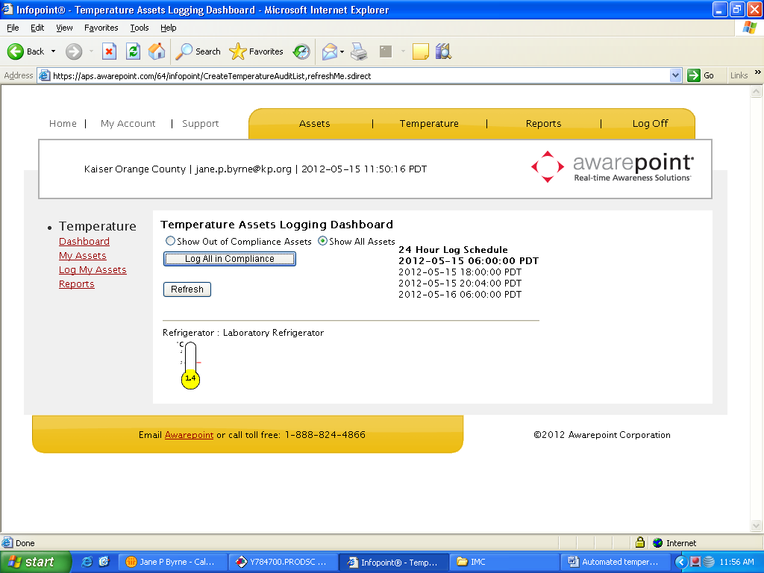
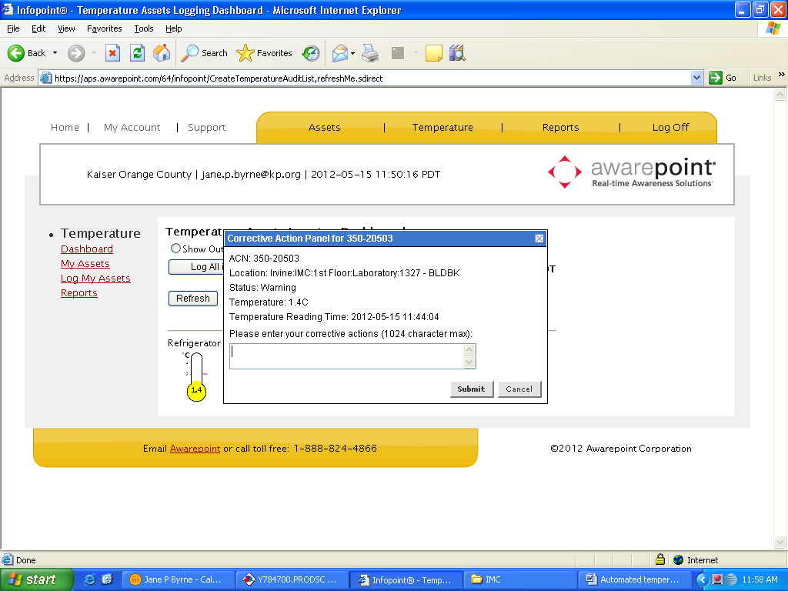
- Once the corrective action is added on & submitted, this will disappear until the next Log In event.
- Do this for each yellow “Out of Range”
- You will need to contact the Lab location that has the equipment with Out-of Range status to take necessary actions
Any equipment that is in Red box will also show as “Out of Compliance” and requires corrective action steps documented. Click on the picture of the thermometer for each equipment to document corrective action steps.
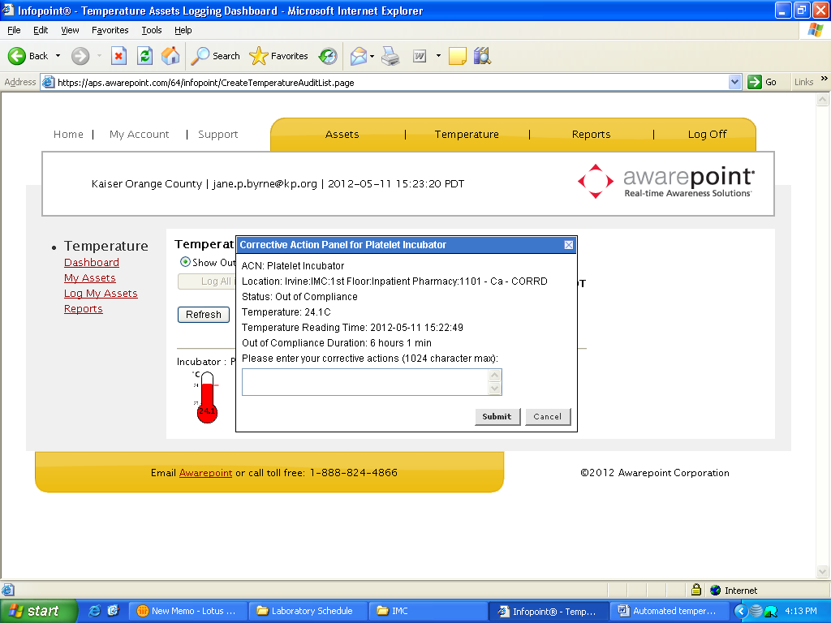
Follow up must occur to ensure that the problem is corrected. If unable to repair, remove contents of freezer or refrigerator to another piece of equipment for temporary storage, until the problem is resolved. Document all actions taken in ATMS for that equipment.

Alert Response & Corrective Action Steps | Step | Action
Alert Response & Corrective Action Steps |  | The system will send an initial alert to security if the temperature of the equipment is out of range continuously for more than the set alert times. Refer to the chart on page 1. Security will call the following Lab during operational hours:  - IMC Lab (6110) for the IMC & ASN Lab equipments  - MVJ Lab for MVJ, FHR, AVO & SJC Lab equipments  - HM Lab for TRM, HM, HB & IMO Lab equipments

Security will notify the end user department or administration with the following script:
Hello, my name is __ and I am calling from the KP Irvine security office to let you know that your __ is currently out of range. The current temperature is__, per the policy the temperature should be between __ and __. This unit is located in ___ and has been out of range for __minutes. Is there any additional information that you need? I can be reached at 949-932-5511.

- The equipment that requires corrective action will display red bell picture, click on the picture.
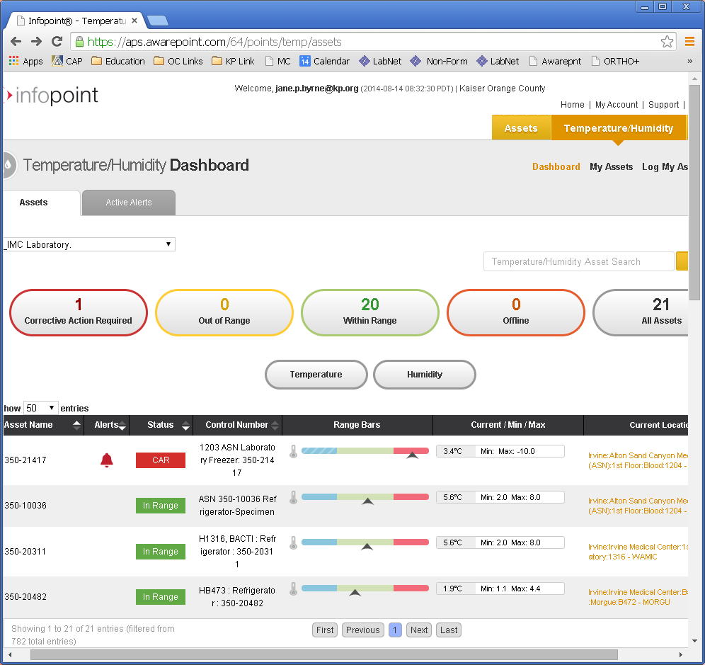

Click on “Alert South”
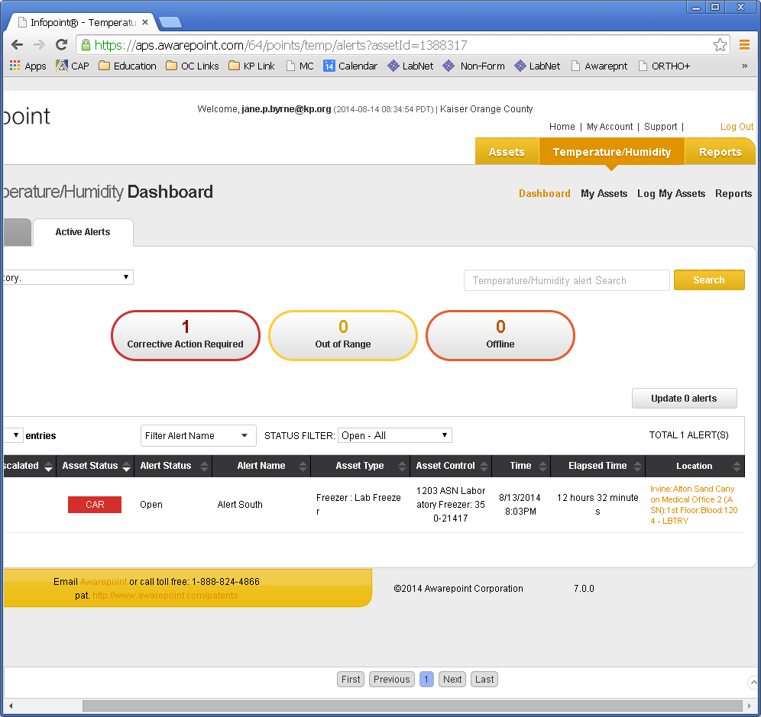
Lab staff will visually inspect the equipment and take appropriate actions, such as closing the door of the equipment that has been left open or contacting engineering. Corrective action steps must be documented and the alert must be acknowledged in ATMS in a timely manner.
- Scroll down so that you can see “Post Alert Update”
- Select “Acknowledge” from the drop down
- Click the box underneath displaying “Please select one of the following, and it will display different options for the corrective action. Select an appropriate action step taken.
- Type in any additional comments in the box if necessary and click on “Post”. Information will post in the system.

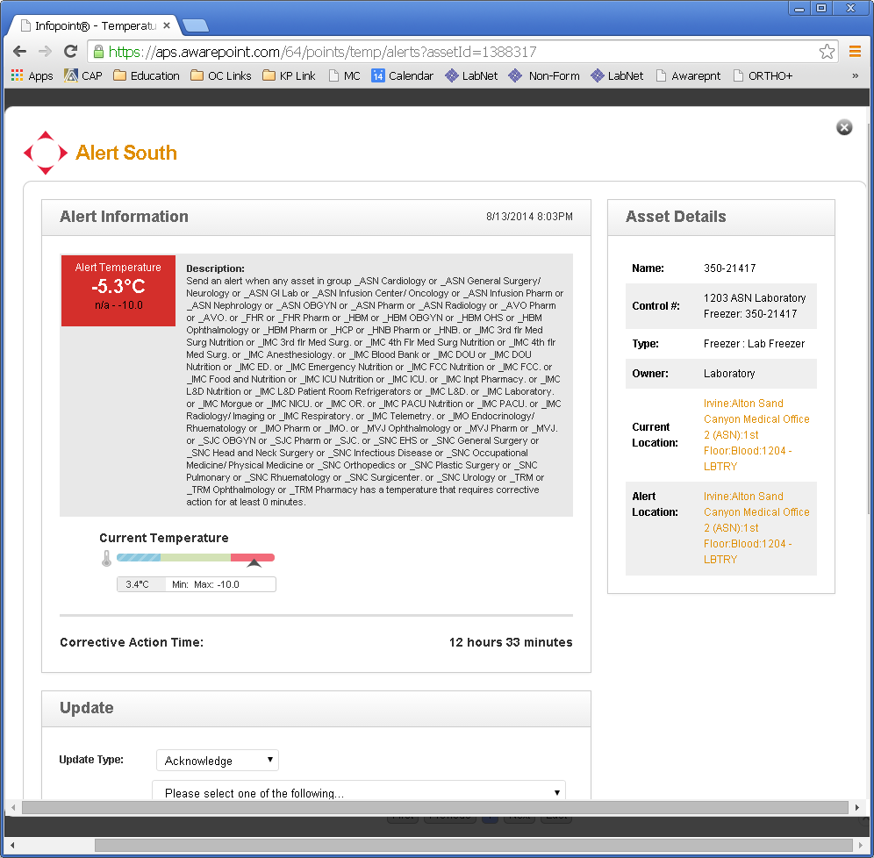

You may need to review historical temperature recording and trending. Click on the Asset number
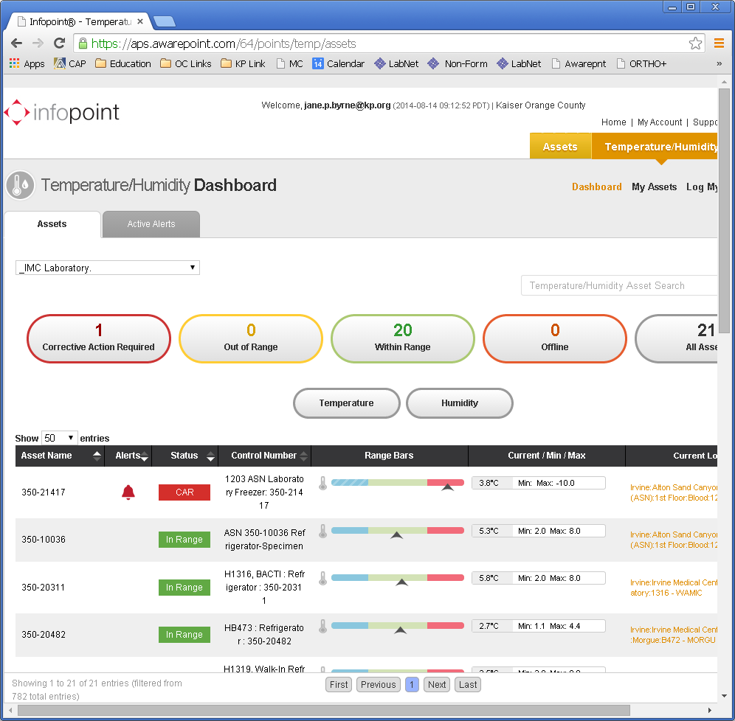

ATMS will display the temperature chart
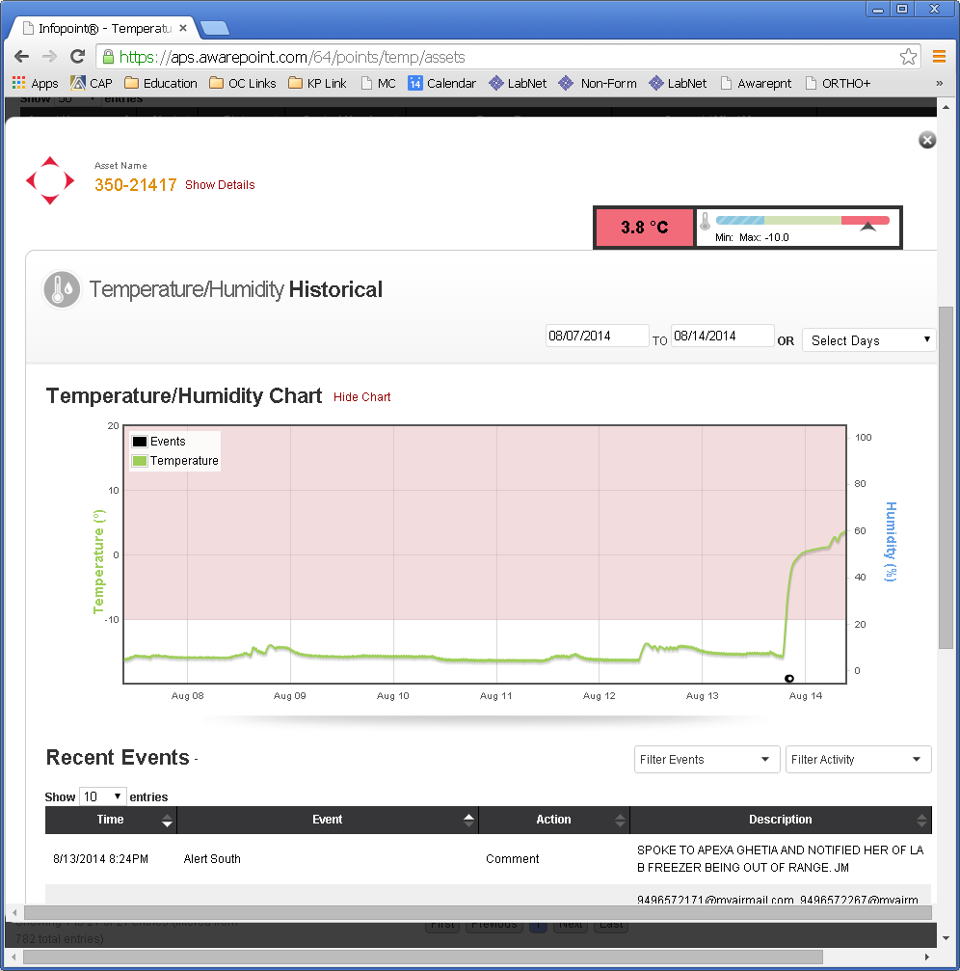

The alert on the equipment will not disappear until the following conditions were met:
- temperature comes within the range, and
- the alert is acknowledged in ATMS

If the temperature of the Freezer has been out for longer than 2 hours and:
- Reagents were stored - validate the reagent reactivity or calibrator reactivity by running tests to check. If the reactivity cannot be validated, notify the supervisor for possible replacement.
- Specimens that were stored - check the stability and storage requirement of the test to see if the specimen is still ok or needs to be redrawn.

If unable to repair remove contents of freezer or refrigerator to backup equipment for temporary storage.

New Equipment or  Equipment is shipped out of the Lab for repair | Step | Action
 | 1. | Following steps must be taken when the equipment that has the ATMS is removed from the facility during repair, or a brand new equipment is acquired & requires temperature monitoring:
 | 2.
 |  |  | If… | Then…
 |  |  | Equipment leaves the facility for repair | - Request engineering to remove the probe temporarily using Easynet or a phone call  - contact the admin support to disable ATMS temporarily
 |  |  | Repaired equipment is returned | - request engineering to re-install the tag, and the admin support to enable ATMS
 |  |  | New equipment is purchased & requires temperature monitoring | - Contact the admin support to install new awarepoint tag & to add the equipment to ATMS.  - Staff who is responsible for the facility equipment must added it under “My Assets”
 |  |  | Equipment is permanently removed | - Request engineering to remove the awarepoint tag  - contact the admin support to disable ATMS
 | 3. | Admin Support:  Cynee Davis, Facility Service Equipment Coordinator  714-279-5137 Cynee.P.Davis@kp.org  IMC Security 949-932-5511

Monthly Review & Documentation | Step | Action
Monthly Review & Documentation | - 1 | The following report will be generated monthly from ATMS system to be reviewed for the temperature and documentation compliance by the supervisor/designee:  - Temperature Event History
Monthly Review & Documentation | - 1. | Select the Reports hyperlink from the sidebar menu on the left of the screen.
Monthly Review & Documentation | - 2. | Click on “Temperature Event History” report.
Monthly Review & Documentation | - 3. | Select the month and date range.
 | - 4. | From the “Asset Group” drop down box, select the appropriate group from the list.  - _IMC Laboratory  - -IMC Blood Bank  - -SO.CO.MOB Labs – HBM, IMO, HNB  - -SO.CO.MOB Labs – MVJ, SJC, AVO  Click Ok.
 |  | Review the report for temperature compliance data and completeness including documentation of proper corrective actions when the temperatures are out of compliance
 | - 5. | Select the “Export Report” icon on top left, select “pdf” from the drop down box. Click “ok”. A report will generate.
 |  | From File menu, select “Save a copy” option; “Save a copy” window will open. Add the name of the month to the end of the report name in the “File name” box in a consistent manner.
Choose and store the reports accordingly the file path in IMC Sup Share drive/ Awarepoint IMC, select one of the folders in appropriate year.
- IMC BB
- IMC Lab
- So.co.HM,IMO,HB
- So.co.MVJ,AVO,SJC,FHR

 |  | Open the appropriate year folder under each folders and click on save. Records storage is 3 years for general laboratory equipments and 10 years for blood bank equipments.

ATMS  Down Time  Process | - When ATMS is down, it is indicated as “offline” for individual equipment, or an entire network can be down.  - Security will notify the end user within specified time.  - Depending on the length of the down time, temperatures will be manually tracked using the ATMS Downtime Temperature Log according to the policy in each department.  - See attachment - ATMS Downtime Temperature Log

References | - KP Orange County Administrative Policy # 03-302 – Automated Temperature Monitoring System http://webshare.ca.kp.org  - Awarepoint Manual

Document History Page

Change type: New, Major, Minor etc. | Changes Made to SOP – describe | Signature responsible person/date | Medical Director Reviewed/ Date | Lab Operations Director reviewed/ date | Date change Imp.
New |  | Jane Byrne
Minor | Awarepoint program was updated, displays had been changed. | Jane Byrne | N.A
Imp. =Implemented

