PROCESSING OF QUEST SEND-OUT SPECIMENS

POLICY | To provide a system for processing and tracking of specimens that are accessioned in KRMS and sent to Quest Diagnostics for testing.  Client #: 55209.

SAFETY | All specimens should be handled as though capable of transmitting infectious diseases. Wear appropriate personal protective equipment when handling patient samples.  Refer to Laboratory Safety Policy and Procedure Manual Infection Control Section.
__________________________________________________________

PROCEDURE

- CREATE A BATCH IN KRMS
Step | Action
1. | Log into KRMS
2. | Go to AF=Accessioning Functions. Select your location.
3. | Under ***OUTSIDE LABORATORY FUNCTIONS***, choose OC- Create specimen packing list.
4. | Choose appropriate shipping temperature  AM= Ambient  RE= Refrigerated  FR= Frozen
5. | Scan or enter each accession number for the samples that are to be sent at that temperature. Scan the same patients next to each other and / or multiple tubes on patient next to each other.
6. | If any of the procedures for the accession number(s) entered has an “unacceptable” temperature, the following screen will display the name of the patient and unacceptable test procedure. The entry would have to be deleted by entering “DE” at the “CMD” field.
7. | A screen will be displayed allowing the accessioner to “review” the packing list. We may “Delete” an entry(s) or “Create” the batch.
8. | Enter CR-Create Batch; a packing list will print on the printer
9. | Repeat steps for each shipping temperature
10. | When done, enter RR
  - VERIFY THE BATCH AND TRANSMIT ORDERS TO QUEST
Step | Action
1. | Under ***OUTSIDE LABORATORY FUNCTIONS***, choose OV.
2. | A screen will appear with all pending batches that need to be verified
3. | Choose each line and enter AB-Accept Batch
4. | Once each batch is accepted, two more packing lists will print on the printer.

  - TRANSPORTING SPECIMENS TO QUEST
Step | Action
1. | Place the specimens in the bags at the appropriate transportation temperature.
2. | When the Quest courier arrives for pickup, he/she will verify that all specimens listed on the packing list are in the Quest transport bag.
3. | The courier will initial both copies on the clipboard, take one copy, and leave one copy on the Quest Send-Out clipboard.
4. | Hole punch and place the initialed copy into the Quest Send Out Logbook.

- ACCESSION MANUAL QUEST TEST USING CARE 360 WEBSITE
Step | Action
1. | Log on Care360, https://cas2.questdiagnostics.com
2. | Log in with User ID and password.
3. | Note: For initial log-in, Set-up the default by doing the following:  Go to Admin> User Profile. Under General tab, Set the Default Landing page to ‘Order Entry’. Check the box next to ‘Use alternate Java Printer Control’, then click SAVE.  On the Label Printer tab, verify that the Make/Model is set to ‘Autodetect’ then click SAVE.

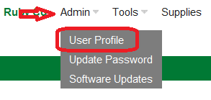
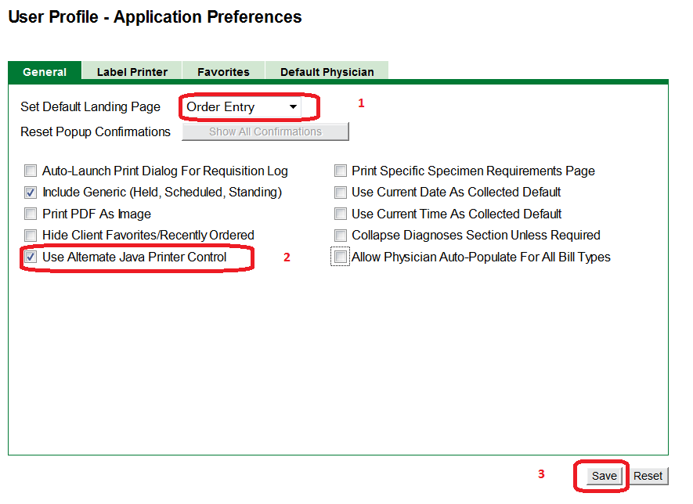
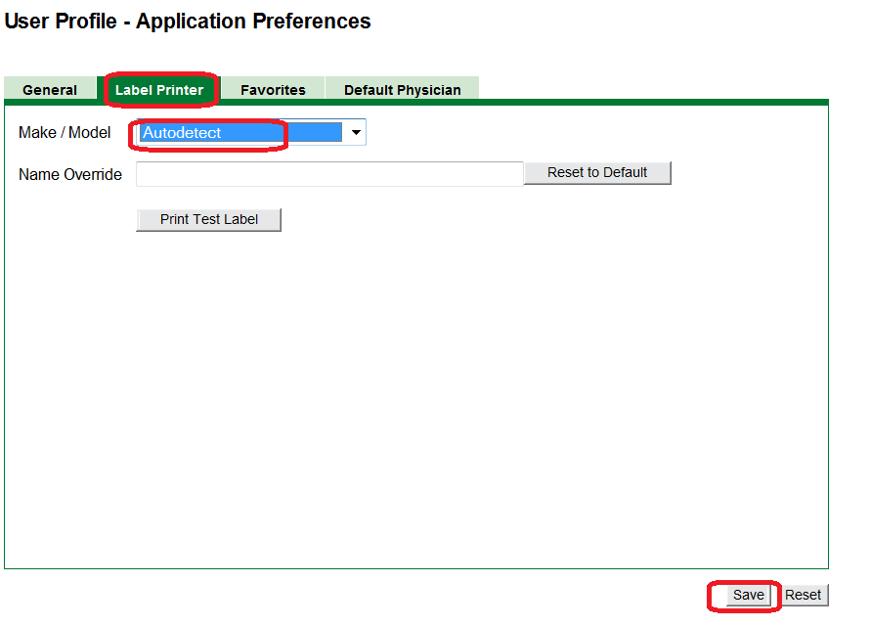
4. | To start entering orders, Select Order Entry tab.  Search for the patient’s name under the Patient information box.  Note: It is important to always look-up the patient first before adding a new patient to avoid duplicating the information.  - If the search shows ‘No records found’, click on ‘Add New Patient’ and enter required information. (Patient ID/MRN, Last name, First name, DOB, and Sex).
5. | Enter the Provider’s information (Last name and first name) and click on Remember Physician for future orders. Bill type should be ‘Client’.

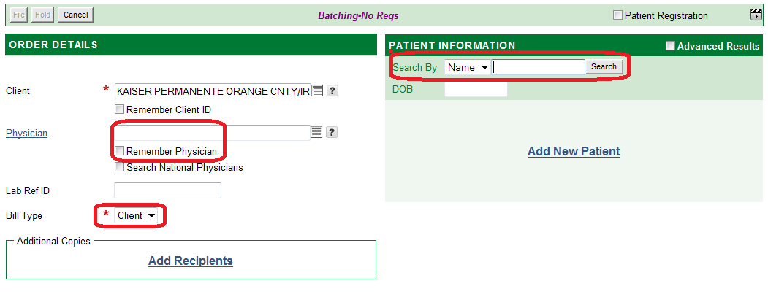
6. | If you found a match on your select, it will be listed under Patient information. Select the correct patient that you will put in orders for.

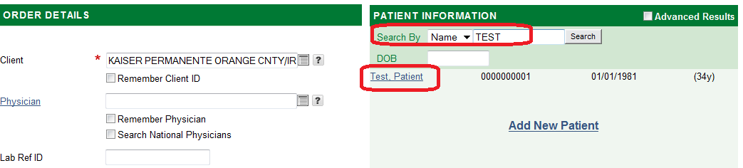

7. | After selecting your patient, the screen will display the area for the entering the Order code. Type in the first 3 letters of the test you need to order and click Search.  Note: If the test code have additional information needed, it will not let you complete the order without filling it in.
8. | Fill in the information for the sample. (Collection date and time, Total volume, Duration, Fasting, etc.)
9. | Select the test to be ordered from the list of search results. The test selected will show under the Profiles/Tests with the temperature requirement.  Click on ‘File’.

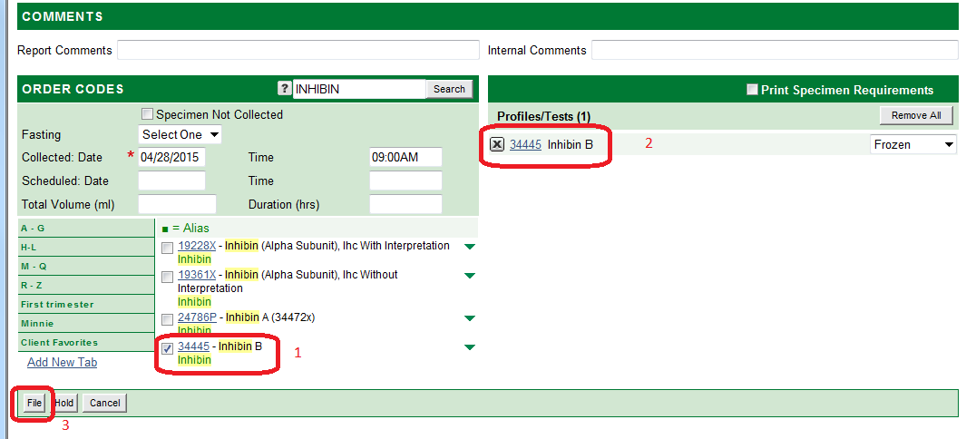

10. | Verify Order- File screen will appear. Check the order and patient information before clicking on ‘Save’.

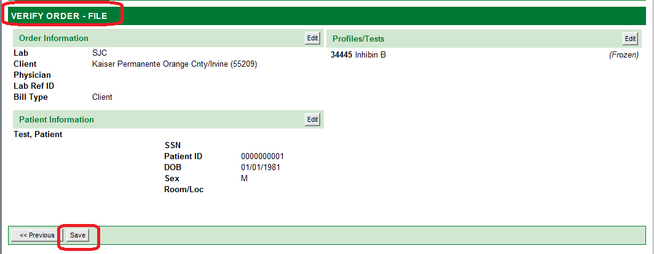

11. | Once you click on Save, the labels will print. Attach the label on the sample.

12. | When the batch is ready, go to Requisitions, and select Batch Processing.

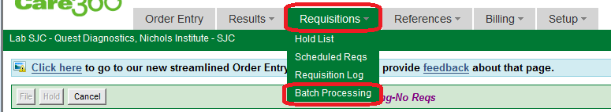

13. | Here you have the options to Edit, Hold or Delete the batch. If no changes are needed, click on ‘Create batches’. To print on the Quest printer, select printer OKI B4600(PCL). All samples listed will be printed on the manifest.
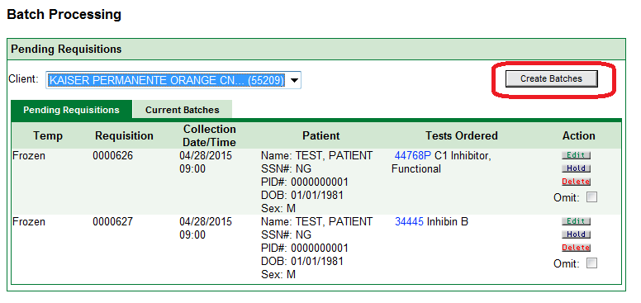

REPRINTING OPTIONS FOR CARE360 | - To reprint a label, go to Requisitions>Requisition Log. Fill in the search dates and click Search. Find your sample, on the Actions area, select Print. You will have the option to print labels or print the requisition.

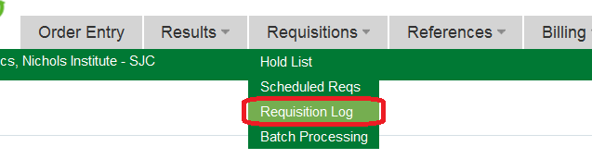

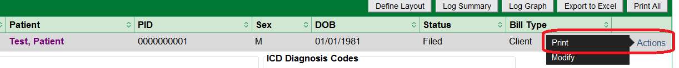

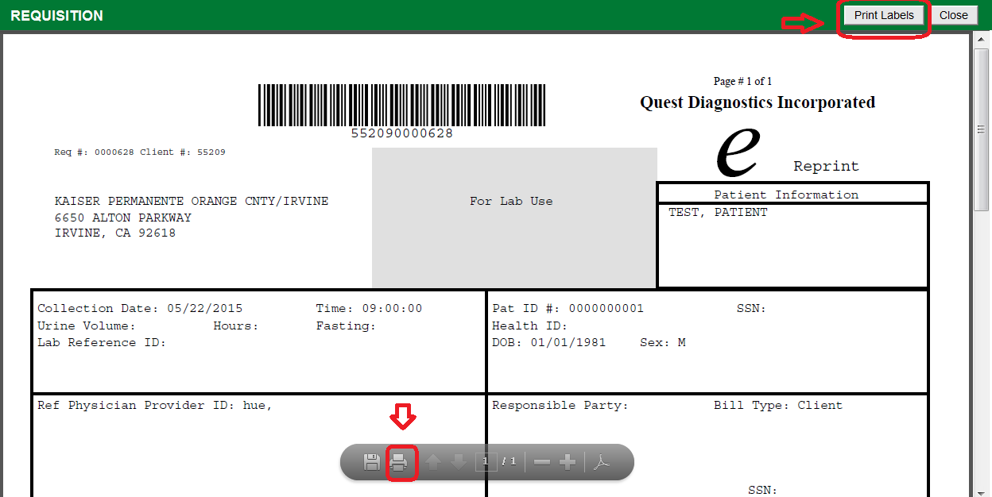

DELETIONS & ADD ONS | - To delete a test that’s already been complete accessioned in KRMS, create a batch with the accession numbers to be deleted, verify the batch then complete a Test Cancellation Request form and fax to QUEST Diagnostics.  - To add a test to a specimen already at Quest, call 1-877-683-7139 and speak to Client services.

SUPPLIES | Order online from Quest Care 360 or fax an order form. These supplies should only be used for Quest Diagnostics specimens.

PROCEDURAL NOTES

- Use white cardboard box for whole blood, serum, plasma, and CSF specimens.
- Individually bag urine, stool specimens, and cultures to prevent contamination of other samples in case of leakage.
- Put parafilm on all CSF specimens.
- When Fecal fat quantitative is ordered, make sure that the specimen duration (24, 48, or 72 hr.) is written on the container.
- When random urine sample is received for a 24 hour total volume test “Random Sample” must be written on the container.
- If printer is out of order and can’t print verification list, send a sheet of paper with batch # and temperature, client ID and write “Do not Accession”.

REFERENCE | CAP LABORATORY GENERAL CHECKLIST

Document History Page

Change type: New, Major, Minor etc. | Changes Made to SOP – describe | Name of responsible person/date | Med. Dir. Reviewed/ Date | Lab Manager reviewed/ date | Date change Implemented
New | PROCESSING OF QUEST SEND-OUT SPECIMENS | Mary Lou Beaumont  6/2011  6/11/11
Major | Use of Care360 for Manual Test orders. | Ruby Co  5/26/15

