#### EOSINOPHIL URINE/SPUTUM

|  |  |  |
| --- | --- | --- |
| PRINCIPLE | The presence of eosinophils in the urine may be noted in patients with tubulointerstitial disease associated with hypersensitivity to drugs such as penicillin and its analogues. Eosinophils are also seen in other acute disorders of the genitourinary tract.  The presence of eosinophils in sputum has been vital in the treatment of patients with allergic or other disorders of the bronchial tract.  Eosinophils are difficult to find in the cell sediment or smear if the total number of leukocytes is low. |  |

|  |  |
| --- | --- |
| SAFETY | All specimens, reagents and controls should be handled as though capable  of transmitting infectious diseases. Wear appropriate personal protective equipment when running patient samples or performing scheduled maintenance.  Refer to: Policy and Procedures Safety Manual *Infection Control and Procedures* 11-085-01 |

|  |  |  |
| --- | --- | --- |
| REAGENTS/ **MATERIALS** | Ames Hema-Tek Slide Stainer Cytology Funnel and Caps  Hema-tek Stain Pak Cytospin Centrifuge  Microscope Cytology Clips  Glass microscope slides Sterile Cotton Swab |  |

|  |  |  |
| --- | --- | --- |
| CONTROLS | Prepare a patient sample that has eosinophils showing orange granules to ensure the quality of the stain is adequate. Document acceptability on log. |  |

|  |  |  |
| --- | --- | --- |
| SPECIMEN | Fresh voided urine  Freshly collected sputum |  |
|  |  |  |

|  |  |  |
| --- | --- | --- |
| PROCEDURE |  |  |

**Urine Smear**

To prepare a urine smear complete the following:

|  |  |
| --- | --- |
| **Step** | **Action** |
| 1. | Prepare a cytocentrifuge preparation from unspun urine using the cytospin slide procedure number 04-190-01. If cytospin centrifuge is not available, spin 10 ml of urine for 10 minutes and make a slide from the sediment. |
| 2. | Remove slides from the cytocentrifuge and allow to air dry. |
| 3. | Stain slide with Wright Stain on Hema-Tek slide stainer. |

**Sputum Smear**

To prepare a sputum smear complete the following

|  |  |
| --- | --- |
| **Step** | **Action** |
| 1. | Label a slide with the patient’s last name, first initial, date and source. |
| 2. | Using a sterile cotton swab, make a round quarter size smear of the sputum on the labeled slide. |
| 3. | Allow to air dry. |
| 4. | Stain slide with Wright Stain on Hema-Tek slide stainer. |

To **READ** the stained urine/sputum smear, do the following:

|  |  |
| --- | --- |
| **Step** | **Action** |
| 1. | View the slide under oil immersion lens (100X). |
| 2. | Count the number of eosinophils seen/100 White cells seen. |
| 3. | Report any Eosinophils cells seen as follows:  A. 0/HPF  B. 0-5/HPF  C. 5-10/HPF  D. 10-25/HPF  E. >25/HPF  Note: See attached picture |

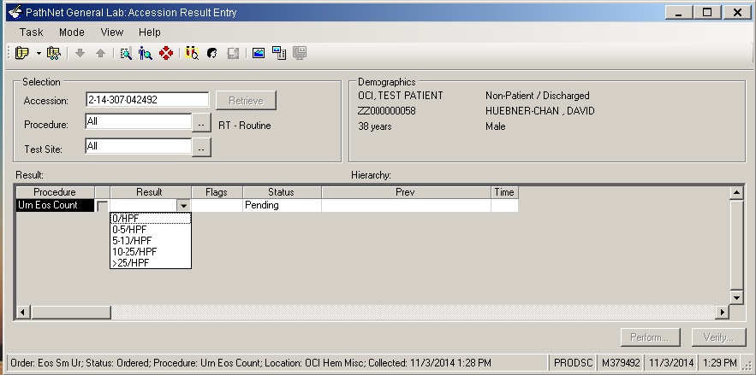

|  |  |
| --- | --- |
| NOTE: Cell and parasite identification can be difficult. If you have any doubt of the correct identification, you may consult your co-worker, supervisor, or pathologist for assistance. | |
| RESULT REPORTING | Results are manually entered in Cerner under the Accession Result Entry (ARE) mode.  For detailed instructions of entering results, please refer to Laboratory Informatics – Cerner Genlab Policies & Procedures Manual, “*Resulting in Cerner GenLab: Manual Entry*” LIS.SCPMG.041 document. | | |
| REFERENCE **RANGE** | | Normal: None seen | | |  |

|  |  |  |
| --- | --- | --- |
| REFERENCE | John Bernhard Henry, M.D. Clinical Diagnosis & Management by  Laboratory Methods, 18th Edition. |  |

Document History Page

|  |  |  |  |  |  |
| --- | --- | --- | --- | --- | --- |
| Change type: New, Major, Minor etc. | Changes Made to SOP – describe | Name of responsible person/date | Med. Dir. Reviewed/ Date | Lab Manager reviewed/ date | Date change Imp. |
| Minor | Reviewed. Added additional information regarding Positive and Negative QC. Revised format. | Charlie Park  11/13/12 |  |  |  |
| Minor | Reviewed.  Updated reagents/materials sections. | Julius Salomon  6/12/14 |  |  |  |
| Major | 1) Added Specimen section.  2) Updated Reagents/Materials section.  3) Revised #3 of Procedure section to reflect correct process in Cerner.  4) Added Result Reporting section  5) Added Labelling section for slides. | Julius Salomon 11/03/14 |  |  |  |
| Major | Reviewed. Revised the following:  1) Added Sputum to title, principle and specimen section.  2) Added a separate section for sputum smear preparation.  3) Removed Labelling Section and incorporated it in the smear preparation. | Julius Salomon  4/01/16 |  |  |  |
|  |  |  |  |  |  |
|  |  |  |  |  |  |
|  |  |  |  |  |  |
|  |  |  |  |  |  |
|  |  |  |  |  |  |

Imp. =Implemented