LAMELLAR BODY COUNT (FETAL LUNG MATURITY)

INTENDED USE | Lamellar body count is useful for predicting fetal lung maturity and assessing the risk of developing neonatal respiratory distress syndrome, when performed during 32 to 39 weeks gestation.
MATERIALS & REAGENTS | Sysmex XE-2100  Plain red top tube (5 ml)
SAFETY | All specimens should be handled as though capable of transmitting infectious diseases. Wear appropriate personal protective equipment when running patient samples or performing scheduled maintenance.  Refer to: Policy and Procedures Safety Manual Infection Control and Procedures 11-085-01
SPECIMEN | Amniotic fluid  - Sample must be submitted in original collection tube.  - Do not centrifuge.  - Do not aliquot.  - Reject specimens contaminated with meconium, blood or those containing readily apparent mucus (gelled samples).

PROCEDURE | Lamellar body particles from amniocentesis are measured directly on the Sysmex XE-2100. Many of the lamellar body surfactant particles are from 2 to 20 fl. in volume, an interval that is commonly used to enumerate and size platelets in whole blood.

Step | Action
1. | Invert the amniocentesis tube five times and transfer to 5 ml plain red top (no additive) tube. Replace cap.
2. | Manually run 2 tubes of cell-pack before analyzing the amniotic fluid.
3. | Manually run the amniotic fluid.
4. | Print the results. The platelet count represents the lamellar body count.

RESULTS Interpretation of results:

REPORTING

Step | Action
1. | Review the lamellar body count and determine which action you need to take
 |  | If count is: | Then it is:
 |  | > or = 50000/uL | MATURE
 |  | 15000 - 49000/uL | INDETERMINATE
 |  | <15000 /uL | IMMATURE
2. | If Lamellar Bodies Count [LBC] is non-mature [IMMATURE or INDETERMINATE], the specimen must be submitted to Quest for LSPG. See send out instructions below.

Results are manually entered in Cerner under the Accession Result Entry (ARE) mode.

For detailed instructions of entering results, please refer to Laboratory Informatics – Cerner Genlab Policies & Procedures Manual, “Resulting in Cerner GenLab: Manual Entry” LIS.SCPMG.041 document.

SEND OUT INSTRUCTIONS | In the event that the specimen will be sent out, give the sample to the processing area. All the details and forms needed for LSPG is located and can be downloaded in LabNet under LSPG.
 |  | Step | Action
 |  | 1. | The CLS will give the sample to the lab assistant assigned to specimen processing and instruct him/her to send the sample to Quest for LSPG testing.
 |  | 2. | The lab assistant will determine the originating lab of the specimen.
 |  | 3. | Once the originating lab is known, the lab assistant will have to access LSPG in LabNet and download the Quest form specific for that location. (see screen shot below)  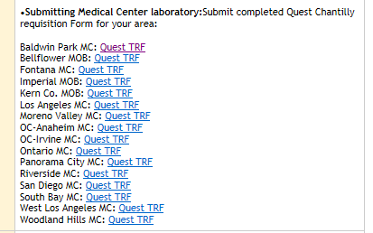
 |  | 4. | The lab assistant must fill out this form completely.
 |  | 5. | Once form is ready, lab assistant prepares the sample for transport to Quest. Take note of proper specimen processing and transport instructions (see screen shot below).  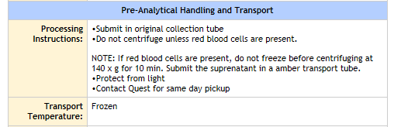
 |  | 6. | Lab assistant to call Quest for a STAT pick up.
REFERENCE RANGE | Mature: > or = 50000 /uL  Indeterminate: 15000-49000 /uL  Immature: <15000 /uL
REFERENCE | Obstetrics and Gynecology Volume 97 #2 Feb 2001 Page 318-320.

Document History Page

Change type: New, Major, Minor etc. | Changes Made to SOP – describe | Name of responsible person/date | Med. Dir. Reviewed/ Date | Lab Manager reviewed/ date | Date change Imp.
Major | Updated format and procedure, added the materials/reagents, safety, specimen and result reporting section to reflect the changes for new LIS, Cerner. | Julius Salomon  04/14
Major | Updated the RESULT REPORTING section and added SEND OUT INSTRUCTIONS section to reflect changes in procedure and workflow. | Julius Salomon 12/16/15
Imp. =Implemented

