STA-COMPACT MAX Calibration: PT, PTT, D-DIMER

Policy | There must be a valid Standard Curve in memory before controls and patient samples are analyzed. Calibration must be performed before using a new reagent lot to avoid wrong calculation of coagulation activity.

Protime | No calibration of the system is necessary for performing a PT if results are reported in seconds.  A current ISI value and Reference Time must be entered in order for the STA Compact Max to calculate an INR value.  The ISI value of the thromboplastin used to determine the prothrombin time must be the one indicated on the Assay Value insert (barcode sheet) for the STA product. The ISI must be confirmed for each lot change, software update, or intervention.  Entering or Modifying the ISI value
  Step | Action
  1 | Click
  2 | Double click the PT test abbreviation
  3 | Click Modify Parameters
  4 | Click arrow for drop down list of reagent lot  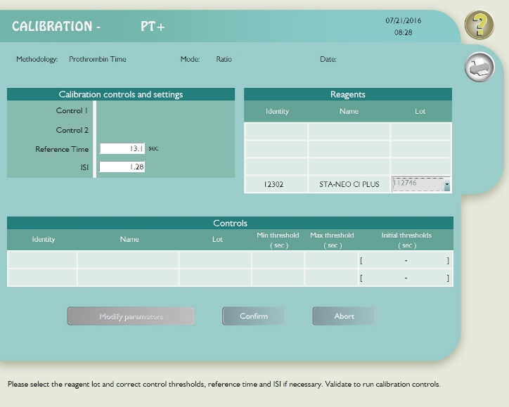
  5 | Click the correct lot number
  6 | If necessary, enter the ISI ratio value
  7 | Click Confirm

Continued on next page

STA-COMPACT MAX Calibration: PT, PTT, D-DIMER

Validation of the normal range geometric mean (Reference Time) must be
confirmed with each new lot of reagent. Refer to MOB.Coag.02-0020 Assaying
New Reagents, Controls, Population Means & Reference Ranges P&P
The geometric mean or Reference Time is entered in the STA Compact Max

Entering or Modifying the Reference Time
Step | Action
1 | Click
2 | Double click the PT test abbreviation
3 | Click Modify Parameters
4 | Click arrow for drop down list of reagent lot
5 | Click the correct lot number
6 | Enter the value of the site specific reference time in seconds
7 | Click Confirm

APTT | No calibrations necessary

Continued on next page

STA-COMPACT MAX Calibration: PT, PTT, D-DIMER
________________________________________________________________________________
D. Dimer | Kit reagents are pre-calibrated: this pre-calibration is valid for all the kits of the same lot.  To enter the calibration on the analyzer, scan the barcode printed on the Assay Value insert across the barcode reader of the instrument. The calibration values for the lot of reagents being used will subsequently be validated after the two D-dimer control levels have been determined.  Running a calibration in pre-calibrated mode:
  Step | Action
  1 | Click to go to menu Calibration
  2 | Window Methodologies list appears
  3 | Double-click the methodology for D. Dimer
  4 | Click calibrate lot
  5 | Select reagent lot
  6 | Click confirm  A yellow triangle is displayed on the right of the methodology  abbreviation for which the calibration was selected (calibration in progress).
  7 | Click to display window Analysis status.
  8 | Check the products on board:  - If the results for both calibrations controls are within the expected ranges, the calibration is automatically validated.  A green triangle is displayed on the right of the  methodology abbreviation (valid calibration).  - If the results of one or several calibration controls are outside the expected ranges, the operator is informed by an error message and the triangle is displayed in blue (calibration to be validated).

Continued on next page

STA-COMPACT MAX Calibration: PT, PTT, D-DIMER

The calibration curve can be examined on the screen of the analyzer in the “Calibration” menu
To view calibration curve:
Step | Action
1 | On the Calibration Screen, click
2 | Select methodology for D. Dimer
3 | Window Information appears:

To print the calibration curve:
Step | Action
1 | Click to go to Calibration menu
2 | Window Methodologies list appears
3 | Select the methodology for which the calibration is to be printed.
4 | Click

Continued on next page

STA-COMPACT MAX Calibration: PT, PTT, D-DIMER

Non-Controlled Documents | The following non-controlled documents support this procedure.  - STA Compact Max ® Operator’s Manual.  - STA Compact Max ® User Guide.  For additional information, please refer to the manufacturer’s package inserts.

Controlled Documents | The following controlled documents support this procedure.  MOB.Coag.02-0020 Assaying  - New Reagents, Controls, Population Means & Reference Ranges

Reference
- STA Compact Max ® Operator’s Manual.
STA Compact Max ® User Guide

Continued on next page

STA-COMPACT MAX Calibration: PT, PTT, D-DIMER

Document History Page

Change type: New, Major, Minor etc. | Changes Made to SOP – describe | Name of responsible person/date | Med. Dir. Reviewed/ date | Lab Manager reviewed/ date | Date change Imp.
New |  | Yvette Lingat  11/8/19 |  |  | 11/20/19
Imp. =Implemented

