Policy | Quality control is performed in order to monitor an analyzer’s performance over time. XN-L CHECK is the material used to monitor the performance of the XN-550 analyzer. Quality control should be run in accordance with regulatory agency requirements. For the BeyondCare Quality Monitor program, a minimum of 2 levels of controls are needed to be run at least once every 24-hours. It should be noted that for troubleshooting purposes, additional control runs may be necessary.  The BeyondCare Quality Monitor (BCQM) program is a quality management program that provides the laboratory with continuous calibration verification, proactive QC monitoring and real-time peer group evaluation.  BCQM program interprets QC data and provide real-time accuracy and precision assessment through the use of real-time analysis using multiple algorithm. BCQMh will detect analyzer issues earlier than previous QC practices.  BCQM program provides:  Evidence Based Quality Control limits: determine the total allowable error of each QC parameter, detects “true” errors while minimizing “false” rejections, combines data from all XN-Series analyzers to determine optimal ranges.  Automatic troubleshooting help: when failures occur, standardized troubleshooting steps are displayed and dynamic screen prompts will guide the end user for the next action, each step allows operator documentation for traceability.
Safety | Refer to the safety manual for general safety requirements.
Reagents | Control Material for XN analyzers:  XN-L CHECK  - Manufactured by Streck, available as a tri-level package.  - Whole blood commercial control used to monitor performance of all XN-550 analyzers.  Storage  - Store vials at 2-8ºC  - Do not freeze or expose to excessive heat.
Reagents, continued | Stability  - Unopened and properly stored, XN-L CHECK is stable until the expiration date printed on the unopened vial.  - Open vial stability is 15 days for XN-L CHECK when promptly refrigerated after each use.  - Record the date on each vial upon opening or cap piercing.  - Heat or freezing can damage XN-L CHECK/XN-CHECK without gross visible changes. Moderate hemolysis can be normal. Deterioration is suspected when the mean of the control results is not within the assay expected ranges after appropriate troubleshooting.  If deterioration is suspected, call the Sysmex Technical Assistance Center 1-888-879-7639 (1-888-8SYSMEX)
Frequency of QC run & review | Frequency of Control use and review:  XN-L CHECK control levels: ALL 3 levels will be run daily on ALL (1st and 2nd) shifts.  QC run time:  AM shift – 0830 +/- 30 minutes (0800 to 0900)  PM shift – 1630 +/- 30 minutes (1600 to 1700)  Note: Since the XN 550 only has one sample pathway, i.e. it only has one needle for aspiration, it does not matter whether it is done in AUTO or MANUAL mode.
Procedure | Mixing Instructions:  Step Action  1 Remove vials from refrigerator and allow them to come to room temperature (18-25ºC), for approximately 15 minutes.  2 Mix vials according to the package insert accompanying the product until the cell button in the bottom of the vial is completely suspended.  3 Perform a close visual inspection of each vial confirming the cell button is completely removed from the bottom of the vial and cellular elements are uniformly suspended with no aggregates.
 | Quality Control Sampler Mode Processing:
 | Step | Action
 | 1 | Confirm the analyzer is in ‘Ready’ state and the button on the right edge of the control menu is [Sampler]
 | 2 | Load all 3 levels of QC material in the sampler adaptor.
 | 3 | Place sampler adaptor into the sampler adapter holder.
 | 4 | Touch the Sampler Start Switch.
 | 5 | Results will be plotted on the L-J Chart as well as the Radar Chart for review.
 | Quality Control Manual Mode Processing:
 | Step | Action
 | 1 | Confirm the analyzer is in ‘Ready’ state and the button on the right edge of the control menu is [Manual]. When the mode is set to [Sampler], press the mode switch button on the main unit.
 | 3 | Touch [Mode] on the control Menu.
 | 4 | Touch the Analysis Mode. Select Whole Blood.
 | 5 | Touch OK.
 | 6 | Touch the [QC] icon on the Menu screen.
 | 7 | Touch the [QC Analysis] icon.
 | 8 | From the QC file list, touch the file you want to analyze.
 | 9 | Perform Manual analysis.
 | 10 | Review Quality Control Results in BeyondCare Quality Monitor.
Evaluate QC | Westgard rules are used to evaluate the acceptability of a set of observed control data. These rules are based on the theory that repeated assays of a control will fall within a random yet predictable "scatter" about a pre-defined mean.  QC Rules & Definitions:  - One 3S rule = One control exceeds X + 3 SD limit, DO NOT REPORT PATIENT RESULTS until corrective action is performed.  - Two 2S rule = (Across run) Same control exceeded the same -2 SD or +2 SD limit, DO NOT REPORT PATIENT RESULTS until corrective action is performed.
Evaluate QC, continued | - Two 2S rule = (Within run) Both controls exceeded the same -2 SD or +2 SD limit, DO NOT REPORT PATIENT RESULTS until corrective action is performed.  - Four 1S rule = Four consecutive values outside the same 1S, report patient results. Monitor future control runs for rules violations  - Ten consecutive values on one side of mean report patient results. Monitor future control runs for rules violations.
Reviewing Quality Control Results in BeyondCare Quality Monitor | 1 Using the Sysmex dedicated laptop or KP PC, login to BCQM. Login: InsightID@bcqm.com Password: bcqm1234  2 Review Analysis Result in the BCQM Dashboard: - If analyzer displays GREEN, this indicates QC passed and analyzer is ready to process samples. - If analyzer displays YELLOW, more information is needed, or QC is overdue. The resolve button becomes active if there is a QC value outside of limits. - RESOLVE is activated: If a QC error has been detected, resolve button becomes active and dynamic troubleshooting prompt guides the end user to the next course of action. The instructions button gives details on how to perform the troubleshooting action. Always follow the prompts to resolve the QC issue. - QC is overdue: End user needs to analyze QC since it exceeds the timeframe from the preferences screen. - If analyzer displays RED, QC failed analysis and analyzer is determined out of service with a reference to a service call. Review Summary Report for a calendar view of whether the QC passed or failed, it will also display background status. P= Last 2 different levels of QC passed F= QC failed B= Background counts pass X= Background counts failed ?= Run QC L=XNBF QC passed D=XNBF QC failed S= service event Calibration (EBC)
Resolving QC issues in  BeyondCare Quality Monitor | Follow the BCQM for troubleshooting Quality Control results exceeding the upper or lower limit of acceptability.  1 Yellow status will display when a QC issue is detected  2 Click the Resolve button 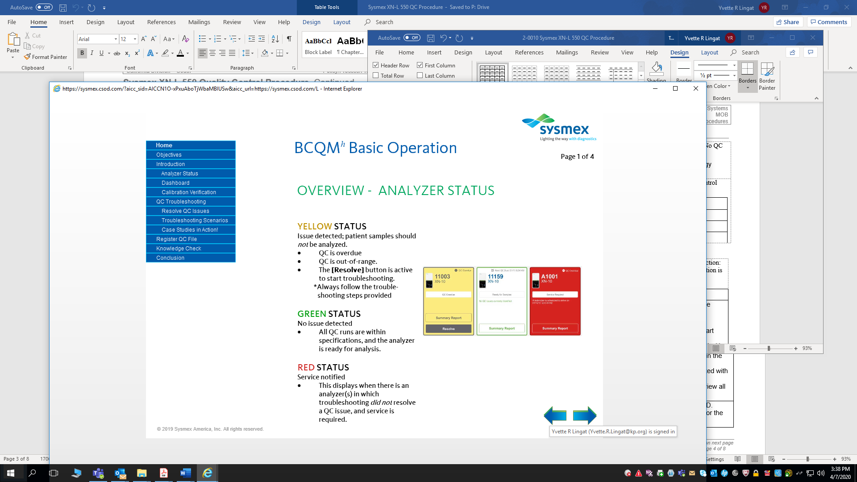  3 Click Yes, Start Troubleshooting 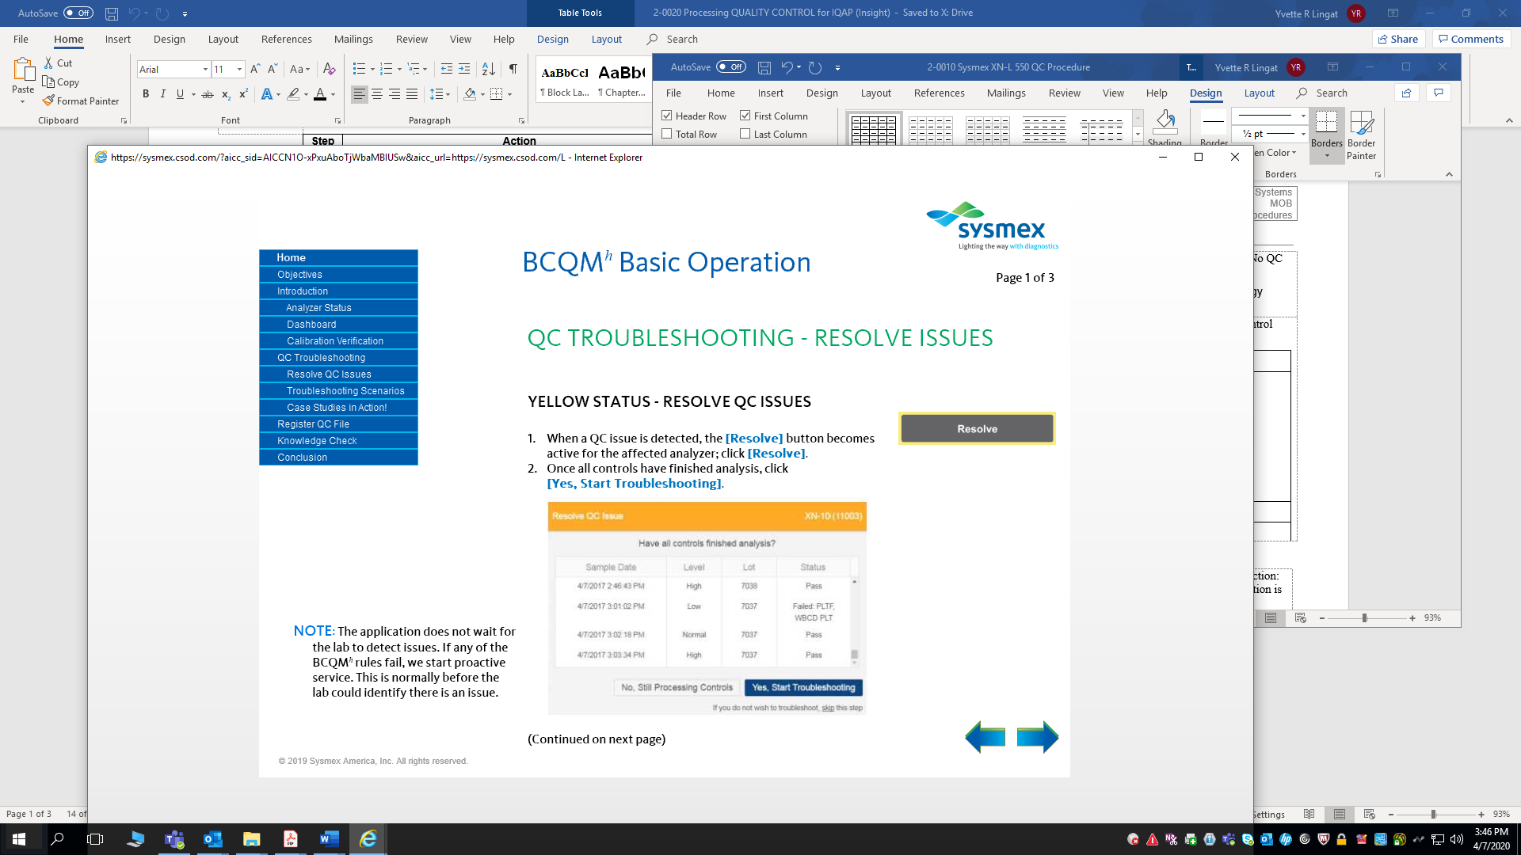  4 Perform the recommended troubleshooting task. Click {Instructions} button for more troubleshooting information 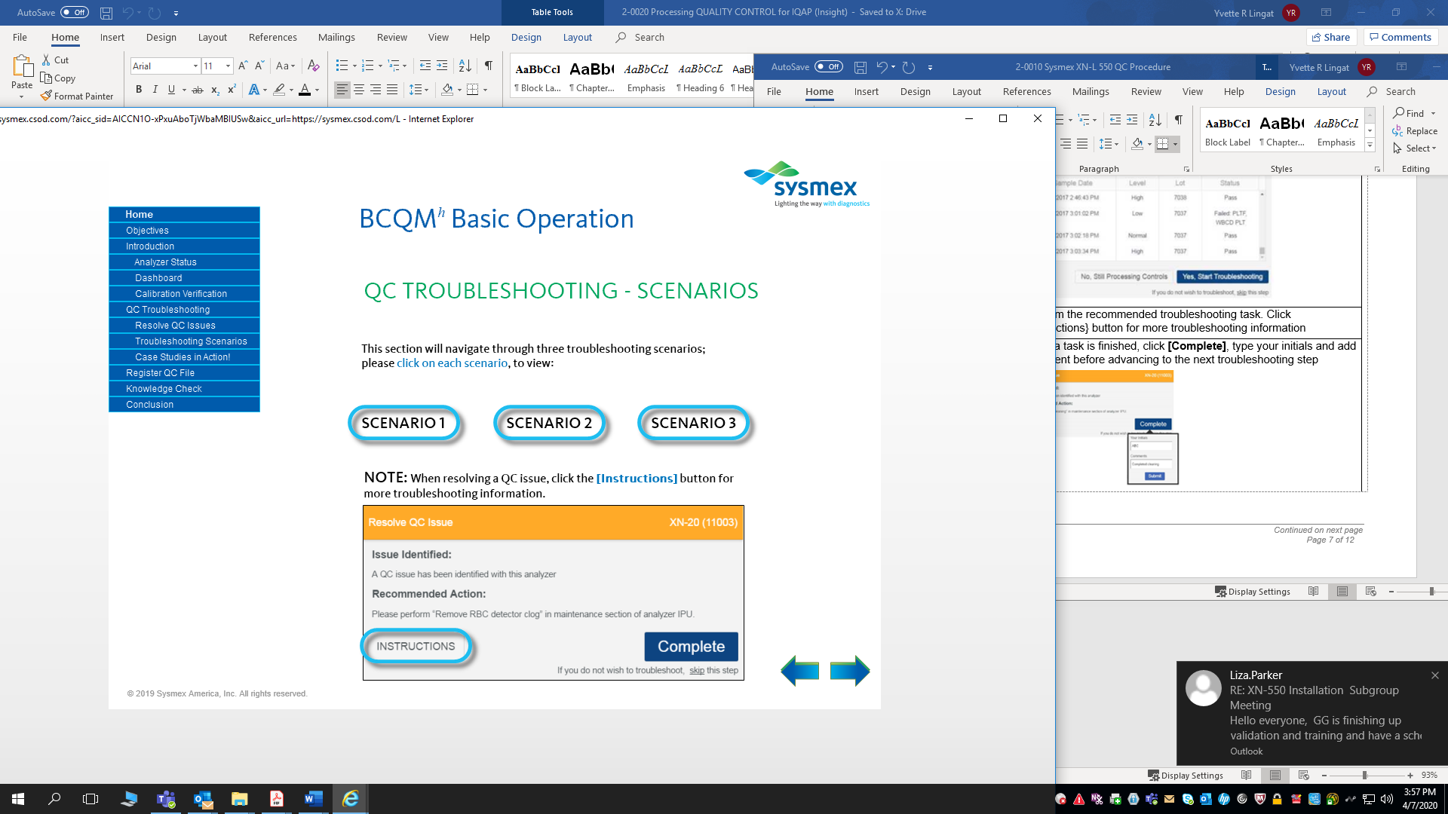  5 Once a task is finished, click [Complete], type your initials and add comment before advancing to the next troubleshooting step. 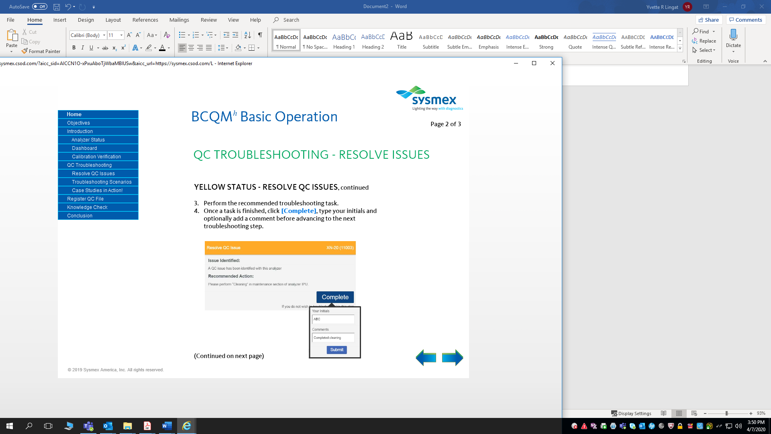  6 If the issue is resolved, Click Exit to Dashboard. The Analyzer status returns to green. Data becomes not manages (removed from calculation). A “SM” (system managed) symbol will appear next to the raw data in the Insight report. 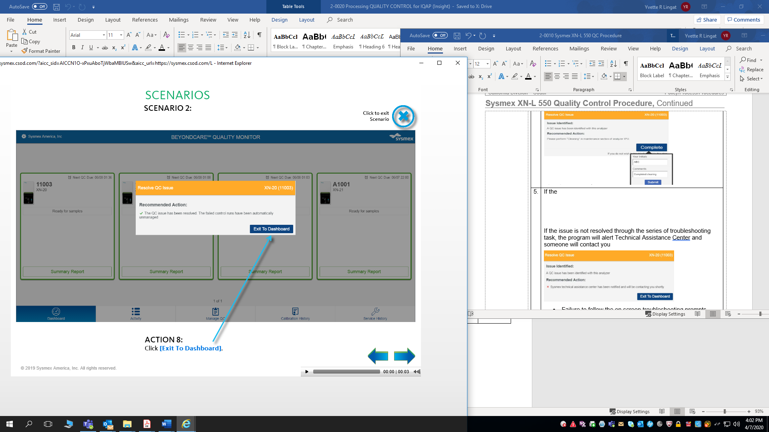  7 If the issue is not resolved through the series of troubleshooting task, the program will alert Technical Assistance Center and someone will contact the lab. The analyzer status will turn red. 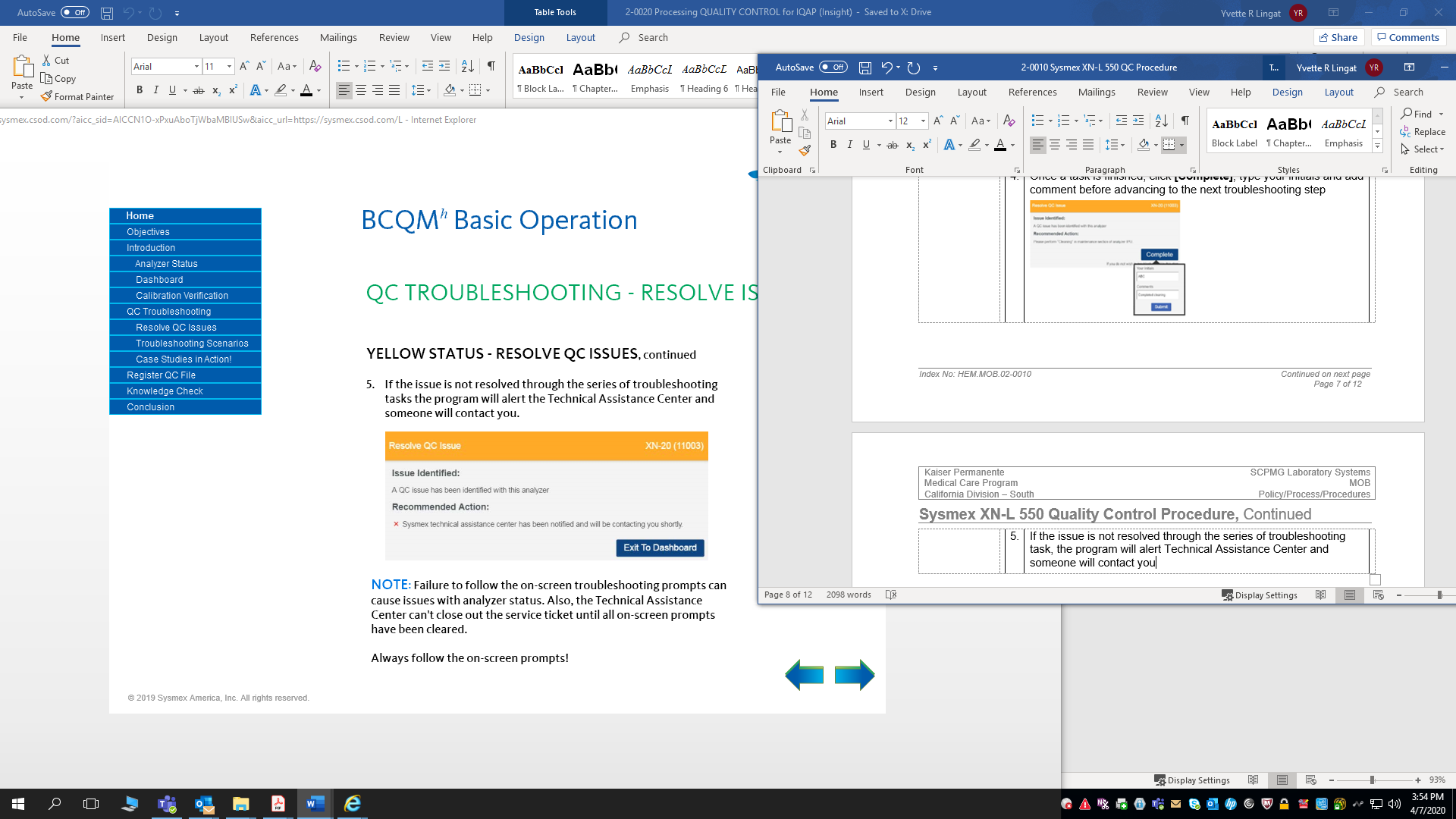  Note: Failure to follow the on-screen troubleshooting prompts causes issues with the analyzer status. Technical Assistance Center can’t close out the service ticket until all on-screen prompts have been cleared.  Refer to Refer to Attachment A: BeyondCare Quality Monitor for Hematology Quick Guide for more details on resolving QC issues.

Reviewing the QC files on the analyzer IPU | In the event SNCS (Sysmex network communication system) loses connection:  a. BCQM becomes unavailable until SNCS connection is restored.  b. Review the QC files on the analyzer IPU.
 | Step | Action
 | 1 | Review QC results for acceptability by clicking on the QC file icon. This will allow you to view the files in:  - QC File screen  - Allows for review of the latest QC results in Radar Chart format for the QC file that is selected in the list.  - Any point exceeding the upper or lower limit is marked with a red “X”.  - QC Chart screen  - Allows for review of detailed graph data of all QC runs for selected file.  - Analysis data is plotted cumulatively and displayed in the chart area as a line graph.  - Any point exceeding the upper or lower limit is marked with a red “X”.  - User must scroll up and down through the chart to view all parameters for each run.
 | 2 | Controls are flagged in red if the values fall outside of 2 SD. When this occurs, the CLS needs to check the QC chart for the corresponding shift and classify rules broken.
 | 3 | When a rule violation occurs, document in the ACTION LOG and perform appropriate remedial action.
QC Management | Refer to: QUALITY CONTROL for IQAP (Insight) for more detailed information.  Follow steps below to manage QC:
 | Step | Action
 | 1 | From the QC Chart view, select the [Manage] button on the toolbar.
 | 2 | Select Cursor Data Management.
 | 3 | Specify whether a QC run should be excluded from the quality control data.
 | 4 | Select [Not Manage] to exclude data from the following:  - Statistical computations (SD, Mean, CV)  - Variable target computation  - Number of data points = n
 | 5 | An open circle will be displayed on the L-J Chart when the QC run is not managed or excluded and is not connected by a line to the adjacent QC runs.  NOTE: XN-L Managed and Not Managed comments and results “Do Not” upload to Insight. To keep Insight consistent with the QC file on the XN-L analyzer, log into Insight and manage the same data point.
 | 6 | A comment may be added to the QC data selected by the cursor:  - Select [Input Any Comment] to input a free text comment.  - Select [Fixed Comments] to use a comment from a list of preset comments in the QC settings menu.  - Select [OK]  - A comment bubble will be displayed when a comment exists for a QC run.  - The comment will be visible in the comment display area when the cursor is placed on the QC run
 | Printing QC Data:
 | Step | Action
 | 1 | Select QC Files Icon and highlight file to output.
 | 2 | Select QC Chart Icon.
 | 3 | Set Range of points to output by clicking [Range] and capturing the points with the cursors.
 | 4 | Select [output] to print the selected chart to either GP or LP.
Controlled Documents | The following controlled documents support this procedure.
 | Reference
 | - Sysmex XN-L Series XN-550/XN-450/XN-350 Basic Operation (North American Edition), Sysmex Corporation, Kobe, Japan.
 | - Sysmex XN-L Series XN-550/XN-450/XN-350 General Information (North American Edition), Sysmex Corporation, Kobe, Japan.
 | - Sysmex XN-L Series XN-550/XN-450/XN-350 Troubleshooting (North American Edition), Sysmex Corporation, Kobe, Japan.
 | - Clinical and Laboratory Standards Institute (CLSI). Laboratory Documents: Development and Control; Approved Guideline; Fifth Edition. (GP2-A5, 2006).
 | - Sysmex Reagents of America Inc., Mundelein, IL. XN CAL, Hematology Calibrators: Calibrators for Sysmex Hematology XN-L Series Analyzers, package insert.
 | - Sysmex America Inc., Lincolnshire, IL. XN-L CHECK Hematology Control for Sysmex XN-L Series Analyzers package insert.
 | - Sysmex America Inc., Lincolnshire, IL. Sysmex Insight Participant Overview Guide.
 | - Koepke, John. Practical Laboratory Hematology. Churchill Livingstone Inc. 1991 p. 24-25, 36-39.
 | - Cornbleet J., Spurious results from automated hematology cell counters. Lab Medicine. 1983;8:509-514.
 | - Sysmex Reagents of America, Inc. SDS sheets and reagent product inserts.
 | - College of American Pathologists (CAP) Hematology-Coagulation Checklist, July 2012.
 | - Stewart, Charles and Koepke, John. Basic Quality Assurance Practices for Clinical Laboratories, Van Nostrand Reinhold, 1989, p 189.
 | - Gulati GL, Asselta A, Chen C. Using vortex to disaggregate platelet clumps, Laboratory Medicine, 28:665, 1997.
 | - Zhou X, Xiaoli W. Amikacin Can Be Added to Blood to Reduce the Fall in Platelet Count, American Journal of Clinical Pathology, 136:646-652, 2011.
 | - Sysmex America Inc., Lincolnshire, IL. XN-L Applications Manual.
 | - Sysmex America Inc., Lincolnshire, IL. BeyondCareSM Quality Monitor User Manual
 | - Sysmex XN-L Series Automated Hematology Systems Flagging Interpretation Guide, Document Number: 1399-LSS, Rev 1, December 2017.
 | - Reagent Unit RU-20 Instructions for Use. Sysmex Corporation, Kobe Japan.
 | - CLSI document H56-A – Body Fluid Analysis for Cellular Composition; Approved
 | - Processing QUALITY CONTROL for IQAP
 | Attachments
 | - BeyondCare Quality Monitor for Hematology Quick Guide

Document History Page

Change type: New, Major, Minor etc. | Changes Made to SOP – describe | Name of responsible person/date | Med. Dir. Reviewed/ Date | Director of Lab Ops. reviewed/ date | Date change Implemented
New | Procedure for new XN instruments. | Yvette Lingat  4/7/2020 |  | Mary Lou  Beaumont | 4/28/2020

