Abbott Instrument Manager: Result Review & Release Procedure

Abbott Instrument Manager: Result Review & Release Procedure 2
Purpose 2
Scope 2
Definitions 2
Policy 2
Procedure: Logging into Instrument Manager 3
Procedure: Accessing Instrument Manager Workspace 4
Procedure: Instrument Manager Workspace Result Review 5
Procedure: Instrument Manager Workspace Result Review, continued 6
Procedure: Safe Zone Critical Result Reporting 9
Procedure: Turning Auto Verification Off 10
Turning Auto Verification On 12
Logging Off Instrument Manager 13
Controlled Documents 14
Non-Controlled Documents 14
Author(s) 14

Abbott Instrument Manager: Result Review & Release Procedure
Purpose | This procedure outlines the results review and release process for instruments connected to the Data Innovations Instrument Manager and its’ middleware rules.

Scope | The autoverification criteria applies to analyzers in the Chemistry department(s) utilizing Abbott’s Data Innovations Instrument Manager.  These instructions apply to tests undergoing approved auto-verification rules resident in the Abbott Data Innovations Instrument Manager and are intended for use by the licensed CLS/MLT staff.

Definitions | Autoverification: Autoverification refers to the automated release of clinical laboratory test or examination results to the medical record based on previously defined criteria and logic established, documented, and tested by the medical staff of the laboratory, from an electronically interfaced instrument.

Policy | The list below states the policies followed by the organization:  - A licensed person must be physically present on site in the clinical laboratory whenever auto verification is being performed. They are responsible for the accuracy and reliability of results being reported. The operator is responsible for suspending auto verification in the event of a problem with the test method, analytical instrument, or auto verification criteria.  - The operator must ensure that all quality controls are performed within the appropriate time intervals with acceptable results prior to performing patient testing.  - If a problem is encountered with an instrument, the operator can turn off auto verification with menu options. When problems are resolved, auto verification may be turned back on.  - Specimen Management Workspace in Instrument Manager is a workspace for results that meet the pre-established laboratory criteria of the middleware rules. The licensed laboratorian is required to investigate and do possible intervention prior to review/release.  - An audit trail will be used to identify all individual who have entered or modified patient data or control files. If auto verification is used, the audit trail in the laboratory system should reflect that the result was verified automatically at a given date and time.  - Instruments that have autoverification enabled must be validated initially and at least annually or when there is change to the system that could affect the autoverification logic and to confirm that algorithm decision rules are functioning properly.
Continued on next page
Abbott Instrument Manager: Result Review & Release Procedure, Continued

Procedure: Logging into Instrument Manager | Step Action  1 From your desktop, double-click the Instrument Manager  icon.  2 A Windows pop-up will appear. Select Run. 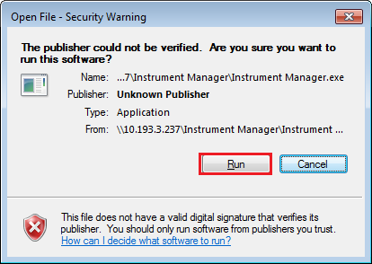  3 When the Logon window displays, read the License Agreement and enter your User ID (NUID) and Password in the text field. Click Accept and Logon. 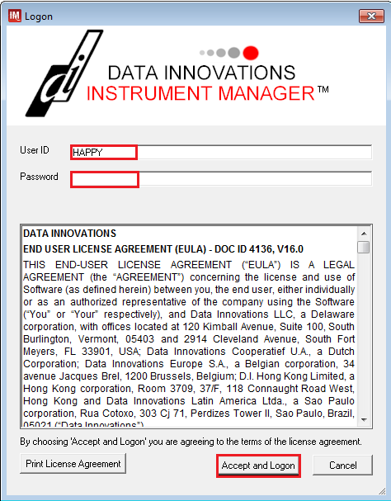  4 The application will open 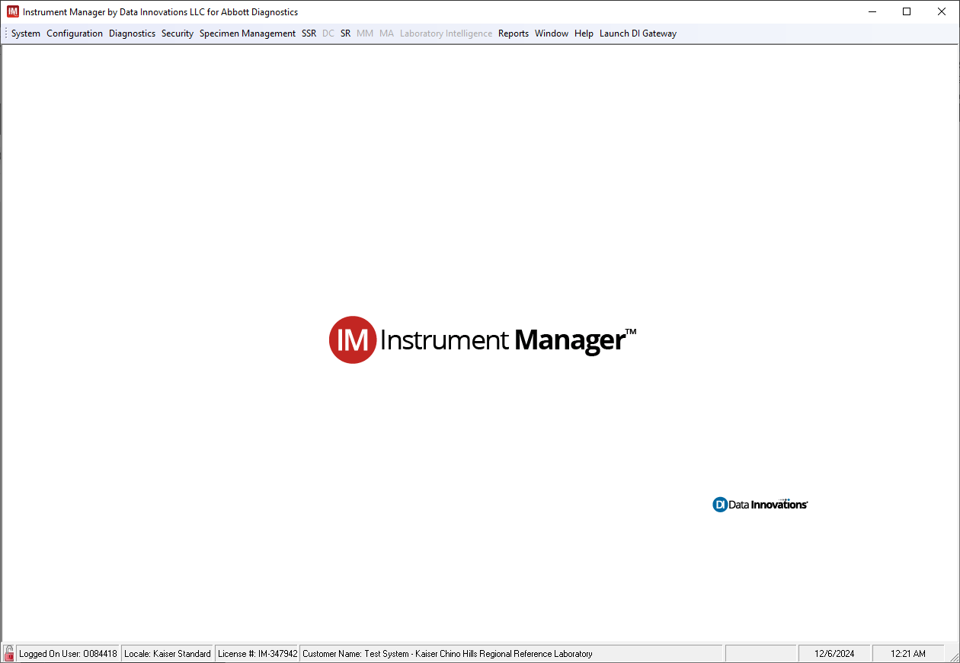
Continued on next page
Abbott Instrument Manager: Result Review & Release Procedure, Continued

Procedure: Accessing Instrument Manager Workspace | Step Action  1 From the Specimen Management menu, click SM Workspace. 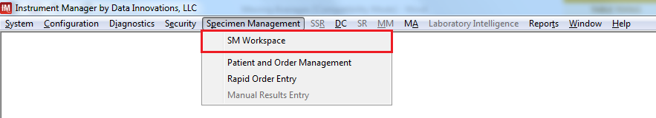  2 Once the workspace window open, proceed to click on the drop down menu 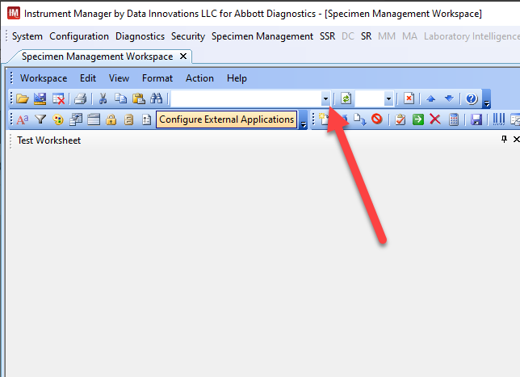  3 Select from the drop-down menu, the instrument workspace for your site. 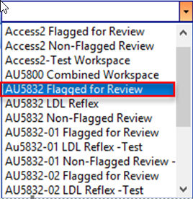
Continued on next page
Abbott Instrument Manager: Result Review & Release Procedure, Continued

Procedure: Instrument Manager Workspace Result Review | Instrument Manager Workspace Result Review  Step Action  1 From the Specimen Worksheet pane, highlight the row with the accession number (see Detail A). The selected accession number will show a pane titled “Patient Information” (see Detail B). There will be Operator Instructions with the appropriate directives or information on the next steps to follow. 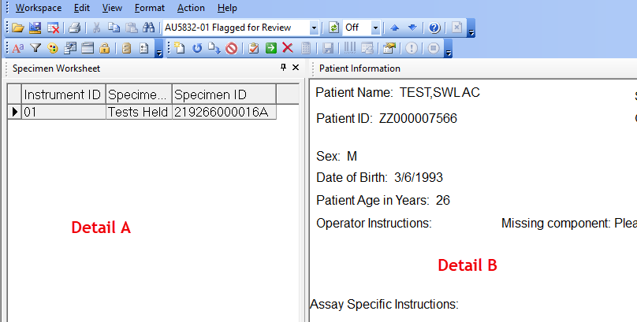 Detail B example (close-up): 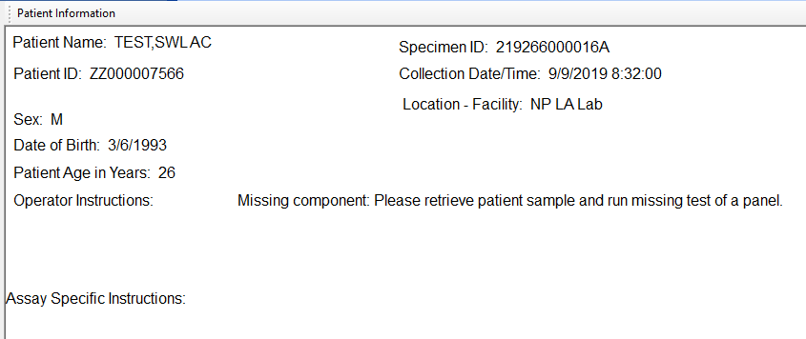
Continued on next page
Abbott Instrument Manager: Result Review & Release Procedure, Continued

Procedure: Instrument Manager Workspace Result Review, continued | Instrument Manager Workspace Result Review  Step Action  2 Investigate the cause(s) of the Flagged Result(s) such as “Error Codes” and “Error Names” and follow “Operator Instructions”, if present in the Patient Information pane. 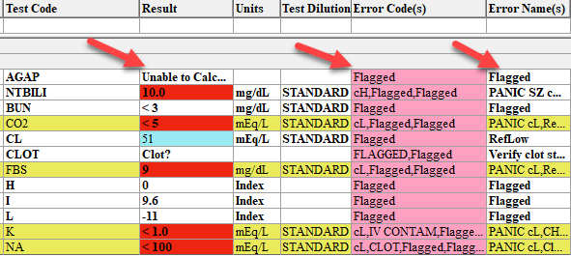  3 Select the accession number that requires decision using pre-established criteria for acceptability and/or logic. Select Release or Reject. Release function Reject function  4 Refresh the workspace by pressing the Refresh button. If no other accession number populates the workspace. All results that filter through the rules cascade and do not hit any of the rules algorithms will Auto verify to our LIS (Cerner).
Continued on next page
Abbott Instrument Manager: Result Review & Release Procedure, Continued

Procedure: Critical Result Reporting | Step Action  1 From the Test Worksheet, select the color coded “Critical Result” enrty with corresponding “Operator Instructions” 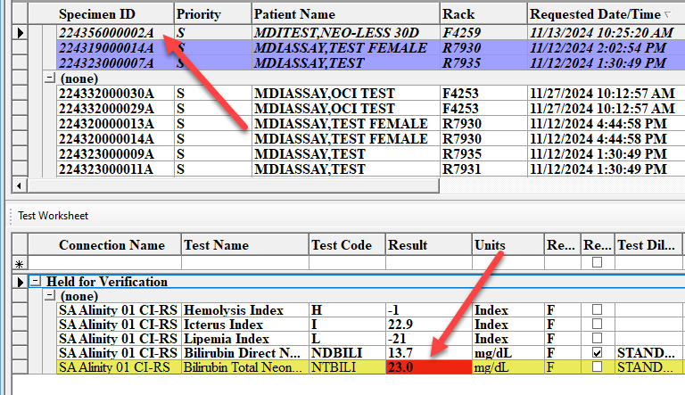 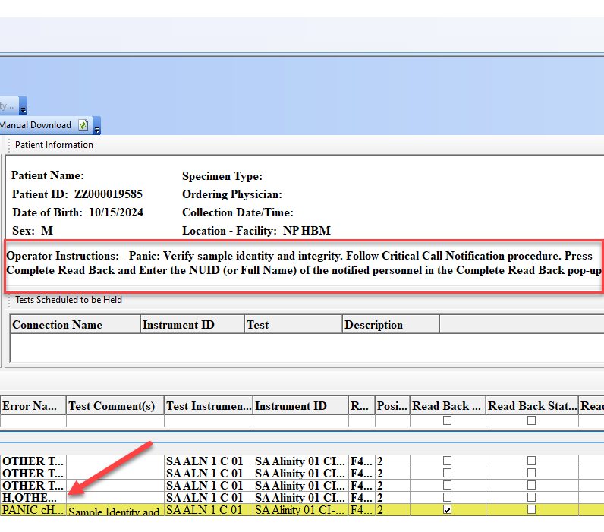  2 Press the “Critical Call Back” button
Continued on next page
Abbott Instrument Manager: Result Review & Release Procedure, Continued

Procedure: Critical Result Reporting, continued | Step Action  3 Enter the NUID or Full Name of the notified personnel in the “Complete Readback” pop up box 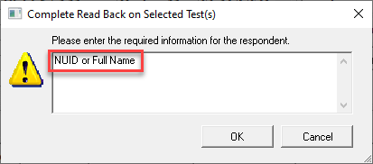  4 Verify the “Readback” process was successfully recorded by confirming change in color coding (yellow light blue) of the critical result entry. Verify that all three readback columns are completed, see “red arrows” on the image below: 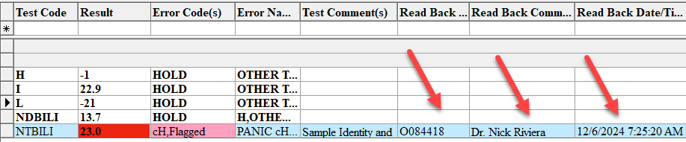  5 Press the “Release” button and acknowledge the “Release Selected Test(s)” prompt box to send results to Cerner (LIS)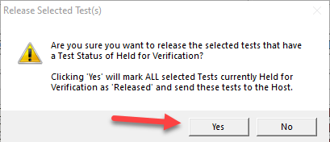
Continued on next page
Abbott Instrument Manager: Result Review & Release Procedure, Continued

Procedure: Safe Zone Critical Result Reporting | Step Action  1 From the Test Worksheet, select the color coded “Critical Result” entry with corresponding “Operator Instructions” for the critical “Safe Zone” verification steps 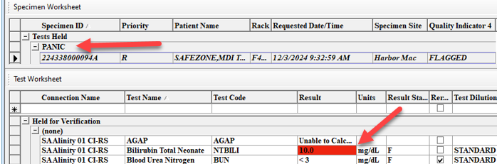 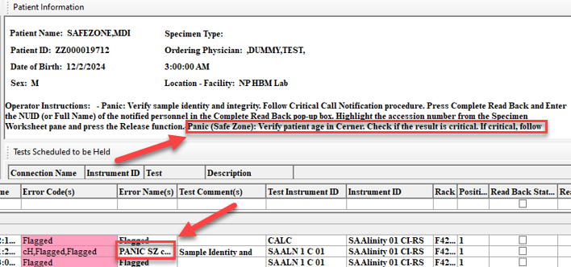  2 Compare patient’s age in IM and Cerner (LIS) If ... Then ... Result is a true critical Follow “Critical Call Notification” procedure Result is not a true critical Release the result
Continued on next page
Abbott Instrument Manager: Result Review & Release Procedure, Continued

Procedure: Turning Auto Verification Off | Step Action  1 Go to the upper lefthand corner, select “System” “Status” to show the list of connections for all sites in IM 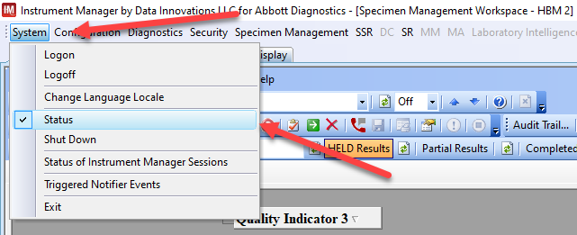  2 Select the instrument that requires turn on/off by highlighting the analyzer and right click to show the menu. 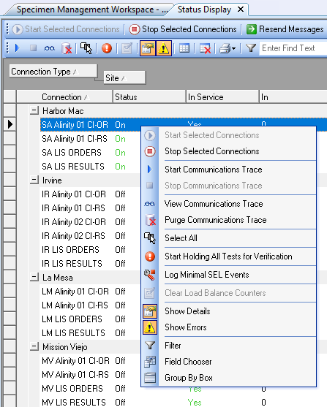  3 Select:
Continued on next page
Abbott Instrument Manager: Result Review & Release Procedure, Continued

Procedure: Turning Auto Verification Off, continued | Step Action  4 Press “Yes” to the prompt window that pops up 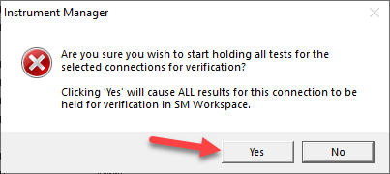  5 All patient results will be held in the “Specimen Management Workspace” until all troubleshooting steps are completed and Autoverification can be turned back “On”
Continued on next page
Abbott Instrument Manager: Result Review & Release Procedure, Continued

Turning Auto Verification On | Step Action  1 Go to the “Specimen Management Workspace” and click on the  “Stop Holding Selected Tests for Verification” button to remove the hold. 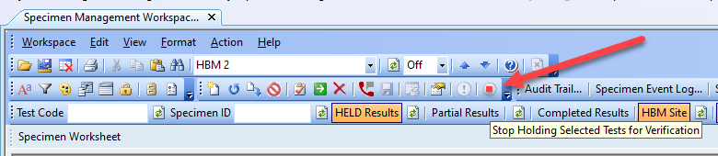  2 Select “Yes” on the Sop Holding Tests confirmation window. 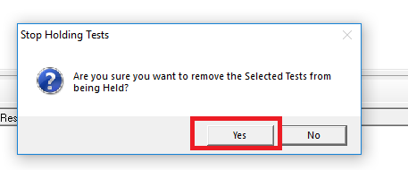  3 Patient testing may resume as applicable.
Continued on next page
Abbott Instrument Manager: Result Review & Release Procedure, Continued

Logging Off Instrument Manager | Step Action  1 Click on “System” “Logoff” 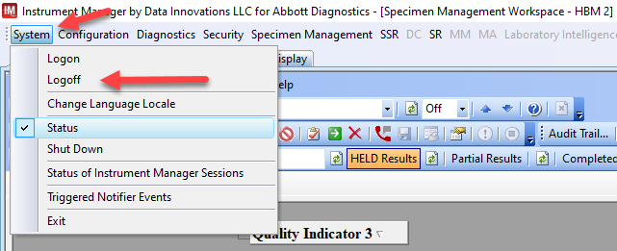  2 Select “Yes” when the prompt window pops up to confirm the logoff request 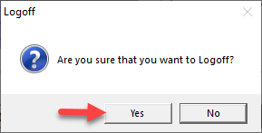  3 The system will return you to the log on screen 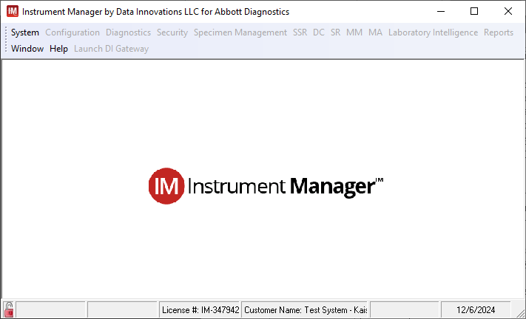
Continued on next page
Abbott Instrument Manager: Result Review & Release Procedure, Continued

Controlled Documents | The following controlled documents support this policy.  SCPMG QMS – 0025 Autoverification

Non-Controlled Documents | The following non-controlled documents support this policy.  - Data Innovations Instrument Manager User Guide

Author(s) | - Josimar Orellana  - Jonathan Lee
- End

