Orders – Inpatient Lactic Acid Protocol to Combat Sepsis
Intended Audience: Nursing, Providers, Lab Staff
Go-Live Date: May 5th, 2025
Summary: Reference ranges for the Lactic Acid orders have been updated to be the same across all three regions. This will impact reflex orders that automatically trigger based on abnormal values. The 2 hour and 4 hours reflex orders have been updated and will appropriately trigger. This will apply to Lactic Acids performed in the lab or Respiratory satellite labs for admissions (inpatient and emergency) encounters. Continue to use the Sepsis OrderSet to locate the base order for Lactic Acid.
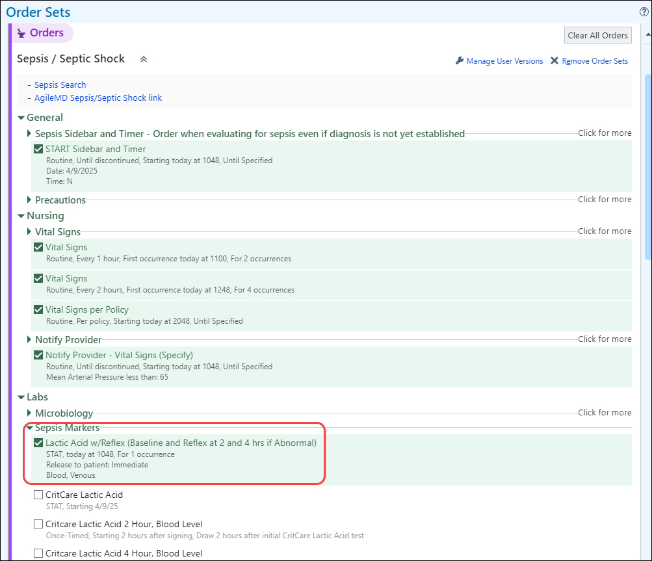

Reference Ranges
- 0-2.1 Normal
- 2.2-3.9 Abnormal
- 4 or greater Critical

How the rules work:
- If the Baseline result is less than or equal to 2.0, the 2-hour order will NOT be ordered.
- If the Baseline result is greater than 2.0, the 2-hour order will be automatically ordered.
- If the 2-Hour result is less than or equal to 2.0, the 4-hour order will NOT be ordered.
- If the 2-hour result is greater than 2.0, the 4-hour order will be automatically ordered.

LAB STAFF ONLY
To help clinical staff be alerted to possible septic changes in a patient in all Corewell Health regions, specifically late onset of septic shock, the above logic was put into place for Lactic Acid ordering based on the previous test’s results. This logic applies to these Lactic Acid orders.
