DOCUMENT SYSTEM FOR SITE SPECIFIC DOCUMENTS & FORMS- (MTS University of Washington-www.medtraining.org)

Purpose | This tool will provide paperless documentation that all personnel have read and are knowledgeable on policies/procedures/processes and form relevant to their job activities which includes but not limited to contents of policy & procedure manuals (including new, revised and changes), memos and technical bulletins.

Policy | - All employees are responsible for all information attached to the documents.  - All employees receive documents notification on general, departmental, job-specific documents and forms on their Kaiser Permanente Lotus email account. KP Lotus Notes email address will be the User ID at the University of Washington (www.medtraining.org) website.  - Each document are read, documented and tracked through the MTS University of Washington- www.medtraining.org website.  - All employees must read and check the “Request Read Receipt” box of the documents in a timely manner indicating that all documents have been read.  - All document system records are maintained and concurrent according to Joint Commission, CAP, COLA, AABB requirements and CLIA, FDA and CDPH regulations.  Each Manager/Supervisor is responsible to upload, assigned and monitors the document(s) in MTS to his/her staff.

Notification thru Lotus Email
  Step | Action
  1 | Email notification thru Lotus Notes titled “Change Control for Site Specific Documents” followed by either department names or group job classifications will be received.
  2 | Read notification summary of the actual change control document(s) on Lotus email.
  3 | Click the first link on the body of the email notification to begin direct access on the change control document(s). This will bring you directly to MTS University of Washington -www.medtraining.com website without the need to log on your User ID and password.

DOCUMENT SYSTEM FOR SITE SPECIFIC DOCUMENTS & FORMS- (MTS University of Washington-www.medtraining.org), continued

Downloading and Reading Documents at MTS- U of W www.medtraining.com
  Step | Action
  1 | If the first link works, proceed to Step 5
  2 | If the first link does not work on Lotus Notes, click the second link and it will direct you to MTS website log in screen.  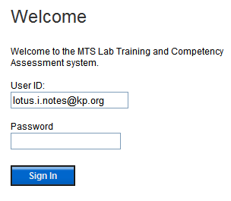  Enter Lotus Notes email address on User ID and your password  NOTE: All users will have their KP Lotus email address as their User ID and “New Users” will have the word “password” as their initial password. Once log in, you may change your password based on your preference
  3 | Once logged in click on “My Assignment” tab on the top left side of your screen.  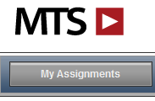
  5 | This will open your assignment list, under KP Riverside (SC) Content you will see document(s) ready for you to read.
DOCUMENT SYSTEM (MTS University of Washington-www.medtraining.org) CHANGE CONTROL FOR SITE SPECIFIC DOCUMENTS & FORMS, continued

Downloading and Reading Documents at MTS- U of W www.medtraining.com, continue
  Step | Action
  5 | Click on the document that must be read. Next screen will look like below.  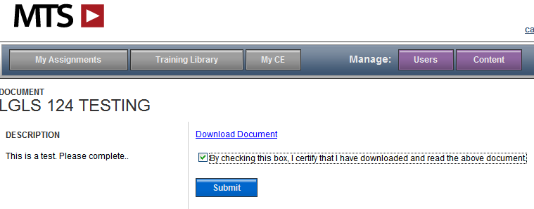
  7 | Click Download Document then “Open” to read. Once done reading close the document by clicking the “X” on the top right corner of your screen. This will bring you back on the screen above.
  8 | Pay attention on “DESCRIPTION” – Sender of the document may put important messages and instructions. A quiz may be included to test your knowledge about the document. A passing grade of =>80% must be obtained on the quiz
  9
  10

Documenting Employee Training, continued

Reviewed and approved by:

SIGNATURE | DATE
Julie Toti, CLS, MS
Manager, Clinical Laboratory – Los Angeles Medical Center
Joseph Thompson, M.D.
Director, Clinical Laboratory – Los Angeles Medical Center

Documenting Employee Training

History Page

Change type: new, major, minor | Changes made to SOP - describe | Signature responsible person / date | Med. Director review / date | Manager review / date | Date change implemented
NEW

