DOCUMENT SYSTEM FOR SITE SPECIFIC DOCUMENTS & FORMS- (MTS University of Washington-www.medtraining.org)

Purpose | This tool will provide paperless documentation that all personnel have read and are knowledgeable on policies/procedures/processes and form relevant to their job activities which includes but not limited to contents of policy & procedure manuals (including new and revised), memos and technical bulletins.

Policy | - All employees are responsible for all information attached to the documents.  - All employees receive notification on general, departmental, job-specific documents and forms on their Kaiser Permanente Lotus email account. KP Lotus Notes email address will be the User ID at the University of Washington (www.medtraining.org) website.  - Each document is read, documented and tracked through the MTS University of Washington- www.medtraining.org website.  - All employees must read and check the “Request Read Receipt” box of the documents in a timely manner indicating that all documents have been downloaded and read.  - All document system records are maintained and concurrent according to The Joint Commission, CAP, COLA, AABB requirements and CLIA, FDA and CDPH regulations.  Each Manager/Supervisor is responsible to upload, assign and monitor the document(s) in MTS to his/her staff.

Notification thru Lotus Email | _________________________________________________________
  Step | Action
  1 | Email notification thru Lotus Notes titled “Change Control for Site Specific Documents” followed by either department names or group job classifications will be received.
  2 | Read notification summary of the actual change control document(s) on Lotus email.
  3 | Click the first link on the body of the email notification to begin direct access on the change control document(s). This will bring you directly to MTS University of Washington -www.medtraining.com website without the need to log on your User ID and password.
DOCUMENT SYSTEM FOR SITE SPECIFIC DOCUMENTS & FORMS- (MTS University of Washington-www.medtraining.org), Continued

Downloading and Reading Documents at MTS- U of W www.medtraining.com | _________________________________________________________  Continued on next page
  Step | Action
  1 | If the first link works, proceed to Step 5
  2 | If the first link does not work on Lotus Notes, click the second link and it will direct you to MTS website log in screen.  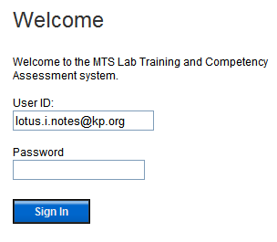  Enter Lotus Notes email address on User ID and your password  NOTE: All users will have their KP Lotus email address as their User ID and “New Users” will have the word “password” as their initial password. Once logged in, you may change your password based on your preference
  3 | After logging in click on “My Assignment” tab on the top left side of your screen.  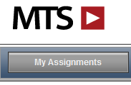
  5 | This will open your assignment list, under KP Riverside (SC) Content you will see document(s) ready for you to read.
DOCUMENT SYSTEM (MTS University of Washington-www.medtraining.org) CHANGE CONTROL FOR SITE SPECIFIC DOCUMENTS & FORMS, Continued

Downloading and Reading Documents at MTS- U of W www.medtraining.com, continue
  Step | Action
  5 | Click on the document that must be read. Next screen will look like below.  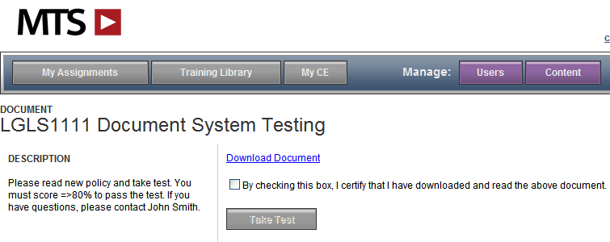
  6 | Pay attention on “DESCRIPTION” – Sender of the document may put important messages and instructions. A test may be included to test your knowledge about the document. A passing grade of ≥80% must be obtained.
  7 | Click Download Document then click “Open” to download and read. Once done close the document by clicking the “X” on the top right corner of the screen. This will bring back the screen above.
  9 | IMPORTANT: After reading the document and description, make sure to check the box of “Read Receipt Box” (By checking this box, I certify that I have downloaded and read the above document.) and click “Submit” button.  If a test is attached to the document click “Take Test” button and this will take you to the testing part of the document.
  10 | Once completed, a score of ≥80% must be obtained to pass the test.  ***In an event of a failure click “Request Retake” and select the manager that sent the document. An email will be sent to the manager selected to reset the test at MTS for you to take the test again.
  11 | Completion dates record for each documents downloaded and read will be maintained on each employees file at MTS.
_________________________________________________________
Continued on next page
DOCUMENT SYSTEM FOR SITE SPECIFIC DOCUMENTS & FORMS- (MTS University of Washington-www.medtraining.org)

References | CAP General Laboratory Checklist and website www.cap.org  MTS University Of Washington website www.medtraining.org

Author | Carlo E. Punu, CLS, MT

Distributions | Kaiser Permanente Riverside Medical Center Laboratory  SCPMG Wildomar Medical Office Laboratory  SCPMG Corona Medical Office Laboratory  SCPMG Temecula Medical Office Laboratory  SCPMG Moreno Valley Heacock Medical Office Laboratory  SCPMG Moreno Valley Iris MOB2 Medical Office Laboratory  SCPMG Palm Springs Medical Office Laboratory  SCPMG Palm Desert Medical Office Laboratory  SCPMG Indio Medical Office Laboratory
Reviewed and approved by:

SIGNATURE | DATE
 | 05/16/2013
Denise Topliff, MHA, CLS
Director, Clinical Laboratory – Riverside Medical Center
 | 05/16/2013
Dong Quach, M.D.
Medical Director, Clinical Laboratory – Riverside Medical Center

____________________________________________________________ Continued on next page
DOCUMENT SYSTEM FOR SITE SPECIFIC DOCUMENTS & FORMS- (MTS University of Washington-www.medtraining.org), Continued

HISTORY PAGE

Effective Date: 05-20-2013

Change type:  New, major, minor | Changes made to SOP - describe | Signature responsible person/date | Medical Director review/date | Laboratory Director review/date | Date change implemented
NEW |  | C.Punu  05/16/2013 | D.Quach MD 05/16/2013 | D. Topliff  05/16/2013 | 05-20-2013

