**LAB Dept MEETING – Huddles**

**Date of Meeting**: November 22, 2016

**Attendees**: Mark Gomez, Elliot Faure, Erin Straub, Janet Gerges, Melanie Magee, Tessa Strickland, Blanca Coscia, Raquel Lecaro, Myrna Ocab, Priscila Dar, Quang Trinh, Art Espidol, Tammy Rantung, Letty Fajardo, Patricia Jasper, Marissa Calilung, Rika Wakelin, Nancy Boyd

|  |  |  |
| --- | --- | --- |
| **Topic** | **Details** | **Action Item, responsible person, date due, or informational only** |
| KUDOS  SAFETY TIP | * None | We encourage everybody to appreciate co-workers during lab huddles. |
| Vacation Bidding | * Vacation bidding to start December 1. Start thinking now about what you want to bid for. | ALL STAFF |
| New lot of QC control (Chemistry) | * Segregate new lots of controls when you store in freezer or refrigerator. Our current process is to write new lot on a piece of paper and tape it to the boxes of new lot so it can easily be seen. As always, make sure to use the correct lot number of control. * Let Marissa know if you’re opening the last box of current lot of control so we can do parallel studies. | CLS |
| Osmolality | * Read osmolality policy on Med Training. This was due 11/17/16. | CLS |
| DXC 600 Calibrators | * Make sure you’re using the right calibrator lot when calibrating in Chemistry. Load calibrator disk if not loaded yet. Before calibration, check if calibrator matches the calibration data loaded. Let Marissa know if you have any questions. | CLS |
| CRL send outs | * All specimens going to CRL must be transferred to CRL. Per regional, even performing site is SWL, you can and you need to transfer to CRL. Let us know in real time if this cannot be done. | Phlebotomist |

Good Morning Moreno Valley Colleagues,

We know that Inventory monitoring at the Clinics and Medical Centers has been an ongoing challenge for years, particularly keeping track of expiration dates for all the special media, swabs etc... required for our Microbiology/Molecular Department testing.

The Microbiology/Molecular Department is still getting expired swabs and we will continue to monitor it every day. **The Swab Expired August 2016.**

Please check the Expiration date of the Bordetella pertussis PCR Specimen Collection Kit on a regular basis. Please notify the nursing stations, MOB's and Material Management to discard any expired collection kits.

Quite frequently, most of the patients for B. pertussis are pediatric patients & we want to make sure that we deliver quality care to our members, especially the babies. Please see below for cancelled order description.

I'm sure working together and through clear communication we will see improvement. Thank you

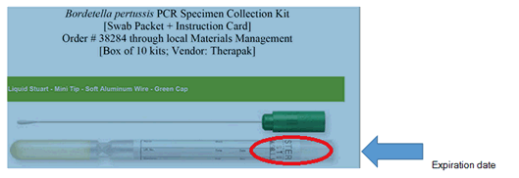

**Robert J Elazegui, CLS, MLS(ASCP)**

Manager Molecular Infectious Disease, Chino Hills RRL



**Department of Microbiology**

13000 Peyton Drive

Chino Hills, 91709

Phone: 909.703.6058

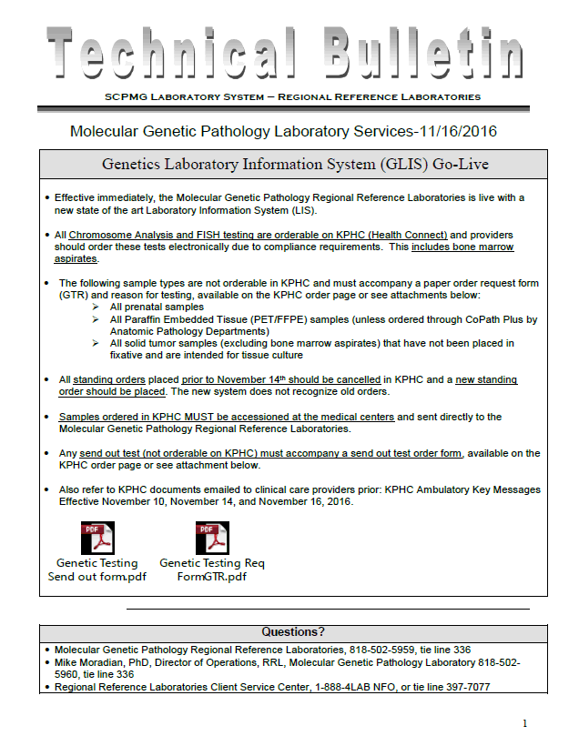

This concludes the Minutes of the November 22, 2016 Lab Staff Meeting.

Prepared by: __Nancy Boyd______ Date: ___November 22, 2016____