LAB Dept MEETING – Huddles

Date of Meeting: January 17, 2016
Attendees: Jocelyn Ybarra, Priscila Dar, Raquel Lecaro, Maria Villafuerte, Tammy Rantung, Tessa Strickland, Letty Fajardo, Mark Gomez, Elliot Faure, Erin Straub, Janet Gerges, Melanie Magee, Marietes Gonzalez, Marissa Calilung, Patricia Jasper, Rika Wakelin

Topic | Details | Action Item, responsible person, date due, or informational only
KUDOS | - none | Informational
SAFETY TIP | - Continue to communicate during hand off any patient issues such as combative patients to alert teammates.  - It’s been raining lately, be careful when driving, too many potholes on the road. | ALL STAFF
Processing Sterile Culture and Gram Stain | - Reminder, do not process culture and gram stain from sterile sites other than BF source.  We have 2 bones and 3 tissues from Dec that was processed. | ALL STAFF
Thrombin | We will discontinue performing Thrombin in-house effective January 31, 2017. We will send specimen to regional lab. | ALL STAFF
Inpatient Micro TAT | MVMC lab has improved since we started the new process.  Please continue to open and close transfer list within 2-3 hours. That should give us at least 2 transfer lists per shift.  Had 2 days on the week of Jan 1-7 that we did 1 transfer list in the morning shift. | Phlebotomist
Storing of documents | We have approval from Denise to save documents such as ED orders, NBS, transfer lists, etc. for one month.  Pathology log must kept indefinitely. | Phlebotomist
Specimen Processing Reminders | - Lab staff needs to be the one putting formalin on specimens due to safety and educational reasons.  - Reminder to send Methotrexate Stat to the next available courier. Put in a yellow bag; do not put in a blue rack! If necessary call CRL to check if there’s a regional courier around the area to pick up stat or use A-Line. Always check Lab Net for immunosuppressant drug level orders for specimen requirements and transport. Check Lab Net, call reference lab or escalate for any test that you’re not sure how to process. | Phlebotomists
Critical Call Process | Critical call process review for Hematology Onco Outpatient (Should be same process on Saturdays and during holiday).  - Call module first and leave a call back message, if module is close, go to next step  - No response, call/page provider  - No response, escalate to manager  - Call Riv ED only after 1700. | CLS
iChem Velocity | iChem Velocity weekly maintenance reminder to do weekly when we load new strips. Check the maintenance log when you load new strips and perform weekly maintenance if not done that week. | CLS
UBT | Please submit your I CARE Star- employee of the quarter | ALL STAFF

This concludes the Minutes of the January 17, 2017 Lab Staff Meeting.

Prepared by: __Patricia Jasper______ Date: ___January 18, 2017____

Lab Informatics Announcement
SCPMG Laboratory System –Lab Informatics Department

Additional Quest Tests Migrating to Cerner RLN
Effective Date: | January 25, 2017
Announcement | Effective 01/25/2017, thirty (30) additional Quest performed tests will be migrating over to Cerner Millennium. This will allow the appropriate result data to be electronically transmitted through the Cerner interface to KPHC directly and is consistent with our current laboratory processes. System interface changes are being done behind the scene.  - There are NO changes in the KPHC order entry workflow for the providers.  - There are NO changes in the transferring/tracking of outside reference laboratory specimens for the medical center laboratories. Follow existing SOPs.
Additional Quest Tests Migrating to Cerner RLN | 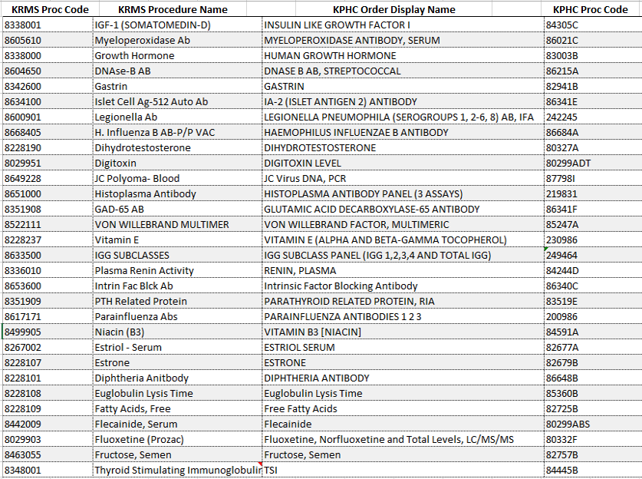
Reference Document | For detail workflow instructions on transferring/tracking outside reference laboratory specimens, refer to the regional SOP and workflow diagram – Transferring/Tracking Outside Reference Laboratory Specimens.
Distributed By: | Laboratory Informatics Department  Phone: (818) 503-6894 or Tie Line: 8-397-6894
Issued Date: | January 13, 2017

