**LAB Dept MEETING – Huddles**

**Date of Meeting**: March 30, 2017

**Attendees**: Juliet Garlejo, Jocelyn Ybarra, Priscila Dar, Mark Gomez, Melanie Magee, Michelle Trammell, Elliott Faure, Greg Johnson, Alan Dandridge, Neil Lim, Marissa Calilung, Denise Topliff, Nancy Boyd

|  |  |  |
| --- | --- | --- |
| **Topic** | **Details** | **Action Item, responsible person, date due, or informational only** |
| KUDOS  SAFETY TIP | * Thank you to Melanie and Myrna for joining me in the L&D and ICU UBT meeting * Thanks to everyone from Denise for no rejected specimens * Thanks to Elliott for his insightfulness and being courteous * Thanks to Greg for being conscientious in helping on wrong KPHC orders * Incubator tote charger cords – trip hazard; always tuck them in. * Big centrifuge by UA area – keep lid partially close after using – it’s so hard to reach when completely open. Put flag on top when there’s specimens. | Informational |
| PHI | * No PHI in regular trash even torn down. Put in shredder container. EVS were doing rounds and found torn DXC patient report by Chemistry area. * See attached Waste Management Stream flyer and policy. | ALL STAFF |
| OR Staff Request | * OR staff is required to enter time the breast specimen was put in formalin. They have pre-filled formalin for small and medium containers. For large containers, they will come to lab and wait until we put formalin so they can document the time.   If this process is not followed, e.g. they came back at different time to ask what time specimen was put in formalin, please report to manager. | Phlebotomist |
| ED Team Meeting Result | * ED will try to draw extra green top for Trop and lavender for BNP * Will communicate to nurses to label tubes appropriately. Use generic labels only if necessary * Will educate nurses not to pull out labels if specimen has not been collected especially for urine specimens. * Use Cerner ORV when processing ED specimens while they’re still working on labeling their tubes properly. We’re still missing some tests like Troponin, HCG and as a result delays the TAT. * Check specimens (especially swabs) first before processing. There was a couple of instances that specimens sent were wrong for tests ordered but fortunately was caught. But there was one sent to RRL and was rejected due to wrong swab used. * Read RRL Technical Bulletins attached.   Important information about send out PTH – pre-analytical handling and transport changes that will go live on 4/4/17. | Phlebotomist |
| Reminders | * Chemistry reagent new lot parallel test is performed by all CLSs when a new lot or new shipment is loaded. New lots can only be used after this is performed and acceptable for patient testing. All fluids being tested using the reagent need to have new lot reagent parallel done. Example: CR-s (creatinine) needs to be done on both serum and urine. The purpose of this check is to confirm that the use of new reagent lot and shipments do not affect patient results due to matrix interferences between different lots of reagents. * For TDM calibration, use only 1 drop of calibrator per test. * Be sure to run the correct QC lot number. * Use judgement and common sense when loading reagents. We don’t want to run out at the middle of the shift but we don’t want to load too early either especially tests that are rarely ordered and cartridges that expire fast. * iQ200 and Velocity – Do not mix QC reagent lots. * Let your coworker know if you load specimens in analyzers before going on break | CLS |
| Other  Patient feedback | Lab Leadership Team,  I received a phone call for a patient who is a frequent flyer due to their diagnosis.  Because this patient uses many of our health system services, they have been asked to provide occasional feedback.  And the feedback yesterday was around our phlebotomy team which was generally quite complimentary.  There was one recent issue though, that resulted in this patient getting a large hematoma because the needle went through the vein (per the patient) so the remind here is to review phlebotomy technique to help ensure it is correct.  Thank you, From Regional Group |  |
| Union | * 715 Section 8.   Although seniority is the determining factor in granting overtime, consideration for patient and employee safety must be given due consideration in offering consecutive overtime shifts.  Lab guidelines. This guideline was formulated a couple of years ago by management, HR, and union.   * No more than 4 days consecutive 12 hours for CLS * No more than 6 days consecutive 8 hours for Phlebs * Volunteer is preferred over drafting. |  |

This concludes the Minutes of the __3/30/17______ Lab Staff Meeting.

Prepared by: ___Nancy Boyd________ Date: ____3/31/17______

YTD Misdirected Specimen Data

|  |  |  |  |  |  |  |  |  |  |  |  |  |  |
| --- | --- | --- | --- | --- | --- | --- | --- | --- | --- | --- | --- | --- | --- |
|  |  |  |  |  |  |  |  |  |  |  |  |  |  |
| **Misdirected Specimens** | **January** | **February** | **Total** |  | | | | | | | | | |
| **ANAHEIM** | 4 | 16 | 20 |
| **BALDWIN PARK** | 16 | 12 | 28 |
| **DOWNEY** | 12 | 3 | 15 |
| **FONTANA** | 42 | 52 | 94 |
| **IRVINE** | 22 | 44 | 66 |
| **MORENO VALLEY** | 0 | 0 | 0 |
| **ONTARIO** | 15 | 24 | 39 |
| **RIVERSIDE** | 32 | 15 | 47 |
| **SAN DIEGO** | 61 | 50 | 111 |
| **BAKERSFIELD** | 6 | 6 | 12 |
| **LAMC** | 55 | 11 | 66 |
| **PAN CITY** | 5 | 3 | 8 |
| **SOUTH BAY** | 5 | 2 | 7 |
| **WEST LA** | 3 | 2 | 5 |
| **WOODLAND HILLS** | 6 | 6 | 12 |
| **TOTAL** | **284** | **246** | 530 |
|  |  |  |  |
|  |  |  |  |  |  |  |  |  |  |  |  |  |  |

YTD Cancelled Urine Culture

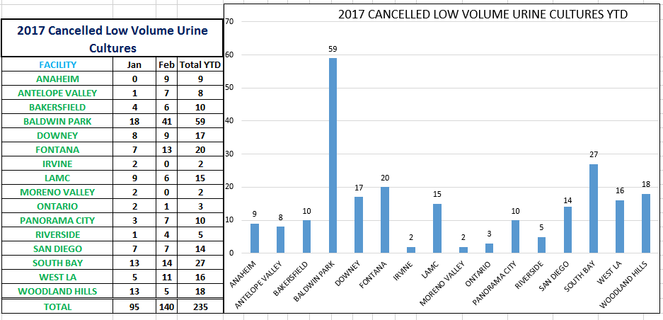

**PLEASE READ – Telephone System Maintenance**

**What’s Happening**

Kaiser is preparing to migrate the Telephony System to version 10.5.  In order to prepare for this upgrade, several activities will be occurring over the next several months.  One of the activities is the replacement of the Voice Gateways which connect analog telephony devices to Kaiser’s digital phone system.  These voice gateways provide connections for: FAX machines, phones in the patient rooms, alarm systems, language lines and other medical devices / systems which require a phone connection.

**Impact**

**Up to 24 devices will be disconnected for 5-8 minutes at one time** in order to move the connection from the old voice gateway to the new voice gateway.  This will disable the phone connectivity for these devices while the project team moves the connection.  Upon completion, the project team plans to randomly verify the connections are working properly.  This process will continue until all the analog phone connections have been moved to the new voice gateways.

**Affected Devices**

* Phones in Patient Rooms
* FAX Machines
* Language Lines (language translation should still be available via the Cisco phones)
* Alarm Systems with analog phone connections
* Medical devices with analog phone connections
* Any other non-digital telephony device or system which requires a phone connection

**When**

Below is the current schedule.  The maintenance effort will be performed **after normal business hours except for the 2 Medical Centers** highlighted below.

**Note** … the Temecula MOB may be rescheduled due to the amount of work scheduled on the same night.

|  |  |  |  |
| --- | --- | --- | --- |
| **Scheduled Date** | **Start Time** | **Affected Location** | **Address** |
| 4/3/2017 | 11:00 PM | Wildomar Medical Offices | 36450 Inland Valley Dr. |
| 4/4/2017 | 7:00 PM | Indio Medical Offices | 46-900 Monroe St. Suite E. |
| 4/4/2017 | After 9 PM | Palm Desert Medical Offices | 75-036 Gerald Ford Dr. |
| 4/5/2017 | 6:00 PM | Coachella Valley Administrative Offices | 73733 Fred Waring Dr., Ste. 109-110 |
| 4/5/2017 | After 7 PM | Palm Springs Medical Offices | 1100 Palm Spring Dr. |
| 4/6/2017 | 11:00 PM | Moreno Valley Community Hospital | 27300 Iris Ave |
| 4/10/2017 | 7:00 PM | Moreno Valley Medical Offices | 12815 Heacock St. |
| 4/10/2017 | 10:00 PM | Iris Medical Offices II | 27200 Iris Ave. |
| 4/11/2017 | 7:00 PM | Granite Street Warehouse | 182 Granite St. |
| 4/11/2017 | 9:00 PM | Corona Medical Offices | 2055 Kellogg Ave. |
| 4/11/2017 | 10:00 PM | Corona Chartroom | 300 South Promenade |
| 4/12/2017 | 7:00 PM | Meridian Medical Offices | 14305 Meridian Pkwy. |
| 4/12/2017 | 9:30 PM | Canyon Crest Mental Health Annex | 5225 Canyon Crest Dr |
| 4/13/2017 | 11:00 PM | Riverside Medical Center | 10800 Magnolia Ave. |
| 4/17/2017 | 11:00 PM |
| 4/18/2017 | 11:00 PM |
| 4/19/2017 | 11:00 PM |
| 4/20/2017 | 7:00 PM | RHC - Riverside Administration | 11080 Magnolia Ave |
| 4/24/2017 | 7:00 PM | Magnolia PT/OT | 10689 Magnolia Ave |
| 4/24/2017 | After 9 PM | Magnolia Home Health | 10917 Magnolia Ave |
| 4/25/2017 | 7:00 PM | Skofstad Marketing & Sales | 11011 Magnolia Ave. |
| 4/25/2017 | After 9 PM | Van Buren Medical Offices | 3951 Van Buren Blvd. |
| 4/25/2017 | 7:00 PM | Temecula Medical Offices | 27309 Madison Ave |

LifeStream will soon begin using a new shipping container for frozen component transport.

Credo Cube boxes use preconditioned inserts instead of dry ice to maintain temperatures of -18c or lower during transport. LifeStream has validated these containers to maintain appropriate shipping temperatures for well over 24 hours.

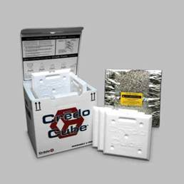

These boxes are durable, reusable, and since they don’t require dry ice, they are safer to transport and easier to unpack.

We’d like to know as soon as possible if you believe the receipt of products in these boxes will impact your facility.



