Purpose | This procedure provides instructions for the sputum smear preparation and screening to determine the quality and acceptability of sputum specimens for culture processing.

Principle | The quality of a gram-stained smear of expectorated sputum is evaluated and determined acceptable or unacceptable for routine bacteriology culture. Lower respiratory tract secretions usually become contaminated with upper respiratory tract secretions (saliva) unless they are collected using invasive techniques. Therefore, sputum specimens are among the least clinically relevant specimens received for culture in the Bacteriology laboratory as well as being among the most numerous and time consuming. The laboratory can influence the quality of specimens received for culture by establishing criteria for acceptable specimens.  Good sputum samples are dependent on thorough patient education and the presence of a health care worker to oversee all phases of the collection process. Patients should be instructed to provide a deep cough specimen. The material should be expelled into a sterile container, with an attempt to minimize contamination with saliva. Specimens should be transported to the laboratory immediately, as even a moderate amount of time at room temperature can result in the loss of some of the etiologic agents of respiratory tract infection.  A portion of the specimen consisting of purulent material is chosen for the stain. An acceptable specimen will yield less than 10 squamous epithelial cells per low-power field (10X). The number of white blood cells, which may be present in an infectious process, may not be relevant.

Scope | This procedure is intended for the Laboratory Assistants, Medical Laboratory Technicians and Clinical Laboratory Scientists in the Medical Center Laboratory. Refer to local Medical Center laboratory for task assignments.  Orderable: Modified Q Score with Reflex to Sputum Culture [87205ZX]

Specimen source | Expectorated sputum

Specimen collection & transport | - Utilize appropriate collection devices. Use sterile equipment and aseptic technique to prevent introduction of microorganism during the procedure.  - Collect specimen before administering antimicrobial agents when possible.  - Store at 2 – 8˚C after collection until arrival at the Medical Center or Regional Laboratory for appropriate plating.  - Specimen stable for ≤2 hours at room temperature or for 24 hours at 2 – 8˚C.

Specimen rejection | See the Rejection Criteria under LabNet. Consult a manager or designee for the acceptability of specimen.

Reagents, Materials and Supplies | Refer to local Medical Center Laboratory protocol for Gram stain procedure

Equipment | Brightfield microscope with low-power and oil immersion objectives

Safety or Special Safety Precautions | Refer to local Medical Center Laboratory protocol for safety manual and general safety requirements.

Quality  Control | All reagents and media are quality controlled according to the State of California  and College of American Pathologists (CAP) regulations. Quality control of  reagents and media are performed as required with each new batch/lot number and/or new shipment.

Before you begin | Prepare, gather and check expiration date of reagents, media, materials and  supplies before use.

Smear Preparation | Follow the steps below to prepare the sputum smear:  Step Action  1 Label the frosted end of a glass microscope slide. Refer to local Medical Center Laboratory protocol for slide labelling.  2 Using a cotton swab select purulent portions of the specimen.  3 Gently roll the material on a glass microscope slide.  4 Air dry in the biological safety cabinet.  5 Place on heat block to fix if applicable.  6 Stain according to the local Medical Center Laboratory Gram stain protocol.

Smear Examination | Step Action  1 Using low-power field (10X), examine the stained smear for the presence of squamous epithelial cells.  2 Scan at least 10 fields before making a determination.

Interpretation | Unacceptable specimen ≥10 squamous epithelial cells per low-power field (LPF)  Acceptable specimen <10 squamous epithelial cells per low-power field (LPF)

Reporting | Cerner Code Result  EPIU >= 10 epithelial cells. Specimen is not acceptable for culture.  EPIA <10 epithelial cells. Specimen acceptable for culture.  For acceptable sputum specimen:  - Quantitate white blood cells under low-power field  - Quantitate and enumerate morphology of bacteria and yeast under oil immersion field (OIF)  For white blood cells:  Cerner Code Quantitation Observation  R Rare <1 per low power field  F Few 1 – 9 per low power field  MOD Moderate 10 – 25 per low power field  M Many >25 per low power field  For bacteria and yeast  Cerner Code Quantitation Observation  R Rare <1 per oil immersion field  F Few 1 – 5 per oil immersion field  MOD Moderate 6 – 10 per oil immersion field  M Many >10 per oil immersion field

Reporting Results on Cerner | Step Action  1 Log on CERNER.  2 On CERNER Apps: - Click on Result Entry for Microbiology 

Reporting Results on Cerner – Unacceptable Specimen |  | Step Action  3 UNACCEPTABLE SPECIMEN At the Result Entry: - Enter the accession number of the patient to be resulted on the Accession field, and press Enter 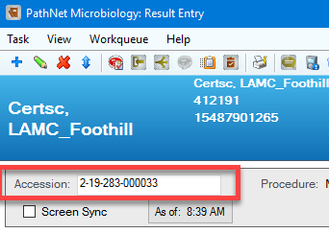  4 At the Result Entry: - Under Entry field, type EPI and press Enter 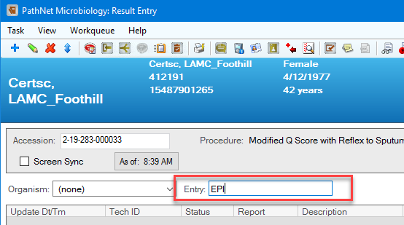 - Add Biochemical – EPI window appears  5 At the Add Biochemical – EPI: - Use the down arrow to select the result. 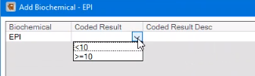
Reporting Results on Cerner – Unacceptable Specimen, continued | Step Action  6 At the Add Biochemical – EPI: - If sputum specimen is >=10 squamous epithelial cells per LPF, select >=10 from the drop-down list, and click Verify 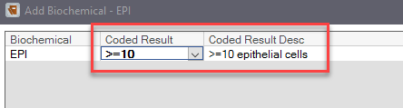 - The result is documented under the work card 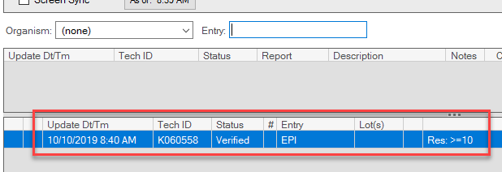  7 At the Result Entry: - Under Entry field, type FIN and press Enter, then Final Report window appears 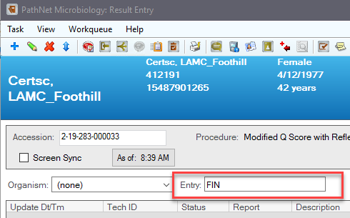

Reporting Results on Cerner – Unacceptable Specimen, continued | Step Action  8 At the Final Report: - Type EPIU on the first response cell 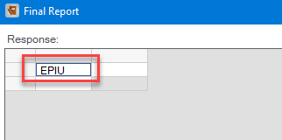 - The result will display under the Chart View area, then click Verify to release Final Report results. 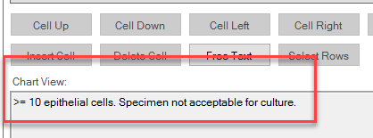  9 At the Result Entry: - The Final Report is displayed and completed. 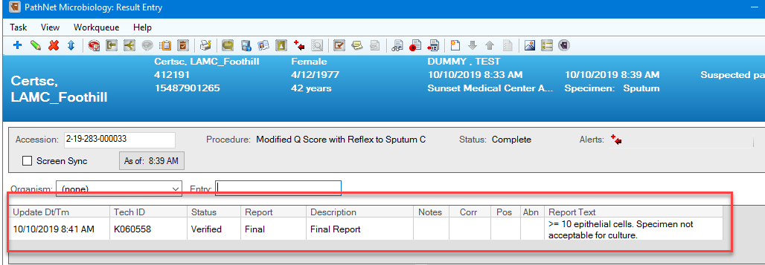  10 If applicable, refer to local Medical Center Laboratory for call notification and documentation protocol.

Reporting Results on Cerner – Acceptable Specimen | Step Action  1 ACCEPTABLE SPECIMEN At the Add Biochemical – EPI: - If sputum specimen is <10 squamous epithelial cells per LPF, select <10 from the drop-down list, and click Verify 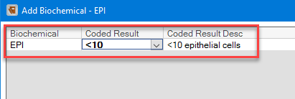 - The result is documented under the work card 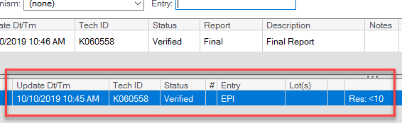  2 At the Result Entry: - Under Entry field, type FIN and press Enter, then Final Report window appears 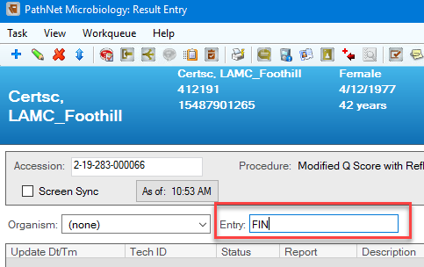

Reporting Results on Cerner – Acceptable Specimen, continued | Step Action  3 At the Final Report: - Type EPIA on the first response cell - Type GS on the second response cell - Enumerate and type the appropriate response value for the Gram stain results on the succeeding cells - The result will display under the Chart View area, then click Verify to release Final Report results 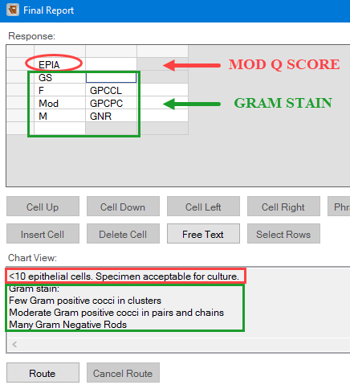

Reporting Results on Cerner – Acceptable Specimen, continued | Step Action  4 At the Result Entry: - The Final Report is displayed and completed. 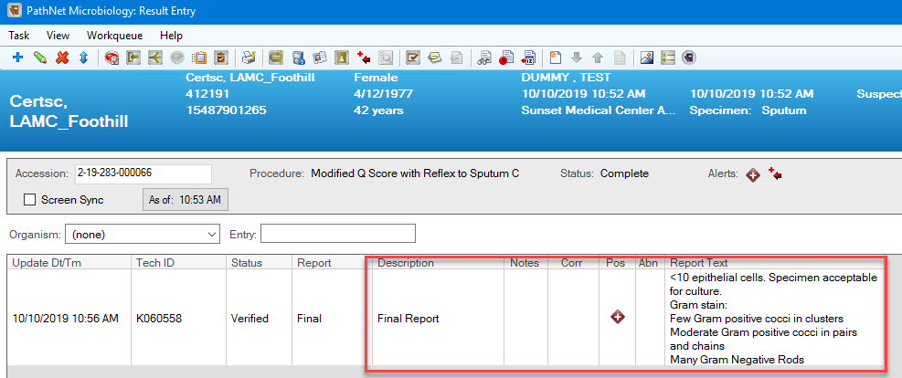  5 At the Order Result Viewer: - The Sputum Culture (C Sputum) is automatically reflexed once the Modified Q Score result is final/complete. 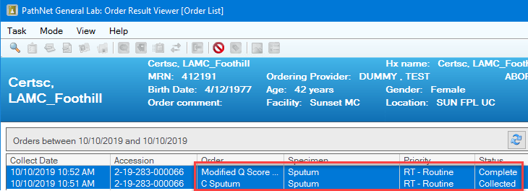  6 Micro Login the Sputum Culture order and print media labels. Inoculate the specimen to Blood Agar, Chocolate Agar and MacConkey Agar by four quadrant streaking method using a 10ul loop.
Limitations |  | - Sputum specimens often contain squamous epithelial cell, few inflammatory cells and grow pharyngeal flora, obscuring any true lower respiratory tract pathogens. For this reason, only those sputum specimens, which appear to be of acceptable quantity will be processed.  - Sputum screening is not indicated for fungal, virus, AFB, nasotracheal, transtracheal or bronchoscopy samples.

Non-Controlled Documents | The following non-controlled documents support this procedure.  Forbes, B.A., et al. 2002. Bailey and Scott’s Diagnostic Microbiology, 11th  Ed. Mosby, St. Louis  Isenberg, Henry D. 2004. Clinical Microbiology Procedures Manual. Section  3.2 ASM Press, Washington, DC.  Leber, Amy L. 2016. Clinical Microbiology Procedures Handbook, 4th  edition. American Society for Microbiology, Washington D.C.  SCPMG LabNet Pathology and Laboratory Medicine http://kpnet.kp.org:81/california/scpmg/labnet/index.htm

