Purpose |  |  | This procedure describes how to do an automated body fluid cell count using the SYSMEX XN-3100 Hematology analyzer.
Scope |  | This procedure is intended for the use of Clinical Laboratory Scientist (CLS) that will use the XN-3100 to perform an automated body fluid cell count and other laboratory personnel who may need to review the assay as part of quality management.
Safety | Refer to the safety manual for general safety requirements.
Reagents |  |  |  | XN-3100 Reagents  Refer to Policy & Procedure Sysmex® XN-3100™ Series Procedure for details on XN-3100 reagents.
Equipment / Supplies | Sysmex® XN-3100™ 12x75 mm Tubes  Calibrated MLA Pipettes for dilutions Sysmex® CELLPACK DCL  Hyaluronidase

Specimen Requirements | Acceptable Body Fluid Types are:  - Cerebrospinal Fluid (CSF) – The use of anticoagulant is not required nor recommended.  - Serous Fluids (Peritoneal, Pleural, Pericardial etc.) – Collected in EDTA-2K anticoagulant.  - Synovial/Joint Fluid – Collected in EDTA-2K anticoagulant with added hyaluronidase to break up mucous.  Required sample volume: 1.0 mL or more.  Aspirated sample volume: approximately 88 µL.  Body Fluid counts should be completed within 1-2 hours of specimen collection.  Refer to RIV-PPP-0456 for Body Fluid Analysis: Cell Count policy for specimen collection and storage requirements.  NOTE: Clotted and highly viscous specimens will not be run automated due to the mucous material that could clog up the instrument.
Quality Control | Frequency of Control use and review  - XN CHECK BF Automated Body Fluid controls: The 2 levels will be performed daily, on each shift, for XN-R and XN-L in Manual BF mode.  - Body Fluid analysis will be done primarily on XN10-R, XN10-L will be the backup.

Procedure
 | Analysis Preparation
 | Step | Action
 | 1 | Check the status of the analyzer. Check the Status indicator LED on the analyzer to confirm analyzer is in READY state.
 | 2 | Press the mode switch to eject the tube holder.
 | 3 | Select the Change Analysis Mode button on the control menu.
 | 4 | Select BODY FLUID.
 | 5 | Analyzer automatically perform a Background Check.  Note: The analyzer will automatically perform a background check three times (3X).
 | 6 | Select [OK].
 | 7 | Ensure Background Check passes, then proceed to QC analysis.
 | Body Fluid Analysis
 | Step | Action
 | 1 | Place a well-mixed patient body fluid in a vial with the correct sample barcode for analysis in the sample tube holder.
 | 2 | Click the Manual Analysis button in the analyzer area.
 | 3 | Confirm that READ ID is checked.
 | 4 | If sample tube is uncapped, click CAP OPEN. If sample tube is capped ensure the CAP OPEN box is unchecked.
 | 5 | Click [OK] and press the start switch (Blue Button).  Perform AUTORINSE between sample runs.
 | 6 | Verify that the body fluid result is acceptable and there are no flagging present such as “@, *, etc.)
 | 7 | Report TCBF and RBCBF, Appearance, Color and Differential in WAM Middleware and verify results in Cerner LIS.  NOTE: TC-BF result of ≤ 0.010 X 10³ µL (≤ 3 µL) AND/OR RBC-BF result of < 0.002 X 10⁶ µL (< 2000 µL), perform the Cell Count manually.

Result Reporting
 | WAM Middleware Reporting
 | Step | Action
 | 1 | 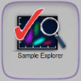  From the Sysmex WAM Main Menu screen, select the Sample Explorer icon
 | 2 | In the Selection Criteria screen, enter the Sample ID in the “From Sample ID” field to retrieve the Sample ID that require manual validation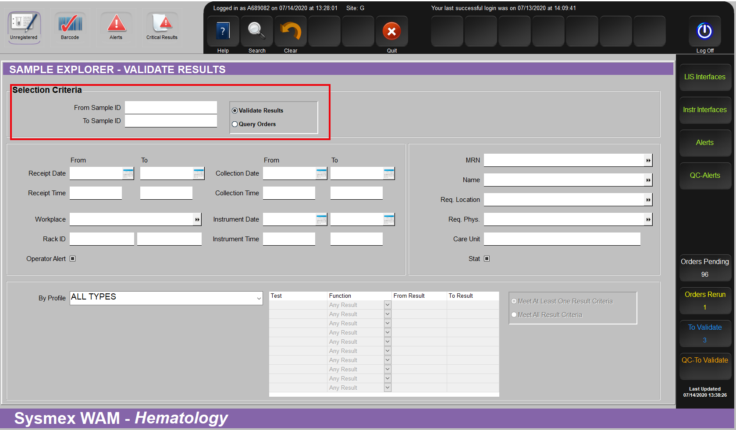
 | 3 |   Click [SEARCH] icon to retrieve the Sample ID
 | 4 | The Result Validation screen will display the searched Sample ID and review of results.  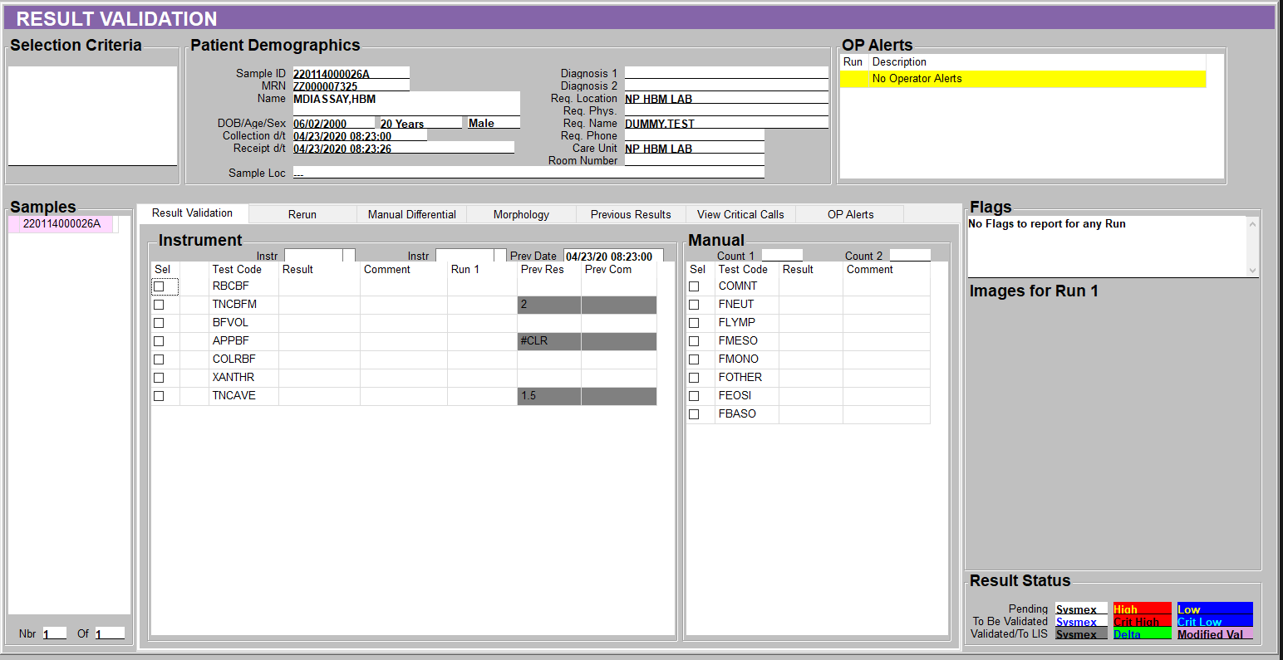  Test Code Interpretation  TCBF TOTAL NUCLEATED BODY FLUID Total Nucleated Count result from automated BF analysis  RBCBF RED BLOOD CELL BODY FLUID Total RBC Count result from automated BF analysis  BFVOL BODY FLUID TOTAL VOLUME Manually enter BF total volume, if applicable  APPBF BODY FLUID APPEARANCE Manually enter BF appearance, double click on the field for choices. - BLOODY - CLEAR - CLOUDY - CLOTTED - HAZY - SLIGHT HAZY  COLBF BODY FLUID COLOR Manually enter BF color, double click on the field for choices - COLORLESS - YELLOW - PINK - RED  XANTHR XANTHOCHROMIA (If indicated) Manually enter Xanthochromia response, double click on the field for choices - YES - NO
 | 5 | 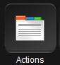  Perform manual cell count, if necessary, otherwise proceed to step 7.  - Click on the [Action] icon  - Select by clicking on the selection box  TNCBFM For manual total nucleated count (hemocytometer count)  RBCBFM For manual total red blood cell count (hemocytometer count)  - Select the [ADD] button. This will add additional result field in the Result Validation screen.
 | 6 | Manually enter the hemocytometer result in the following result field  Test Code Interpretation  TNCBFM/ RBCBFM TOTAL NUCLEATED / RED BLOOD CELL MANUAL COUNT Calculated field for TNC or RBC. WAM will automatically calculate.  TNCCALC/ RBCCALC TOTAL NUCLEATED / RED BLOOD HEMOCYTOMETER CHAMBER SQUARES COUNTED Select which square counted on the hemocytometer - Large - Small  TNCSD1/ RBCSD1 RAW COUNT ON ONE CHAMBER OF THE HEMOCYTOMER Manually enter the TNC or RBC raw count of one chamber of the hemocytometer  TNCSD2/ RBCSD2 RAW COUNT ON THE OTHER CHAMBER OF THE HEMOCYTOMER Manually enter the TNC or RBC raw count of the other chamber of the hemocytometer NOTE: The counts from each chamber must agree within 10% or the count must be repeated.  TNCAVE/ RBCAVE AVERAGE COUNT OF THE TWO CHAMBERS OF THE HEMOCYTOMETER Calculated TNC average for both raw counts. WAM will automatically calculate.  TNCDIL/ RBCDIL DILUTION FACTOR Manually enter the dilution factor. If no dilution performed enter 1  TNCSQ/ RBCSQ NUMBER OF SQUARES COUNTER IN EACH CHAMBER OF THE HEMOCYTOMETER Manually enter the number of squares counted  Select the [SAVE] icon 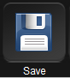 to calculate all the automated calculations by WAM
 | 7 | Select the [MANUAL DIFFERENTIAL] tab to perform the BF differential.  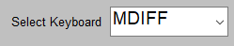  In the Manual Differential screen, change the default [MDIFF] and select [FDIFF] in the drop-down menu for Select Keyboard to switch the counter key to body fluid mode.
 | 8 | Using the counter key, perform the Body Fluid Differential. Counting will automatically stop at 100 cell count.  TEST COUNTER KEY  FNEUT +  FLYMPH 6  FMONO 5  FMESO 4  FEOSI 7  FBASO 8  FOTHER 1
 | 9 | Select the [SAVE] icon to save all the changes made.
 | 10 | Select [Val All] icon 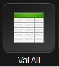 to validate the responses.
 | 11 | Verify body fluid cell count and differential results in Cerner LIS.

Reference Range | Refer to SCPMG-PPP-0105 Reference on LabNet for reference ranges.

Controlled Documents | The following controlled documents support this procedure.

Reference
- Sysmex XN-3100 Series Instructions for Use (North American Edition), Sysmex Corporation, Kobe, Japan.

Related Documents
- RIV-PPP-0455 Body Fluid Cell Count Hemocytometer Quality Control
- RIV-PPP-0456 Body Fluids Analysis Cell Count
- Sysmex® XN-3100 Series Procedure

