**BACTERIOLOGY DEPARTMENT**

**GRAM STAIN QUIZ**

Please identify the organisms below:

1. ____________________________________________________________________________________

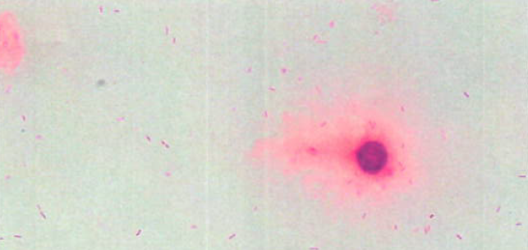

1. _____________________________________________________________________________________

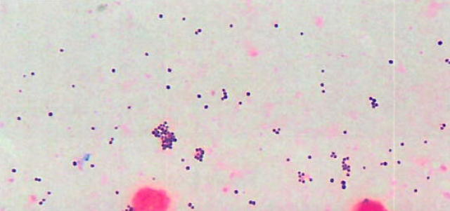

1. _____________________________________________________________________________________

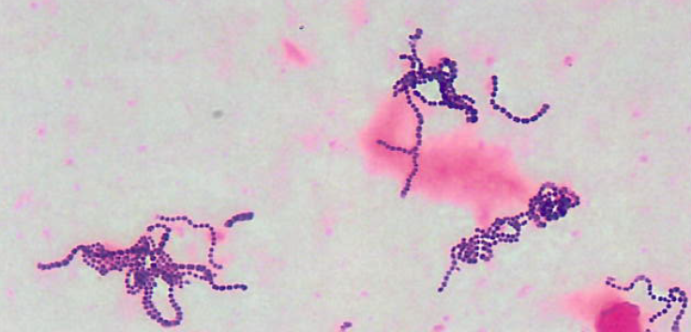

1. _____________________________________________________________________________________

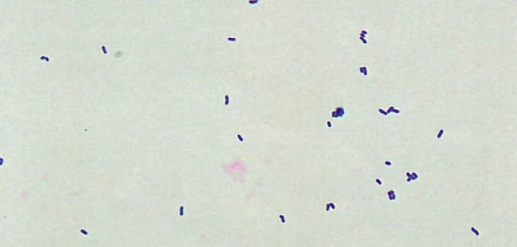

1. _____________________________________________________________________________________

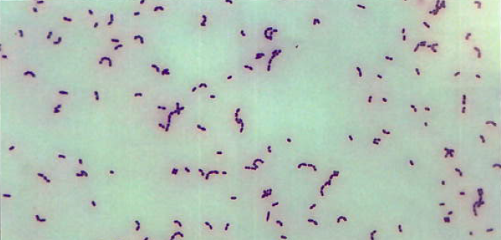

1. _____________________________________________________________________________________

