# **OhioHealth Laboratory Services**

# **Transfusion Services**

Columbus, Ohio

Problem Solving Competency 2023

**Tech Name ________________________________________ Date ____________________**

Specimen Processing:

1. A specimen is received today for preadmission testing. The specimen can be used for a maximum of _____ days if the patient has not been pregnant or transfused within the last three months.
   1. 18
   2. 3
   3. 21
   4. 7
      1. TXS-PT-01
2. True or False: When performing a history check on a patient, check the ABY button for previous history only if it is bolded.
   1. True
   2. False
      1. TXS-PT-02

Gel ABORh and Gel Weak D:

1. Reagents (choose the correct answers):
   1. Diluent is stored at 2-8˚C.
   2. Diluent is stored at 1-6 ˚C.
   3. Reagents can be used beyond the expiration date if QC is acceptable.
   4. Reagents do not need to be brought to room temperature (18-25 ˚C) prior to use.
      1. TXS-BT-02
2. The following results were obtained in a gel ABD forward and reverse typing card. What would be recorded as the interpretation in BBS for the initial gel type?

|  |  |  |  |  |  |
| --- | --- | --- | --- | --- | --- |
| Anti A | Anti B | Anti D | Control | A1 Cells | B Cells |
| 0 | 4+ | 0 | 2+ | 4+ | 0 |

1. B neg
2. INV
3. B pos
4. A neg
   1. TXS-BT-02
5. Based off the previous results (control microtube is positive), what step correctly demonstrates what to do next?
   1. Perform tube testing.
   2. No additional testing is needed.
   3. Reorder the gel ABO/Rh and repeat testing using washed cells with warm saline.
   4. Result as B neg.
      1. TXS-BT-02
6. A neonate has the following reactions. What is the neonate’s weak D interpretation?

|  |  |  |
| --- | --- | --- |
| Anti D (gel) | Weak D (tube) | DAT (gel) |
| 0 | 3+ | 0 |

* 1. unknown
  2. negative
  3. positive
     1. TXS-BT-07

Tube DAT:

1. A physician ordered a POLYDAT on a patient. Which of the following is performed for ALL POLYDAT testing?
   1. History check
   2. IgG DAT
   3. C3 DAT
      1. TXS-ST-02
2. The quality control for a POLYDAT in tube requires the following:
   1. 1 negative control, 1 positive control
   2. 2 negative controls, 1 positive control
   3. 2 positive controls, 2 negative controls
   4. 2 positive controls, 1 negative control
      1. TXS-QC-06, TXS-ST-02
3. Which of the following tests do you let sit at room temperature for 5 minutes before recentrifuging and grading the results if the IS result was nonreactive?
   1. Poly, IgG, C3
   2. Poly, C3
   3. IgG, C3
   4. Poly, IgG
      1. TXS-ST-02
4. Check cells are required for the following when a POLYDAT is performed in tube:
   1. POLYDAT quality control
   2. POLYDAT patient testing
   3. Both A and B
      1. TXS-QC-06, TXS-ST-02

Antigen Testing:

1. The positive control for C antigen typing would be the following:
   1. C+, c+
   2. C+, c-
   3. C-, c+
   4. Both A and B
      1. TXS-AD-08
2. Based on the following package insert, which choice correctly displays how the negative control would be written on the Rare Antisera QC Sheet?

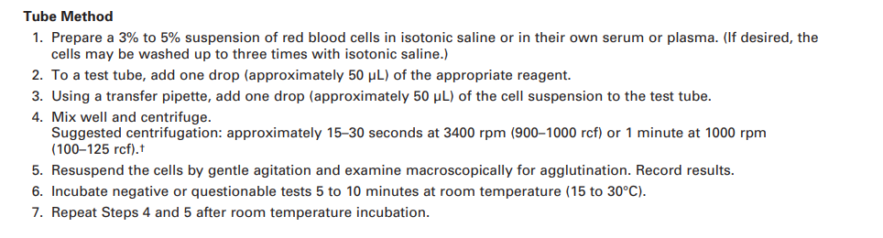

* 1. 0√
  2. 0/0√
  3. 0/0
  4. 0
     1. TXS-AD-08

Component Issue/ Return from Issue:

1. A red cell can be returned to and accepted into inventory if it meets the following criteria:
   1. Returned within 30 minutes of issue
   2. The temperature is less than 10 C
   3. Temperature indicator is activated
   4. Both A and B
      1. TXS-CI-09
2. A unit was brought back in a cooler and the cooler log showed the product was issued in a cooler. The tech forgot to put the cooler into the blood bank system (BBS) when they issued the units. The units were returned within 2 hours of issue and the temperature indicators were acceptable along with the visual inspection. What actions should the tech take in BBS when returning the unit?
   1. Return to available even though it has been out too long based on BBS logic
   2. Quarantine then return to available
   3. Discard the unit
   4. Quarantine then discard
      1. TXS-CI-09
3. A baby needs to be emergently transfused and there are no appropriate baby units in your inventory, or you do not routinely transfuse babies at your site. What should you do?
   1. Call another site to send a unit by a STAT courier
   2. Order a unit from the blood supplier
   3. Call your Transfusion Service Medical Director to help find the most appropriate unit
   4. Call your Supervisor to help find the most appropriate unit
      1. TXS-ON-14 or TXS-ON-15

Quality Control:

1. A freezer was being repaired and taken out of service. In order to place the freezer back into service which of the following statements is correct?
   1. Monitor and record the temperature for 24 hours after the repair was completed
   2. Complete alarm checks
   3. Once the correct temperature is reached, the products can be returned to the freezer
   4. A and B
   5. A and C
      1. TXS-QC-27
2. When recording temperatures of the chart or CheckPoint compared to the actual temperature of the unit, the difference between the two temperatures can differ by a maximum of ____.
   1. 1 C
   2. 2 C
   3. 3 C
   4. 4 C
      1. TXS-QC-03
3. A tech spilled the 6% albumin and needed to make more 6% albumin. Which of the following has the correct ratio on how to make 6% albumin from 22% albumin?
   1. Dilute 5mL of 22% albumin with 8mL of isotonic saline
   2. Dilute 8mL of 22% albumin with 3mL of isotonic saline
   3. Dilute 15mL of 22% albumin with 20mL of isotonic saline
   4. Dilute 3mL of 22% albumin with 8mL of isotonic saline
      1. TXS-QC-41
4. A tech discovered that quality control was successfully performed but on an expired reagent. Units were issued to a patient based on this testing. Which of the following best describes the course of action that should be taken?
   1. Nothing and hope that no one notices during the review process the expired reagent
   2. Complete a Performance Problem Documentation form, repeat testing/ QC, alert management, no reporting to the FDA is needed
   3. Complete a Performance documentation form, repeat testing/ QC, alert management, report the BPD to the FDA
   4. Repeat testing and QC
      1. TXS-GI-19
5. A tech discovers that quality control was not performed correctly for AHG. The positive control was not completed for C3. The only testing completed was a POLYDAT. Which of the following best describes the course of action that should be taken?
   1. Nothing and hope that no one notices during the review process the missing QC
   2. Complete a Performance Problem Documentation form, repeat testing/ QC, alert management, no reporting to the FDA is needed
   3. Complete a Performance documentation form, repeat testing/QC, alert management, report the BPD to the FDA
   4. Repeat testing and QC
      1. TXS-GI-19

Vision Testing:

1. A specimen had the result code TFC. The sample and reagents had a sufficient volume. In order to report the result, which one of the following actions should be taken?
   1. Check that the reagents were suspended with a sufficient volume, rereun the test
   2. Check that the reagents were suspended with a sufficient volume, manually read the reactions and enter the results into BBS
   3. Both A and B are acceptable
      1. TXS-VS-07
2. Quality control on the Vision should give the following results for Alba Q-Check Vial 1.
   1. Type: Aneg Screen: negative (both screening cells)
   2. Type: Aneg Screen: positive (both screening cells)
   3. Type: Aneg Screen: screening cell 1 positive, screening cell 2 negative
   4. Type: Aneg Screen: screening cell 2 positive, screening cell 1 negative
      1. TXS-VS-05
3. True or false: e connectivity doesn’t be refreshed when the Vision is shut down
   1. False
      1. TXS-VS-02

Fetal Screen:

1. When performing a fetal screen, the number of red cell agglutinates is counted in ___ fields.
   1. 3
   2. 4
   3. 5
   4. 6
      1. TXS-ON-02
2. Fetal screen quality control is performed:
   1. Only with each new lot number
   2. Once per week
   3. With each test or batch of specimens
   4. A and B
      1. TXS-ON-02

Titer:

1. A change in titer of ___ tubes or more is considered a significant change.
   1. 1
   2. 2
   3. 3
   4. 4
      1. TXS-ON-05

Eluate:

1. An elution must be performed when the DAT is due to IgG and when:
   1. DAT increases in strength on a transfused patient
   2. Physician determines the patient to be hemolyzing
   3. DAT becomes positive on a patient transfused in the last 2 months
   4. All of the above
      1. TXS-ST-03

Reference Testing:

1. When sending a sample to an OhioHealth reference lab for antibody identification:
   1. Send the original tube to the reference lab
   2. Have a total of 3 tubes drawn from the patient
   3. Send 3 out of 4 tubes to the reference lab
   4. Send 1 out of 4 tubes to the reference lab
      1. TXS-PT-10, 13
2. When sending a C3DAT to an OhioHealth reference lab:
   1. Send the original tube to the reference lab
   2. Have 4 tubes redrawn and send 3 tubes to the reference lab
   3. The referring technologist does not need to order the C3DAT in the LIS. This is done by the reference lab.
   4. Remove an aliquot of 0.5 mL of packed RBCs
      1. TXS-PT-10

Emergency Issue:

1. Units are emergency issued on a patient without any transfusion history in the BBS. The antibody screen is positive. Who needs to be notified immediately?
   1. Medical director
   2. Clinical care team/ patient’s physician
   3. Supervisor
   4. A and B
      1. TXS-EM-02

Antibody Identification:

1. Panel A and panel B displayed no pattern to a specific antibody. Which of the following could be the next logical step to complete the antibody identification?
   1. Identify the antibody as INC
   2. Perform a PeG screen
   3. Perform a saline screen
   4. All of the above
      1. TXS-AD-05
2. A patient’s ABSC had the following results based on the panel below:

- Screening cell 1: 1+ reaction in gel

- Screening cell 2: 3+ reaction in gel

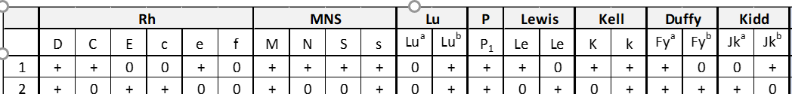

Based on this information, which would be the most likely interpretation of the antibody screen?

1. The patient has an autoantibody
2. The patient has one alloantibody
3. The patient has multiple antibodies
4. Both A and B

-TXS-AD-01,3,8

1. The patient has no history in the BBS. Based on the following results of the antibody screen, which would be the most logical test to perform next?

- Screening cell 1: 2+ in gel

- Screening cell 2: 0 in gel



* 1. Run a panel in gel with an autocontrol
  2. Perform a PeG screen
  3. Result the ABID, no further testing is indicated
  4. Send to the blood suppliers reference lab for further workup
     + TXS-AD-01, 3, 8

1. Which would be the most likely antibody based on the following results?

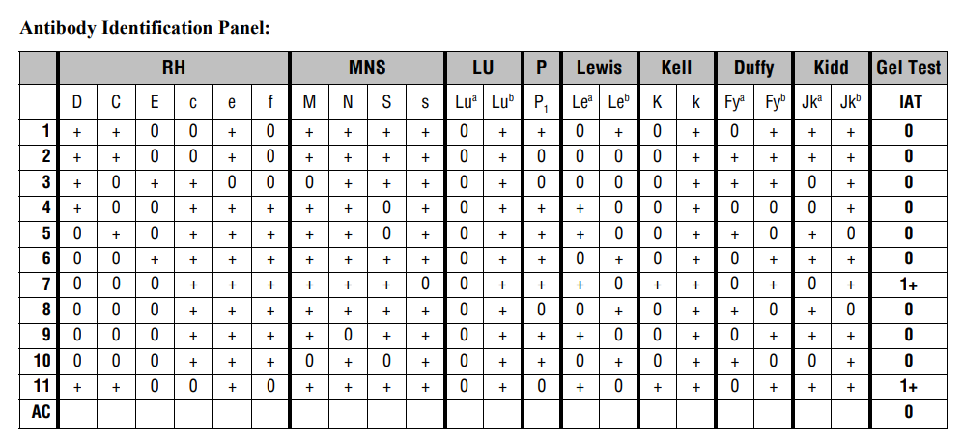

* 1. Anti-Lea
  2. Anti-Lua
  3. Anti-K
  4. Anti-Jkb

1. What panel cell based on the panel results below is most appropriate to rule out anti-Fyb?



* 1. Cell 7
  2. Cell 6
  3. Cell 2
  4. Cell 8

1. Based on the panel, which cells would be chosen to antigen type for the E antigen?

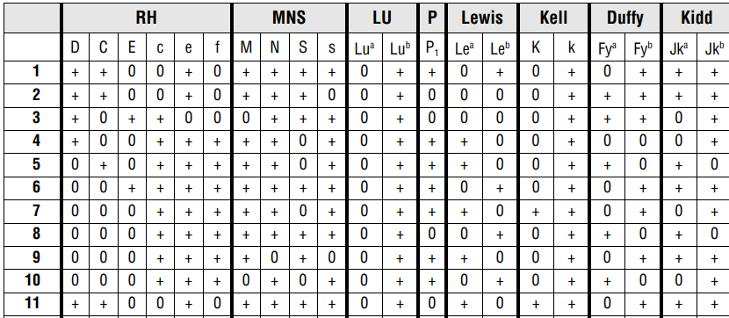

* 1. Positive cell #: 3

Negative cell #: 2

* 1. Positive cell #: 6

Negative cell #: 3

* 1. Positive cell #: 3

Negative cell #: 4

* 1. Positive cell #: 6

Negative cell #: 2

Crossmatching:

1. There is a **downtime** in the BBS. Based on the patient’s results, which type of crossmatch should be performed? Screening cell 1 and 2 are negative (0) in gel. The patient has no antibody history.
   1. Electronic crossmatch
   2. Immediate spin crossmatch
   3. Gel crossmatch
   4. LISS crossmatch
      1. TXS-CT-02, 04
2. A patient has a history of Anti-Leb. The current screen is negative. Which type of crossmatch can be performed based on these results?
   1. Electronic crossmatch
   2. Gel crossmatch
   3. LISS crossmatch
   4. PeG crossmatch
      1. TXS-CT-05 (remember to deactivate the antibody!)