# **OhioHealth Laboratory Services**

# **Transfusion Services**

Columbus, Ohio

Problem Solving Competency 2024

Please note: the quiz is to be placed into MTS (MedTraining System) for each site. We have a variety of activity menus making the quiz slightly different for each site. The passing score is 80%.

Specimen Processing:

1. A specimen is received today for preadmission testing. The specimen can be used for a maximum of _____ days if the patient has not been pregnant or transfused within the last three months.
   1. 18
   2. 3
   3. 21
   4. 7
      1. TXS-PT-01
2. The patient has a truncated name denoted by an asterisk (*) at the end of the name. What information must be confirmed on the label to match the electronic requisition or the computer system?
   1. Medical Record Number and Date of Birth
   2. Medical Record Number
   3. Date of Birth
   4. None of the above
      1. TXS-PT-01
3. Specimens older than 3 days will not be retrieved for crossmatching except in the cases below:
   1. There are no exceptions to this rule
   2. Preadmission testing patients who haven’t been pregnant or transfused in the last 3 months.
   3. Specimens for problem patients at the discretion of the medical director.
   4. B and C
      1. TXS-PT-01

Gel ABORh:

1. Reagents (choose the correct answers):
   1. Diluent is stored at 2-8˚C.
   2. Diluent is stored at 1-6 ˚C.
   3. Gel cards are stored at 1-6 ˚C.
   4. Reagents do not need to be brought to room temperature (18-25 ˚C) prior to use.
      1. TXS-BT-02
2. The following results were obtained in a gel ABD forward and reverse typing card. What would be recorded as the interpretation in BBS for the initial gel type?

|  |  |  |  |  |  |
| --- | --- | --- | --- | --- | --- |
| Anti A | Anti B | Anti D | Control | A1 Cells | B Cells |
| 0 | 4+ | 0 | 2+ | 4+ | 0 |

1. B neg
2. INV
3. B pos
4. A neg
   1. TXS-BT-02
5. The patient was typed in gel using the ABD forward and reverse typing card. The control microtube is positive, what step demonstrates what can be performed next?
   1. Send the sample to the American Red Cross to workup.
   2. No additional testing is needed.
   3. Reorder the gel ABO/Rh and repeat testing using washed cells with warm saline.
   4. Result the type disregarding the control well.
      1. TXS-BT-02

Tube DAT:

1. Check cells are required for the following when a POLYDAT is performed in tube:
   1. POLYDAT quality control
   2. POLYDAT patient testing
   3. Check Cell aren’t needed for patient testing or quality control
   4. Both A and B
      1. TXS-QC-06, TXS-ST-02
2. The quality control for a POLYDAT in tube requires the following:
   1. 1 negative control, 1 positive control
   2. 2 negative controls, 1 positive control
   3. 2 positive controls, 2 negative controls
   4. 2 positive controls, 1 negative control
      1. TXS-QC-06, TXS-ST-02

Crossmatching:

1. There is a **downtime** in the BBS. Based on the patient’s results, which type of crossmatch should be performed? Screening cell 1 and 2 are negative (0) in gel. The patient has no antibody history.
   1. Electronic crossmatch
   2. Immediate spin crossmatch
   3. Gel crossmatch
   4. LISS crossmatch
      1. TXS-CT-02, 04
2. A patient has a history of Anti-Leb. The current screen is negative. Which type of crossmatch can be performed based on these results?
   1. Electronic crossmatch
   2. Gel crossmatch
   3. LISS crossmatch
   4. PeG crossmatch
      1. TXS-CT-05 (remember to deactivate the antibody and add a note that it is deactivated!)

Component Issue/Return from Issue:

1. A unit of RBCs was brought back in a cooler and the cooler log showed the product was issued in a cooler. The tech forgot to put the cooler into the blood bank system (BBS) when they issued the units. The units were returned within 2 hours of issue and the temperature indicators were acceptable along with the visual inspection. What actions should the tech take in BBS when returning the unit?
   1. Return to available even though it has been out too long based on BBS logic
   2. Quarantine then return to available
   3. Discard the unit
   4. Quarantine then discard
      1. TXS-CI-09
2. A red cell can be returned and accepted into inventory if it meets the following criteria:
   1. Returned within 30 minutes of issue
   2. The temperature is less than 10 C
   3. Temperature indicator is activated
   4. Both A and B
      1. TXS-CI-09
3. 2 units are being issued in SafeTrace. Before completing the process, what should you look for in SafeTrace to verify that both units were issued?
   1. Green banner
   2. Blue banner
   3. Green stop sign
   4. Yellow banner
      1. TXS-CI-01
4. There is a patient who needs 2 RBCs emergency issued. The transporter didn’t come down with the Transfuse Order paperwork. The transporter only has the room number. What else can be used?
   1. Unacceptable and the proper paperwork needs to be brought down with the transporter as transfusion service won’t accept any other document.
   2. Have the transporter write down or retrieve the chart label containing the name, date of birth and medical record number along with the requested products.
   3. In an emergent situation, it is acceptable to issue the product based off of the patient’s room number.
   4. In an emergent situation, only the medical record number is needed to pick up blood products.
      1. TXS-CI-01

Quality Control/Error Correction:

1. When recording temperatures of the chart or electronic temperature recordings (Viewpoint or Checkpoint) compared to the actual temperature of the unit, the difference between the two temperatures can differ by a maximum of ____.
   1. 1 C
   2. 2 C
   3. 3 C
   4. 4 C
      1. TXS-QC-03
2. The refrigerator was taken out of service and is being repaired. Once the issue is resolved, what actions are needed to place the unit back into service?
   1. Monitor and record the temperature for 24 hours after the repair was completed ensuring the appropriate temperature is reached.
   2. Complete alarm checks.
   3. Once the correct temperature is reached, the products can be returned to the freezer.
   4. A and B
   5. A and C
      1. TXS-QC-20
3. A site orders a new refrigerator to use for blood products. They would like to use this refrigerator as a backup for blood bank reagents too. What would be the appropriate temperature range to set the refrigerator to?
   1. 1-6 C
   2. 2-8 C
   3. 2-10 C
   4. 2-6 C
      1. TXS-QC-20
4. A tech discovered that quality control was successfully performed but on an expired reagent. Units were issued to a patient based on this testing, but the unit was already transfused. Which of the following best describes the course of action?
   1. Nothing and hope that no one notices the expired reagent during the review process.
   2. Complete a Lab Incident, repeat testing/ QC, alert management, no reporting to the FDA is needed
   3. Complete a Lab Incident, repeat testing/ QC, alert management so they can report the BPD to the FDA
   4. Repeat testing and QC
      1. TXS-GI-19
5. A tech discovers that quality control was not performed correctly for AHG. The positive control was not completed for C3. The only testing completed was a POLYDAT. Which of the following best describes the course of action that should be taken?
   1. Nothing and hope that no one notices during the review process the missing QC
   2. Complete an Event Form, repeat testing/ QC, alert management, no reporting to the FDA is needed
   3. Complete an Event Form, repeat testing/QC, alert management, report the BPD to the FDA
   4. Repeat testing and QC
      1. TXS-GI-19
6. A Biologic Product Deviation (BPD) is discovered at Site ABC. The site manager is on TAP for a month-long vacation in New Zealand. What is the correct document number of the form to follow to ensure the BPD is escalated appropriately?
   1. OHLS-TXS-fGI-0400
   2. OHLS-TXS-fGI-4000
   3. OHLS-TXS-fGI-0004
   4. OHLS-TXS-fGI-0040
      1. TXS-fGI-0040
7. The QC sheet #1 needs a primary review completed. Are there any errors that need to be corrected?
   1. Incorrect reactions
   2. Check cells are missing for AHG
   3. Incorrect expiration date
   4. No errors
      1. TXS-QC-41 For the dilution of albumin, the expiration date is based off saline, which is 1 month once opened or the date on the bottle. (Whatever one is the soonest expiration date.) Written is the expiration date of the 22% albumin, undiluted, bottle.

QC Sheet #1

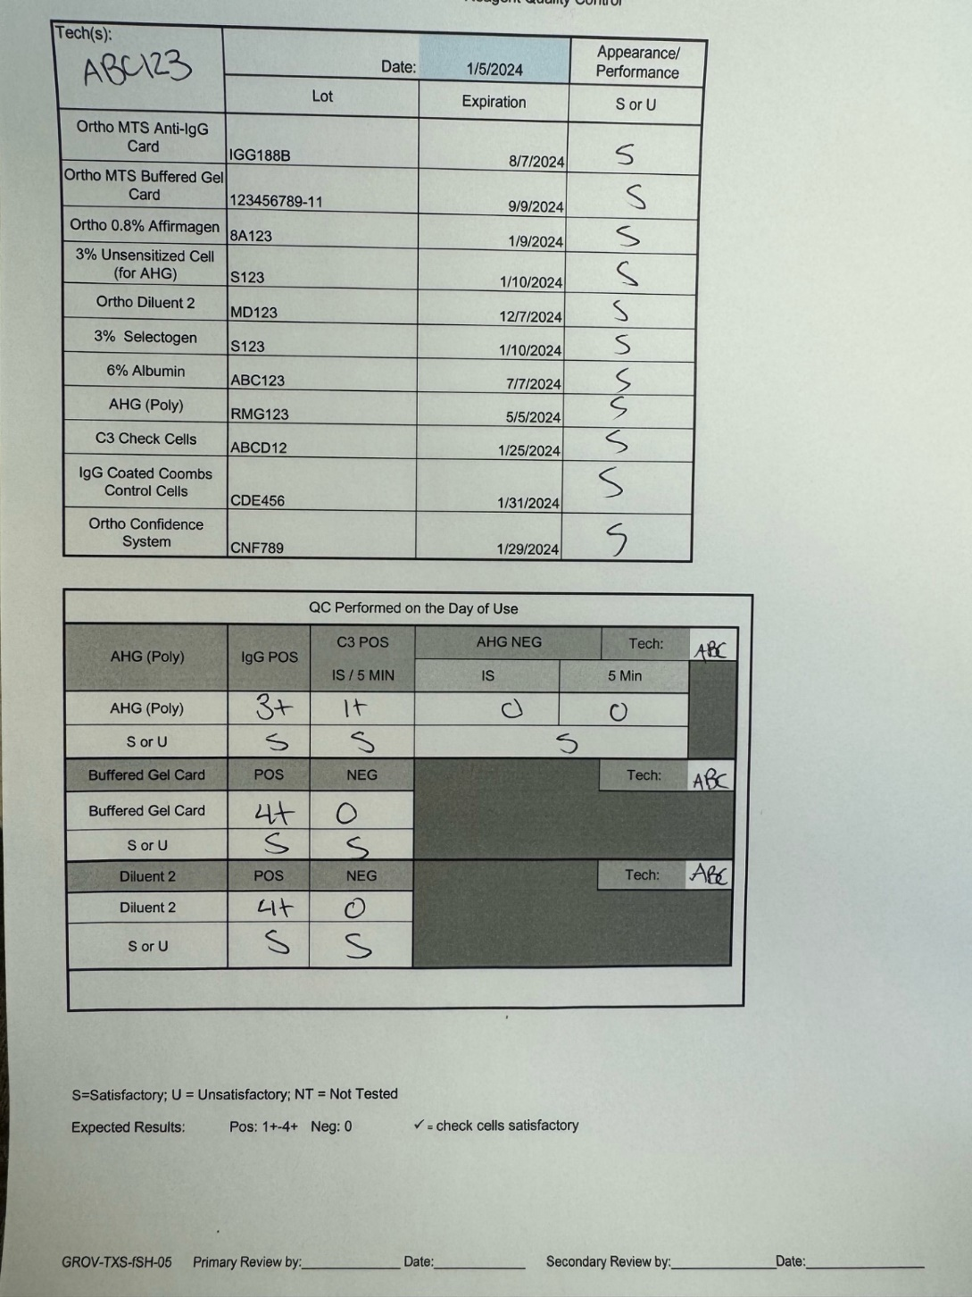

1. A tech caught their own error while writing the lot number on a QC form. What is the proper way to correct the error?
   1. Single strike through so the previous result is legible and initials
   2. Strike throughs so the previous result is illegible, initial and date
   3. Single strike through so the previous result is legible, initial and date
   4. B and C
      1. OHL-SHA-AN-02

Emergency Issue:

1. When you receive a phone call for an emergency issued product, which pieces of information should you ask for about the patient?
   1. Name, Medical Record Number, Sex (if available)
   2. Name only
   3. Medical Record only
   4. Name, Room Number
      1. TXS-EM-02

Reference Testing:

1. Ideally when sending a sample to an OhioHealth reference lab for antibody identification:
   1. Send the original tube to the reference lab
   2. Have a total of 3 tubes drawn from the patient
   3. Send 3 out of 4 tubes to the reference lab
   4. Send 1 out of 4 tubes to the reference lab
      1. TXS-PT-10, 13
2. When sending a C3DAT to an OhioHealth reference lab:
   1. Send all of the original tube to the reference lab
   2. Have 4 tubes redrawn and send 3 tubes to the reference lab
   3. Have 4 tubes redrawn and send all 4 tubes to the reference lab
   4. Remove an aliquot of at least 0.5 mL of packed RBCs to send to the reference lab
      1. TXS-PT-10

Passing score: 80%

The passing score is from OHL-QUA-PR-05