**OhioHealth Laboratory Services – Campus Shelby**

**Competency Quiz Assessment Year 2024**

**Initial Semiannual (first year) Annual**

|  |  |
| --- | --- |
| **Name:** | **Title:** |

**Coagulation Dept.**

1. The amount of anticoagulant in the sodium citrate tube must be adjusted prior to collecting samples from patients who have hematocrit values above what %?
   1. 45
   2. 55
   3. 65
   4. 75
2. The STA aPTT reagent is reconstituted with ______ml of Nerl H20 and must sit for ______ min at room temp.
   1. 5 ml / 60 min
   2. 5 ml / 30 min
   3. 5 ml / 15 min
   4. 10 ml / 30 min
3. Which coagulation test(s) performed **at Shelby** must be refrigerated for stability? ____________
4. **APTT** QC level 1 is acceptable and QC level 2 is unacceptable. **PT** QC level 1 is acceptable and QC level 2 is unacceptable. You have repeated the unacceptable QC and it is still flagging out. What is a probable cause for the QC being unacceptable? _________________________________________________________________
5. **D-Dimer** QC is processed once per 24 hours. True / False

**Chemistry Dept.**

1. When is it required to complete a patient lookback?
   1. When QC is acceptable
   2. When QC is out and troubleshooting was just repeating the QC
   3. It is never required to complete a patient lookback
   4. When QC is out and troubleshooting consisted of calibration
2. A **TROPONIN** test result has a Hemolysis Index of 105. It is acceptable to accept the result. True / False
3. A Lipase result was diluted on the analyzer and the result is still greater than the Extended AMR. What is the next step if the physician ask for a result? ________________________________________________________________________________
4. A urine sample can be placed in a Blue rack to be processed on the chemistry analyzer? True / False
5. When performing I-stat Blood Gases, what is the patient ID number
6. Medical Record Number (MRN)
7. Sample ID number (SID)
8. Account number (CSN)
9. Barcode label

**Hematology Dept**.

1. Once opened, XN Check controls are good for 21 days. True False
2. A CBC sample drawn 72 hours ago is acceptable for testing when stored at refrigerated temps. True / False
3. When reviewing a differential slide from a patient with Chronic Iron Deficiency, you would expect to see what RBC morphology? ____________________
4. A patient has a parasitic infection. What would you expect to see on the differential slide? __________________
5. The iSED QC must be stored protected from light when not in use? True / False
6. Post Vasectomy samples can be accepted for testing up to ______ hours after collection.
7. 72
8. 36
9. 24

**Urinalysis/Body Fluid Dept.**

1. QC is performed every _____ hours and the stability of an opened QC vial is________:
2. 8 hours/ 31 days
3. 24 hours / 31 days
4. 12 hours/ 31 days
5. The lid of the reagent Chemstrips are left opened for a time unknown. What is the next step before patient testing?
6. Nothing, should be ok because the temperature in the lab is ok.
7. Run QC on the strips
8. Put lid back on reagent strips and proceed with patient testing
9. Freshly voided normal urine is usually clear; however, if it is alkaline, a white turbidity may be present due to:
   1. Yeast
   2. White Blood Cells
   3. Amorphous phosphates and carbonates
10. A urine report shows Positive Protein, Blood and Nitrates. What would you expect to see in the microscopic
    1. RBC, Casts and Bacteria
    2. WBC only
    3. WBC, Bacteria and Casts
11. You are manually counting a CSF sample with no dilution on the hemocytometer. By counting all 4 large squares (labeled “W” in the diagram below), you get 10 RBCs on side A and 10 RBCs on Side B. Determine the RBC count? (Hint: Formula: #cells counted x 10 x reciprocal of dilution x reciprocal of squares counted)

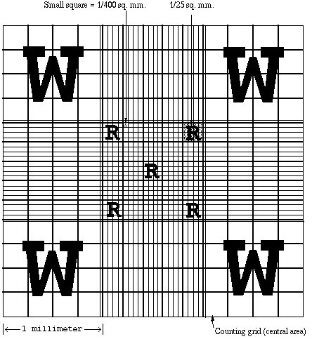

1. The cells seen in the Body Fluid image below are: _____________, _____________, ____________, _____________

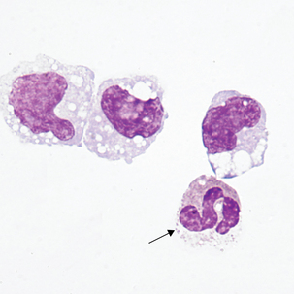

1. This is seen in a vaginal wet prep. You would report this positive for what? ___________________________________

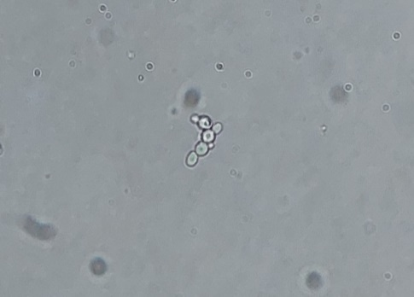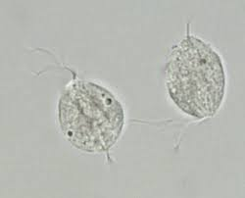

**Serology/Kit Tests Dept**.

1. For stool specimens to be acceptable for CDIFF testing, the specimen must be NON-FORMED. True / False
2. The result of the CDIFF test is “Indeterminate”. You must ask for a recollect. True / False
3. A Rapid Strep (RSA) specimen must be collected in an UTM. True / False
4. All of the following are acceptable specimen types for RSV testing **except**:
5. Throat swab
6. Nasopharyngeal washing
7. NP swab
8. A POSITIVE result for a Mono test consists of a line only at the Control (C ) and no line at the Test (T). True / False
9. The acceptable swab type for the Covid-19/Flu Combo test is __________________________
10. What is the time limit to start the LIAT testing once the test cartridge is inoculated with the patient sample? _______________
11. The fecal occult blood test must be read in _____ minutes.

Associate received acceptable score (≥ 80%): Yes or No

Associate Signature: _______________________________________________________________________ Date: ______________________________

Observer Signature: _______________________________________________________________________ Date: ______________________________

Corrective Action if not acceptable: