OhioHealth Laboratory Services

Transfusion Services

Problem Solving Competency 2026
Please note: the quiz is to be placed into MTS (MedTraining System) for each site. We have a variety of activity menus making the quiz slightly different for each site.
**Sites with a MTP policy should include a question for their site’s quiz. Any additional “problem” areas at sites, please create questions to represent those issues.
The passing score is 80%.

Specimen Processing:
- A specimen is received today for preadmission testing. The specimen can be used for a maximum of _____ days if the patient has not been pregnant or transfused within the last three months.
  - 18
  - 3
  - 21
  - 7
    - TXS-PT-01
- True or False: patients must be marked as “not duplicate” prior to being merged?
  - True
  - False
    - OHLS-TXS-PT-0014
Gel ABORh, ABSC and Weak D:
- Reagents (choose the correct answers):
  - Diluent is stored at 2-8˚C.
  - Diluent is stored at 1-6 ˚C.
  - Gel cards are stored at 1-6 ˚C.
  - Reagents do not need to be brought to room temperature prior to use.
    - TXS-BT-02
- A gel antibody screen, GABSC, uses ____% screening cells?
  - 3%
  - 0.8%
  - 5%
  - Both 3% and 0.8%
    - TXS-AD-01
- The following results were obtained in a gel ABD forward and reverse typing card. What would be recorded as the interpretation in BBS for the initial gel type?
Anti A | Anti B | Anti D | Control | A1 Cells | B Cells
0 | 4+ | 0 | 1+ | 3+ | 0
- B neg
- INV
- B pos
- A neg
  - TXS-BT-02
- If the DAT is positive, a weak D test can be performed for a neonatal patient?
  - True
  - False
    - TXS-BT-07

Tube DAT:
- The quality control for a POLYDAT in tube requires the following:
  - 1 negative control, 1 positive control
  - 2 negative controls, 1 positive control
  - 2 positive controls, 1 negative control
  - 2 positive controls, 2 negative control
    - TXS-QC-06, TXS-ST-02
- A positive result with polyspecific AHG needs additional testing for which of the following?
  - Anti-IgG only
  - Anti-C3 only
  - No additional testing is needed
  - Anti-IgG and Anti-C3
    - TXS-ST-02
Tube ABORh:
- An O positive RBC was ordered for a patient. What unit confirmation testing needs to be performed on the O positive unit?
  - Anti-A,B
  - Anti-A and Anti-B
  - Anti-A,B and Anti-D
  - Anti-D
    - TXS-IM-07
Tube Antibody Screen:
- If check cells (IgG Coated Coombs Control Cells) are not reactive in the tube antibody screen QC, the test is_________.
  - Recorded on the appropriate QC sheet and left for the primary review is to be completed.
  - Recorded as invalid, begin troubleshooting the issue, no further testing is performed using all reagents in QC until the issue is resolved.
  - Recorded as invalid, begin troubleshooting, testing using all reagents in QC can continue.
  - Record as invalid, leave on the management desk for when they get back from a meeting in 3 hours to decide the next steps.
    - TXS-QC-07
Crossmatching:
- A crossmatch is completed by the buffered and anti-IgG gel card method. The detection of ABO incompatibility with donor red cells is detected in ____ microtube. The detection of IgG antibodies occurs when the sensitized RBCs react with ____ in the microtube.
  - anti-IgG gel, buffered gel card
  - anti-IgG gel, anti IgG gel
  - buffered gel card, buffered gel card
  - buffered gel card, anti-IgG gel
    - TXS-CT-03
- There is a downtime in the BBS. Based on the patient’s results, which type of crossmatch should be performed? Screening cell 1 and 2 are negative (0) in gel. The patient has no antibody history.
  - Immediate spin crossmatch
  - Electronic crossmatch
  - Gel crossmatch
  - A and B
    - TXS-CT-02, 04
- A patient is in the ED and needs their appendix removed. The patient was identified as having a CAA, cold autoantibody, that is currently detectable. Which type of crossmatch would be the most reasonable to perform based on the situation?
  - Electronic crossmatch
  - Gel crossmatch
  - LISS crossmatch
  - PeG crossmatch
    - TXS-CT-05
Component Issue/Emergency Issue:
- 2 units are being issued in SafeTrace that required a serologic crossmatch. Which choice isn’t part of the readback process between the issuing tech and transporter?
  - Product type
  - Verify the green bar is present on the computer screen
  - Product code
  - Crossmatch interpretation
  - All of the above
    - TXS-CI-0001

- A 40-year-old male patient has a routine order for 2 RBCs and they have a history of an antibodies, A-K, A-E. The patient’s condition worsens, and they cannot wait for completion of the ABID and antigen negative units. What is the most appropriate next course of action?
  - Emergency issue 2 O RBCs.
  - Inform the care team they must wait until the ABID and antigen negative units are available.
  - Inform the care team they must wait until antigen negative units are available.
  - Consult the transfusion service medical director to perform a serologic crossmatch in gel.
    - TXS-CT-0009

- Liquid plasma can be given in place of thawed plasma for any STAT order?
  - True
  - False
    - TXS-CM-17
- A female patient has a previous history in BBS of type B negative. The type isn’t completed but they need the products emergency issued. The nurse confirms the patient’s blood type with previous records in Care Everywhere. True or False: You can give the patient B negative RBCs?
  - True
  - False
    - TXS-EM-0002
- You get a call from surgery that a 57-year-old female patient with no previous history in BBS needs two units of RBCs emergency issued. A tech grabs two O positive units to emergency issue. Is this product appropriate to give in this situation?
  - Yes
  - No
    - TXS-EM-0002
Transfusion Reaction:
- Which tests are performed on ALL transfusion reaction workups?
  - Perform the type on the post specimen and perform the tube POLYDAT on the pre and post specimen.
  - Perform the type on the post specimen and perform the tube POLYDAT on the post specimen.
  - Perform the type on the post specimen and perform the DAT in gel on the post specimen.
  - Perform the type on the post specimen, perform the tube POLYDAT on the post specimen and complete antibody screen on the post specimen.
    - TXS-AR-01
Quality Control/Error Correction:
- A refrigerator was being repaired due to the unit alarming for a high temperature and taken out of service for 3 days. In order to place the unit back into service, which of the following statements is correct?
  - Monitor and record the temperature for 24 hours after the repair was completed
  - Complete alarm checks
  - Confirm the temperature is within range and immediately place RBCs into the unit
  - A and B
  - A and C
    - TXS-QC-20
- A new refrigerator is purchased to replace a broken unit. The tech is determining the proper range for the new refrigerator that will be used to store blood products. Also, the tech wants to store extra Diluent 2 and 0.8% Affirmagen when they get a new shipment. What range should the tech use for the new refrigerator in transfusion services at their site?
  - 2-6 ˚C
  - 2-8 ˚C
  - 2-10 ˚C
  - 1-6 ˚C
    - TXS-QC-0005, QC-19, QC-20
- A tech caught their own error while writing the lot number on a QC form. What is the proper way to correct the error?
  - Single strike through so the previous result is legible and initials
  - Strike through so the previous result is illegible, initial and date
  - Single strike through so the previous result is legible, initial and date
  - B and C
    - OHL-SHA-AN-02

Antibody Screen and Antibody Identification:
Screening Cells A: The 58 year old male patient from above has the following ABSC results:
Cell 1: 3+
Cell 2: 0
- Given the results of the antibody screen on picture, Screening Cells A, which would be the MOST LIKELY interpretation?
a. No antibodies are present in the patient’s serum
b. The patient has one alloantibody
c. The patient has multiple alloantibodies
d. The patient has an autoantibody
- AD-01,3,8

25. Which of the following tests would be the BEST next step in this case to find the ABID for the results on Screening Cell A?
a. Repeat the antibody screen using polyethylene glycol (PeG)
b. Report the findings and do no further testing
c. Test a Gel panel with an autocontol
d. Crossmatch 2units of type O neg red blood cells
- AD-01,3,8

26. A patient with a positive screen in cell 1 has no ABID history and panel A and B were completed. Panel A had 2 positive cells and panel B had 0 positive cells. No antibody pattern or antibody identification was able to be determined. What is the best next course of action?
a. Identify the antibody as inconclusive
b. Consult transfusion service management
c. Perform a prewarm screen
d. Perform a PeG screen
- OHLS-TXS-AD-0005

Panel A:
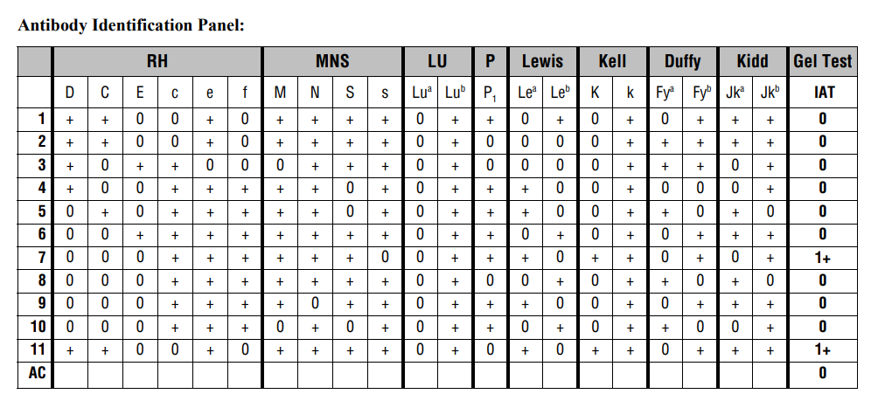
- Which would be the most likely antibody based on the following results in Panel A?
  - Inconclusive
  - Anti-Jkb
  - Anti-Lea
  - Anti-K
    - AD-01, 3, 8
- Which cell from Panel A would be the MOST appropriate to rule out anti-E based on the panel reactions displayed?
  - Cell 3
  - Cell 6
  - Cell 1
  - Cell 11
    - TXS-AD-08
- A patient needs to be antigen typed due to having A-E. Based on Panel A, which would be the most appropriate cell to use for the positive control for QC for E antisera?
  - Cell 3
  - Cell 6
  - Cell 1
  - Cell 11
    - TXS-AD-08
- The patient has a previously identified clinically significant antibody, but the screen is currently negative, does a result comment need to be entered into BBS?
  - No
  - Yes
    - TXS-AD-01 ABIDHX-more time is needed for a compatible crossmatch
- A tech has an O positive patient, no previous ABID or transfusion history, and identified anti-E on the current specimen. The auto control was negative. The patient was antigen typed for E, which was negative. Is there additional testing that needs to be performed?
  - Yes
  - No
    - Little c should be antigen typed TXS-AD-08

Reference Testing:
- Ideally when sending a sample to an OhioHealth reference lab for antibody identification:
  - Send the original tube to the reference lab
  - Have a total of 3 tubes drawn from the patient
  - Send 3 out of 4 tubes to the reference lab
  - Send 1 out of 4 tubes to the reference lab
    - TXS-PT-10, 13
Thawing Plasma/Cryo:
- After thawing plasma at 30-37 C, what temperature is the thawed plasma stored until the product is issued?
  - 30-37 C
  - 20-25 C
  - 1-6 C
  - B and C
    - TXS-CM-17
- A patient is type AB negative and needs 2 units of plasma thawed for a procedure in 2 days. Which type of plasma would be the best choice to thaw in advance for their procedure?
  - O
  - A
  - O or AB
  - AB
    - TXS-CM-17

- The mom is Rh negative. The baby is Rh positive. What is the next most appropriate course of action?
  - Fetal Screen to determine the RhIg dosage
  - Kleihauer-Betke to determine the RhIg dosage
  - Mom isn’t a RhIg candidate
  - Mom gets 1 vial of RhIg, no further testing is needed
    - TXS-ON-01

Neonatal Emergent (all sites):
- A neonate needs an emergent transfusion of platelets. Which platelet type is most preferred in an emergent situation where the neonate’s type is unknown?
  - AB
  - B
  - A
  - O
    - TXS-ON-0015

