

***USER***

***REFERENCE***

***GUIDE***

***Saint Francis Laboratory***

***Tulsa, Oklahoma***

***Table of Contents***

***Section One – Introduction to Instrument Manger***

1. Understanding Data Flow . . . . . . . . p. 3
2. Opening, Logging on and off IM . . . p. 3
3. Opening a Predefined Workspace . . . p. 4
4. SM Workspaces – Panes . . . . . . . . . . p. 5

***Section Two – Processing Patient Results***

I. Processing Results in SM . . . . . . . . . p. 9

II. Searching for Patients, Results . . . . . p. 11

III. Using Filters. . . . . . . . . . . . . . . . . . . p. 12

***Section One – Introduction to Instrument Manager***

***I. Understanding Data Flow***

Instrument Manager is a middleware application between laboratory instruments and the Epic application. It provides additional functionality to our workflow, such as rules logic and the use of color.

Patient orders originate in Epic and are transmitted to Instrument Manager when the **specimen is collected**. Instrument Manager reviews those orders and routes the orders to the correct analyzer.

The appropriate tests are run on the instruments and the data is sent back to Instrument Manager. Result rules are then applied to this data. Reference ranges, error codes, and results flags can be added, as well as processing of autoverification parameters. Acceptable patient results are released to the host (Epic). Test status in Specimen Management workspace changes to “complete”.

Patient results which have associated error codes or do not meet all criteria for autoverification are “held for verification” and are accessible through a defined Specimen Management (SM) workspace.

The user must review the “held” results and process appropriately. At user discretion, data can be released to host, rerun, edited, rejected, or cancelled. Prior results may be viewable in the SM workspace. Once the user releases the data from the SM workspace, it is sent to Epic and the result status changes to complete.

***II. Opening, Logging In and Out of Instrument Manager***

See LIS procedure – LIS.03.01.00.00 for these instructions.

***III. Opening a Predefined Workspace***

Once you are logged into the IM application with your user ID and password, you will open a predefined Specimen Management Workspace to review and release test results.

1. Click on Specimen Management in the menu bar at the top center of the IM screen. A drop-down box will appear.

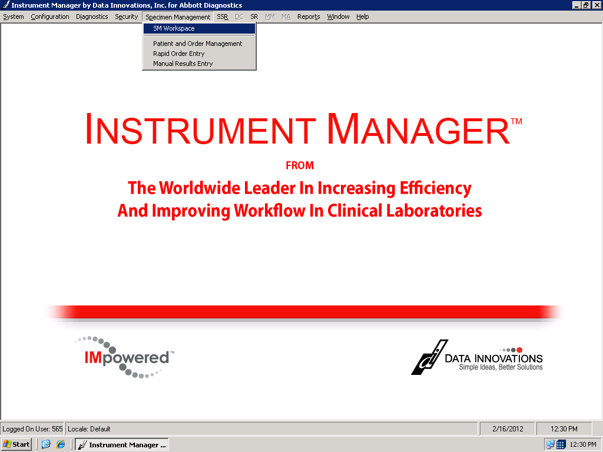

1. Click on SM Workspace.
2. Just below the menu bar words for “Workspace”, “Edit” and “View” is the box used for selecting a predefined SM Workspace. Click on the *Workspace* down arrow and the drop down menu will appear to choose a particular format.

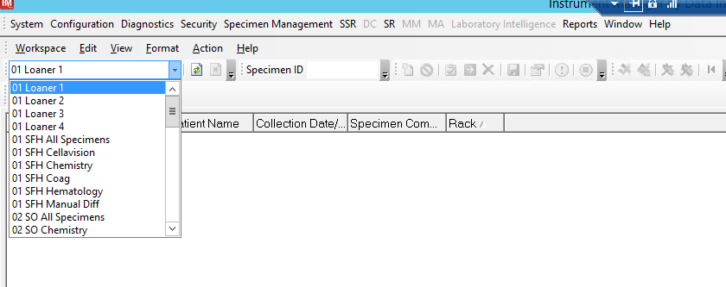

***IV. Specimen Management Workspace -Panes***

When looking at a workspace screen, there are six main areas of information, or “*panes*”, each containing different type of data. The panes are *Specimen Worksheet, Patient Information*, *Run Worksheet*, *Test Worksheet* and *Previous Results*. For ease of use, most workspaces are defined consistently with the same panes in the same positions on the screen.

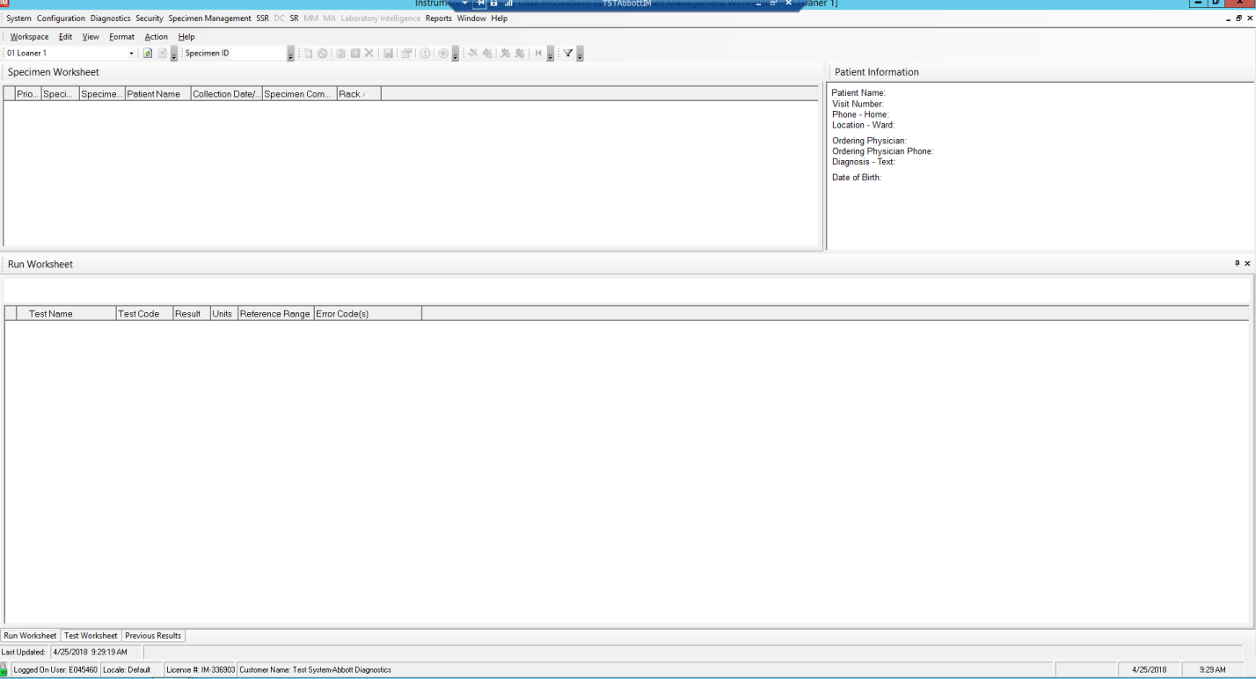

***A. Specimen Worksheet Pane***

**Specimen Worksheet** displays several columns of information:

**Priority -** STAT is “ST” or “S”, ASAP is “AS”, Routine is “R” or “RO”

**Specimen Completion Status -** Status can be Complete, Partial, Pending, or Tests Held

**Specimen ID –** this is our specimen number. Quality Control bar code numbers may also appear in this column.

**Patient Name –** Displays the patient’s last name and first name.

**Collection Date & Time –** This information is transmitted from the Architect and may be helpful to locate a specimen.

**Specimen Comments** – This is the comment that comes from Epic, Users may see “Fasting”, “1 Hour” , “Peak” or “Trough” etc.

Other columns are defined and can be different from workspace to workspace, depending on the instrument generating the results.

***B. Patient Information Pane***

Patient demographic information is displayed in this pane. The most basic information is in the top few lines. Scroll, if needed, to display more information.

**Patient Name** – Last name and first name are listed. No middle initials, no “Jr.” or other information is displayed. (Note there is **no** space between the last name, comma, and first name.)

Other information such as ordering physician, date of birth, diagnosis, etc. is available in the Patient Information Pane.

**Note:** A “Show All Data” icon is available on the toolbar (looks like a hand over a folder). Users can click on this box at any time. It will list all the available specimen, test, or patient data that has been received from the host computer.

***C. Run Worksheet***

This pane displays all the test data in a vertical format so you can compare multiple runs on the same specimen easily and prevent duplicate results from being sent to the LIS. Tests will be groups according to groups defined in IM.

**Test Name** – this will be the name of the profile or test when the test is pending (before any result data is received.)

**Test Code** – shows the individual test name.

**Test Result** – results from the analyzer

**Reference Range** – this reference range is specific for this patient age and sex.

**Units** – units of measure for each analyte.

**Error Codes** – Error codes in this column may come from two different sources: error flags related to analyzer issues, or error flags related to result parameters.

**Colors** - Colors are used to highlight certain information. A lavender cell indicates a result **higher** than reference range, while light **yellow** indicates a low value. **Green** indicates a delta failure**. Red** indicates a critical result. **Orange** is used when a Free T4 should be added to a “ TSH w FT4 if indicated.” A **blue** message indicates an invalid test order, or a blue background indicates an absurd value.

***D. Test Worksheet Pane***

This pane of information displays all the **test** result data. Some of the information may not be of interest for all specimens or all instruments. Users may shrink or expand the columns as needed.

**Test Connection** – shows which instrument the data is coming from.

**Test Name** – this will be the name of the profile or test when the test is pending (before any result data is received.)

**Test Code** – shows the individual test name.

**Test Status** – pending, held for verification, released, complete.

**Test Result** – results from the analyzer

**Reference Range** – this reference range is specific for this patient age and sex.

**Result date & time** – this is the time the result was complete on the instrument.

**Units** – units of measure for each analyte.

**Test Comment -** This is where users can add comments such as “repeated,” “called”, etc. There are coded comments available, as well as the option for free text comments.

**NOTE:** These comments are NOT transmitted into Epic.

**Error Codes** – Error codes in this column may come from two different sources: error flags related to analyzer issues, or error flags related to result parameters.

**Previous Results** – Displays previous results for this patient (based on MRN.) IM is set to display the last 2 previous results. (The first run of a rerun result may display in this field.)

**Previous Results, date & time** - Displays the date and time of previous results.

**Colors** - Colors are used to highlight certain information. A lavender cell indicates a result **higher** than reference range, while light **yellow** indicates a low value. **Green** indicates a delta failure**. Red** indicates a critical result. **Orange** is used when a Free T4 should be added to a “ TSH w FT4 if indicated.” A **blue** message indicates an invalid test order, or a blue background indicates an absurd value.

***E. Previous Results Pane***

This pane is used to display any previous result information we have for the patient in Instrument Manager. IM only keeps 14 days of “live” data, so for any results beyond the date limit will need to be accessed in Epic.

***F. Panes – General Information***

1. Data within the columns can be sorted by clicking on the column headings.
2. There are other panes available within the IM application. A “**QC Hold**” pane may be used with some instruments, and not with others.
3. If a user makes changes to the workspace (minimizing or sorting) then **logs off,** the workspace will return to that format at next logon **for that user**.
4. If a user makes changes to the display and doesn’t know how to return to the original format, simply exit to another workspace, and under the Security tab, click “Reset All Form Layouts”. This will reset all layouts to default.

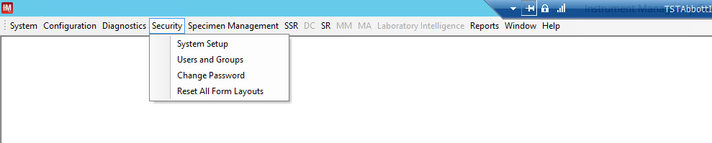

***E. Tool Bar Icons***

1. **Release** 
2. - Releases results that have been held for verification for transmission to host (Epic).
3. **Send to Host**  – Retransmits results to the host (Epic).
4. **Reject result**  - prevents a result from being released to the host.
5. **Cancel** – will cancel a test in IM. Does NOT cancel the test in Epic.
6. **Order New Test**  – Orders the test in IM only. Does **not** order the test in Epic.
7. **Show All Data**  – Displays Specimen Worksheet data, Patient Information, or Test Worksheet information
8. **QC Action Log**  - Allows the user to add corrective action comments to the Unity QC log.
9. **Stop Holding Selected Results**  – Used to stop holding patient results once a QC issue has been resolved. Only used by certain instruments, not all.
10. **Filter** (Funnel)  – allows the user to choose, or “filter” what information is available on a screen.
11. **Verify Run With Cell Counter**   - Allows users to send a hematology result to the cell counter for manual differential or slide review.
12. **Release Run/Reject Other Runs**  - In the Run Workspace, this allows the user to release the selected run while rejecting all other runs at the same time.
13. **Reject Run**  - Allows the to reject a selected run in the run workspace.

**If an icon is grayed out, the user does not have security to use that function, or that function is not available at this time or for this circumstance.

***Section Two – Processing Results***

***I. Processing Results in Specimen Manager***

***A. Test Result Status***

When a user opens an SM Workspace, a variety of patient results may display depending on the “filters”, or options chosen.

1. **Completed tests** results may or may not be displayed at the discretion of the user. They have already been transmitted to Epic.
2. **Pending tests** will be listed if desired. Tests will show up in a workspace as pending when they have been **documented as collected.**  They will not show up until that point. **Checking incomplete worksheets must still be done in Epic.**
3. **Tests Held** are results which need user action. They may be held because of hi and lo flags, delta check failures, QC failures, rerun values, etc.

***B. Releasing Held Tests***

In order to release patient results for a specimen having a result status of **“Tests Held”** in a workspace, perform the following procedure:

1. Click on a Specimen Worksheet row, or a Test Worksheet row within the workspace. This will highlight the row for the selected **sample** or **test.**
2. Right click upon the highlighted row and select *release* from the drop-down menu, or click the *release* icon on the tool bar.
3. When prompted, select “Yes” to release the specimen.
4. Multiple tests may be released simultaneously. Click on the **sample** in the **Specimen Worksheet** to release everything on that sample, or hold the CTRL button down and **select multiple tests** from the **Test Worksheet pane** to release individual tests.
5. Releasing results from the SM workspace causes results to be sent to the host (Epic.)
6. Test Status should go to “Complete” when all results are sent.

***C. Send to Host***

In order to send results to the host from SM Workspace perform the following procedure.

1. Click on a *Specimen Worksheet* or a *Test Worksheet* row within the Specimen Workspace. This will highlight the row for the selected sample or test.
2. Right click on the highlighted row and select *Send to Host* from the pull down menu, or click on the *Send to Host* icon.
3. When prompted, select ***yes*** to *Send to Host* for the specimen.
4. Only results which have already been released can be sent to the host. Most often this option is used to **resend** results to the host because of some transmission failure.

***D. Reject Results***

In order to **reject** results from a workspace, perform the following procedure:

1. Click upon a Test Worksheet row within the workspace.
2. Right click on the highlighted row and select *Reject Results* from the pull-down menu, or click on the *Reject Results* icon from the toolbar.
3. When prompted, select *yes to Reject* *Selected* *Test(s*) for the specimen.
4. It will be necessary to reject a result when there are two results for a test, for example, when Architect has performed a rerun on a critical potassium. Both values cannot be sent to Epic, so the user must choose one value to **reject** and one value to **release.**
5. Results which are neither released nor rejected will remain in the workspace as “Held”. They will “clutter” the workspace until removed.

***E. Cancel Results***

In order to cancel results in a workspace, perform the following procedure:

1. Click on a *Specimen Worksheet* or a *Test Worksheet* row within the workspace. This will highlight the row for the selected sample or test.
2. Right click on the highlighted row and select *Cancel* from the pull down menu, or click on the *Cancel* icon.
3. When prompted, select **Yes** to *Cancel Selected* *Tests* for the specimen.
4. The user may choose to use this option when tests have been cancelled in Epic, when a specimen has been sent for recollect, or in any way is not acceptable for release into Epic. Once a test is cancelled, it cannot be “un-cancelled”. Results are no longer available for transmission.

***F. Release Run/Reject Other Runs***

When working in the Run Workspace, there may be more than one set of results for a specimen. In order to release only one set of results into Epic, the user must use this function to release the results appropriately.

1. Click on a *result* column under the run you want to release. Make sure the header of the run turns blue.
2. Right click on the highlighted run and select *Release Run/Reject Other Runs* from the pull down menu.
3. When prompted, select **Yes**.
4. This will reject the other runs that were not highlighted, and release the run the user selected into Epic.

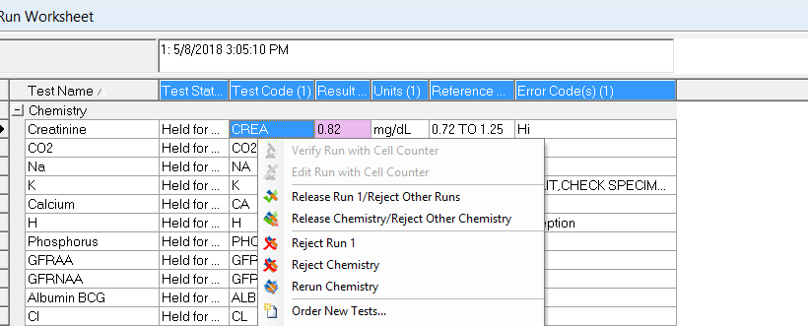

***G. Release Group/Reject Other Group***

Test Codes are grouped according to rules built in Instrument Manager. Users have the ability to release and reject according to groups.

1. Click on a *result* column under the run you want to release. Make sure the header of the run turns blue.
2. Right click on the highlighted run and select *Release Group/Reject Other Groups* from the pull down menu.
3. When prompted, select **Yes**.
4. This will reject the other runs of the same group that were not highlighted, and release the group the user selected into Epic.



***II. Searching for Patients, Results***

1. In the toolbar of the workspace, locate the “Specimen ID” box.



1. Enter your Specimen ID number that you are searching for.
2. Press the “Refresh” button and your specimen ID will be displayed in the workspace.



***III. Using Filters***

When working within Specimen Management workspaces, it is possible for the user to limit, or select, the specimens a user wants to see by using *filters.*

A. Each of the predefined workspaces will have default filters selected. These may be adjusted as needed by the user.

1. To access filters, click on the icon that looks like a funnel.
2. Clicking on the funnel opens a screen with multiple options which can be selected. Checking a box will limit the display to data that fits that criteria.
3. For example, the user may choose to view only specimens that have a specimen completion status of “Tests Held”, and not to view “Pending” or “Completed” specimens. Or the user may select only one “connection”, (one analyzer) to view; or only results with a test error code of Critical. The more boxes selected, the more restricted the data will be.

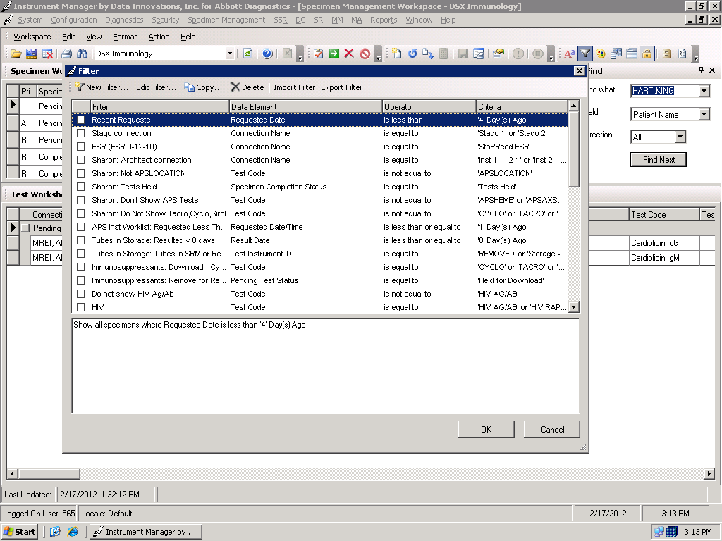

B. When a user signs on, the filters will default to whatever settings the user had chosen before signing off.

**Instrument Manager Workspace Colors**

 Critical Result

 Greater Than Result – Check Dilution Status

 Rejected Result

 Delta Check

 Stat Specimen

 Invalid Order

 Invalid Result (Hemo)

 High Result

 Low Result

 Positive HIV/Hepatitis

 T4 is indicated

 Manual Differential Required

 Call Troponin to floor

 Platelet Clumps

Resetting Instrument Interface Connections in Instrument Manager

1. Log in to Instrument Manager and locate the Status Screen

(System -> Status).

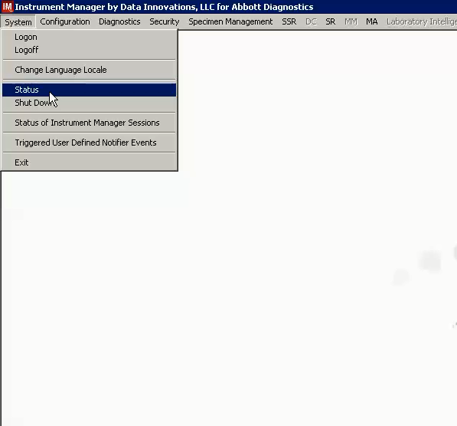

1. On the Status Screen, locate the name of the instrument that is having an issue communicating.

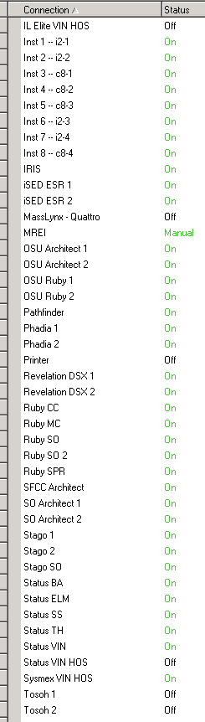

1. Select the instrument and make sure it is highlighted blue.

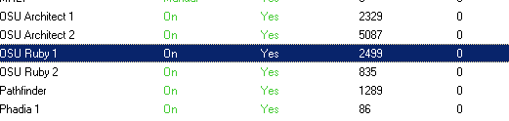

1. With the instrument line highlighted blue, click the button “Stop Selected Connection” located on the top tool bar of the status screen.

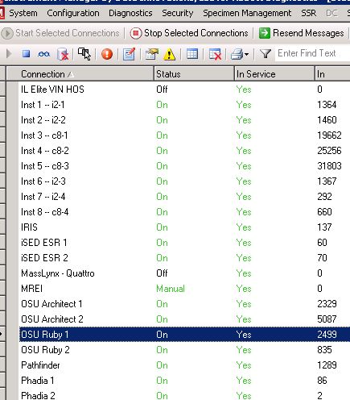

1. When the connection has been stopped, the status will turn to “Off”.

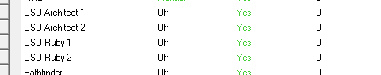

4. Wait 30 seconds after the status changes to “off” and then turn the connection back on by clicking the button “Start Selected Connections” on the top toolbar. Make sure the connection you want to turn on is highlighted.

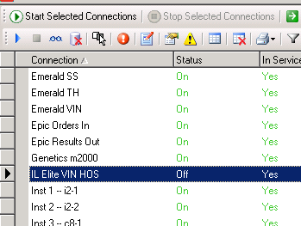

1. If the connection has been successfully reset, the status will change back to “On”. Check the LIS Status on your instruments, they should also show a successful connection (Ruby – blue arrow up, Architect – no yellow triangle on the LIS box).
2. In the event that resetting your connection does not reestablish the IM interface and you are still having connection issues, please contact the Saint Francis Helpdesk 24/7 at 918-494-1486. State that it is an **urgent issue** and you need the Instrument Manager Administrator that is on call paged immediately. IM Admin will contact you within 30 minutes.