|  |
| --- |
| **Department of Veterans Affairs, Lexington, KY Pathology & Laboratory Medicine Service** |
| **Temp Trak Procedure Manual** |
|  |
|  |
|  |
| **4/2/2018** |

|  |
| --- |
| **Temp Trak Procedure Manual**  **Pathology & Laboratory Medicine Service**  **VA Medical Center Lexington, KY** |

|  |  |  |  |  |
| --- | --- | --- | --- | --- |
| **Prepared by:** | Vicki Richardson |  | **Authorized / Approved by:** | David Hunt, MD |
| **Title:** | Bar Code Expansion Coordinator |  | **Title:** | Chief, P&LMS |
| **Date Prepared:** | 1/7/2013 |  | **Date Authorized:** | 1/8/2013 |
| **Date Implemented:** | 1/8/2013 |  |  |  |

|  |  |
| --- | --- |
| **Review Authority:** | Quality Manager  Ancillary Testing Coordinator |
| **Review Authority:** | Chief, Pathology & Laboratory Medicine Service |

|  |  |  |  |  |
| --- | --- | --- | --- | --- |
| **Reviewed**  **(Date)** | ***By*** |  | **Revised**  **(Date)** | ***By*** |
| 1/8/2013 | David Hunt, MD |  | 12/1/2014 | Vicki Richardson |
| 12/1/2014 | David Hunt, MD |  | 8/26/2015 | Vicki Richardson |
| 8/26/2015 | David Hunt, MD |  | 9/19/2017 | Chip Logan(minor revision) |
| 9/22/2017 | David Hunt, MD |  | 4/2/2018 | Chip Logan |
| 12/14/2018 | Dr. Laura Crump, MD |  | 12/18/2018 | Chip Logan |
| 4/2/2018 | Chip Logan |  |  |  |
| 12/18/2018 | Chip Logan |  |  |  |
|  |  |  |  |  |
|  |  |  |  |  |
|  |  |  |  |  |
|  |  |  |  |  |
|  |  |  |  |  |
|  |  |  |  |  |
|  |  |  |  |  |
|  |  |  |  |  |
|  |  |  |  |  |
|  |  |  |  |  |
|  |  |  |  |  |

I Purpose 3

II Responsibilities 3

A. Quality Manager/Ancillary Testing Coordinator 3

B. Engineering Service 3

C. Midwest Medical Equipment/Cooper-Atkins Corporation 4

D. Section Supervisor 4

E. All clinical employees 5

III Procedures 6

A. System Login 6

B. TempTrak’s Dashboard 7

C. Basic Navigation 8

D. Performing the Daily Group Audit 9

E. Transmitter Reading Examples 11

F. Transmitter Information Detail 11

G. Identifying Alert Types 14

H. Notification of temperatures that are out of range 15

I. Responding to Sensor Temperature Alarms (Clearing Alarms) 15

IV. Reports 19

A. Navigating the Report Display 19

B. Various Reports Available 20

C. Printing Reports 23

V NIST Certification 24

VI NIST Calibration 24

A. Initiation appointment 24

B. Cooper-Atkins onsite visit 24

C. Ultra-Low Probe NIST Calibration 24

VII Troubleshooting Assistance 25

A. P&LMS Level 25

B. Facility Level 25

C. Cooper-Atkins Support 25

VIII References 25

ATTACHMENT A 2015 TempTrak Sensors, Probes and Settings 26

# Purpose

Temp Trak is a temperature and humidity monitoring system that uses wireless technology to monitor refrigerators, freezers, incubators and ambient temperatures. It provides 24/7 real-time data to on-site monitors and/or remote PC’s and instantly alerts users when temperatures or humidity is not within a specified range. Thermometric standard devices must be recalibrated, recertified, or replaced prior to the date of expiration of the guarantee of calibration or they are subject to requirements for non-certified thermometers.

# Responsibilities

## Quality Manager/Ancillary Testing Coordinator

1. Ensures that Cooper-Atkins performs NIST certification (recertifies, certifies, calibrates, and/or recalibrates) of the P&LMS TempTrak devices before the annual expiration
2. Engineering Service controls the Cooper-Atkins contract; therefore, the Engineering Service must schedule the annual NIST certification site visit.
3. Notifies Engineering Service approximately 2 months before the annual expiration. The current Engineering Service contact is Robert Clark, Utility System Foreman, ENG.
4. Responsible for the Pathology and Laboratory Medicine Service’s (P&LMS) ability to utilize Temp Trak.
   * 1. This includes maintaining the group profiles, device attributes, alarm profiles, and notification profiles.
5. Liaison between Engineering Service and P&LMS to ensure that Temp Trak functions properly

## Engineering Service

1. Responsible for scheduling the Cooper-Atkins annual NIST certification site visit
2. Responsible for ordering TempTrak parts and devices
3. Responsible for the maintenance and troubleshooting of Temp Trak
4. Responsible for installing new NIST certified TempTrak devices as needed –
5. All TempTrak devices installed in the P&LMS Service must be NIST certified and a current NIST certificate must be provided upon installation.
6. Responsible for replacing TempTrak devices if they become inoperable
7. Responsible for providing the “Standard Certificate of Calibration” when a new TempTrak device is installed
8. Engineering Service must send the ultra-low probes (long wires inside of metal conduit) off site for NIST calibration

## Midwest Medical Equipment/Cooper-Atkins Corporation

1. Responsible for calibrating, recalibrating, certifying or recertifying the sensor and probe devices prior to the date of NIST certification expiration.
2. Responsible for providing a “Standard Certificate of Calibration” for new devices
   1. The “Standard Certificate of Calibration” contains
      1. the date of the device’s NIST calibration
      2. the model # of equipment calibrated
      3. the serial # of equipment calibrated
3. Responsible for providing a “Certificate of Calibration” for re-used devices
   1. The “Certificate of Calibration” is provided during the calibrating, recalibrating, certifying or recertifying annual NIST site visit.
   2. The “Certificate of Calibration” contains
      1. calibration information
      2. instrument identification
      3. reference standards and/or measurement equipment used during the calibration
      4. calibration data
      5. certification of calibration
4. Responsible for evaluating the TempTrak devices for damage during the site visit
5. Responsible for replacing TempTrak devices if they have obvious damage during the site visit
6. Responsible for replacing TempTrak devices if they fail recalibration or recertification during the site visit

## Section Supervisor

1. Responsible for ensuring adequate TempTrak training for clinical employees
2. Responsible for defining acceptable temperature ranges for all P&LMS temperature dependent equipment
3. Responsible for monitoring temperature and/or humidity of all P&LMS temperature dependent equipment
4. Responsible for utilizing Temp Trak as intended per CAP, JC and VHA regulations
5. Responsible for entering work orders for refrigerator, freezer or incubator troubleshooting as indicated by Temp Trak sensor readings
6. Responsible for clearing alarms, providing and documenting appropriate corrective actions for temperatures that are out of acceptable range. If acceptable temperature ranges for refrigerators and/or freezers are exceeded, reagents, controls, calibrators, etc. must be evaluated for possible adverse effects, with documentation of results
7. Responsible for reviewing documentation of appropriate corrective actions, supervisor notification and documentation of results of any possible adverse effects.
8. Responsible for calibrating back up thermometers yearly with the Temp Trak system.

## All clinical employees

1. Responsible for daily documentation of the functionality of the Temp Trak system
2. Responsible for monitoring temperature and/or humidity of all P&LMS temperature dependent equipment
3. Responsible for clearing alarms, providing and documenting appropriate corrective actions for temperatures that are out of acceptable range utilizing Temp Trak software. If acceptable temperature ranges for refrigerators and/or freezers are exceeded, reagents, controls, calibrators, etc. must be evaluated for possible adverse effects, with documentation of results.
4. Responsible for notification and documentation of notification of supervisor when temperatures exceed the acceptable range and the corrective action performed.

The Temp Trak monitoring system is used for refrigerators, freezers, incubators and ambient temperatures. If the Temp Trak system fails, backup thermometers that are verified with a NIST certified thermometer will be used until the Temp Trak system is back in service. Temperature charts will be recorded daily.

# Procedures

## System Login

1. Temp Trak’s System Login screen can be accessed by:
2. Open Internet Explorer
3. Type in the following internet address: http://vhalexapp05/TempTrak/Login.aspx
4. The login screen appears
5. Type in your Login ID
6. Type in your Password

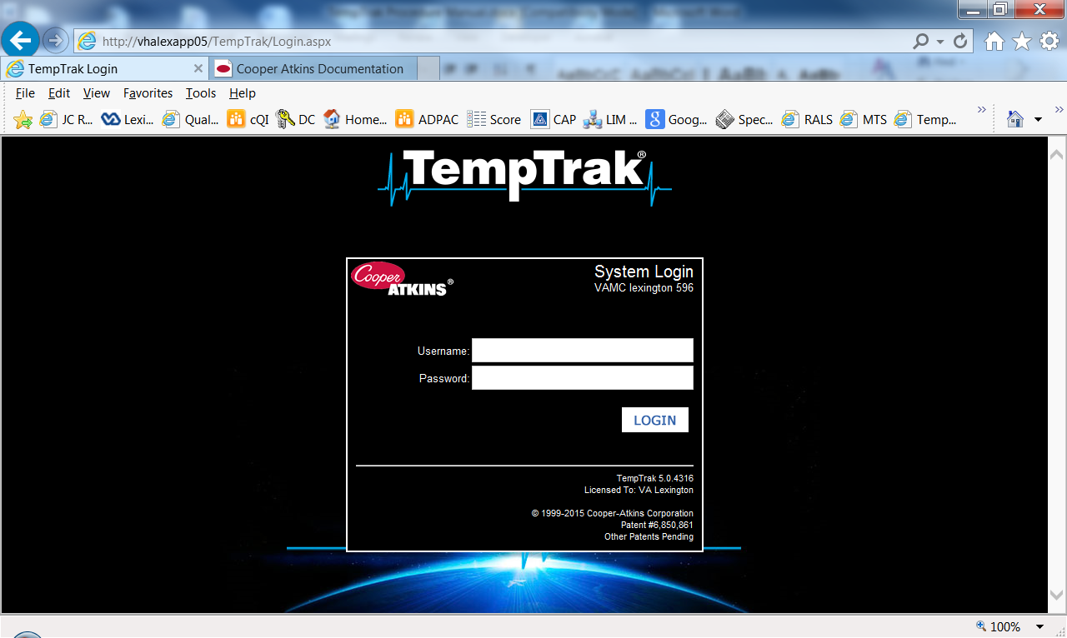

## TempTrak’s Dashboard

TempTrak uses a dashboard layout for the default home page. The dashboard is configurable allowing users to customize their experience depending on what information they need to monitor.

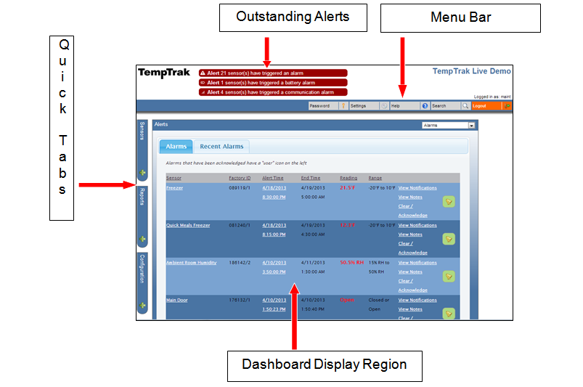

## Basic Navigation

1. TempTrak Logo



Clicking on TempTrak logo takes you to Dashboard home page.

1. Outstanding Alerts

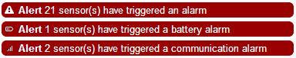

Clicking on one of the blinking Alerts will take you to the corresponding alarm page (Alerts, Battery, and Communication)

1. Menu Bar

r



The top menu provides the ability to change your password, modify user settings, obtain page help, and search for a sensor or group, and logout of TempTrak.

1. Quick Tabs



The Sensors and Reports tabs on the left open a scrolling menu with additional options corresponding to the tab name. Depending on user security and access rights, one or more tabs may not appear.

Performing the Daily Group Audit

1. Group audits must be performed daily on each TempTrak sensor and probe in the laboratory.
2. Daily group audits can be performed by each section (P&LMS Chemistry and Hematology, P&LMS Cytology, etc.) or all together as a whole service (P&LMS). Routine daily group audits are to be performed by each section in the laboratory.
3. After the user logs into TempTrak, a screen with each section’s sensors is displayed. If not, select your group of sensors from the “Sensors” tab (circled in screen shot picture below) on the left of the screen. The Groups are displayed in **bold lettering** (underlined in screen shot picture below) at the top of a list of its sensors.

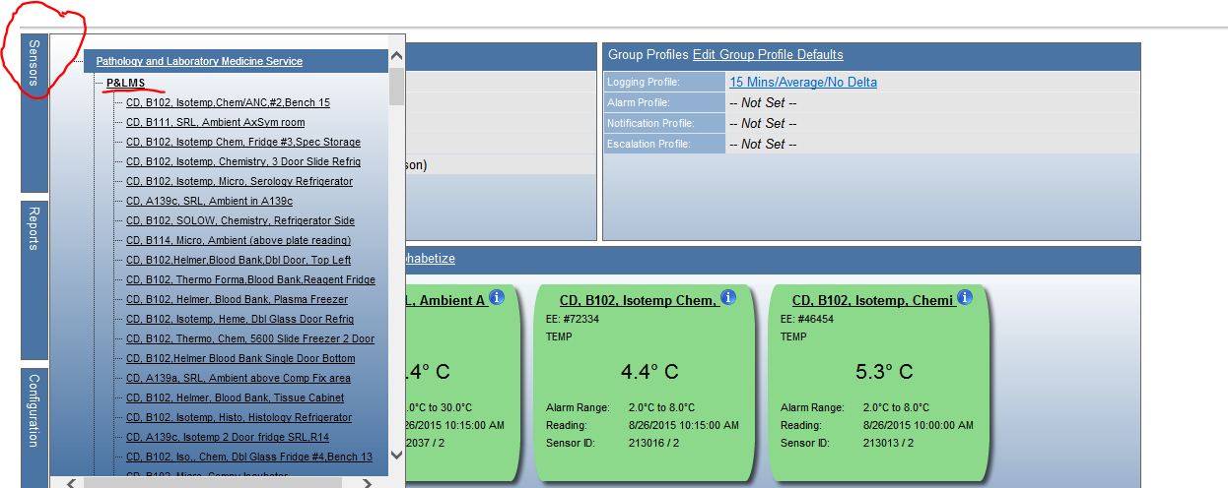

1. After getting the appropriate group up on your screen, select “Group Audit” (circled in screen shot picture below) from the top left of your screen

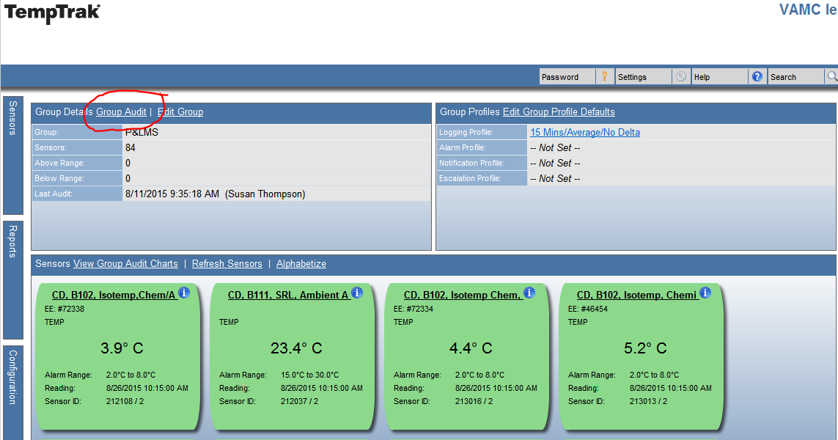

1. When the “Group Audit” screen appears, click inside the comments box and type your daily audit comment.
   1. The audit comment should indicate a statement indicating the status of your section’s device temperatures. If all are acceptable and within the specified range, type it in the comments section. If something is not acceptable, it is important to comment on the device that is not in range and the corrective action initiated. It is also important to indicate that everything else is okay.
   2. The date of the audit must be recorded.
   3. The initials of the auditor must be recorded.
   4. Click on the “Save” button to save your comments.

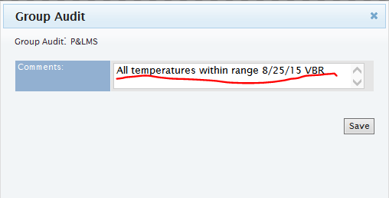

## Transmitter Reading Examples

TempTrak can monitor a wide variety of equipment, with each piece of equipment characterized by a color coded box: green, red, or blue. Each box displays information about how the equipment is currently running and configured in TempTrak.

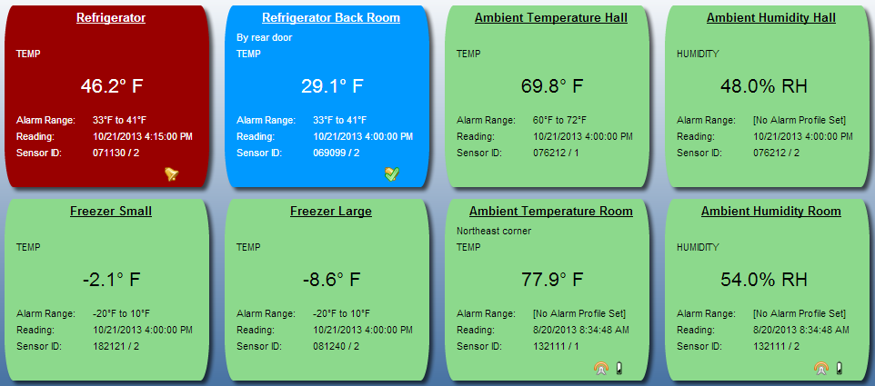

## Transmitter Information Detail

Each transmitter contains a wealth of detail information allowing the user to quickly identify and understand the current state of the equipment being monitored.

Transmitter Name

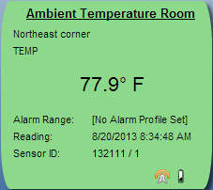

Reading Type

Valid Reading Range

Sensor ID

Description Current Current Reading

Last Recorded Date/Time

Alarms/Conditions

1. **Sensor Conditions** To quickly identify a piece of equipment’s current condition, TempTrak uses a coloring system based on three colors: green, red, and blue.
2. 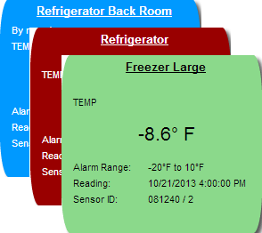**Green** = Unit is reading in range
3. **Red** = Unit is reading out of range

and exceeding maximum range

setting or too warm

1. **Blue** = Unit is reading out of range

and exceeding minimum range

settings or too cold

Equipment in an alert state will be either blue (too cold) or red (too warm). A small bell will appear in the lower right corner of the colored box.

1. **Unit Currently In Alert**

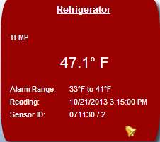

The unit has been out of range longer than the predefined time limit set for the transmitter. It has gone into alert mode and generated a notification to alert. An alarm bell will appear in the lower right corner.

1. **Red** = Unit’s reading are exceeding maximum range setting
2. **Blue** = Unit’s reading are exceeding minimum range setting
3. **Unit Alert Acknowledged**

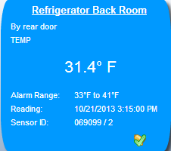

The unit is currently out of range and the generated alert has been acknowledged, but not cleared. A bell with a check mark will appear in the lower right corner.

The checked bell will disappear once the alert has been cleared.

1. **Unit Out Of Range But Not Alarming**

The unit is currently out of range but has not generated an alert due to the unit not exceeding the assigned delay factor.

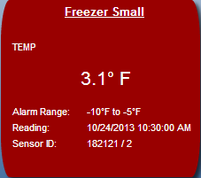

The delay factor establishes a time delay where an alarm has not been generated, but the unit has exceeded its valid operating range. Once the time delay has been exceeded, an alarm will be generated.

1. **Sensor Alarms/Conditions Icons**

There are three alarm conditions that can affect equipment: Exception (out of valid range – too hot/high or too cold/low), Low Battery, and Communication. These icons will display in the lower right corner of the colored box.



Each transmitter can have three alarms associated with it at any given time. When one of the icons is selected, it will open the corresponding alert page. This information will be covered in a subsequent document.



Exception Alarm Low Battery Alert

Communication Alert

## Identifying Alert Types

There are three alert types in TempTrak: Sensor Alarm, Battery Alarm, and Communication Alarm. Anytime an alarm is generated by one of the three alert types, a red blinking alert indicator appears at the top of the screen.

* 1. Sensor Alarms



Sensor Alarms provide current information on outstanding alarms and recently cleared alarms. This provides a quick overview of any immediate alert issues that need to be addressed as well as those alarms that have recently been cleared.

* 1. Battery Alarms



Battery Alarms appear when the battery on a transmitter is close to being drained. If a battery alert is generated for a 900 MHz or Wi-Fi transmitter, you will have roughly two weeks before the battery is drained. When the batteries are replaced, the sensor’s battery alarm will be automatically cleared.

* 1. Communication Alarms



Communication Alarms are indicated by a wireless symbol and appear when sensor is not communicating with the TempTrak application for roughly 45 minutes. When a sensor starts communicating again, the sensor’s communication alarm will automatically be cleared.

## Notification of temperatures that are out of range

The Lexington P&LMS TempTrak has been configured to alert appropriate personnel via email notification and remote popup notification. When a temperature is out of range, TempTrak will log it once at the logging interval (determined by the section supervisor or lead technologist) without alarming. If the temperature is still out of range for the second consecutive logging interval, TempTrak will alarm and notify appropriate personnel. If the alarm has not been cleared by the third consecutive logging interval, an **Escalation Notification** will be initiated.

1. TempTrak will send an email notification alert via Microsoft Outlook. In order for an individual to receive this notification, the Microsoft Outlook program must be open. An example of email notification:

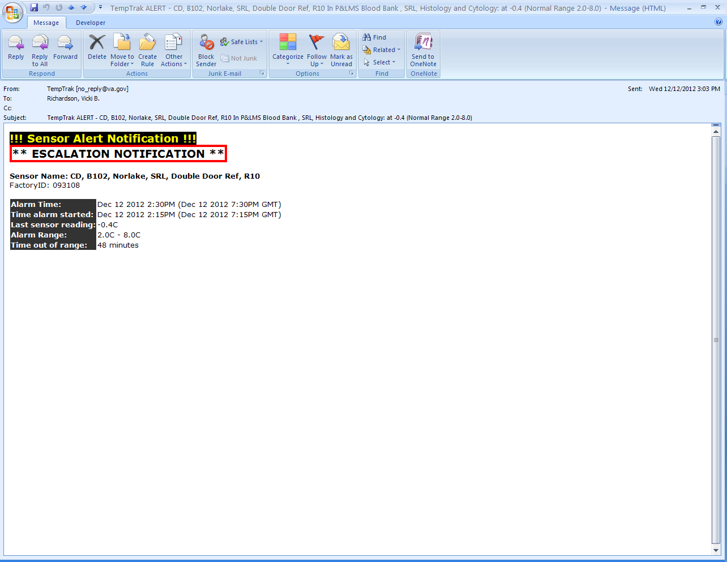

1. TempTrak will initiate a remote popup notification in addition to the email notification. Here is an example of the remote popup notification. This popup comes up on each pertinent PC in the laboratory depending upon the alarming device’s location.



1. If the alarm has not been cleared within 30 minutes, an Escalation Notification will be initiated. The Escalation Notification notifies the P&LMS management personnel, the electric shop, the Chief of Engineering, and the AOD.

## Responding to Sensor Temperature Alarms (Clearing Alarms)

1. After having logged into TempTrak, if you see the following blinking alarm indicator, there are one or more sensors that have triggered a temperature alarm.



1. Click on the blinking sensor alarm indicator to bring up the Alarms page displaying all outstanding alarms and any recently cleared alarms.

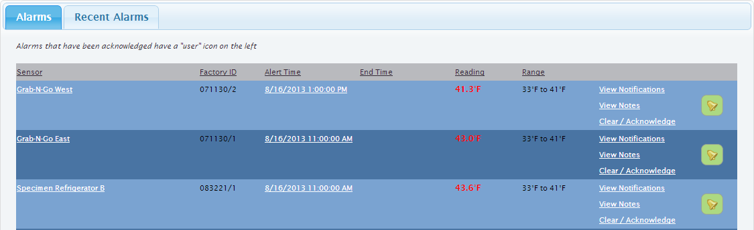

1. Locate the sensor you want to address from the list of sensors that are in an alarm status. Click “Clear / Acknowledge”. The Clear/Acknowledge Alarm page will appear.

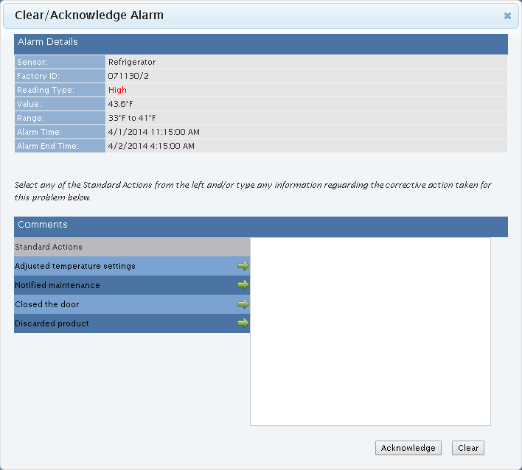

1. Here you will be able to document the corrective action (standard actions or custom entered text) to resolve the alarm.
2. There are two sections: Alarm Details and Comments. At the top of the alarm window is the alarm details, providing information about what sensor is in an alarm status to whether it was above or below range to when the alarm finally ended (returned to a valid reading).

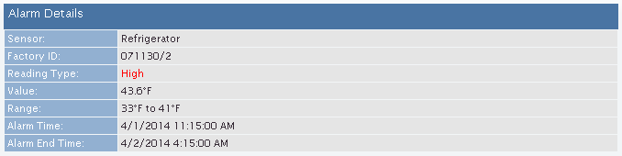

1. The bottom section is where you add any comments or standard actions (actions set up by your administrator). Each standard action has a green arrow to the right. Clicking on the green arrow places that standard action in the comment field to the right. If you need to add additional notes, you can click inside the comment field and type the additional information.

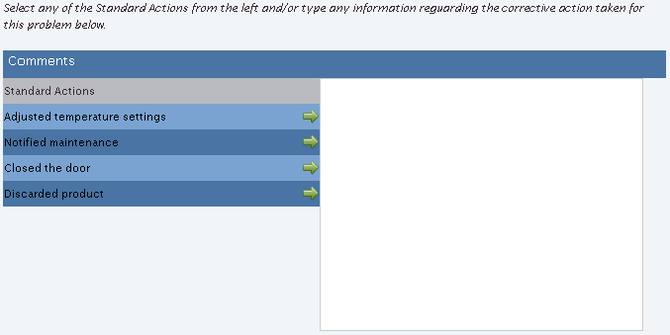

1. After you have entered your comments or corrective action, record your initials and date.
2. At this point, you are presented with two options, acknowledging an alarm or clearing an alarm.
   1. **Acknowledge an Alarm**



If you cannot address the alarm yourself and need to get other’s involved, you should acknowledge the alarm. When you perform this action, you will be adding the comments you either selected from the standard actions or wrote in to the alarm (multiple corrective actions may be selected). From this point, TempTrak will assume the alarm is being handled and will not generate any further alarms.

***Note: When an alert is generated for a transmitter (sensor), no further alert notifications will be sent out for that transmitter (sensor) unless an escalation profile has been created and attached to the transmitter (sensor), or if the alert has been cleared for that transmitter (sensor).***

* 1. **Clearing an Alarm**



If you can address the alarm yourself, you should clear the alarm. Clearing the alarm states that the issue has been addressed and everything is working correctly. If the sensor goes out of range, then a new alarm will be generated.

# Reports

## Navigating the Report Display

* 1. The HEADER tells the user the name of the report
  2. The REPORT CONTENT is the e report content requested
  3. The FOOTER gives the report period dates and the date the user ran the report.
  4. Notice the bar at the top of the report.
     1. Use the blue arrows to navigate through the pages of the report.
     2. Click on the  to save the report in Excel, Word, PDF, TIFF file, etc.
     3. Click on the  to refresh the report.
     4. Click on the  to print the report (see IV C. for further print instructions)



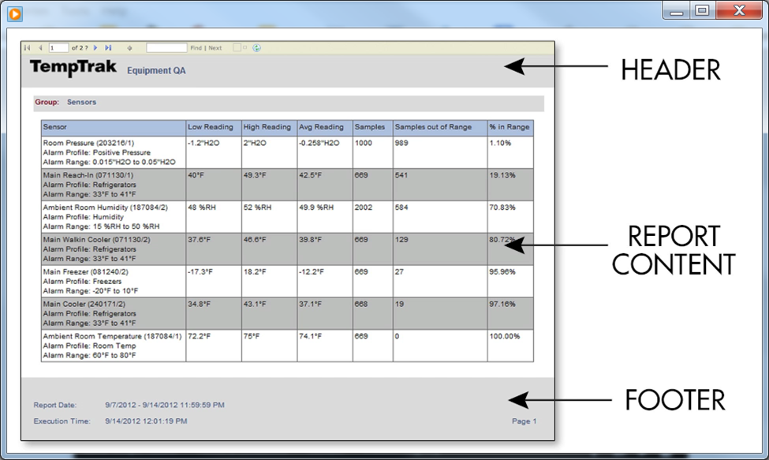

## Various Reports Available

1. Daily Sensor Summary

This report displays an average reading for the selected groups for a 2hr, 12hr, or 24hr period

1. Sensor History

This report displays a graphical chart and every reading from the one selected sensor. The report selection period can range from one day to one year.

* + 1. Select sensor
    2. Scroll down a little bit to find the report selection period.
    3. Specify date range
    4. Select “Run”

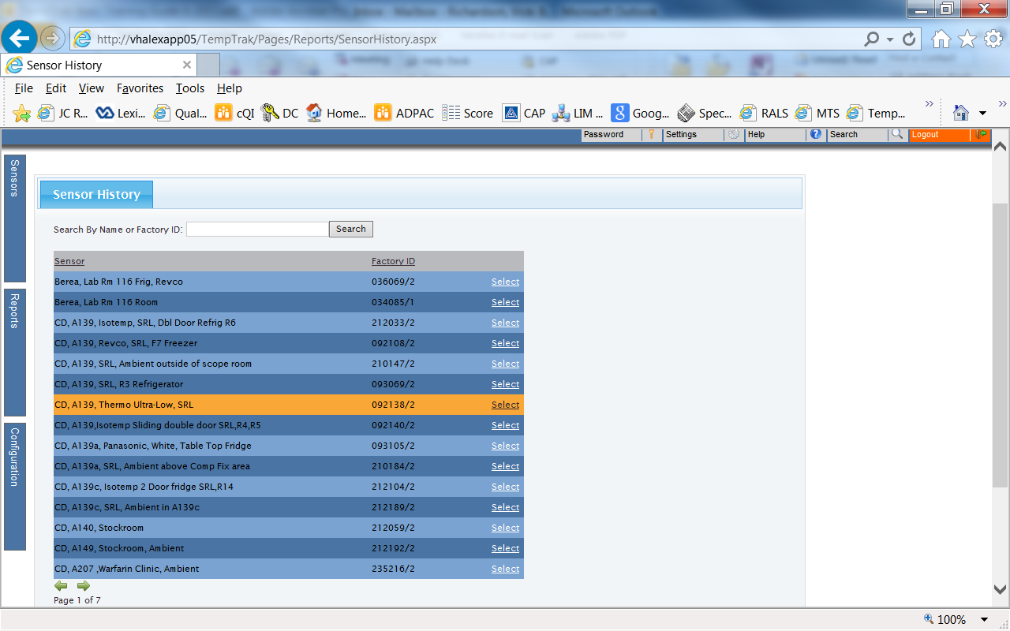

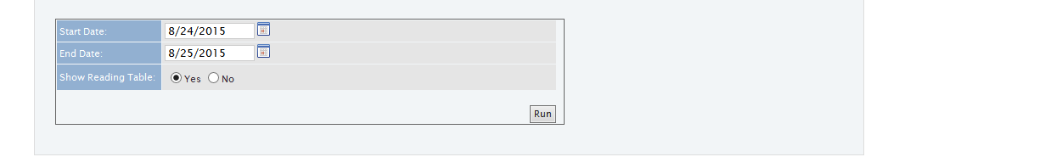

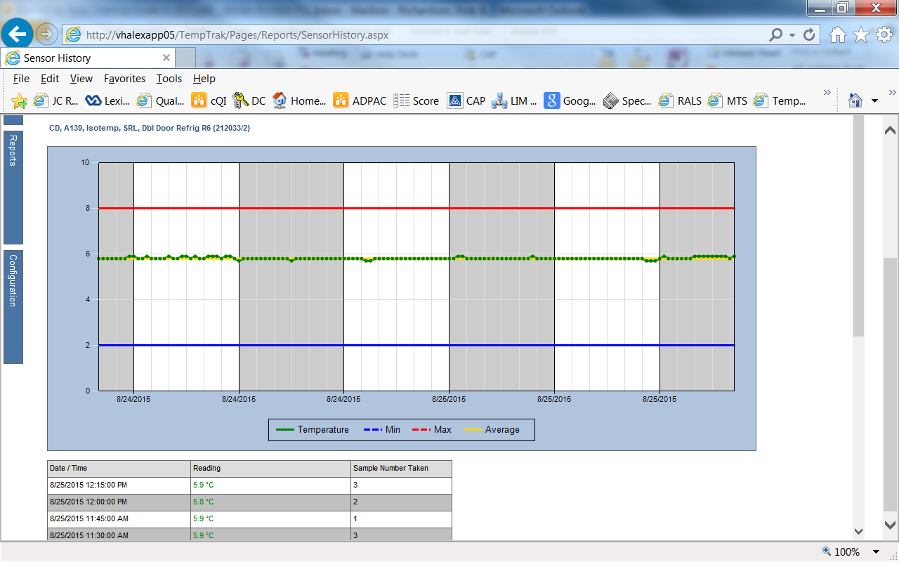

1. Sensor Alarm Report

This report displays all Alarms, Notes and Audits on one selected sensor for the given reporting period. The report selection period can range from one day to one year.

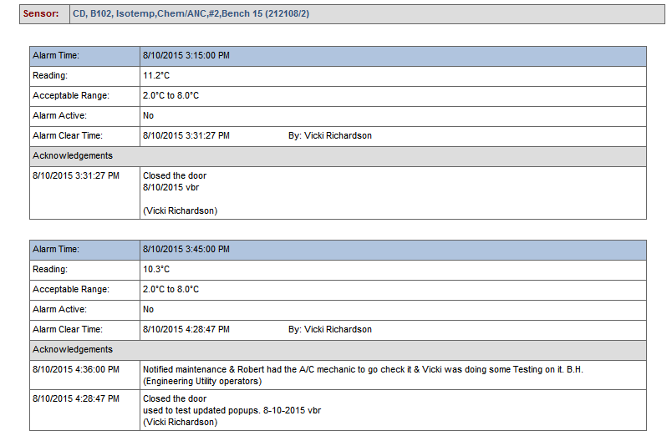

1. Alerts By Day

This report displays all Alarms for all sensors based on the group(s) selected. The report selection period can range from one day to one year.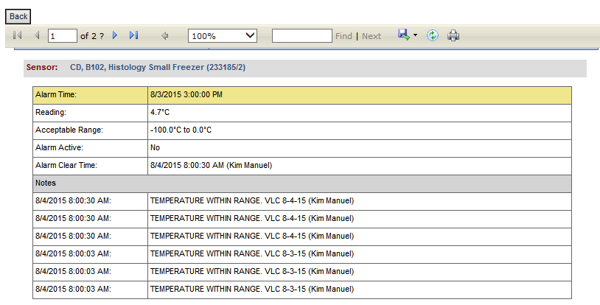

1. Sensor Audit Report

This report can display multiple sensor audits by users, groups, or sensors. The report selection period can range from one day to one year.

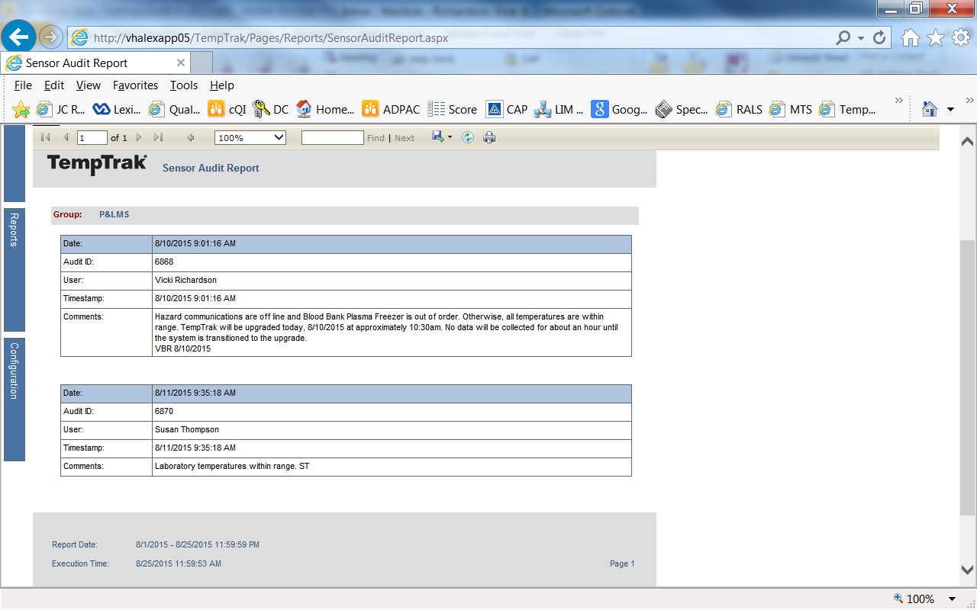

1. Equipment QA

This report displays a group based summary of the Low Reading, High Reading, Average Reading, and number of Samples out of Range. The report selection start and end date can be manually selected by using the calendar picker or typing the desired dates into the start and end date fields.

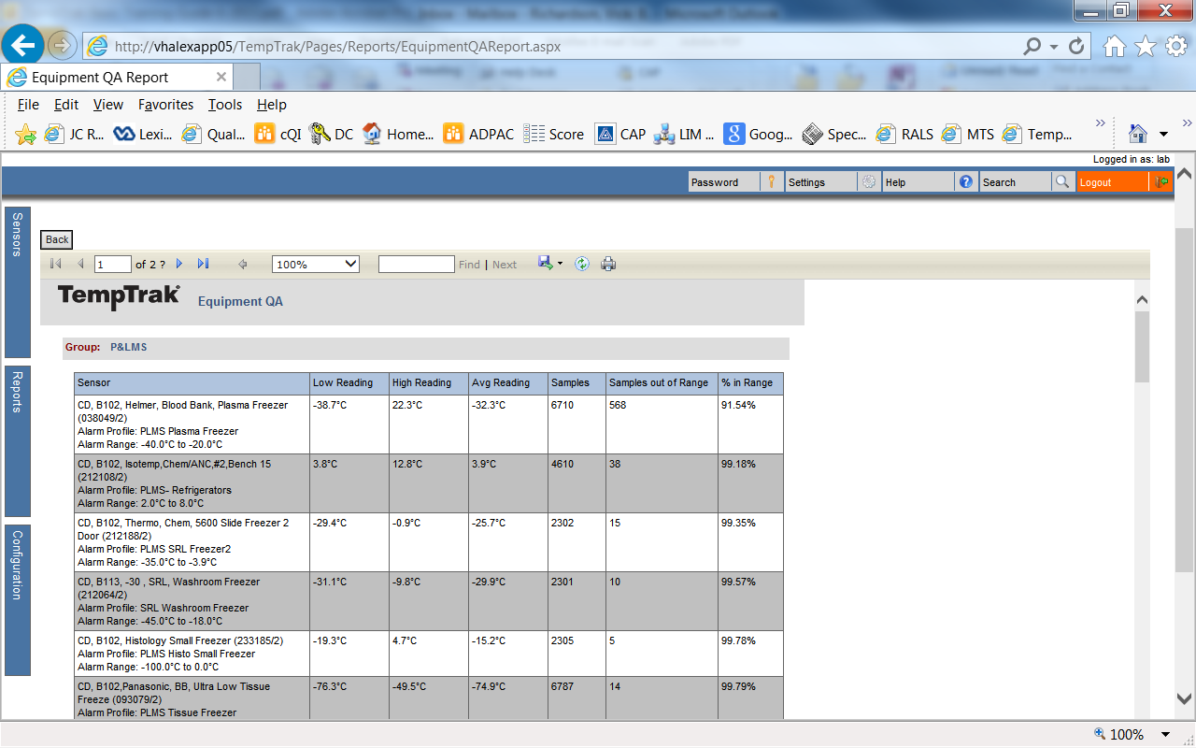

## Printing Reports

* 1. You will not be able to print reports directly from TempTrak. When the report is queued to print, this window will pop up. Repeated attempts to enter credentials will not help.

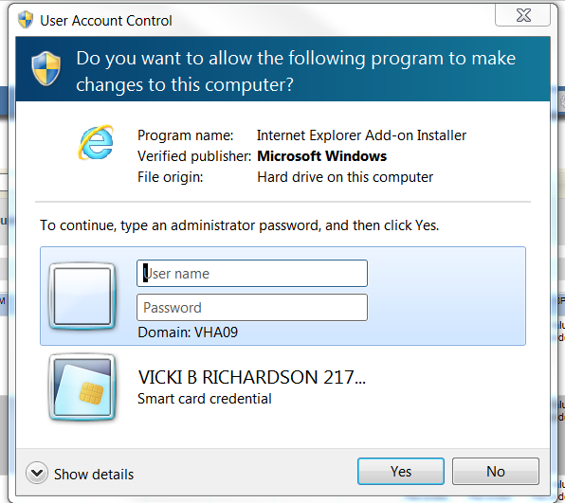

* 1. To print the selected report, the report must be saved to the computer and then printed from the saved document.
     1. Click on the  to save the report in Excel, Word, PDF, TIFF file, etc.
     2. Open the saved document and then print as any other document.

# NIST Certification

All TempTrak devices installed in the P&LMS Service must be NIST certified and a current NIST certificate must be provided upon installation.

# NIST Calibration

Thermometric standard devices must be recalibrated, recertified, or replaced prior to the date of expiration of the guarantee of calibration or they are subject to requirements for non-certified thermometers.

## Initiation appointment

The Quality Manager will contact Cooper-Atkins annually to set up an on-site NIST calibration of all of our temperature monitors and probes (except ultra low monitors).

## Cooper-Atkins onsite visit

1. A Cooper-Atkins representative will arrive onsite and perform the NIST calibrations over a period of about 3 days.
2. The Cooper-Atkins representative will replace all of the batteries in each monitoring device.
3. Upon completion of the NIST calibrations, the Cooper-Atkins representative will provide a certificate of calibrations for each monitoring device except the ultra-low probes.
4. The certificates of calibrations will be kept in a binder labeled “TempTrak Calibration Certificates” in the Quality Manager’s Coordinator’s office.

## Ultra-Low Probe NIST Calibration

1. Engineering Service must send the ultra-low probes (long wires inside of metal conduit) off site for NIST calibration to the following address:

NIST recalibration for RH and Temp sides

33 Reeds Gap Road

Middlefield, CT 06455

# Troubleshooting Assistance

## P&LMS Level

1. Quality Manager
2. Ancillary Testing Coordinator

## Facility Level

The persons listed below are your local contacts if you have questions or experience problems when using the Intelli-Ware system.

|  |  |  |
| --- | --- | --- |
| Name | Phone Number | Email Address |
| Michael M. Young/Eng Svc | 859-281-3850 | michael.young7@va.gov |
| Allen Rogers/Eng Svc M&O Super CD | x4340 | Allen.Rogers@va.gov |
| Ricky Steele/Eng Svc M&O Super LD | x3378 | ricky.steele@va.gov |
| Steven Curry/Asst. Chief, Eng Svc | x3350 or 859-494-6287 | steven.curry3@va.gov |
|  | | |

## 

## 

## Cooper-Atkins Support

1. Cooper-Atkins Support Contact Information:  
   [I-Care@Cooper-Atkins.com](mailto:I-Care@cooper-atkins.com?subject=Intelli%2DWare%20Support%20Request%3A%20VAMC%20lexington%20596) (Technical support questions)
2. [Click Here For **TempTrak® Training Videos - Version 5.0**](http://www.cooper-atkins.com/Support_TechnicalSupport.htm#Wireless)

<http://www.cooper-atkins.com/support.asp>

1. Phone: (888) 533-6900 x2

(513)-793-5366

**Business Hours:** Mon-Fri 8am-8pm EST

Closed Sat-Sun

# References

1. Temp Trak Basic Training Guide, Revision A, 2014 Cooper-Atkins Corporation
2. TempTrak Training Videos – Version 5.0

<http://www.cooper-atkins.com/support.asp>

# 

# ATTACHMENT A 2015 TempTrak Sensors, Probes and Settings

|  |  |  |  |  |  |  |  |  |
| --- | --- | --- | --- | --- | --- | --- | --- | --- |
| **Sensor** | **Description** | **Sensor ID** | **Type** | **Logging Profile** | **Alarm Profile** | **Notification Profile** | **Escalation Profile** | **In Use** |
| Berea, Lab Rm 116 Room | Lab Rm Temp by Refrigerator | 034085/1 | TEMP | Berea CBOC: 15 Mins/Average/No Delta | PC - Room Temps | Berea CBOC: PCS - Primary Care | P&LMS ATC | Yes |
| Berea, Lab Rm 116 Freezer, Revco | EE71901 | 034085 / 2 | TEMP | Berea CBOC: 15 Mins/Average/No Delta | CBOC Freezers | Berea CBOC: PCS - Primary Care | P&LMS ATC | Yes |
| ~~NULL~~ | ~~NULL~~ | ~~075254/1~~ | ~~TEMP~~ | ~~15 Mins/Average/No Delta~~ | ~~PLMS- Refrigerators~~ | ~~--Blank Group Default--~~ | ~~Lex Eng Temp Trak~~ | ~~No~~ |
| ~~BLDG 1, RM 026, FREEZER~~ | ~~EE: #48203~~ | ~~076075/1~~ | ~~TEMP~~ | ~~15 Mins/Average/No Delta~~ | ~~PLMS Phlebotomy Freezer~~ | ~~--Blank Group Default--~~ | ~~--Blank Group Default--~~ | ~~No~~ |
| ~~NEW Internal TEMP SENSOR 88-119/I~~ | ~~NULL~~ | ~~088119/1~~ | ~~TEMP~~ | ~~P&LMS: 15 Mins/Average/No Delta~~ | ~~--Blank Group Default--~~ | ~~--Blank Group Default--~~ | ~~--Blank Group Default--~~ | ~~No~~ |
| ~~NEW Internal TEMP SENSOR 88-128/I~~ | ~~NULL~~ | ~~088128/1~~ | ~~TEMP~~ | ~~P&LMS: 15 Mins/Average/No Delta~~ | ~~--Blank Group Default--~~ | ~~--Blank Group Default--~~ | ~~--Blank Group Default--~~ | ~~No~~ |
| ~~CD, B102, Histology Vacuum Oven~~ | ~~EE: #49552~~ | ~~092107/1~~ | ~~TEMP~~ | ~~15 Mins/Average/No Delta~~ | ~~NULL~~ | ~~--Blank Group Default--~~ | ~~--Blank Group Default--~~ | ~~No~~ |
| ~~NEW Internal TEMP SENSOR 217-53/I~~ | ~~NULL~~ | ~~217053/1~~ | ~~TEMP~~ | ~~P&LMS: 15 Mins/Average/No Delta~~ | ~~--Blank Group Default--~~ | ~~--Blank Group Default--~~ | ~~--Blank Group Default--~~ | ~~No~~ |
| Hazard, Lab Rm 105 Freezer | EE# 71903 | 129022/2 | TEMP | Hazard CBOC: 15 Mins/Average/No Delta | CBOC Freezers | Hazard CBOC: PCS - Primary Care | P&LMS ATC | Yes |
| Hazard, Lab Rm 105, Refrigerator Temp | EE # 71903 | 141227/2 | TEMP | Hazard CBOC: 15 Mins/Average/No Delta | PLMS- Refrigerators | Hazard CBOC: PCS - Primary Care | P&LMS ATC | Yes |
| Hazard, Lab Rm 105, Room Temperature | Ambient | 183038/1 | TEMP | Hazard CBOC: 15 Mins/Average/No Delta | PC - Room Temps | Hazard CBOC: PCS - Primary Care | P&LMS ATC | Yes |
| Morehead, Lab Rm 138 Freezer | EE# 71896, Thermo Scientific, Sensor 34-184 | 034184/2 | TEMP | Morehead CBOC: 15 Mins/Average/No Delta | CBOC Freezers | Morehead CBOC: PCS - Primary Care | P&LMS ATC | Yes |

|  |  |  |  |  |  |  |  |  |
| --- | --- | --- | --- | --- | --- | --- | --- | --- |
| **Sensor** | **Description** | **Sensor ID** | **Type** | **Logging Profile** | **Alarm Profile** | **Notification Profile** | **Escalation Profile** | **In Use** |
| Morehead, Lab Rm 138 Refrigerator | EE# 71896, Thermo Scientific, Sensor 92-46/E | 092046/2 | TEMP | Morehead CBOC: 15 Mins/Average/No Delta | PLMS- Refrigerators | Morehead CBOC: PCS - Primary Care | P&LMS ATC | Yes |
| Morehead, Lab Rm 138 TEMP | Ambient | 182158/1 | TEMP | Morehead CBOC: 15 Mins/Average/No Delta | PLMS - Room Temps | Morehead CBOC: PCS - Primary Care | P&LMS ATC | Yes |
| CD, A624, Blood Bank, OR Refrigerator | EE: #31367 | 093087/2 | TEMP | 5 mins/Average/No Delta/Every Packet | Blood Bank Refrigerators | OR BB Refrigerator | P&LMS OR BB Refrigerator | Yes |
| CD, B102,Helmer,Blood Bank, Dbl Door, Bottom Right | EE: #68273 | 021128/2 | TEMP | 5 mins/Average/No Delta/Every Packet | Blood Bank Refrigerators | P&LMS Blood Bank | P&LMS | Yes |
| CD, B102, Forma, Blood Bank, Water Bath | EE: #37044 | 034082/2 | TEMP | 5 mins/Average/No Delta/Every Packet | PLMS Water Bath | P&LMS Blood Bank | P&LMS | Yes |
| CD, B102, Helmer, Blood Bank, Plasma Freezer | EE: #54496 | 038049/2 | TEMP | 5 mins/Average/No Delta/Every Packet | PLMS Plasma Freezer | P&LMS Blood Bank | P&LMS | Yes |
| CD, B102, RT Tissue Drawer, Blood Bank, Ambient | Ambient | 088128/2 | TEMP | 5 mins/Average/No Delta/Every Packet | PLMS Cabinets | P&LMS Blood Bank | P&LMS | Yes |
| CD, B102, Helmer, Blood Bank, Platelet Cabinet | EE: #71164 | 090030/2 | TEMP | 5 mins/Average/No Delta/Every Packet | PLMS Cabinets | P&LMS Blood Bank | P&LMS | Yes |
| CD, B102,Panasonic, BB, Ultra Low Tissue Freeze | Ultra-Low EE: #69859 | 093079/2 | TEMP | 5 mins/Average/No Delta/Every Packet | PLMS Tissue Freezer | P&LMS Blood Bank | P&LMS | Yes |
| **Sensor** | **Description** | **Sensor ID** | **Type** | **Logging Profile** | **Alarm Profile** | **Notification Profile** | **Escalation Profile** | **In Use** |
| CD, B102, Helmer Blood Bank Refrigerator, Reagent Refrigerator | EE: #81544 | 21219312 | TEMP | 5  mins/Average/No Delta/Every Packet | Blood Bank Refrigerators | P&LMS Blood Bank | P&LMS | Yes |
| CD, B102 Room Temperature Gel Cabinet, Blood Bank, Ambient | Ambient | 1272042 | TEMP | 5  mins/Average/No Delta/Every Packet | Cabinet | P&LMS Blood Bank | P&LMS | Yes |
| CD,B102, Helmer Blood Bank Single Door Top | EE: #72202 | 119064/2 | TEMP | 5 mins/Average/No Delta/Every Packet | Blood Bank Refrigerators | P&LMS Blood Bank | P&LMS | Yes |
| CD, B102,Helmer,Blood Bank,Dbl Door Bottom Left | EE: #68273 | 209225/2 | TEMP | 5 mins/Average/No Delta/Every Packet | Blood Bank Refrigerators | P&LMS Blood Bank | P&LMS | Yes |
| CD, B102,Helmer,Blood Bank,Dbl Door, Top Left | EE: #68273 | 212038/2 | TEMP | 5 mins/Average/No Delta/Every Packet | Blood Bank Refrigerators | P&LMS Blood Bank | P&LMS | Yes |
| CD, B102, Helmer, Blood Bank, Tissue Cabinet | EE: #44240 | 212068/2 | TEMP | 5 mins/Average/No Delta/Every Packet | PLMS Cabinets | P&LMS Blood Bank | P&LMS | Yes |
| CD, B102,Helmer Blood Bank Single Door Bottom | EE: #72202 | 212072/2 | TEMP | 5 mins/Average/No Delta/Every Packet | Blood Bank Refrigerators | P&LMS Blood Bank | P&LMS | Yes |
| ~~CD, B102, Thermo Forma,Blood Bank,Reagent Fridge~~ | ~~EE: #39996~~ | ~~212193/2~~ | ~~TEMP~~ | ~~5 mins/Average/No Delta/Every Packet~~ | ~~PLMS BB Refrigerators 2~~ | ~~P&LMS Blood Bank~~ | ~~P&LMS~~ | ~~Yes~~ |
| CD, B102,Helmer,Blood Bank,Dbl Door, Top Right | EE: #68273 | 214183/2 | TEMP | 5 mins/Average/No Delta/Every Packet | Blood Bank Refrigerators | P&LMS Blood Bank | P&LMS | Yes |
| CD, B102, REVCO, Chem, Freezer,Bench 13 | EE: #71035 | 008216/2 | TEMP | 15 Mins/Average/No Delta | PLMS - Freezer | P&LMS Chem and Heme | P&LMS | Yes |
| CD, B102, Thermo, Chem, Refrig,Outside of B105 | EE: #71080 | 088119/2 | TEMP | 15 Mins/Average/No Delta | PLMS- Refrigerators | P&LMS Chem and Heme | P&LMS | Yes |
| ~~CD, B102, Chemistry, Big Blue Chest Frz~~ | ~~Ultra Low - EE: #7813~~ | ~~092040/2~~ | ~~TEMP~~ | ~~1Hr/Average/No Delta~~ | ~~PLMS - Freezer~~ | ~~P&LMS Chem and Heme~~ | ~~P&LMS~~ | ~~No~~ |
| **Sensor** | **Description** | **Sensor ID** | **Type** | **Logging Profile** | **Alarm Profile** | **Notification Profile** | **Escalation Profile** | **In Use** |
| CD, B102, Isotemp,Chem, 1 Door Freezer, Bench 9 | EE: #72340 | 093072/2 | TEMP | 15 Mins/Average/No Delta | PLMS - Freezer | P&LMS Chem and Heme | P&LMS | Yes |
| CD,B102,small Kenmore,Chemistry,QC Freezer | EE: #71719 | 139244/2 | TEMP | 1Hr/Average/No Delta | PLMS - Freezer | P&LMS Chem and Heme | P&LMS | Yes |
| CD, B102, SO-LOW, Chemistry, Freezer Side | EE: #72406 | 210193/2 | TEMP | 15 Mins/Average/No Delta | PLMS - Freezer | P&LMS Chem and Heme | P&LMS | Yes |
| CD, A140, Stockroom | Ambient | 212059/2 | TEMP | 15 Mins/Average/No Delta | PLMS - Room Temps | P&LMS Chem and Heme | P&LMS | Yes |
| CD, B102, SOLOW, Chemistry, Refrigerator Side | EE: #72406 | 212069/2 | TEMP | 15 Mins/Average/No Delta | PLMS- Refrigerators | P&LMS Chem and Heme | P&LMS | Yes |
| CD, B102, Isotemp, Chem,Fridge #1,Sendout/QC | EE: #45115 | 212078/2 | TEMP | 1Hr/Average/No Delta | PLMS- Refrigerators | P&LMS Chem and Heme | P&LMS | Yes |
| CD, B109 Walk-In Refrig | EE: #SPB109-01-CDD | 212080/2 | TEMP | 15 Mins/Average/No Delta | PLMS- Refrigerators | P&LMS Chem and Heme | P&LMS | Yes |
| CD, B102, Isotemp,Chem/ANC,#2,Bench 15 | EE: #72338 | 212108/2 | TEMP | 15 Mins/Average/No Delta | PLMS- Refrigerators | P&LMS Chem and Heme | P&LMS | Yes |
| CD, B102, Thermo, Chem, 5600 Slide Freezer 2 Door | EE: #72341 Ser # 0112965501130919 | 212188/2 | TEMP | 15 Mins/Average/No Delta | PLMS SRL Freezer2 | P&LMS Chem and Heme | P&LMS | Yes |
| CD, B102, Iso,, Chem, Dbl Glass Fridge #4,Bench 13 | EE: #44352 | 212191/2 | TEMP | 1Hr/Average/No Delta | PLMS- Refrigerators | P&LMS Chem and Heme | P&LMS | Yes |
| CD, A149, Stockroom, Ambient | Ambient | 212192/2 | TEMP | 15 Mins/Average/No Delta | PLMS - Room Temps | P&LMS Chem and Heme | P&LMS | Yes |
| CD, B102, Isotemp, Heme, Dbl Glass Door Refrig | EE: #57748 | 212255/2 | TEMP | 1Hr/Average/No Delta | PLMS- Refrigerators | P&LMS Chem and Heme | P&LMS | Yes |
| CD, B102, Isotemp, Chemistry, 3 Door Slide Refrig | EE: #46454 | 213013/2 | TEMP | 1Hr/Average/No Delta | PLMS- Refrigerators | P&LMS Chem and Heme | P&LMS | Yes |
| CD, B102, Isotemp Chem, Fridge #3,Spec Storage | EE: #72334 | 213016/2 | TEMP | 15 Mins/Average/No Delta | PLMS- Refrigerators | P&LMS Chem and Heme | P&LMS | Yes |
| **Sensor** | **Description** | **Sensor ID** | **Type** | **Logging Profile** | **Alarm Profile** | **Notification Profile** | **Escalation Profile** | **In Use** |
| ~~NEW Internal TEMP SENSOR 139-244/I~~ | ~~NULL~~ | ~~139244/1~~ | ~~TEMP~~ | ~~P&LMS Chemistry and Hematology: 1Hr/Average/No Delta~~ | ~~--Blank Group Default--~~ | ~~P&LMS Chemistry and Hematology: P&LMS Chem and Heme~~ | ~~P&LMS Chemistry and Hematology: P&LMS~~ | ~~No~~ |
| CD, B102, Cytology Ambient | Ambient | 092077/2 | TEMP | 15 Mins/Average/No Delta | PLMS - Room Temps | P&LMS Cytology | P&LMS | Yes |
| CD, B102,Cyto, Isotemp Single Door Refrigerator | EE: #72339 | 212035/2 | TEMP | 15 Mins/Average/No Delta | PLMS- Refrigerators | P&LMS Cytology | P&LMS | Yes |
| ~~CD, B115, Isotemp, Cutting Room Refrigerator~~ | ~~EE#72720~~ | ~~008215/2~~ | ~~TEMP~~ | ~~15 Mins/Average/No Delta~~ | ~~PLMS- Refrigerators~~ | ~~P&LMS Histology~~ | ~~P&LMS~~ | ~~No~~ |
| CD, B115,Histo Cutting Room Refrigerator | EE: #72720 | 092080/2 | TEMP | 15 Mins/Average/No Delta | PLMS- Refrigerators | P&LMS Histology | P&LMS | Yes |
| CD, B102, Histology Vacuum Oven | EE: #49552 | 092107/2 | TEMP | 15 Mins/Average/No Delta | PLMS Histo Vacuum Oven | P&LMS Histology | P&LMS | Yes |
| CD, A606, Histo, Ambient Frozen Section Room | Ambient | 092142/2 | TEMP | 15 Mins/Average/No Delta | PLMS - Room Temps | P&LMS Histology | P&LMS | Yes |
| CD, B102, Histology, Ambient, Bench 30 | Ambient | 093065/2 | TEMP | 15 Mins/Average/No Delta | PLMS - Room Temps | P&LMS Histology | P&LMS | Yes |
| CD, A606, Bally, Histo, Frozen Section Refrig | EE: #32525 | 093071/2 | TEMP | 15 Mins/Average/No Delta | PLMS- Refrigerators | P&LMS Histology | P&LMS | Yes |
| CD, B102, Histology Sliding Door Refrigerator | EE: #72405 | 128110/2 | TEMP | 15 Mins/Average/No Delta | PLMS- Refrigerators | P&LMS Histology | P&LMS | Yes |
| ~~CD, B102, Histology, Ambient, Bench 30~~ | ~~NULL~~ | ~~161009/1~~ | ~~TEMP~~ | ~~15 Mins/Average/No Delta~~ | ~~PLMS - Room Temps~~ | ~~P&LMS Histology~~ | ~~P&LMS~~ | ~~No~~ |
| ~~CD, B110 , Histo, Ambient Temperature~~ | ~~NULL~~ | ~~161163/1~~ | ~~TEMP~~ | ~~15 Mins/Average/No Delta~~ | ~~PLMS - Room Temps~~ | ~~P&LMS Histology~~ | ~~P&LMS~~ | ~~No~~ |
| CD, B110 , Histo, Ambient Temperature | Ambient | 161163/2 | TEMP | 15 Mins/Average/No Delta | PLMS - Room Temps | P&LMS Histology | P&LMS | Yes |
| **Sensor** | **Description** | **Sensor ID** | **Type** | **Logging Profile** | **Alarm Profile** | **Notification Profile** | **Escalation Profile** | **In Use** |
| CD, B006, Morgue | EE: #2788 | 211012/2 | TEMP | 15 Mins/Average/No Delta | PLMS- Refrigerators | P&LMS Histology | P&LMS | Yes |
| CD, B102, Isotemp, Histo, Histology Refrigerator | EE: #72721 | 212061/2 | TEMP | 15 Mins/Average/No Delta | PLMS- Refrigerators | P&LMS Histology | P&LMS | Yes |
| CD, B115, Histo, Cutting Room Ambient Temperature | Ambient | 213017/2 | TEMP | 15 Mins/Average/No Delta | PLMS - Room Temps | P&LMS Histology | P&LMS | Yes |
| CD, B102, Histology Isotemp Oven | EE: #48913 | 233144/2 | TEMP | 15 Mins/Average/No Delta | PLMS Histo Isotemp Oven | P&LMS Histology | P&LMS | Yes |
| CD, B102, Histo, Special Stains Oven | EE: #18331 | 233148/2 | TEMP | 15 Mins/Average/No Delta | PLMS Special Stains Oven | P&LMS Histology | P&LMS | Yes |
| CD, B102, Histology Small Freezer | EE: #71172 | 233185/2 | TEMP | 15 Mins/Average/No Delta | PLMS Histo Small Freezer | P&LMS Histology | P&LMS | Yes |
| ~~NEW Internal TEMP SENSOR 233-144/I~~ | ~~NULL~~ | ~~233144/1~~ | ~~TEMP~~ | ~~P&LMS Histology: 15 Mins/Average/No Delta~~ | ~~--Blank Group Default--~~ | ~~P&LMS Histology: P&LMS~~ | ~~P&LMS Histology: P&LMS~~ | ~~No~~ |
| ~~NEW Internal TEMP SENSOR 233-148/I~~ | ~~NULL~~ | ~~233148/1~~ | ~~TEMP~~ | ~~P&LMS Histology: 15 Mins/Average/No Delta~~ | ~~--Blank Group Default--~~ | ~~P&LMS Histology: P&LMS~~ | ~~P&LMS Histology: P&LMS~~ | ~~No~~ |
| ~~NEW Internal TEMP SENSOR 233-185/I~~ | ~~NULL~~ | ~~233185/1~~ | ~~TEMP~~ | ~~P&LMS Histology: 15 Mins/Average/No Delta~~ | ~~--Blank Group Default--~~ | ~~P&LMS Histology: P&LMS~~ | ~~P&LMS Histology: P&LMS~~ | ~~No~~ |
| ~~NEW Internal TEMP SENSOR 235-216/I~~ | ~~NULL~~ | ~~235216/1~~ | ~~TEMP~~ | ~~P&LMS Histology: 15 Mins/Average/No Delta~~ | ~~--Blank Group Default--~~ | ~~P&LMS Histology: P&LMS~~ | ~~P&LMS Histology: P&LMS~~ | ~~No~~ |
| CD, B102, Micro, Fungus Incubator | EE: #71047 | 036062/2 | TEMP | 15 Mins/Average/No Delta | PLMS Fungus Incubator | P&LMS Microbiology | P&LMS | Yes |
| CD, B114d, Micro, Ambient Stain Room | Ambient | 092083/2 | TEMP | 15 Mins/Average/No Delta | PLMS - Room Temps | P&LMS Microbiology | P&LMS | Yes |
| CD, B114d, Micro,Frz in Stain Rm | EE: #71170 | 093066/2 | TEMP | 15 Mins/Average/No Delta | PLMS Micro -20 Freezer | P&LMS Microbiology | P&LMS | Yes |
| CD, B113, Ultra-Low in Wash Room Micro -80 | Ultra-Low - EE: #72203 | 093067/2 | TEMP | 15 Mins/Average/No Delta | PLMS SRL Ultra Low Freezer 2 | P&LMS Microbiology | P&LMS | Yes |
| **Sensor** | **Description** | **Sensor ID** | **Type** | **Logging Profile** | **Alarm Profile** | **Notification Profile** | **Escalation Profile** | **In Use** |
| CD, B114, Micro, Explosion Proof Refrigerator | EE: #71085 | 093101/2 | TEMP | 15 Mins/Average/No Delta | SRL Refrigerators2 | P&LMS Microbiology | P&LMS | Yes |
| ~~CD, B114, Micro, Ambient above O&P area~~ | ~~NULL~~ | ~~097168/1~~ | ~~TEMP~~ | ~~15 Mins/Average/No Delta~~ | ~~PLMS - Room Temps~~ | ~~P&LMS Microbiology~~ | ~~P&LMS~~ | ~~No~~ |
| CD, B114, Micro, Ambient above O and P area | Ambient | 097168/2 | TEMP | 15 Mins/Average/No Delta | PLMS - Room Temps | P&LMS Microbiology | P&LMS | Yes |
| CD, B102, Micro, Ambient Serology | Ambient | 160240/1 | TEMP | 15 Mins/Average/No Delta | PLMS - Room Temps | P&LMS Microbiology | P&LMS | Yes |
| ~~CD, B102, Micro, Ambient Serology~~ | ~~NULL~~ | ~~160240/2~~ | ~~TEMP~~ | ~~15 Mins/Average/No Delta~~ | ~~PLMS - Room Temps~~ | ~~P&LMS Microbiology~~ | ~~P&LMS~~ | ~~No~~ |
| ~~CD, B114d, Micro, Ambient Stain Room~~ | ~~NULL~~ | ~~160247/1~~ | ~~TEMP~~ | ~~15 Mins/Average/No Delta~~ | ~~PLMS - Room Temps~~ | ~~P&LMS Microbiology~~ | ~~P&LMS~~ | ~~No~~ |
| CD, B114, Isotemp Refrig, Micro, Dbl Door Refrig | EE: #34380 | 210180/2 | TEMP | 15 Mins/Average/No Delta | SRL Refrigerators2 | P&LMS Microbiology | P&LMS | Yes |
| CD, B102,Isotemp, Micro, Triple Media Refrigerator | EE: #64503 | 211109/2 | TEMP | 15 Mins/Average/No Delta | SRL Refrigerators2 | P&LMS Microbiology | P&LMS | Yes |
| CD, B114, Micro, Ambient (above plate reading) | Ambient | 212036/2 | TEMP | 15 Mins/Average/No Delta | PLMS - Room Temps | P&LMS Microbiology | P&LMS | Yes |
| CD, B102, Isotemp, Micro, Mycology Refrigerator | EE: #72404 | 212039/2 | TEMP | 15 Mins/Average/No Delta | PLMS- Refrigerators | P&LMS Microbiology | P&LMS | Yes |
| CD, B114a, Micro, Ambient PCR Suite | Ambient | 212077/2 | TEMP | 15 Mins/Average/No Delta | PLMS - Room Temps | P&LMS Microbiology | P&LMS | Yes |
| CD, B114a, Micro, PCR Suite Refrigerator | EE: #46683 | 212079/2 | TEMP | 15 Mins/Average/No Delta | SRL Refrigerators2 | P&LMS Microbiology | P&LMS | Yes |
| CD, B102, Micro, Campy Incubator | EE: #71171 | 212081/2 | TEMP | 15 Mins/Average/No Delta | PLMS Campylobacter Incubator | P&LMS Microbiology | P&LMS | Yes |
| CD, B114, Thermo Incubator, Micro, CO2 Incubator | EE: #51550 | 212114/2 | TEMP | 15 Mins/Average/No Delta | PLMS MICRO INCUBATORS | P&LMS Microbiology | P&LMS | Yes |
| CD, B114, Norlake, Micro, Urine Incubator | EE: #44652 | 212190/2 | TEMP | 15 Mins/Average/No Delta | PLMS MICRO INCUBATORS | P&LMS Microbiology | P&LMS | Yes |
| **Sensor** | **Description** | **Sensor ID** | **Type** | **Logging Profile** | **Alarm Profile** | **Notification Profile** | **Escalation Profile** | **In Use** |
| CD, B114a, Bldg Tower, Incubator | EE: #51551 | 214214/2 | TEMP | 15 Mins/Average/No Delta | PLMS B114a Incubator | P&LMS Microbiology | P&LMS | Yes |
| CD, B102, Isotemp, Micro, Serology Refrigerator | EE: #72403 | 214222/2 | TEMP | 15 Mins/Average/No Delta | PLMS- Refrigerators | P&LMS Microbiology | P&LMS | Yes |
| LD, Bldg 1, Rm 26, GE Refrigerator | EE: #48203 | 075254/2 | TEMP | 15 Mins/Average/No Delta | PLMS- Refrigerators | P&LMS Phlebo | P&LMS | Yes |
| LD, Bldg 1, Rm 26, GE Freezer | EE: #48203 | 076075/2 | TEMP | 15 Mins/Average/No Delta | PLMS Phlebotomy Freezer | P&LMS Phlebo | P&LMS | Yes |
| LD,BLDG 16,RM 09 REFRIGERATOR | EE: #71174 | 141174/2 | TEMP | 15 Mins/Average/No Delta | PLMS- Refrigerators | P&LMS Phlebo | P&LMS | Yes |
| LD, BLDG 16, ROOM 9, FREEZER | EE: #71174 | 141233/2 | TEMP | 15 Mins/Average/No Delta | PLMS Phlebotomy Freezer | P&LMS Phlebo | P&LMS | Yes |
| ~~NEW Internal TEMP SENSOR 141-174/I~~ | ~~NULL~~ | ~~141174/1~~ | ~~TEMP~~ | ~~P&LMS Phlebotomy: 15 Mins/Average/No Delta~~ | ~~--Blank Group Default--~~ | ~~P&LMS Phlebotomy: P&LMS Phlebo~~ | ~~P&LMS Phlebotomy: P&LMS~~ | ~~No~~ |
| ~~NEW Internal TEMP SENSOR 141-233/I~~ | ~~NULL~~ | ~~141233/1~~ | ~~TEMP~~ | ~~P&LMS Phlebotomy: 15 Mins/Average/No Delta~~ | ~~--Blank Group Default--~~ | ~~P&LMS Phlebotomy: P&LMS Phlebo~~ | ~~P&LMS Phlebotomy: P&LMS~~ | ~~No~~ |
| CD, B102, SRL, Ambient Air near B112 | Ambient | 016212/2 | TEMP | 15 Mins/Average/No Delta | PLMS - Room Temps | P&LMS SRL | P&LMS | Yes |
| CD, A139, Revco, SRL, F7 Freezer | EE: #53046 | 092108/2 | TEMP | 15 Mins/Average/No Delta | PLMS SRL Freezer2 | P&LMS SRL | P&LMS | Yes |
| CD, A139, Thermo Ultra-Low, SRL | EE: #41269 | 092138/2 | TEMP | 15 Mins/Average/No Delta | PLMS SRL Ultra Low Freezer 2 | P&LMS SRL | P&LMS | Yes |
| CD, A139,Isotemp Sliding double door SRL,R4,R5 | EE: #72333 | 092140/2 | TEMP | 15 Mins/Average/No Delta | SRL Refrigerators2 | P&LMS SRL | P&LMS | Yes |
| CD, B102, Jewett Freezer, SRL,By Aptus | EE# 75851 | 092141/2 | TEMP | 15 Mins/Average/No Delta | SRL Washroom Freezer | P&LMS SRL | P&LMS | Yes |
| CD, A139, SRL, R3 Refrigerator | EE: #72402 | 093069/2 | TEMP | 15 Mins/Average/No Delta | SRL Refrigerators | P&LMS SRL | P&LMS | Yes |
| **Sensor** | **Description** | **Sensor ID** | **Type** | **Logging Profile** | **Alarm Profile** | **Notification Profile** | **Escalation Profile** | **In Use** |
| CD, A139a, Panasonic, White, Table Top Fridge | EE: #72407 | 093105/2 | TEMP | 15 Mins/Average/No Delta | SRL Refrigerators | P&LMS SRL | P&LMS | Yes |
| CD, B102, Isotemp 2 Door by Aptus SRL,R10 | EE: #72336 | 093108/2 | TEMP | 15 Mins/Average/No Delta | SRL Refrigerators | P&LMS SRL | P&LMS | Yes |
| CD, B111, Isotemp, SRL, F15, PCR Freezer | EE: #45531 | 093109/2 | TEMP | 15 Mins/Average/No Delta | PLMS - Freezer | P&LMS SRL | P&LMS | Yes |
| CD, A139, SRL, Ambient outside of scope room | NULL | 210147/2 | TEMP | 15 Mins/Average/No Delta | PLMS - Room Temps | P&LMS SRL | P&LMS | Yes |
| CD, A139a, SRL, Ambient above Comp Fix area | Ambient | 210184/2 | TEMP | 15 Mins/Average/No Delta | PLMS - Room Temps | P&LMS SRL | P&LMS | Yes |
| CD, A139, Isotemp, SRL, Dbl Door Refrig R6 | EE: #46162 | 212033/2 | TEMP | 15 Mins/Average/No Delta | SRL Refrigerators | P&LMS SRL | P&LMS | Yes |
| CD, B111, SRL, Ambient AxSym room | Ambient | 212037/2 | TEMP | 15 Mins/Average/No Delta | PLMS - Room Temps | P&LMS SRL | P&LMS | Yes |
| CD, B113, -30 , SRL, Washroom Freezer | EE: #72342 | 212064/2 | TEMP | 15 Mins/Average/No Delta | SRL Washroom Freezer | P&LMS SRL | P&LMS | Yes |
| CD, A139c, Isotemp 2 Door fridge SRL,R14 | EE: #72335 | 212104/2 | TEMP | 15 Mins/Average/No Delta | SRL Refrigerators2 | P&LMS SRL | P&LMS | Yes |
| CD, A139c, SRL, Ambient in A139c | Ambient | 212189/2 | TEMP | 15 Mins/Average/No Delta | PLMS - Room Temps | P&LMS SRL | P&LMS | Yes |
| Berea, Lab Rm 116 Frig, Revco | EE 71901 | 036069/2 | TEMP | Berea CBOC: 15 Mins/Average/No Delta | PLMS- Refrigerators | PCS - Primary Care | P&LMS ATC | Yes |
| Somerset CBOC Lab Refrigerator Room 4 | EE# 71900 | 139245/2 | TEMP | 15 Mins/Average/No Delta | PLMS- Refrigerators | PCS - Primary Care | P&LMS ATC | Yes |
| Somerset Lab Freezer Rm 04 | EE: #71900 | 211221/2 | TEMP | 15 Mins/Average/No Delta | PLMS - Freezer | PCS - Primary Care | P&LMS ATC | Yes |
| CD, D124, Urology, Ambient | Ambient | 217053/2 | TEMP | 15 Mins/Average/No Delta | iStat Room Temp | PLMS ATC | P&LMS | Yes |
| CD, A207 ,Warfarin Clinic, Ambient | Ambient | 235216/2 | TEMP | 15 Mins/Average/No Delta | iStat Room Temp | PLMS ATC | P&LMS | Yes |
| **Sensor** | **Description** | **Sensor ID** | **Type** | **Logging Profile** | **Alarm Profile** | **Notification Profile** | **Escalation Profile** | **In Use** |
| Somerset, ISTAT RM 08 Room | Ambient | 001161/1 | TEMP | Somerset CBOC: 15 Mins/Average/No Delta | iStat Room Temp | Somerset CBOC: PCS - Primary Care | P&LMS ATC | Yes |
| Somerset, LAB RM 04, Room | Ambient | 240006/1 | TEMP | Somerset CBOC: 15 Mins/Average/No Delta | PLMS - Room Temps | Somerset CBOC: PCS - Primary Care | P&LMS  Bottom of Form | Yes |