Department of Veterans Affairs Lexington, KY

Chemical Hygiene/Hazardous Communication Plan
Pathology and Laboratory Medicine Service
4/20/2022

Pathology and Laboratory Medicine Service Chemical Hygiene/Hazardous Communication Plan

Prepared by: | Vicki B. Richardson |  | Authorized by: | Dr. Bonnie Mitchell
Title: | Lab Safety Officer |  | Title: | Chief PLMS
Date Prepared: | 12/9/09 |  | Date Authorized: | 12/31/2009

Review Authority: | Chief PLMS
Review Authority: | Lab Safety Officer

Reviewed  (Date) | By |  | Revised (Date) | By
12/31/2009 | Dr. Bonnie Mitchell |  | 11/19/2010 |  | Vicki Richardson
11/23/2010 | Dr. Bonnie Mitchell |  | 1/27/2012 |  | Vicki Richardson
11/16/2011 | Dr. Luis Samayoa |  | 11/21/2013 |  | Vicki Richardson
1/27/2012 | Dr. Luis Samayoa |  | 12/31/2015 |  | Vicki Richardson
8/28/2012 | Dr. David Hunt |  | 3/20/2017 |  | Clyde Logan
11/21/2013 | Dr. David Hunt |  | 3/8/2019 |  | Clyde Logan
12/31/2015 | Vicki Richardson |  | 10/25/2021 |  | Clyde Logan
3/4/2016 | Dr. David Hunt |  | 4/20/2022 |  | Clyde Logan
3/20/2017 | Clyde Logan
12/14/2017 | Dr. Laura Crump, MD
3/8/2019 | Clyde Logan
3/16/2020 | Clyde Logan
5/21/2021 | Clyde Logan
10/25/2021 | Clyde Logan
4/20/2022 | Clyde Logan

Table of Contents
I. PURPOSE 2
II. POLICY 2
III. SCOPE 2
IV. RESPONSIBILITIES 2
V. HAZARD DETERMINATION 2
VI. LOCATION of the P&LMS Chemical Hygiene/Hazardous Communication Plan 2
VII. PROCEDURES 2
A. Hazardous Chemical Management Analysis 2
B. Training 2
C. Hazardous Substance and Reagent Labeling Requirements 2
D. Components of Chemical Hazard Labels and their Meanings 2
E. SDS Files 2
F. Chemical Inventory 2
G. Hazardous Chemicals in Our Laboratory 2
H. Standard Operating Procedures for Select Hazards 2
I. Personal Protective Equipment 2
J. Purchase Request and Acquisition 2
K. Hazardous Chemical Delivery 2
L. Chemical Storage 2
M. Chemical Explosions and Spill Response 2
N. Chemical Waste Characterization and Labeling Requirements 2
O. Proper Chemical Waste Disposal 2
P. Contractor Hazard Information Exchange 2
Q. Record Maintenance 2
R. Monitoring for Exposure 2
S. Medical Surveillance 2
T. Emergency First Aid Procedures 2
U. Accident Reporting 2
V. Policy regarding medical evaluation of employees who habitually demonstrate unsafe work practices. 2
VIII. References 2
Attachment A: The OSHA Laboratory Standard (29 CFR 1910.1450) 2
Attachment B: Memorandum 138-60 Hazard Communication Program 2
ATTACHMENT A HAZARD COMMUNICATION PROGRAM DEFINITIONS 2
Attachment C: Hazard Analysis Worksheet 2
Attachment D: Memorandum No. 138-40 Hazardous Waste Management 2
Attachment E: NIOSH Carcinogen List 2
Attachment F: International Agency for Research on Cancer (Groups 1, 2a, and 2b) 2
Attachment G: National Toxicology Program Report on Carcinogens (RoC)-13th RoC (2014) 2
Attachment H: Target Organ Poster 2
Attachment I: Chemical Incompatibility Chart 2
Attachment J: Using CEOSH to Pull Up SDS’s 2
Attachment K: Printing Chemical labels using the 3E SDS Library 2
Attachment L: Formaldehyde VA Medical Center Lexington, KY SOP-ENG-138-12 (Formerly Memorandum 138-31) 2
Attachment M: Standard, 29CFR 1910.1048 and Appendices A, B, C, D, and E 2
Attachment N: Formaldehyde OSHA Fact Sheet 2
Attachment O: OSHA Quick Card – Elements of Safety Data Sheets 2
Attachment P: Management of Mercury in VHA Facilities VHA Directive 7706 2

PURPOSE
The purpose of the written hazard communication (hazcom) program is to establish policy, assign responsibility, and outline procedures for ensuring that the transmittal of information regarding hazardous chemicals is accomplished by means of a comprehensive hazard communication program, which includes container labeling, Safety Data Sheets (SDS), and employee training. This will help to ensure and promote a safe work environment and protect employees, patients, and visitors from exposure to hazards by educating laboratory workers about the risks associated with hazardous chemicals.

POLICY

This written hazard communication program complies with OSHA requirements and ensures that employees are effectively informed concerning potential and existing chemical hazards on a continuous basis. Through education and information on the risks posed by chemicals on the job, workers will be better prepared to handle materials, prevent overexposure and adverse health effects, and respond to emergencies. P&LMS will strive to keep exposure limits below permissible limits specified in 29CFR1910 Subpart Z and will comply with pertinent local, state, and federal regulations.

The major elements of this program are as follows:
- Hazard risk analysis
- Chemical inventory
- Safety Data Sheets (SDS) from suppliers
- Safety Data Sheet Automated Library: e-MSDS through the Center for Engineering and Occupational Safety and Health (CEOSH)
- Labels and other forms of warning
- Employee information and training
- Methods for informing employees of hazards of non-routine tasks
- Methods for informing contractor employers of hazards their employees may be exposed to while working in the laboratory
- Exposure monitoring
- Recordkeeping
- Hazardous waste disposal

The Hazard Communication Program applies to chemicals in the work place that may pose a hazard to employees under normal conditions, when performing non-routine tasks, or responding to foreseeable emergencies. This Hazard Communication Program relies on Safety Data Sheets (SDS) from manufacturers and suppliers for the purpose of hazard determination.

SCOPE

To provide the necessary training to laboratory personnel regarding safe work practices, hazardous chemicals and materials to which they may be exposed, by means of safety training, a hazard communication program, product labeling, safety data sheets, training and monitoring compliance of the personnel.

RESPONSIBILITIES

- VA Medical Facility Directors

- Ensures effective hazard communication procedures are practiced and resources are available to support the program.

- Facility Hazardous Chemicals Management Program Coordinator (aka Industrial Hygienist)
Per VHA Directive 7705, the facility Hazardous Chemicals Management Program Coordinator, in consultation with facility safety, radiation safety, industrial hygiene personnel, and others as appropriate, is responsible for:

- Developing an ongoing, comprehensive evaluation of the work processes of the facility with the goals of reducing the reliance on toxic materials and minimizing the quantities of hazardous chemicals and wastes and potential employee exposures

- Documenting that employees who use or come in contact with hazardous chemicals are provided training concerning established policies and procedures, and that the employee name, date, and adequacy of the response(s) to an employee questionnaire (see Appendix B) are documented.

NOTE: Deficiencies and recommended corrective actions are referred to the responsible official (Hazardous Chemicals Management Program Coordinator) identified by the medical facility Director.

- Assessing routinely that employees have assimilated knowledge and understanding concerning established policies and procedures

- Ensuring printed or electronic copies of Safety Data Sheets (SDS) for each hazardous chemical on-site are maintained and made readily available to all workers

NOTE: Facilities may search for and download an online SDS for use at their local site through VHA’s Center for Engineering and Occupational Safety and Health (CEOSH).

- Developing and maintaining an inventory listing of all hazardous chemicals at the facility, including their purchase, storage, use, and disposal

- Including the results of the AWE in the annual Waste Minimization and Compliance Report

- Evaluate the content and effectiveness of the provisions of the P&LMS Infection Control and the Chemical Hygiene/Hazard Communication Plan

- Monitor exposure to hazardous chemicals, such as formaldehyde and xylene, on a regular basis

- Designated as SDS Coordinator
Duties include maintaining the Medical Center SDS file and the Medical Center chemical inventory

- Provide a comprehensive hood maintenance program to ensure proper and adequate performance

- The Chief Pathologist, Pathology & Laboratory Medicine Service or designee

- Implements a Hazard Communication Program within Pathology and Laboratory Medicine Service including the additional requirements contained in the Federal Regulation 29 CFR1910.1450, “Occupational Exposure to Hazardous Chemicals in Laboratories.” Implementation shall include maintaining a chemical inventory, service specific SDS files, and ensuring that training is received/conducted and documented according to VA MEDICAL CENTER MEMORANDUM 138-07 “HAZARD COMMUNICATION PROGRAM” and VHA DIRECTIVE 7705.

- Prepares and maintains a hazardous chemical inventory, utilizing the assistance or the Industrial Hygienist when needed.

- Ensures that the words “Hazardous – SDS Required” are included in the description of all purchase requests for materials containing hazardous chemicals. This requirement applies to procurement requests for A&LS. If the item requested is a new hazardous material/chemical not currently on the service inventory, the Industrial Hygienist must be informed prior to acquisition for evaluation.

- Maintains a copy of each SDS received with a hazardous chemical for use in his/her service. The Safety Data Sheets will be readily accessible during each work shift to employees when they are in their work area.

- Provides annual training on hazard communication to their employees and maintains a record of this training.

- Ensures the addition of new chemicals to the hazardous chemical inventory list for the service.

Electronically submits an updated chemical inventory semi-annually to the Industrial Hygienist (138CD) for all chemicals used by the service. (Attachment B) SDS Chemical Inventory Verification Form
- Ensures a safe workplace environment for the employees and volunteers within the service

- Enforces the medical center/hospital policy and all relevant procedures regarding employee safety, and volunteers performing tasks within the P&LMS ensuring that the requirements of various accrediting agencies are fulfilled

- Provides the designated laboratory safety officer with necessary support in obtaining resources and personnel to implement the P&LMS Chemical Hygiene/Hazardous Communication Plan

- Ensures that corrective action is taken for any problems/deficiencies identified

- Monitors P&LMS Chemical Hygiene/Hazardous Communication Plan compliance within the laboratory

- The Designated Laboratory Safety Officer

- Serve as HazCom Service Coordinator (HCSC) and Chemical Hygiene Officer

- Develop policies and procedures for operations that involve hazardous chemicals

- Review and evaluate the P&LMS Chemical Hygiene/Hazardous Communication Plan

- Assist with education and training of employees in procedures relating to laboratory safety and handling of hazardous chemicals

- Document and monitor compliance of P&LMS and hospital/medical center safe work policies via the Quality Improvement Program of P&LMS

- Maintain a current and detailed inventory of all chemicals used in the laboratory and provide an electronic listing to the Safety Office/SDS Coordinator (138CDD)

- Serve as Chairman of the Laboratory Safety Subcommittee

- Perform annual evaluation of the effectiveness of the P&LMS Chemical Hygiene/Hazardous Communication Plan by reviewing accidents, checking for patterns of accidents, prevention efforts, and presenting this information in the form of graphical analysis as related to the employee’s work section and type of accident

- Thoroughly investigate incidents or unsafe conditions concerning laboratory safety and chemicals, and assuring prompt action is taken to prevent recurrence

- Review all accident reports and ensure proper documentation

- Ensure that monthly safety inspections of P&LMS are performed and assure compliance of the facility’s safety program.

- The Section Supervisor/Lead Technologist

- Perform a hazard analysis of each workstation

- Identify each employee using hazardous chemicals in the performance of assigned duties

NOTE: Per VHA Directive 7705, employees who use, or may reasonably be expected to come in contact with hazardous chemicals, shall be identified by their supervisor for a risk assessment by facility occupational health and safety staff.

- Assess each employee’s training needs concerning hazardous chemicals

- Conducts specific training on the use of hazardous chemical used in the workplace, including the use of appropriate protective equipment

- Ensure that documentation of the amount and content of training concerning hazardous chemicals is recorded in the employee’s training record. Records should be readily accessible to supervisor, employees, and facility safety, industrial hygiene, and Green Environmental Management Systems (GEMS) staff.

- Ensure that employees assigned to non-routine tasks are informed of any hazards associated with infrequently used or unusual chemicals.

- Identify types and quantities of hazardous waste generated and ensure methods used to dispose of each type of waste comply with applicable requirements.

- Complete an inventory of hazardous chemicals
  - The Chemical Inventory must be complete in January and July of each year
  - The chemical inventories must include:
    - Common or trade name of chemical
    - Manufacturer’s name
    - Storage location
    - Disposal method
    - Acute toxicity (any route of exposure)
    - Carcinogenicity
    - Reproductive toxicity

  - Records should be readily accessible to area supervisor, affected employees, and facility safety, industrial hygiene, and GEMS staff.

  - All storage areas must be inspected at least twice each year and more frequently if required, to identify hazardous materials stored in inappropriate locations or stored with incompatible with incompatible substances.

- Ensure that if labels are damaged or removed from chemical containers, they are relabeled quickly and appropriately

- Ensure proper labeling of chemicals that are prepared or diluted in-house

- Ensure that all laboratory work practices comply with service specific policies, as detailed in this plan

- Enforce safe work practices and the use of personal protective equipment within the assigned section

- Display the appropriate signage, for all areas in which hazardous chemicals are being stored or handled

- Implement appropriate corrective action when problems or deficiencies are identified

- Advise employees of safe medical treatment or first aid should the need arise

- Investigate all reported accidents within the assigned section

- Coordinate the entry of employee reported accident data into the ASISTS program

- Complete VA Form 2162, "Report of Accident" for each employee reported accident
  - If indicated, complete the CA-1 U.S. Department of Labor form “Federal Employee’s Notice of Traumatic Injury and Claim for Continuation of Pay/Compensation”
  - If indicated, complete the CA-2 U.S. Department of Labor form “Notice of Occupational Disease and Claim for Compensation”
  - If indicated, complete the CA-7 U.S. Department of Labor form “Claim for Compensation”
  - If indicated, complete the CA-17 U.S. Department of Labor form “Duty Status Report”

- Each employee

- Follow established policies and procedures designed to protect employees

- Use PPE as appropriate for each procedure that involves hazardous chemicals.

- Recognize potential safety hazards and report them to appropriate supervisors in a timely manner

- Promote good housekeeping practices in the laboratory or work area.

- Report all incidents or accidents so that steps may be taken to prevent their recurrence

- Complete mandatory training assignments in a timely manner

- Review the P&LMS Chemical Hygiene/Hazardous Communication Plan as required

- Safe use, handling and labeling of all chemicals and materials, and for becoming familiar with properties of the hazardous chemicals in their work area including those not routinely used

HAZARD DETERMINATION
Title 29 Code of Federal Regulations (CFR) 1910.1200 defines a hazardous chemical as any chemical which is classified as a physical hazard or a health hazard, a simple asphyxiant, combustible dust, pyrophoric gas, or hazard not otherwise classified by the Health Hazard Criteria in 29 CFR 1910.1200 Appendix A, as posing one of the following hazardous effects:
(1) Acute toxicity (any route of exposure)
(2) Skin corrosion or irritation
(3) Serious eye damage or eye irritation
(4) Respiratory or skin sensitization
(5) Germ cell mutagenicity
(6) Carcinogenicity
(7) Reproductive toxicity
(8) Specific target organ toxicity (single or repeated exposure)
(9) Aspiration toxicity

- Manufacturers, importers and distributors will be relied upon to perform the appropriate hazard determination for the substances they produce or sell.

- The following materials are not covered by the Hazard Communication Standard:
  - Any hazardous waste as defined by the Solid Waste Disposal Act, as amended by the Resource Conservation and Recovery Act (RCRA) of 1976, as amended (42 USC 6901 et seq.) when subject to regulations issued under that act by the Environmental Protection Agency.
  - Tobacco or tobacco products
  - Wood or all wood products except wood dust
  - Consumer products (including pens, pencils, adhesive tape) used in the work place under typical consumer usage.
  - Foods, drugs, or cosmetics intended for personal consumption by employees while in the workplace.

LOCATION of the P&LMS Chemical Hygiene/Hazardous Communication Plan

- Paper copies
  - The bookshelf outside of B112
  - Room A606
  - Outpatient phlebotomy areas

- Electronic copy
  - P&LMS SharePoint site https://dvagov.sharepoint.com/:w:/r/sites/lexington/pathology/DocumentReferences/Chemical%20Hygiene%20-%20Hazardous%20Communication%20Plan.doc?d=wef4cdacc47144a27ac289a9c99d20446&csf=1&web=1&e=X5a1QK

PROCEDURES

Hazardous Chemical Management Analysis
- Hazard Analysis
  - Each supervisor will perform a hazard analysis on each workstation to ensure hazards are identified and appropriate controls are in place.
  - A Hazard Analysis Worksheet (see Attachment C) must be completed for each workstation and forwarded to the Safety Office (138 LD) for review.
  - Copies of the section’s Hazard Analysis Worksheets must be kept within each section and should be readily accessible to supervisor, employees, and facility safety, industrial hygiene, and Green Environmental Management Systems (GEMS) staff.

Training
Per VAMC Directive 7705, MANAGEMENT OF HAZARDOUS CHEMICALS

- Each employee or student using hazardous chemicals in the performance of assigned duties must be identified by the supervisor of each laboratory section.

- Each employee’s and student’s need for training concerning hazardous chemicals must be assessed, training must be provided, and the amount and content of training provided must be documented. Records should be readily accessible to supervisor, employees, and facility safety, industrial hygiene, and Green Environmental Management Systems (GEMS) staff.

- Supervisors will provide employees with information and training on hazardous chemicals and chemical products in their work area at the time of initial assignment and whenever a new/modified hazardous chemical or chemical product is introduced in their work area. Certification of training will be recorded in the Pathology Education Management Program and retained in the Service Line respective files.

- Training will include, but not limited to the following:

- Informing employees or students of operations or procedures in the work area where hazardous chemicals or chemical products are utilized

- Physical and health hazards of chemicals in the work area

- Location and availability of the written hazard communication program, SDS, and the chemical inventory

- Chemical-specific information must always be available through labels and SDS’s.
  - Explanation of the SDS and chemical container labels, proper reading of SDS and chemical container labels, and how employees can obtain and use the appropriate hazard information

- Informing employees and students of methods and observations that may be used to detect the presence or release of a hazardous chemical in the work area (such as monitoring conducted by the employer, continuous monitoring devices, visual appearance or odor of hazardous chemicals when being released, etc.)

- Measures the employee and student can take to protect themselves from these hazards, including specific handling procedures and work practices that have been implemented to protect employees from exposure, and personal protective equipment to be used

- When PPE is necessary, each affected employee and student shall be trained to know at least when PPE is necessary; what PPE is necessary; and the proper care, maintenance, useful life and disposal of the PPE.

- An annual review of the P&LMS Chemical Hygiene/Hazardous Communication Plan

- All employees and students who are assigned to workplaces that come in contact with formaldehyde, must participate in a training program at the time of their initial assignment and annually thereafter.

- The Safety Office (138 CDD) will provide generic training, upon request, to supervisors and research investigators regarding regulations and required topics for employee training.

- Each affected employee and student shall demonstrate an understanding of the training received.

Hazardous Substance and Reagent Labeling Requirements

- Always regard unlabeled containers as dangerous!

- There should never be any unlabeled containers in the work area.

- Labels must be legible, in English, and prominently displayed. Other languages may be displayed in addition to English.

- All chemicals must be kept in properly labeled containers. The original labels will not be removed or defaced. If the original label is lost or becomes illegible, it must be relabeled or marked immediately with required information. It is not required to label portable containers into which hazardous chemicals are transferred from labeled containers when they are intended only for the immediate use by the employee who performs the transfer. For example, the pouring of a chemical from a stock bottle into a measuring container when preparing a solution.

- It is the responsibility of each employee to assure that each container of a hazardous substance in the laboratory (whether original, diluted or prepared in-house) is marked, labeled, or tagged with the manufacturer’s label or a GHS/CLP North American label.

- Containers used by outside service contractors must be properly labeled with a manufacturer’s label or a label with all required information prior to the use of the hazardous substance.

- If a substance is transferred from its original container into a portable container which is not labeled, the portable container must be labeled to identify the contents of the container.

- Reagents, calibrators, controls, stains, chemicals, and solutions must be labeled properly as applicable and appropriate, with the following elements:
- Content and quantity, concentration or titer
- Strength
- Date received
- Expiration date (expired chemicals or reagents will not be used)
- Date prepared, filtered or reconstituted by laboratory
- Storage requirements
- Cautionary and accessory information

- All chemical solutions of 1% or greater must bear the same hazard warning label as the concentrated chemical.
  - Content and quantity, concentration or titer
  - Strength
  - Date received
  - Expiration date, if any (expired chemicals or reagents will not be used)
  - Date opened
  - Date prepared, filtered or reconstituted by laboratory
  - Storage requirements
  - Cautionary and accessory information

- P&LMS will use the GHS/CLP (Globally Harmonized System/Classification, Labeling, and Packaging) North American labels to meet OSHA’s labeling requirements.

  - See Attachment K for label printing instructions
  - The labels should be printed on a color printer as needed.

Example:
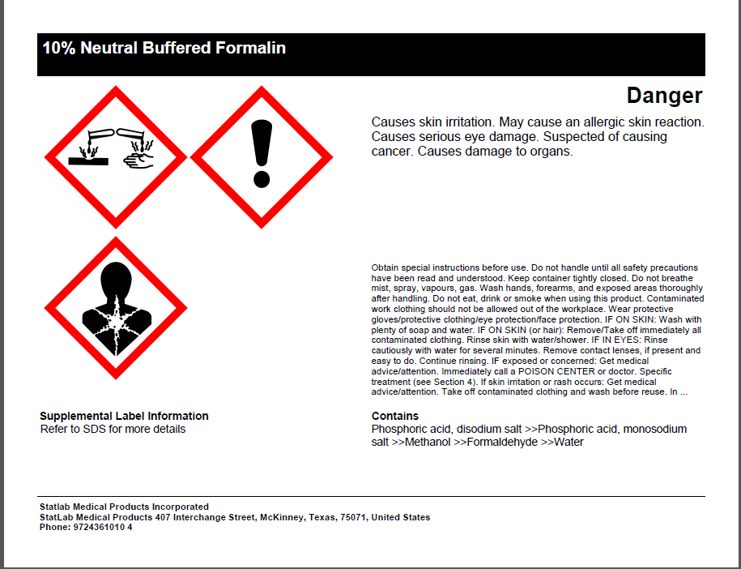

Components of Chemical Hazard Labels and their Meanings

As of June 1, 2015, the OSHA HCS required chemical manufacturers, importers, or distributors to ensure that each container of hazardous chemicals leaving the workplace is labeled, tagged or marked with the following information:

- Name, address, and telephone number of the chemical manufacturer

- Product identifier
This can be (but is not limited to) the chemical name, code number or batch number. The manufacturer, importer, or distributor can decide the appropriate product identifier. The same product identifier must be both on the label and in section 1 of the SDS.

- Signal word
Used to indicate the relative level of severity of the hazard and alert the reader to a potential hazard on the label. There are only two words used as signal words, “Danger” and “Warning.”
  - “Danger” is used for the more severe hazards
  - “Warning” is used for the less severe hazards.

- Hazard Statement
Hazard Statements describe the nature of the hazard(s) of a chemical, including, where appropriate, the degree of hazard. For example: “Causes damage to kidneys through prolonged or repeated exposure when absorbed through the skin.” All of the applicable hazard statements must appear on the label. Hazard statements may be combined where appropriate to reduce redundancies and improve readability. The hazard statements are specific to the hazard classification categories, and chemical users should always see the same statement for the same hazards no matter what the chemical is or who produces it.

- Precautionary Statements
Precautionary Statements describe recommended measures that should be taken to minimize or prevent adverse effects resulting from exposure to the hazardous chemical or improper storage or handling. For example, a chemical presenting a specific target organ toxicity (repeated exposure) hazard would include the following on the label: “Do not breathe dust/fume/gas/mist/vapors/spray. Get medical advice/attention if you feel unwell. Dispose of contents/container in accordance with local/regional/ national and international regulations.”

There are four types of precautionary statements:
  - prevention (to minimize exposure)
  - response (in case of accidental spillage or exposure emergency response, and first-aid)
  - storage
  - disposal

- Pictogram
Pictogram is a symbol plus other graphic elements, such as a border, background pattern, or color that is intended to convey specific information about the hazards of a chemical. Each pictogram consists of a different symbol on a white background within a red square frame set on a point (i.e. a red diamond). There are nine pictograms under the GHS. However, only eight pictograms are required under the HCS.

  - HCS Pictograms and Hazards
Health Hazard   | Flame  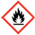 | Exclamation Mark  
• Carcinogen  • Mutagenicity  • Reproductive Toxicity  • Respiratory Sensitizer  • Target Organ Toxicity  • Aspiration Toxicity | • Flammables  • Pyrophorics  • Self-Heating  • Emits Flammable Gas  • Self-Reactives  • Organic Peroxides | • Irritant (skin and eye)  • Skin Sensitizer  • Acute Toxicity (harmful)  • Narcotic Effects  • Respiratory Tract Irritant  • Hazardous to Ozone Layer  (Non-Mandatory)
Gas Cylinder   | Corrosion   | Exploding Bomb  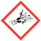
• Gases under Pressure | • Skin Corrosion/ burns  • Eye Damage  • Corrosive to Metals | • Explosives  • Self-Reactives  • Organic Peroxides
Flame over Circle  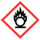 | Environment  (Non Mandatory)   | Skull and Crossbones  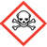
• Oxidizers | • Aquatic Toxicity | • Acute Toxicity (fatal or toxic)

Health Hazard  - Carcinogen  - Mutagenicity  - Reproductive Toxicity  - Respiratory Sensitizer  - Target Organ Toxicity  - Aspiration Toxicity | Flame  - Flammables  - Pyrophorics  - Self-Heating  - Emits Flammable Gas  - Self-Reactives  - Organic Peroxides | Exclamation Mark  - Irritant (skin and eye)  - Skin Sensitizer  - Acute Toxicity  - Narcotic Effects  - Respiratory Tract Irritant  - Hazardous to Ozone Layer (Non-Mandatory)
Gas Cylinder  - Gases Under Pressure | Corrosion  - Skin Corrosion/Burns  - Eye Damage  - Corrosive to Metals | Exploding Bomb  - Explosives  - Self-Reactives  - Organic Peroxides
Flame Over Circle  - Oxidizers | Environment  (Non-Mandatory)  - Aquatic Toxicity | Skull and Crossbones  - Acute Toxicity (fatal or toxic)
  - GHS Pictograms and Hazard Classes

  - Transport Pictograms

Transport "Pictograms"
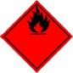 |  | 
Flammable Liquid Flammable Gas Flammable Aerosol | Flammable solid Self-Reactive Substances | Pyrophorics (Spontaneously Combustible) Self-Heating Substances
 | 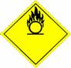 | 
Substances, which in contact with water, emit flammable gases (Dangerous When Wet) | Oxidizing Gases Oxidizing Liquids Oxidizing Solids | Explosive Divisions 1.1, 1.2, 1.3
 |  | 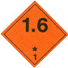
Explosive Division 1.4 | Explosive Division 1.5 | Explosive Division 1.6
 | 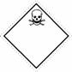 | 
Compressed Gases | Acute Toxicity (Poison): Oral, Dermal, Inhalation | Corrosive
 | 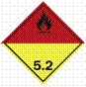
Marine Pollutant | Organic Peroxides

  - Acute Oral Toxicity
ACUTE ORAL TOXICITY - Annex 1
 | Category 1 | Category 2 | Category 3 | Category 4 | Category 5
LD₅₀ | £ 5 mg/kg | > 5 < 50 mg/kg | ³ 50 < 300 mg/kg | ³ 300 < 2000 mg/kg | ³ 2000 < 5000 mg/kg
Pictogram | 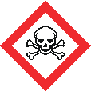 |  |  |  | No symbol
Signal word | Danger | Danger | Danger | Warning | Warning
Hazard statement | Fatal if swallowed | Fatal if swallowed | Toxic if swallowed | Harmful if swallowed | May be harmful if swallowed
- Labels that may still exist within the laboratory

  - The Hazardous Materials Identification System (HMIS) is a numerical hazard rating that incorporates the use of color coded labels with color-coded bars as well as training materials. The four bars are color-coded, using the modern color bar symbols with blue indicating the level of health hazard, red for flammability, orange for a physical hazard, and white for Personal Protection. The number ratings range from 0-4 (see the following page).

The HMIS label will provide the following information:
- Product Identifier
- Supplier Identification
- Client Custom Values
- HMIS® Rating

- The NFPA labeling system operates on the same principle as the HMIS (Hazardous Materials Identification System) labels. Blue indicates health hazard, red indicates flammability, yellow indicates instability, and special information (such as what personal protective equipment to wear) will be provided in the white section. It also uses a numerical system from 0-4 to indicate the severity of the hazards

The NFPA label will provide the following information:
  - Product Identifier
  - Supplier Identification
  - Client Custom Values
  - NFPA Rating
  - Client Note

- Key To Label Numerical Ratings

HEALTH
4 | Deadly: even the slightest exposure to this substance would be life threatening. Only specialized protective clothing, for these materials, should be worn.
3 | Extreme Danger: serious injury would result from exposure to this substance. Do not expose any body surface to these materials. Full protective measures should be taken.
2 | Dangerous: exposure to this substance would be hazardous to health. Protective measures are indicated.
1 | Slight Hazard: irritation or minor injury would result from exposure to this substance. Protective measures are indicated.
0 | No Hazard: exposure to this substance offers any significant risk to health.

FLAMMABILITY
4 | Flash Point Below 73ºF and Boiling Point Below 100ºF: this substance is very flammable, volatile or explosive depending on its state. Extreme caution should be used in handling or storing of these materials.
3 | Flash Point Below 100ºF: flammable, volatile or explosive under almost all normal temperature conditions. Exercise great caution in storage or handling of these materials.
2 | Flash Point Below 200ºF: moderately heated conditions may ignite this substance. Caution procedures should be employed in handling.
1 | Flash Point Above 200ºF: this substance must be preheated to ignite. Most combustible solids would be in this category.
0 | Will Not Burn: substances that will not burn.

INSTABILITY
4 | May Detonate: substances that are readily capable of detonation or explosion at normal temperatures and pressures. Evacuate area if exposed to heat or fire.
3 | Explosive: substances that are readily capable of detonation or explosion by a strong initiating source, such as heat, shock or water. Monitor from behind explosion-resistant barriers.
2 | Unstable: violent chemical changes are possible at normal or elevated temperatures and pressures. Potentially violent or explosive reaction may occur when mixed with water. Monitor from a safe distance.
1 | Normally stable: substances that may become unstable at elevated temperatures and pressures or when mixed with water. Approach with caution.
0 | Stable: substances which will remain stable when exposed to heat, pressure or water.

- The white space is reserved for indicating what personal protective equipment to use. It also uses a numerical system from 0 – 4 to indicate the severity of the hazard. This is by far the largest area of difference between the NFPA and HMIS systems. In the NFPA system, the white area is used to convey special hazards whereas HMIS uses the white section to indicate what personal protective equipment (PPE) should be used when working with the material.

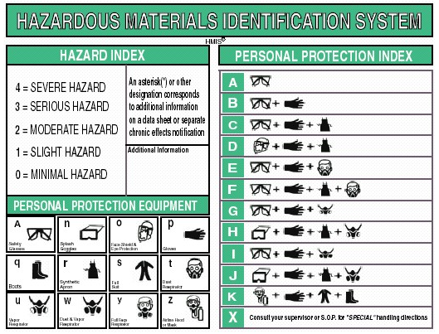

- The NFPA/HMIS® label is a label that combines the NFPA and HMIS® classification onto a single label.

The NFPA/HMIS® label will provide the following information:

- Product Identifier
- Supplier Identification
- Client Custom Values
- NFPA Rating
- HMIS® Rating

SDS Files

- Each P&LMS service section will maintain a three ring binder specific to each section and an electronic file of SDS’s for hazardous chemicals used in the workplace. SDS’s shall be readily accessible to all employees during each work shift.

- Each department’s SDS’s will be updated semiannually when the chemical inventory is performed.

- Each department’s SDS binder will be the same color. P&LMS’s SDS binders will be yellow and black.

- Each department’s chemical inventory list will be used as the index for their SDS binders.

- When an SDS is not received at the time of the first shipment, contact the company of origin to obtain the SDS before using the chemical.

- SDS’s may also be obtained through VHA’s Center for Engineering and Occupational Safety and Health (CEOSH) Service (See Attachment J for complete directions)

- If employees must travel between workplaces during a work shift, i.e. their work is carried out at more than one geographical location, the safety data sheets may be kept at the primary workplace facility. In this situation, the employer shall ensure that employees can immediately obtain the required information in an emergency.

Chemical Inventory

- The SDS Coordinator will maintain an inventory of hazardous chemicals used in the Pathology and Laboratory Medicine Service.

- Each department supervisor or lead technologist will conduct a semiannual inventory of chemicals and forward an electronic copy to the P&LMS Safety Officer. The P&LMS Safety Officer will review the inventories for completeness and then forward the inventory to the Safety Office/SDS Coordinator (138CDD).

- The chemical inventories must include:
  - Common or trade name of chemical
  - Manufacturer’s name
  - Storage location
  - Disposal method
  - Acute toxicity (any route of exposure)
  - Carcinogenicity
  - Reproductive toxicity

- The inventory must be submitted in January and July of each year.

- The chemicals in the inventory will use the identity that is referenced on the appropriate SDS.

Hazardous Chemicals in Our Laboratory

- Flammables

Location | Product Name | Manufacturer | NFPA Fire Rating
Cytology | Denatured Alcohol 95% Histoprep | Fisher Scientific | 4
Cytology | Gleme Glass Cleaner | Ric Mar Industries, Inc. | 4
Histology | Denatured Alcohol 95% Histoprep | Fisher Scientific | 4
Microbiology | Zinc, Powder, -200 Mesh, 99.9999% | Fisher Scientific | 4
Ancillary Testing | PURELL 2 in 1 INSTANT HAND SANITIZER | GoJo Industries, Inc | 3
Ancillary Testing | Super Sani-Cloth Germicidal Disposable Wipes | Nice-Pak Products Inc. | 3
Ancillary Testing | ThinPrep PreservCyt Solution | Hologic | 3
Blood Bank | GOJO Premium Foam Antibacterial Handwash | GOJO | 3
Blood Bank | Purell Instant Hand Sanitizer Foam | GOJO Industries, Inc. | 3
Blood Bank | Super Sani-Cloth Germicidal Disposable Wipes | Nice-Pak Products Inc. | 3
Chemistry | PURELL 2 in 1 INSTANT HAND SANITIZER | GoJo Industries, Inc | 3
Cytology | Hema 3 Fixative | Fisher Scientific | 3
Cytology | Histoprep 100% Alcohol | Fisher Scientific | 3
Cytology | Permount Mounting Media | Fisher Scientific | 3
Cytology | Reagent Alcohol, 95% | Leica Biosystems | 3
Cytology | Super Sani-Cloth Germicidal Disposable Wipes | Nice-Pak Products Inc. | 3
Cytology | Thinprep Orange G Solution | Hologic | 3
Cytology | ThinPrep PreservCyt Solution | Hologic | 3
Cytology | Thinprep Stain EA Solution | Hologic | 3
Hematology | 2-Propanol | Fisher Scientific / Acros Organic | 3
Hematology | Buffered Wright Stain | Richard-Allan Scientific | 3
Hematology | Hemoccult Developer (Part A) | Beckman Coulter, Inc | 3
Hematology | Isopropyl alcohol | Fisher Scientific | 3
Hematology | Lens Cleaner | Scientific Device Laboratory | 3
Hematology | Methyl Alcohol | EKI Industries Inc. | 3
Hematology | Permount Mounting Media | Fisher Scientific | 3
Hematology | Purell Foaming Hand Sanitizer | GOJO Industries, Inc. | 3
Hematology | Super Sani-Cloth Germicidal Disposable Wipes | Nice-Pak Products Inc. | 3
Hematology | Sysmex Hematology Controls, Calibrators, and Linearity Products | Streck / Streck Laboratories, Inc. | 3
Histology | 2-Propanol | Fisher Scientific / Acros Organic | 3
Histology | Acetone | Fisher Scientific | 3
Histology | Alcoholic Eosin 515 | Leica MicroSystems
Histology | Alcian Yellow 1% Solution | Poly Scientific R&D Corp. | 3
Histology | Alkaline Alcohol 50% | Poly Scientific R&D Corp. | 3
Histology | Cytoseal XYL | Richard-Allan Scientific | 3
Histology | Envirocide Surface Disinfectant/Decontaminant Cleaner | Metrex Research Corporation | 3
Histology | Fisherbrand Hema 3 Fixative | Fisher Scientific | 3
Histology | Hema 3 Fixative | Fisher Scientific | 3
Histology | Histoprep 100% Alcohol | Fisher Scientific | 3
Histology | Histoprep Mold Releasing Agent | Fisher Scientific | 3
Histology | Luxol Fast Blue 0.1% Alcoholic | Poly Scientific R&D Corp. | 3
Histology | Lymph Node Revealing Solution | Poly Scientific R&D Corp. | 3
Histology | Lymph-ID (Formalin Aceto-Alcoholic) Item | Statlab Medical Products Incorporated | 3
Histology | Mayer's Mucicarmine Solution | Poly Scientific R&D Corp. | 3
Histology | Methanol | Fisher Scientific | 3
Histology | Micromount Mounting Medium | Leica MicroSystems | 3
Histology | Permount Mounting Media | Fisher Scientific | 3
Histology | Picric Acid Acetone 0.1% | Poly Scientific R&D Corp. | 3
Histology | Reagent Alcohol - 190 Proof | Statlab Medical Products Incorporated | 3
Histology | Reagent Alcohol, 100% | Leica Biosystems | 3
Histology | Reagent Alcohol, 95% | Leica Biosystems | 3
Histology | X8000 | Xennia Technology Ltd, UK | 3
Histology | Xylenes, mixed isomers with ethylbenzene | Fisher Scientific | 3
Histology | Xylenes, Purified | Leica MicroSystems | 3
Microbiology | 70% Isopropyl Alcohol | Enturia | 3
Microbiology | Affirm Sample VP III Assay Kit | BD Diagnostic Systems | 3
Microbiology | Alcohol Prep Pad | Medline Industries, Inc. | 3
Microbiology | Bactidrop Ninhydrin Reagent | Remel Inc | 3
Microbiology | Ethanol 70% | Alpha-Tec Systems Inc | 3
Microbiology | GRAM CRYSTAL VIOLET | Remel | 3
Microbiology | Gram Decolorizer | BD Diagnostics | 3
Microbiology | Gram Stain Set w/Stabilized Iodine | Bd Diagnostic Systems | 3
Microbiology | Methanol | Pharmco-AAPER | 3
Microbiology | Methanol | Fisher Scientific | 3
Microbiology | Microscan Reagent Q.C. Peptidate | Dade Behring Inc | 3
Microbiology | NIN | BioMérieux, Inc. | 3
Microbiology | Purell Hand Sanitizer | GOJO Industries, Inc. | 3
Microbiology | Purell Instant Hand Sanitizer with Aloe | GOJO Industries, Inc. | 3
Microbiology | Reagent Alcohol, 95% | Leica Biosystems | 3
Microbiology | Sanihol 70 | Decon Laboratories Inc. | 3
Microbiology | Substrate Solutions | BD Biosciences | 3
Microbiology | Super Sani-Cloth Germicidal Disposable Wipes | Nice-Pak Products Inc. | 3
Microbiology | VP2 | bioMerieux, Inc. | 3
Microbiology | Webcol/Curity Alcohol Prep Pads | Kendall Healthcare/ Tyco Healthcare/ Covidien | 3
Microbiology | Xpert EV | Cepheid USA | 3
Microbiology | Xpert Flu | Xpert Flu | 3
Phlebotomy | Chloraprep 2.0% | CareFusion | 3
Phlebotomy | ChloraPrep with Orange Tint | Enturia | 3
Phlebotomy | Super Sani-Cloth Germicidal Disposable Wipes | Nice-Pak Products Inc. | 3
Phlebotomy | Webcol/Curity Alcohol Prep Pads | Kendall Healthcare/ Tyco Healthcare/ Covidien | 3
Special Reference Lab | Super Sani-Cloth Germicidal Disposable Wipes | Nice-Pak Products Inc | 3
Special Reference Lab | ViraStripe / ViraBlot Antigen Strips | Viramed Biotech AG | 3
Washroom | Purell Instant Hand Sanitizer with Aloe | GOJO Industries, Inc. | 3
Washroom | Super Sani-Cloth Germicidal Disposable Wipes | Nice-Pak Products Inc. | 3

- Oxidizers
Oxidizing chemicals are materials that spontaneously evolve oxygen at room temperature or with slight heating or promote combustion. Strong oxidizers are capable of forming explosive mixtures when mixed with combustible, organic, or easily oxidized materials.

Location | Product Name | Manufacturer
Histology | Potassium Iodate | Avantor Performance Materials
Histology | Potassium Permanganate | Fisher Scientific
Histology | Silver Nitrate | Fisher Scientific
Histology | Silver Nitrate STK Solution B | Poly Scientific R&D Corp.
Histology | Sodium Iodate | Fisher Scientific

- Corrosives
A corrosive is a substance defined by the DOT, as causing visible destruction or permanent changes in human skin tissue at the site of contact, or is highly corrosive to steel. They represent a significant hazard because skin or eye contact can readily occur from splashes, and their effect on human tissue generally takes place very rapidly.

Location | Product Name | Manufacturer
Ancillary Testing | Hydrochloric Acid Solutions, 0.5%-50% V/V, 0.01N-6.25N | LabChem Inc.
Ancillary Testing | Nickel Metal Hydride (NiMH) Battery | Harding Energy Systems, Inc.
Blood Bank | Clorox Commercial Solutions Ultra Clorox Germicidal Bleach | The Clorox Company
Chemistry | Cleaning Solution | NOVA Biomedical
Chemistry | Clorox Commercial Solutions Ultra Clorox Germicidal Bleach | The Clorox Company
Chemistry | Hydrochloric Acid Solutions, 0.5%-50% V/V, 0.01N-6.25N | LabChem Inc.
Chemistry | Vitros Immunodiagnostic Products B12/Folate Denaturant Reagent | Ortho-Clinical Diagnostics, UK
Cytology | Clorox Commercial Solutions Ultra Clorox Germicidal Bleach | The Clorox Company
Hematology | Clorox Commercial Solutions Ultra Clorox Germicidal Bleach | The Clorox Company
Hematology | IRIS System Cleanser | Iris Diagnostics a Div. of Iris International, Inc
Hematology | Sysmex Hematology Controls, Calibrators, and Linearity Products | Streck / Streck Laboratories, Inc.
Hematology | Sysmex Hematology Controls, Calibrators, and Linearity Products | Streck / Streck Laboratories, Inc.
Histology | Bond Aspirating Probe Cleaning System | Leica Biosystems Newcastle Ltd
Histology | Bond Polymer Refine Red Detection | Leica Biosystems Newcastle Ltd
Histology | Chromic Acid 4% Aqueous | Poly Scientific R&D Corp.
Histology | Clorox Commercial Solutions Ultra Clorox Germicidal Bleach | The Clorox Company
Histology | Ferric Chloride 10% Aqueous | Poly Scientific R&D Corp.
Histology | Hydrochloric Acid 20% Aqueous NA1789 | Poly Scientific R&D Corp.
Histology | Hydrochloric Acid 5% Aqueous | Poly Scientific R&D Corp.
Histology | Periodic Acid | EKI Industries Inc.
Histology | Schiff Reagent | Poly Scientific R&D Corp.
Histology | Sodium Hydroxide 3% Aqueous | Poly Scientific R&D Corp.
Microbiology | Calcofluor White Stain Kit | Remel Inc
Microbiology | FilmArray Reagent Kit | BioFire Diagnostics, Inc.
Microbiology | Hype-Wipe (Disinfecting Towel With Bleach) | Current Technologies
Microbiology | MicroScan 0.5% N,N-Dimethylalphanaphthylamine | Dade Behring Inc
Microbiology | MicroScan 0.8% Sulfanilic Acid Reagent | Dade Behring Inc
Microbiology | MicroScan 40% Potassium Hydroxide | Siemens
Microbiology | Microscan Kovac's Reagent | Siemens Healthcare Diagnostics
Microbiology | Para-Pak SAF, Para-Pak ULTRA SAF (Sodium acetate-acetic acid-formalin fixative) | MERIDIAN BIOSCIENCES, INC.
Microbiology | PVA Fixative | Scientific Device Laboratory
Microbiology | VP1 | bioMerieux, Inc.
Microbiology | Xpert C. Difficile | Cepheid USA
Microbiology | Xpert MRSA | Cepheid USA
Special Reference Laboratory | Abbott Realtime HCV Amplification Reagent Kit | Abbott Molecular
Special Reference Laboratory | Anti-Jo-1 | Diamedix Corporation
Special Reference Laboratory | Anti-Scl-70 | Diamedix Corporation
Special Reference Laboratory | Anti-SM | Diamedix Corporation
Location | Product Name | Manufacturer
Special Reference Laboratory | anti-Sm/RNP | DiaMedix
Special Reference Laboratory | Anti-SSA | Diamedix Corporation
Special Reference Laboratory | Anti-SSB | Diamedix Corporation
Special Reference Laboratory | ENA-6 Screens | Diamedix Corporation
Special Reference Laboratory | GS HIV Combo Ag/Ab EIA | Bio-Rad Laboratories
Special Reference Laboratory | H. Pylori IgG | Diamedix Corporation
Special Reference Laboratory | Liaison Borrelia | Diasorin Inc.
Special Reference Laboratory | LIAISON Starter kit | DiaSorin Inc.
Special Reference Laboratory | Measles IgG | Diamedix Corporation
Special Reference Laboratory | Multispot HIV-1/HIV-2 Rapid Test | Bio-Rad Laboratories USSD Clinical Diagnostics
Special Reference Laboratory | Mumps IgG | Diamedix Corporation
Special Reference Laboratory | Mycoplasma IgG Kit | Innominata dba GenBio
Special Reference Laboratory | Mycoplasma IgM Kit | Innominata dba GenBio
Special Reference Laboratory | PK - Positive Control, CO - Cut off Control, NK - Negative Control, HK - Control High, LK - Control Low, WK - Weak Control | Viramed Biotech AG
Special Reference Laboratory | R2. Wash Solution Concentrate (30X) | Bio-Rad Laboratories USSD Clinical Diagnostics
Special Reference Laboratory | R3. HIV-1/HIV-2 Plus O EIA Specimen Diluent | Bio-Rad Laboratories USSD Clinical Diagnostics
Special Reference Laboratory | Rubella IgG | Diamedix Corporation
Special Reference Laboratory | Toxoplasma IgG | Diamedix Corporation
Special Reference Laboratory | Toxoplasma IgM Capture | Diamedix Corporation
Special Reference Laboratory | VZV IgG (Varicella) | Diamedix Corporation
Washroom | Clorox Commercial Solutions Ultra Clorox Germicidal Bleach | The Clorox Company

- Carcinogens

  - IARC (International Agency for Research on Cancer) Group 1
The chemical (mixture) is carcinogenic to humans.
Location | Product Name | Manufacturer | CAS | Chemical Name
Ancillary Testing | Formaldehyde Solution 10% W/W or Formalin Solution 10% | Fisher Scientific | 000050-00-0 | Formaldehyde
Ancillary Testing | Nickel Metal Hydride (NiMH) Battery | Harding Energy Systems, Inc. | 012054-48-7 | Nickel hydroxide (Ni(OH)2)
Ancillary Testing | Uni-Safe/Univeral Gel Sorbent | PND CORPORATION | 014464-46-1 | Cristobalite (SiO2)
Ancillary Testing | Uni-Safe/Univeral Gel Sorbent | PND CORPORATION | 068855-54-9 | Kieselguhr, soda ash flux-calcined
Blood Bank | GP Forward SC General Purpose Cleaner | Johnson Diversey | 000075-07-0 | Acetaldehyde
Blood Bank | GP Forward SC General Purpose Cleaner | Johnson Diversey | 000075-21-8 | Oxirane
Blood Bank | Provon Moisturizing Hand & Body Lotion | GOJO Industries, Inc. | 008009-03-8 | Petrolatum
Chemistry | GP Forward SC General Purpose Cleaner | Johnson Diversey | 000075-07-0 | Acetaldehyde
Chemistry | GP Forward SC General Purpose Cleaner | Johnson Diversey | 000075-21-8 | Oxirane
Chemistry | Liquichek Immunoassay Plus Control | Bio-Rad Laboratories | 000050-28-2 | estradiol
Chemistry | Tri-Flow Superior Lubricant with PTFE, 21021 21013 22025 26020 29200 | Sherwin Williams | 064742-52-5 | Distillates, petroleum, hydrotreated heavy naphthenic
Hematology | Formaldehyde Solution 10% W/W or Formalin Solution 10% | Fisher Scientific | 000050-00-0 | Formaldehyde
Hematology | Semen Analysis Kit (Solution I-Semen Diluting Fluid) | ENG Scientific, Inc. | 000050-00-0 | Formaldehyde
Histology | 10% Neutral Buffered Formalin | Richard-Allan Scientific | 000050-00-0 | Formaldehyde
Histology | 10% Neutral Buffered Formalin | Statlab Medical Products Incorporated | 000050-00-0 | Formaldehyde
Histology | Bond Aspirating Probe Cleaning System | Leica Biosystems Newcastle Ltd | 007664-93-9 | Sulfuric Acid
Location | Product Name | Manufacturer | CAS | Chemical Name
Histology | Bouin's Fixative | Poly Scientific R&D Corp. | 000050-00-0 | Formaldehyde
Histology | Carbol Fuchsin Ziehl Neelsen | Poly Scientific R&D Corp. | 000569-61-9 | Basic Fuchsin
Histology | Chromic Acid 4% Aqueous | Poly Scientific R&D Corp. | 001333-82-0 | Chromium (Vi) Oxide, Chromic Acid
Histology | Formaldehyde, 37 Wt% Solution, Stabilized with Methanol | Fisher Scientific | 000050-00-0 | Formaldehyde
Histology | Formalin 10% Buffered pH 6.9-7.1 | Poly Scientific R&D Corp. | 000050-00-0 | Formaldehyde
Histology | Formalin, 10% Buffered | U.S. Biotex Corporation | 000050-00-0 | Formaldehyde
Histology | Lymph Node Revealing Solution | Poly Scientific R&D Corp. | 000050-00-0 | Formaldehyde
Histology | Lymph-ID (Formalin Aceto-Alcoholic) Item | Statlab Medical Products Incorporated | 000050-00-0 | Formaldehyde
Histology | Protocol 10% Neutral Buffered Formalin | Thermo Fisher Scientific, Inc. | 000050-00-0 | Formaldehyde
Histology | Schiff Reagent | Poly Scientific R&D Corp. | 000569-61-9 | Benzenamine, 4-[(4-aminophenyl)(4-imino-2,5-cyclohexadien-1-ylidene)methyl]-, monohydrochloride
Microbiology | Drierite | WA Hammond Drierite | 014808-60-7 | Quartz (SiO2)
Microbiology | Formaldehyde Solution, Buffered 10% | Avantor Performance Materials | 000050-00-0 | Formaldehyde
Microbiology | GP Forward SC General Purpose Cleaner | Johnson Diversey | 000075-07-0 | Acetaldehyde
Microbiology | GP Forward SC General Purpose Cleaner | Johnson Diversey | 000075-21-8 | Oxirane
Microbiology | Microscan Mineral Oil | Siemens | 008012-95-1 | Paraffin oils
Microbiology | Para-Pak SAF, Para-Pak ULTRA SAF (Sodium acetate-acetic acid-formalin fixative) | MERIDIAN BIOSCIENCES, INC. | 000050-00-0 | Formaldehyde
Phlebotomy | 3-In-One Multi-Purpose Oil | WD-40 Company | 064742-52-5 | Distillates, petroleum, hydrotreated heavy naphthenic
Special Reference Laboratory (SRL) | GP Forward SC General Purpose Cleaner | Johnson Diversey | 000075-07-0 | Acetaldehyde
Special Reference Laboratory (SRL) | GP Forward SC General Purpose Cleaner | Johnson Diversey | 000075-21-8 | Oxirane
Special Reference Laboratory (SRL) | GS HIV Combo Ag/Ab EIA | Bio-Rad Laboratories | 007664-93-9 | Sulfuric Acid
Special Reference Laboratory (SRL) | H. Pylori IgG | Diamedix Corporation | 007664-93-9 | Sulfuric Acid
Special Reference Laboratory (SRL) | Liquichek Immunoassay Plus Control | Bio-Rad Laboratories | 000050-28-2 | estradiol
Special Reference Laboratory (SRL) | Multispot HIV-1/HIV-2 Rapid Test | Bio-Rad Laboratories USSD Clinical Diagnostics | 007664-93-9 | Sulfuric Acid
Special Reference Laboratory (SRL) | Mumps IgG | Diamedix Corporation | 007664-93-9 | Sulfuric Acid
Special Reference Laboratory (SRL) | R2. Wash Solution Concentrate (30X) | Bio-Rad Laboratories USSD Clinical Diagnostics | 007664-93-9 | Sulfuric Acid
Special Reference Laboratory (SRL) | R2. Wash Solution Concentrate (30X) | Bio-Rad Laboratories USSD Clinical Diagnostics | 014808-60-7 | Quartz (SiO2)
Special Reference Laboratory (SRL) | R3. HIV-1/HIV-2 Plus O EIA Specimen Diluent | Bio-Rad Laboratories USSD Clinical Diagnostics | 007664-93-9 | Sulfuric Acid
Special Reference Laboratory (SRL) | Stop Solution | Diasorin Inc. | 007664-93-9 | Sulfuric Acid
Special Reference Laboratory (SRL) | Sulfuric Acid | Avantor Performance Materials | 007664-93-9 | Sulfuric Acid
Washroom | Uni-Safe/Univeral Gel Sorbent | PND CORPORATION | 014464-46-1 | Cristobalite (SiO2)
Washroom | Uni-Safe/Univeral Gel Sorbent | PND CORPORATION | 068855-54-9 | Kieselguhr, soda ash flux-calcined
- IARC Group 2a
The chemical (mixture) is probably carcinogenic to humans. This category is used when there is limited evidence of carcinogenicity in humans and sufficient evidence of carcinogenicity in experimental animals. Exceptionally, a chemical may be classified in this category solely on the basis of limited evidence of carcinogenicity in humans or of sufficient evidence of carcinogenicity in experimental animals strengthened by supporting evidence from other relevant data.

Location | Product Name | Manufacturer | Probable Carcinogenic Ingredient | CAS
Blood Bank | Checkcell (weak) | Immucor Inc | Acetamide, 2,2-dichloro-N-[(1R,2R)-2-hydroxy-1-(hydroxymethyl)-2-(4-nitrophenyl)ethyl]- | 000056-75-7
Blood Bank | Complement Control Cells | Immucor Gamma | Acetamide, 2,2-dichloro-N-[(1R,2R)-2-hydroxy-1-(hydroxymethyl)-2-(4-nitrophenyl)ethyl]- | 000056-75-7
Blood Bank | CorQC Test System | Immucor | Acetamide, 2,2-dichloro-N-[(1R,2R)-2-hydroxy-1-(hydroxymethyl)-2-(4-nitrophenyl)ethyl]- | 000056-75-7
Chemistry | Cardiac Marker Control VS | Cliniqa Corporation | Acetamide, 2,2-dichloro-N-[(1R,2R)-2-hydroxy-1-(hydroxymethyl)-2-(4-nitrophenyl)ethyl]- | 000056-75-7
Chemistry | Liquichek Cardiac Markers Plus Lt Control | Bio-Rad Laboratories USSD Clinical Diagnostics | Acetamide, 2,2-dichloro-N-[(1R,2R)-2-hydroxy-1-(hydroxymethyl)-2-(4-nitrophenyl)ethyl]- | 000056-75-7
Chemistry | Liquichek Immunoassay Plus Control | Bio-Rad Laboratories | Acetamide, 2,2-dichloro-N-[(1R,2R)-2-hydroxy-1-(hydroxymethyl)-2-(4-nitrophenyl)ethyl]- | 000056-75-7
Chemistry | Liquichek Immunoassay Plus Control | Bio-Rad Laboratories | Pregn-4-ene-3,20-dione | 000057-83-0
Chemistry | Liquichek Immunoassay Plus Control | Bio-Rad Laboratories | Androst-4-en-3-one, 17-hydroxy-, (17b)- | 000058-22-0
Hematology | HBA1C Control Set | Canterbury Scientific Ltd | Acetamide, 2,2-dichloro-N-[(1R,2R)-2-hydroxy-1-(hydroxymethyl)-2-(4-nitrophenyl)ethyl]- | 000056-75-7
Histology | Congo Red 1% Aqueous | Poly Scientific R&D Corp. | 1-Naphthalenesulfonic acid, 3,3'-[[1,1'-biphenyl]-4,4'-diylbis(azo)]bis[4-amino-, disodium salt | 000573-58-0
Special Reference Laboratory (SRL) | Liquichek Immunoassay Plus Control | Bio-Rad Laboratories | Acetamide, 2,2-dichloro-N-[(1R,2R)-2-hydroxy-1-(hydroxymethyl)-2-(4-nitrophenyl)ethyl]- | 000056-75-7
Special Reference Laboratory (SRL) | Liquichek Immunoassay Plus Control | Bio-Rad Laboratories | Pregn-4-ene-3,20-dione | 000057-83-0

- IARC Group 2B
The chemical is possibly carcinogenic to humans. The exposure circumstance entails exposures that are possibly carcinogenic to humans. This category is generally used for chemicals for which there is limited evidence in humans in the absence of sufficient evidence in experimental animals. It may also be used when there is inadequate evidence of carcinogenicity in experimental animals. In some instances, a chemical for which there is inadequate evidence or no data in humans, but limited evidence of carcinogenicity in experimental animals together with supporting evidence from other relevant data, may be placed in this group.

Location | Product Name | Manufacturer | Possible Carcinogenic Ingredient | CAS
Ancillary Testing | Accu-Chek Inform II Battery Pack | ROCHE DIAGNOSTICS | Nickel | 007440-02-0
Ancillary Testing | Accu-Chek Inform II Battery Pack | ROCHE DIAGNOSTICS | Cobalt lithium oxide (CoLiO2) | 012190-79-3
Ancillary Testing | Nickel Metal Hydride (NiMH) Battery | Harding Energy Systems, Inc. | Nickel | 007440-02-0
Ancillary Testing | Nickel Metal Hydride (NiMH) Battery | Harding Energy Systems, Inc. | Cobalt | 007440-48-4
Ancillary Testing | Uni-Safe/Univeral Gel Sorbent | PND CORPORATION | Cristobalite (SiO2) | 014464-46-1
Blood Bank | GP Forward SC General Purpose Cleaner | Johnson Diversey | Acetaldehyde | 000075-07-0
Blood Bank | GP Forward SC General Purpose Cleaner | Johnson Diversey | Ethanol, 2,2'-iminobis- | 000111-42-2
Blood Bank | GP Forward SC General Purpose Cleaner | Johnson Diversey | 1,4-Dioxane | 000123-91-1
Blood Bank | GP Forward SC General Purpose Cleaner | Johnson Diversey | Glycine, N,N-bis(carboxymethyl)-, trisodium salt | 005064-31-3
Chemistry | DRI Negative Urine Calibrator | Thermo Scientific | 2H-1,4-Benzodiazepin-2-one, 7-chloro-1,3-dihydro-3-hydroxy-5-phenyl- | 000604-75-1
Chemistry | GP Forward SC General Purpose Cleaner | Johnson Diversey | Acetaldehyde | 000075-07-0
Chemistry | GP Forward SC General Purpose Cleaner | Johnson Diversey | Ethanol, 2,2'-iminobis- | 000111-42-2
Chemistry | GP Forward SC General Purpose Cleaner | Johnson Diversey | 1,4-Dioxane | 000123-91-1
Chemistry | GP Forward SC General Purpose Cleaner | Johnson Diversey | Glycine, N,N-bis(carboxymethyl)-, trisodium salt | 005064-31-3
Chemistry | Liquichek Immunoassay Plus Control | Bio-Rad Laboratories | 2,4,6(1H,3H,5H)-Pyrimidinetrione, 5-ethyl-5-phenyl- | 000050-06-6
Chemistry | Liquichek Immunoassay Plus Control | Bio-Rad Laboratories | Card-20(22)-enolide, 3-[(O-2,6-dideoxy-b-D-ribo-hexopyranosyl-(1®4)-O-2,6-dideoxy-b-D-ribo-hexopyranosyl-(1®4)-2,6-dideoxy-b-D-ribo-hexopyranosyl)oxy]-12,14-dihydroxy-, (3b,5b,12b)- | 020830-75-5
Chemistry | Liquichek Unassayed Chemistry Control (Human) | Bio-Rad Laboratories Ltd | 2,4,6(1H,3H,5H)-Pyrimidinetrione, 5-ethyl-5-phenyl- | 000050-06-6
Chemistry | Liquid Unassayed Multiqual | Bio-Rad Laboratories, Diagnostic Group | 2,4,6(1H,3H,5H)-Pyrimidinetrione, 5-ethyl-5-phenyl- | 000050-06-6
Chemistry | Liquid Unassayed Multiqual | Bio-Rad Laboratories, Diagnostic Group | Card-20(22)-enolide, 3-[(O-2,6-dideoxy-b-D-ribo-hexopyranosyl-(1®4)-O-2,6-dideoxy-b-D-ribo-hexopyranosyl-(1®4)-2,6-dideoxy-b-D-ribo-hexopyranosyl)oxy]-12,14-dihydroxy-, (3b,5b,12b)- | 020830-75-5
Chemistry | VIDAS BRAHMS PCT | Biomerieux | Ethanol, 2,2'-iminobis- | 000111-42-2
Chemistry | Vitros Chemistry Products Tdm Performance Verifier III | Johnson & Johnson Clinical Diagnostics | phenytoin | 000057-41-0
Chemistry | Vitros Chemistry Products Tdm Performance Verifier III | Johnson & Johnson Clinical Diagnostics | 4,6(1H,5H)-Pyrimidinedione, 5-ethyldihydro-5-phenyl- | 000125-33-7
Cytology | Vionex Antimicrobial Liquid Soap | Metrex Research Corporation | Ethanol, 2,2'-iminobis- | 000111-42-2
Cytology | Vionex Antimicrobial Liquid Soap | Metrex Research Corporation | Amides, coco, N,N-bis(hydroxyethyl) | 068603-42-9
General | AR-150TD/TD-J/TD-C/DC/MI/LI/CI./AR-151LI/AR-152MI (Black Developer) | Sharp Corporation | Carbon black | 001333-86-4
General | Black Toner, Type 9 | Oki Data | Styrene | 000100-42-5
General | Black Toner, Type 9 | Oki Data | Carbon black | 001333-86-4
General | Hp Color Laserjet Q6470A Black Print Cartridge | Hewlett Packard Company | Carbon black | 001333-86-4
General | T430 Return Program Print Cartridge | Lexmark International Inc. | Carbon black | 001333-86-4

Standard Operating Procedures for Select Hazards

- Flammables
  - Consult the SDS prior to use for emergency information, exposure routes, signs/symptoms of exposure.

  - Appropriate portable fire extinguishers must be provided for all areas in which flammable and combustible liquids are stored or handled.

  - In each laboratory area, up to 1 gallon of Class I, II and IIIA liquids may be stored outside of fire-resistant cabinets for each 100 ft² of space defined by fire-resistant walls/doors. Up to 2 gallons of Class I, II, and IIIA liquids may be stored in safety cans and safety cabinets for each 100 ft². These amounts may be doubled if there is an automatic fire suppression system (e.g. sprinklers).

  - Safety cans should be used for bulk storage of flammable and combustible liquid (National Fire Protection Association classes I and II). Safety cans should be used instead of glass bottles if the purity required does not mandate glass storage.

  - Proper ventilation should be maintained when using flammable and combustible liquids. Material should be stored in approved flammable storage cabinets with a minimum stored on bench tops for experiment use, generally only enough for work being conducted.

  - Properly functioning fume hoods should be utilized when handling flammable and combustible liquids and should generally NOT be used as storage areas unless specifically designed.

  - When handling or using flammable and/or combustible liquids, all sources of ignition should be controlled or eliminated.

  - Personnel handling oxidizing chemicals must wear adequate eye protection equipped with side shields.

  - Gloves should be worn when handling flammable and combustible chemicals. Disposable nitrile gloves provide adequate protection against accidental hand contact with small quantities of most laboratory chemicals.

  - Appropriate protective clothing should be worn if the possibility of skin contact is likely. Open toe shoes are not appropriate when handling chemicals in a laboratory or in other areas where there is a potential for exposure.

  - In the event of a spill or adverse reaction notify lab personnel immediately that an incident has occurred. Do not attempt to handle a large spill/reaction/fire, or one in which you are not trained or equipped for. Turn off all ignition sources if this can be done safely, vacate the area and call for assistance.

  - Only approved containers shall be used to store flammable and combustible liquids.

  - Do not store flammable or combustible materials near incompatible material, in particular with oxidizing materials.

  - Wash hands and arms with soap and water immediately after handling any chemical.

  - Clean work areas carefully when done. Dispose of contaminated material in the hazardous waste storage container. Do not dispose of waste with incompatible material. Paper towels or other similar material may pose a fire risk when contaminated. Proceed with caution when working with flammables and combustibles around other organic material (paper, wood, cloth).

- Oxidizers

  - Consult the SDS prior to use for emergency information, exposure routes, signs/symptoms of exposure.

  - Personnel handling oxidizing chemicals must wear adequate eye protection equipped with side shields.

  - Gloves should be worn when handling oxidizing chemicals. Disposable nitrile gloves provide adequate protection against accidental hand contact with small quantities of most laboratory chemicals.

  - All manipulations of oxidizing chemicals, which pose this risk, should occur in a fume hood with the sash in the lowest feasible position (18 inches or less).

  - Oxidizers should be stored in a cool and dry location. Segregate oxidizers from all other chemicals in the laboratory. Minimize the quantities of strong oxidizers stored in the laboratory.

  - All materials contaminated with oxidizing chemicals pose a fire hazard and should be disposed of as hazardous waste.

  - Clean work areas carefully when done. Dispose of contaminated material in the hazardous waste storage container. Do not dispose of waste with incompatible material. Paper towels or other similar material may pose a fire risk when contaminated. Proceed with caution when working with oxidizers around other organic material (paper, wood, cloth).

- Caustic (Corrosive) Materials

  - Consult the SDS prior to use for emergency information, exposure routes, signs/symptoms of exposure.

  - Personnel handling oxidizing chemicals must wear adequate eye protection equipped with side shields. When there is the potential for significant splash hazards, additional eye/face protection should be worn in the form of goggles or a face shield.

  - Gloves should be worn when handling corrosive chemicals. Nitrile gloves should be adequate for handling most of these in general laboratory settings. An MSDS should be reviewed if handling may involve extended or high exposure to lab personnel to ensure adequate skin protection is provided.

  - A lab coat or apron is advised if exposure could involve more than normal handling operations would be expected.

  - No open-toe shoes are allowed.

  - Never store corrosive liquids above eye level.

  - Always add acids or bases to water (and not the reverse). When mixing corrosive solids with water, always slowly add the corrosive solid to the water, stirring continuously. Cooling may also be necessary.

  - Segregate acids and bases in storage.

  - If there is a possibility that you may generate a significant amount of dust, conduct work in a fume hood.

  - Store corrosives material away from heat/flames, oxidizers and water sources. Keep containers closed and ensure that manufacturer’s labels and warnings remain intact.

  - Bottle carriers are used to transport all glass containers larger than 500 mL that contain hazardous chemicals.

- Toxic (includes reproductive toxicity and acute toxicity) and Reactive Chemicals

  - Consult the SDS prior to use for emergency information, exposure routes, signs/symptoms of exposure. Reactivity information can be found on a chemical SDS or container label.

  - Safety Data Sheets state the recommended limits or OSHA mandated guidelines for exposure to toxic chemicals.

  - When a Threshold Limit Value (TLV) or Permissible Exposure Limit (PEL) for a chemical (i.e. glutaraldehyde) is greater than 50 ppm, the employee using the chemical shall handle the chemical in a fume hood which has been certified and approved for use.

  - Whenever handling toxic substances with vapor pressures likely to exceed air concentration limits (i.e. formaldehyde, xylene), such work shall be conducted in a fume hood.

  - Reactive chemicals shall be handled with appropriate safety precautions, including segregation in storage and use of appropriate personal protective equipment.

- Carcinogens
The Occupational Safety and Health Administration (OSHA) definition of a human carcinogen is a compound that meets one of the following criteria:

  - It is regulated by OSHA as a carcinogen

  - It is listed as a known or reasonably anticipated human carcinogen in the annual report on carcinogens published by the National Toxicology Program (NTP)

  - It is listed by the International Agency for Research on Cancer (IARC) as either a
    - Group 1 - carcinogenic to humans
    - Group 2A - probably carcinogenic to humans
    - Group 2B - possibly carcinogenic to humans

  - See Attachments E, F, and G for a complete listing of carcinogens and potential carcinogens as outlined above.

  - Carcinogen Handling Requirements

- Do not ingest a carcinogen.

- Appropriate laboratory clothing should be specified in the procedure manual. Appropriate clothing may include laboratory coats, aprons, respiratory masks or respirators, and gloves.

- Appropriate eye protective devices should be available and used in the work area. Such devices may include close-fitting goggles.

- Personnel should wash hands and forearms after the completion of any procedure in which a chemical carcinogen has been used. Following gross contact with carcinogenic material, thorough showering, and clothes change is mandatory.

- Access to chemical carcinogens should be limited to knowledgeable individuals. The work area should be designed to preclude casual contact by others.

- Work surfaces should be covered by dry absorbent plastic-backed paper which should be disposed of after each procedure. Alternatively, the work surface should be constructed of impervious material and thoroughly decontaminated after each procedure.

- Working quantities should be maintained at a minimum.

- Labeling of the chemicals and of the work area where carcinogenic risk is significant is mandatory.

- Flammable or Compressed Gases

  - Consult the SDS prior to use for emergency information, exposure routes, signs/symptoms of exposure.

  - Compressed gas cylinders must be secured to prevent accidental falling and damage to the valve or regulator. Only one standby cylinder (full or empty) may be stored in the laboratory at a time.

  - Valve safety covers should be left on until pressure regulators are attached. Only approved regulators may be used.

  - Containers must be clearly labeled with name of contents and hazards.

  - Hand trucks or dollies with a securing device installed must be used when moving cylinders.

  - The use of oil, grease, or lubricants on valves is prohibited.

  - Do not attempt to repair damaged cylinders or force frozen cylinder valves.

  - No more than two cylinders may be manifolded together; however, several instruments or outlets are permitted for a single cylinder.

  - When more than one cylinder of a highly flammable gas is to be used in one room, specific approval by the Center Director or Medical Center Safety Office must be obtained.

  - Valves on all flammable gases cylinders shall be shut off when the unit is unattended.

Personal Protective Equipment

- Personal Protective Equipment (PPE) includes gloves, goggles, face shields, aprons, fluid impervious lab coats/gowns, and masks. The equipment must be available for situations when an unexpected exposure to chemical substances, physical agents or biological materials could have serious consequences.

- Appropriate PPE will be provided without cost to employees and the supervisor ensures that the employee wears them.

- Personal Protection Equipment
All personal protective equipment shall be removed prior to leaving the work area.

  - Eye
- Chemical safety goggles and/or face shields, rather than safety glasses or prescription glasses should be used when pouring any hazardous chemicals or hazardous waste as they provide the best protection against splashes.
- Protective eyewear must be available in all areas where hazardous substances are utilized.
- Protective eyewear should be easy to clean and disinfect.
- For those employees who wear glasses, goggles must fit over the glasses.

  - Gloves
- Nitrile gloves are provided for all employees.
- Employees are required to wear gloves when handling all patient specimens.
- Gloves must be replaced whenever torn or soiled with blood or body fluids.
- Special acid resistant gloves will be provided in all areas utilizing acids.
- Nitrile gloves should never be washed or decontaminated and reused.
- Information and training are provided in Reference VA Directive 7701 – Latex Sensitivity/Allergy.

  - Aprons and Lab Coats
    - Lab coats must be impermeable to fluids so that no blood or body fluid will soak through to the clothing or skin of the employee.

    - If a safety apron is required for chemical handling, it must be rubberized and acid resistant.

Purchase Request and Acquisition

- All chemicals must be purchased through normal purchasing and distribution channels.

- When any chemical or chemical product is purchased initially, the Service Chief or his/her designee will ensure that the words, “Hazardous: - SDS required”, are included in the description of all purchase requests. This requirement applies to procurement requests for A&MMSL.

- The Acquisition and Material Management Service Logistic Manager (A&MMSL) will ensure that the hazardous material requirements in the Federal Acquisition Regulation (FAR) Subpart 23.3 are contained in the acquisition document if the purchase request includes this requirement.

- The Contracting Officer is responsible for utilizing the technical assistance of the Industrial Hygienist (IH) for assuring the SDS meets the requirements of 29 CFR 1910.1200(g). If the item requested is a new hazardous material/chemical not currently on the service inventory, the Industrial Hygienist must be informed prior to acquisition for evaluation.

- If the Contracting/Purchasing Agent receives a SDS, it will be sent to the Warehouse or Logistics. When the hazardous material or chemical is delivered, the SDS will be given to the using service with the chemical. If the chemical is received and the SDS has not been included, the Warehouse or Logistics will notify the Contracting Officer/Purchasing Agent and hold the chemical until the SDS is received or upon notification from the Industrial Hygienist to deliver. The Industrial Hygienist may allow immediate delivery if the SDS for the specific hazardous material manufactured by the same manufacturer is already on file.

Hazardous Chemical Delivery

- When a hazardous chemical or chemical product is received with its SDS, the SDS will be attached to the receiving report to be delivered with the chemical to the requesting service line.

- If a hazardous chemical or chemical product is received without its SDS, the chemical will be delivered to the requesting service. The section supervisor must ensure that the chemical is not used until sufficient information is available to assure safe handling. The section supervisor must contact the manufacturer and request that the SDS be faxed or mailed or access the VHA – CEOSH website (http://vaww.hefp.va.gov/occupational-safety-health-gems/safety-data-sheetchemical-inventory-service)

- The Logistic Manager, A&MMSL will be notified to ensure that the purchase contract includes the required request for the SDS.

Chemical Storage

- General

  - Stored chemicals shall be examined annually for replacement, deterioration, and container integrity.

  - Storage of acids and bases must be below eye level. Storage near the floor is recommended.

  - Strong acids and bases should not be stored under sinks, where contamination by moisture may occur.

  - Storage containers of acids and bases should be adequately separated to prevent a chemical reaction in the event of an accident/spill/leak.

  - Bottle carriers are used to transport all glass containers larger than 500 mL that contain hazardous chemicals.

  - Chemicals shall be stored by reactive class (i.e. flammable with flammables). Incompatible chemicals must be segregated from each other in storage.

  - SDS and label information must be followed for storage requirements.

  - Maintain existing labels on incoming containers of chemicals and other materials.

  - Labels on containers used for storing hazardous chemicals must include the chemical identification and appropriate hazard warnings.

  - The contents of all other chemical containers and transfer vessels, including, but not limited to, beakers, flasks, reaction vessels, and process equipment, must be properly identified.

  - Chemical shipments should be dated upon receipt and stock rotated.

  - Consult the SDS and keep incompatibles separate during transport, storage, use, and disposal.

  - Chemicals should not be stored in the chemical hood, on the floor, in areas of egress, on the benchtop, or in areas near heat or in direct sunlight.

  - Laboratory-grade, flammable-rated refrigerators and freezers should be used to store sealed chemical containers of flammable liquids that require cool storage. Do not store food or beverages in the laboratory refrigerator.

  - Highly hazardous chemicals should be stored in a well-ventilated and secure area designated for that purpose.

  - Flame cabinet doors must always be closed except when adding or removing chemicals.

Chemical Explosions and Spill Response

- Blast and Explosion Guidance
  - Don’t enter unstable areas
  - Be alert for secondary explosions
  - Be aware of poisonous gas exposure

- Chemical Spill Guidance

  - Notify staff in the immediate area and the appropriate safety staff
  - If spilled material is flammable, turn off ignition and heat sources.
  - Isolate and contain the spill if possible. Only cleanup spills within your training capabilities.
  - If spills are less than one liter, they may be handled by the staff, only if the cleanup is within their training capabilities.
  - If spill is large, notify supervisor, VA Police (ext. 4500) and Safety Officer (ext. 4176 at CDD, 3365 at LD, Pager 223, VA cell phone (859) 825-8836).
  - Close doors and secure affected area; and, if available, place damp cloths or towels at base of door to prevent escape of vapors from room.
  - DO NOT ATTEMPT CLEANUP YOURSELF UNLESS THE CLEANUP IS WITHIN YOUR TRAINING CAPABILITIES.
  - Call for help!
    - Safety Office – ext. 4176 ext. 3365 or (859) 825-8836
    - VA Police – ext. 4500
  - Refer to the product’s SDS for appropriate action.
  - Remove any contaminated clothing or personal protective equipment (PPE)
  - Use emergency eyewash or shower if needed.
- Mercury spill

- Evacuate everyone from the area and control access.
- Immediately notify both Environmental Management Service (ext. 4908 or pager 616) and Safety Officer (ext. 4176 at CDD, 3365 at LD) as to location and degree of spillage.
- For clean-up after normal working hours, page the Environmental Management Service Supervisor on duty (Pager 616).

- Chemical Spill Kits

  - Locate the spill kits in your area.
  - Spill control kits are located throughout the laboratory.
    - Cooper Drive Laboratory, room B102
      - There is a Chemical Spill Treatment Kit in marked boxes in the Chemistry Section along the back wall.
      - There is a Chemical Spill Treatment Kit in a mounted green case near the overhead shower, between rooms B112 and B113b
      - There is a Formaldehyde/Solvent Spill Treatment Kit in a mounted green case near Histology in room B102
      - There are miscellaneous spill agents in Histology’s Hood B
    - Cooper Drive Laboratory, room B110
      - There is a Formaldehyde/Solvent Spill Treatment Kit in a mounted green case in the tissue processing room, B110.
    - Spill X-FP (Formaldehyde Polymerizer) located in the frozen section room, A606
    - Spill X-FP (Formaldehyde Polymerizer) located in the grossing room, B115

  - The Spill Kits are checked annually by the Laboratory Safety Officer.
    - The supplies are checked for completeness and condition.
    - The spill agents are checked for clumping and color change.
    - If any component of the spill kit is unsatisfactory, the item will be removed and replaced with a satisfactory item.
    - If items are missing, the item will be replaced.

Chemical Waste Characterization and Labeling Requirements
All hazardous waste will be managed from "cradle to grave" in accordance with the Environmental
Protection Agency's (EPA) Resource Conservation and Recovery Act (RCRA). For further guidance, see the Medical Center’s policy on Hazardous Waste Management – MCM 138-16 or call the facility’s GEMS coordinator at ext. 3354.

- Hazardous Waste Label
  - Upon generation, all hazardous wastes will be placed in appropriate containers and marked with the words "Hazardous Waste".
  - A description and percentage of each constituent in the waste or chemical name must be recorded on the Hazardous Waste label
  - Accumulation Start Date
    - Never date the label while the container is in use (while you are continuing to add to it) and within the generator’s control (out of eyesight from your work area)
    - When a hazardous waste leaves the generator’s control and is no longer at the “point of generation” a date must be written on the Hazardous Waste label in the satellite accumulation area.

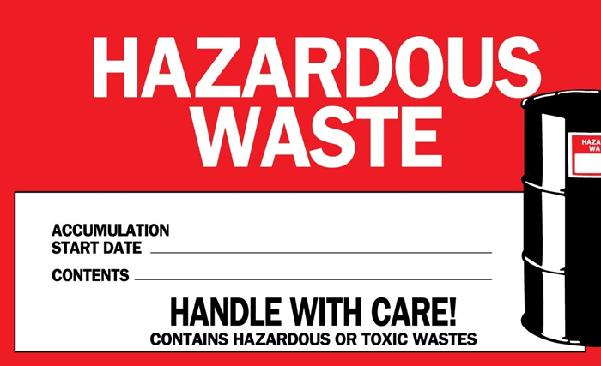

- Non-Regulated Waste
Non-Regulated Waste is the category for certain materials failing to meet EPA criteria of a characteristic or listed hazardous waste that may still present a hazard to people and the environment.
  - Record the “Shipper” as Lexington, KY VAMC
  - Record the description and percentage of each constituent in the waste container.
  - We are not required to record a date of any kind on the label.
  - Unused reagents that contain Sodium azide should be disposed of as “Non-Regulated Waste” or RCRA equivalent.
  - When the non-regulated waste container is full, fill out a chemical pickup form, and place the labeled non-regulated waste container in the hazardous waste satellite accumulation area.

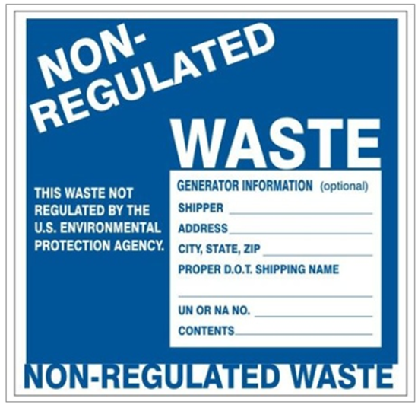

- Universal Waste

Universal waste is a category of waste materials designated as "hazardous waste", but containing materials that are very common to all industry groups and facilities.

  - Universal waste must be labeled with a “Universal Waste” label.
    - Record the contents of the waste container
    - Record the start date of accumulation
    - Record the address as Lexington, KY VAMC
  - Universal waste may be accumulated for no longer than one year
  - Common items that must be categorized as ‘Universal Waste”
    - Batteries
    - Mercury containing light bulbs
      - Fluorescent tubes
      - Compact Fluorescent Lights (CFL)

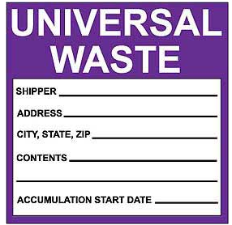

Proper Chemical Waste Disposal

- Accumulation Requirements

  - Chemical waste is accumulated at or near the point of generation, under the control of trained laboratory workers.

  - Each waste type should be stored in a compatible container pending transfer or disposal. Waste containers should be clearly labeled with the appropriate waste label.

  - Inspect daily for spills, proper closure, properly protected drains, and full containers are in the process of being picked up.

  - Ensure limits of 55 gallons of hazardous waste or 1 quart of acute hazardous waste are not being reached.

  - Never store incompatible waste next to one another. Waste containers should be segregated by how they will be managed. Waste containers should be stored in a designated location that does not interfere with normal laboratory operations. Ventilated storage and secondary containment may be appropriate for certain waste types.
Waste Streams | Are not Compatible with…
Cyanides | Acids
Sulfides | Acids
Oxidizers | Organics or Flammables
Strong Acids | Bases
Hydrazine | Oxidizers
Strong Acids and Bases | Flammables
Acids | Chlorine Compounds
Water or Air Reactive | Almost Everything

- Point of Generation

  - When a hazardous waste leaves the generator’s control and is no longer at the “point of generation” a date must be written on the Hazardous Waste label in the central accumulation area.

  - Is it in a central accumulation area, which is out of eyesight from your work area? If so, date the label.

  - P&LMS has five Hazardous Waste Satellite Accumulation Areas and one Hazardous Waste Central Accumulation Area (Room B110).

    - Cytology waste which is under the generator’s control; therefore, no date is placed on the container during the period the container is being used. When the waste is moved to B110 an accumulation date is required. The appropriate HCS pictogram should be attached to the accumulation container.
    - Histology waste in B110 is under the generator’s control; therefore, no date is placed on the container during the period the container is being used. If the waste is from an area outside of Histology (outside of generator’s control), an accumulation date and appropriate HCS pictogram is required.
    - Cepheid waste in B102 is under the generator’s control; therefore, no date is on the container during the period the container is being used.
    - Hematology waste in B102 is under the generator’s control; therefore, no date is on the container during the period the container is being used.
    - Microbiology waste in B114 is under the generator’s control; therefore, no date is placed on the container during the period the container is being used. If the waste is from an area outside of Microbiology (outside of generator’s control), an accumulation date is required.

- Container Management

  - Containers must always be closed in storage, except when adding or removing waste.
  - Container lids must be tight fitting and non-leaking.
  - Improper lids include:
    - Corks
    - Parafilm
    - Funnels
  - Leave containers with 1-2 inches of head space for thermal expansion.
  - When possible, use the original chemical container for the waste chemical.

- Waste Minimization

  - Substitution – If possible, replace use of a hazardous material with a less hazardous or non-hazardous one
  - Redistribution – If no longer needed in your lab, consider another lab that might use it
  - Ordering Practices – Order only what you need based on shelf life & amounts needed
  - Do not place any non-hazardous items in hazardous waste if all possible

- Liquid wastes

  - Some liquids may be flushed into the sewer system with copious amounts of water if the chemical volume is minimal – refer to the SDS.

  - Disposal through the sewer system must comply with all Federal, State, and local regulations and ordinances.

  - The Safety Officer shall be consulted when in doubt of whether a chemical can be disposed via the sewer system.

- Chemicals containing Methanol, Mercury, Ethanol, and Stain Waste

  - Shall be collected into separate containers and labeled with a hazardous waste label.

  - Xylene and alcohol may be collected in the same container.

  - Do not store container near a sink in case of accidental spill.

  - The chemicals must be disposed of at one of the laboratory’s designated Hazardous Waste Satellite Accumulation Areas.

- Mercury Disposal

Based on the mercury reduction goal presented by the Environmental Protection Agency (EPA) and the American Hospital Association to eliminate mercury from hospitals by 2005, our laboratory eliminates or reduces mercury as it is found and is replaced (if possible) with an acceptable substitute. For more information, see Attachment P: Management of Mercury in VHA Facilities VHA Directive 7706.

  - Items found containing mercury shall be reported to the Laboratory Safety Officer. If possible, these items are collected in a safe location, pending disposal by the Safety Office per contract.

  - Chemical waste containing mercury (stains, fixatives, etc) shall be collected into containers with a hazardous waste label.
    - A complete list and percentage of all chemicals contained must be included on the label.
    - Do not store next to sink in case of accidental spill.
    - When full, the containers shall be moved to the appropriate satellite accumulation area to await disposal per contract.

- Unused acids or bases must be disposed of as “Hazardous Waste”

  - Do not store container near a sink in case of accidental spill.

  - Acid and base waste must be kept separate.

  - The chemicals must be disposed of at one of the laboratory’s Hazardous Waste Satellite Accumulation Areas.

- Thiocyanate must be handled as a RCRA equivalent.

  - RCRA equivalent reagents and chemicals shall be disposed of in a bin or container marked “Non-Regulated Waste” (found on the back bench of Chemistry) When the bin or container is near full, fill out a chemical pickup form and have the GEMS coordinator pick them up.

  - Label shall include the shipper’s name, and a complete list and percentage of all chemicals in the container.

- Cepheid waste cartridges containing sodium hydroxide (NaOH) and should be managed as
waste pH > 12.5. Additionally, waste cartridges containing chemical reagents and biological fluids should be considered “mixed waste”. The flu cartridges contain ethanol and should also be considered as “mixed waste”

  - The Cepheid cartridges shall be collected in a container labeled as mixed waste.

  - When the container is near full, fill out a chemical pickup form and have the GEMS coordinator pick them up.

  - Label should include date accumulation ends and complete list and percentage of all chemicals in the container.

- How to Request a VA Chemical Pickup

- Go to the Public drive via "My Computer". First, open the "Safety Office" folder and then open its subfolder "Request for a VA Chemical Pickup". This will give you access to the "\\v09.med.va.gov\lex\Public\Safety Office\Request for a VA Chemical Pickup\Request for a VA Chemical Pickup.xsn" template (see circled xsn file below). Double click on this file. Microsoft InfoPath needs to be on your computer and you must have access to Outlook to submit this form.
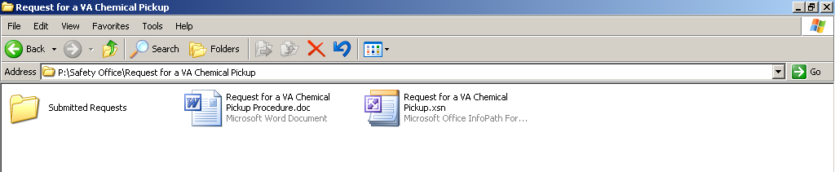

- Below is the initial page with instructions.

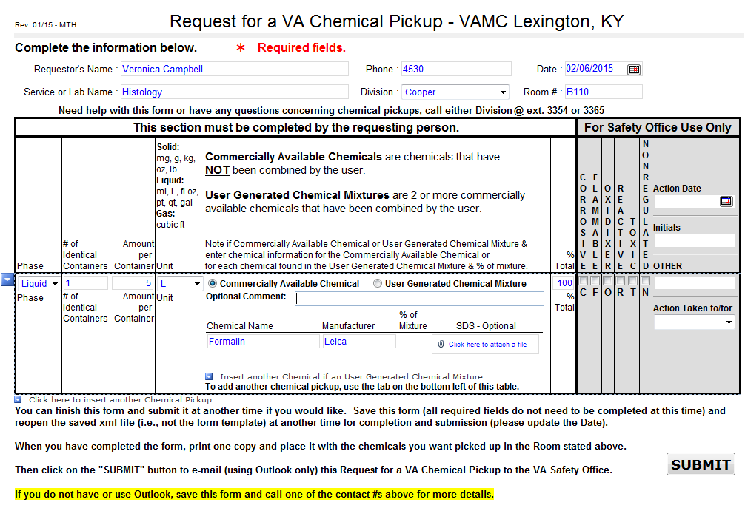


Contractor Hazard Information Exchange

- A Contractor’s employees may be exposed to hazardous chemicals used or stored at this facility in the process of doing their work. Likewise, the Contractor’s employees may use hazardous chemicals that could expose VA employees.

- The Engineering Service, Planning Section delegated Project Manager will obtain SDS’ from the Contractor and make copies available to the supervisor(s) in the area where the Contractor’s employees will be working.

- The delegated manager will introduce the contractor’s foreman to the VA supervisor (s) in the work area.

- The VA supervisor will show the foreman where the SDS’ are located.

- The VA supervisor(s) and Contractor foreman will exchange any necessary hazards and label information so both the VA and the Contractor are fully informed about hazardous chemicals to be used in the area.

- These individuals will train their respective employees on the hazards involved and on any emergency procedures required.

- The delegated Project Manager will submit an e-mail with an attachment documenting the completion of the above procedures to the Safety Office/SDS Coordinator (138 CDD).

Record Maintenance

- Engineering Service, Safety Section will maintain exposure records, i.e. workplace monitoring results, for at least thirty (30) years.

- Employee Health records will be maintained by the Occupational Health Office.

- Service Chiefs will maintain related training records.

- According to 29 CFR 1910.1020(d) (1) (ii) (B), SDS’ for chemicals no longer in use shall be retained for 30 years. The retired SDS should also document when the chemical was used, what department it was used in and the retirement date. The retired SDS’s will be stored in B112 in binders titled “Retired SDS’s”.

Monitoring for Exposure
- Exposure or exposed means that an employee is subjected to a hazardous chemical in the course of employment through any route entry (inhalation, ingestion, skin contact or absorption, etc.) and includes potential (e.g. accidental or possible) exposure as referenced by the SDS. When the employer discovers that an employee has received an exposure to any substance or agent, the employer must immediately notify the employee and take such steps that may be necessary to provide medical evaluation, monitoring, or treatment. Likewise, an employee that has received a potentially hazardous exposure to a substance or agent must immediately notify the employer of such exposure.

- Employees are notified of any monitoring results within 15 working days after the receipt of the results.

- The following chemicals are routinely monitored:
  - Formaldehyde
    - Signs of formaldehyde overexposure include:
      - irritation of the eyes, nose, and throat, even at low levels for short periods
      - Longer exposure or higher doses can cause coughing or choking.
      - Severe exposure can cause death from throat swelling or from chemical burns to the lungs.
      - Direct contact with the skin, eyes, or gastrointestinal tract can cause serious burns.
    - Exposure to any formaldehyde solution, gas or mixture composed of more than 0.1% formaldehyde is considered a potential carcinogen.
    - When employees’ skin could have become splashed with solutions containing 0.1% or greater formaldehyde, employees must flush the affected area with copious amounts of water.
    - The employer must assure that no employee is exposed to an airborne concentration of formaldehyde exceeding 0.75 ppm calculated as an eight hour time weighted average or 2 ppm as a 15 minute STEL (short term exposure limit).
    - The initial monitoring process shall be repeated each time there is a change in production, equipment, process, personnel, or control measures which may result in new or additional exposure to formaldehyde.
    - The employer shall periodically measure and accurately determine exposure to formaldehyde for employees shown by the initial monitoring to be exposed at or above the action level or at or above the STEL
    - Affected employees or their designated representatives have an opportunity to observe any monitoring of employee exposure to formaldehyde required by OSHA standard.
    - If the last monitoring results reveal employee exposure at or above the action level, the employer shall repeat monitoring of the employees at least every 6 months.
    - If the last monitoring results reveal employee exposure at or above the STEL, the employer shall repeat monitoring of the employees at least once a year under worst conditions.
    - The employer may discontinue periodic monitoring for employees if results from two consecutive sampling periods taken at least 7 days apart show that employee exposure is below the action level and the STEL. The results must be statistically representative and consistent with the employer's knowledge of the job and work operation.
    - Employees at risk of potential over exposure to formaldehyde are monitored by badge on a semi-annual basis and if positive, then quarterly thereafter.
    - Exposure badges are furnished by the Safety Office and are sent to an outside laboratory for analysis.
    - The safety Office will forward the original copy of the results for review by the Medical Safety Officer. A copy will be given to the Anatomic, Microbiology or Hematology supervisor. The Service Chief will be notified in the event of an overexposure.
    - In the event of overexposure, the employee must be notified in writing by supervisor within 15 days of receiving results. Employee Health must also be notified.
    - All results must be shared with the employee(s) monitored.
    - Plans must be implemented to reduce exposure.Areas identified as exceeding permissible exposure limits must be identified with the following warning:

DANGER
FORMALDEHYDE
Irritant and possible cancer hazard
AUTHORIZED PERSONNEL ONLY

  - Xylene
    - Signs of Xylene overexposure include:
      - dizziness, excitement, drowsiness, incoordination, staggering gait, impaired reaction time, impaired short-term memory; headache; eye, nose, throat irritation; corneal vacuolization; anorexia; nausea, vomiting, abdominal pain; dryness and scaling of the skin, dermatitis;
      - reversible liver and kidney damage after exposure to sudden high concentrations.
    - The odor threshold for xylene is 1 part per million ppm parts of air. Because this value is below the Occupational Safety and Health Administration (OSHA) current permissible exposure limit (PEL) of 100 ppm [29 CFR 1910.1000, Table Z-1-A], xylene is considered to have adequate warning properties.
    - The current OSHA PEL for xylene is 100 ppm (435 milligrams per cubic meter (mg/m (3)) of air) as an 8-hour time-weighted average (TWA) concentration. The OSHA limits are based on the risk of irritant, narcotic, and chronic effects associated with exposure to xylene.
    - Exposure is not to exceed 150 ppm per 15 minute short term exposure limit (STEL).
    - Employees at risk of exposure are monitored by badge on a semi-annual basis.
    - Exposure badges are furnished by the Safety Office and sent to an outside laboratory for analysis.
    - The Safety Office will forward the original copy of the results for review by the Medical Center Safety Officer. A copy will be given to the Anatomic, Microbiology or Hematology Section Supervisor. The Service Chief will be notified in the event of an overexposure.
    - The employee must be notified of any monitoring results in writing by supervisor within 15 days of receiving results. Employee Health must also be notified.
    - In the event of an exposure, plans must be implemented to reduce future exposure.

  - Mercury (only in the case of a large spill)
For more information, see Attachment P: Management of Mercury in VHA Facilities VHA Directive 7706.
    - Signs of Mercury overexposure include:
      - Tremors; emotional changes (e.g., mood swings, irritability, nervousness, excessive shyness); insomnia; neuromuscular changes (such as weakness, muscle atrophy, twitching); headaches; disturbances in sensations; changes in nerve responses; performance deficits on tests of cognitive function.
      - At higher exposures, there may be kidney effects, respiratory failure and death.

    - The allowable airborne concentration of mercury shall be interpreted as 0.1 mg/m⁽³⁾ as determined on the basis of the full shift time-weighted average.

Medical Surveillance

- The Personnel Health Service administers the medical surveillance program for all VA employees who work with hazardous chemicals under the following circumstances:

  - Whenever an employee develops signs and symptoms possibly associated with exposure to a hazardous chemical in the lab

  - Where exposure monitoring reveals an exposure level routinely above the action level, permissible exposure, or short term exposure limit for a regulated hazardous chemical

  - Whenever an employee is believed to have been exposed to a hazardous chemical during an emergency (spill, leak, etc.).

- This program allows affected employees to receive medical attention, including any follow-up examinations that the examining physician determines to be necessary. The physician will be provided the following information:

  - The identity of the hazardous chemical(s) to which the employee was exposed

  - The conditions under which the exposure occurred including any quantitative exposure data

  - A description of the signs and symptoms of exposure that the employee is experiencing

- The examining physician will provide his written opinion to include:

  - Any recommendations for further medical follow-up

  - The results of medical examination and testing

  - Any medical condition which may place the employee at increased risk as a result of exposure

  - A statement that the employee has been informed of the results of examination and any medical condition that may require further follow-up

Emergency First Aid Procedures

- Eye
  - In the event of a chemical splash to the eyes, ask co-workers to help you wash the eyes thoroughly. Lift eye lids to avoid pooling of chemicals under eyelids. Flush with water for 15 minutes.

  - Seek medical attention immediately

  - Report accident to immediate supervisor

- Cuts, punctures and needle sticks: (MUST BE REPORTED TO EMPLOYEE HEALTH)

  - If the injuries are clean cuts, punctures, or needle sticks, clean the affected area immediately with soap, then flood or soak affected area in water. Bandage to prevent infection.

  - If the injuries are dirty cuts, punctures, or needle sticks, i.e. those contaminated with patient blood or body fluids or bacterial agents, proceed as above as long as no object which caused the wound is left in the wound.

  - If the object causing the injury is not easily removed, do not attempt to cleanse the area. Doing so may cause further damage. Consult Employee Health immediately.

  - If the objects which cause the injury are contaminated with patient's specimens, identify the specimen with the patient's name for further evaluation and investigation by Employee Health. Thoroughly cleanse wound. Report to Employee Health at once.

  - Report all accidents of any degree to your supervisor and consult Employee Health.

- Chemical Burns

  - Corrosives can cause second or third degree burns. These chemicals include alkalis such as sodium hydroxide and common acids such as hydrochloric, sulfuric, and nitric.

  - Chemicals should be diluted and washed off with copious amounts of water. Minor splashes and spills can be flooded in a sink. Larger splashes and spills require the use of the emergency drench type laboratory shower. Enlist the help of co-workers. Some chemical powders should be brushed off the skin, before flooding with water, to avoid further skin and tissue damage. Always consult the chemical manufacturer's SDS for emergency first aid procedures BEFORE working with any chemical.

Accident Reporting

- Employees who incur a work related injury or illness must notify their supervisor immediately.

- Supervisors must initiate the ASISTS accident report (VA Form 2162) immediately followed by an accident investigation within 72 hours of the notification to allow the organization to meet the OSHA recordkeeping requirements

- Corrective actions shall be initiated quickly to prevent repeating the incident and to remove the hazardous condition.

- If the employee needs to be seen by a physician, a CA-17 must be filled out by the supervisor and given to the employee to take with them to the physician.

- If the employee is filing for Worker’s Compensation, the CA 1 and 2 on ASISTS will need to be filled out.

- Printed copies of all reports will be submitted to the Laboratory Safety Officer and kept on file.

Policy regarding medical evaluation of employees who habitually demonstrate unsafe work practices.

- Each laboratory employee is responsible for complying with oral and written safety rules, regulations and procedures required for the task assigned.

- In the event that an employee habitually does not follow safe work practices, they will be referred to the Laboratory Chief Medical Technologist for evaluation and, if necessary, in turn be referred to the Employee Health Physician for subsequent evaluation.

References

Comprehensive Guide to Laboratory Safety, 2nd Edition | Terry Jo Gile, MT(ASCP), MA Ed
Formaldehyde | SOP-ENG-138-12 (Formerly Memorandum 138-31
Hazard Communication Program | VAMC Memorandum 138-07
Hazardous Waste Management | VAMC Memorandum 138-16
International Agency for Research on Cancer | Group 1
International Agency for Research on Cancer | Group 2A
International Agency for Research on Cancer | Group 2B
National Toxicology Program Report on Carcinogens | 13th ROC (2014)
NIOSH Carcinogen List  Last updated: May 2, 2012 | http://www.cdc.gov/niosh/topics/cancer/npotocca.html
OSHA Laboratory Standard | 29 CFR 1910.1450
OSHA 1910, Subpart Z, Toxic and Hazardous Substances | 29 CFR 1910, Subpart Z
Formaldehyde Standard | 29CFR 1910.1048 and Appendices A, B, C, D, and E
Formaldehyde OSHA Fact Sheet | https://www.osha.gov/OshDoc/data_General_Facts/formaldehyde-factsheet.html
National Research Council Recommendations Concerning Chemical Hygiene in Laboratories (Non-Mandatory) 1910.1450 App A | https://www.osha.gov/pls/oshaweb/owadisp.show_document?p_table=STANDARDS&p_id=10107
Management of Hazardous Chemicals | VHA Directive 7705
Occupational Safety and Health (OSH) Program Procedures | VHA Handbook 7701.01
Occupational Safety And Health (OSH) | VHA Directive 7701
OSHA Quick Card - Hazard Communication  Safety Data Sheets | https://www.osha.gov/Publications/OSHA3493QuickCardSafetyDataSheet.pdf
Mercury Management | VA Directive 7706

Attachment A: The OSHA Laboratory Standard (29 CFR 1910.1450)
Part Number: | 1910
• Part Title: | Occupational Safety and Health Standards
• Subpart: | Z
• Subpart Title: | Toxic and Hazardous Substances
• Standard Number: | 1910.1450
• Title: | Occupational exposure to hazardous chemicals in laboratories.
• Appendix: | A , B
• GPO Source: | e-CFR

1910.1450(a)
Scope and application.
1910.1450(a)(1)
This section shall apply to all employers engaged in the laboratory use of hazardous chemicals as defined below.
1910.1450(a)(2)
Where this section applies, it shall supersede, for laboratories, the requirements of all other OSHA health standards in 29 CFR part 1910, subpart Z, except as follows:
1910.1450(a)(2)(i)
For any OSHA health standard, only the requirement to limit employee exposure to the specific permissible exposure limit shall apply for laboratories, unless that particular standard states otherwise or unless the conditions of paragraph (a)(2)(iii) of this section apply.
1910.1450(a)(2)(ii)
Prohibition of eye and skin contact where specified by any OSHA health standard shall be observed.
1910.1450(a)(2)(iii)
Where the action level (or in the absence of an action level, the permissible exposure limit) is routinely exceeded for an OSHA regulated substance with exposure monitoring and medical surveillance requirements paragraphs (d) and (g)(1)(ii) of this section shall apply.
1910.1450(a)(3)
This section shall not apply to:
1910.1450(a)(3)(i)
Uses of hazardous chemicals which do not meet the definition of laboratory use, and in such cases, the employer shall comply with the relevant standard in 29 CFR part 1910, subpart Z, even if such use occurs in a laboratory.
1910.1450(a)(3)(ii)
Laboratory uses of hazardous chemicals which provide no potential for employee exposure. Examples of such conditions might include:
1910.1450(a)(3)(ii)(A)
Procedures using chemically-impregnated test media such as Dip-and-Read tests where a reagent strip is dipped into the specimen to be tested and the results are interpreted by comparing the color reaction to a color chart supplied by the manufacturer of the test strip; and
1910.1450(a)(3)(ii)(B)
Commercially prepared kits such as those used in performing pregnancy tests in which all of the reagents needed to conduct the test are contained in the kit.
1910.1450(b)
Definitions —
Action level means a concentration designated in 29 CFR part 1910 for a specific substance, calculated as an eight (8)-hour time-weighted average, which initiates certain required activities such as exposure monitoring and medical surveillance.
Assistant Secretary means the Assistant Secretary of Labor for Occupational Safety and Health, U.S. Department of Labor, or designee.
Carcinogen (see select carcinogen).
Chemical Hygiene Officer means an employee who is designated by the employer, and who is qualified by training or experience, to provide technical guidance in the development and implementation of the provisions of the Chemical Hygiene Plan. This definition is not intended to place limitations on the position description or job classification that the designated individual shall hold within the employer's organizational structure.
Chemical Hygiene Plan means a written program developed and implemented by the employer which sets forth procedures, equipment, personal protective equipment and work practices that (i) are capable of protecting employees from the health hazards presented by hazardous chemicals used in that particular workplace and (ii) meets the requirements of paragraph (e) of this section.
Emergency means any occurrence such as, but not limited to, equipment failure, rupture of containers or failure of control equipment which results in an uncontrolled release of a hazardous chemical into the workplace.
Employee means an individual employed in a laboratory workplace who may be exposed to hazardous chemicals in the course of his or her assignments.
Hazardous chemical means any chemical which is classified as health hazard or simple asphyxiant in accordance with the Hazard Communication Standard (§1910.1200).
Health hazard means a chemical that is classified as posing one of the following hazardous effects: Acute toxicity (any route of exposure); skin corrosion or irritation; serious eye damage or eye irritation; respiratory or skin sensitization; germ cell mutagenicity; carcinogenity; reproductive toxicity; specific target organ toxicity (single or repeated exposure); aspiration hazard. The criteria for determining whether a chemical is classified as a health hazard are detailed in appendix A of the Hazard Communication Standard (§1910.1200) and §1910.1200(c) (definition of "simple asphyxiant").
Laboratory means a facility where the "laboratory use of hazardous chemicals" occurs. It is a workplace where relatively small quantities of hazardous chemicals are used on a non-production basis.
Laboratory scale means work with substances in which the containers used for reactions, transfers, and other handling of substances are designed to be easily and safely manipulated by one person. "Laboratory scale" excludes those workplaces whose function is to produce commercial quantities of materials.
Laboratory-type hood means a device located in a laboratory, enclosure on five sides with a moveable sash or fixed partial enclosed on the remaining side; constructed and maintained to draw air from the laboratory and to prevent or minimize the escape of air contaminants into the laboratory; and allows chemical manipulations to be conducted in the enclosure without insertion of any portion of the employee's body other than hands and arms.
Walk-in hoods with adjustable sashes meet the above definition provided that the sashes are adjusted during use so that the airflow and the exhaust of air contaminants are not compromised and employees do not work inside the enclosure during the release of airborne hazardous chemicals.
Laboratory use of hazardous chemicals means handling or use of such chemicals in which all of the following conditions are met:
(i) Chemical manipulations are carried out on a "laboratory scale;"
(ii) Multiple chemical procedures or chemicals are used;
(iii) The procedures involved are not part of a production process, nor in any way simulate a production process; and
(iv) "Protective laboratory practices and equipment" are available and in common use to minimize the potential for employee exposure to hazardous chemicals.
Medical consultation means a consultation which takes place between an employee and a licensed physician for the purpose of determining what medical examinations or procedures, if any, are appropriate in cases where a significant exposure to a hazardous chemical may have taken place.
Mutagen means chemicals that cause permanent changes in the amount or structure of the genetic material in a cell. Chemicals classified as mutagens in accordance with the Hazard Communication Standard (§1910.1200) shall be considered mutagens for purposes of this section.
Physical hazard means a chemical that is classified as posing one of the following hazardous effects: Explosive; flammable (gases, aerosols, liquids, or solids); oxidizer (liquid, solid, or gas); self reactive; pyrophoric (gas, liquid or solid); self-heating; organic peroxide; corrosive to metal; gas under pressure; in contact with water emits flammable gas; or combustible dust. The criteria for determining whether a chemical is classified as a physical hazard are in appendix B of the Hazard Communication Standard (§1910.1200) and §1910.1200(c) (definitions of "combustible dust" and "pyrophoric gas").
Protective laboratory practices and equipment means those laboratory procedures, practices and equipment accepted by laboratory health and safety experts as effective, or that the employer can show to be effective, in minimizing the potential for employee exposure to hazardous chemicals.
Reproductive toxins mean chemicals that affect the reproductive capabilities including adverse effects on sexual function and fertility in adult males and females, as well as adverse effects on the development of the offspring. Chemicals classified as reproductive toxins in accordance with the Hazard Communication Standard (§1910.1200) shall be considered reproductive toxins for purposes of this section.
Select carcinogen means any substance which meets one of the following criteria:
(i) It is regulated by OSHA as a carcinogen; or
(ii) It is listed under the category, "known to be carcinogens," in the Annual Report on Carcinogens published by the National Toxicology Program (NTP) (latest edition); or
(iii) It is listed under Group 1 ("carcinogenic to humans") by the International Agency for Research on Cancer Monographs (IARC) (latest editions); or
(iv) It is listed in either Group 2A or 2B by IARC or under the category, "reasonably anticipated to be carcinogens" by NTP, and causes statistically significant tumor incidence in experimental animals in accordance with any of the following criteria:
(A) After inhalation exposure of 6–7 hours per day, 5 days per week, for a significant portion of a lifetime to dosages of less than 10 mg/m³;
(B) After repeated skin application of less than 300 (mg/kg of body weight) per week; or
(C) After oral dosages of less than 50 mg/kg of body weight per day.
1910.1450(c)
Permissible exposure limits. For laboratory uses of OSHA regulated substances, the employer shall assure that laboratory employees' exposures to such substances do not exceed the permissible exposure limits specified in 29 CFR part 1910, subpart Z.
1910.1450(d)
Employee exposure determination --
1910.1450(d)(1)
Initial monitoring. The employer shall measure the employee's exposure to any substance regulated by a standard which requires monitoring if there is reason to believe that exposure levels for that substance routinely exceed the action level (or in the absence of an action level, the PEL).
1910.1450(d)(2)
Periodic monitoring. If the initial monitoring prescribed by paragraph (d)(1) of this section discloses employee exposure over the action level (or in the absence of an action level, the PEL), the employer shall immediately comply with the exposure monitoring provisions of the relevant standard.
1910.1450(d)(3)
Termination of monitoring. Monitoring may be terminated in accordance with the relevant standard.
1910.1450(d)(4)
Employee notification of monitoring results. The employer shall, within 15 working days after the receipt of any monitoring results, notify the employee of these results in writing either individually or by posting results in an appropriate location that is accessible to employees.
1910.1450(e)
Chemical hygiene plan -- General. (Appendix A of this section is non-mandatory but provides guidance to assist employers in the development of the Chemical Hygiene Plan).
1910.1450(e)(1)
Where hazardous chemicals as defined by this standard are used in the workplace, the employer shall develop and carry out the provisions of a written Chemical Hygiene Plan which is:
1910.1450(e)(1)(i)
Capable of protecting employees from health hazards associated with hazardous chemicals in that laboratory and
1910.1450(e)(1)(ii)
Capable of keeping exposures below the limits specified in paragraph (c) of this section.
1910.1450(e)(2)
The Chemical Hygiene Plan shall be readily available to employees, employee representatives and, upon request, to the Assistant Secretary.
1910.1450(e)(3)
The Chemical Hygiene Plan shall include each of the following elements and shall indicate specific measures that the employer will take to ensure laboratory employee protection;
1910.1450(e)(3)(i)
Standard operating procedures relevant to safety and health considerations to be followed when laboratory work involves the use of hazardous chemicals;
1910.1450(e)(3)(ii)
Criteria that the employer will use to determine and implement control measures to reduce employee exposure to hazardous chemicals including engineering controls, the use of personal protective equipment and hygiene practices; particular attention shall be given to the selection of control measures for chemicals that are known to be extremely hazardous;
1910.1450(e)(3)(iii)
A requirement that fume hoods and other protective equipment are functioning properly and specific measures that shall be taken to ensure proper and adequate performance of such equipment;
1910.1450(e)(3)(iv)
Provisions for employee information and training as prescribed in paragraph (f) of this section;
1910.1450(e)(3)(v)
The circumstances under which a particular laboratory operation, procedure or activity shall require prior approval from the employer or the employer's designee before implementation;
1910.1450(e)(3)(vi)
Provisions for medical consultation and medical examinations in accordance with paragraph (g) of this section;
1910.1450(e)(3)(vii)
Designation of personnel responsible for implementation of the Chemical Hygiene Plan including the assignment of a Chemical Hygiene Officer, and, if appropriate, establishment of a Chemical Hygiene Committee; and
1910.1450(e)(3)(viii)
Provisions for additional employee protection for work with particularly hazardous substances. These include "select carcinogens," reproductive toxins and substances which have a high degree of acute toxicity. Specific consideration shall be given to the following provisions which shall be included where appropriate:
1910.1450(e)(3)(viii)(A)
Establishment of a designated area;
1910.1450(e)(3)(viii)(B)
Use of containment devices such as fume hoods or glove boxes;
1910.1450(e)(3)(viii)(C)
Procedures for safe removal of contaminated waste; and
1910.1450(e)(3)(viii)(D)
Decontamination procedures.
1910.1450(e)(4)
The employer shall review and evaluate the effectiveness of the Chemical Hygiene Plan at least annually and update it as necessary.
1910.1450(f)
Employee information and training.
1910.1450(f)(1)
The employer shall provide employees with information and training to ensure that they are apprised of the hazards of chemicals present in their work area.
1910.1450(f)(2)
Such information shall be provided at the time of an employee's initial assignment to a work area where hazardous chemicals are present and prior to assignments involving new exposure situations. The frequency of refresher information and training shall be determined by the employer.
1910.1450(f)(3)
Information. Employees shall be informed of:
1910.1450(f)(3)(i)
The contents of this standard and its appendices which shall be made available to employees;
1910.1450(f)(3)(ii)
the location and availability of the employer's Chemical Hygiene Plan;
1910.1450(f)(3)(iii)
The permissible exposure limits for OSHA regulated substances or recommended exposure limits for other hazardous chemicals where there is no applicable OSHA standard;
1910.1450(f)(3)(iv)
Signs and symptoms associated with exposures to hazardous chemicals used in the laboratory; and
1910.1450(f)(3)(v)
The location and availability of known reference material on the hazards, safe handling, storage and disposal of hazardous chemicals found in the laboratory including, but not limited to, safety data sheets received from the chemical supplier.
1910.1450(f)(4)
Training.
1910.1450(f)(4)(i)
Employee training shall include:
1910.1450(f)(4)(i)(A)
Methods and observations that may be used to detect the presence or release of a hazardous chemical (such as monitoring conducted by the employer, continuous monitoring devices, visual appearance or odor of hazardous chemicals when being released, etc.);
1910.1450(f)(4)(i)(B)
The physical and health hazards of chemicals in the work area; and
1910.1450(f)(4)(i)(C)
The measures employees can take to protect themselves from these hazards, including specific procedures the employer has implemented to protect employees from exposure to hazardous chemicals, such as appropriate work practices, emergency procedures, and personal protective equipment to be used.
1910.1450(f)(4)(ii)
The employee shall be trained on the applicable details of the employer's written Chemical Hygiene Plan.
1910.1450(g)
Medical consultation and medical examinations.
1910.1450(g)(1)
The employer shall provide all employees who work with hazardous chemicals an opportunity to receive medical attention, including any follow-up examinations which the examining physician determines to be necessary, under the following circumstances:
1910.1450(g)(1)(i)
Whenever an employee develops signs or symptoms associated with a hazardous chemical to which the employee may have been exposed in the laboratory, the employee shall be provided an opportunity to receive an appropriate medical examination.
1910.1450(g)(1)(ii)
Where exposure monitoring reveals an exposure level routinely above the action level (or in the absence of an action level, the PEL) for an OSHA regulated substance for which there are exposure monitoring and medical surveillance requirements, medical surveillance shall be established for the affected employee as prescribed by the particular standard.
1910.1450(g)(1)(iii)
Whenever an event takes place in the work area such as a spill, leak, explosion or other occurrence resulting in the likelihood of a hazardous exposure, the affected employee shall be provided an opportunity for a medical consultation. Such consultation shall be for the purpose of determining the need for a medical examination.
1910.1450(g)(2)
All medical examinations and consultations shall be performed by or under the direct supervision of a licensed physician and shall be provided without cost to the employee, without loss of pay and at a reasonable time and place.
1910.1450(g)(3)
Information provided to the physician. The employer shall provide the following information to the physician:
1910.1450(g)(3)(i)
The identity of the hazardous chemical(s) to which the employee may have been exposed;
1910.1450(g)(3)(ii)
A description of the conditions under which the exposure occurred including quantitative exposure data, if available; and
1910.1450(g)(3)(iii)
A description of the signs and symptoms of exposure that the employee is experiencing, if any.
1910.1450(g)(4)
Physician's written opinion.
1910.1450(g)(4)(i)
For examination or consultation required under this standard, the employer shall obtain a written opinion from the examining physician which shall include the following:
1910.1450(g)(4)(i)(A)
Any recommendation for further medical follow-up;
1910.1450(g)(4)(i)(B)
The results of the medical examination and any associated tests;
1910.1450(g)(4)(i)(C)
Any medical condition which may be revealed in the course of the examination which may place the employee at increased risk as a result of exposure to a hazardous workplace; and
1910.1450(g)(4)(i)(D)
A statement that the employee has been informed by the physician of the results of the consultation or medical examination and any medical condition that may require further examination or treatment.
1910.1450(g)(4)(ii)
The written opinion shall not reveal specific findings of diagnoses unrelated to occupational exposure.
1910.1450(h)
Hazard identification.
1910.1450(h)(1)
With respect to labels and safety data sheets:
1910.1450(h)(1)(i)
Employers shall ensure that labels on incoming containers of hazardous chemicals are not removed or defaced.
1910.1450(h)(1)(ii)
Employers shall maintain any safety data sheets that are received with incoming shipments of hazardous chemicals, and ensure that they are readily accessible to laboratory employees.
1910.1450(h)(2)
The following provisions shall apply to chemical substances developed in the laboratory:
1910.1450(h)(2)(i)
If the composition of the chemical substance which is produced exclusively for the laboratory's use is known, the employer shall determine if it is a hazardous chemical as defined in paragraph (b) of this section. If the chemical is determined to be hazardous, the employer shall provide appropriate training as required under paragraph (f) of this section.
1910.1450(h)(2)(ii)
If the chemical produced is a byproduct whose composition is not known, the employer shall assume that the substance is hazardous and shall implement paragraph (e) of this section.
1910.1450(h)(2)(iii)
If the chemical substance is produced for another user outside of the laboratory, the employer shall comply with the Hazard Communication Standard (29 CFR 1910.1200) including the requirements for preparation of safety data sheets and labeling.
1910.1450(i)
Use of respirators. Where the use of respirators is necessary to maintain exposure below permissible exposure limits, the employer shall provide, at no cost to the employee, the proper respiratory equipment. Respirators shall be selected and used in accordance with the requirements of 29 CFR 1910.134.
1910.1450(j)
Recordkeeping.
1910.1450(j)(1)
The employer shall establish and maintain for each employee an accurate record of any measurements taken to monitor employee exposures and any medical consultation and examinations including tests or written opinions required by this standard.
1910.1450(j)(2)
The employer shall assure that such records are kept, transferred, and made available in accordance with 29 CFR 1910.1020.
1910.1450(k)
[Reserved]
1910.1450(l)
Appendices. The information contained in the appendices is not intended, by itself, to create any additional obligations not otherwise imposed or to detract from any existing obligation.
[55 FR 3327, Jan. 31, 1990; 55 FR 7967, March, 6, 1990; 55 FR 12777, March 30, 1990; 61 FR 5507, Feb. 13, 1996; 71 FR 16674, April 3, 2006; 77 FR 17887, March 26, 2012]
Part Number: 1910
• Part Title: Occupational Safety and Health Standards
• Subpart: Z
• Subpart Title: Toxic and Hazardous Substances
• Standard Number: 1910.1450 App A
• Title: National Research Council Recommendations Concerning Chemical Hygiene in Laboratories (Non-Mandatory)

Attachment B: Memorandum 138-60 Hazard Communication Program
HAZARD COMMUNICATION PROGRAM
1. PURPOSE: To inform employees of known chemical hazards that may exist in the workplace in order to help maintain a safe environment for patients, visitors and employees. This will be accomplished through training, proper container labeling and Safety Data Sheets (SDS). The scope of this written Hazard Communications Program will cover both campuses of the Lexington VA Health Care System as well as all VA Clinics served by the Lexington VA Health Care System.
- 2. POLICY: This written hazard communication program complies with OSHA requirements and ensures employees are effectively informed concerning potential and existing chemical hazards. It is the policy of this medical center to pursue the greatest reasonable level of caution when using hazardous materials.

- a. The major elements of this program are as follows:

- Labels and other forms of warning

- Safety Data Sheets (SDS) from suppliers

- Safety Data Sheet Automated Library: e-MSDS through the Center for Engineering and Occupational Safety and Health (CEOSH)

- (4) Employee information and training

- (5) List of hazardous chemicals known to be present in the workplace

- (6) Methods for informing employees of hazards of non-routine tasks

- (7) Methods for informing contractor employers of hazards their employees may be exposed to while working in the medical center.

- b. Hazard communication - is one of the many aspects of the Occupational Safety and Health Program. It includes management commitment and active support; engineering controls for safety and health hazards; effective education and training programs; enforcement of safety rules and procedures; recognition, evaluation and control of occupational safety and health hazards; medical surveillance; accountability and management of hazardous waste.

- c. The Hazard Communication Program - applies to chemicals in the work place that may pose a hazard to employees under normal conditions when performing non-routine tasks or responding to foreseeable emergencies. This Hazard Communication Program relies on Safety Data Sheets (SDS) from manufacturers and suppliers for the purpose of hazard determination.
3. DEFINITIONS
a. For the purpose of this policy, the term “Hazardous” is used in a broad and general sense with respect to inventories, SDS files and the purchase of supplies. This is done to ensure that all hazardous chemicals are included and the latest SDS’ are on file.
b. Hazardous Chemical. Any chemical which is a physical hazard or health hazard.
c. Health Hazard. A chemical for which there is statistically significant evidence based on at least one study conducted in accordance with established scientific principles that acute or chronic health effects may occur in exposed employees. The term “health hazard” includes chemicals which are carcinogens, toxic or highly toxic agents, reproductive toxins, irritants, corrosives, sensitizers, hepatotoxins, nephrotoxins, and neurotoxins, agents which act on the hematopoietic system and agents which damage the lungs, skin, eyes or mucous membranes.
d. Physical Hazard. A chemical for which there is scientifically valid evidence that it is a combustible liquid, a compressed gas, explosive, flammable, an organic peroxide, an oxidize, pyrochoric, unstable (reactive), or water reactive. (See ATTACHMENT A for an expanded list of definitions)
- 4. RESPONSIBILITIES
a. Medical Center Director. Ensures effective hazard communication procedures are practiced and resources are available to support the program.
b. Service Chiefs or designees.
(1) Prepares and maintains a hazardous chemical inventory, utilizing the assistance of the Industrial Hygienist when needed.
(2) Ensures that the words “Hazardous – SDS Required” are included in the description of all purchase requests for materials containing hazardous chemicals. This requirement applies to procurement requests. If the item requested is a new hazardous material/chemical not currently on the service inventory, the Industrial Hygienist must be informed prior to acquisition for evaluation.
(3) Maintains a copy of each SDS received with a hazardous chemical for use in his/her service. The Safety Data Sheets will be readily accessible during each work shift to employees when they are in their work area.
(4) Provides annual training on hazard communication to their employees and maintain a record of this training.
(5) Ensures that any new chemicals are added to the hazardous chemical inventory list for the service.
(6) Electronically submits an updated chemical inventory semi-annually to the Industrial Hygienist (138CD) for all chemicals used by the service and/or CEOSH Electronic Inventory System.
c. Logistics Contracting Officer or Purchasing Agent. Ensures the hazardous material requirements in Federal Acquisition Regulation (FAR) Subpart 23.3 are contained in the acquisition document when the words “Hazardous – SDS Required” are on the purchase request. The Contracting Officer is responsible for utilizing the technical assistance of the Industrial Hygienist (IH) for assuring the SDS meets the requirements of 29 CFR 1910.1200(g). If the item requested is a new hazardous material/chemical not currently on the service inventory, the Industrial Hygienist must be informed prior to acquisition for evaluation. If the Contracting/Purchasing Agent receives a SDS, it will be sent to the Warehouse or Sterile Processing Service (SPS). When the hazardous material or chemical is delivered, the SDS will be given to the using service with the chemical. If the chemical is received and the SDS has not been included, the Warehouse or SPS will notify the Contracting Officer/Purchasing Agent and hold the chemical until the SDS is received or upon notification from the Industrial Hygienist to deliver. The Industrial Hygienist may allow immediate delivery, if the SDS for the specific hazardous material manufactured by the same manufacturer is already on file.
d. Credit Cardholder and Approving Official.
(a) At the time an order is placed, requests a copy of the SDS. The words “Hazardous – SDS Required” are to be included on the purchase order. If the item requested is a new hazardous material/chemical not currently on the service inventory, the Industrial Hygienist must be informed prior to acquisition for evaluation.
(b) When the chemical is received, the SDS is to remain in the service.
(c) Ensures that if an item is received without a SDS, the item is not delivered or used until a SDS is obtained. The Industrial Hygienist may allow immediate delivery, if the SDS for the specific hazardous material manufactured by the same manufacturer is already on file.
(d) Orders the smallest amount possible of the chemical to meet the immediate need. This allows the user to control access, use and minimize waste disposal costs due to outdated chemicals.
e. Industrial Hygienist.
(1) Implements the Hazardous Communication Program and assist services with the development and maintenance of a current list of chemicals used.
(2) Aids in the determination as to whether chemicals used are “hazardous” as defined by OSHA’s General Industry Standard 29 CFR 1910.1200.
(3) Aids in establishing proper review procedure to ensure compliance with JC standards which require that hazardous chemicals be handled safely.
(4) Reviews new chemical requests to ensure that the chemical is added to the service’s chemical inventory list and a current SDS is on file.
(5) Contacts the manufacturer and request a hard copy of a SDS be faxed immediately in an emergency or otherwise.
(6) Reviews in advance copies of Safety Data Sheets and provide recommendations as appropriate.
(7) Grants exemptions for requiring an SDS to be received before a chemical is released from the Warehouse or SPS as long as he/she established and verifies safety precautions for the exemption. Any hazardous material received by the facility without a SDS will be brought to the Industrial Hygienist’s immediate attention by the purchaser and instruction on its disposition will not exceed the next work day. The Industrial Hygienist will either grant an exemption or will instruct the purchaser to return it to the vendor. The Industrial Hygienist will consult with the user of a requested hazardous chemical without a SDS before a final disposition is made. The requesting service will be instructed to identify the user on the purchase request.
(8) Notifies the Union and affected employees of exemptions. Each exemption is limited to a maximum period of thirty (30) days. The contracting officer shall contact the supplier within 72 hours after the exception is granted.
(9) Assists the supervisors in the training of their employees on the safe handling, storage, and disposal of the hazardous chemicals in their area and how to interpret their SDS and container label warnings.
f. Supervisors.
(1) Ensures copies of all SDS for each hazardous material used in the work place is readily accessible during each work shift to employees when they are in their work areas.
(2) Maintains a current Hazardous Chemical List which will be placed at the beginning of the SDS book. The Hazard Chemical List will serve as an index and will assist in located a SDS quickly. Employees may request a copy of SDS if they wish.
(3) Conducts specific training on the use of hazardous chemical used in the workplace, including the use of appropriate protective equipment; make the chemical inventory and SDS accessible to employees during each work shift; make sure that labels and other forms of warning are not damaged or removed from chemical containers.
(4) Ensures those employees assigned non-routine tasks are informed of any hazards associated with infrequently used or unusual chemicals.
g. Research Service Investigators. Implements the Hazard Communication Program within Research Service, including the additional requirements contained in the Federal Regulation 29CFR1910.1450, “Occupational Exposure to Hazardous Chemicals in Laboratories.” This will include, but is not limited to, ensuring that SDS’ are available for hazardous chemicals purchased with both VA and other funds, and ensuring that training is received/conducted and documented according to this policy for both VA and no VA employees. All chemicals are received and distributed through the Research Office. Chemicals that are brought into the VA from other facilities will be brought into the Research Office for review and approval prior to distribution into the laboratories. Research Service chemical inventories are electronically submitted semi-annually utilizing the VA Biological and Chemical Inventory form (P:\Safety Office\Chemical Inventory\Submitted Inventories\Inventory Templates\VA Biological and Chemical Inventory.xns)
h. Chief, Pathology and Laboratory Medicine Service. Implements the Hazard Communication Program within Pathology and Laboratory Medicine Department including the additional requirements contained in the Federal Regulation 29CFR1910.1450, “Occupational Exposure to Hazardous Chemicals in Laboratories.”
i. Employees. The safe use handling and labeling of all chemicals and materials, and for becoming familiar with properties of the hazardous chemicals in their work area including those not routinely used through the training and SDS. We recommend personal protective equipment listed and inspected for hazard assessment and documents.
5. PROCEDURES
a. Employees - are discouraged from bringing any chemicals from home into the work environment to protect patients and staff from potential negative health exposures.
b. Chemicals - that are purchased over the counter as a consumer product and if their use is of the same duration or frequency as that of normal consumer use (see 29 CFR 1910.1200 (b) (6) (vii), an SDS may not be needed. Contact the Safety Office for guidance.
c. Labels and Other Forms of Warnings – Chemical manufacturers, importers, and distributors provide labels, tags or other markings for containers of hazardous chemicals. This identification includes the following information:
- Identity of the hazardous chemical
- Appropriate hazard warnings
- Name and address of the chemical manufacturer, distributor or other responsible party.
(1) The containers of hazardous materials in the workplace are required to be labeled, tagged or marked with the identity of the hazardous chemical and appropriate hazard warning.
(2) Portable containers of hazardous chemicals do not have to be labeled if they contain chemicals transferred from labeled containers and which are intended only for the immediate use of the employee who performs the transfer.
(3) All labels on incoming containers must not be defaced in any way. Missing or defaced labels must be immediately reported to the supervisor so appropriate labels can be reapplied immediately.
d. Safety Data Sheets (SDS) – SDSs are in English and contain: The identity of the chemical; the physical and chemical characteristics; the physical and health hazards; primary routes of entry; exposure limits; precautions for safe handling; controls to limit exposure; emergency and first aid procedures; and name of manufacturer or distributor. SDS may be obtained from the manufacturer or through the electronic library provided by the Center for Engineering and Occupational Safety and Health (CEOSH). Access to this site is available through the CEOSH intranet site (http://ceosh.med.va.gov).
(1) The SDS files consist of paper copies of SDS’ which are kept in three-ring binders. This file will be readily accessible in case of emergency.
(2) Each service will maintain a three ring binder of SDS for hazardous chemicals used in the workplace and will ensure that they are readily accessible to employees during each work shift.
(3) An SDS can be filed in any order suitable to the service; however, alphabetical filing by trade name or pure chemical name is the most common way. The most current copy of the SDS should be on file.
(4) The chemical inventory list will be used as the index for the SDS file.
(5) Chemicals that are obsolete and/or no longer in use will have SDS archived with the date the chemical was removed from service. The archived SDS may be scanned and saved electronically with the service for future retrieval.
e. Employee Information, Education and Training:
(1) The information, education and training program is provided by the supervisors to ensure employees know about hazardous chemicals in the workplace and the appropriate control measures to reduce exposure to them. This program is coordinated by the Safety Office/Industrial Hygienist. New employees will receive appropriate safety and health information, education and training soon after their initial assignment. This training will include information about hazardous material and classroom instruction. New employee safety and health training will begin upon hire during New Employee Training presented by the Safety Office. This training will include information about hazardous material and continue with on-site training by the employee’s supervisor. The specific information in the safety and health training includes:
- General chemical hazards
- Hazards associated with non-routine tasks
- Recognition, evaluation and control of hazardous chemicals. Methods and observations that may be used to detect the presence of released hazardous chemicals in the work area.
- Chemical labeling, tagging or marking
- Hazards associated with unlabeled piping and processing systems
- Safety Data Sheets
- Access to information on hazardous chemicals
- Compliance with safety and health rules and regulations
- Requirements of federal hazard communication regulations
- Specific hazards present in work areas
- The location and availability of the medical centers written hazard communication program and all supporting information
- The measures employees can take to protect themselves from hazards, including pertinent work practices, agencies, emergency procedures and personal protective equipment.

- (2) All employees are to be informed by their supervisor concerning the Hazard Communication Program, the medical center’s labeling system, SDSs, and how appropriate hazard information may be obtained. A report of all employees training will be maintained by the Service.
g. Material Inventory:
(1) An inventory of all hazardous chemicals and materials containing hazardous chemicals will be made for each service. The recommended electronic chemical inventory form is accessible on the public drive in the safety office file folder and also included in the annual email reminder sent to all service chiefs. (Attachment B) After the inventory is complete, SDSs will be ordered if they are not already available. All new hazardous chemicals added at a later date will go through the same process.
(2) After receiving an SDS in the Logistics Service, the SDS will be maintained in the using service’s file. These data sheets are to be used for guidance in the safe handling of hazardous materials. Employees desiring to see this list should contact their supervisor.
h. Continuing Education: It is necessary for work area supervision to provide additional employee training concerning work place hazards when:
- New materials or processes are introduced into the workplace
- Process or equipment changes are made that could cause new or increased employee exposure
- Procedures or work practices are introduced or changed, which could cause changes in the employee’s exposure
- Employees are transferred from one work area to another where different hazards are present
i. Non-routine Tasks: The supervisor of an employee performing a non-routine task, such as cleaning process equipment, is responsible for properly training the employee concerning the potential hazards associated with the task. The employee also shares in this responsibility by making sure his or her immediate supervisor knows that they will be performing a non-routine task.
- j Multi-Employee Workplaces (Contractors):

- (1) On –site contractors coming in direct contact with hazardous chemicals at this facility will be informed of the hazards involved.
- (2) On-site contractors will have a chemical inventory list, SDSs and their companies Hazard Communication Program available at a central location at their work site. A copy of the inventory, SDSs, or program will be provided to the COR per the contract specifications..

- (3) Contractor personnel will also be informed of proper labeling and container warnings. All labels of hazardous material containers must include the identity of the chemical or common name, and the appropriate hazard warning (e.g. Caution!). Shipped container labels must also include name and address of the manufacturer or importer.

- (4) On-site contractors will be informed of precautionary methods needed to be taken during the workplace’s normal operating conditions and in foreseeable emergencies.

- (5) The contractor will inform this facility of hazardous chemicals and hazards involved by hazardous material brought on site.

- (6) The contractor will coordinate with the Engineering Service Project Manager/COR and Safety Office.

- k. Program Availability: The medical center’s hazard communication program is available upon request to employees, OSHA representatives and contractors.

- l. Record Maintenance:
(1) Engineering Service, Safety Office will maintain exposure records, i.e. workplace monitoring results for at least thirty (30) days.
(2) Employee Health records will be maintained by the Occupational Health Office.
(3) Service Chief or designee will maintain related training records.
m. Exemptions (OSHA 29CFR 1910.1200)
(1) The following chemicals are exempt from the labeling requirements:
- Any pesticide as defined in the Federal Insecticide, Fungicide and Rodenticide Act.
- Any chemical substance or mixture as defined in the Toxic substance Control Act.
- Items covered under the Federal Food, Drug and Cosmetic Act or the Virus-Serum-Toxin Act 1913.
- Any hazardous substance as defined by the Comprehensive Environmental Response, Compensation and Liability Act; and waste subject to the Resource Conservation and Recovery Act of 1976.
(2) The following chemicals are exempt from all requirements:
(a) Articles (a manufactured item other than a fluid or particle, which: (i) is formed to a specific shape or design during manufacturer; (ii) has end use function(s) dependent in whole or in part upon its shape or design during end use; and, (iii) under normal conditions of use does not release more than very small quantities (e.g., minute or trace amounts of a hazardous chemical) and does not pose a physical hazard or health risk to employees).
(b) Items (consumer product or hazardous substances subject to the Consumer Product Safety Act and Federal Hazardous Substances Act where the employer can show that it is used in the workplace for the purpose intended by the chemical manufacturer or importer of the product, and the use results in a duration and frequency of exposure that is not greater than the range of exposures that could reasonably be experienced by consumers when used for the purpose intended).
(c) Any drug as that is defined in the Federal Food, Drug and Cosmetic Act which is in solid, final form for direct administration to the patient (e.g., tablets or pills); drugs that are packaged by the chemical manufacturer for sale to consumers in a retail establishment (e.g., over-the-counter drugs); and, drugs intended for personal consumption by employees while in the workplace (e.g., first aid supplies).
(d) Nuisance particulates where the chemical manufacturer can establish that they do not pose any physical or health hazard covered under this section.
(e) Ionizing and non-ionizing radiation.
(f) Biological hazards.
6. REFERENCES: OSHA 29CFR Part 1910.1200; 29CFR Part 1910.1450;
7. FOLLOW-UP RESPONSIBILLITY: Chief, Engineering Service (138).
8. RECERTIFICATION: March 2, 2025.

Michael M. Young
Chief Engineering
Attachments

ATTACHMENT A HAZARD COMMUNICATION PROGRAM DEFINITIONS
Absorption - The movement of a hazardous chemical through the skin and into the blood stream.
Acute - Short-term effect, usually of a temporary high-level exposure.
Boiling Point - The temperature at which a liquid boils at atmospheric pressure.
Carcinogen - A chemical which causes cancer.
Catalyst - A chemical which, without changing itself, causes a chemical reaction to proceed faster.
Ceiling Valve (C) - A maximum level. No exposure should ever exceed this level.
Chemical - Any element, chemical compound, or mixture of elements and/or compounds.
Chemical Name - The scientific designation of a chemical in accordance with the nomenclature system developed by the International Union of Pure and Applied Chemistry (IUPAC) or the Chemical Abstracts Service (CAS) rules of nomenclature, or a name which will clearly identify the chemical for the purpose of conducting a hazard evaluation.
Chronic - Long-term effect. Low-level exposure over long periods gives rise to symptoms that develop over time.
Combustible - A liquid that becomes flammable when heated above 100 degrees Fahrenheit.
Container - Any bag, barrel, bottle, box, can, cylinder, drum, reaction vessel, storage tank, or the like that contains a hazardous chemical.
Corrosive - A chemical that causes visible destruction on living tissue by chemical action at the site of contact.
Evaporation Rate - The time it takes a given amount of material too completely dry up, compared with an equal amount of a reference material.
Explosive - A chemical that causes a sudden, almost instantaneous release of pressure, gas, and heat when subjected to sudden shock, pressure, or high temperature.
Exposure or Exposed - Subjected to a hazardous chemical in the course of employment through any route of entry (inhalation, ingestion, skin contact or absorption, etc.), and includes potential (e.g. accidental or possible) exposure.
Flammable (Explosive) - Limits-LEL and UEL - A flammable material will burn in air when ignited. These materials are referred to as flammable, combustible, or explosive. The range of concentration in which these materials will burn is limited by the Lower Explosive Limit (LEL). When the gas or vapor is below this concentration, the mixture is too lean to burn. The Upper Explosive Limit (UEL) above this concentration is too rich for the mixture to burn.
Flash Point - The temperature at which a flammable liquid produces enough vapor to burn.
Hazard Warning - Any words, pictures, symbols, or combination thereof appearing on a label or other appropriate form of warning which convey the hazards of the chemical in the container.
Identity - Any chemical or common name which is indicated on the MSDS for the chemical. The identity used shall permit cross-references to be made among the required list of hazardous chemicals, the label and the MSDS.
Ingestion - Taking a material by mouth; eating it.
Inhalation - Breathing in a material.
Irritant - A chemical which causes a reversible inflammatory effect on living tissue by chemical action at the site of contact.
Label - Any written, printed, or graphic material displayed on or affixed to containers of hazardous chemicals.
Material Safety Data Sheet (MSDS) - Written or printed material concerning a hazardous chemical.
Medical Surveillance - Includes those activities and judgments that permit the early determination of a person's physiological and psychological response to toxic substances.
Mixture - Any combination of two or more chemicals if the combination is not, in whole or in part, the result of a chemical reaction.
Oral Dose (LD50) - The amount, usually expressed in milligrams per kilogram, which when fed to a group of animals will cause 50 per cent of them to die.
Oxidizing Agent - A material which gives off oxygen in a chemical reaction.
Reactivity - The ability of a material to undergo a reaction with release of energy or heat.
Sensitizer - A chemical which causes a substantial portion of exposed people to develop an allergic reaction in normal tissue after repeated exposure.
Solubility - The tendency of a material to dissolve in water or other solvent.
Specific Gravity - The weight per volume when compared to water.
Stability - The tendency of a material to resist undesirable chemical changes during storage or transportation.
Thermal Decomposition - The breakdown of a material when heated.
Threshold Limit Value (TLV and PEL) - The TLV is a safe exposure level set by the American Conference of Governmental Industrial Hygienists (ACGIH). A Permissible Exposure Limit (PEL) is a similar level set by OSHA. Both signify a level at which you can be exposed day after day with no adverse effects.
Toxicity - The degree of injury or illness caused by a poisonous material.
Unstable (reactive) - A chemical which in the pure state, or as produced or transported, will vigorously polymerize, decompose, condense, or will become self-reactive under conditions of shocks, pressure, or temperature.

ATTACHMENT B

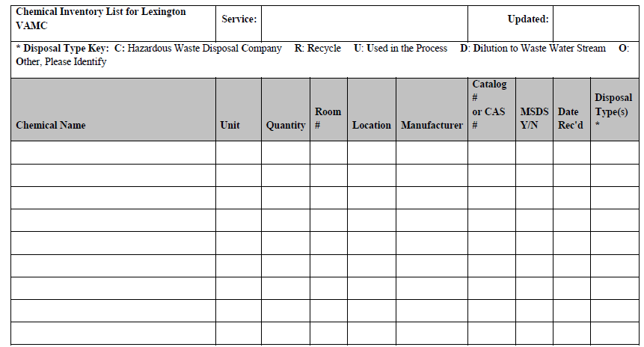

Attachment C: Hazard Analysis Worksheet

Activity/facility description: VA Medical Center | Service/Group:
Location: Lexington, KY | Date:
Contact: Vicki Richardson ext. 5627 | Safety Office Contact: Robert Clouse  ext. 4176
INSTRUCTIONS
The user will complete as much information as possible and forward this worksheet to the Safety Office (138-LD). The Safety Office will review and identify additional potential hazards to be addressed. This hazard analysis worksheet shall be retained by the Safety Office as a part of the facility’s risk assessment documentation.
SCOPE OF OPERATIONS / ACTIVITY DESCRIPTION
Description of Activity:
New activity, or Change to an existing activity. Describe change:

Equipment Description:

Chemicals/Materials:

Process Parameters (temperature/pressure):
SAFETY & HEALTH HAZARD REVIEW
Check all that apply. Write in specific information describing hazard. Items indicated with an asterisk (*) are extremely hazardous.
Acids | Asbestos / lead (circle) concerns
Bases | Biohazards
Carcinogen* | Compressed gas
Confined spaces | Construction/maintenance activities
Cryogen | Destructive testing
Dusty material/atmosphere | Electrical (high voltage)
Electrical (low voltage) Max 50V | Energized electrical work
Explosive* | Extremely Hazardous Chemicals
Falls from elevation | Fire
Fire protection system modification | Flammable gas
Flammable liquid | Flammable solid
Forklift operation | Glassware
Handtools | High acute toxicity*
Highly toxic* | Hot work
Hydraulic systems | Ionizing radiation-generating devices
Ladders/scaffolds | Lasers. Specify number and type.
Lighting | Manlift operation
Manual materials handling/Ergonomic concerns | Animals
Noise | Non-ionizing radiation other than laser
Operating/rotating equipment | Organic peroxide
OSHA Chemical Specific Standard material | Oxidizer
Pressure vessels/systems | Pyrophoric*
Radioactive materials | Reproductive hazard*
Sensitizer | Toxic Toxic Metals
Unstable/reactive* | Other Thermal
ADDITIONAL ACTIONS REQUIRED?
Do existing Service procedures, programs and/or operating manuals address the hazards? No
Yes
Special Work Permit Required?
No Yes, Specify type(s).
Personal Protective Equipment (PPE) requirements (note this form serves a “certificate of hazard assessment”, per OSHA 1910.132):

Additional comments/recommendations:
SIGNATURE
Service Contact Signature |  | Date
Safety Contact Signature |  | Date

Attachment D: Memorandum No. 138-40 Hazardous Waste Management
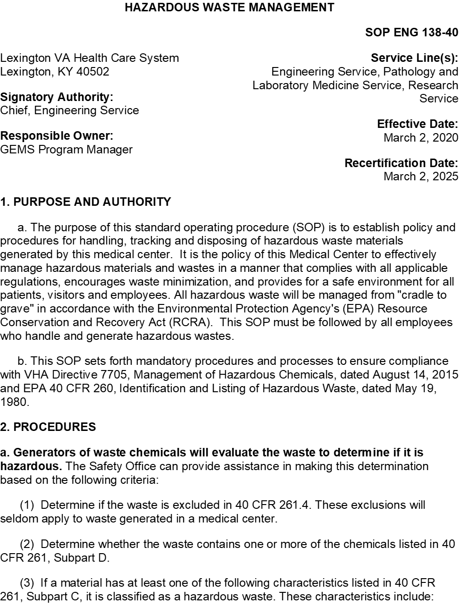

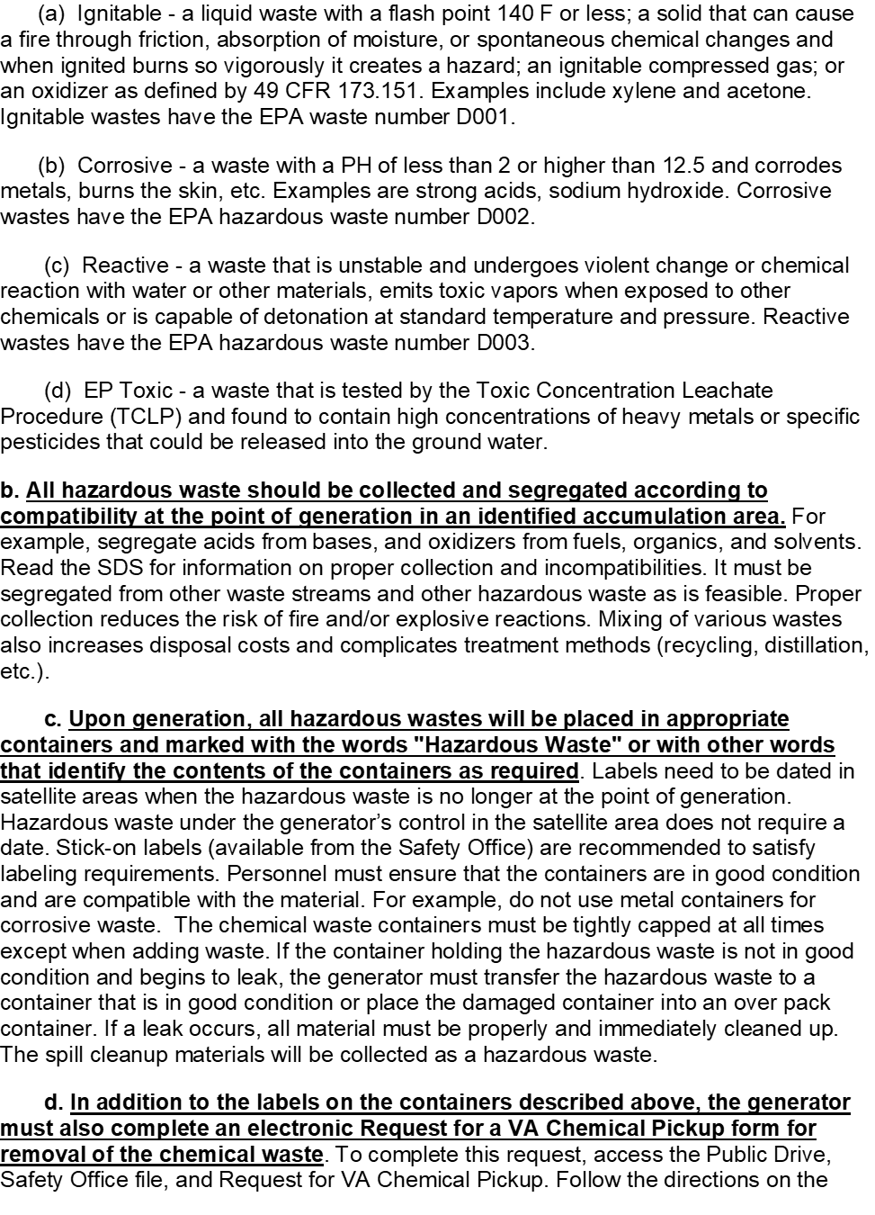

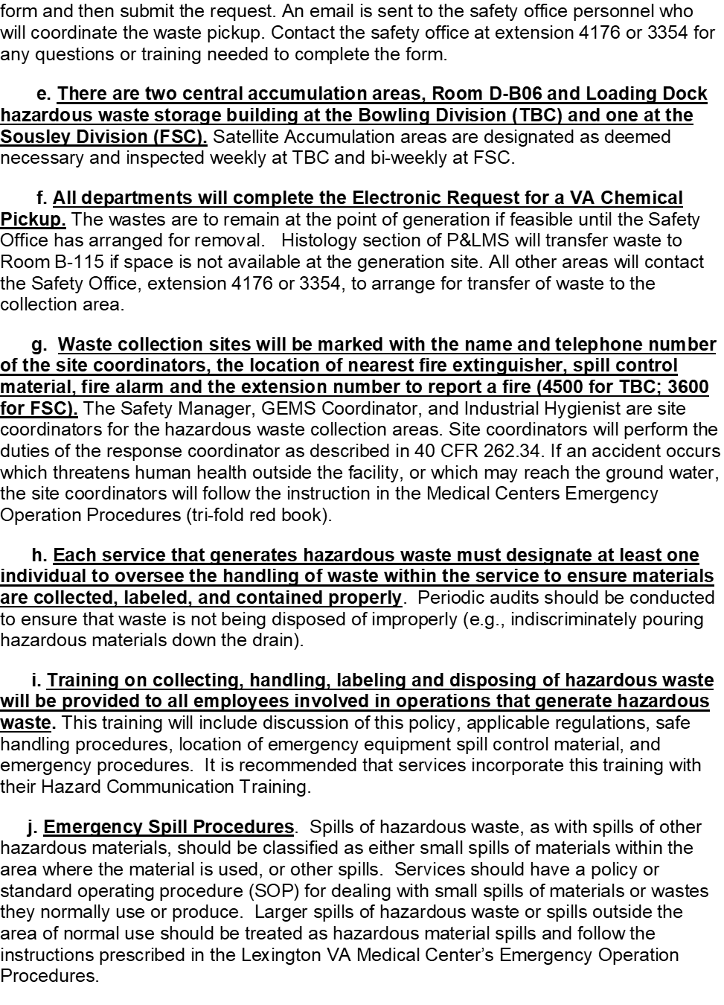

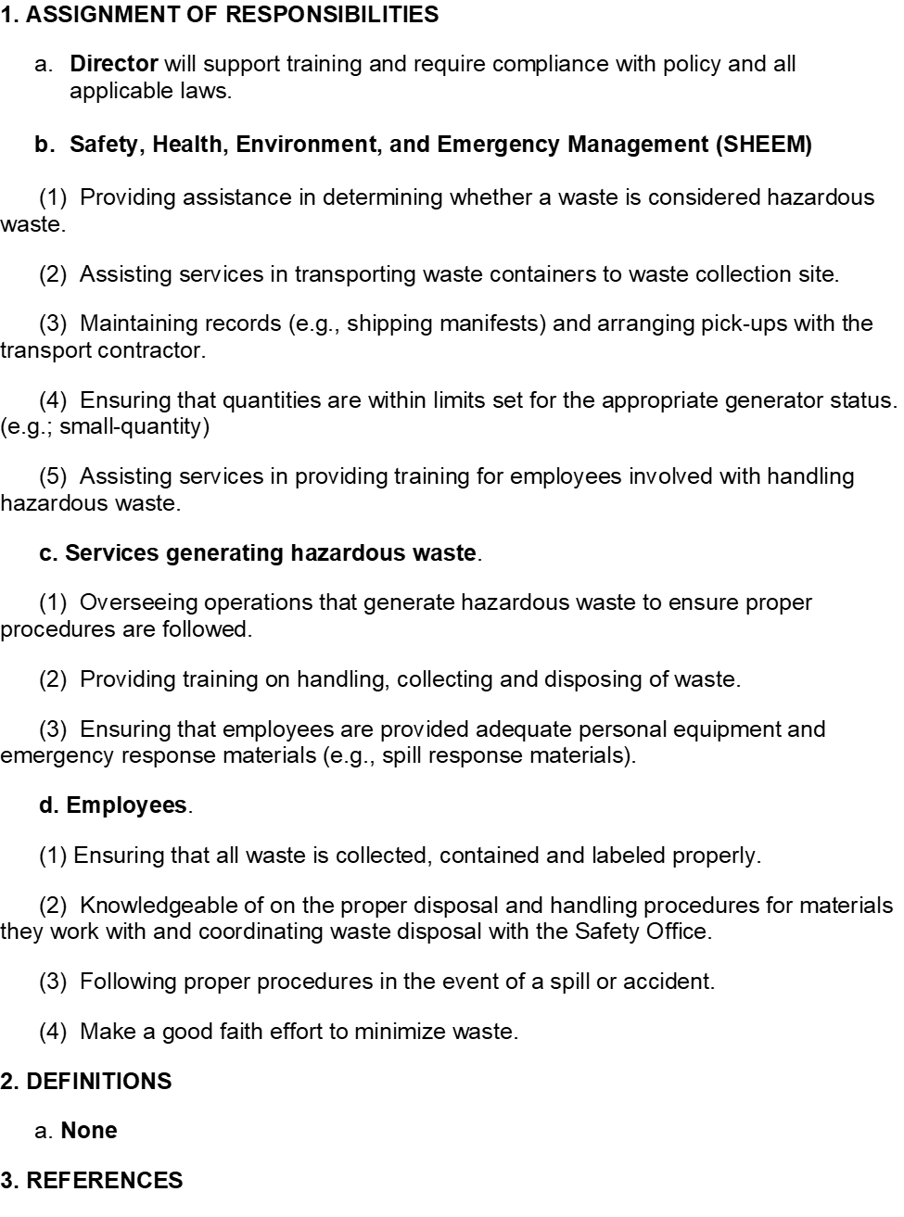

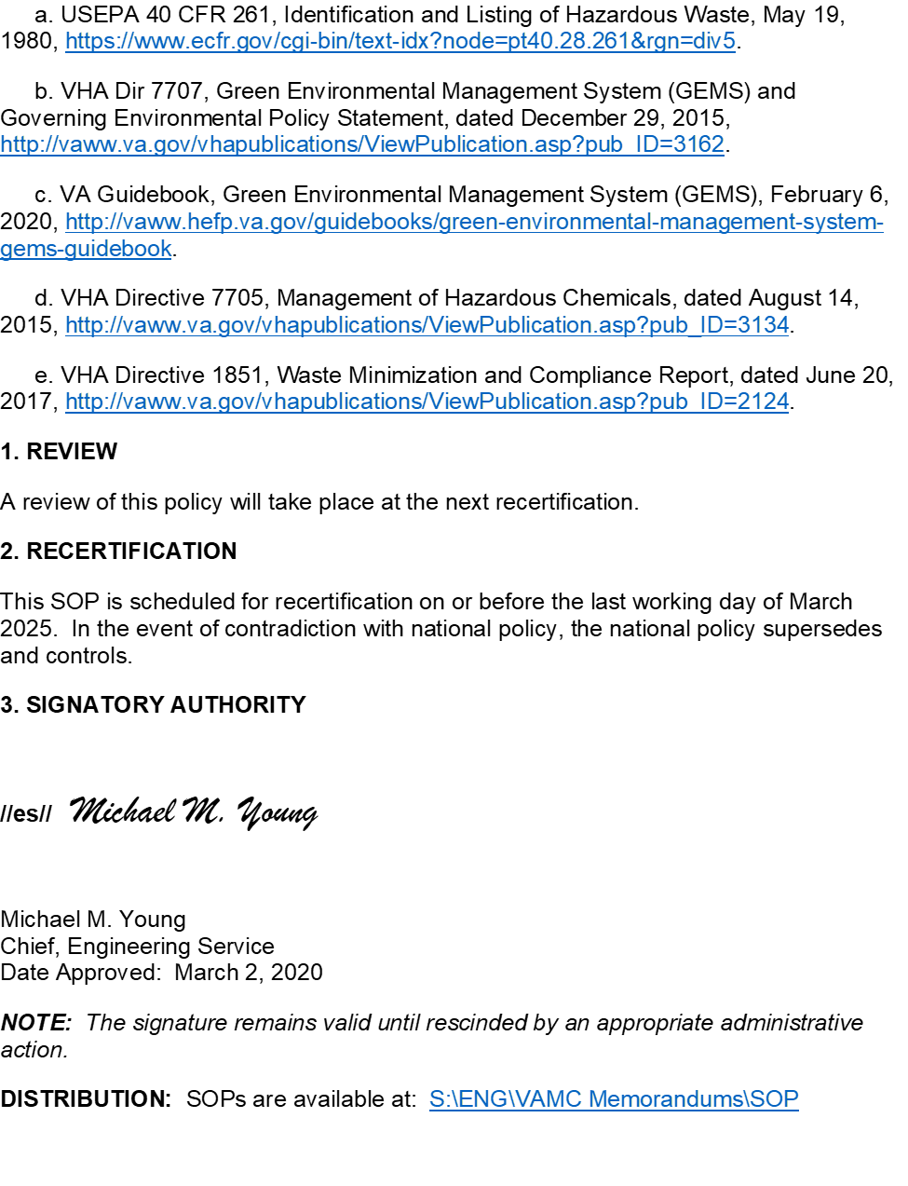

Attachment E: NIOSH Carcinogen List

Last Reviewed May 18, 2012 http://www.cdc.gov/niosh/topics/cancer/npotocca.html
The following is a list of substances NIOSH considers to be potential occupational carcinogens.
A number of the carcinogen classifications deal with groups of substances: aniline and homologs, chromates, dintrotoluenes, arsenic and inorganic arsenic compounds, beryllium and beryllium compounds, cadmium compounds, nickel compounds, and crystalline forms of silica. There are also substances of variable or unclear chemical makeup that are considered carcinogens, coal tar pitch volatiles, coke oven emissions, diesel exhaust and environmental tobacco smoke.
Some of the potential carcinogens listed in this index may be re-evaluated by NIOSH as new data become available and the NIOSH recommendations on these carcinogens either as to their status as a potential occupational carcinogen or as to the appropriate recommended exposure limit may change.

A  Acetaldehyde  2-Acetylaminofluorene  Acrylamide  Acrylonitrile  Aldrin  4-Aminodiphenyl  Amitrole  Aniline and homologs  o-Anisidine  p-Anisidine  Arsenic and inorganic arsenic compounds  Arsine  Asbestos  Asphalt fumes | C  Cadmium dust and fume  Captafol  Captan  Carbon black (exceeding 0.1% PAHs)  Carbon tetrachloride  Chlordane  Chlorinated camphene  Chlorodiphenyl (42% chlorine); class polychlorinated biphenyls  Chlorodiphenyl (54% chlorine); class polychlorinated biphenyls  Chloroform  Chloromethyl methyl ether  bis(Chloromethyl) ether  B-Chloroprene  Chromium, hexavalent [Cr(VI)]  Chromyl chloride; class, chromium hexavalent  Chrysene  Coal tar pitch volatiles; class, coal tar products  Coke oven emissions

B
Benzene
Benzidine
Benzidine-based dyes
Beryllium
Butadiene
tert-Butyl chromate; class, chromium hexavalent
D  DDT (dichlorodiphenyltrichloroethane)  Di-2-ethylhexyl phthalate (DEHP)  2,4-Diaminoanisoleo  o-Dianisidine-based dyes  1,2-Dibromo-3-chloropropane (DBCP)  Dichloroacetylene  p-Dichlorobenzene  3,3'-Dichlorobenzidine  Dichloroethyl ether  1,3-Dichloropropene  Dieldrin  Diesel exhaust  Diglycidyl ether (DGE); class, glycidyl ethers  4-Dimethylaminoazobenzene  Dimethyl carbomoyl chloride  1,1-Dimethylhydrazine; class, hydrazines  Dimethyl sulfate  Dinitrotoluene  Dioxane | M  Malonaldehyde  Methoxychlor  Methyl bromide; class, monohalomethanes  Methyl chloride  Methyl iodide; class, monohalomethanes  Methyl hydrazine; class, hydrazines4,4'-Methylenebis(2-chloroaniline) (MBOCA)  Methylene chloride  4,4-Methylenedianiline (MDA)
E-G  Environmental tobacco smoke  Epichlorohydrin  Ethyl acrylate  Ethylene dibromide  Ehtylene dichloride  Ethylene oxide  Ethyleneimine  Ethylene thiourea  Formaldehyde  Gallium arsenide  Gasoline | N  a-Naphylamine  B-Naphylamine  Nickel, metal, soluble, insoluble, and inorganic; class, nickel, inorganic  Nickel carbonyl  Nickel sulfide roasting  4-Nitrobiphenyl  p-Nitrochlorobenzene  2-Nitronaphthalene  2-Nitropropane  N-Nitrosodimethylamine

H-K  Heptachlor  Hexachlorobutadiene  Hexachloroethane  Hexamethyl phosphoric triamide (HMPA)  Hydrazine  Kepone | P  Pentachloroethane; class, chloroethanes  N-Phenyl-b-naphthylamine; class, b-naphthalene  Phenyl glycidyl ether; class, glycidyl ethers  Phenylhydrazine; class, hydrazines  Propane Sultone  B-Propiolactone  Propylene dichloride  Proplyene imine  Propylene oxide

R-S
Radon
Rosin core solder, pyrolysis products (containing formaldehyde)
Silica, crystalline cristobalite
Silica, crystalline quartz
Silica, crystalline tripoli
Silica, crystalline tridymite
silica, fused
Soapstone, total dust silicates

T
Tremolite silicates
2,3,7,8-Tetrachlorodibenzo-p-dioxin (TCDD) (dioxin)
1,1,2,2-Tetrachloroethane
Tetrachloroethylene
Titanium dioxide
o-Tolidine-based dyes
o-Tolidine
Toluene diisocyanate (TDI)
Toluene diamine (TDA)
o-Toluidine
p-Toluidine
1,1,2-Trichloroethane; class, chloroethanes
Trichloroethylene
1,2,3-Trichloropropane

Attachment F: International Agency for Research on Cancer (Groups 1, 2a, and 2b)
Last update: 26 October 2015

Group 1 |  | Carcinogenic to humans |  |  |  | 118 agents
Group 2A |  | Probably carcinogenic to humans |  |  |  | 75
Group 2B |  | Possibly carcinogenic to humans |  |  |  | 288
Agents Classified by the IARC Monographs, Volumes 1–114
CAS No. | Agent |  | Group | Volume | Year |  | Additional information
50-00-0 | Formaldehyde |  | 1 | Sup 7, 62, 88, 100F | 2012
50-18-0  6055-19-2 | Cyclophosphamide |  | 1 | 26, Sup 7, 100A | 2012
50-32-8 | Benzo[a]pyrene |  | 1 | Sup 7, 92, 100F | 2012 |  | NB: Overall evaluation upgraded to Group 1 based on mechanistic and other relevant data
52-24-4 | Thiotepa |  | 1 | Sup 7, 50, 100A | 2012
55-98-1 | Busulfan |  | 1 | 4, Sup 7, 100A | 2012
56-53-1 | Diethylstilbestrol |  | 1 | 21, Sup 7, 100A | 2012
58-89-9 | Lindane (see also Hexachlorocyclohexanes) |  | 1 | 113 | In prep.
62-44-2 | Phenacetin |  | 1 | 24, Sup 7, 100A | 2012 |  | NB: Overall evaluation upgraded to Group 1 with supporting evidence from other relevant data
64-17-5 | Ethanol in alcoholic beverages |  | 1 | 96, 100E | 2012
71-43-2 | Benzene |  | 1 | 29, Sup 7. 100F | 2012
75-01-4 | Vinyl chloride |  | 1 | Sup 7, 97, 100F | 2012
75-07-0 | Acetaldehyde associated with consumption of alcoholic beverages |  | 1 | 100E | 2012
75-21-8 | Ethylene oxide |  | 1 | Sup 7, 60, 97, 100F | 2012 |  | NB: Overall evaluation upgraded to Group 1 based on mechanistic and other relevant data
78-87-5 | 1,2-Dichloropropane |  | 1 | 41, Sup 7, 71, 110 | In prep.

CAS No. | Agent | Group | Volume | Year | Additional information
79-01-6 | Trichloroethylene | 1 | Sup 7, 63, 106 | 2014
91-59-8 | 2-Naphthylamine | 1 | 4, Sup 7, 99, 100F | 2012
92-67-1 | 4-Aminobiphenyl | 1 | 1, Sup 7, 99, 100F | 2012
92-87-5 | Benzidine | 1 | 29, Sup 7, 99, 100F | 2012
95-53-4 | ortho-Toluidine | 1 | Sup 7, 77, 99, 100F | 2012
101-14-4 | 4,4'-Methylenebis(2-chloroaniline) (MOCA) | 1 | Sup 7, 57, 99, 100F | 2012 | NB: Overall evaluation upgraded to Group 1 based on mechanistic and other relevant data
106-99-0 | 1,3-Butadiene | 1 | Sup 7, 54, 71, 97, 100F | 2012
148-82-3 | Melphalan | 1 | 9, Sup 7, 100A | 2012
298-81-7 | Methoxsalen (8-methoxypsoralen) plus ultraviolet A radiation | 1 | 24, Sup 7, 100A | 2012
299-75-2 | Treosulfan | 1 | 26, Sup 7, 100A | 2012
305-03-3 | Chlorambucil | 1 | 26, Sup 7, 100A | 2012
313-67-7 | Aristolochic acid | 1 | 82, 100A | 2012 | NB: Overall evaluation upgraded to Group 1 based on mechanistic and other relevant data
313-67-7 | Aristolochic acid, plants containing | 1 | 82, 100A | 2012
446-86-6 | Azathioprine | 1 | 26, Sup 7, 100A | 2012
494-03-1 | Chlornaphazine | 1 | 4, Sup 7, 100A | 2012
505-60-2 | Sulfur mustard | 1 | 9, Sup 7, 100F | 2012
542-88-1  107-30-2 | Bis(chloromethyl)ether; chloromethyl methyl ether (technical-grade) | 1 | 4, Sup 7, 100F | 2012

CAS No. | Agent | Group | Volume | Year | Additional information
1332-21-4  13768-00-8  12172-73-5  17068-78-9  12001-29-5  12001-28-4  14567-73-8 | Asbestos (all forms, including actinolite, amosite, anthophyllite, chrysotile, crocidolite, tremolite) | 1 | 14, Sup 7, 100C | 2012 | NB: Mineral substances (e.g. talc or vermiculite) that contain asbestos should also be regarded as carcinogenic to humans
1336-36-3 | Polychlorinated biphenyls | 1 | 18, Sup 7, 107 | In prep.
1402-68-2 | Aflatoxins | 1 | 56, 82, 100F, Sup 7 | 2012
1746-01-6 | 2,3,7,8-Tetrachlorodibenzo-para-dioxin | 1 | Sup 7, 69, 100F | 2012
7440-07-5 | Plutonium | 1 | 78, 100D | 2012
7440-29-1 | Thorium-232 and its decay products | 1 | 78, 100D | 2012
7440-38-2 | Arsenic and inorganic arsenic compounds | 1 | 23, Sup 7, 100C | 2012
7440-41-7 | Beryllium and beryllium compounds | 1 | Sup 7, 58, 100C | 2012
7440-43-9 | Cadmium and cadmium compounds | 1 | 58, 100C | 2012
8007-45-2 | Coal-tar distillation | 1 | 92, 100F | 2012
10043-92-2 | Radon-222 and its decay products | 1 | 43, 78, 100D | 2012
10540-29-1 | Tamoxifen | 1 | 66, 100A | 2012 | NB: There is also conclusive evidence that tamoxifen reduces the risk of contralateral breast cancer in breast cancer patients
13233-32-4 | Radium-224 and its decay products | 1 | 78, 100D | 2012
13909-09-6 | Semustine [1-(2-Chloroethyl)-3-(4-methylcyclohexyl)-1-nitrosourea, Methyl-CCNU] | 1 | Sup 7, 100A | 2012
13982-63-3 | Radium-226 and its decay products | 1 | 78, 100D | 2012
14596-37-3 | Phosphorus-32, as phosphate | 1 | 78, 100D | 2012
CAS No. | Agent | Group | Volume | Year | Additional information
14808-60-7 | Silica dust, crystalline, in the form of quartz or cristobalite | 1 | Sup 7, 68, 100C | 2012
15262-20-1 | Radium-228 and its decay products | 1 | 78, 100D | 2012
16543-55-8  64091-91-4 | N'-Nitrosonornicotine (NNN) and 4-(N-Nitrosomethylamino)-1-(3-pyridyl)-1-butanone (NNK) | 1 | Sup 7, 89, 100E | 2012 | NB: Overall evaluation upgraded to Group 1 based on mechanistic and other relevant data
18540-29-9 | Chromium (VI) compounds | 1 | Sup 7, 49, 100C | 2012
33419-42-0 | Etoposide | 1 | 76, 100A | 2012 | NB: Overall evaluation upgraded to Group 1 based on mechanistic and other relevant data
33419-42-0  15663-27-1  11056-06-7 | Etoposide in combination with cisplatin and bleomycin | 1 | 76, 100A | 2012
57117-31-4 | 2,3,4,7,8-Pentachlorodibenzofuran | 1 | 100F | 2012 | NB: Overall evaluation upgraded to Group 1 based on mechanistic and other relevant data
57465-28-8 | 3,4,5,3’,4’-Pentachlorobiphenyl (PCB-126) | 1 | 100F | 2012 | See Polychlorinated biphenyls, dioxin-like, with a TEF according to WHO
59865-13-3  79217-60-0 | Cyclosporine | 1 | 50, 100A | 2012
65996-93-2 | Coal-tar pitch | 1 | 35, Sup 7, 100F | 2012
66733-21-9 | Erionite | 1 | 42, Sup 7, 100C | 2012
68308-34-9 | Shale oils | 1 | 35, Sup 7, 100F | 2012
 | Acheson process, occupational exposure associated with | 1 | 111 | In prep.
 | Acid mists, strong inorganic | 1 | 54, 100F | 2012
 | Alcoholic beverages | 1 | 44, 96, 100E | 2012
 | Aluminium production | 1 | 34, Sup 7, 92, 100F | 2012
 | Areca nut | 1 | 85, 100E | 2012
CAS No. | Agent | Group | Volume | Year | Additional information
 | Auramine production | 1 | Sup 7, 99, 100F | 2012
 | Benzidine, dyes metabolized to | 1 | 99, 100F | 2012 | NB: Overall evaluation upgraded to Group 1 based on mechanistic and other relevant data
 | Betel quid with tobacco | 1 | Sup 7, 85, 100E | 2012
 | Betel quid without tobacco | 1 | Sup 7, 85, 100E | 2012
 | Clonorchis sinensis (infection with) | 1 | 61, 100B | 2012
 | Coal gasification | 1 | Sup 7, 92, 100F | 2012
 | Coal, indoor emissions from household combustion of | 1 | 95, 100E | 2012
 | Coke production | 1 | Sup 7, 92, 100F | 2012
 | Engine exhaust, diesel | 1 | 46, 105 | 2013
 | Epstein-Barr virus | 1 | 70, 100B | 2012
 | Estrogen therapy, postmenopausal | 1 | 72, 100A | 2012
 | Estrogen-progestogen menopausal therapy (combined) | 1 | 72, 91, 100A | 2012
 | Estrogen-progestogen oral contraceptives (combined) | 1 | 72, 91, 100A | 2012 | NB: There is also convincing evidence in humans that these agents confer a protective effect against cancer in the endometrium and ovary
 | Fission products, including strontium-90 | 1 | 100D | 2012
 | Fluoro-edenite fibrous amphibole | 1 | 111 | In prep.
 | Haematite mining (underground) | 1 | 1, Sup 7, 100D | 2012
 | Helicobacter pylori (infection with) | 1 | 61, 100B | 2012
 | Hepatitis B virus (chronic infection with) | 1 | 59, 100B | 2012
 | Hepatitis C virus (chronic infection with) | 1 | 59, 100B | 2012
CAS No. | Agent | Group | Volume | Year | Additional information
 | Human immunodeficiency virus type 1 (infection with) | 1 | 67, 100B | 2012
 | Human papillomavirus types 16, 18, 31, 33, 35, 39, 45, 51, 52, 56, 58, 59 | 1 | 64, 90, 100B | 2012 | NB: The HPV types that have been classified as carcinogenic to humans can differ by an order of magnitude in risk for cervical cancer
 | Human T-cell lymphotropic virus type I | 1 | 67, 100B | 2012
 | Ionizing radiation (all types) | 1 | 100D | 2012
 | Iron and steel founding (occupational exposure during) | 1 | 34, Sup 7, 100F | 2012
 | Isopropyl alcohol manufacture using strong acids | 1 | Sup 7, 100F | 2012
 | Kaposi sarcoma herpesvirus | 1 | 70, 100B | 2012
 | Leather dust | 1 | 100C | 2012
 | Magenta production | 1 | Sup 7, 57, 99, 100F | 2012
 | Mineral oils, untreated or mildly treated | 1 | 33, Sup 7, 100F | 2012
 | MOPP and other combined chemotherapy including alkylating agents | 1 | Sup 7, 100A | 2012
 | Neutron radiation | 1 | 75, 100D | 2012 | NB: Overall evaluation upgraded to Group 1 with supporting evidence from other relevant data
 | Nickel compounds | 1 | Sup 7, 49, 100C | 2012
 | Opisthorchis viverrini (infection with) | 1 | 61, 100B | 2012
 | Outdoor air pollution | 1 | 109 | In prep.
 | Outdoor air pollution, particulate matter in | 1 | 109 | In prep.

CAS No. | Agent | Group | Volume | Year | Additional information
 | Painter (occupational exposure as a) | 1 | 47, 98, 100F | 2012
 | Phenacetin, analgesic mixtures containing | 1 | Sup 7, 100A | 2012
 | Polychlorinated biphenyls, dioxin-like, with a Toxicity Equivalency Factor (TEF) according to WHO (PCBs 77, 81, 105, 114, 118, 123, 126, 156, 157, 167, 169, 189) | 1 | 107 | In prep. | NB: Overall evaluation upgraded to Group 1 with strong supporting evidence from other relevant data
 | Processed meat (consumption of) | 1 | 114 | In prep.
 | Radioiodines, including iodine-131 | 1 | 78, 100D | 2012
 | Radionuclides, alpha-particle-emitting, internally deposited | 1 | 78, 100D | 2012 | NB: Specific radionuclides for which there is sufficient evidence in humans are also listed individually as Group 1 agents
 | Radionuclides, beta-particle-emitting, internally deposited | 1 | 78, 100D | 2012 | NB: Specific radionuclides for which there is sufficient evidence in humans are also listed individually as Group 1 agents
 | Rubber manufacturing industry | 1 | 28, Sup 7, 100F | 2012
 | Salted fish, Chinese-style | 1 | 56, 100E | 2012
 | Schistosoma haematobium (infection with) | 1 | 61, 100B | 2012
 | Solar radiation | 1 | 55, 100D | 2012
 | Soot (as found in occupational exposure of chimney sweeps) | 1 | 35, Sup 7, 92, 100F | 2012
 | Tobacco smoke, second-hand | 1 | 83, 100E | 2012
 | Tobacco smoking | 1 | 83, 100E | 2012
 | Tobacco, smokeless | 1 | Sup 7, 89, 100E | 2012

CAS No. | Agent | Group | Volume | Year | Additional information
 | Ultraviolet radiation (wavelengths 100-400 nm, encompassing UVA, UVB, and UVC) | 1 | 55, 100D | 2012
 | Ultraviolet-emitting tanning devices | 1 | 100D | 2012
 | Wood dust | 1 | 62, 100C | 2012
 | X- and Gamma-Radiation | 1 | 75, 100D | 2012
50-29-3 | DDT (4,4'-Dichlorodiphenyltrichloroethane) | 2A | Sup 7, 53, 113 | In prep.
51-75-2 | Nitrogen mustard | 2A | 9, Sup 7 | 1987
51-79-6 | Ethyl carbamate (Urethane) | 2A | 7, Sup 7, 96 | 2010
53-70-3 | Dibenz[a,h]anthracene | 2A | Sup 7, 92 | 2010 | NB: Overall evaluation upgraded to Group 2A with supporting evidence from other relevant data
55-18-5 | N-Nitrosodiethylamine | 2A | 17, Sup 7 | 1987 | NB: Overall evaluation upgraded to Group 2A with supporting evidence from other relevant data
56-75-7 | Chloramphenicol | 2A | Sup 7, 50 | 1990 | NB: Overall evaluation upgraded to Group 2A with supporting evidence from other relevant data
62-75-9 | N-Nitrosodimethylamine | 2A | 17, Sup 7 | 1987 | NB: Overall evaluation upgraded to Group 2A with supporting evidence from other relevant data
64-67-5 | Diethyl sulfate | 2A | 54, 71 | 1999 | NB: Overall evaluation upgraded to Group 2A with supporting evidence from other relevant data
66-27-3 | Methyl methanesulfonate | 2A | 7, Sup 7, 71 | 1999 | NB: Overall evaluation upgraded to Group 2A with supporting evidence from other relevant data
70-25-7 | N-Methyl-N´-nitro-N-nitrosoguanidine (MNNG) | 2A | 4, Sup 7 | 1987 | NB: Overall evaluation upgraded to Group 2A with supporting evidence from other relevant data
75-02-5 | Vinyl fluoride | 2A | Sup 7, 63, 97 | 2008 | NB: (1) Overall evaluation upgraded to Group 2A based on mechanistic and other relevant data;  (2) For practical purposes, vinyl fluoride should be considered to act similarly to the human carcinogen vinyl chloride

CAS No. | Agent | Group | Volume | Year | Additional information
75-09-2 | Dichloromethane (Methylene chloride) | 2A | Sup 7, 71, 110 | In prep.
75-87-6 | Chloral | 2A | 63, 84, 106 | 2014
77-78-1 | Dimethyl sulfate | 2A | 4, Sup 7, 71 | 1999 | NB: Overall evaluation upgraded to Group 2A with supporting evidence from other relevant data
79-06-1 | Acrylamide | 2A | 60, Sup 7 | 1994 | NB: Overall evaluation upgraded to Group 2A with supporting evidence from other relevant data
79-44-7 | Dimethylcarbamoyl chloride | 2A | 12, Sup 7, 71 | 1999 | NB: Overall evaluation upgraded to Group 2A with supporting evidence from other relevant data
88-72-2 | 2-Nitrotoluene | 2A | 101 | 2013 | NB: Overall evaluation upgraded to Group 2A with supporting evidence from other relevant data
95-69-2 | 4-Chloro-ortho-toluidine | 2A | 77, 99 | 2010
96-09-3 | Styrene-7,8-oxide | 2A | Sup 7, 60 | 1994 | NB: Overall evaluation upgraded to Group 2A with supporting evidence from other relevant data
96-18-4 | 1,2,3-Trichloropropane | 2A | 63 | 1995
98-87-3  98-07-7  100-44-7  98-88-4 | alpha-Chlorinated toluenes (benzal chloride, benzotrichloride, benzyl chloride) and benzoyl chloride (combined exposures) | 2A | 29, Sup 7, 71 | 1999
106-89-8 | Epichlorohydrin | 2A | 11, Sup 7, 71 | 1999 | NB: Overall evaluation upgraded to Group 2A with supporting evidence from other relevant data
106-93-4 | Ethylene dibromide | 2A | 15, Sup 7, 71 | 1999 | NB: Overall evaluation upgraded to Group 2A with supporting evidence from other relevant data
116-14-3 | Tetrafluoroethylene | 2A | 19, Sup 7, 71, 110 | In prep. | NB: Overall evaluation upgraded to Group 2A on the basis of sufficient evidence in experimental animals with a striking and atypical pattern of tumours
121-75-5 | Malathion | 2A | 30, Sup 7, 112 | In prep.
126-72-7 | Tris(2,3-dibromopropyl) phosphate | 2A | 20, Sup 7, 71 | 1999 | NB: Overall evaluation upgraded to Group 2A with supporting evidence from other relevant data
127-18-4 | Tetrachloroethylene (Perchloroethylene) | 2A | Sup 7, 63, 106 | 2014
CAS No. | Agent | Group | Volume | Year | Additional information
154-93-8 | Bischloroethyl nitrosourea (BCNU) | 2A | 26, Sup 7 | 1987
191-30-0 | Dibenzo[a,l]pyrene | 2A | Sup 7, 92 | 2010 | NB: Overall evaluation upgraded to Group 2A with supporting evidence from other relevant data
224-42-0 | Dibenz[a,j]acridine | 2A | 32, Sup 7, 103 | 2013 | NB: Overall evaluation upgraded to Group 2A with supporting evidence from other relevant data
302-17-0 | Chloral hydrate | 2A | 63, 84, 106 | 2014
320-67-2 | Azacitidine | 2A | 50 | 1990 | NB: Overall evaluation upgraded to Group 2A with supporting evidence from other relevant data
333-41-5 | Diazinon | 2A | 112 | In prep. | NB: Overall evaluation upgraded to Group 2A based on mechanistic evidence
366-70-1 | Procarbazine hydrochloride | 2A | 26, Sup 7 | 1987 | NB: Overall evaluation upgraded to Group 2A with supporting evidence from other relevant data
484-20-8 | 5-Methoxypsoralen | 2A | 40, Sup 7 | 1987 | NB: Overall evaluation upgraded to Group 2A with supporting evidence from other relevant data
540-73-8 | 1,2-Dimethylhydrazine | 2A | 4, Sup 7, 71 | 1999 | NB: Overall evaluation upgraded to Group 2A with supporting evidence from other relevant data
556-52-5 | Glycidol | 2A | 77 | 2000 | NB: Overall evaluation upgraded to Group 2A with supporting evidence from other relevant data
593-60-2 | Vinyl bromide | 2A | 39, Sup 7, 71, 97 | 2008 | NB: (1) Overall evaluation upgraded to Group 2A based on mechanistic and other relevant data;  (2) For practical purposes, vinyl bromide should be considered to act similarly to the human carcinogen vinyl chloride
684-93-5 | N-Methyl-N-nitrosourea | 2A | 17, Sup 7 | 1987 | NB: Overall evaluation upgraded to Group 2A with supporting evidence from other relevant data
759-73-9 | N-Ethyl-N-nitrosourea | 2A | 17, Sup 7 | 1987 | NB: Overall evaluation upgraded to Group 2A with supporting evidence from other relevant data
1071-83-6 | Glyphosate | 2A | 112 | In prep.
1120-71-4 | 1,3-Propane sultone | 2A | 4, Sup 7, 71, 110 | In prep. | NB: Overall evaluation upgraded to Group 2A with supporting evidence from other relevant data
2425-06-1 | Captafol | 2A | 53 | 1991 | NB: Overall evaluation upgraded to Group 2A with supporting evidence from other relevant data
5522-43-0 | 1-Nitropyrene | 2A | Sup 7, 46, 105 | 2014 | NB: Overall evaluation upgraded to Group 2A with supporting evidence from other relevant data

CAS No. | Agent | Group | Volume | Year | Additional information
7440-48-4  12070-12-1 | Cobalt metal with tungsten carbide | 2A | 86 | 2006
7496-02-8 | 6-Nitrochrysene | 2A | Sup 7, 46, 105 | 2014 | NB: Overall evaluation upgraded to Group 2A with supporting evidence from other relevant data
8001-58-9 | Creosotes | 2A | Sup 7, 92 | 2010
13010-47-4 | 1-(2-Chloroethyl)-3-cyclohexyl-1-nitrosourea (CCNU) | 2A | 26, Sup 7 | 1987 | NB: Overall evaluation upgraded to Group 2A with supporting evidence from other relevant data
15663-27-1 | Cisplatin | 2A | 26, Sup 7 | 1987 | NB: Overall evaluation upgraded to Group 2A with supporting evidence from other relevant data
22398-80-7 | Indium phosphide | 2A | 86 | 2006 | NB: Overall evaluation upgraded to Group 2A
23214-92-8 | Adriamycin | 2A | 10, Sup 7 | 1987 | NB: Overall evaluation upgraded to Group 2A with supporting evidence from other relevant data
27208-37-3 | Cyclopenta[cd]pyrene | 2A | Sup 7, 92 | 2010 | NB: Overall evaluation upgraded to Group 2A with supporting evidence from other relevant data
29767-20-2 | Teniposide | 2A | 76 | 2000 | NB: Overall evaluation upgraded to Group 2A with supporting evidence from other relevant data
54749-90-5 | Chlorozotocin | 2A | 50 | 1990 | NB: Overall evaluation upgraded to Group 2A with supporting evidence from other relevant data
59536-65-1 | Polybrominated biphenyls | 2A | 41, Sup 7, 107 | In prep. | NB: Overall evaluation upgraded to Group 2A with supporting evidence from other relevant data, namely mechanistic similarity with polychlorinated biphenyls classified in Group 1
64742-93-4 | Bitumens, occupational exposure to oxidized bitumens and their emissions during roofing | 2A | 103 | 2013
76180-96-6 | IQ (2-Amino-3-methylimidazo[4,5-f]quinoline) | 2A | Sup 7, 56 | 1993 | NB: Overall evaluation upgraded to Group 2A with supporting evidence from other relevant data
111025-46-8 | Pioglitazone | 2A | 108 | In prep.
409-21-2 | Silicon carbide whiskers | 2A | 111 | In prep.
 | Androgenic (anabolic) steroids | 2A | Sup 7 | 1987

CAS No. | Agent | Group | Volume | Year | Additional information
 | Art glass, glass containers and pressed ware (manufacture of) | 2A | 58 | 1993
 | Biomass fuel (primarily wood), indoor emissions from household combustion of | 2A | 95 | 2010
 | Carbon electrode manufacture | 2A | 92 | 2010
 | Frying, emissions from high-temperature | 2A | 95 | 2010
 | Hairdresser or barber (occupational exposure as a) | 2A | 57, 99 | 2010
 | Human papillomavirus type 68 | 2A | 100B | 2012
 | Lead compounds, inorganic | 2A | Sup 7, 87 | 2006
 | Malaria (caused by infection with Plasmodium falciparum in holoendemic areas) | 2A | 104 | 2013
 | Mate, hot | 2A | 51 | 1991
 | Merkel cell polyomavirus (MCV) | 2A | 104 | 2013
 | Nitrate or nitrite (ingested) under conditions that result in endogenous nitrosation | 2A | 94 | 2010
 | Non-arsenical insecticides (occupational exposures in spraying and application of) | 2A | 53 | 1991
 | Petroleum refining (occupational exposures in) | 2A | 45 | 1989

CAS No. | Agent | Group | Volume | Year | Additional information
 | Red Meat (consumption of) | 2A | 114 | In prep.
 | Shiftwork that involves circadian disruption | 2A | 98 | 2010
50-06-6 | Phenobarbital | 2B | Sup 7, 79 | 2001
50-07-7 | Mitomycin C | 2B | 10, Sup 7 | 1987
51-52-5 | Propylthiouracil | 2B | Sup 7, 79 | 2001
56-04-2 | Methylthiouracil | 2B | Sup 7, 79 | 2001
56-23-5 | Carbon tetrachloride | 2B | 20, Sup 7, 71 | 1999
56-38-2 | Parathion | 2B | 30, Sup 7, 112 | In prep.
56-55-3 | Benz[a]anthracene | 2B | 92, Sup 7 | 2010
57-14-7 | 1,1-Dimethylhydrazine | 2B | 4, Sup 7, 71 | 1999
57-41-0 | Phenytoin | 2B | Sup 7, 66 | 1996
57-57-8 | beta-Propiolactone | 2B | 4, Sup 7, 71 | 1999
57-74-9 | Chlordane | 2B | Sup 7, 53, 79 | 2001
58-93-5 | Hydrochlorothiazide | 2B | 50, 108 | in prep
59-89-2 | N-Nitrosomorpholine | 2B | 17, Sup 7 | 1987
60-09-3 | para-Aminoazobenzene | 2B | 8, Sup 7 | 1987
60-11-7 | para-Dimethylaminoazobenzene | 2B | 8, Sup 7 | 1987
60-35-5 | Acetamide | 2B | 7, Sup 7, 71 | 1999
61-57-4 | Niridazole | 2B | 13, Sup 7 | 1987
62-50-0 | Ethyl methanesulfonate | 2B | 7, Sup 7 | 1987
62-55-5 | Thioacetamide | 2B | 7, Sup 7 | 1987
62-73-7 | Dichlorvos | 2B | Sup 7, 53 | 1991
63-92-3 | Phenoxybenzamine hydrochloride | 2B | 24, Sup 7 | 1987
66-75-1 | Uracil mustard | 2B | 9, Sup 7 | 1987
67-66-3 | Chloroform | 2B | Sup 7, 73 | 1999
67-72-1 | Hexachloroethane | 2B | 73 | 1999
71-58-9 | Medroxyprogesterone acetate | 2B | 21, Sup 7 | 1987
72-57-1 | Trypan blue | 2B | 8, Sup 7 | 1987
75-07-0 | Acetaldehyde | 2B | 36, Sup 7, 71 | 1999
CAS No. | Agent | Group | Volume | Year | Additional information
75-27-4 | Bromodichloromethane | 2B | 52, 71 | 1999
75-52-5 | Nitromethane | 2B | 77 | 2000
75-55-8 | 2-Methylaziridine (Propyleneimine) | 2B | 9, Sup 7, 71 | 1999
75-56-9 | Propylene oxide | 2B | Sup 7, 60 | 1994
75-60-5 | Dimethylarsinic acid | 2B | 100C | 2012
76-03-9 | Trichloroacetic acid | 2B | 63, 84, 106 | 2014
76-44-8 | Heptachlor | 2B | Sup 7, 53, 79 | 2001
77-09-8 | Phenolphthalein | 2B | 76 | 2000
78-79-5 | Isoprene | 2B | 60, 71 | 1999
79-34-5 | 1,1,2,2-Tetrachloroethane | 2B | 20, Sup 7, 71, 106 | 2014
79-43-6 | Dichloroacetic acid | 2B | 63, 84, 106 | 2014
79-46-9 | 2-Nitropropane | 2B | 29, Sup 7, 71 | 1999
81-49-2 | 1-Amino-2,4-dibromoanthraquinone | 2B | 101 | 2013
84-65-1 | Anthraquinone | 2B | 101 | 2013
86-74-8 | Carbazole | 2B | 32, Sup 7, 71, 103 | 2013
87-62-7 | 2,6-Dimethylaniline (2,6-Xylidine) | 2B | 57 | 1993
89-82-7 | Pulegone | 2B | 108 | In prep.
90-04-0 | ortho-Anisidine | 2B | Sup 7, 73 | 1999
90-94-8 | Michler’s ketone [4,4´-Bis(dimethylamino)benzophenone] | 2B | 99 | 2010
91-20-3 | Naphthalene | 2B | 82 | 2002
91-23-6 | 2-Nitroanisole | 2B | 65 | 1996
91-94-1 | 3,3'-Dichlorobenzidine | 2B | 29, Sup 7 | 1987
93-15-2 | Methyleugenol | 2B | 101 | 2013
94-58-6 | Dihydrosafrole | 2B | 10, Sup 7 | 1987
94-59-7 | Safrole | 2B | 10, Sup 7 | 1987
94-75-7 | 2,4-D (2,4-dichlorophenoxyacetic acid) (See also Chlorophenoxy herbicides) | 2B | 113 | In prep.
95-06-7 | Sulfallate | 2B | 30, Sup 7 | 1987
CAS No. | Agent | Group | Volume | Year | Additional information
95-80-7 | 2,4-Diaminotoluene | 2B | 16, Sup 7 | 1987
95-83-0 | 4-Chloro-ortho-phenylenediamine | 2B | 27, Sup 7 | 1987
96-12-8 | 1,2-Dibromo-3-chloropropane | 2B | 20, Sup 7, 71 | 1999
96-13-9 | 2,3-Dibromopropan-1-ol | 2B | 77 | 2000
96-23-1 | 1,3-Dichloro-2-propanol | 2B | 101 | 2013
96-24-2 | 3-Monochloro-1,2-propanediol | 2B | 101 | 2013
97-56-3 | ortho-Aminoazotoluene | 2B | 8, Sup 7 | 1987
98-82-8 | Cumene | 2B | 101 | 2013
98-83-9 | a-Methylstyrene | 2B | 101 | 2013
98-95-3 | Nitrobenzene | 2B | 65 | 1996
100-40-3 | 4-Vinylcyclohexene | 2B | Sup 7, 60 | 1994
100-41-4 | Ethylbenzene | 2B | 77 | 2000
100-42-5 | Styrene | 2B | 60, 82 | 2002
100-75-4 | N-Nitrosopiperidine | 2B | 17, Sup 7 | 1987
101-61-1 | Michler’s base [4,4´-methylenebis(N,N-dimethyl)benzenamine] | 2B | 27, Sup 7, 99 | 2010
101-77-9 | 4,4'-Methylenedianiline | 2B | 39, Sup 7 | 1987
101-80-4 | 4,4'-Diaminodiphenyl ether | 2B | 29, Sup 7 | 1987
101-90-6 | Diglycidyl resorcinol ether | 2B | 36, Sup 7, 71 | 1999
106-46-7 | para-Dichlorobenzene | 2B | Sup 7, 73 | 1999
106-47-8 | para-Chloroaniline | 2B | 57 | 1993
106-87-6 | 4-Vinylcyclohexene diepoxide | 2B | Sup 7, 60 | 1994
106-88-7 | 1,2-Epoxybutane | 2B | 47, 71 | 1999 | NB: Overall evaluation upgraded to Group 2B with supporting evidence from other relevant data
107-06-2 | 1,2-Dichloroethane | 2B | 20, Sup 7, 71 | 1999
107-13-1 | Acrylonitrile | 2B | 71 | 1999
CAS No. | Agent | Group | Volume | Year | Additional information
108-05-4 | Vinyl acetate | 2B | Sup 7, 63 | 1995
108-10-1 | Methyl isobutyl ketone | 2B | 101 | 2013
110-00-9 | Furan | 2B | 63 | 1995
111-42-2 | Diethanolamine | 2B | 77, 101 | 2013
115-02-6 | Azaserine | 2B | 10, Sup 7 | 1987
115-28-6 | Chlorendic acid | 2B | 48 | 1990
117-10-2 | Dantron (Chrysazin; 1,8-Dihydroxyanthraquinone) | 2B | 50 | 1990
117-81-7 | Di(2-ethylhexyl)phthalate | 2B | Sup 7, 77, 101 | 2013
118-74-1 | Hexachlorobenzene | 2B | Sup 7, 79 | 2001
119-61-9 | Benzophenone | 2B | 101 | 2013
119-90-4 | 3,3'-Dimethoxybenzidine (ortho-Dianisidine) | 2B | 4, Sup 7 | 1987
119-93-7 | 3,3'-Dimethylbenzidine (ortho-Tolidine) | 2B | 1, Sup 7 | 1987
120-71-8 | para-Cresidine | 2B | 27, Sup 7 | 1987
120-80-9 | Catechol | 2B | 15, Sup 7, 71 | 1999
121-14-2 | 2,4-Dinitrotoluene | 2B | 65 | 1996
122-60-1 | Phenyl glycidyl ether | 2B | 47, 71 | 1999
123-91-1 | 1,4-Dioxane | 2B | 11, Sup 7, 71 | 1999
124-58-3 | Methylarsonic acid | 2B | 100C | 2012
124-58-3 | Monomethylarsonic acid (see Methylarsonic acid) | 2B | 100C | 2012
125-33-7 | Primidone | 2B | 108 | In prep.
126-07-8 | Griseofulvin | 2B | Sup 7, 79 | 2001
126-85-2 | Nitrogen mustard N-oxide | 2B | 9, Sup 7 | 1987
126-99-8 | Chloroprene | 2B | Sup 7, 71 | 1999
129-15-7 | 2-Methyl-1-nitroanthraquinone (uncertain purity) | 2B | 27, Sup 7 | 1987
129-43-1 | 1-Hydroxyanthraquinone | 2B | 82 | 2002
CAS No. | Agent | Group | Volume | Year | Additional information
132-27-4 | Sodium ortho-phenylphenate | 2B | Sup 7, 73 | 1999
136-40-3 | Phenazopyridine hydrochloride | 2B | 24, Sup 7 | 1987
139-13-9 | Nitrilotriacetic acid and its salts | 2B | 48, 73 | 1999 | NB: Evaluated as a group
139-65-1 | 4,4'-Thiodianiline | 2B | 27, Sup 7 | 1987
140-57-8 | Aramite® | 2B | 5, Sup 7 | 1987
140-88-5 | Ethyl acrylate | 2B | 39, Sup 7, 71 | 1999
141-90-2 | Thiouracil | 2B | Sup 7, 79 | 2001
142-83-6 | 2,4-Hexadienal | 2B | 101 | 2013
143-50-0 | Chlordecone (Kepone) | 2B | 20, Sup 7 | 1987
151-56-4 | Aziridine | 2B | 9, Sup 7, 71 | 1999 | NB: Overall evaluation upgraded to Group 2B with supporting evidence from other relevant data
189-55-9 | Dibenzo[a,i]pyrene | 2B | 92 | 2010
189-64-0 | Dibenzo[a,h]pyrene | 2B | Sup 7, 92 | 2010
193-39-5 | Indeno[1,2,3-cd]pyrene | 2B | Sup 7, 92 | 2010
194-59-2 | 7H-Dibenzo[c,g]carbazole | 2B | 32, Sup 7, 103 | 2013
195-19-7 | Benzo[c]phenanthrene | 2B | 92, Sup 7 | 2010 | NB: Overall evaluation upgraded to Group 2B with supporting evidence from other relevant data
202-33-5 | Benz[j]aceanthrylene | 2B | 92 | 2010 | NB: Overall evaluation upgraded to Group 2B with supporting mechanistic and other relevant data
205-82-3 | Benzo[j]fluoranthene | 2B | 92 | 2010
205-99-2 | Benzo[b]fluoranthene | 2B | 92 | 2010
207-08-9 | Benzo[k]fluoranthene | 2B | 92 | 2010
218-01-9 | Chrysene | 2B | 92 | 2010
224-53-3 | Dibenz[c,h]acridine | 2B | 103 | 2013 | NB: Overall evaluation upgraded to Group 2B with supporting evidence from other relevant data
226-36-8 | Dibenz[a,h]acridine | 2B | 32, Sup 7, 103 | 2013
271-89-6 | Benzofuran | 2B | 63 | 1995
302-01-2 | Hydrazine | 2B | 4, Sup 7, 71 | 1999
303-34-4 | Lasiocarpine | 2B | 10, Sup 7 | 1987
303-47-9 | Ochratoxin A | 2B | Sup 7, 56 | 1993
315-22-0 | Monocrotaline | 2B | 10, Sup 7 | 1987
CAS No. | Agent | Group | Volume | Year | Additional information
331-39-5 | Caffeic acid | 2B | 56 | 1993
335-67-1 | Perfluorooctanoic acid | 2B | 110 | In prep.
396-01-0 | Triamterene | 2B | 108 | In prep.
443-48-1 | Metronidazole | 2B | 13, Sup 7 | 1987
492-80-8 | Auramine | 2B | 1, Sup 7, 99, 100F | 2012
509-14-8 | Tetranitromethane | 2B | 65 | 1996
513-37-1 | 1-Chloro-2-methylpropene | 2B | 63 | 1995
531-76-0 | Merphalan | 2B | 9, Sup 7 | 1987
531-82-8 | N-[4-(5-Nitro-2-furyl)-2-thiazolyl]acetamide | 2B | 7, Sup 7 | 1987
542-75-6 | 1,3-Dichloropropene (technical-grade) | 2B | 41, Sup 7, 71 | 1999
555-84-0 | 1-[(5-Nitrofurfurylidene)amino]-2-imidazolidinone | 2B | 7, Sup 7 | 1987
569-61-9 | CI Basic Red 9 | 2B | 57, 99 | 2010
592-62-1 | Methylazoxymethanol acetate | 2B | 10, Sup 7 | 1987
599-79-1 | Sulfasalazine | 2B | 108 | In prep.
602-87-9 | 5-Nitroacenaphthene | 2B | 16, Sup 7 | 1987
604-75-1 | Oxazepam | 2B | Sup 7, 66 | 1996
606-20-2 | 2,6-Dinitrotoluene | 2B | 65 | 1996
607-57-8 | 2-Nitrofluorene | 2B | 46, 105 | 2013
613-35-4 | N,N'-Diacetylbenzidine | 2B | 16, Sup 7 | 1987
615-05-4 | 2,4-Diaminoanisole | 2B | Sup 7, 79 | 2001
615-53-2 | N-Methyl-N-nitrosourethane | 2B | 4, Sup 7 | 1987
621-64-7 | N-Nitrosodi-n-propylamine | 2B | 17, Sup 7 | 1987
630-20-6 | 1,1,1,2-Tetrachloroethane | 2B | 41, Sup 7, 71, 106 | 2014
631-64-1 | Dibromoacetic acid | 2B | 101 | 2013
632-99-5 | Magenta | 2B | Sup 7, 57, 99, 100F | 2012
680-31-9 | Hexamethylphosphoramide | 2B | 15, Sup 7, 71 | 1999
693-98-1 | 2-Methylimidazole | 2B | 101 | 2013

CAS No. | Agent | Group | Volume | Year | Additional information
712-68-5 | 2-Amino-5-(5-nitro-2-furyl)-1,3,4-thiadiazole | 2B | 7, Sup 7 | 1987
765-34-4 | Glycidaldehyde | 2B | 11, Sup 7, 71 | 1999
794-93-4 | Panfuran S (containing dihydroxymethylfuratrizine) | 2B | 24, Sup 7 | 1987
817-09-4 | Trichlormethine (Trimustine hydrochloride) | 2B | Sup 7, 50 | 1990
822-36-6 | 4-Methylimidazole | 2B | 101 | 2013
838-88-0 | 4,4'-Methylene bis(2-methylaniline) | 2B | 4, Sup 7 | 1987
924-16-3 | N-Nitrosodi-n-butylamine | 2B | 17, Sup 7 | 1987
930-55-2 | N-Nitrosopyrrolidine | 2B | 17, Sup 7 | 1987
1116-54-7 | N-Nitrosodiethanolamine | 2B | 17, Sup 7, 77 | 2000
1309-64-4 | Antimony trioxide | 2B | 47 | 1989
1314-62-1 | Vanadium pentoxide | 2B | 86 | 2006
1333-86-4 | Carbon black | 2B | Sup 7, 65, 93 | 2010
1615-80-1 | 1,2-Diethylhydrazine | 2B | 4, Sup 7, 71 | 1999
1694-09-3 | Benzyl violet 4B | 2B | 16, Sup 7 | 1987
1836-75-5 | Nitrofen (technical-grade) | 2B | 30, Sup 7 | 1987
1897-45-6 | Chlorothalonil | 2B | Sup 7, 73 | 1999
2385-85-5 | Mirex | 2B | 20, Sup 7 | 1987
2429-74-5 | CI Direct Blue 15 | 2B | 57 | 1993
2475-45-8 | Disperse Blue 1 | 2B | 48 | 1990
2646-17-5 | Oil Orange SS | 2B | 8, Sup 7 | 1987
2784-94-3 | HC Blue No. 1 | 2B | 57 | 1993
2973-10-6 | Diisopropyl sulfate | 2B | 54, 71 | 1999
3068-88-0 | beta-Butyrolactone | 2B | 11, Sup 7, 71 | 1999
3252-43-5 | Dibromoacetonitrile | 2B | 52, 71, 101 | 2013
3296-90-0 | 2,2-Bis(bromomethyl)propane-1,3-diol | 2B | 77 | 2000

CAS No. | Agent | Group | Volume | Year | Additional information
3564-09-8 | Ponceau 3R | 2B | 8, Sup 7 | 1987
3570-75-0 | 2-(2-Formylhydrazino)-4-(5-nitro-2-furyl)thiazole | 2B | 7, Sup 7 | 1987
3688-53-7 | AF-2 [2-(2-Furyl)-3-(5-nitro-2-furyl)acrylamide] | 2B | 31, Sup 7 | 1987
3697-24-3 | 5-Methylchrysene | 2B | Sup 7, 92 | 2010
3761-53-3 | Ponceau MX | 2B | 8, Sup 7 | 1987
3771-19-5 | Nafenopin | 2B | 24, Sup 7 | 1987
3795-88-8 | 5-(Morpholinomethyl)-3-[(5-nitrofurfurylidene)amino]-2-oxazolidinone | 2B | 7, Sup 7 | 1987
4342-03-4 | Dacarbazine | 2B | 26, Sup 7 | 1987
4549-40-0 | N-Nitrosomethylvinylamine | 2B | 17, Sup 7 | 1987
5589-96-8 | Bromochloroacetic acid | 2B | 101 | 2013
6358-53-8 | Citrus Red No. 2 | 2B | 8, Sup 7 | 1987
6459-94-5 | CI Acid Red 114 | 2B | 57 | 1993
6795-23-9 | Aflatoxin M1 | 2B | 56 | 1993
7439-92-1 | Lead | 2B | 23, Sup 7 | 1987
7440-02-0 | Nickel, metallic and alloys | 2B | Sup 7, 49 | 1990
7440-48-4 | Cobalt and cobalt compounds | 2B | 52 | 1991 | NB: Evaluated as a group
7440-48-4 | Cobalt metal without tungsten carbide | 2B | 86 | 2006
7481-89-2 | Zalcitabine | 2B | 76 | 2000
7758-01-2 | Potassium bromate | 2B | Sup 7, 73 | 1999
8001-35-2 | Toxaphene (Polychlorinated camphenes) | 2B | Sup 7, 79 | 2001
8052-42-4  64741-56-6 | Bitumens, occupational exposure to straight-run bitumens and their emissions during road paving | 2B | 103 | 2013
9000-38-8 | Kava extract | 2B | 108 | In prep.
CAS No. | Agent | Group | Volume | Year | Additional information
9004-66-4 | Iron-dextran complex | 2B | 2, Sup 7 | 1987
10026-24-1 | Cobalt sulfate and other soluble cobalt(II) salts | 2B | 86 | 2006
10048-13-2 | Sterigmatocystin | 2B | 10, Sup 7 | 1987
10595-95-6 | N-Nitrosomethylethylamine | 2B | 17, Sup 7 | 1987
11056-06-7 | Bleomycins | 2B | 26, Sup 7 | 1987 | NB: Overall evaluation upgraded to Group 2B with supporting evidence from other relevant data
12174-11-7 | Palygorskite (Attapulgite) (long fibres, > 5 micrometres) | 2B | 68 | 1997
13256-22-9 | N-Nitrososarcosine | 2B | 17, Sup 7 | 1987
13463-67-7 | Titanium dioxide | 2B | 47, 93 | 2010
14807-96-6 | Talc-based body powder (perineal use of) | 2B | 93 | 2010
14901-08-7 | Cycasin | 2B | 10, Sup 7 | 1987
17117-34-9 | 3-Nitrobenzanthrone | 2B | 105 | 2014 | NB: Overall evaluation upgraded to Group 2A with supporting evidence from other relevant data
18883-66-4 | Streptozotocin | 2B | 17, Sup 7 | 1987
20830-75-5 | Digoxin | 2B | 108 | In prep.
20830-81-3 | Daunomycin | 2B | 10, Sup 7 | 1987
22248-79-9 | Tetrachlorvinphos | 2B | 30, Sup 7, 112 | In prep.
22506-53-2 | 3,9-Dinitrofluoranthene | 2B | 46, 65, 105 | 2013
23246-96-0 | Riddelliine | 2B | 10, Sup 7, 82 | 2002
25013-16-5 | Butylated hydroxyanisole (BHA) | 2B | 40, Sup 7 | 1987
25962-77-0 | trans-2-[(Dimethylamino)methylimino]-5-[2-(5-nitro-2-furyl)-vinyl]-1,3,4-oxadiazole | 2B | 7, Sup 7 | 1987
26148-68-5 | A-alpha-C (2-Amino-9H-pyrido[2,3-b]indole) | 2B | 40, Sup 7 | 1987

CAS No. | Agent | Group | Volume | Year | Additional information
26471-62-5 | Toluene diisocyanates | 2B | 39, Sup 7, 71 | 1999
28434-86-8 | 3,3'-Dichloro-4,4'-diaminodiphenyl ether | 2B | 16, Sup 7 | 1987
30516-87-1 | Zidovudine (AZT) | 2B | 76 | 2000
37319-17-8 | Pentosan polysulfate sodium | 2B | 108 | In prep.
42397-64-8 | 1,6-Dinitropyrene | 2B | 46, 105 | 2013
42397-65-9 | 1,8-Dinitropyrene | 2B | Sup 7, 46, 105 | 2013
51264-14-3 | Amsacrine | 2B | 76 | 2000
53973-98-1 | Carrageenan, degraded (Poligeenan) | 2B | 31, Sup 7 | 1987
57835-92-4 | 4-Nitropyrene | 2B | 46, 105 | 2013
60153-49-3 | 3-(N-Nitrosomethylamino)propionitrile | 2B | Sup 7, 85 | 2004
62450-06-0 | Trp-P-1 (3-Amino-1,4-dimethyl-5H-pyrido[4,3-b]indole) | 2B | 31, Sup 7 | 1987
62450-07-1 | Trp-P-2 (3-Amino-1-methyl-5H-pyrido[4,3-b]indole) | 2B | 31, Sup 7 | 1987
65271-80-9 | Mitoxantrone | 2B | 76 | 2000
67730-10-3 | Glu-P-2 (2-Aminodipyrido[1,2-a:3',2'-d]imidazole) | 2B | 40, Sup 7 | 1987
67730-11-4 | Glu-P-1 (2-Amino-6-methyldipyrido[1,2-a:3',2'-d]imidazole) | 2B | 40, Sup 7 | 1987
68006-83-7 | MeA-alpha-C (2-Amino-3-methyl-9H-pyrido[2,3-b]indole) | 2B | 40, Sup 7 | 1987
68603-42-9 | Coconut oil diethanolamine condensate | 2B | 101 | 2013
75321-20-9 | 1,3-Dinitropyrene | 2B | 46, 105 | 2013

CAS No. | Agent | Group | Volume | Year | Additional information
77094-11-2 | MeIQ (2-Amino-3,4-dimethylimidazo[4,5-f]quinoline) | 2B | Sup 7, 56 | 1993
77439-76-0 | 3-Chloro-4-(dichloromethyl)-5-hydroxy-2(5H)-furanone | 2B | 84 | 2004
77500-04-0 | MeIQx (2-Amino-3,8-dimethylimidazo[4,5-f]quinoxaline) | 2B | Sup 7, 56 | 1993
90045-36-6 | Ginkgo biloba extract | 2B | 108 | In prep.
101043-37-2 | Microcystin-LR | 2B | 94 | 2010
105650-23-5 | PhIP (2-Amino-1-methyl-6-phenylimidazo[4,5-b]pyridine) | 2B | 56 | 1993
105735-71-5 | 3,7-Dinitrofluoranthene | 2B | 46, 65, 105 | 2013
116355-83-0 | Fumonisin B<sub>1</sub> | 2B | 82 | 2002
116355-83-0 | Fusarium moniliforme, toxins derived from (fumonisin B<sub>1</sub>, fumonisin B<sub>2</sub>, and fusarin C) | 2B | 56 | 1993
308068-56-6 | Carbon nanotubes, multi-walled MWCNT-7 | 2B | 111 | In prep.
308076-74-6 | Silicon carbide, fibrous | 2B | 111 | In prep.
 | Aloe vera, whole leaf extract | 2B | 108 | In prep.
 | Bitumens, occupational exposure to hard bitumens and their emissions during mastic asphalt work | 2B | 103 | 2013
 | BK polyomavirus (BKV) | 2B | 104 | 2013
 | Bracken fern | 2B | 40, Sup 7 | 1987

CAS No. | Agent | Group | Volume | Year | Additional information
 | Carpentry and joinery | 2B | 25, Sup 7 | 1987
 | Chlorinated paraffins of average carbon chain length C12 and average degree of chlorination approximately 60% | 2B | 48 | 1990
 | Chlorophenoxy herbicides | 2B | 41, Sup 7 | 1987
 | Coffee (urinary bladder) | 2B | 51 | 1991 | NB: There is some evidence of an inverse relationship between coffee drinking and cancer of the large bowel; coffee drinking could not be classified as to its carcinogenicity to other organs
 | Diesel fuel, marine | 2B | 45 | 1989 | NB: Overall evaluation upgraded to Group 2B with supporting evidence from other relevant data
 | Dry cleaning (occupational exposures in) | 2B | 63 | 1995
 | Engine exhaust, gasoline | 2B | 46, 105 | 2013
 | Firefighter (occupational exposure as a) | 2B | 98 | 2010
 | Fuel oils, residual (heavy) | 2B | 45 | 1989
 | Gasoline | 2B | 45 | 1989 | NB: Overall evaluation upgraded to Group 2B with supporting evidence from other relevant data
 | Goldenseal root powder | 2B | 108 | In prep.
 | Hexachlorocyclohexanes | 2B | 20, Sup 7 | 1987
 | Human immunodeficiency virus type 2 (infection with) | 2B | 67 | 1996
 | Human papillomavirus types 26, 53, 66, 67, 70, 73, 82 | 2B | 100B | 2012
 | Human papillomavirus types 30, 34, 69, 85, 97 | 2B | 100B | 2012 | NB: Classified by phylogenetic analogy to the HPV genus alpha types classified in Group 1
CAS No. | Agent | Group | Volume | Year | Additional information
 | Human papillomavirus types 5 and 8 (in patients with epidermodysplasia verruciformis) | 2B | 100B | 2012
 | JC polyomavirus (JCV) | 2B | 104 | 2013
 | Magnetic fields, extremely low-frequency | 2B | 80 | 2002
 | Methylmercury compounds | 2B | 58 | 1993 | NB: Evaluated as a group
 | Pickled vegetables (traditional Asian) | 2B | 56 | 1993
 | Polychlorophenols and their sodium salts (mixed exposures) | 2B | 53, 71 | 1999
 | Printing processes (occupational exposures in) | 2B | 65 | 1996
 | Progestins | 2B | Sup 7 | 1987
 | Progestogen-only contraceptives | 2B | 72 | 1999
 | Radiofrequency electromagnetic fields | 2B | 102 | 2013
 | Refractory ceramic fibres | 2B | 43, 81 | 2002
 | Schistosoma japonicum (infection with) | 2B | 61 | 1994
 | Special-purpose fibres such as E-glass and '475' glass fibres | 2B | 81 | 2002

CAS No. | Agent | Group | Volume | Year | Additional information
 | Surgical implants and other foreign bodies:  - Polymeric implants prepared as thin smooth film (with the exception of poly(glycolic acid))  - Metallic implants prepared as thin smooth films  - Implanted foreign bodies of metallic cobalt, metallic nickel and an alloy powder containing 66-67% nickel, 13-16% chromium and 7% iron | 2B | 74 | 1999
 | Textile manufacturing industry (work in) | 2B | 48 | 1990
 | Welding fumes | 2B | 49 | 1990 | NB: Volume 100D concluded that there is sufficient evidence for ocular melanoma in welders

http://monographs.iarc.fr/ENG/Classification/index.php

Attachment G: National Toxicology Program Report on Carcinogens (RoC)-13th RoC (2014)
http://ntp.niehs.nih.gov/ntp/roc/content/listed_substances_508.pdf

Substances Listed in the Thirteenth Report on Carcinogens
Bold entries indicate new or changed listings in the Thirteenth Report on Carcinogens.
Known To Be Human Carcinogens
Aflatoxins
Alcoholic Beverage Consumption
4-Aminobiphenyl
Analgesic Mixtures Containing Phenacetin (see Phenacetin and Analgesic Mixtures Containing Phenacetin)
Aristolochic Acids
Arsenic and Inorganic Arsenic Compounds
Asbestos
Azathioprine
Benzene
Benzidine (see Benzidine and Dyes Metabolized to Benzidine)
Beryllium and Beryllium Compounds
Bis(chloromethyl) Ether and Technical-Grade Chloromethyl Methyl Ether
1,3-Butadiene
1,4-Butanediol Dimethanesulfonate
Cadmium and Cadmium Compounds
Chlorambucil
1-(2-Chloroethyl)-3-(4-methylcyclohexyl)-1-nitrosourea (see Nitrosourea Chemotherapeutic Agents)
Chromium Hexavalent Compounds
Coal Tars and Coal-Tar Pitches
Coke-Oven Emissions
Cyclophosphamide
Cyclosporin A
Diethylstilbestrol
Dyes Metabolized to Benzidine (Benzidine Dye Class) (see Benzidine and Dyes Metabolized to Benzidine)
Erionite
Estrogens, Steroidal
Ethylene Oxide
Formaldehyde
Hepatitis B Virus
Hepatitis C Virus
Human Papillomaviruses: Some Genital-Mucosal Types
Melphalan
Methoxsalen with Ultraviolet A Therapy
Mineral Oils: Untreated and Mildly Treated
Mustard Gas
2-Naphthylamine
Neutrons (see Ionizing Radiation)
Nickel Compounds (see Nickel Compounds and Metallic Nickel)
Radon (see Ionizing Radiation)
Silica, Crystalline (Respirable Size)
Solar Radiation (see Ultraviolet Radiation Related Exposures)
Soots
Strong Inorganic Acid Mists Containing Sulfuric Acid
Sunlamps or Sunbeds, Exposure to (see Ultraviolet Radiation Related Exposures)
Tamoxifen
2,3,7,8-Tetrachlorodibenzo-p-dioxin
Thiotepa
Thorium Dioxide (see Ionizing Radiation)
Tobacco Smoke, Environmental (see Tobacco-Related Exposures)
Tobacco Smoking (see Tobacco-Related Exposures)
Tobacco, Smokeless (see Tobacco-Related Exposures)
o-Toluidine
Ultraviolet Radiation, Broad-Spectrum (see Ultraviolet Radiation Related Exposures)
Vinyl Chloride (see Vinyl Halides [selected])
Wood Dust
X-Radiation and Gamma Radiation (see Ionizing Radiation)
Reasonably Anticipated To Be Human Carcinogens
Acetaldehyde
2-Acetylaminofluorene
Acrylamide
Acrylonitrile
Adriamycin
2-Aminoanthraquinone
o-Aminoazotoluene
1-Amino-2,4-dibromoanthraquinone
2-Amino-3,4-dimethylimidazo[4,5-f]quinoline (see Heterocyclic Amines [Selected])
2-Amino-3,8-dimethylimidazo[4,5-f]quinoxaline (see Heterocyclic Amines [Selected])
1-Amino-2-methylanthraquinone
2-Amino-3-methylimidazo[4,5-f]quinoline (see Heterocyclic Amines [Selected])
2-Amino-1-methyl-6-phenylimidazo[4,5-b]pyridine (see Heterocyclic Amines [Selected])
Amitrole
o-Anisidine and Its Hydrochloride
Azacitidine
Basic Red 9 Monohydrochloride
Benz[a]anthracene (see Polycyclic Aromatic Hydrocarbons: 15 Listings)
Benzo[b]fluoranthene (see Polycyclic Aromatic Hydrocarbons: 15 Listings)
Benzo[j]fluoranthene (see Polycyclic Aromatic Hydrocarbons: 15 Listings)
Benzo[k]fluoranthene (see Polycyclic Aromatic Hydrocarbons: 15 Listings)
Benzo[a]pyrene (see Polycyclic Aromatic Hydrocarbons: 15 Listings)
Benzotrichloride
2,2-Bis(bromomethyl)-1,3-propanediol (Technical Grade)
Bis(chloroethyl) Nitrosourea (see Nitrosourea Chemotherapeutic Agents)
Bromodichloromethane
1-Bromopropane
Butylated Hydroxyanisole
Captafol
Carbon Tetrachloride
Ceramic Fibers (Respirable Size)
Chloramphenicol
Chlorendic Acid
Chlorinated Paraffins (C₁₂, 60% Chlorine)
Chloroform
1-(2-Chloroethyl)-3-cyclohexyl-1-nitrosourea (see Nitrosourea Chemotherapeutic Agents)
3-Chloro-2-methylpropene
4-Chloro-o-phenylenediamine
Chloroprene
p-Chloro-o-toluidine and Its Hydrochloride
Chlorozotocin (see Nitrosourea Chemotherapeutic Agents)
Cisplatin
Cobalt Sulfate
Cobalt–Tungsten Carbide: Powders and Hard Metals
p-Cresidine
Cumene
Cupferron
Dacarbazine
Danthron
2,4-Diaminoanisole Sulfate
2,4-Diaminotoluene
Diazoaminobenzene
Dibenz[a,h]acridine (see Polycyclic Aromatic Hydrocarbons: 15 Listings)
Dibenz[a,j]acridine (see Polycyclic Aromatic Hydrocarbons: 15 Listings)
Dibenz[a,h]anthracene (see Polycyclic Aromatic Hydrocarbons: 15 Listings)
7H-Dibenzo[c,g]carbazole (see Polycyclic Aromatic Hydrocarbons: 15 Listings)
Dibenzo[a,e]pyrene (see Polycyclic Aromatic Hydrocarbons: 15 Listings)
Dibenzo[a,h]pyrene (see Polycyclic Aromatic Hydrocarbons: 15 Listings)
Dibenzo[a,i]pyrene (see Polycyclic Aromatic Hydrocarbons: 15 Listings)
Dibenzo[a,l]pyrene (see Polycyclic Aromatic Hydrocarbons: 15 Listings)
1,2-Dibromo-3-chloropropane
1,2-Dibromoethane
2,3-Dibromo-1-propanol
1,4-Dichlorobenzene
3,3′-Dichlorobenzidine and Its Dihydrochloride
Dichlorodiphenyltrichloroethane
1,2-Dichloroethane
Dichloromethane
1,3-Dichloropropene (Technical Grade)
Diepoxybutane
Diesel Exhaust Particulates
Di(2-ethylhexyl) Phthalate
Diethyl Sulfate
Diglycidyl Resorcinol Ether
3,3′-Dimethoxybenzidine (see 3,3′-Dimethoxybenzidine and Dyes Metabolized to 3,3′-Dimethoxybenzidine)
4-Dimethylaminoazobenzene
3,3′-Dimethylbenzidine (see 3,3′-Dimethylbenzidine and Dyes Metabolized to 3,3′-Dimethylbenzidine)
Dimethylcarbamoyl Chloride
1,1-Dimethylhydrazine
Dimethyl Sulfate
Dimethylvinyl Chloride
1,6-Dinitropyrene (see Nitroarenes [Selected])
1,8-Dinitropyrene (see Nitroarenes [Selected])
1,4-Dioxane
Disperse Blue 1
Dyes Metabolized to 3,3′-Dimethoxybenzidine (3,3′-Dimethoxybenzidine Dye Class) (see 3,3′-Dimethoxybenzidine and Dyes Metabolized to 3,3′-Dimethoxybenzidine)
Dyes Metabolized to 3,3′-Dimethylbenzidine (3,3′-Dimethylbenzidine Dye Class) (see 3,3′-Dimethylbenzidine and Dyes Metabolized to 3,3′-Dimethylbenzidine)
Epichlorohydrin
Ethylene Thiourea
Ethyl Methanesulfonate
Furan
Glass Wool Fibers (Inhalable), Certain
Glycidol
Hexachlorobenzene
Hexachloroethane
Hexamethylphosphoramide
Hydrazine and Hydrazine Sulfate
Hydrazobenzene
Indeno[1,2,3-cd]pyrene (see Polycyclic Aromatic Hydrocarbons: 15 Listings)
Iron Dextran Complex
Isoprene
Kepone
Lead and Lead Compounds
Lindane, Hexachlorocyclohexane (Technical Grade), and Other Hexachlorocyclohexane Isomers
2-Methylaziridine
5-Methylchrysene (see Polycyclic Aromatic Hydrocarbons: 15 Listings)
4,4′-Methylenebis(2-chloroaniline)
4,4′-Methylenebis(N,N-dimethyl)benzenamine
4,4′-Methylenedianiline and Its Dihydrochloride
Methyleugenol
Methyl Methanesulfonate
N-Methyl-N′-Nitro-N-Nitrosoguanidine (see N-Nitrosamines: 15 Listings)
Metronidazole
Michler’s Ketone
Mirex
Naphthalene
Nickel, Metallic (see Nickel Compounds and Metallic Nickel)
Nitrilotriacetic Acid
o-Nitroanisole
Nitrobenzene
6-Nitrochrysene (see Nitroarenes [Selected])
Nitrofen
Nitrogen Mustard Hydrochloride
Nitromethane
2-Nitropropane
1-Nitropyrene (see Nitroarenes [Selected])
4-Nitropyrene (see Nitroarenes [Selected])
N-Nitrosodi-n-butylamine (see N-Nitrosamines: 15 Listings)
N-Nitrosodiethanolamine (see N-Nitrosamines: 15 Listings)
N-Nitrosodiethylamine (see N-Nitrosamines: 15 Listings)
N-Nitrosodimethylamine (see N-Nitrosamines: 15 Listings)
N-Nitrosodi-n-propylamine (see N-Nitrosamines: 15 Listings)
N-Nitroso-N-ethylurea (see N-Nitrosamines: 15 Listings)
4-(N-Nitrosomethylamino)-1-(3-pyridyl)-1-butanone (see N-Nitrosamines: 15 Listings)
N-Nitroso-N-methylurea (see N-Nitrosamines: 15 Listings)
N-Nitrosomethylvinylamine (see N-Nitrosamines: 15 Listings)
N-Nitrosomorpholine (see N-Nitrosamines: 15 Listings)
N-Nitrosonornicotine (see N-Nitrosamines: 15 Listings)
N-Nitrosopiperidine (see N-Nitrosamines: 15 Listings)
N-Nitrosopyrrolidine (see N-Nitrosamines: 15 Listings)
N-Nitrososarcosine (see N-Nitrosamines: 15 Listings)
o-Nitrotoluene
Norethisterone
Ochratoxin A
4,4′-Oxydianiline
Oxymetholone
Pentachlorophenol and By-products of Its Synthesis
Phenacetin (see Phenacetin and Analgesic Mixtures Containing Phenacetin)
Phenazopyridine Hydrochloride
Phenolphthalein
Phenoxybenzamine Hydrochloride
Phenytoin and Phenytoin Sodium
Polybrominated Biphenyls
Polychlorinated Biphenyls
Procarbazine and Its Hydrochloride
Progesterone
1,3-Propane Sultone
β-Propiolactone
Propylene Oxide
Propylthiouracil
Reserpine
Riddelliine
Safrole
Selenium Sulfide
Streptozotocin (see Nitrosourea Chemotherapeutic Agents)
Styrene
Styrene-7,8-oxide
Sulfallate
Tetrachloroethylene
Tetrafluoroethylene
Tetranitromethane
Thioacetamide
4,4′-Thiodianiline
Thiourea
Toluene Diisocyanates
Toxaphene
Trichloroethylene
2,4,6-Trichlorophenol
1,2,3-Trichloropropane
Tris(2,3-dibromopropyl) Phosphate
Ultraviolet Radiation A (see Ultraviolet Radiation Related Exposures)
Ultraviolet Radiation B (see Ultraviolet Radiation Related Exposures)
Ultraviolet Radiation C (see Ultraviolet Radiation Related Exposures)
Urethane
Vinyl Bromide (see Vinyl Halides [Selected])
4-Vinyl-1-cyclohexene Diepoxide
Vinyl Fluoride (see Vinyl Halides [Selected])

Attachment H: Target Organ Poster

Attachment I: Chemical Incompatibility Chart

Attachment J: Using CEOSH to Pull Up SDS’s

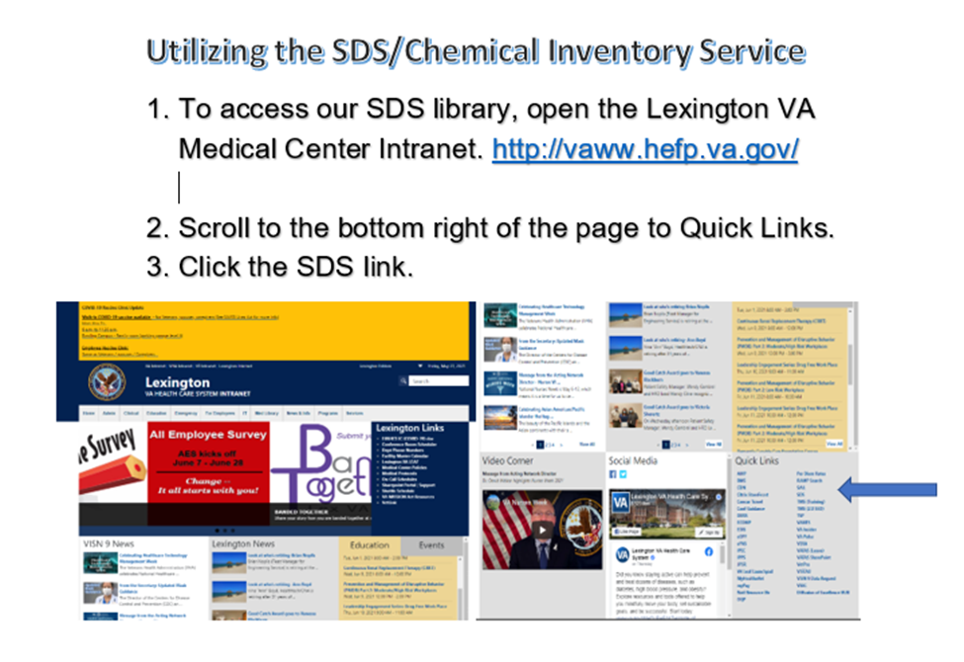

4. When this screen opens, select “SDS Search”
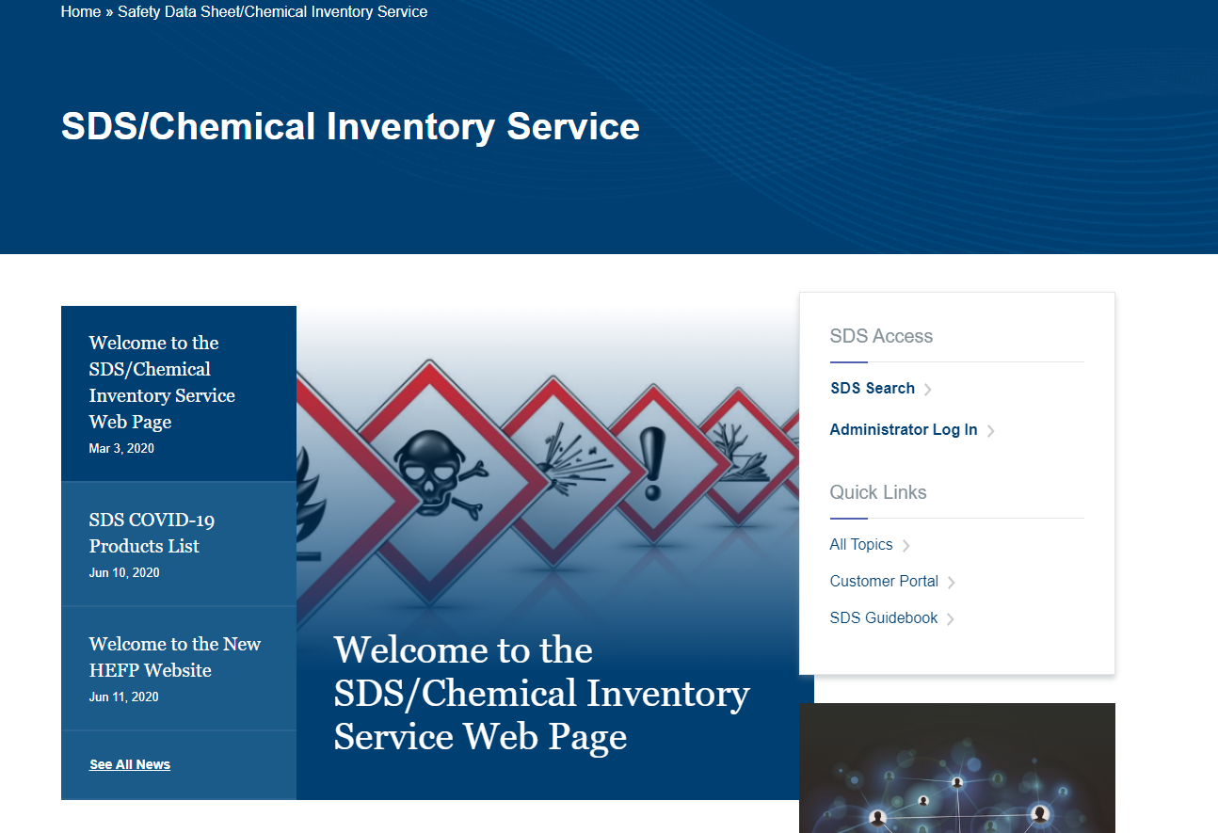

5. When this screen opens, click on “+My Locations”

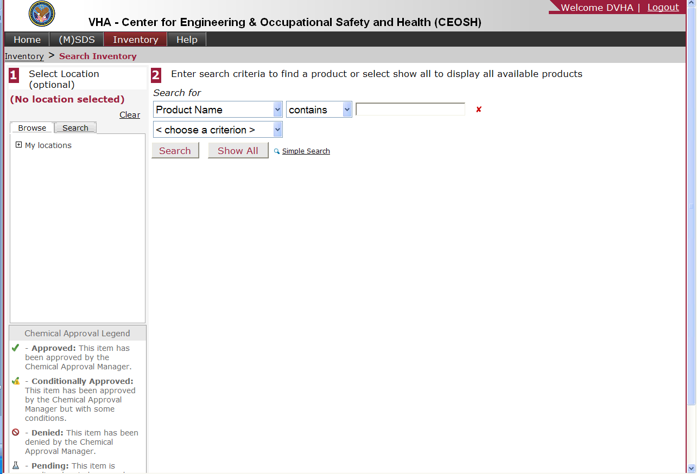

6. Click on VISN 09
7. Click on Lexington, KY –
8. Click on Pathology & Laboratory Medicine
a. At this time, you may choose an individual department by clicking on
it; however, just selecting Pathology & Laboratory Medicine will
allow you to bring up all chemicals in our service

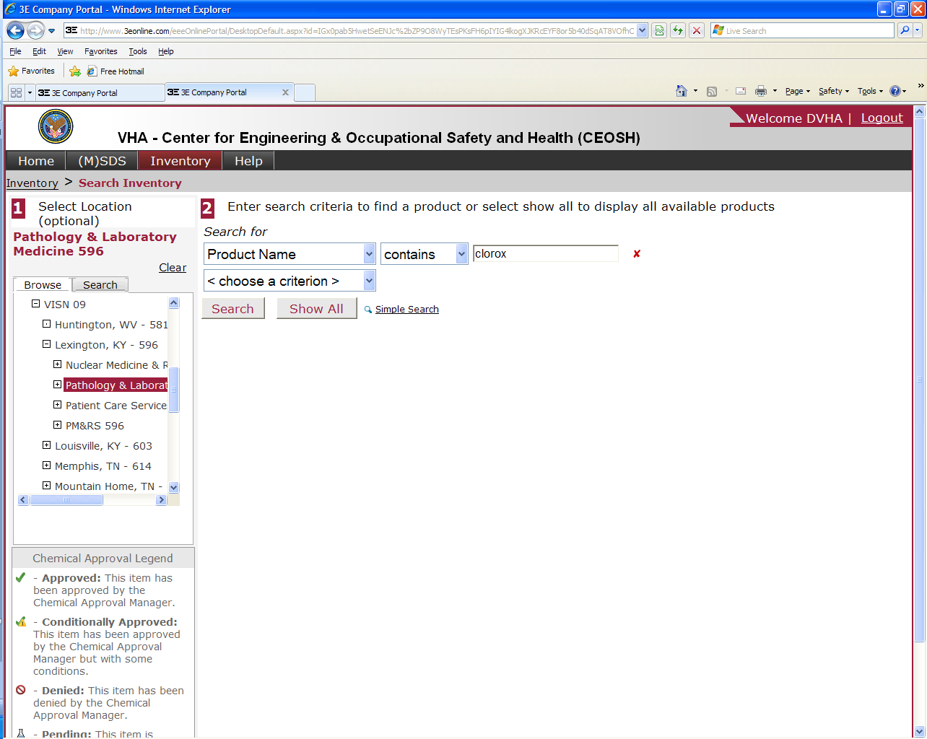

9. Type in the chemical name you would like to search for in the rectangle next to
the word “contains”
10. Click on “Search”

11. After clicking on “Search”, a screen with your choices will come up.

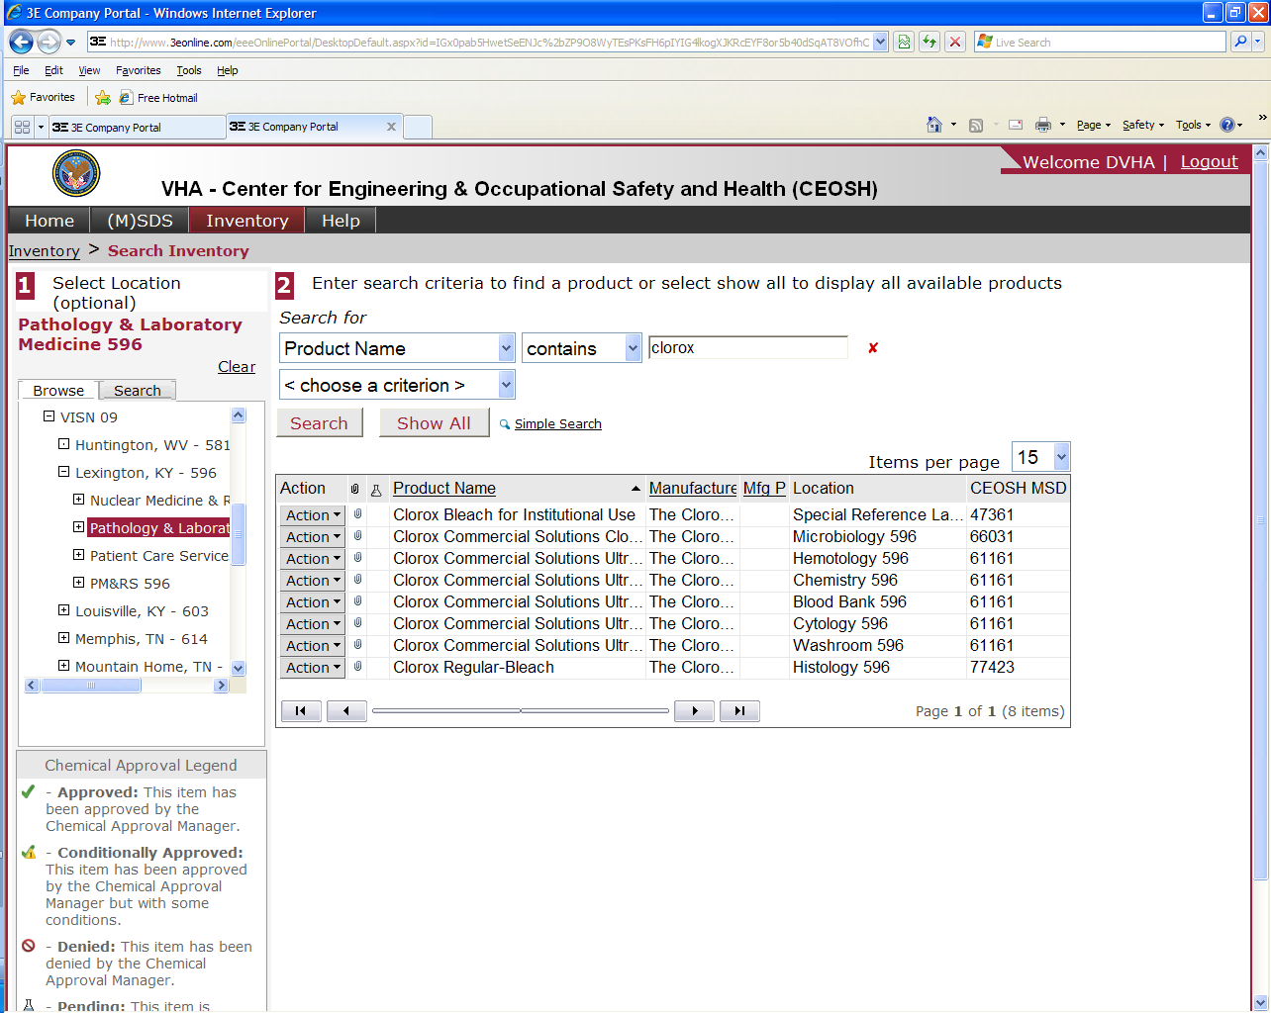

12. Click on “Action” next to the chemical you would like to select
13. At this time, a pop up box appears with 8 choices.
14. If you would like to view the SDS for the chemical you selected,
Click on “View SDS & Attachments.
15. Another pop up box will appear. At this time you will have the option of
viewing, emailing or faxing the SDS. Click on “View” if you wish to view
the SDS
16. The SDS appears on the screen. At this time you may view it, save it or
print it.

Attachment K: Printing Chemical labels using the 3E SDS Library

1. Go through steps 1-13 in attachment J (previous attachment)
2. If you would like to print labels for the chemical, click on “Labels”
3. Select GHS/CLP
4. Select North American
5. Select the number of labels desired per page
6. Choose a Source Document for your label data
a. Choose SDS (English, UNITED STATES OF AMERICA):
7. Click on “Process Label”
8. - Review the label data, gives you the option to edit the information
9. - Choose label placement, tells you what kind of labels to load and gives you
the opportunity to print only the amount of labels you need.
10. Click on “View Label” for a print preview.
11. If everything is okay, load the required labels and print the labels using the
color printer (LEX-PTPLM02_COLOR) in B112.

Attachment L: Formaldehyde VA Medical Center Lexington, KY SOP-ENG-138-12 (Formerly Memorandum 138-31)
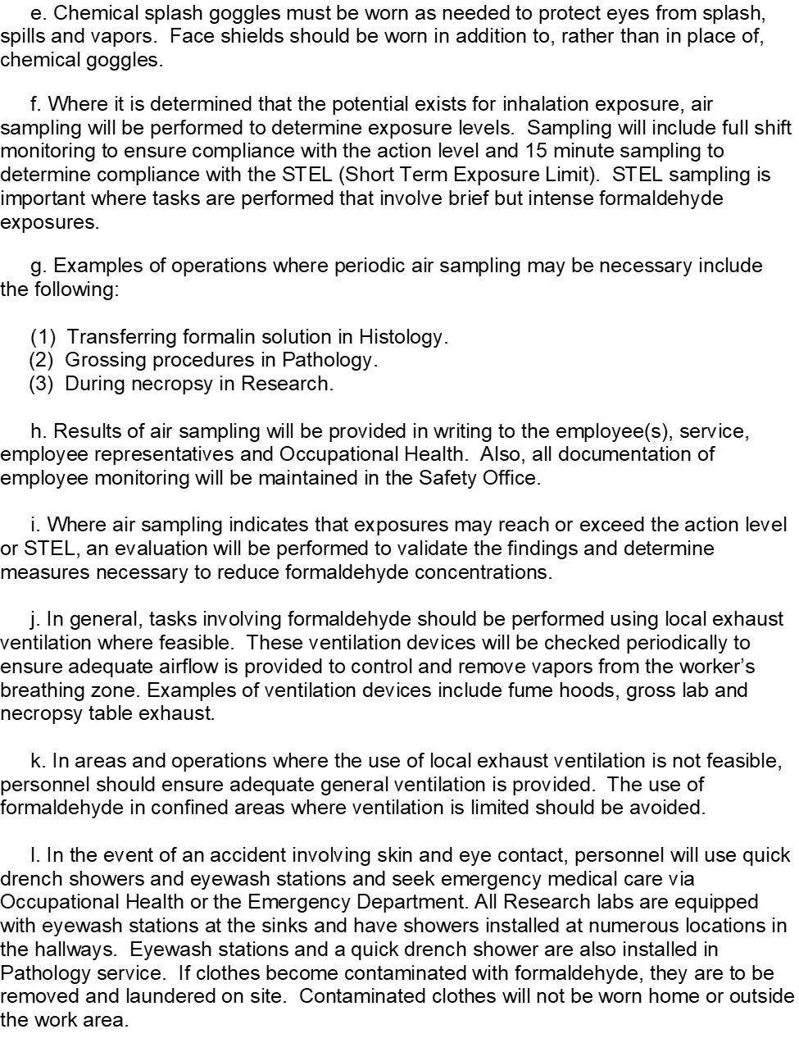

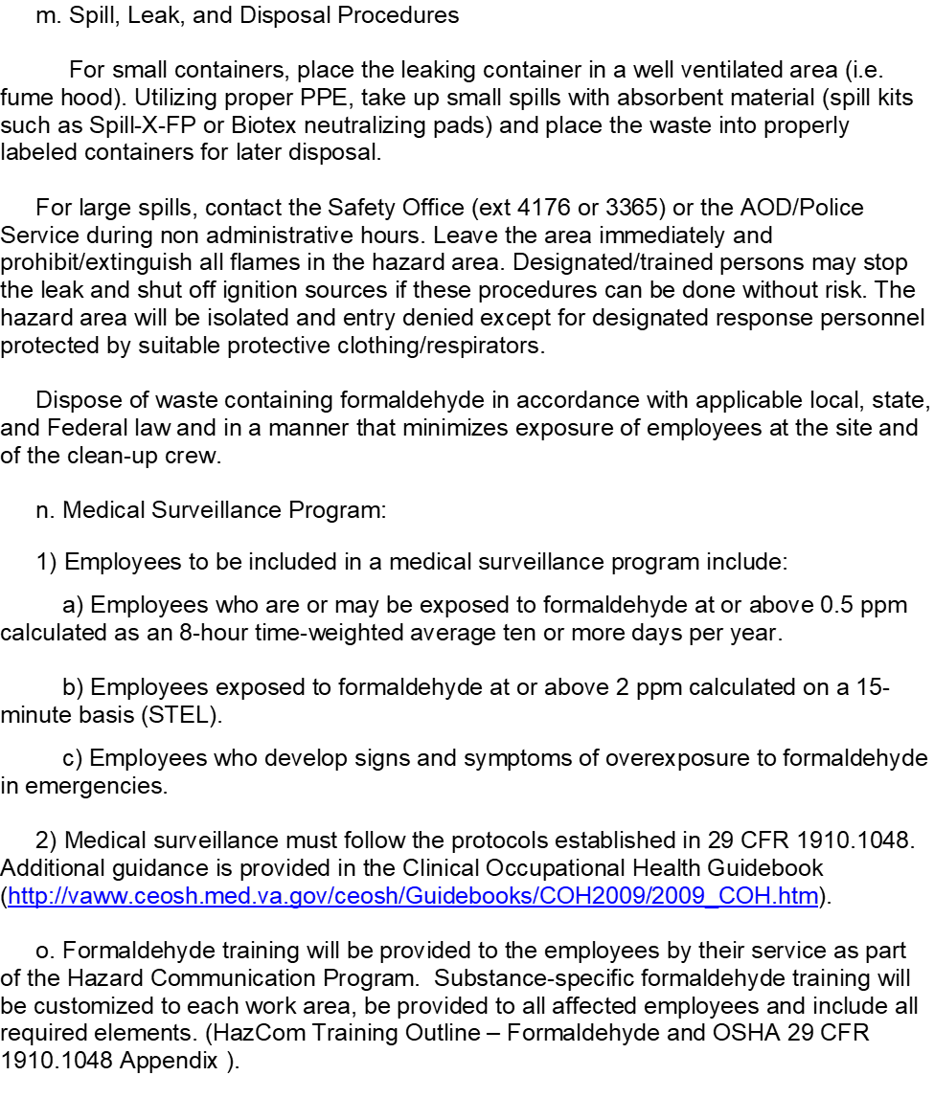
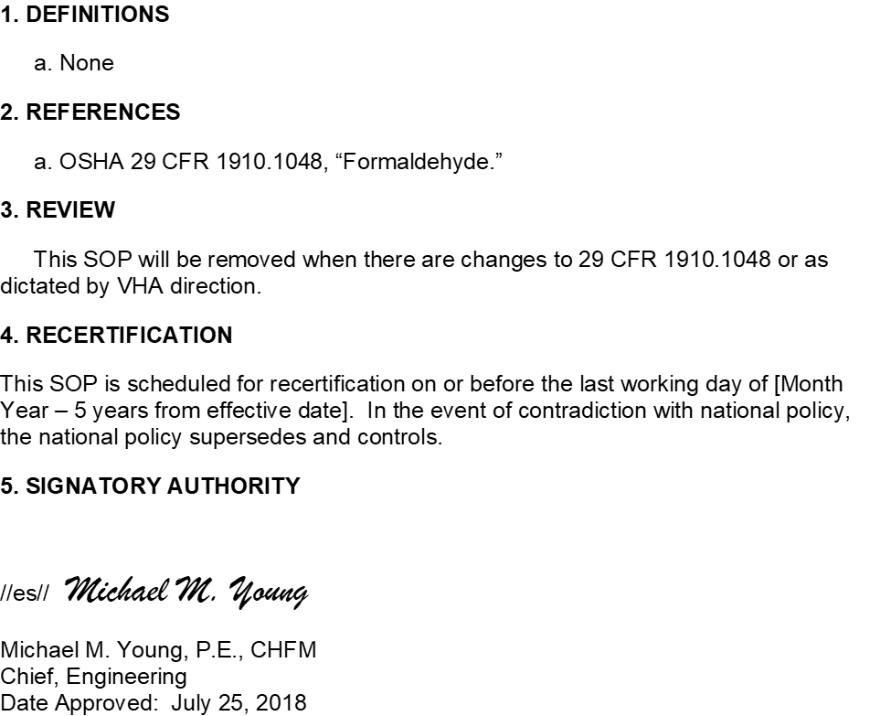

Attachment M: Standard, 29CFR 1910.1048 and Appendices A, B, C, D, and E
Part Number: | 1910
• Part Title: | Occupational Safety and Health Standards
• Subpart: | Z
• Subpart Title: | Toxic and Hazardous Substances
• Standard Number: | 1910.1048
• Title: | Formaldehyde.
• Appendix: | A , B , C , D , E
• GPO Source: | e-CFR

1910.1048(a)
Scope and application. This standard applies to all occupational exposures to formaldehyde, i.e. from formaldehyde gas, its solutions, and materials that release formaldehyde.
1910.1048(b)
Definitions. For purposes of this standard, the following definitions shall apply:
Action level means a concentration of 0.5 part formaldehyde per million parts of air (0.5 ppm) calculated as an eight (8)-hour time-weighted average (TWA) concentration.
Assistant Secretary means the Assistant Secretary of Labor for the Occupational Safety and Health Administration, U.S. Department of Labor, or designee.
Authorized Person means any person required by work duties to be present in regulated areas, or authorized to do so by the employer, by this section, or by the OSH Act of 1970.
Director means the Director of the National Institute for Occupational Safety and Health, U.S. Department of Health and Human Services, or designee.
Emergency is any occurrence, such as but not limited to equipment failure, rupture of containers, or failure of control equipment that results in an uncontrolled release of a significant amount of formaldehyde.
Employee exposure means the exposure to airborne formaldehyde which would occur without corrections for protection provided by any respirator that is in use.
Formaldehyde means the chemical substance, HCHO, Chemical Abstracts Service Registry No. 50-00-0.
1910.1048(c)
Permissible Exposure Limit (PEL) -
1910.1048(c)(1)
TWA: The employer shall assure that no employee is exposed to an airborne concentration of formaldehyde which exceeds 0.75 parts formaldehyde per million parts of air (0.75 ppm) as an 8-hour TWA.
1910.1048(c)(2)
Short Term Exposure Limit (STEL): The employer shall assure that no employee is exposed to an airborne concentration of formaldehyde which exceeds two parts formaldehyde per million parts of air (2 ppm) as a 15-minute STEL.
1910.1048(d)
Exposure monitoring -
1910.1048(d)(1)
General.
1910.1048(d)(1)(i)
Each employer who has a workplace covered by this standard shall monitor employees to determine their exposure to formaldehyde.
1910.1048(d)(1)(ii)
Exception. Where the employer documents, using objective data, that the presence of formaldehyde or formaldehyde-releasing products in the workplace cannot result in airborne concentrations of formaldehyde that would cause any employee to be exposed at or above the action level or the STEL under foreseeable conditions of use, the employer will not be required to measure employee exposure to formaldehyde.
1910.1048(d)(1)(iii)
When an employee's exposure is determined from representative sampling, the measurements used shall be representative of the employee's full shift or short-term exposure to formaldehyde, as appropriate.
1910.1048(d)(1)(iv)
Representative samples for each job classification in each work area shall be taken for each shift unless the employer can document with objective data that exposure levels for a given job classification are equivalent for different work shifts.
1910.1048(d)(2)
Initial monitoring. The employer shall identify all employees who may be exposed at or above the action level or at or above the STEL and accurately determine the exposure of each employee so identified.
1910.1048(d)(2)(i)
Unless the employer chooses to measure the exposure of each employee potentially exposed to formaldehyde, the employer shall develop a representative sampling strategy and measure sufficient exposures within each job classification for each workshift to correctly characterize and not underestimate the exposure of any employee within each exposure group.
1910.1048(d)(2)(ii)
The initial monitoring process shall be repeated each time there is a change in production, equipment, process, personnel, or control measures which may result in new or additional exposure to formaldehyde.
1910.1048(d)(2)(iii)
If the employer receives reports of signs or symptoms of respiratory or dermal conditions associated with formaldehyde exposure, the employer shall promptly monitor the affected employee's exposure.
1910.1048(d)(3)
Periodic monitoring.
1910.1048(d)(3)(i)
The employer shall periodically measure and accurately determine exposure to formaldehyde for employees shown by the initial monitoring to be exposed at or above the action level or at or above the STEL.
1910.1048(d)(3)(ii)
If the last monitoring results reveal employee exposure at or above the action level, the employer shall repeat monitoring of the employees at least every 6 months.
1910.1048(d)(3)(iii)
If the last monitoring results reveal employee exposure at or above the STEL, the employer shall repeat monitoring of the employees at least once a year under worst conditions.
1910.1048(d)(4)
Termination of monitoring. The employer may discontinue periodic monitoring for employees if results from two consecutive sampling periods taken at least 7 days apart show that employee exposure is below the action level and the STEL. The results must be statistically representative and consistent with the employer's knowledge of the job and work operation.
1910.1048(d)(5)
Accuracy of monitoring. Monitoring shall be accurate, at the 95 percent confidence level, to within plus or minus 25 percent for airborne concentrations of formaldehyde at the TWA and the STEL and to within plus or minus 35 percent for airborne concentrations of formaldehyde at the action level.
1910.1048(d)(6)
Employee notification of monitoring results. The employer must, within 15 working days after the receipt of the results of any monitoring performed under this section, notify each affected employee of these results either individually in writing or by posting the results in an appropriate location that is accessible to employees. If employee exposure is above the PEL, affected employees shall be provided with a description of the corrective actions being taken by the employer to decrease exposure.
1910.1048(d)(7)
Observation of monitoring.
1910.1048(d)(7)(i)
The employer shall provide affected employees or their designated representatives an opportunity to observe any monitoring of employee exposure to formaldehyde required by this standard.
1910.1048(d)(7)(ii)
When observation of the monitoring of employee exposure to formaldehyde requires entry into an area where the use of protective clothing or equipment is required, the employer shall provide the clothing and equipment to the observer, require the observer to use such clothing and equipment, and assure that the observer complies with all other applicable safety and health procedures.
1910.1048(e)
Regulated areas.
1910.1048(e)(1)
Signs.
1910.1048(e)(1)(i)
The employer shall establish regulated areas where the concentration of airborne formaldehyde exceeds either the TWA or the STEL and post all entrances and access ways with signs bearing the following legend:
DANGER
FORMALDEHYDE
MAY CAUSE CANCER
CAUSES SKIN, EYE, AND RESPIRATORY IRRITATION
AUTHORIZED PERSONNEL ONLY
1910.1048(e)(1)(ii)
Prior to June 1, 2016, employers may use the following legend in lieu of that specified in paragraph (e)(1)(i) of this section:
DANGER
FORMALDEHYDE
IRRITANT AND POTENTIAL CANCER HAZARD
AUTHORIZED PERSONNEL ONLY
1910.1048(e)(2)
The employer shall limit access to regulated areas to authorized persons who have been trained to recognize the hazards of formaldehyde.
1910.1048(e)(3)
An employer at a multiemployer worksite who establishes a regulated area shall communicate the access restrictions and locations of these areas to other employers with work operations at that worksite.
1910.1048(f)
Methods of compliance -
1910.1048(f)(1)
Engineering controls and work practices. The employer shall institute engineering and work practice controls to reduce and maintain employee exposures to formaldehyde at or below the TWA and the STEL.
1910.1048(f)(2)
Exception. Whenever the employer has established that feasible engineering and work practice controls cannot reduce employee exposure to or below either of the PELs, the employer shall apply these controls to reduce employee exposures to the extent feasible and shall supplement them with respirators which satisfy this standard.
1910.1048(g)
Respiratory protection.
1910.1048(g)(1)
General. For employees who use respirators required by this section, the employer must provide each employee an appropriate respirator that complies with the requirements of this paragraph. Respirators must be used during:
1910.1048(g)(1)(i)
Periods necessary to install or implement feasible engineering and work-practice controls.
1910.1048(g)(1)(ii)
Work operations, such as maintenance and repair activities or vessel cleaning, for which the employer establishes that engineering and work-practice controls are not feasible.
1910.1048(g)(1)(iii)
Work operations for which feasible engineering and work- practice controls are not yet sufficient to reduce employee exposure to or below the PELs.
1910.1048(g)(1)(iv)
Emergencies.
1910.1048(g)(2)
Respirator program.
1910.1048(g)(2)(i)
The employer must implement a respiratory protection program in accordance with § 1910.134(b) through (d) (except (d)(1)(iii), (d)(3)(iii)(b)(1), and (2)), and (f) through (m), which covers each employee required by this section to use a respirator.
1910.1048(g)(2)(ii)
When employees use air-purifying respirators with chemical cartridges or canisters that do not contain end-of-service-life indicators approved by the National Institute for Occupational Safety and Health, employers must replace these cartridges or canisters as specified by paragraphs (d)(3)(iii)(B)(1) and (B)(2) of 29 CFR 1910.134, or at the end of the workshift, whichever condition occurs first.
1910.1048(g)(3)
Respirator selection.
1910.1048(g)(3)(i)
Employers must:
1910.1048(g)(3)(i)(A)
Select, and provide to employees, the appropriate respirators specified in paragraph (d)(3)(i)(A) of 29 CFR 1910.134.
1910.1048(g)(3)(i)(B)
Equip each air-purifying, full facepiece respirator with a canister or cartridge approved for protection against formaldehyde.
1910.1048(g)(3)(i)(C)
For escape, provide employees with one of the following respirator options: A self-contained breathing apparatus operated in the demand or pressure-demand mode; or a full facepiece respirator having a chin-style, or a front-or back-mounted industrial-size, canister or cartridge approved for protection against formaldehyde.
1910.1048(g)(3)(ii)
Employers may substitute an air-purifying, half mask respirator for an air-purifying, full facepiece respirator when they equip the half mask respirator with a cartridge approved for protection against formaldehyde and provide the affected employee with effective gas-proof goggles.
1910.1048(g)(3)(iii)
Employers must provide employees who have difficulty using negative pressure respirators with powered air-purifying respirators permitted for use under paragraph (g)(3)(i)(A) of this standard and that affords adequate protection against formaldehyde exposures.
1910.1048(h)
Protective equipment and clothing. Employers shall comply with the provisions of 29 CFR 1910.132 and 29 CFR 1910.133. When protective equipment or clothing is provided under these provisions, the employer shall provide these protective devices at no cost to the employee and assure that the employee wears them.
1910.1048(h)(1)
Selection. The employer shall select protective clothing and equipment based upon the form of formaldehyde to be encountered, the conditions of use, and the hazard to be prevented.
1910.1048(h)(1)(i)
All contact of the eyes and skin with liquids containing 1 percent or more formaldehyde shall be prevented by the use of chemical protective clothing made of material impervious to formaldehyde and the use of other personal protective equipment, such as goggles and face shields, as appropriate to the operation.
1910.1048(h)(1)(ii)
Contact with irritating or sensitizing materials shall be prevented to the extent necessary to eliminate the hazard.
1910.1048(h)(1)(iii)
Where a face shield is worn, chemical safety goggles are also required if there is a danger of formaldehyde reaching the area of the eye.
1910.1048(h)(1)(iv)
Full body protection shall be worn for entry into areas where concentrations exceed 100 ppm and for emergency reentry into areas of unknown concentration.
1910.1048(h)(2)
Maintenance of protective equipment and clothing.
1910.1048(h)(2)(i)
The employer shall assure that protective equipment and clothing that has become contaminated with formaldehyde is cleaned or laundered before its reuse.
1910.1048(h)(2)(ii)
When formaldehyde-contaminated clothing and equipment is ventilated, the employer shall establish storage areas so that employee exposure is minimized.
1910.1048(h)(2)(ii)(A)
Signs. Storage areas for contaminated clothing and equipment shall have signs bearing the following legend:
DANGER
FORMALDEHYDE-CONTAMINATED [CLOTHING] EQUIPMENT
MAY CAUSE CANCER
CAUSES SKIN, EYE AND RESPIRATORY IRRITATION
DO NOT BREATHE VAPOR
DO NOT GET ON SKIN
1910.1048(h)(2)(ii)(B)
Labels. The employer shall ensure containers for contaminated clothing and equipment are labeled consistent with the Hazard Communication Standard, Sec. 1910.1200, and shall, as a minimum, include the following:
DANGER
FORMALDEHYDE-CONTAMINATED [CLOTHING] EQUIPMENT
MAY CAUSE CANCER
CAUSES SKIN, EYE, AND RESPIRATORY IRRITATION
DO NOT BREATHE VAPOR
DO NOT GET ON SKIN
1910.1048(h)(2)(ii)(C)
Prior to June 1, 2016, employers may use the following legend in lieu of that specified in paragraph (h)(2)(ii)(A) of this section:
DANGER
FORMALDEHYDE-CONTAMINATED [CLOTHING] EQUIPMENT
AVOID INHALATION AND SKIN CONTACT
1910.1048(h)(2)(ii)(D)
Prior to June 1, 2015, employers may include the following information on containers of protective clothing and equipment in lieu of the labeling requirements in paragraphs (h)(2)(ii)(B) of this section:
DANGER
FORMALDEHYDE-CONTAMINATED [CLOTHING] EQUIPMENT
AVOID INHALATION AND SKIN CONTACT
1910.1048(h)(2)(iii)
The employer shall assure that only persons trained to recognize the hazards of formaldehyde remove the contaminated material from the storage area for purposes of cleaning, laundering, or disposal.
1910.1048(h)(2)(iv)
The employer shall assure that no employee takes home equipment or clothing that is contaminated with formaldehyde.
1910.1048(h)(2)(v)
The employer shall repair or replace all required protective clothing and equipment for each affected employee as necessary to assure its effectiveness.
1910.1048(h)(2)(vi)
The employer shall inform any person who launders, cleans, or repairs such clothing or equipment of formaldehyde's potentially harmful effects and of procedures to safely handle the clothing and equipment.
1910.1048(i)
Hygiene protection.
1910.1048(i)(1)
The employer shall provide change rooms, as described in 29 CFR 1910.141 for employees who are required to change from work clothing into protective clothing to prevent skin contact with formaldehyde.
1910.1048(i)(2)
If employees' skin may become splashed with solutions containing 1 percent or greater formaldehyde, for example, because of equipment failure or improper work practices, the employer shall provide conveniently located quick drench showers and assure that affected employees use these facilities immediately.
1910.1048(i)(3)
If there is any possibility that an employee's eyes may be splashed with solutions containing 0.1 percent or greater formaldehyde, the employer shall provide acceptable eyewash facilities within the immediate work area for emergency use.
1910.1048(j)
Housekeeping. For operations involving formaldehyde liquids or gas, the employer shall conduct a program to detect leaks and spills, including regular visual inspections.
1910.1048(j)(1)
Preventative maintenance of equipment, including surveys for leaks, shall be undertaken at regular intervals.
1910.1048(j)(2)
In work areas where spillage may occur, the employer shall make provisions to contain the spill, to decontaminate the work area, and to dispose of the waste.
1910.1048(j)(3)
The employer shall assure that all leaks are repaired and spills are cleaned promptly by employees wearing suitable protective equipment and trained in proper methods for cleanup and decontamination.
1910.1048(j)(4)
Formaldehyde-contaminated waste and debris resulting from leaks or spills shall be placed for disposal in sealed containers bearing a label warning of formaldehyde's presence and of the hazards associated with formaldehyde. The employer shall ensure that the labels are in accordance with paragraph (m) of this section.
1910.1048(k)
Emergencies. For each workplace where there is the possibility of an emergency involving formaldehyde, the employer shall assure appropriate procedures are adopted to minimize injury and loss of life. Appropriate procedures shall be implemented in the event of an emergency.
1910.1048(l)
Medical surveillance -
1910.1048(l)(1)
Employees covered.
1910.1048(l)(1)(i)
The employer shall institute medical surveillance programs for all employees exposed to formaldehyde at concentrations at or exceeding the action level or exceeding the STEL.
1910.1048(l)(1)(ii)
The employer shall make medical surveillance available for employees who develop signs and symptoms of overexposure to formaldehyde and for all employees exposed to formaldehyde in emergencies. When determining whether an employee may be experiencing signs and symptoms of possible overexposure to formaldehyde, the employer may rely on the evidence that signs and symptoms associated with formaldehyde exposure will occur only in exceptional circumstances when airborne exposure is less than 0.1 ppm and when formaldehyde is present in material in concentrations less than 0.1 percent.
1910.1048(l)(2)
Examination by a physician. All medical procedures, including administration of medical disease questionnaires, shall be performed by or under the supervision of a licensed physician and shall be provided without cost to the employee, without loss of pay, and at a reasonable time and place.
1910.1048(l)(3)
Medical disease questionnaire. The employer shall make the following medical surveillance available to employees prior to assignment to a job where formaldehyde exposure is at or above the action level or above the STEL and annually thereafter. The employer shall also make the following medical surveillance available promptly upon determining that an employee is experiencing signs and symptoms indicative of possible overexposure to formaldehyde.
1910.1048(l)(3)(i)
Administration of a medical disease questionnaire, such as in Appendix D, which is designed to elicit information on work history, smoking history, any evidence of eye, nose, or throat irritation; chronic airway problems or hyperreactive airway disease: allergic skin conditions or dermatitis; and upper or lower respiratory problems.
1910.1048(l)(3)(ii)
A determination by the physician, based on evaluation of the medical disease questionnaire, of whether a medical examination is necessary for employees not required to wear respirators to reduce exposure to formaldehyde.
1910.1048(l)(4)
Medical examinations. Medical examinations shall be given to any employee who the physician feels, based on information in the medical disease questionnaire, may be at increased risk from exposure to formaldehyde and at the time of initial assignment and at least annually thereafter to all employees required to wear a respirator to reduce exposure to formaldehyde. The medical examination shall include:
1910.1048(l)(4)(i)
A physical examination with emphasis on evidence of irritation or sensitization of the skin and respiratory system, shortness of breath, or irritation of the eyes.
1910.1048(l)(4)(ii)
Laboratory examinations for respirator wearers consisting of baseline and annual pulmonary function tests. As a minimum, these tests shall consist of forced vital capacity (FVC), forced expiratory volume in one second (FEV(1)), and forced expiratory flow (FEF).
1910.1048(l)(4)(iii)
Any other test which the examining physician deems necessary to complete the written opinion.
1910.1048(l)(4)(iv)
Counseling of employees having medical conditions that would be directly or indirectly aggravated by exposure to formaldehyde on the increased risk of impairment of their health.
1910.1048(l)(5)
Examinations for employees exposed in an emergency. The employer shall make medical examinations available as soon as possible to all employees who have been exposed to formaldehyde in an emergency.
1910.1048(l)(5)(i)
The examination shall include a medical and work history with emphasis on any evidence of upper or lower respiratory problems, allergic conditions, skin reaction or hypersensitivity, and any evidence of eye, nose, or throat irritation.
1910.1048(l)(5)(ii)
Other examinations shall consist of those elements considered appropriate by the examining physician.
1910.1048(l)(6)
Information provided to the physician. The employer shall provide the following information to the examining physician:
1910.1048(l)(6)(i)
A copy of this standard and Appendix A, C, D, and E;
1910.1048(l)(6)(ii)
A description of the affected employee's job duties as they relate to the employee's exposure to formaldehyde;
1910.1048(l)(6)(iii)
The representative exposure level for the employee's job assignment;
1910.1048(l)(6)(iv)
Information concerning any personal protective equipment and respiratory protection used or to be used by the employee; and
1910.1048(l)(6)(v)
Information from previous medical examinations of the affected employee within the control of the employer.
1910.1048(l)(6)(vi)
In the event of a nonroutine examination because of an emergency, the employer shall provide to the physician as soon as possible: a description of how the emergency occurred and the exposure the victim may have received.
1910.1048(l)(7)
Physician's written opinion.
1910.1048(l)(7)(i)
For each examination required under this standard, the employer shall obtain a written opinion from the examining physician. This written opinion shall contain the results of the medical examination except that it shall not reveal specific findings or diagnoses unrelated to occupational exposure to formaldehyde. The written opinion shall include:
1910.1048(l)(7)(i)(A)
The physician's opinion as to whether the employee has any medical condition that would place the employee at an increased risk of material impairment of health from exposure to formaldehyde;
1910.1048(l)(7)(i)(B)
Any recommended limitations on the employee's exposure or changes in the use of personal protective equipment, including respirators;
1910.1048(l)(7)(i)(C)
A statement that the employee has been informed by the physician of any medical conditions which would be aggravated by exposure to formaldehyde, whether these conditions may have resulted from past formaldehyde exposure or from exposure in an emergency, and whether there is a need for further examination or treatment.
1910.1048(l)(7)(ii)
The employer shall provide for retention of the results of the medical examination and tests conducted by the physician.
1910.1048(l)(7)(iii)
The employer shall provide a copy of the physician's written opinion to the affected employee within 15 days of its receipt.
1910.1048(l)(8)
Medical removal.
1910.1048(l)(8)(i)
The provisions of paragraph (l)(8) apply when an employee reports significant irritation of the mucosa of the eyes or of the upper airways, respiratory sensitization, dermal irritation, or dermal sensitization attributed to workplace formaldehyde exposure. Medical removal provisions do not apply in the case of dermal irritation or dermal sensitization when the product suspected of causing the dermal condition contains less than 0.05 percent formaldehyde.
1910.1048(l)(8)(ii)
An employee's report of signs or symptoms of possible overexposure to formaldehyde shall be evaluated by a physician selected by the employer pursuant to paragraph (l)(3). If the physician determines that a medical examination is not necessary under paragraph (l)(3)(ii), there shall be a two-week evaluation and remediation period to permit the employer to ascertain whether the signs or symptoms subside untreated or with the use of creams, gloves, first aid treatment or personal protective equipment. Industrial hygiene measures that limit the employee's exposure to formaldehyde may also be implemented during this period. The employee shall be referred immediately to a physician prior to expiration of the two-week period if the signs or symptoms worsen. Earnings, seniority and benefits may not be altered during the two-week period by virtue of the report.
1910.1048(l)(8)(iii)
If the signs or symptoms have not subsided or been remedied by the end of the two-week period, or earlier if signs or symptoms warrant, the employee shall be examined by a physician selected by the employer. The physician shall presume, absent contrary evidence, that observed dermal irritation or dermal sensitization are not attributable to formaldehyde when products to which the affected employee is exposed contain less than 0.1 percent formaldehyde.
1910.1048(l)(8)(iv)
Medical examinations shall be conducted in compliance with the requirements of paragraph (l)(5)(i) and (ii). Additional guidelines for conducting medical exams are contained in Appendix C.
1910.1048(l)(8)(v)
If the physician finds that significant irritation of the mucosa of the eyes or of the upper airways, respiratory sensitization, dermal irritation, or dermal sensitization result from workplace formaldehyde exposure and recommends restrictions or removal, the employer shall promptly comply with the restrictions or recommendation of removal. In the event of a recommendation of removal, the employer shall remove the affected employee from the current formaldehyde exposure and if possible, transfer the employee to work having no or significantly less exposure to formaldehyde.
1910.1048(l)(8)(vi)
When an employee is removed pursuant to paragraph (l)(8)(v), the employer shall transfer the employee to comparable work for which the employee is qualified or can be trained in a short period (up to 6 months), where the formaldehyde exposures are as low as possible, but not higher than the action level. The employer shall maintain the employee's current earnings, seniority, and other benefits. If there is no such work available, the employer shall maintain the employee's current earnings, seniority and other benefits until such work becomes available, until the employee is determined to be unable to return to workplace formaldehyde exposure, until the employee is determined to be able to return to the original job status, or for six months, whichever comes first.
1910.1048(l)(8)(vii)
The employer shall arrange for a follow-up medical examination to take place within six months after the employee is removed pursuant to this paragraph. This examination shall determine if the employee can return to the original job status, or if the removal is to be permanent. The physician shall make a decision within six months of the date the employee was removed as to whether the employee can be returned to the original job status, or if the removal is to be permanent.
1910.1048(l)(8)(viii)
An employer's obligation to provide earnings, seniority and other benefits to a removed employee may be reduced to the extent that the employee receives compensation for earnings lost during the period of removal either from a publicly or employer-funded compensation program or from employment with another employer made possible by virtue of the employee's removal.
1910.1048(l)(8)(ix)
In making determinations of the formaldehyde content of materials under this paragraph the employer may rely on objective data.
1910.1048(l)(9)
Multiple physician review.
1910.1048(l)(9)(i)
After the employer selects the initial physician who conducts any medical examination or consultation to determine whether medical removal or restriction is appropriate, the employee may designate a second physician to review any findings, determinations or recommendations of the initial physician and to conduct such examinations, consultations,and laboratory tests as the second physician deems necessary and appropriate to evaluate the effects of formaldehyde exposure and to facilitate this review.
1910.1048(l)(9)(ii)
The employer shall promptly notify an employee of the right to seek a second medical opinion after each occasion that an initial physician conducts a medical examination or consultation for the purpose of medical removal or restriction.
1910.1048(l)(9)(iii)
The employer may condition its participation in, and payment for, the multiple physician review mechanism upon the employee doing the following within fifteen (15) days after receipt of the notification of the right to seek a second medical opinion, or receipt of the initial physician's written opinion, whichever is later;
1910.1048(l)(9)(iii)(A)
The employee informs the employer of the intention to seek a second medical opinion, and
1910.1048(l)(9)(iii)(B)
The employee initiates steps to make an appointment with a second physician.
1910.1048(l)(9)(iv)
If the findings, determinations or recommendations of the second physician differ from those of the initial physician, then the employer and the employee shall assure that efforts are made for the two physicians to resolve the disagreement. If the two physicians are unable to quickly resolve their disagreement, then the employer and the employee through their respective physicians shall designate a third physician who shall be a specialist in the field at issue:
1910.1048(l)(9)(iv)(A)
To review the findings, determinations or recommendations of the prior physicians; and
1910.1048(l)(9)(iv)(B)
To conduct such examinations, consultations, laboratory tests and discussions with the prior physicians as the third physician deems necessary to resolve the disagreement of the prior physicians.
1910.1048(l)(9)(v)
In the alternative, the employer and the employee or authorized employee representative may jointly designate such third physician.
1910.1048(l)(9)(vi)
The employer shall act consistent with the findings, determinations and recommendations of the third physician, unless the employer and the employee reach an agreement which is otherwise consistent with the recommendations of at least one of the three physicians.
1910.1048(m)
Communication of hazards.
1910.1048(m)(1)
Hazard communication - General.
1910.1048(m)(1)(i)
Chemical manufacturers, importers, distributors and employers shall comply with all requirements of the Hazard Communication Standard (HCS) (§ 1910.1200) for formaldehyde.
1910.1048(m)(1)(ii)
In classifying the hazards of formaldehyde at least the following hazards are to be addressed: Cancer; skin and respiratory sensitization; eye, skin and respiratory tract irritation; acute toxicity effects; and flammability.
1910.1048(m)(1)(iii)
Employers shall include formaldehyde in the hazard communication program established to comply with the HCS (§ 1910.1200). Employers shall ensure that each employee has access to labels on containers of formaldehyde and to safety data sheets, and is trained in accordance with the requirements of HCS and paragraph (n) of this section.
1910.1048(m)(1)(iv)
Paragraphs (m)(1)(i), (m)(1)(ii), and (m)(1)(iii) of this section apply to chemicals associated with formaldehyde gas, all mixtures or solutions composed of greater than 0.1 percent formaldehyde, and materials capable of releasing formaldehyde into the air at concentrations reaching or exceeding 0.1 ppm.
1910.1048(m)(1)(v)
In making the determinations of anticipated levels of formaldehyde release, the employer may rely on objective data indicating the extent of potential formaldehyde release under reasonably foreseeable conditions of use.
1910.1048(m)(2)(i)
In addition to the requirements in paragraphs (m)(1) through (m)(1)(iv) of this section, for materials listed in paragraph (m)(1)(iv) capable of releasing formaldehyde at levels above 0.5 ppm, labels shall appropriately address all hazards as defined in paragraph (d) of § 1910.1200 and Appendices A and B to § 1910.1200, including cancer and respiratory sensitization, and shall contain the hazard statement "May Cause Cancer."
1910.1048(m)(2)(ii)
As a minimum, for all materials listed in paragraph (m)(1)(i) and (iv) of this section capable of releasing formaldehyde at levels of 0.1 ppm to 0.5 ppm, labels shall identify that the product contains formaldehyde; list the name and address of the responsible party; and state that physical and health hazard information is readily available from the employer and from safety data sheets.
1910.1048(m)(2)(iii)
Prior to June 1, 2015, employers may include the phrase "Potential Cancer Hazard" in lieu of "May Cause Cancer" as specified in paragraph (m)(2)(i) of this section.
1910.1048(n)
Employee information and training -
1910.1048(n)(1)
Participation. The employer shall assure that all employees who are assigned to workplaces where there is exposure to formaldehyde participate in a training program, except that where the employer can show, using objective data, that employees are not exposed to formaldehyde at or above 0.1 ppm, the employer is not required to provide training.
1910.1048(n)(2)
Frequency. Employers shall provide such information and training to employees at the time of initial assignment, and whenever a new exposure to formaldehyde is introduced into the work area. The training shall be repeated at least annually.
1910.1048(n)(3)
Training program. The training program shall be conducted in a manner which the employee is able to understand and shall include:
1910.1048(n)(3)(i)
A discussion of the contents of this regulation and the contents of the Material Safety Data Sheet.
1910.1048(n)(3)(ii)
The purpose for and a description of the medical surveillance program required by this standard, including:
1910.1048(n)(3)(ii)(A)
A description of the potential health hazards associated with exposure to formaldehyde and a description of the signs and symptoms of exposure to formaldehyde.
1910.1048(n)(3)(ii)(B)
Instructions to immediately report to the employer the development of any adverse signs or symptoms that the employee suspects is attributable to formaldehyde exposure.
1910.1048(n)(3)(iii)
Description of operations in the work area where formaldehyde is present and an explanation of the safe work practices appropriate for limiting exposure to formaldehyde in each job;
1910.1048(n)(3)(iv)
The purpose for, proper use of, and limitations of personal protective clothing and equipment;
1910.1048(n)(3)(v)
Instructions for the handling of spills, emergencies, and clean-up procedures;
1910.1048(n)(3)(vi)
An explanation of the importance of engineering and work practice controls for employee protection and any necessary instruction in the use of these controls; and
1910.1048(n)(3)(vii)
A review of emergency procedures including the specific duties or assignments of each employee in the event of an emergency.
1910.1048(n)(4)
Access to training materials.
1910.1048(n)(4)(i)
The employer shall inform all affected employees of the location of written training materials and shall make these materials readily available, without cost, to the affected employees.
1910.1048(n)(4)(ii)
The employer shall provide, upon request, all training materials relating to the employee training program to the Assistant Secretary and the Director.
1910.1048(o)
Recordkeeping -
1910.1048(o)(1)
Exposure measurements. The employer shall establish and maintain an accurate record of all measurements taken to monitor employee exposure to formaldehyde. This record shall include:
1910.1048(o)(1)(i)
The date of measurement;
1910.1048(o)(1)(ii)
The operation being monitored;
1910.1048(o)(1)(iii)
The methods of sampling and analysis and evidence of their accuracy and precision;
1910.1048(o)(1)(iv)
The number, durations, time, and results of samples taken;
1910.1048(o)(1)(v)
The types of protective devices worn; and
1910.1048(o)(1)(vi)
The names, job classifications, social security numbers, and exposure estimates of the employees whose exposures are represented by the actual monitoring results.
1910.1048(o)(2)
Exposure determinations. Where the employer has determined that no monitoring is required under this standard, the employer shall maintain a record of the objective data relied upon to support the determination that no employee is exposed to formaldehyde at or above the action level.
1910.1048(o)(3)
Medical surveillance. The employer shall establish and maintain an accurate record for each employee subject to medical surveillance under this standard. This record shall include:
1910.1048(o)(3)(i)
The name and social security number of the employee;
1910.1048(o)(3)(ii)
The physician's written opinion;
1910.1048(o)(3)(iii)
A list of any employee health complaints that may be related to exposure to formaldehyde; and
1910.1048(o)(3)(iv)
A copy of the medical examination results, including medical disease questionnaires and results of any medical tests required by the standard or mandated by the examining physician.
1910.1048(o)(4)
Respirator fit testing.
1910.1048(o)(4)(i)
The employer shall establish and maintain accurate records for employees subject to negative pressure respirator fit testing required by this standard.
1910.1048(o)(4)(ii)
This record shall include:
1910.1048(o)(4)(ii)(A)
A copy of the protocol selected for respirator fit testing.
1910.1048(o)(4)(ii)(B)
A copy of the results of any fit testing performed.
1910.1048(o)(4)(ii)(C)
The size and manufacturer of the types of respirators available for selection.
1910.1048(o)(4)(ii)(D)
The date of the most recent fit testing, the name and social security number of each tested employee, and the respirator type and facepiece selected.
1910.1048(o)(5)
Record retention. The employer shall retain records required by this standard for at least the following periods:
1910.1048(o)(5)(i)
Exposure records and determinations shall be kept for at least 30 years.
1910.1048(o)(5)(ii)
Medical records shall be kept for the duration of employment plus 30 years.
1910.1048(o)(5)(iii)
Respirator fit testing records shall be kept until replaced by a more recent record.
1910.1048(o)(6)
Availability of records.
1910.1048(o)(6)(i)
Upon request, the employer shall make all records maintained as a requirement of this standard available for examination and copying to the Assistant Secretary and the Director.
1910.1048(o)(6)(ii)
The employer shall make employee exposure records, including estimates made from representative monitoring and available upon request for examination, and copying to the subject employee, or former employee, and employee representatives in accordance with 29 CFR 1910.1020 (a)-(e) and (g)-(i).
1910.1048(o)(6)(iii)
Employee medical records required by this standard shall be provided upon request for examination and copying, to the subject employee or former employee or to anyone having the specific written consent of the subject employee or former employee in accordance with 29 CFR 1910.1020 (a)-(e) and (g)-(i).
[56 FR 10378, Mar. 12, 1991; 56 FR 26909, June 12, 1991; 56 FR 37651, Aug. 8, 1991; 56 FR 57593, Nov. 13, 1991; 57 FR 2682, Jan. 23, 1992; 57 FR 19262, May 5, 1992; 57 FR 22290, May 27, 1992; 61 FR 5507, Feb. 13, 1996; 63 FR 1152, Jan. 8, 1998; 63 FR 20098, April 23, 1998; 70 FR 1143, Jan. 5, 2005; 71 FR 16672 and 16673, April 3, 2006; 71 FR 50190, August 24, 2006; 73 FR 75586, Dec. 12, 2008; 77 FR 17784, March 26, 2012; 78 FR 9313, February 8, 2013]

Attachment N: Formaldehyde OSHA Fact Sheet
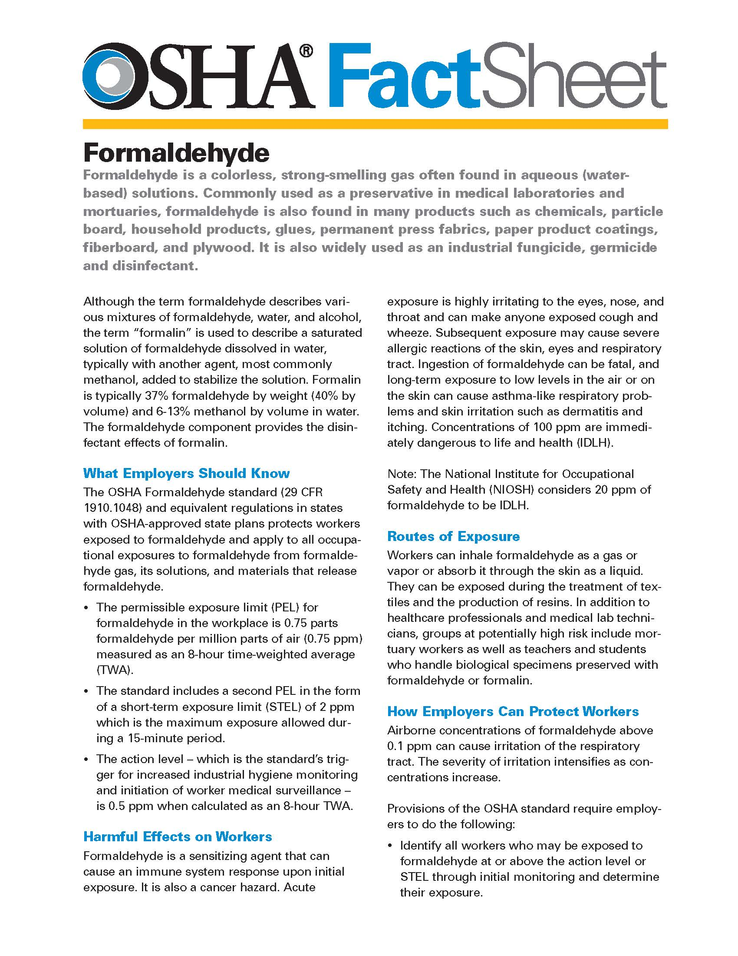
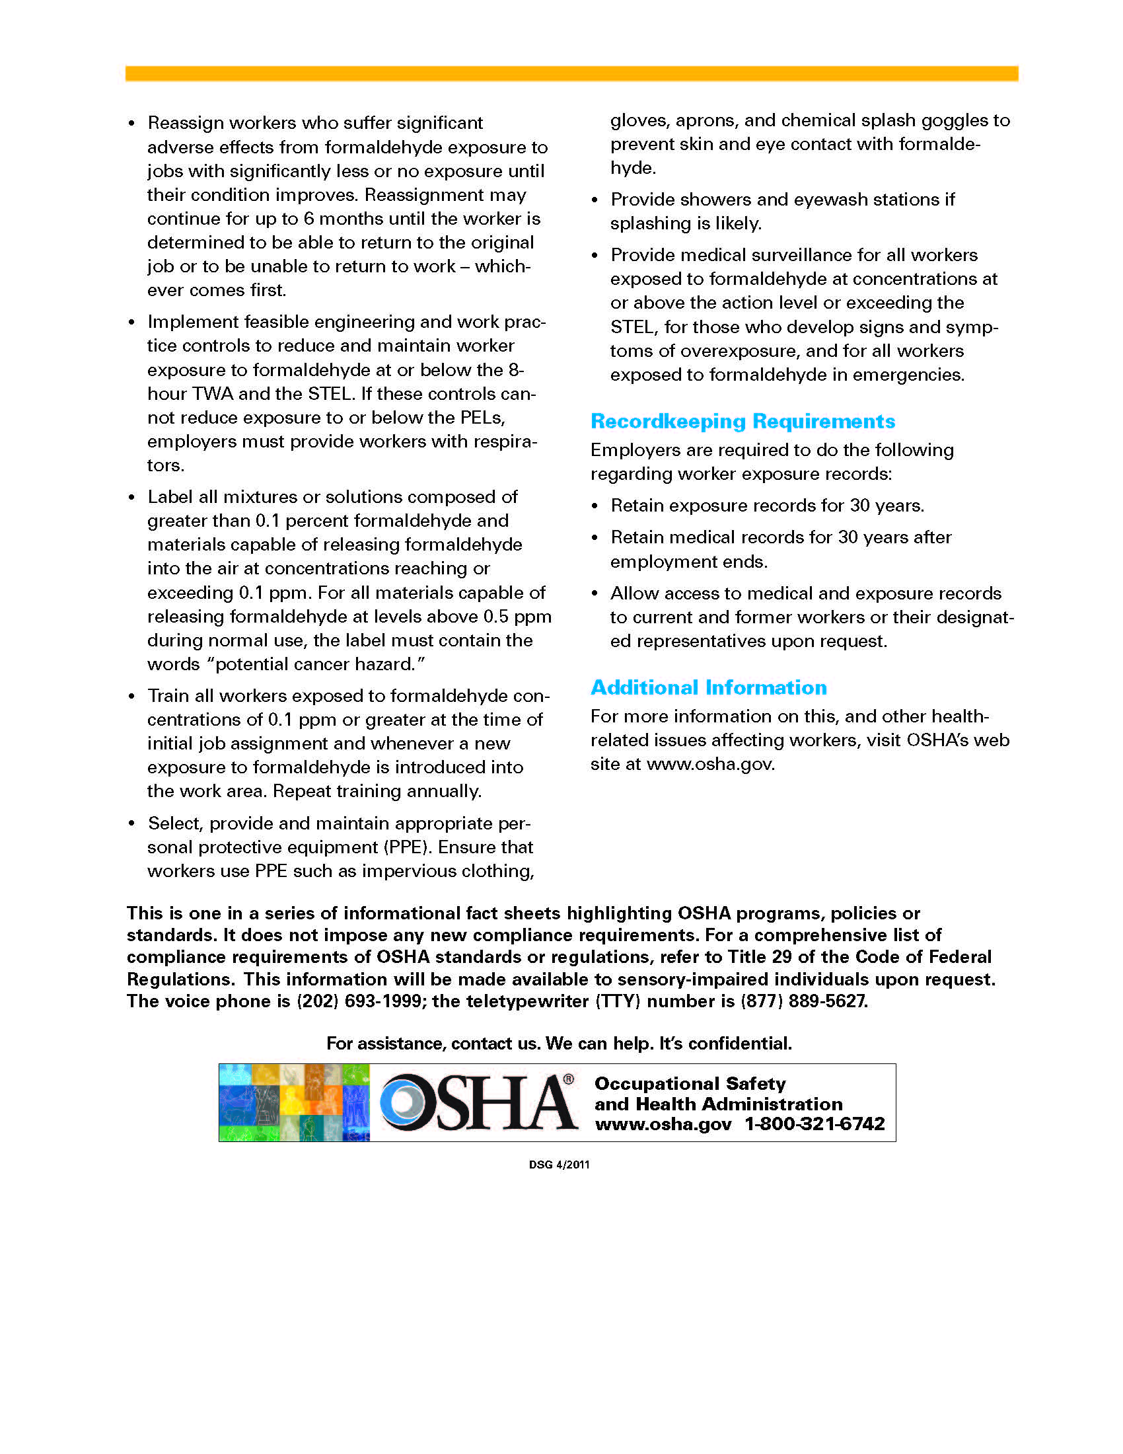

Attachment O: OSHA Quick Card – Elements of Safety Data Sheets

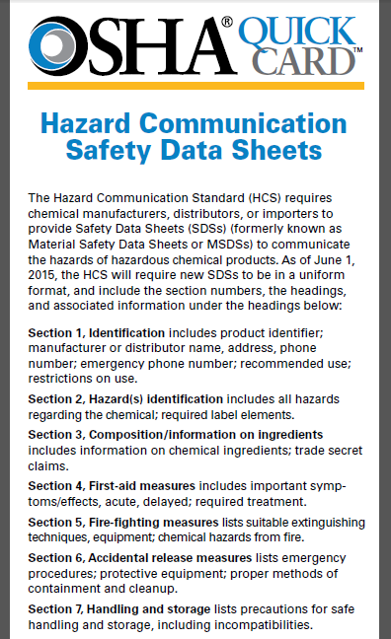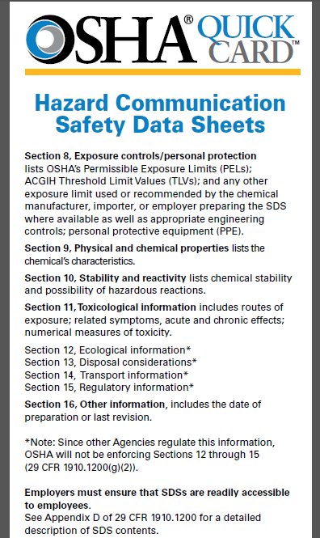

Attachment P: Management of Mercury in VHA Facilities VHA Directive 7706

Department of Veterans Affairs VHA DIRECTIVE 7706
Veterans Health Administration Transmittal Sheet
Washington, DC 20420 January 7, 2016

MANAGEMENT OF MERCURY IN VETERANS HEALTH ADMINISTRATION FACILITIES

1. REASON FOR ISSUE: This Veterans Health Administration (VHA) Directive assigns responsibility and describes procedures for the management, reduction, and virtual elimination of mercury and mercury containing compounds in VA medical facilities in a manner that is safe, protective of the environment and compliant with all applicable regulations.

2. SUMMARY OF MAJOR CHANGES: Adds information related to a new executive order, updates responsibilities for VHACO offices and VISN Directors, and clarifies requirement to utilize non-mercury alternatives when possible.

3. RELATED ISSUES: VA Directive 7700, Occupational Safety & Health; VHA Directive 7701, Safety and Health Program; VHA Directive 2009-065, Waste Minimization and Compliance Report, VHA Handbook 7701.01, Occupational Safety and Health (OSH) Program Procedures.

4. RESPONSIBLE OFFICE: The Deputy Under Secretary for Health for Operations and Management (10N) is responsible for the contents of this Directive. Questions may be directed to the Director, Occupational Safety, Health and GEMS Programs (10NA8) at 202-632-7889.

5. RESCISSIONS: VHA Directive 2002-018, dated April 1, 2002, is rescinded.

6. RECERTIFICATION: This VHA Directive is scheduled for recertification on or before the last working day of January 2021.
David J. Shulkin, M.D.
Under Secretary for Health
DISTRIBUTION: Emailed to the VHA Publication Distribution List on 1/11/2016.

January 7, 2016 VHA DIRECTIVE 7706

MANAGEMENT OF MERCURY IN VETERANS HEALTH ADMINISTRATIONFACILITIES
1. PURPOSE
This Veterans Health Administration (VHA) Directive assigns responsibility and describes procedures for the management, reduction, and virtual elimination of mercury and mercury containing compounds in VA medical facilities in a manner that is safe, protective of the environment and compliant with all applicable regulations. AUTHORITY: 38 U.S.C. 7301(b).

2. BACKGROUND
Mercury (chemical symbol Hg) is a naturally occurring, highly toxic element most commonly seen as a shiny, silver-white odorless liquid metal. Mercury and its compounds may enter the body by inhalation, ingestion or absorption though the skin. The most likely routes of exposure in the VHA are inhalation of inorganic mercury vapors following a spill, or ingestion/absorption of methyl mercury. As a persistent, bioaccumulative neurotoxin, mercury and its compounds are subject to stringent environmental laws and other guidance governing its use and disposal. These include:
a. The Pollution Prevention Act of 1990. This law, codified at 42 U.S.C. chapter 133, introduced the concept of ‘source reduction’ as practices that reduce, eliminate, or prevent pollution at its source. Today it is called Pollution Prevention (P2), and has been established as a national objective. The act also establishes an environmental protection hierarchy where the most desirable method of pollution abatement is prevention, followed by source reduction and recycling. Disposal or other release into the environment should be done only as a last resort and then in an environmentally safe manner.

b. The Resource Conservation and Recovery Act (RCRA) of 1976. This law, codified at 42 U.S.C. chapter 82, covers the generation, treatment, storage, disposal and transportation of both hazardous and non-hazardous waste and emphasizes source reduction as the highest priority. RCRA requires the “cradle-to-grave” management of hazardous waste (HW), encourages recycling and reuse, and further requires HW generators and treatment, storage, and disposal facility owners to certify that the generator has a program in place to “reduce the volume or quantity and toxicity” of waste.

c. Executive Order (EO) 13693, Planning for Federal Sustainability in the Next Decade. Among other requirements, this EO requires that federal agencies reduce or minimize the quantity of toxic and hazardous chemicals and materials acquired, used, or disposed of through source reduction. It also requires (to the maximum extent practicable) purchase of products or services with a reduced environmental impact.

d. VHA Directive 2009-065 Waste Minimization and Compliance Report. This policy requires that VHA facility directors collect and report data on waste generation, waste disposal, and waste handling using Report Control Number 10-99-904, and on data collection websites. This data is tabulated and reported to the Office of the Federal Environmental Executive, the Agency Environmental Executive, and the Environmental Protection Agency.

e. Memorandum of Understanding (MOU), Environmental Protection Agency (EPA) and the American Hospital Association. Signed on June 24, 1998, these two groups agreed to jointly develop a mercury waste elimination plan, with the goal of eliminating mercury from health care waste streams. This MOU identified stresses P2 techniques and source reduction as preferable to recycling and disposal into the waste stream. The MOU became the cornerstone of what is now called Practice Greenhealth.

3. POLICY
It is VHA policy to manage the use of elemental mercury and mercury-containing compounds in health care facilities, in compliance with applicable federal, state and local environmental regulations, and when possible reduce or eliminate mercury-containing compounds from inventories and waste streams.

4. RESPONSIBILITIES

a. Under Secretary for Health. The VHA Under Secretary for Health shall:
(1) Oversee VHA Environmental Programs and policies; and
(2) Establish Environmental program performance standards for the Deputy Under Secretary for Health for Operations and Management.
NOTE: Hg reduction and control guidance and information are contained in Attachment A.

b. Deputy Under Secretary for Health for Operations and Management.
(1) Oversee the development and implementation of the VHA Environmental Programs and policies; and
(2) Establish OSH Program performance standards for the Assistant Deputy Under Secretary for Health for Operations and Management for Administrative Operations.

c. Assistant Deputy Under Secretary for Health for Administrative Operations. The Assistant Deputy Under Secretary for Health for Administrative Operations shall:
(1) Oversee the Office of Occupational Safety, Health and Green Environmental Management System (GEMS) Programs; and

(2) Ensure staffing and funding are adequate to implement mercury management programs within the VHA Occupational Safety, Health, and GEMS Program Office.

d. Director, Office of Occupational Safety, Health, and GEMS Programs. The Director, Office of Occupational Safety, Health, and GEMS Programs shall:

(1) Interpret environmental compliance requirements for acquisition, storage and disposal of mercury and mercury-containing products.

(2) Review the results of the VISN External GEMS Audits and other VISN GEMS evaluations of facility-level mercury management programs.

(3) Identify national trends and develop program improvement recommendations to VHA mercury management policy; provide periodic updates to the Assistant Deputy Under Secretary for Health for Administrative Operations as needed.

(4) Ensure that Occupational Safety, Health, and GEMS Programs personnel designated as the VHA Mercury Management Program Manager have appropriate subject matter expertise and experience to oversee the program.

e. Veterans Integrated Service Network Director. The Veterans Integrated Service Network (VISN) Directors shall:
(1) Provide adequate resources for the implementation of this Directive.
(2) Ensure that the Mercury Management Program at each facility is evaluated at least annually by the VISN GEMS Program Manager.

f. VA Medical Facility Directors. VA Medical Facility Directors shall:
(1) Assign responsibility for the facility mercury management program to appropriate staff.
NOTE: This can be the GEMS Program Manager, but other staff are acceptable based on qualifications and experience.
(2) Develop a facility-specific Mercury Control and Reduction Plan, to be reviewed annually by the respective VISN GEMS Program Manager. The plan must include a statement of management commitment to mercury control, reduction, and proper disposal.
(3) Develop an inventory of the number and types of devices or equipment containing mercury (medical and non-medical), including: mercury barometers, manometers or sphygmomanometers, mercury switches, mercury-compounds or reagents, dental materials, cleaning chemicals, and pharmaceuticals.
(4) Ensure that non-mercury alternatives are used during maintenance or end-of-service-life replacement of mercury-containing devices or equipment, unless required by patient care considerations.

(5) Develop a plan to reduce mercury containing waste, and the number of mercury-containing products, by 50 percent between calendar years 2014 and 2019 (calendar year 2013 baseline) where suitable substitutes are available. The ultimate goal is to achieve a mercury-free environment within the constraints of safe and effective patient care and supporting operations.

(6) Ensure guidance, policies and operating procedures are developed to implement mercury reduction in facility and research operations.

(7) Ensure mercury elimination and reduction is considered during all phases of acquisition and procurement, as well as the operation of the facility management program.

(8) Promote employee training and awareness programs on mercury reduction and hazard recognition.

(9) Complete the Report Control Number 10-99-904, Waste Minimization and Compliance Report, in accordance with VHA Directive 2009-065 (or subsequent guidance). Directive 2009-065 requires the following data to be collected by the Facility Director:

(a) Solid and regulated medical waste,
(b) Hazardous waste,
(c) Radioactive waste,
(d) Recycling activities, and
(e) Information regarding procurement of biobased, biopreferred, and recycled content products (required for RCRA, Section 6002 reporting).
(10) Dispose of mercury-containing products in accordance with all applicable regulations.

(11) When requested, provide facility mercury management program information to VHA Central Office.
g. Chief Facilities Management. The Chief of Facilities Management shall:
(1) Incorporate mercury control, reduction and tracking into a local work practices, procedures, and specifications.
(2) Implement facility-level mercury replacement, control and reduction projects.
(3) Communicate recommendations for mercury program improvement or correction to the VA Medical Facility Director.
(4) Document waste reduction accomplishments into the VHA Environmental Programs Service Green Health Tracker web based waste management tracking system.

5. REFERENCES
a. Pollution Prevention Act of 1990, codified at 42 U.S.C. chapter 133.
b. Resource Conservation and Recovery Act of 1976, codified at 42 U.S.C. chapter 82.
c. EO 13693, Planning for Federal Sustainability in the Next Decade, March 19, 2015.
d. VHA Directive 2009-065 (Report Control Number 10-99-904) Waste Minimization and Compliance Report.
e. Memorandum of Understanding between United States Environmental Protection Agency Region V, and the American Hospital Association, June 24, 1998 (In January of 2008, efforts related to this initiative were reorganized and renamed Practice Greenhealth).
f. VA Directive 7348 Utilization and Disposal of Personal Property and VA Handbook 7348 Transmittal Sheet March 30, 2012 Utilization and Disposal of Personal Property.
g. Mercury-Free Healthcare Device List, found at Mercury Free Healthcare http://www.mercuryfreehealthcare.org/.

APPENDIX A
ADDITIONAL GUIDANCE FOR MERCURY CONTROL AND REDUCTION
1. Health Impacts.
a. All forms of mercury are toxic to humans, but the various forms of organic and inorganic mercury have different toxicity. Generally, organic forms are much more toxic than inorganic forms.
b. The organic forms of mercury are primarily neurotoxins. Therefore exposure can damage the brain and nervous system. The developing brain of a fetus or child is especially vulnerable to organic mercury exposure. Inorganic forms of mercury primarily affect the kidney, but are also neurotoxins.
c. Other organs and systems of the body can also be harmed by exposure to mercury. Recent studies suggest that exposure to mercury contaminants may also alter the immune response to pathogens, contribute to the development of cardiovascular disease, and favor the growth of populations of multiple antibiotic resistant bacteria.
d. Occupational exposure to mercury may occur via three routes: inhalation, ingestion and absorption. The most likely routes of exposure are inhalation of inorganic mercury vapor after a spill, or during a manufacturing process, or through accidental ingestion of methyl mercury hand-to-mouth as a result of improper barrier protection protocol or cross-contamination.
2. Mercury in VA Medical Facilities.
a. Common medical uses of mercury or it’s compounds include:
(1) Thermometers;
(2) Sphygmomanometers (blood pressure monitors);
(3) Esophageal dilators (also called ‘bougie tubes’);
(4) Cantor tubes and Miller-Abbott tubes (used to clear intestinal obstructions);
(5) Feeding tubes;
(6) Dental amalgam;
(7) Laboratory Chemicals (fixatives, stains, reagents, preservatives);
(8) Medical batteries containing mercury;
(9) Pharmaceuticals (vaccines, insulin); and
(10) Calibration thermometers used in Laboratory and Pathology Service and Research Laboratories.
b. Mercury may also be encountered in the following non-medical settings or applications:
(1) Cleaning solutions with caustic soda or chlorine (may be contaminated with mercury during the production process);
(2) Batteries containing mercury;
(3) Fluorescent lamps and high-intensity mercury lamps;
(4) Bulb-crushing operations (used to reduce waste volume);
(5) Non-electronic thermostats;
(6) Pressure gauges;
(7) Some electrical switches used for lights and appliances;
(8) Laboratory glassware cleaners used in clinical and research laboratories; and
(9) Combustion of fossil fuels and incineration of medical wastes.
3. Hg Exposure.
There is minimal risk of mercury exposure during normal use of products that are handled correctly. However, problems may occur if the mercury in a product is exposed to air, or if a product is not properly discarded in a manner to keep mercury out of the environment. Concerns about the health impacts of mercury are leading to mercury pollution prevention programs at the Federal, state, and local levels. The highest priority of any pollution prevention program is source reduction, which means avoiding the use of mercury and mercury containing products where practical.

4. When Adequate Hg Alternatives are Unavailable.
When adequate mercury alternatives are not available and mercury must be used, it may be possible to recycle mercury in order to prevent release into the environment. Recycling is the second tier of mercury pollution prevention. Disposal of mercury that is irreversibly contaminated should be the last resort.

5. Examples of Hg Control and Reduction.
Some excellent examples of mercury control and reduction include the following:

a. Replace mercury sphygmomanometers (blood pressure monitors) with aneroid/electronic sphygmomanometers;
b. Replace mercury thermometers with non-mercury thermometers;
c. Replace mercury intestinal and esophageal dilators and feeding tubes with alternatives using water, saline or tungsten;

d. Use low-mercury fluorescent lights and recycle used fluorescent lighting. Replace mercury-containing fluorescent lights with light-emitting diode (LED) lamps;

e. Use mercury-free batteries and/or rechargeable products;

f. Replace mercury thermostats, pressure gauges, barometers, switches and other building or facility equipment with mercury-free alternatives;

g. Replace mercury fixatives and preservatives with mercury-free alternatives;
h. Use mercury-free bleach and cleaning chemicals, and

i. Set up a program for appropriate collection of used amalgam and install amalgam separators in sinks and drains in the dental clinic.

6. Best Management Practices.
Best Management Practices for the management of mercury within VA medical facilities include, but are not limited to:
a. Train employees who work with mercury containing materials on the hazards, proper use, handling, disposal, and use of alternatives.
b. Recycling of mercury-containing products when they can no longer be used.
c. Pre-planning for mercury spill response and cleanup, including external vendors; emergency contacts; federal/state reportable quantities and reporting requirements.
d. Occupational exposure monitoring for personnel at elevated risk.
e. Require suppliers to certify the mercury content on the medication or medical product before purchase.
f. Document mercury-containing products with no alternative product available; periodically re-evaluate to determine if suitable substitutes have been developed.

7. Benefits of Hg Pollution Prevention Programs.
Pollution prevention programs protect human health by reducing occupational exposures and release of mercury to the air, water and land. They reduce costs associated with the use of mercury, including:
a. Disposal or recycling;

b. Collection and storage prior to disposal;

c. Paperwork for tracking hazardous waste disposal;

d. Training and equipment for spill response;

e. Training for hospital employees who handle mercury-containing products; and

f. Liability for environmental contamination or worker exposure.

