

# Correct Istat Results using Enter/Edit Results

## How to correct erroneous results using Enter/Edit Results

When results contain an error, those results must be corrected. (Example: wrong patient or wrong comment code applied). Follow these steps to correct the result:

|  |  |
| --- | --- |
| Try It Out | Try It Out |

1. With the patient’s encounter open, go to the **Enter/Edit Results** activity.

* May find Enter/Edit Results through the More Activities button on the bottom left corner of hyperspace window.

1. Click , select **Point of Care Testing-Docked Device** from the Order Type column.
2. Select the All radio button.
3. Click .

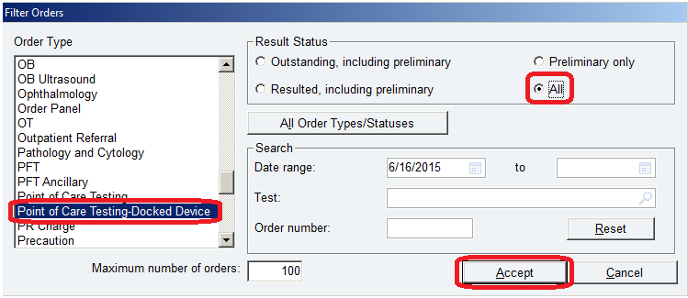

1. Double click on the test to correct.
2. On the bottom pane, correct the result. See scenarios below:

**Correcting a Sample Misidentification:**

* Replace all values with XXX
* If comment present, replace with XXX
* In either COMMENT section, enter this text: INVALID RESULT, PATIENT SAMPLE MISIDENTIFICATION, NOTIFIED *enter the full name of the provider that was notified with credentials and the date and time of notification* BY *the name of the person that notified the provider*
* Click Accept

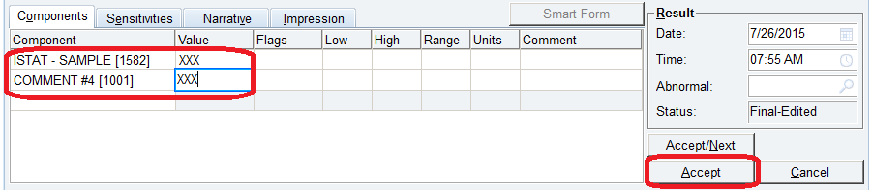

**Correcting Erroneous Temperature Corrected Blood Gas Results in Wake One:**

* **Replace the erroneous patient temperature entered into the i-STAT handheld and the temperature corrected pH, pCO2, and pO2 values** with “XXX”.
* In the patient temperature COMMENT section, enter this text: INVALID PATIENT TEMPERATURE, NOTIFIED *enter the full name of the provider that was notified with credentials and the date and time of notification* BY *the name of the person that notified the provider*
* Click Accept

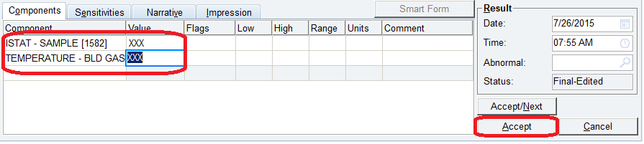

**Flagging questionable i-STAT results if posted to Wake One:**

* Replace ALL questionable results with XXX
* In the first COMMENT section, enter this text: QUESTIONABLE I-STAT RESULTS, NOTIFIED *enter the full name of the provider that was notified with credentials and the date and time of notification* BY *the name of the person that notified the provider*
* Click Accept



**Flagging tests that were not ordered by the physician**

* DO NOT REMOVE ANY TEST RESULTS
* **In the first COMMENT section, enter this text: TESTING PERFORMED WITHOUT PHYSICIAN ORDER—CREDIT PENDING, NOTIFIED *enter the full name of the provider that was notified with credentials and the date and time of notification* BY *the name of the person that notified the provider***

🡪Once the result has been corrected, file an RL6 with Compliance

**For DHP Phlebotomy, Family Medicine Lab, and Davie Lab ONLY  
Documentation of critical value notification**

* In the COMMENT section for INR, enter this text: CRITICAL VALUE CALLED TO AND READ BACK BY, *enter the full name of the provider that was notified with credentials and the date and time of notification* BY *the name of the person that notified the provider*