|  |  |  |  |
| --- | --- | --- | --- |
|  | **Power Express Automation System**  **CL – H22** | **Dept:** | Clinical Core Lab-  Hematology Section |
| **Effective Date:** | March 5, 2019 |
| **Revised Date:** |  |
| **Contact:** | Clinical Core Lab-  Hematology Management |
| **Name & Title:** Gregory J. Pomper, MD,  Medical Director of Pathology Laboratories | | **Date:** |  |
| **Signature:** | | | |

1. **General Procedure Statement:** 
   1. **Scope:** To provide laboratory testing personnel with instructions for performing

laboratory procedures as deemed appropriate by industry practices and regulatory agencies to assist in quality patient care.

* 1. **Responsible Department/Party/Parties:** 
     1. Procedure owner: Clinical Core Laboratory Management-Hematology
     2. Procedure: Clinical Core Laboratory Personnel
     3. Procedure prepared by: Jason Spinelli

Heather Lawson

* + 1. Supervision: Clinical Core Laboratory Management-Hematology

Clinical Core Laboratory Specialist and Designees

Medical Director Clinical Hematology

1. Implementation: Clinical Core Laboratory Management-Hematology

Clinical Core Laboratory Specialist and Designees

Medical Director Clinical Hematology

1. **Definitions:**

N/A

1. **Procedure:**

**PRINCIPLE**

The Beckman Coulter Power Express is a scalable sample tube processing system that automates preanalytical, analytical, and post-analytical processes in the clinical laboratory. You can

configure Power Express to perform pre-analytical sample tube preparation, sort sample

tubes directly to the required analyzers for analysis, and then route tubes to an outlet

rack or to storage. Samples are introduced to the Power Express system from its sample Inlet Unit. From the Inlet Unit, samples are delivered to the DxH analyzers in single sample tube carriers on the automated conveyor belt. When all processing is complete, samples go to the Outlet Unit to predefined sort locations or to the Stockyard Storage Unit.

The Cennexus line controller is responsible for controlling the automation line. It maintains a database of each sample tube’s position and status on the track. Test orders are received via an interface from the LIS and downloaded to the Cennexus and Remisol Advance which in turn downloads that information to the Automation Line and the DxH analyzers. The analyzers process samples according to their orders and transmits the results via an interface to the Remisol Advance. Results are processed through Remisol Advance, transmitted to the LIS and are then available to the patient’s records.

**SAFETY**

* + - Gloves worn at all times
    - Impermeable lab coats, worn closed at all times.
    - Shield when removing sample caps and pushing smears and any time there is a risk of sample or reagent splashing.
    - Approved Protective Eyewear when there is a risk of reagent splashing, pressurized air or instrument parts detaching and becoming airborne.
    - Be aware of moving parts; making sure that all system modules are paused or powered down before placing your hands inside the unit.

**SPECIMEN**

A properly labeled EDTA whole blood vacutainer is the specimen of choice. Specimens should be analyzed as soon as possible for optimum accuracy. Specimens for a CBC or CBCD should be processed within 24 hours after collection if stored at room temperature or within 48 hours after collection if stored at 2 to 80C. Samples for Retic counts should be processed within 24 hours after collection if stored at room temperature or within 72 hours after collection if stored at 2 to 80C.Sample tubes processed on the Automation Line must contain a minimum of 1.0 milliliters. MAP and Microtainer tubes can be processed in the Manual mode on the Automation Line. Both tubes must contain a minimum of 250 microliters of whole blood.

Samples that are Clotted, QNS, Old or otherwise found Unsatisfactory will be rejected, orders credited, and the caregiver notified for a new sample.

**COMPONENTS**

Cennexus Computer – Line Controller

Inlet Unit

Outlet Unit

DxH1601

DxH801

Connection Units and Tracking System (Composed of multiple modules)

Stockyard

**PREVENTIVE MAINTENANCE**

***Daily***

***Wait for all samples to finish processing and to be sorted to the Outlet or Storage***

1. Outlet

* Reset all racks in the outlet

2. Line Control Shutdown

* **System Operation** → **Shutdown** → **OK** *(If “Sample present on the system” message appears, make sure there is no sample on the track before clicking OK)*
* Confirm **System status**: **OFF** and **Cennexus**: **ONLINE**

3. Inlet

* Confirm tube carriers are present between **SN041** and **SN028**
  + If there are missing carries: Put control panel into **Manual** **Mode** → Select **Maintenance** → Enter **04** and hit Enter TWICE → Sample Carriers should fill in the space

4. Line Control Thru Lane

* Go into **Line** **Control** → Select **System** **Setup** and **System** **Setup** one more time → Select **Thru Lane On/Off** → Confirm modules are **ON** → Select **Exit**

5. Press the **Red** **POWER OFF** Button *(inspect line for foreign objects)*

6. Line Control/Cennexus Exit

* In **LINE** **CONTROL** Select **Exit** and **OK**
* In **Cennexus** Select **Exit** and **OK** *(wait for computer to shut down completely)*

7. Press the **Green POWER ON** Button

* Turn Cennexus computer on → wait for Line Control window to appear → Press Alt+Windows Key to get to the desktop screen and double click on Cennexus → Log into Cennexus using a 3 character username (ex. 123) with no password → Go to Line Control and Select **System** **Operations** tab → **Startup** → Select **Delete** **Processed** **Samples** **Only** → Confirm **System** **Status**: **ON** and **Cennexus**: **ONLINE**

***Weekly***

***Wait for all samples to finish processing and to be sorted to the Outlet or Storage***

1. Outlet

* Reset all racks in the outlet

2. Line Control Shutdown

* **System Operation** → **Shutdown** → **OK** *(If “Sample present on the system” message appears, make sure there is no sample on the track before clicking OK)*
* Confirm **System status**: **OFF** and **Cennexus**: **ONLINE**

3. Inspect and Clean **Fiber Optic Sensors**, **Bar Code Readers**, and **Bar Code Spinners** *(use kimwipes and alcohol pads)*

4. At **ALL** Control Panels with a loading/unloading arm:

* Select the **Maintenance** Button → Enter **54** → Hit Enter **TWICE** → Press the ***A***key to open and close the grippers to check proper movement → **Exit** to the main screen

5. Stockyard

* Repeat **Function 54**
* Select the **Maintenance** Button → Enter **32** → Hit Enter **TWICE** → Press the ***A*** key and move the gripper belts up and down to confirm proper movement → **Exit** to the main screen

6. Dump the water in the bucket located underneath the Stockyard

7. **Continue with Daily Maintenance**

***Monthly***

***Wait for all samples to finish processing and to be sorted to the Outlet or Storage***

1. Outlet

* Reset all racks in the outlet

2. Line Control Shutdown

* **System Operation** → **Shutdown** → **OK** *(If “Sample present on the system” message appears, make sure there is no sample on the track before clicking OK)*
* Confirm **System status**: **OFF** and **Cennexus**: **ONLINE**

3. Inspect the Green Conveyor belts to confirm they are not damaged. Vacuum and clean the exposed areas of the track.

4. At **ALL** Control Panels with a loading/unloading arm:

* Select the **Maintenance** Button → Enter **54** → Hit Enter **TWICE** → Press the ***A***key to open and close the grippers to check proper movement → Inspect and Clean grippers with 70% isopropyl alcohol → **Exit** to the main screen

5. Stockyard

* Repeat **Function 54** → Inspect and Clean grippers with 70% isopropyl alcohol.
* Select the **Maintenance** Button → Enter **32** → Hit Enter **TWICE** → Press the ***A*** key and move the gripper belts up and down to confirm proper movement → **Exit** to the main screen

6. Continue with the remaining **Weekly** and **Daily Maintenance**

**BASIC OPERATION**

1. **Attaching Bar Code Labels**
2. Each sample tube must have a unique, readable bar code label
3. The system sends samples with duplicate sample IDs and damaged or unreadable

bar code labels to the Error Lane

1. Do not apply more than three bar code labels, including the tube manufacturer’s

label, to a sample tube

1. Bar code labels must be attached vertically to the side of the sample tube below

the cap. There must be 5 mm white space between the edge of the bar code label and the

first line of the bar code (refer to 1 below)

There must be 5 mm white space between the last line of the bar code and the

edge of the label (refer to 2 below)

1. There must be 15 mm of space between the edge of the label and the bottom of

the sample tube (refer to 3 below)

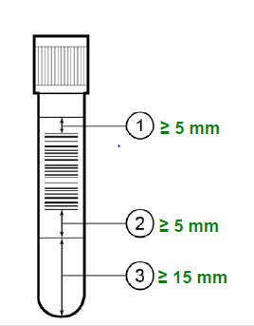

1. **Loading Sample Tubes into the Inlet Racks**

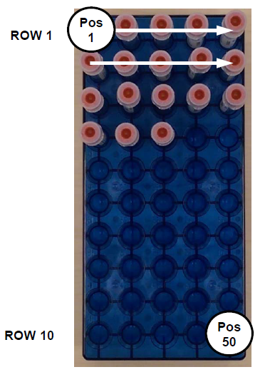

1. Power Express uses four rack types for different kinds of sample processing: Priority (red), Routine (blue), Centrifuge Bypass (white), Remap (yellow).

CAUTION: Load sample tubes in the correct rack type to prevent delayed results, incorrect results, or instrument damage.

1. Sample tubes must be loaded into Inlet racks for processing on Power Express; confirm tubes are fully seated in racks.
2. Rows do not need to be full, but it is recommended to fill a row from left to right, starting with position 1
3. Empty positions in the beginning of a row or in between samples in a row will send empty carriers to the Error Lane
4. When the Inlet module does not detect any sample tubes in a row, it begins processing the next rack.
5. Do not manually load a sample tube into a sample tube carrier (puck). The system cannot process the sample tube correctly without the Inlet rack information, and sorts the tube to the Error Lane.
6. **Loading Racks into the Inlet Module**
7. A rack exchange is required to load racks into the Inlet Module. The Inlet control panel is used to perform the rack exchange.
8. A rack legend displays on the control panel to identify the rack types loaded. Each rack is keyed to identify the rack type and to fit in the Inlet rack drawers in only one direction (position 1 should be towards the back of the Inlet)
9. The rack legend identifies the rack types in the Inlet drawers when the operator removes and replaces the rack, or selects the Inlet drawer position from the control panel rack legend.
10. The operator can change a position back to empty (E) by selecting the identified rack position on the control panel rack legend.
11. The Inlet processes samples from racks in the following priority:

1. RED: Priority

2. BLUE: Routine

3. WHITE: Centrifuge Bypass (We do not utilize for Hematology only automation Line)

4. YELLOW: Remap

**NOTE: When a remap rack is loaded, the default destination is to refrigerated storage**

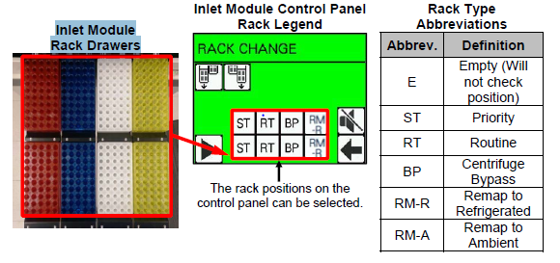

1. **Removing Sample Tubes from the Error Lane**
2. The system routes sample tubes to the Error Lane for the following reasons

* The system did not load the sample tube from a rack
* The system cannot read the bar code
* The bar code is the wrong length or type
* There is no sample programming for the sample ID, or there is a programming conflict
* The operator tried to remap a sample tube that had already been remapped
* The operator tried to remap a sample tube that still has a related sample tube on the system
* The system has previously read the same sample ID and it is still on the system
* Processing for the sample tube requires modules that are not available, such as the Decapper or Aliquot Module
* Tube size is inconsistent with the required processing

1. When 5 sample tubes accumulate in the Error Lane, the system activates an audible alarm and flashing beacon, and the module goes into PAUSE mode. The operator is required to remove sample tubes from the Error Lane when it is full; any additional sample tubes with errors will stay queued on the track and may prevent samples from processing. Sample tubes can also be removed from the Error Lane before it is full.

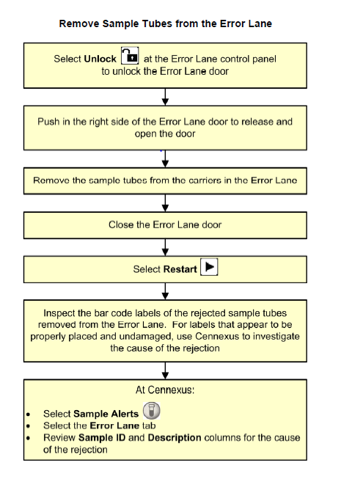

1. **Unloading Outlet Racks**
2. A rack exchange is required to unload racks from the Outlet Module by System-initiated rack exchange, or Operator-initiated rack exchange.
3. When an Outlet rack or subsection is full, the system activates an audible alarm and a flashing beacon to alert the operator to remove the rack. All samples from an Outlet rack need to be removed even if only one subsection on the rack is full; the system clears out the entire rack when a rack exchange is performed.
4. The Outlet control panel is used to perform the rack exchange. A rack legend displays on the control panel to identify the rack exchange status of each Outlet drawer rack position.

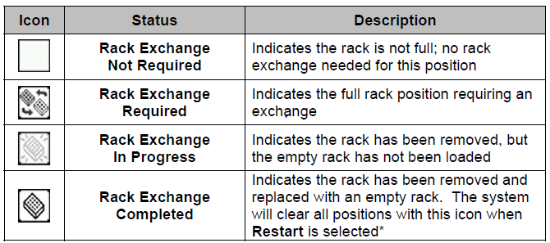

**NOTE: To cancel the clearing of a rack, select the position so that it changes back to the Rack Exchange Not Required icon (white box).**

1. Racks must be present in all eight positions in the drawers, or the module remains in *PAUSE* mode.
2. Each rack is keyed to fit in the Outlet rack drawers in only one direction (position 1 should be towards the back of the Outlet.
3. A rack exchange is required for all Outlet positions before shutting down the system. Restarting the Power Express resets all Outlet positions as empty

**Cennexus -Line Controller**

The Cennexus Line Controller Computer is responsible for controlling the automation line. It provides sample locator capabilities to determine a sample's status (pending, complete) and position (Outlet, Stockyard, DXH1601 or DXH801) on the system. It maintains a database of samples currently in process. It provides the ability to retrieve samples from the Outlet or Stockyard and return them to the system for further testing.

**System Errors**

For assistance with system errors see additional information found in the Instructions for use for the Power Express Storage Modules, Power Express Inlet and Outlet Modules and Power Express Rack Builder Modules. You may also call Beckman Coulter Technical support using the information affixed to the affected module which includes contact number and system ID.

1. **Review/Revision/Implementation:**
   1. Review Cycle: 2 years
   2. Office of Record: Department of Clinical Core Laboratory-Hematology
   3. All new procedures and procedures that have major revisions must be signed by the Laboratory Director.
   4. All reviewed procedures and procedures with minor revisions can be signed by the designated section medical director.
2. **Related Procedures:**

CBC Using Beckman Coulter DxH 800/SMS CL-H04

1. **References, National Professional Organizations, etc.:**

* Power Express In-Lab Training Manual Version 2.0 (July 2016)
* Power Express Storage Modules Instructions For Use (July 2016)
* Power Express Inlet and Outlet Modules Instructions For Use (July 2016)
* Power Express Rack Builder Modules Instructions For Use (July 2016)

1. **Attachments:**

Power Express Maintenance log CL-H22-1

1. **Revision Dates:**

|  |  |  |
| --- | --- | --- |
| **Review Date** | **Revision Date** | **Signature** |
|  |  |  |
|  |  |  |
|  |  |  |
|  |  |  |
|  |  |  |