|  |  |  |  |
| --- | --- | --- | --- |
|  | **HBA1c 2.0**  **CL-CH184** | **Dept:** | Clinical Core Lab-  Chemistry Section |
| **Effective Date:** | 08/11/2019 |
| **Revised Date:** |  |
| **Contact:** | Clinical Core Lab-  Chemistry Management |
| **Name & Title:** Gregory J. Pomper, MD  Medical Director of Pathology Laboratories | | **Date:** |  |
| **Signature:** | | | |

1. **General Procedure Statement:** 
   1. **Scope:** To provide laboratory testing personnel with instructions for performing laboratory procedures as deemed appropriate by industry practices and regulatory agencies to assist in quality patient care.
   2. **Responsible Department/Party/Parties:** 
      1. Procedure owner: Clinical Core Laboratory Management- Chemistry
      2. Procedure: Clinical Core Laboratory Personnel
      3. Procedure prepared by: Johanna Waldron
      4. Supervision: Clinical Core Laboratory Management-Chemistry

Clinical Core Laboratory Specialist and Designees

Medical Director Clinical Chemistry

1. Implementation: Clinical Core Laboratory Management-Chemistry

Clinical Core Laboratory Specialist and Designees

Medical Director Clinical Chemistry

1. **Definitions:**
2. **Procedure:**

This procedure is valid for the following Chemistry analyzers:

* Variant II Turbo 2.0

**Priniciple**

**Priniciples of the Procedure**

The Bio-Rad VARIANT II TURBO HbA1c Kit - 2.0 utilizes principles of ion-exchange high-performance liquid chromatography (HPLC). The samples are automatically diluted on the VARIANT II TURBO Sampling Station (VSS) and injected into the analytical cartridge. The VARIANT II TURBO Chromatographic Station (VCS) dual pumps deliver a programmed buffer gradient of increasing ionic strength to the cartridge, where the hemoglobins are separated based on their ionic interactions with the cartridge material. The separated hemoglobins then pass through the flow cell of the filter photometer, where changes in the absorbance at 415 nm are measured. An additional filter at 690 nm corrects for background absorbance.

The VARIANT II TURBO Clinical Data Management (CDM™) software collects raw data from each analysis and calculates HbA1c values based on a bi-level calibration curve. A sample report, including retention times of detected peaks and a chromatogram, is generated by CDM for each sample. The A1c peak is shaded. This area is calculated using an exponentially modified Gaussian (EMG) algorithm.

The VARIANT II TURBO HbA1c Kit - 2.0 is for use only with the Bio-Rad VARIANT II TURBO Hemoglobin Testing System and VARIANT II TURBO Link Hemoglobin Testing System.

**Summary and Explanation**

Diabetes mellitus is a condition characterized by hyperglycemia resulting from the body’s inability to use blood glucose for energy. In Type 1 diabetes, the pancreas no longer makes insulin and therefore, blood glucose cannot enter the cells to be used for energy. In Type 2 diabetes, either the pancreas does not make enough insulin or the body is unable to use insulin correctly.1 The direct and indirect effects of hyperglycemia on the human vascular system are the major source of morbidity and mortality in both Type 1 and Type 2 diabetes. These effects include macrovascular complications (coronary artery disease, peripheral arterial disease, and stroke) and microvascular complications (diabetic nephropathy, neuropathy, and retinopathy).2 Diabetes mellitus affects >8% of the world population.3

HbA1c testing has been recommended for the diagnosis of Type 2 diabetes by the International Expert Committee (IEC), the American Diabetes Association (ADA), and the World Health Organization (WHO), which recommend a diagnostic threshold of ≥6.5% (≥48 mmol/mol) HbA1c.4–6 HbA1c testing has also been recommended for the identification of individuals at increased risk for developing diabetes (pre-diabetic). The ADA has defined the HbA1c range for pre-diabetes as 5.7–6.4% (39–47 mmol/mol).4 Detection and treatment of pre-diabetes may reduce or eliminate the risk of developing Type 2 diabetes and related complications.

Therapy for diabetes requires the long-term maintenance of a blood glucose level as close as possible to a normal level, minimizing the risk of long-term vascular consequences.7,8  A single fasting blood glucose measurement is an indication of the patient’s immediate past condition (hours), but may not represent the true status of blood glucose regulation.9,10 The measurement of hemoglobin A1c (HbA1c) every two to three months has been accepted as a measure of glycemic control in the care and treatment of patients with diabetes mellitus.

HbA1c, the glycohemoglobin of interest, is formed in two steps by the nonenzymatic glycation of HbA. The first step is the formation of an unstable aldimine (labile A1c, or pre-A1c), a reversible reaction between the carbonyl group of glucose and the N terminal valine of the β-chain of hemoglobin. Labile A1c formation is directly proportional to the blood glucose concentration. During red blood cell circulation, some of the labile A1c is converted (Amadori rearrangement) to form a stable ketoamine, HbA1c.11

**Specimen Collection**

**Specimen Type**

Whole blood.

**Specimen Additives, Preservatives**

The whole blood specimens should be collected in a vacuum collection tube containing K2-EDTA or K3-EDTA.

**Specimen Storage**

Whole blood specimens may be stored as follows:

* 1 day at room temperature (15–30 °C)
* Up to 7 days at 2–8 °C
* Up to at least 2 months at −70 °C

**Specimen Preparation**

* No sample preparation is required. Mixing the sample tubes before loading is not necessary.
* If the sample is in an abnormal size/type tube, or if the height of the sample in the tube appears to be less than 25 mm, then the sample must be prediluted 1:300 prior to analysis:

1. Before pipetting, thoroughly mix the sample by gently inverting the tube.
2. To predilute, pipet 1.5 mL of Wash/Diluent Solution into a labeled predilution vial, followed by 5 µL of the whole blood sample.
3. Cap the sample vial and mix thoroughly.

**Specimen Shipping**

All samples of human origin must be shipped in accordance with national and international transportation regulations.

**Preparation and Storage of Reagents**

To install or change Elution Buffers and Wash/Diluent Solution, follow the procedure described in the Variant II Turbo Hemoglobin Testing System Operational Manual Section 4.2.2

**Elution Buffers and Wash/Diluent Solution**

Allow the Elution Buffers and Wash/Diluent Solution to reach room temperature (15–30 °C) before performing the test. Mix each bottle by gently inverting prior to installation.

The Elution Buffers and Wash/Diluent Solution are stable until the expiration date when stored unopened at 15–30 °C. After opening the bottles, Elution Buffer A is stable for 30 days, Elution Buffer B is stable for 90 days, and Wash/Diluent Solution is stable for 60 days, when stored at 15–30 °C.

With a new kit, install one bottle of each reagent and follow the procedure for *Installing a New Kit Lot* in the *Procedure* section.

Buffers are compatible within a resin lot. Buffer and cartridge labels are coded using alphabetical letters to indicate compatibility. A compatible set of buffers and cartridge will have the same letter code on each label. Do not use combinations of cartridges and buffers with different letter codes.

The Wash/Diluent Solution is interchangeable between kit lots.

**Whole Blood Primer**

Use fresh aliquots of Whole Blood Primer when installing a new analytical cartridge.

The Whole Blood Primer is stable until the expiration date when stored unopened at 2–8 °C.

The Whole Blood Primer is provided in lyophilized form for increased stability.

Reconstitute each Whole Blood Primer by adding 1.0 mL of deionized water to each vial.

Replace the vial stoppers and allow vials to stand for 10 minutes at 15–30 °C.

Swirl gently to dissolve and ensure complete mixing.

The reconstituted Whole Blood Primer is stable for 1 day when stored at 2–8 °C.

The Whole Blood Primer is interchangeable between lots.

**Calibrator/Diluent Set**

The Calibrator/Diluent Set is stable until the expiration date when stored unopened at 2–8 °C.

The Calibrator Diluent is ready to use. The Diluent is stable for 60 days, after opening the bottle, when stored at 2–8 °C. The Diluent is interchangeable between lots.

The Calibrators are provided in lyophilized form for increased stability.

Using a volumetric pipette, reconstitute each Calibrator by adding 7 mL of cold Calibrator Diluent to each vial.

Replace the vial stoppers and allow vials to stand 2 minutes.

Swirl gently to dissolve.

The reconstituted Calibrators are stable for 24 hours when stored capped at 2–8 °C. Do not use the reconstituted Calibrators after 24 hours.

Do not freeze the reconstituted Calibrators.

See the *value card* included with the current lot of calibrators for value assignment. Values are entered automatically using the Update Kit CD. Values must be entered manually if a different lot is being used; see the *CDM Software Operation Manual* to manually enter values in the **Setup/Sample Types/Calibrator** screen.

**Extracted Standards**

This HPLC method does not use extracted standards.

**Controls**

Reconstitute and store the controls according to the manufacturer’s package insert. Also see insert for value ranges.

Bio-Rad Lyphochek Diabetes Controls must be diluted 1:300 prior to analysis. Pipet 1.5 mL of Wash/Diluent Solution into a labeled predilution vial, followed by 5 µL of the reconstituted control. Cap each control vial and mix thoroughly.

**Analytical Cartridge and Prefilters**

The Analytical Cartridge should be stored at 2–8 °C. The Analytical Cartridge is stable for 90 days or 2500 tests when installed on the instrument.

The Prefilters should be stored at 2–30 °C.

**Indications of Instability or Deterioration of Reagents**

If reagents were frozen during shipment, mix each bottle by gently inverting before installing on instrument.

Do not use any reagents which have any indications of discoloration, cloudiness, or precipitation.

Do not use any reagents that show any signs of leakage.

Do not use the calibrator or whole blood primer if the pellet is brown or the vial is broken. If the lyophilized material contains insoluble matter, discard the material and reconstitute a new vial.

If the system overpressures due to excessive particulates (e.g., sample clots or precipitates), the cartridge prefilter should be replaced. Continue to replace the prefilter every 500 tests until the cartridge lifetime (2500 tests or 90 days) is completed. If the prefilter replacement does not resolve the overpressure, then the cartridge may require replacement; contact Bio-Rad Technical Service for troubleshooting assistance.

**Procedure**

## Installing a new kit lot (update kit cd)

* When changing to a different lot of reagents and/or cartridge, the parameters from the matching CD must be installed to ensure optimum performance of the program.
* The Reagent Set number that appears in the **Setup/Test** screen on CDM is the same as the CD .

Check that number to verify that you are using the correct CD.

From the **Setup/Test** screen:

1. Insert Update Kit CD into CD drive.
2. Click **Update Kit**.
3. Select drive e:\.
4. Select test to be updated.
5. Click **OK**.

## Installing a new analytical cartridge

Priming and calibration must be performed before first analysis with a new analytical cartridge.

1. Replace cartridge (install with arrow pointing up). See the *VARIANT II TURBO and VARIANT II TURBO Link Hemoglobin Testing Systems Operation Manual* for instructions.
2. Go to the **Maintain/Instruments** screen. Select **Do Startup Actions** from the Execute Commands list. Click **Start**.
3. Check for leaks and gradually tighten loose fittings as needed.
4. After the startup actions are completed, return the instrument to Ready state by clicking **Return to READY state**.
5. The cartridge is now ready for priming.
6. See the *VARIANT II TURBO Quick Guide* for run setup and sample order.

## Installing a new prefilter

Replace the prefilter at 500 injections. See the *VARIANT II TURBO Quick Guide* for instructions.

Update the prefilter injection counter in CDM:

1. Go to the **Setup/Test/Cartridges** screen.
2. Change the **In Use** column entry from **Yes** to **No** for the used prefilter; a new line is generated for the new prefilter.
3. In the new prefilter line, enter **“N/A”** in the **Lot #** column and **500** in the **Inj. Limit** column.
4. In the **In Use** column, select **Yes**.

## Calibration

Calibration must be performed after priming a new analytical cartridge. See the *VARIANT II TURBO HBA1c Kit 2.0 Quick Guide* for run setup and sample order.

## QC Requirements

In keeping with good laboratory practice, at least one diabetic and one non-diabetic control specimen should be tested each day patient samples are tested. Each laboratory should establish its own guidelines for corrective action to be taken if the expected control values are not obtained.

**Controls**

Bio-Rad Lypochek Diabetes Control, Level 1 and Level 2, Product No. 740. Controls are stable unreconstituted until the expiration date on the package when stored at 2-8° C. Reconstitute controls with 0.5 mL with deionized water. Let stand for 2 to 3 minutes and then swirl to dissolve. Controls are stable 7 days after reconstitution when stored tightly capped at 2-8° C.

Quality Control is verified using Westgard Rules programmed into the LIS system, Beaker. Corrective action to resolve control failures includes repeat analysis, recalibration, new reagent and/or control material, lot change discrepancy investigation, and if necessary, field service. Once Quality Control is deemed acceptable, specimen processing may proceed.

Control Codes: **GHBN** and **GHBE**

## Routine Run

Once calibration is completed, use the routine run configuration. See the *VARIANT II TURBO HBA1c Kit 2.0 Quick Guide.*

**Certification/Traceability to Reference Material and Method**

The VARIANT II TURBO HbA1c Kit - 2.0 is traceable to the reference methods of both the National Glycohemoglobin Standardization Program (NGSP) and the International Federation of Clinical Chemistry and Laboratory Medicine (IFCC).

The VARIANT II TURBO HbA1c Kit - 2.0 is certified by the NGSP as having documented traceability to the reference method of the Diabetes Control and Complications Trial (DCCT), where the relationship between mean blood glucose and risk for vascular complications was established.12

The IFCC Working Group on HbA1c Standardization developed and maintains the reference measurement procedure used as the analytical anchor for traceability of HbA1c.13 This reference method is used to assign IFCC values to secondary reference materials that are used by manufacturers to assign product calibrator values.14

In May 2007, the American Diabetes Association, European Association for the Study of Diabetes, International Diabetes Federation, and IFCC issued a consensus statement on the worldwide standardization of the HbA1c measurement. They recommended use of the IFCC SI units (mmol/mol).15

The master equations for conversion between IFCC and NGSP13 and examples of patient results are as follows:

|  |  |
| --- | --- |
| **DCM** | **Conversion from IFCC to DCM10** |
| NGSP (USA) | NGSP = (0.09148 × IFCC) + 2.152 |

Examples of Patient Results:

|  |  |
| --- | --- |
| **IFCC** | **NGSP** |
| 39 mmol/mol | 5.7% |
| 48 mmol/mol | 6.5% |
| 64 mmol/mol | 8.0% |
| 108 mmol/mol | 12.0% |

**Guidelines to Interpretation of Results**

Observe the following guidelines to ensure acceptable results:

1. The system must pass calibration.
2. Total area of each analysis should range from 1.0 million to 3.5 million units. Results should not be reported if the area is outside this range.
3. The peaks A1c and A0 must be correctly identified.
4. Quality Control values should be in range.
5. The reportable range for HbA1c was established based on data presented in *Performance Characteristics, Linearity*. If the HbA1c result falls outside the reportable range, it should not be reported.

**NCBH REPORTABLE RANGE: <4.1% to >16.8 %**

1. Any sample with >15% or >140 mmol/mol HbA1c should be suspected of having a hemoglobin variant.16
2. Any sample with a combined area of >50% in the Variant and/or C windows should be suspected of having a homozygous or double-heterozygous variant, or a variant–β-thalassemia phenotype.17,18 The HbA1c result should not be reported for these samples.
3. Whole blood specimens that have been stored or shipped outside of manufacturer guidelines may exhibit an increase in the P3 and P4 peak area. The following peak concentrations do not interfere with the test:
   * P3 peak ≤5% for hemoglobin variant samples (i.e., HbS-, HbC-, HbD-, and HbE-trait)
   * P3 peak ≤10% for non-variant samples
   * P4 peak ≤10%

If either peak exceeds the cutoff, the HbA1c result should not be reported; a fresh sample should be obtained for analysis.

1. For diagnosis purposes, results should be interpreted in conjunction with the patient’s medical history and clinical findings.

**Interpretation of “Unknown” Peaks**

Several minor components of hemoglobin A may be resolved and listed as “Unknown” peaks in the sample report. The number of minor “Unknown” peaks and their integrated area will vary from sample to sample. See Figure 11 for a typical example of the integration and reporting of minor “Unknown” peaks. The two largest minor components of hemoglobin A are given designated peak windows P3 and P4.19 In all cases, all components of hemoglobin A (e.g., P3, P4, Unknown) are appropriately included in the total area to accurately determine the relative percent of HbA1c.

**Limitations of the Procedure**

**Sample Dilution**

Normal total hemoglobin concentration corresponds to a total area of approximately 2.5 million units. The required total area range for the VARIANT II TURBO HbA1c Kit - 2.0 is 1.0 million to 3.5 million units.

If the sample area is outside of the expected range, manually predilute the sample following the *Specimen Preparation* guidelines. If the sample area is still outside of the expected range, the sample should be rediluted and rerun to achieve values within the 1.0 million to 3.5 million total area count range.

**Special Considerations**

* The HbA1c test is not intended for analysis of samples collected from newborns.
* The HbA1c test should not be used to replace glucose testing in pediatric patients, pregnant women, or patients with Type 1 diabetes.
* In cases of rapidly evolving Type 1 diabetes, the increase of HbA1c values might be delayed compared to the acute increase in glucose concentrations. In these conditions, diabetes mellitus must be diagnosed based on plasma glucose concentration and/or the typical clinical symptoms.
* The HbA1c test should not be used to diagnose diabetes during pregnancy or to diagnose gestational diabetes.
* The HbA1c test should not be used to diagnose diabetes in patients with the following conditions:
  + Any condition that alters the life span of the red blood cells, including recent blood loss, transfusion, significant iron deficiency, hemolytic anemia (including hereditary spherocytosis) or other hemolytic diseases, hemoglobinopathies and thalassemias, as the altered red blood cell turnover interferes with the relationship between mean blood glucose and HbA1c values
  + Malignancies or severe chronic hepatic and renal disease.16,20−22

**Hemoglobin Variants**

The most common heterozygous hemoglobin variants (i.e., HbAS, HbAC, HbAD, and HbAE) do not interfere with the test. Typical chromatograms for these variants are provided in Figures 5–8.

**NOTE:** *Hemoglobins E, D, and S elute in the Variant Window.*

In the homozygous and double-heterozygous forms of variant hemoglobins (e.g., SS, CC, SC), there is no HbA present; therefore, no HbA1c value can be determined.

The effect of common hemoglobin variants on the HbA1c result was evaluated based on the CLSI EP07-A2 guideline, “Interference Testing in Clinical Chemistry”. The relative % bias to the comparative method is summarized in Table 2.

|  |  |  |
| --- | --- | --- |
| **Hemoglobin Variant** | **Relative % Bias from Comparative Method observed at**  **Low and High Concentrations of HbA1c** | |
| **Relative % Bias (StDev) for HbA1c ~6.5%** | **Relative % Bias (StDev) for HbA1c ~8.0%** |
| HbS | 1.9 (± 2.8) | 2.8 (± 1.8) |
| HbC | −0.3 (± 3.5) | −2.5 (± 2.5) |
| HbD | −1.1 (± 1.7) | −1.2 (± 1.0) |
| HbE | 0.7 (± 3.0) | 2.2 (± 1.4) |

***Table 2:*** *Results of Hemoglobin Variants Interference Study*

Other abnormal hemoglobin variants have not been evaluated on the VARIANT II TURBO HbA1c Kit - 2.0. For the confirmation of any particular hemoglobin variant, alternative methods are required.

**Interfering Substances**

Interference studies were conducted in accordance with the CLSI EP07-A2 guideline, “Interference Testing in Clinical Chemistry”. Each interfering substance was evaluated using specimens with hemoglobin concentrations of approximately 6.5% (48 mmol/mol) and ≥8.0% (≥64 mmol/mol). The following are the results of the interference studies.

* Hemoglobin F concentrations up to 25% do not interfere with the test.
* β-thalassemia trait, as indicated by increased HbA2 concentrations, does not interfere with the test.

|  |  |  |
| --- | --- | --- |
| **Hemoglobin** | **Relative % Bias from Reference Method observed at Low and High Concentrations of HbA1c** | |
| **Relative % Bias (StDev) for HbA1c ~6.5%** | **Relative % Bias (StDev) for HbA1c** ≥**8.0%** |
| HbF | −1.9 (± 3.1) | −0.1 (± 2.1) |
| HbA2 | 1.4 (± 2.3) | 2.0 (± 4.1) |

* At physiologically occurring concentrations, there is no interference from labile A1c, carbamylated hemoglobin, or acetylated hemoglobin.23
* Common drugs at therapeutic concentrations do not interfere with the test.23
* No significant interference is observed from the following endogenous substances up to the stated concentrations:

|  |  |  |
| --- | --- | --- |
| **Endogenous Substance** | **Concentration** | |
| **Conventional (US) Units** | **SI Units** |
| Lipemia (Intralipid®) | 6000 mg/dL | 60 g/L |
| Conjugated bilirubin | 60 mg/dL | 712 µmol/L |
| Unconjugated bilirubin | 60 mg/dL | 1026 µmol/L |
| Glucose | 2000 mg/dL | 111 mmol/L |
| Rheumatoid factor | 750 IU/mL | 750 kIU/L |
| Total protein | 21 g/dL | 210 g/L |

**Expected Values / Reference Range**

**NCBH REFERENCE RANGE:**

**Normal: Less than 5.7%**

**Prediabetes: 5.7% to 6.4%**

**Diabetes: Greater than 6.4%**

**Diagnosis of Diabetes**

The following HbA1c ranges recommended by the American Diabetes Association (ADA) may be used as an aid in the diagnosis of diabetes mellitus.

|  |  |  |
| --- | --- | --- |
| **Hemoglobin A1c** | | **Suggested Diagnosis** |
| **NGSP %** | **IFCC mmol/mol** |
| ≥6.5 | ≥48 | Diabetic4–6 |
| 5.7–6.4 | 39–47 | Pre-Diabetic4 |
| <5.7 | <39 | Non-Diabetic |

**Monitoring HbA1c in Diabetic Patients**

The following HbA1c ranges may be used for interpretation of results; however, factors such as duration of diabetes, adherence to therapy, and the age of the patient should also be considered in assessing the degree of blood glucose control. These values are for nonpregnant adults.

|  |  |  |
| --- | --- | --- |
| **Hemoglobin A1c** | | **Glycemic Goal22** |
| **NGSP %** | **IFCC mmol/mol** |
| <8 | <64 | Less Stringent Goal* |
| <7 | <53 | General Goal† |
| <6.5 | <48 | More Stringent Goal‡ |

* *May be appropriate for patients with a history of severe hypoglycemia, limited life expectancy, advanced microvascular or macrovascular complications, extensive comorbid conditions, and those with longstanding diabetes in whom the general goal is difficult to attain.*

1. *Shown to reduce microvascular and neuropathic complications and, if implemented soon after diagnosis of diabetes, is associated with long-term reduction in macrovascular disease.*

‡ *May be appropriate for selected patients (e.g., those with short duration of diabetes, long life expectancy, and no significant cardiovascular disease) if this can be achieved without significant hypoglycemia or other adverse effects of treatment.*

**Performance Characteristics**

**Precision**

The precision of the VARIANT II TURBO HbA1c Kit - 2.0 was evaluated based on the CLSI EP05-A2 guideline, “Evaluation of Precision Performance of Quantitative Measurement Methods” using a modified study design. HbA1c results were obtained for a series of samples across the clinical range of the test by analyzing each sample in duplicate in 2 runs per day on 3 instruments for 20 days. The study was repeated using 3 different kit lots, yielding a total of 720 results per sample over a 60-day period. The results of the precision study are summarized in Tables 3a (NGSP %) and 3b (IFCC mmol/mol).

|  |  |  |  |  |  |  |  |  |
| --- | --- | --- | --- | --- | --- | --- | --- | --- |
| **Variation Source** |  |  | **Instrument 1 % CV by Sample** | | | |  |  |
| **Patient 1 (5.1%)** | **Patient 2 (6.7%)** |  | **Patient 3 (8.0%)** | **Patient 4 (12.0%)** |  | **Control 1 (5.5%)** | **Control 2 (9.9%)** |
| Repeatability | 0.5 | 0.6 |  | 1.0 | 0.3 |  | 0.5 | 0.3 |
| Between-Run | 0.3 | 0.0 |  | 0.2 | 0.3 |  | 0.4 | 0.0 |
| Between-Day | 0.8 | 0.7 |  | 0.6 | 0.5 |  | 0.8 | 0.6 |
| Between-Lot | 1.0 | 0.8 |  | 0.6 | 0.6 |  | 0.8 | 0.6 |
| Total Precision | 1.4 | 1.2 |  | 1.3 | 0.9 |  | 1.4 | 0.9 |
| **Variation Source** |  |  | **Instrument 2 % CV by Sample** | | | |  |  |
| **Patient 1 (5.1%)** | **Patient 2 (6.6%)** |  | **Patient 3 (7.9%)** | **Patient 4 (12.0%)** |  | **Control 1 (5.5%)** | **Control 2 (9.8%)** |
| Repeatability | 0.6 | 0.6 |  | 0.5 | 0.4 |  | 0.5 | 0.3 |
| Between-Run | 0.5 | 0.0 |  | 0.3 | 0.4 |  | 0.4 | 0.2 |
| Between-Day | 0.4 | 0.5 |  | 0.7 | 0.3 |  | 0.5 | 0.3 |
| Between-Lot | 0.9 | 0.7 |  | 0.6 | 0.4 |  | 0.9 | 0.7 |
| Total Precision | 1.3 | 1.0 |  | 1.1 | 0.8 |  | 1.2 | 0.9 |
| **Variation Source** |  |  | **Instrument 3 % CV by Sample** | | | |  |  |
| **Patient 1 (5.1%)** | **Patient 2 (6.6%)** |  | **Patient 3 (8.0%)** | **Patient 4 (12.1%)** |  | **Control 1 (5.4%)** | **Control 2 (9.7%)** |
| Repeatability | 0.8 | 0.8 |  | 0.5 | 0.4 |  | 0.6 | 0.5 |
| Between-Run | 0.1 | 0.0 |  | 0.0 | 0.2 |  | 0.2 | 0.0 |
| Between-Day | 0.6 | 0.5 |  | 0.5 | 0.4 |  | 0.6 | 0.3 |
| Between-Lot | 1.6 | 1.4 |  | 1.0 | 0.7 |  | 2.0 | 0.9 |
| Total Precision | 1.9 | 1.7 |  | 1.3 | 0.9 |  | 2.2 | 1.1 |
| **Variation Source** |  |  | **Combined % CV by Sample** | | | |  |  |
| **Patient 1 (5.1%)** | **Patient 2 (6.6%)** |  | **Patient 3 (7.9%)** | **Patient 4 (12.1%)** |  | **Control 1 (5.4%)** | **Control 2 (9.8%)** |
| Repeatability | 0.7 | 0.7 |  | 0.7 | 0.4 |  | 0.5 | 0.4 |
| Between-Run | 0.4 | 0.0 |  | 0.2 | 0.3 |  | 0.3 | 0.0 |
| Between-Day | 0.6 | 0.5 |  | 0.6 | 0.4 |  | 0.7 | 0.4 |
| Between-Instrument | 0.4 | 0.0 |  | 0.4 | 0.6 |  | 1.3 | 1.1 |
| Between-Lot | 1.2 | 1.0 |  | 0.8 | 0.6 |  | 1.4 | 0.8 |
| Total Precision | 1.6 | 1.3 |  | 1.3 | 1.1 |  | 2.1 | 1.5 |

***Table 3a:*** *Results of Precision Study (NGSP %)*

**Accuracy**

The VARIANT II TURBO HbA1c Kit - 2.0 was compared to the NGSP Secondary Reference Laboratory (SRL) method in a study based on the CLSI EP09-A2-IR guideline, “Method Comparison and Bias Estimation Using Patient Samples”. The samples were analyzed in singlicate over 4 days using 1 instrument. The range of values on the VARIANT II TURBO HbA1c Kit - 2.0 was 3.4–20.0% (14–195 mmol/mol) HbA1c. The results of the method comparison are presented in Figures 1a (NGSP %) and 1b (IFCC mmol/mol). The VARIANT II TURBO HbA1c Kit - 2.0 estimated bias compared to the NGSP SRL Method is presented in Table 4.

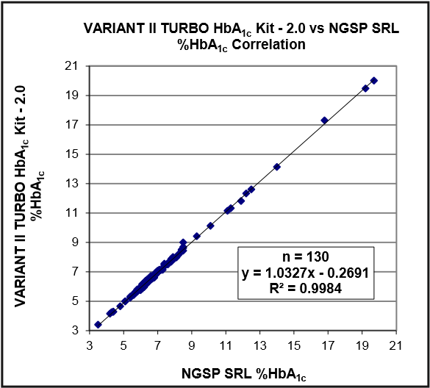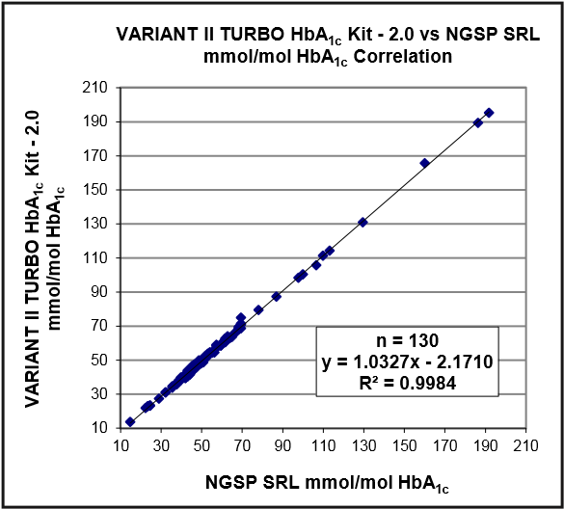

***Figure 1a:*** *Correlation of VARIANT II TURBO HbA1c* ***Figure 1b:*** *Correlation of VARIANT II TURBO HbA1c Kit - 2.0 vs NGSP SRL Method (NGSP %) Kit - 2.0 vs NGSP SRL Method (IFCC mmol/mol)*

|  |  |  |
| --- | --- | --- |
| **% HbA1c** | **Bias (% HbA1c)** | **% Bias** |
| 5.0 | −0.11 | −2.11 |
| 6.5 | −0.06 | −0.87 |
| 8.0 | −0.01 | −0.09 |
| 12.0 | 0.12 | 1.03 |

|  |  |
| --- | --- |
| n | 130 |
| Mean Difference | −0.03% |
| Lower 95% CI | −0.32% |
| Upper 95% CI | 0.22% |

***Table 4:*** *VARIANT II TURBO HbA1c Kit - 2.0 Estimated Bias*

**Linearity**

To demonstrate the linearity of the HbA1c measurement throughout the reportable range, a normal and a diabetic HbA1c whole blood patient sample were used to prepare dilutions, and the diluted samples were analyzed with the VARIANT II TURBO HbA1c Kit - 2.0. The linearity was assessed following the CLSI EP06-A guideline “Evaluation of the Linearity of Quantitative Measurement Procedures: A Statistical Approach”. The results of the study demonstrate HbA1c linearity from 3.4−20.6% (14–203 mmol/mol) within a maximum measured difference of ± 0.03% (or ± 0.38 mmol/mol) in this interval.

Examples of Patient Chromatograms:

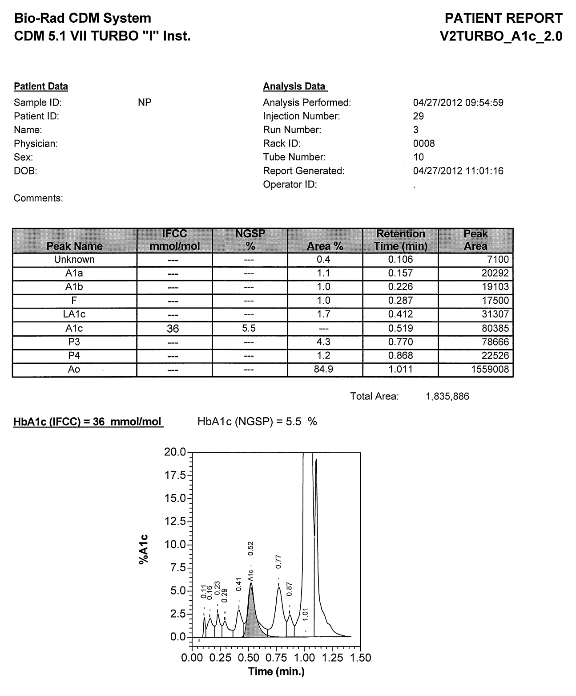

Unknown

***Figure 2:*** *Non-Diabetic (Normal) Result*

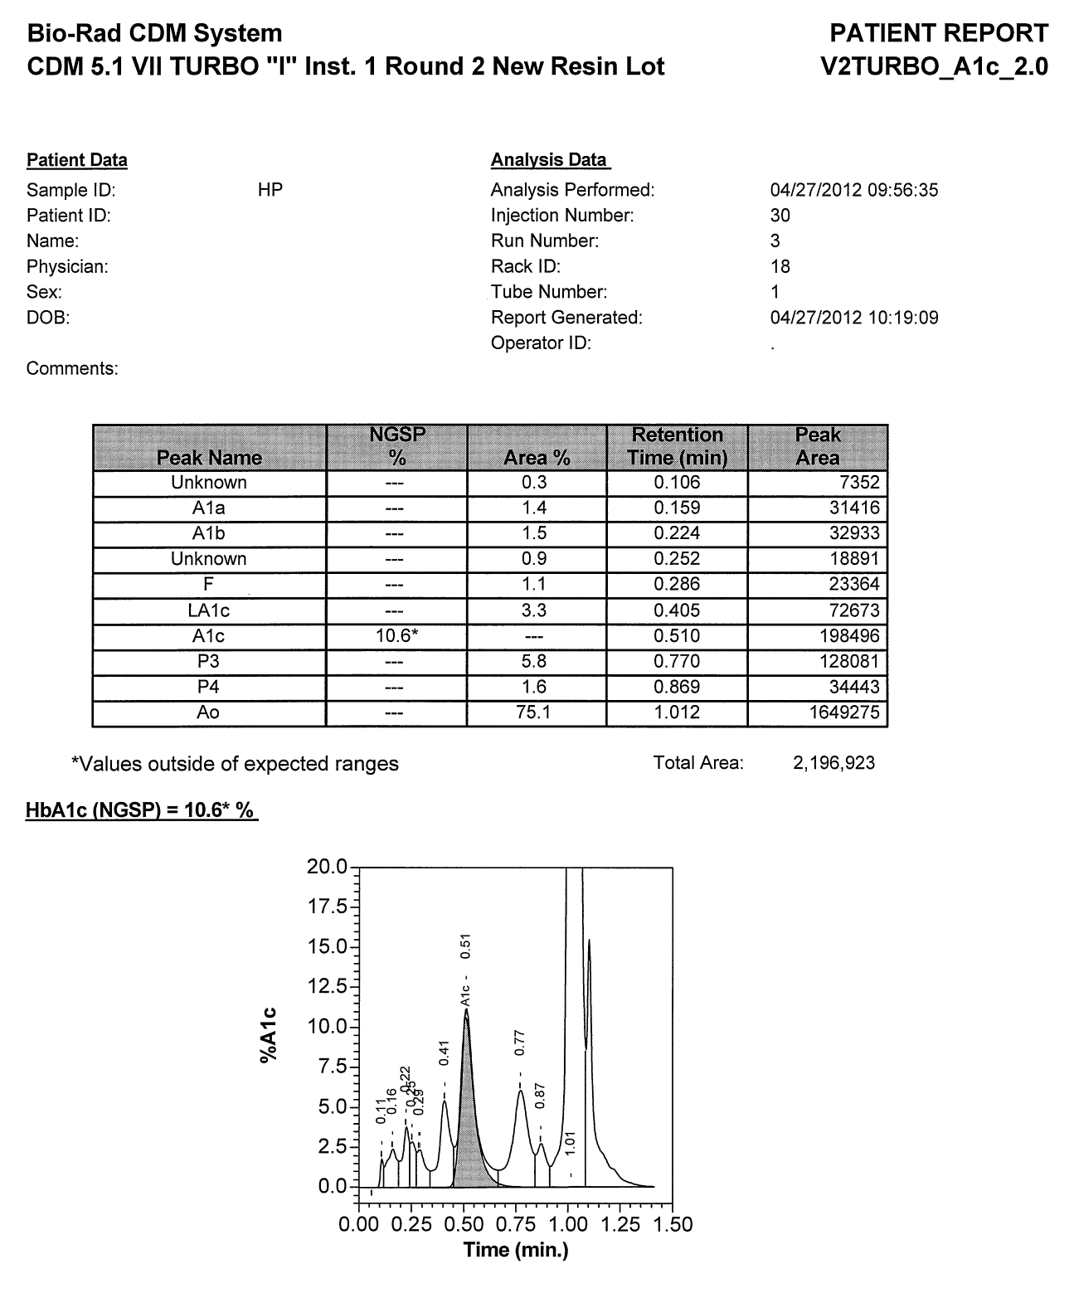

Unknown

***Figure 3:*** *Diabetic Result with an Elevated HbA1c Level*

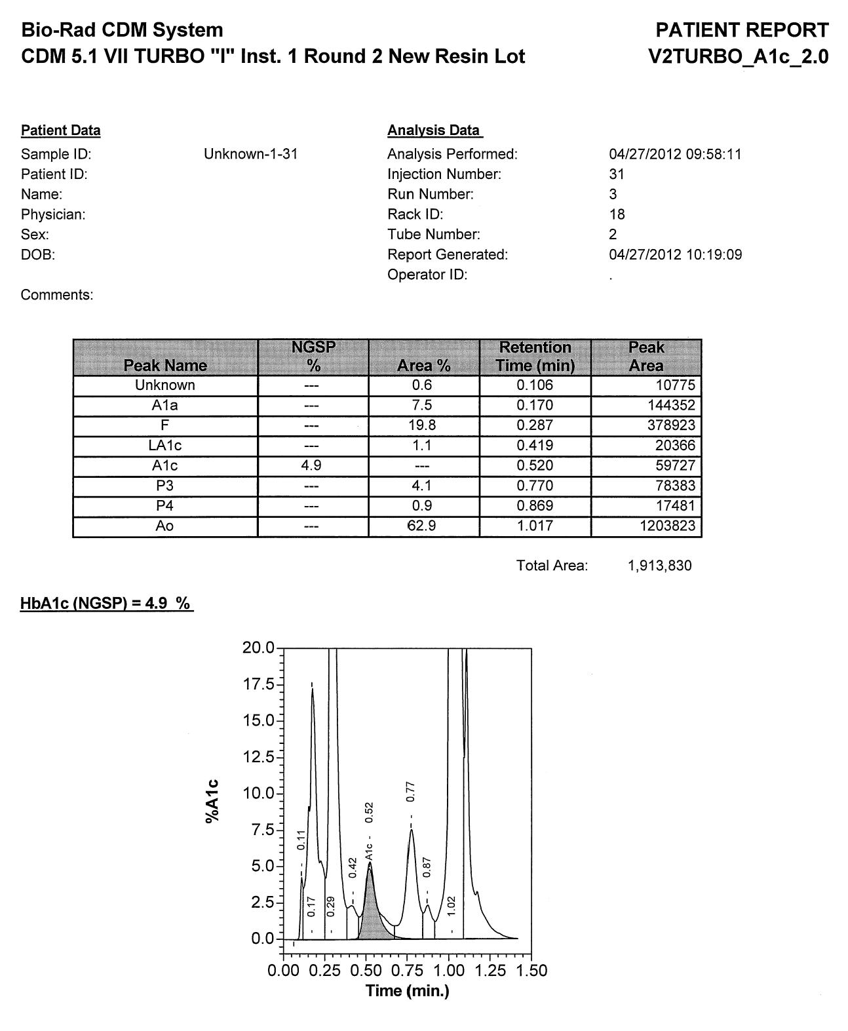

Unknown

***Figure 4:*** *Non-Diabetic Result with Elevated HbF*

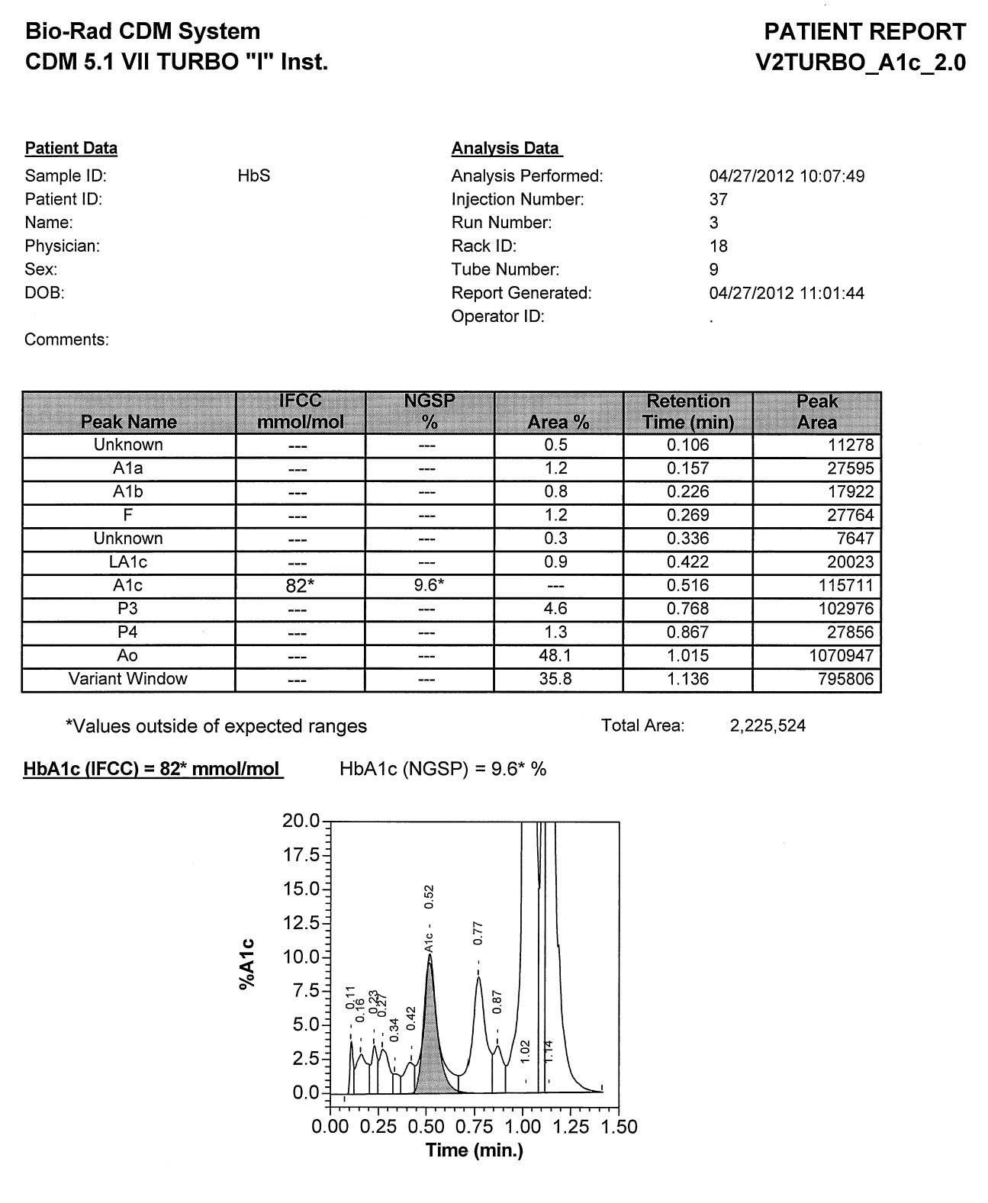

Unknown

***Figure 5:*** *Diabetic Result with Hemoglobin S Trait, or Sickle Cell Trait (AS)*

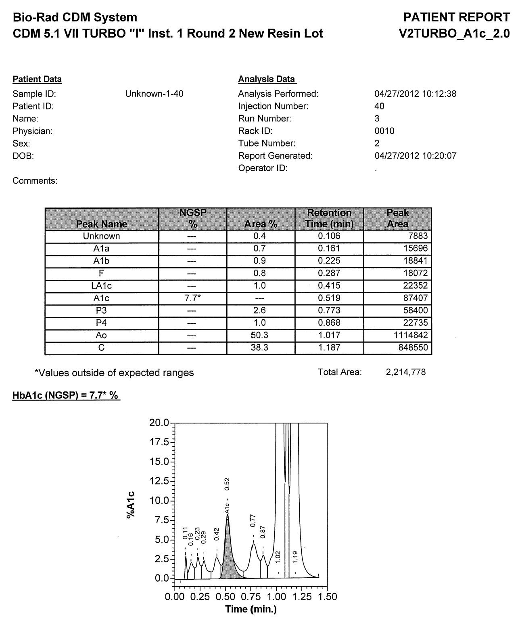

Unknown

***Figure 6:*** *Diabetic Result with Hemoglobin C Trait (AC)*

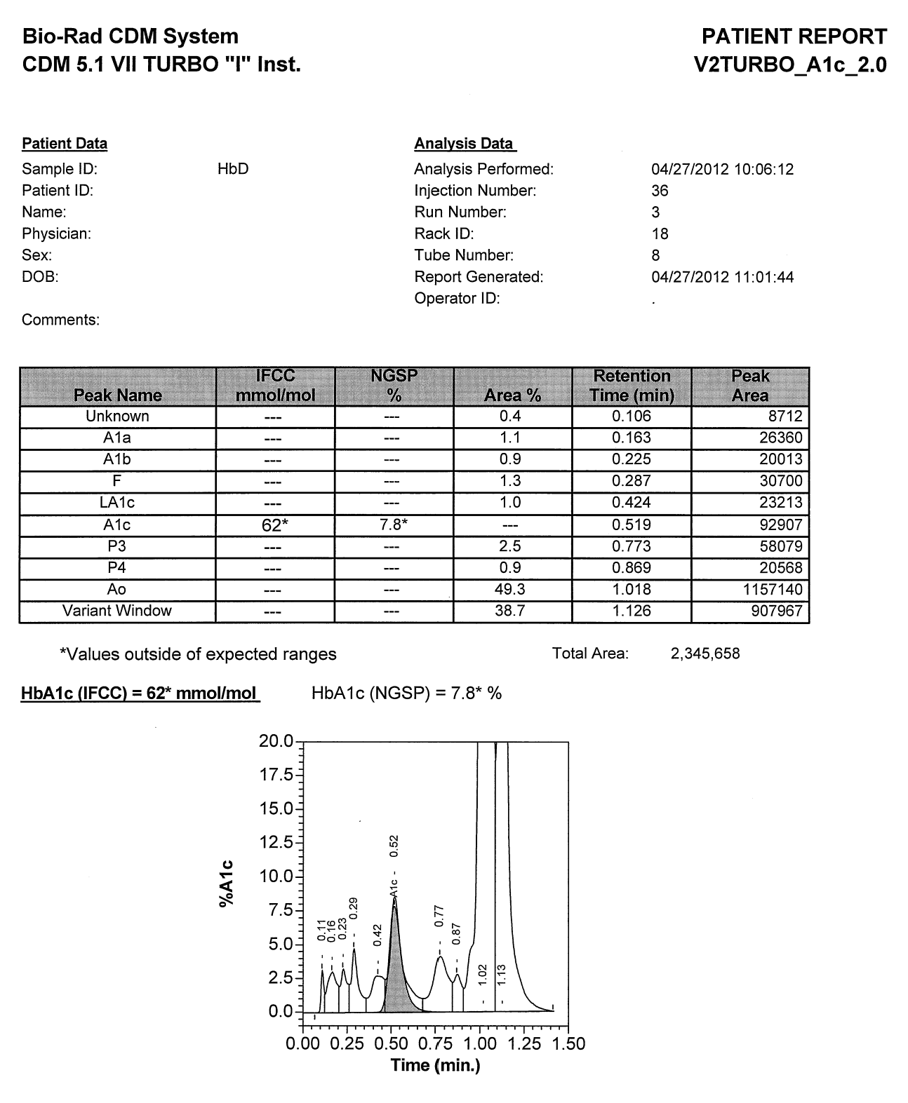

Unknown

***Figure 7:*** *Diabetic Result with Hemoglobin D Trait (AD)*

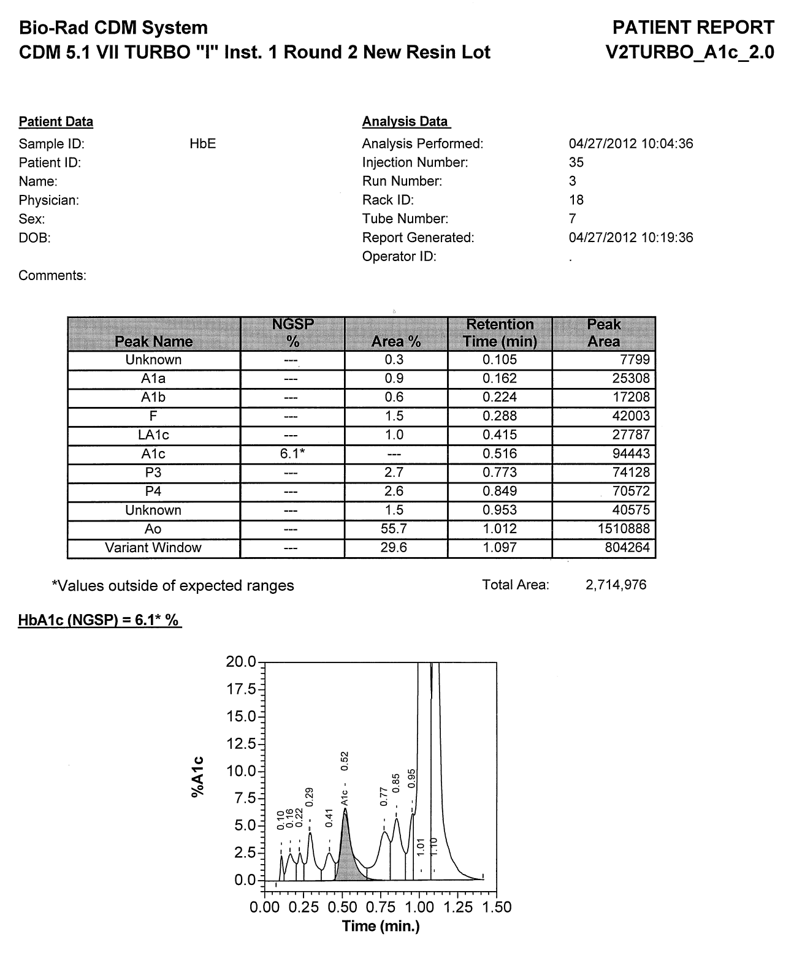

Unknown

***Figure 8:*** *Result with Hemoglobin E Trait (AE)*

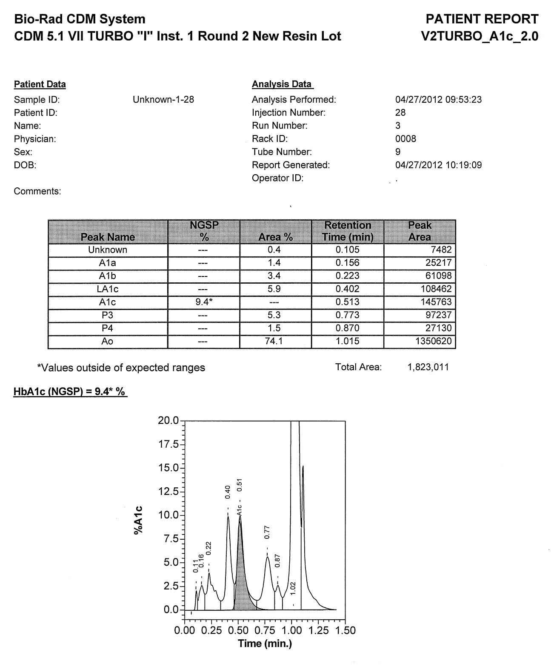

Unknown

***Figure 9:*** *Diabetic Result with Elevated Labile A1c (LA1c)*

***Figure 10:*** *Non-Diabetic Result with Elevated Carbamylated Hemoglobin*  **NOTE:** *Carbamylated hemoglobin elutes in the LA1c window.*

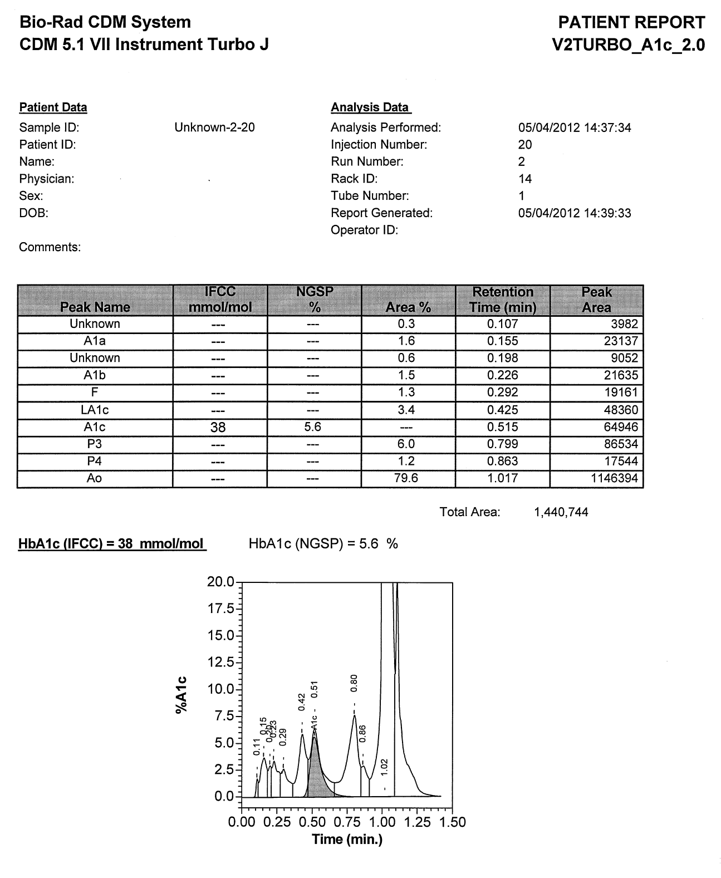

Unknown

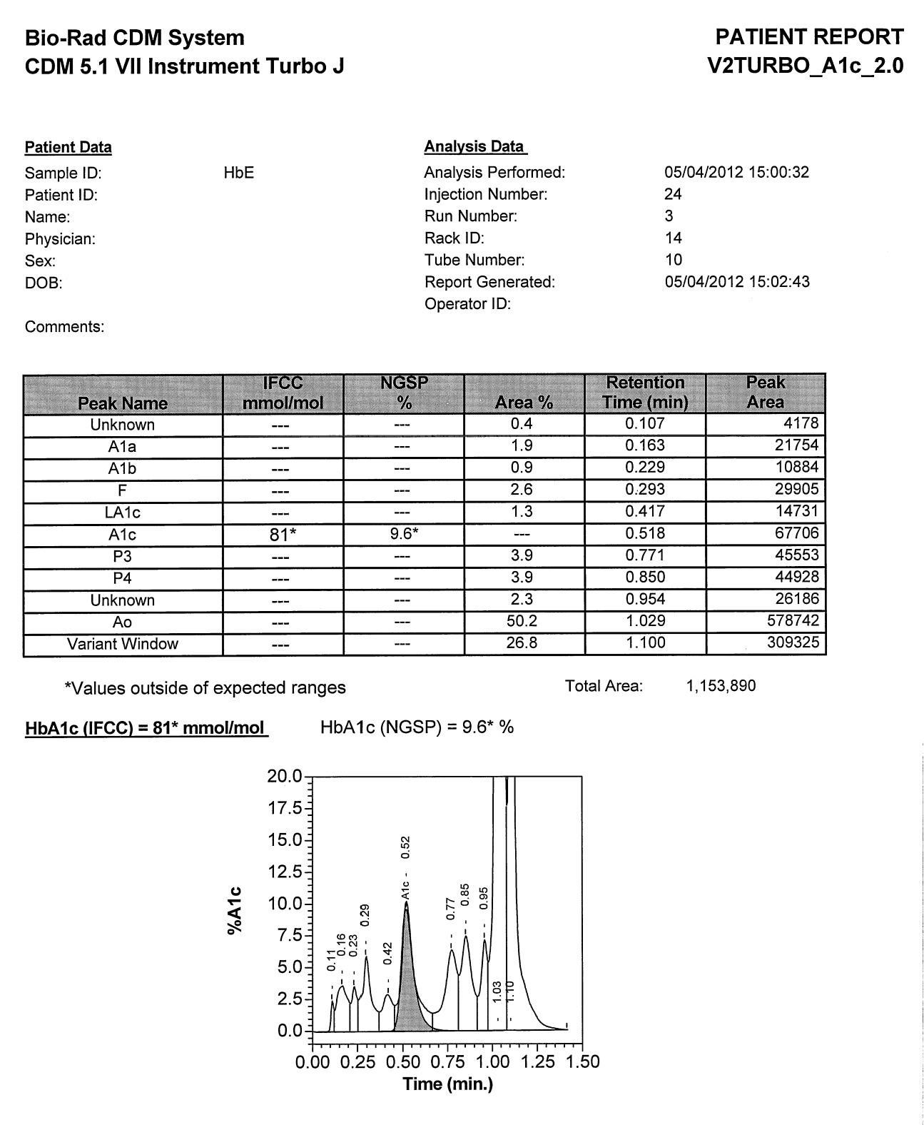

Unknown

***Figure 11:*** *Diabetic Result with Multiple Minor Components (Unknown Peaks) Integrated*

**Trademark information**

VARIANT, CDM, and Liquichek are trademarks of Bio-Rad Laboratories, Inc.

Lyphochek is a registered trademark of Bio-Rad Laboratories, Inc.

All other trademarks are the property of their respective companies.

**Technical Assistance**

In the USA: Call toll-free 1-800-2BIORAD (224-6723), available 24 hours a day, 7 days a week.

1. **Review/Revision/Implementation:**
   1. Review Cycle: 2 years
   2. Office of Record: Department of Clinical Core Laboratory-Chemistry
   3. All new procedures and procedures that have major revisions must be signed by the Laboratory Director.
   4. All reviewed procedures and procedures with minor revisions can be signed by the designated section medical director.
2. **Related Procedures:**
3. **References, National Professional Organizations, etc.:**

**References**

1. American Diabetes Association. Diabetes Basics. <http://www.diabetes.org/diabetes-basics/?loc=GlobalNavDB>(accessed July 2014).
2. Fowler, M. J. Microvascular and Macrovascular Complications of Diabetes. *Clin. Diabetes* **2008,** *26* (2), 77–82.
3. Whiting, D. R.; Guariguata, L.; Weil, C.; Shaw, J. IDF Diabetes Atlas: Global Estimates of the Prevalence of Diabetes for 2011 and 2030. *Diabetes Res. Clin. Pract.* **2011,** *94,* 311–321.
4. American Diabetes Association. Diagnosis and Classification of Diabetes Mellitus. *Diabetes Care* **2010,** *33* (Suppl. 1), S62–S69.
5. International Expert Committee. Report on the Role of the A1c Assay in the Diagnosis of Diabetes. *Diabetes Care* **2009,** *32* (7), 1327–1334.
6. World Health Organization. Use of Glycated Haemoglobin (HbA1c) in the Diagnosis of Diabetes Mellitus. http://www.who.int/diabetes/publications/diagnosis_diabetes2011/en/ (accessed July 2014).
7. Forsham, P. H. Diabetes Mellitus: A Rational Plan for Management. *Postgrad. Med.* **1982,** *71,* 139–154.
8. Hollander, P. The Case for Tight Control in Diabetes. *Postgrad. Med.* **1984,** *75,* 80–87.
9. Baynes, J. W.; Bunn, H. F.; Goldstein, D.; Harris, M.; Martin, D. B.; Peterson, C.; Winterhalter, K. National Diabetes Data Group: Report of the Expert Committee on Glucosylated Hemoglobin. *Diabetes Care* **1984,** *7,* 602–606.
10. Nathan, D. M.; Singer, D. E.; Hurxthal, K.; Goodson, J. D. The Clinical Information Value of the Glycosylated Hemoglobin Assay. *N. Engl. J. Med.* **1984,** *310,* 341–346.
11. Mayer, T. K.; Freedman, Z. R. Protein Glycosylation in Diabetes Mellitus: A Review of Laboratory Measurements and of Their Clinical Utility. *Clin. Chim. Acta* **1983,** *127,* 147–184.
12. Rohlfing, C. L.; Little, R. R.; Wiedmeyer, H. M.; England, J. D.; Madsen, R.; Harris, M. I.; Flegal, K. M.; Eberhardt, M. S.; Goldstein, D. E. Use of GHb (HbA1c) in Screening for Undiagnosed Diabetes in the U.S. Population. *Diabetes Care* **2000,** *23,* 187–191.
13. International Federation of Clinical Chemistry and Laboratory Medicine Home Page. [http://www.ifcchba1c. net](http://www.ifcchba1c.net/) (accessed July 2014).
14. Hoelzel, W.; Weykamp, C.; Jeppsson, J. O.; Miedema, K.; Barr, J. R.; Goodall, I.; Hoshino, T.; John, W. G.; Kobold, U.; Little, R.; Mosca, A.; Mauri, P.; Paroni, R.; Susanto, F.; Takei, I.; Thienpont, L.; Umemoto, M.; Wiedmeyer, H. M.; IFCC Working Group on HbA1c Standardization. IFCC Reference System for Measurement of Hemoglobin A1c in Human Blood and the National Standardization Schemes in the United States, Japan, and Sweden: A Method-Comparison Study. *Clin. Chem.* **2004,** *50* (1), 166–174.
15. American Diabetes Association, European Association for the Study of Diabetes, International Federation of Clinical Chemistry and Laboratory Medicine, and International Diabetes Federation. Consensus Statement on the Worldwide Standardization of the Hemoglobin A1c Measurement. *Diabetes Care* **2007,** *30* (9), 2399–2400.
16. National Academy of Clinical Biochemistry. Hb A1c. In *Guidelines and Recommendations for Laboratory Analysis in the Diagnosis and Management of Diabetes Mellitus* [Online]; Sacks, D. B., Ed.; 2011; Chapter 9, pp 25–30. http://www.aacc.org/members/nacb/LMPG/OnlineGuide/PublishedGuidelines/diabetes_update/ Pages/default.aspx# (accessed July 2014).
17. Safko, R. Anemias of Abnormal Globin Development—Hemoglobinopathies. In *Clinical Hematology: Principles, Procedures, Correlations,* 2nd ed.; Stiene-Martin, E. A., Lotspeich-Steininger, C. A., Koepke, J. A., Eds.; Lippincott-Raven Publishers: Philadelphia, PA, 1998; Chapter 14, pp 192–216.
18. NHS Sickle Cell and Thalassemia Screening Programme. Interpretation and Reporting of Antenatal Screening Results. *Sickle Cell and Thalassemia Handbook for Laboratories,* 2nd ed.; London, 2009; pp 30–33.
19. Bissé, E.; Huaman-Guillen, P.; Hörth, P.; Busse-Grawitz, A.; Lizama, M.; Krämer-Guth, A.; Haehnel, W.; Wieland, H. Heterogeneity of Hemoglobin A1d: Assessment and Partial Characterization of Two New Minor

Hemoglobins, A1d3a and A1d3b, Increased in Uremic and Diabetic Patients, Respectively. *J. Chromatogr. B, Biomed. Appl.* **1996,** *687,* 349–356.

1. NIH National Heart, Lung, and Blood Institute. Types of Hemolytic Anemia.

http://www.nhlbi.nih.gov/health/health-topics/topics/ha/types.html (accessed July 2014).

1. National Glycohemoglobin Standardization Program (NGSP). Factors that Interfere with HbA1c Test Results. http://www.ngsp.org/factors.asp (accessed July 2014).
2. American Diabetes Association. Standards of Medical Care in Diabetes—2014. *Diabetes Care* **2014,** *37* (Suppl. 1), S14–S80.
3. Data on file at Bio-Rad Laboratories, Inc
4. **Attachments:**
5. **Revision Dates:**

|  |  |  |
| --- | --- | --- |
| **Review/Revision Date** | **Review/Revision Description** | **Signature** |
|  |  |  |
|  |  |  |
|  |  |  |
|  |  |  |
|  |  |  |
|  |  |  |
|  |  |  |