|  |  |  |  |
| --- | --- | --- | --- |
|  | **Variant II Turbo**  **Operating Procedure 2.0**  **CL-CH185** | **Dept:** | Clinical Core Lab-  Chemistry Section |
| **Effective Date:** | 08/11/2019 |
| **Revised Date:** |  |
| **Contact:** | Clinical Core Lab-  Chemistry Management |
| **Name & Title:** Gregory J. Pomper, MD  Medical Director of Pathology Laboratories | | **Date:** |  |
| **Signature:** | | | |

1. **General Procedure Statement:** 
   1. **Scope:** To provide laboratory testing personnel with instructions for performing laboratory procedures as deemed appropriate by industry practices and regulatory agencies to assist in quality patient care.
   2. **Responsible Department/Party/Parties:** 
      1. Procedure owner: Clinical Core Laboratory Management-Chemistry
      2. Procedure: Clinical Core Laboratory Personnel
      3. Procedure prepared by: Johanna Waldron
      4. Supervision: Clinical Core Laboratory Management-Chemistry

Clinical Core Laboratory Specialist and Designees

Medical Director Clinical Chemistry

1. Implementation: Clinical Core Laboratory Management-Chemistry

Clinical Core Laboratory Specialist and Designees

Medical Director Clinical Chemistry

1. **Definitions:**
2. **Procedure:**

**Priniciple**

The VARIANT II TURBO uses the principles of high-performance liquid chromatography (HPLC) for the separation and determination of normal and abnormal hemoglobin.

Two dual-piston pumps in the VCS deliver a buffer solution to the analytical cartridge and the detector. Samples from primary sample tubes are drawn, diluted, and introduced to the analytical flow path using automatic injection. Between sample injections, the sample needle is rinsed with wash solution to minimize sample carryover.

The sample is carried by the buffer through the analytical cartridge, where the sample is separated into its individual components. The separated components then pass through the dual-wavelength detector, where absorbance of the sample components is measured at 415 nm. Background noise is reduced with the use of a secondary wavelength at 690 nm. The absorbance data is transmitted from the detector to the PC and displayed by CDM as a real-time chromatogram (graph of absorbance vs time).

The processed data is incorporated into a printed report, which contains the following:

1. A complete summary of the sample’s detected components (i.e., peak identification, retention time, area).
2. The sample’s chromatogram.
3. Date and time of analysis.
4. Vial number and sample identification.

**Specimen Required**

The whole blood specimens should be collected in a vacuum collection tube containing EDTA. Minimum sample required to perform this test is 2.5 mL for direct sampling. A pre-dilution can be made requiring a minimum of 5 uL of whole blood. Sample stability: 1 day Room Temp (15-30 ºC), and 7 days Refrigerated (2-8º C). Frozen samples are acceptable up to at least 2 months at -70°C,

**Materials Required**

* Elution Buffer A
* Elution Buffer B
* Wash / Diluent Solution
* Analytical Cartridge and Prefilters
* CD-ROM
* Calibrator/Diluent Set
* Whole Blood Primer
* Sample Vials

**Equipment Required**

* Bio-Rad Variant II Turbo

**Protective Equipment: lab coat and gloves**

**Operation**

## General Information

* Automatic and manual operation of the VARIANT II TURBO system is performed using CDM. See the *CDM Software Operation Manual* for more information. All runs are started and stopped from the **Run/Worklist** screen.
* Up to 10 tubes with diameters from 12 mm to 16 mm and heights from 64 mm to 100 mm can be loaded in each Sysmex rack. Adapters are used to allow 1.5-mL microvials and 10 mm x 50 mm pediatric tubes to be sampled. A maximum of 10 racks can be loaded onto the VARIANT II TURBO at a time.
* Each run uses one method. Method parameters cannot be changed while a run is in progress. If the method in progress must be changed, you must stop the run, make the required changes, and then restart the run.
* The VARIANT II TURBO uses the “continuous worklist” concept; samples may be continuously added to a run in progress. The maximum number of entries per worklist is 500.

**Routine for Each Sample Analysis**

**Primary Sample Tubes**

1. Barcode information for the sample tube is read by the barcode reader.
2. The sample needle pierces, then withdraws sample from the tube.
3. The sample is diluted in the dilution chamber.
4. The sample is injected into the buffer stream.
5. The sample needle and line are flushed to prevent cross-contamination between samples.
6. The sample and buffer mixture flows through the cartridge, where the sample is separated into its constituents.
7. The sample constituents and buffer flow through the detector, where the absorbance of each sample constituent is measured.
8. The resulting chromatogram is shown on CDM.
9. A system flush removes any residual sample components.

**Prediluted Samples**

1. Barcode information on the microvial adapter is read by the barcode reader.
2. The sample needle pierces, then withdraws sample from the microvial. The sample is transferred to the dilution chamber.
3. The sample is injected into the buffer stream.
4. The sample needle and line are flushed to prevent cross-contamination between samples.
5. The sample and buffer mixture flows through the cartridge, where the sample is separated into its constituents.
6. The sample constituents and buffer flow through the detector, where the absorbance of each sample constituent is measured.
7. The resulting chromatogram is shown on CDM.
8. A system flush removes any residual sample components.

**Maintenance Procedures**

**Daily Maintenance:**

**Pre-Run**

Before beginning daily operation of the VARIANT II TURBO, complete the Pre-Run Checklist section of the Daily Maintenance Log.

* **Warm-Up Procedure**

1. From CDM, go to the **Maintain/Instruments** screen.
2. Click **Return to Active**.
3. In the dialog box, click **No** (do not perform automatic warm-up operations).
4. Select **Do Startup Actions** from the Execute Commands list.
5. Click **Start**. The startup actions last approximately 4 minutes.
6. After the warm-up is completed, return the instrument to Ready state by clicking **Return to READY state**.

* **Check the Buffer and Wash/Diluent Solution Levels**

Ensure the buffer and wash/diluent solution bottles contain sufficient solution to complete the next run. If the levels are low, an alarm sounds and a message appears on CDM. To replace one of these bottles:

1. Remove the empty bottle from the weight sensor and set it on the benchtop. Click **OK** to acknowledge the alarm on CDM.
2. Unscrew the on-line cap and pull the sinker (attached to the end of the line) up and out of the bottle.
3. Remove the cap from the new bottle. Fasten the cap onto the old bottle and properly dispose of the old bottle.
4. Place the sinker into the new bottle; ensure the sinker is positioned at the bottom of the bottle. Secure the on-line cap.
5. Place the full bottle onto the weight sensor. The buffer level icon on the CDM status panel changes from blinking red to green.
6. Perform a system flush:
   1. From CDM, go to the **Setup/Test/Reagents** screen.
   2. Click **Start System Flush**.
   3. Select **Short Flush.**

.

* **Document the Cartridge and Prefilter Injection Counts**

The cartridge and prefilter injection counts are automatically updated in the CDM **Setup/Test/ Cartridges** screen. Record the number of injections in the Daily Maintenance Log.

* **Check the Level of the Waste Container**

Ensure the waste container has sufficient room to accommodate waste from the next run. To empty the waste container:

1. Unscrew the main cap from the waste container. Lift the cap and waste sensor up and out of the container. See Figure 4-1. Place the cap and sensor on an absorbent towel.

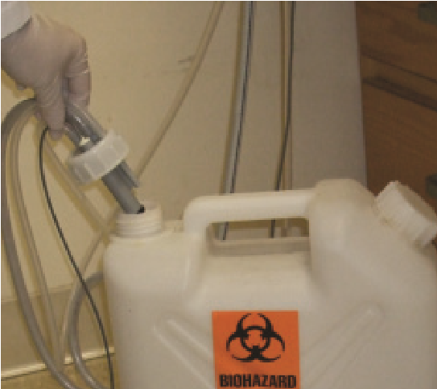

***Figure 4-1:*** *Removing the Main Waste Cap and Sensor*

1. Dispose of the waste properly (contact your laboratory safety officer).
2. Place the sensor back into the waste container; secure the main cap.

**WARNING:** *Some reagents used with the VARIANT II TURBO contain sodium azide as a preservative (see labels). Azide may react with lead or copper plumbing to form potentially explosive metal azides. When disposing of reagents containing sodium azide, always flush with large volumes of water to prevent metal azide buildup. For further information, consult the manual Safety Management, No. CDC-22, “Decontamination of Laboratory Sink Drains to Remove Azide Salts” (Centers for Disease Control and Prevention, Atlanta, GA, April 30, 1976).*

* **Inspect the Piston/Seal Wash Tubing for Liquid**

1. Fill the 10-mL syringe with deionized water. Insert the syringe into the piston/seal wash port. See Figure 3-11.

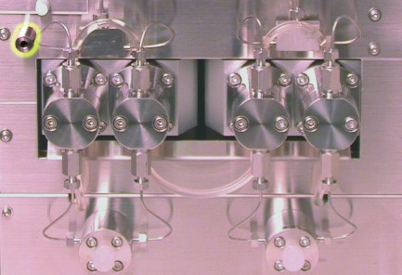

***Figure 3-11:*** *Piston/Seal Wash Port*

1. Slowly depress the syringe plunger until all liquid has been dispensed. Leave the water in the lines.
2. Remove the empty syringe.

* **Pressure Check Pump A and Pump B**

Flush the system using manual pump control for 10 minutes to stabilize the pressure and check for leaks.

* + In the CDM **Maintain/Instruments** screen, set %B to 0% and the Flow Timer to 5.00 minutes. Make sure flow rate is at 2.0 mL/min. Click **Start Flow.**
  + After pump A stops, set %B to 100%. Click **Start Flow.**
  + After pump B stops, return the system to Ready state.
  + Record pressure readings on Daily Maintenance Log.
* **Check for Leaks**
* **Check Paper Supply**

**Post-Run**

When all runs for the day are finished, complete the Post-Run Checklist section of the Daily Maintenance Log.

* **Remove Samples**

Properly dispose of any remaining samples. Sample waste should be considered potentially biohazardous and must be disposed of in the appropriate manner. Refer to your laboratory’s standard operating procedure or contact your safety officer.

* **Wipe Up Spills and Decontaminate Surface Area**

Wipe up any spills. Sample spills are potentially biohazardous; treat appropriately. If any sample spills occur in the automatic sampler area, decontaminate the automatic sampler area using the surface decontamination solution of your choice.

1. Remove all racks from the VSS.
2. Prepare decontamination solution of your choice. Do not use corrosive liquids (e.g., bleach).
3. Dampen a disposable towel with the decontamination solution.
4. From the CDM **Maintain/Instruments** screen, select **Cleaning Belts** from the Execute Commands list. Click **Start**.
5. Wipe the conveyor belts with the damp towel.
6. After decontamination, let the belts air-dry before use.

**Kit Change Maintenance:**

* **Exterior Surface Cleaning**

1. Use a cloth or sponge dampened with water to wipe the exterior surface of the system.
2. If required, use a mild soap solution diluted with water to clean the surface, then wipe with a damp cloth or sponge to remove any soap residue.
3. Do not use abrasive cleaners.

* **Interior Surface Cleaning**

1. Wipe up any fluid using a soft disposable towel or tissue.
2. Clean fluid from the lower interior surface; tighten any leaking connections.
3. The VSS conveyor belts can be activated in the **Maintain/Instruments** screen. Select **Cleaning Belts** from the Execute Commands list. Click **Start**.

* **Clean the Barcode Reader (if needed)**

1. Inspect the barcode reader face twice per month.
2. If necessary, clean using a soft cotton cloth dampened with DI water, gently wiping the barcode reader face. Be careful not to scratch the barcode reader face.
3. Do not use alcohol or any other solvent, as this damages the reader.

* **Clean the Dilution Chamber**

**WARNING:** *The sample needle is very sharp. Use caution when handling to avoid injury.*

**CAUTION:** *The sample needle cover is interlocked. When open, the interlock switch shuts off power to the needle assembly unit.*

1. Turn off the VSS power switch.
2. Remove the sample needle cover.
3. Push the needle gantry all the way back, away from the dilution chamber.
4. Fill the dilution chamber with DI water. Use cotton swabs to clean and soak up loose particulate.
5. Reinstall the sample needle cover.
6. Turn on the VSS power switch, waiting for sampler to complete initialization and flush cycle.
7. Click **OK** on the CDM communication error, sampler resetting, and rack resetting messages. Return the system to Ready state.

* **Clean the Sample Needle**

**WARNING:** *The sample needle is very sharp. Use caution when handling to avoid injury. Do not attempt to replace a broken needle that has detached from its base. Contact your local Bio-Rad office for technical assistance.*

**CAUTION:** *The sample needle cover is interlocked. When open, the interlock switch shuts off power to the needle assembly unit.*

1. From CDM, go to the **Maintain/Instruments** screen.
2. Under Sampler, click **Replace Needle**.
3. After the needle is repositioned, remove the sample needle cover.
4. Clean the sample needle with a cloth, removing debris. Do not use bleach. Be careful not to bend the needle.
5. Reinstall the sample needle cover.
6. Click **Return to READY state**.
7. Click **Move Needle Home**. The needle returns to its home position.
8. A message appears prompting you to flush the sampler. Click **Yes** to perform this automatic flush.
9. Observe the needle during the flush for proper alignment; the needle should move up and down easily, without obstructions. If needed, correct the needle’s alignment, and repeat the sampler flush to ensure proper alignment.

* **Clean and Decontaminate the Sampling Fluid Path**

The decontamination procedure should be performed at every kit change or for troubleshooting. Perform the decontamination procedure when any of the following symptoms occur:

* Carryover from a hemoglobin variant sample generates an identified peak in the next injection.
* High total area counts occur across multiple samples.
* Buildup is visible inside the injection valve tubing.
* Blood is visible in the dilution chamber.

**NOTE:** *The prefilter must be discarded after this decontamination procedure is completed.*

1. Disconnect the cartridge-to-detector tubing from the cartridge holder.
2. Remove the analytical cartridge.
3. Rinse the cartridge holder with DI water.
4. Install the PEEK dummy cartridge into the holder.
5. Install the decon tubing onto the outlet of the cartridge holder. Place the outlet side of the decon tubing into a beaker to collect waste from the decontamination.

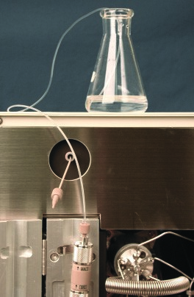

***Figure 5-1:*** *Decon Tubing Installed*

1. Select the **Decon_T** test from the **Setup/Test** screen.

**Current Test:** Decon_T

**Reagent Set:** Default

1. Click **OK** on the Test dialog box.
2. Place 5 sample microvials filled with 5% sodium hypochlorite solution (undiluted household bleach) into adapters in the first 5 positions of a sample rack.
3. Place 5 sample microvials filled with DI water into adapters in the last 5 positions of the sample rack.
4. Prepare 5 mL of a 1:10 dilution of whole blood in DI water (i.e., 500 µL of whole blood in 4.5 mL of DI water). Mix thoroughly.
5. Place 5 sample microvials, containing 1 mL each of the 1:10 hemolysate solution, into adapters in the first 5 positions of a second sample rack.
6. Place the STOP adapter with an empty sample microvial into position 6 of the second sample rack. Place both sample racks on the VSS.
7. Start the Worklist.
8. When the status returns to Ready, remove the PEEK dummy cartridge. Rinse the cartridge holder again with DI water. Reinstall the original or new analytical cartridge.
9. Remove the decon tubing from the cartridge holder. Discard the beaker waste.
10. Reconnect the cartridge-to-detector tubing, securing both tubing end connections.
11. Remove the used prefilter from the PEEK housing and replace with a new one.
12. Remove the racks. Select the **V2TURBO_A1c** test from the **Setup/Test** screen.

**Periodic Maintenance:**

* **Replace the Sample Needle**

**WARNING:** *The sample needle is very sharp. Use caution when handling to avoid injury. Do not attempt to replace a broken needle that has detached from its base. Contact your local Bio-Rad office for technical assistance.*

**CAUTION:** *The sample needle cover is interlocked. When open, the interlock switch shuts off power to the needle assembly unit.*

Replace the needle every 20,000 injections and when it is bent. As an extra biohazard precaution, you can perform the decontamination procedure before replacing the sample needle.

1. From CDM, go to the **Maintain/Instruments** screen.
2. Under Sampler, click **Replace Needle**.
3. After the needle is repositioned, remove the sample needle cover.
4. Unscrew the tube fitting from the sampling assembly and slide the needle out through the top.

See Figure 5-2. Discard the old needle according to your laboratory’s standard operating procedures for sharps.

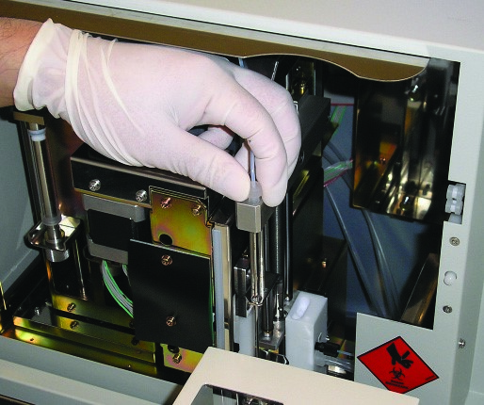

***Figure 5-2:*** *Replacing the Sample Needle*

1. Unwrap a new needle. Place the new needle in the assembly with the needle hole facing left. Reconnect the tube fitting. Remove the plastic cover from the needle.
2. Reinstall the sample needle cover.
3. Click **Return to READY state**.
4. Click **Move Needle Home**. The needle returns to its home position. Check alignment of the needle with the home position wash port; correct if needed by gently flexing the needle.
5. A message appears prompting you to flush the sampler. Click **Yes** to perform this automatic flush.
6. Observe the needle during the flush for proper alignment; the needle should move up and down easily, without obstructions. If needed, correct the needle’s alignment, and repeat the sampler flush to ensure proper alignment.

* **Backup Database Procedure**

The database should be backed up and cleared after every 5,000 injections.

1. In the **Setup / Configuration** Screen, select **Backup Database.**
2. A file name is automatically created based on the default drive (D:) and date that the database was created / saved. **DO NOT** change the name of the file or the drive.
3. Select **Backup and Clear.**
4. Click **OK** to begin backup.
5. CDM will automatically restart after completion of the backup.

**Shutdown and Start Up**

1. Turn off computer.
2. Power off both VCS and VSS.
3. Wait 1 minute, then turn computer power on. Allow computer to run through its auto check sequence.
4. Press the “Ctrl + Alt + Delete” keys simultaneously to log on when prompted.
5. Press the “Enter” key when prompted to enter a password.
6. At the Microsoft desktop, double click on the CDM icon. Allow CDM to load.
7. When CDM will give a CDM communication error message, turn power on to VCS and VSS. Allow 3 minutes for power up sequence of modules.
8. Instrument is ready to Start.

**Loading Reagents**

Ensure the buffer and wash/diluent solution bottles contain sufficient solution to complete the next run. If the levels are low, an alarm sounds and a message appears on CDM. To replace one of these bottles:

1. Remove the empty bottle from the weight sensor and set it on the benchtop. Click **OK** to acknowledge the alarm on CDM.
2. Unscrew the on-line cap and pull the sinker (attached to the end of the line) up and out of the bottle.
3. Remove the cap from the new bottle. Fasten the cap onto the old bottle and properly dispose of the old bottle.
4. Place the sinker into the new bottle; ensure the sinker is positioned at the bottom of the bottle. Secure the on-line cap.
5. Place the full bottle onto the weight sensor. The buffer level icon on the CDM status panel changes from blinking red to green.
6. Perform a system flush:

a. From CDM, go to the **Setup/Test/Reagents** screen.

b. Click **Start System Flush**.

c. Select **Short Flush.**

**Taking Corrective Action:**

If the Quality Control results do not fall within the suggested expected values, then do the following:

* Consider the sample results invalid and do not report results. Repeat sample testing with new controls.
* Review these instructions to make sure that the assay was performed according to the procedures recommended by Bio-Rad Laboratories.
* Verify that the materials are not expired.
* Verify that required maintenance was performed.
* Investigate and determine the cause for the unacceptable control results. When the condition is corrected, retest the controls and confirm that results are within acceptable limits. It is advisable to repeat all patient specimens before reporting results for this run.
* If necessary, contact Bio-Rad Laboratories for more assistance. Phone # 1-800-224-6723.

**Limitations of Instrument**

The Variant II Turbo may malfunction or become inoperable. If the issue can be resolved by the operating technologist, appropriate actions to resume normal operation will be performed, i.e. quality control, calibration, etc… if necessary. Specimens will be held correctly stored until processing can resume.

Issues beyond the capability of the technologist to resolve will be diverted to Bio-Rad field service for repair.

To return the Variant II Turbo to normal operating status, the technologist first ensures any necessary quality control has been performed. Once completed and within acceptable limits, specimen processing may resume.

**Limitations of the Assay**

Refer to HBA1c procedure for specific limitations.

1. **Review/Revision/Implementation:**
   1. Review Cycle: 2 years
   2. Office of Record: Department of Clinical Core Laboratory-Chemistry
   3. All new procedures and procedures that have major revisions must be signed by the Laboratory Director.
   4. All reviewed procedures and procedures with minor revisions can be signed by the designated section medical director.
2. **Related Procedures:**
3. **References, National Professional Organizations, etc.:**

**References:**

1. Variant II Turbo Operation Manual, Ref # L70241502, September 2010
2. Variant II Turbo Instruction Manual, Ref # L70241103, August 2010
3. **Attachments:**
4. **Revision Dates:**

|  |  |  |
| --- | --- | --- |
| **Review/Revision Date** | **Review/Revision Description** | **Signature** |
|  |  |  |
|  |  |  |
|  |  |  |
|  |  |  |
|  |  |  |
|  |  |  |
|  |  |  |