|  |  |  |  |
| --- | --- | --- | --- |
|  | **Ordering Sickle Cell Testing on Blood Products in Epic**  BB.BBIS.1015 | **Dept:** | 324311 |
| **Dept Name:** | Blood Bank |
| **Effective Date:** |  |
| **Revised Date:** |  |
| **Name & Title**: CLIA Laboratory Medical Director | | **Contact:** | Julie H. Simmons/ Christina S. Warren |
| **Signature:** | | **Date:** |  |



1. **General Procedure Statement:**
2. **Purpose:** Testing red cells for hemoglobin S (Sickle cell) is routinely performed on units by the American Red Cross before they are sent. On occasion a unit needs to be tested after it has arrived from the supplier. This testing is performed by the WFBMC Core Lab in Hematology lab. The Blood Bank orders the test in Epic for the Hematology lab to result. This procedure ensures that the test is ordered correctly.

1. **Responsible Department/Scope:**

i. Procedure owner/Implementer: Julie H. Simmons/ Christina S. Warren

ii. Procedure prepared by: Julie Jackson

iii. Who performs procedure: Department staff/management

1. **Definitions:**

**NA**

1. **Sections**:

**NA**

1. **Procedure:**

Chemical Risk Assessment: None

Biological Risk Assessment: None

Protective Equipment: Lab coat, gloves

Supplies: None

Reagents: None

Equipment: None

Specimen Requirements: None

* 1. Order in **Requisition Entry** in **Beaker**
     1. Go to the search box in upper right corner
     2. Type in **Req** and hit Enter

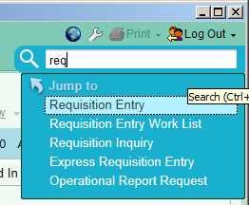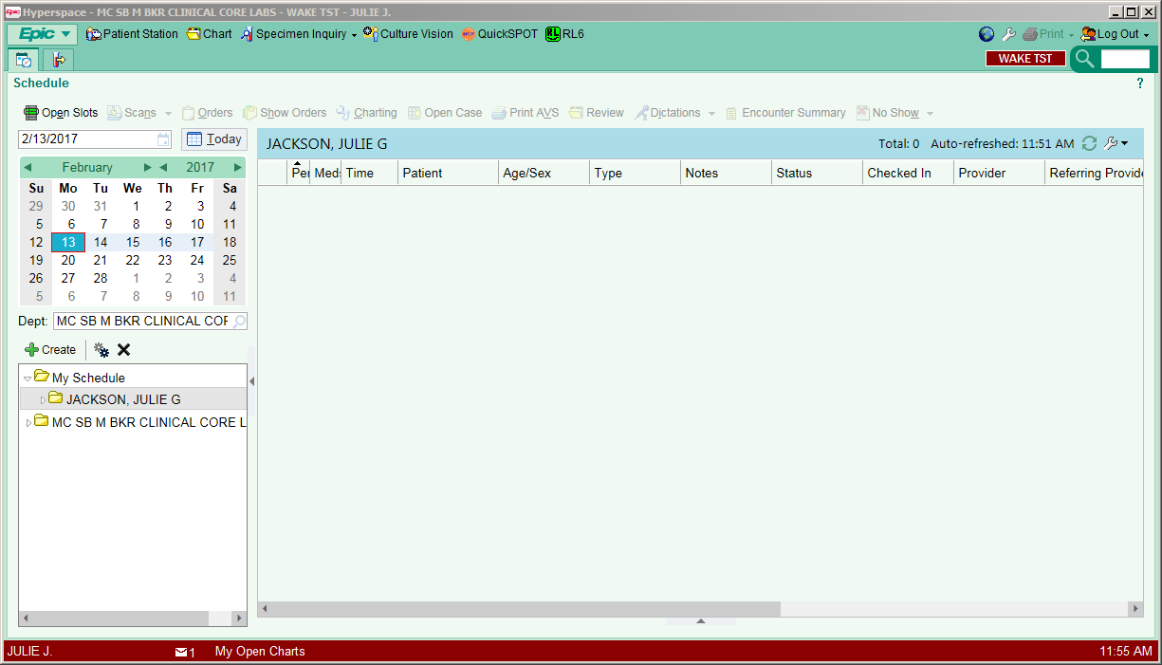

1

* 1. At Submitter enter **WC Blood Bank**
  2. Be sure Non-human is highlighted in the Requisition Entry toolbar.
  3. Patient /Source: enter (last Name) **Blood Bank**, (First Name) [**Unit #]** 
     1. Ex. **Blood Bank, W201216859332**

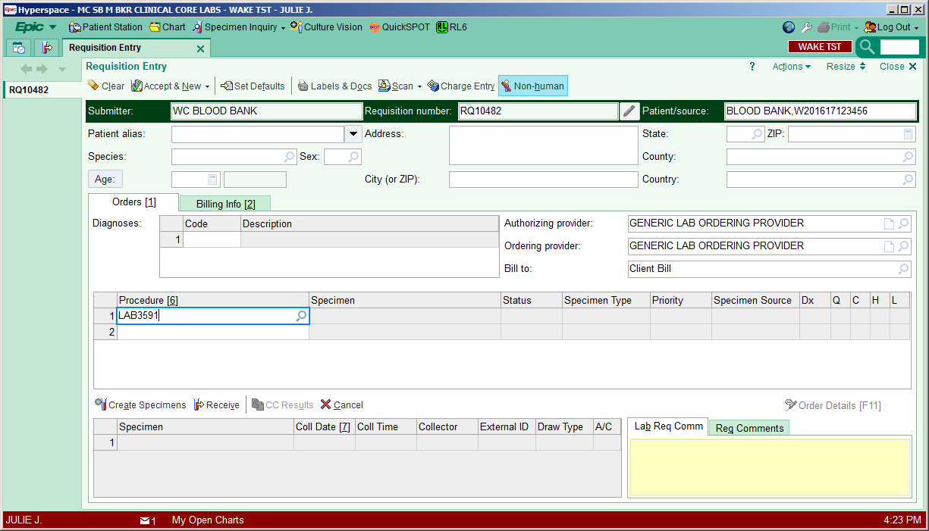

3

4

5

2

* 1. In the Procedure field
     1. Enter the test code **LAB3591** and Enter
     2. Click on Database lookup in upper right corner of box

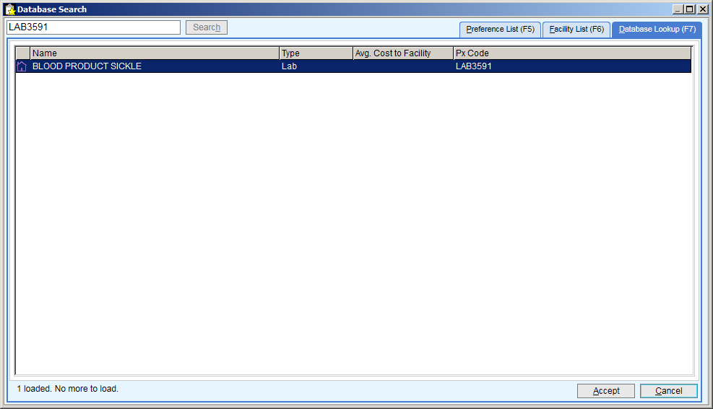

* 1. Click on Create Specimens. This gives the Specimen ID/Accession number.
  2. Enter the Coll date (enter T for Today’s date) and Coll time (Enter N for now).
  3. Click Receive
  4. On the Requisition Entry toolbar, Click on the Accept &New.

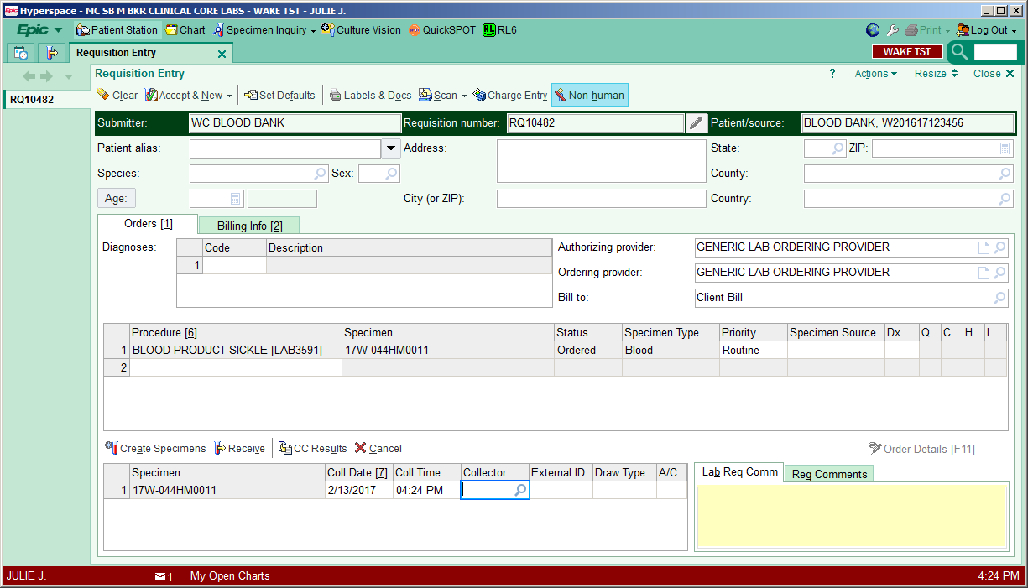

9

8

7

6

* 1. Your sample should be on the Outstanding List for hematology.
  2. Place accession sticker on tube with segments.
  3. Send to Core lab (tube station 21).
  4. The results will print in the Blood Bank on the Front Desk printer.
  5. Charge the patient for the sickle testing by ordering (or adding to one already ordered) an AGTYP Action.

1. **Review/Revised/Implemented:**

All procedures must be reviewed according to the Document Change Protocol.

All new procedures that have major revisions must be signed by the CLIA Director.

All reviewed procedures with minor revisions can be signed by the designated section Medical Director.

1. **Related Procedures:** NA

1. **References**: NA

1. **Attachments**: NA
2. **Revised/Reviewed Dates and Signatures:**

See Document Change Control

|  |  |  |  |  |  |  |  |  |  |  |  |  |  |  |  |  |  |
| --- | --- | --- | --- | --- | --- | --- | --- | --- | --- | --- | --- | --- | --- | --- | --- | --- | --- |
| Document Change Control | | | | | | | | | | | | | | | | | |
| **Title:** Ordering Sickle Cell Testing on Blood Products in Epic | | | | | | | | | | | | | | | | | |
| Previous title: | | | | | | | | | | | | | | | | | |
| Written date | | | | 4/21/20 | | | | | Written by | | | | JJackson | | | | | |
| Validation date | | | |  | | | | | Validation by | | | |  | | | | | |
| Reviewed date | | | |  | | | | | Reviewed by | | | |  | | | | | |
| Approved date | | | |  | | | | | Approved by | | | |  | | | | | |
| Approved date | | | |  | | | | | Approved by | | | |  | | | | | |
| Effective date in use | | | |  | | | | | In use by | | | |  | | | | | |
| **Revisions** | | | | | | | | | | | | | | | | | |
| Revised Date | By | | MD  Date | | By | | MD  Date | By | | | Review Date | By | | | Effective Date | | By |
|  |  | |  | |  | |  |  | | |  |  | | |  | |  |
| Validate Date | By | | Revisions: | | | | | | | | | | | | | | |
|  |  | |
| Revised Date | By | | MD Date | | By | | MD Date | By | | | Review Date | By | | | Effective Date | | By |
|  |  | |  | |  | |  |  | | |  |  | | |  | |  |
| Validate Date | By | | Revisions: | | | | | | | | | | | | | | |
|  |  | |
| Revised Date | By | | MD  Date | | By | | MD  Date | By | | | Review Date | By | | | Effective Date | | By |
|  |  | |  | |  | |  |  | | |  |  | | |  | |  |
| Validate Date | By | | Revisions: | | | | | | | | | | | | | | |
|  |  | |
| Locations | |  | | | | Out of Use Date | | | |  | | | | By | |  | |
|  | | | |  | | | | | | | | | | | |
|  | | | | Reason: | | | | | | | | | | | |

|  |  |  |  |  |  |  |  |
| --- | --- | --- | --- | --- | --- | --- | --- |
| **Reviews: Record Date/Initials** | | | | | | | |
| Date | Initials | Date | Initials | Date | Initials | Date | Initials |
|  |  |  |  |  |  |  |  |
|  |  |  |  |  |  |  |  |