**II. Protocol for PUBS Transfusion**

1. The provider orders the PUBS test on the mother’s MRN. The sample will be labeled with mother’s name and MRN. The Wake One Order is: Intrauterine Transfusion Orders (PUBS).

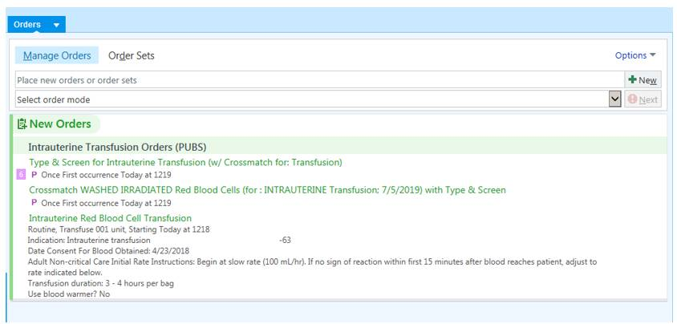

* 1. This test includes specially created tests that will not interfere with mother’s history:

PABO, PRH, PDATG

* 1. Other tests may be added on by Blood Bank staff as needed including titers and antigen testing specific for PUBS testing

|  |  |
| --- | --- |
| **TEST TO BE DONE** | **TEST NAME IN SCC\*** |
| Rh System Antigen testing  (C, c, E, e, Cw, V) | PC, PE, PLC, PLE, PCW, PV |
| Kell System Antigen testing  (K, k, Jsa, Kpa) | PK, PLK, PJSA, PKPA |
| Duffy Antigen testing (Fya, Fyb) | PFYA, PFYB |
| Kidd Antigen Testing (Jka, Jkb) | PJKA, PJKB |
| MNS System Antigen testing  (M, N, S, LS) | PM, PN, PS, PLS |
| Other Antigens not listed above | POT |
| Titers (antibodies to: L, E, D, LC, LE, K, FYA, FYB, JKA, JKB, S, M, N, A, A1, B) | PTAB1 (first antibody)  PTAB2 (second antibody)  PTAB3 (third antibody) |

*the P in front indicates it is for PUBS

1. A TSX will also be collected on the mother to identify any antibodies present and crossmatching the unit. The BBID used for this sample will be used for the IUT red cell unit.
2. The IUT red cell unit must be:
   1. Fresh (< 7 days old)
   2. Washed (See step 4.0)
   3. Irradiated
   4. CMV negative equivalent (leukoreduced)
   5. HGBS negative
   6. O Negative (unless infant is O positive and O positive is needed to provide antigen negative)
   7. Antigen negative for the offending antibody
   8. Crossmatch compatible with mother’s TSX sample
   9. HCT after washing 75 to 80%.
3. WASHING SPECIAL INSTRUCTIONS
   1. Transfer the unit to a transfer bag after washing and label per SOP.
   2. Obtain a segment from the transfer tubing (it should be well mixed after transfer) and take to BMT lab (if open) for HCT. (Take to Hematology if BMT is closed.)
   3. Determine next steps based on HCT.

|  |  |
| --- | --- |
| Hematocrit Result | Step(s) |
| >75% | Record on bag. Call that unit is ready. |
| <75% | Take bag to BMT.  Centrifuge per whole blood packing SOP.  Express saline into a transfer bag and seal.  Strip tubing and mix bag.  Make a segment and repeat the HCT.  Consult management if still <75%. |

1. PUBS will be of limited quantity and normal reflex testing may not be possible.
2. A Pedi filter must be given with unit.
   1. In SCC:
      1. Add as a supply when irradiating
      2. Add as an instruction after selecting to patient
3. A second transfusion label must accompany the unit to the floor.
   1. Refer to Section I under Protocol, step 5.1.b.