|  |  |  |  |
| --- | --- | --- | --- |
|  | **Biosafety Cabinet Maintenance**  **M##** | **Department:** | Microbiology Lab |
| **CLIA Medical Director, Gregory Pomper, MD**  **Signature: Electronic** | |  |  |

# General Procedure Statement:

This document describes the cleaning procedures for all Biosafety Cabinets in Clinical Microbiology, Wake Forest Baptist Hospital. This Document will be maintained and revised as appropriate with document control flow changes in the Title 21 system.

1. **Scope:**  The Biosafety Cabinet Cleaning procedures applies to all Biosafety Cabinets located in Clinical Microbiology, South Building and Gray Building.
2. Responsible Department/Party/Parties:
   1. Policy Owner: Microbiology
   2. Procedure: Microbiology
   3. Supervision: Dr. Gregory Pomper, Dr. Elizabeth Palavecino
   4. Implementation: Dr. Elizabeth Palavecino, Christopher Powers

Definitions: For purposes of this procedure, the following terms and definitions apply:

1. BSC: Biosafety Cabinet or Hood

# Procedure:

1. General Information
   1. The BSC is to be cleaned daily prior to use and after each use. If the hood is not used that day, no cleaning needs to be performed.
   2. Items stored in the BSC must be kept at a minimum and away from air gents that can disrupt proper airflow.
   3. When working in the BSC, do not block airflow by placing objects or arms on the front air grill. This will disrupt the airflow and could cause contamination.
2. Daily Cleaning
   1. Prior to beginning work in the BSC, spray down the hood interior with RNase AWAY or equivalent cleaner (10% bleach (final concentration) followed by 70% alcohol (final concentration)wipe to remove residue). Allow it to sit for at least 3 minutes. Then wipe down the hood using a clean Wypall or equivalent.
      1. Wipe the hood from top to bottom and back to front, finishing with the work surface and front grill.
   2. After use of the BSC repeat 2.a.  After last use of the day/shift, turn the Ultravioltet Light (UV) on to further inactivate any DNA/RNA that may still be present, resulting in reduction of false positives.
   3. Document cleaning with your initials on the BSC/Hood Cleaning Record for today’s date.
3. Monthly Maintenance
   1. Monthly Maintenance is to be performed every month that the BSC is in use.
   2. Spray down the hood interior with 10% bleach (final concentration, prepared day of use, and allow it to sit for at least 3 minutes on surfaced being cleaned), followed by 70% alcohol (final concentration) wipe to remove residue. Spray internal walls of the BSC, sides and back. Then wipe down the hood using a clean Wypall or equivalent.
      1. Wipe the hood from top to bottom and back to front, finishing with the work surface and front grill. Use the BSC cleaning stick with a clean Wypall or equivalent to reach rear wall.
      2. Open the work surface tray and clean under the grill using 10% bleach (final concentration), allow it to sit for at least 3 minutes, followed by 70% alcohol (final concentration) wipe to remove residue.
      3. Replace the work surface tray and clean the space between the outside of the hood and the grill with 10% bleach (final concentration, prepared day of use, and allow it to sit for at least 3 minutes on surfaced being cleaned), followed by 70% alcohol (final concentration) wipe to remove residue.
   3. Document cleaning with your initials on the BSC/Hood Cleaning Record for today’s date.
4. Annual Maintenance
   1. Facilities or contracted vendor shall certify, perform preventative maintenance and provide documentation that the BSC is safe to use.
   2. All non-routine maintenance will be performed by contracted vendor. This includes:
      1. Replacement of filters, belts, etc., and decontamination and certification if the BSC is moved to a new location.

# Biosafety Cabinet Diagram

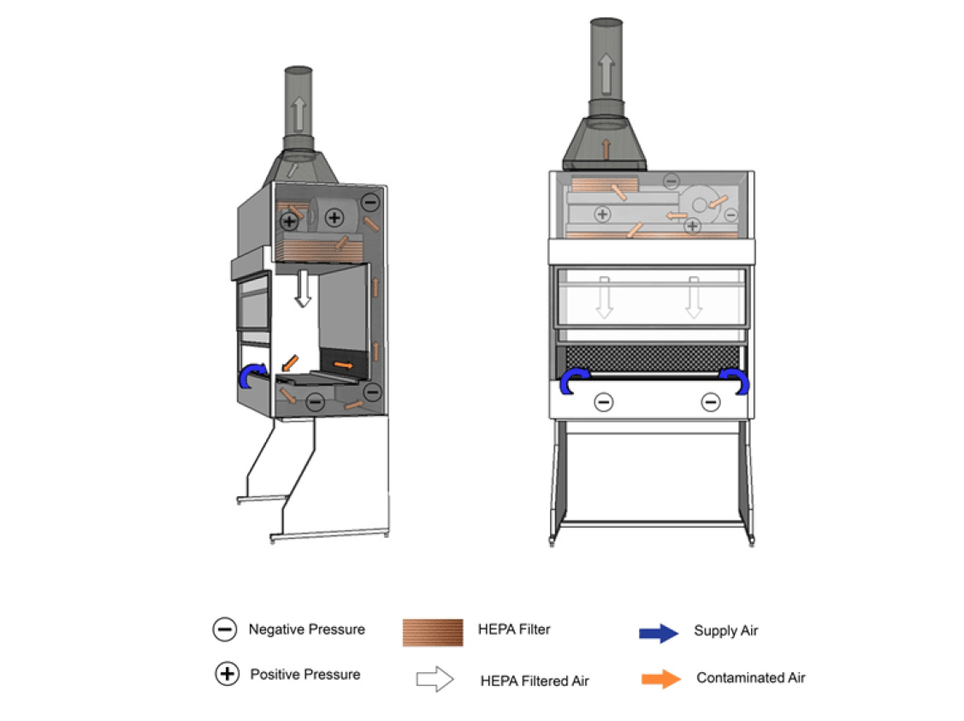

# Review/Revision/Implementation:

1. Review Cycle: 2 years All new policies/procedures/guidelines and those that have major revisions must be reviewed/signed by the CLIA Laboratory Director.
2. Office of Record: Microbiology