**Make sure you do the following before taking the test in MedTraining Solutions (MTS):**

1. Log in to the Department of Pathology document control system, Title 21. The link to access Title 21 is <https://wfdc.title21.com/Login/Login>
2. Read all the policies and procedures shown below that are within the **Molecular Dx** (Molecular Diagnostics IHC) eBinders:
3. **Equipment Manual**

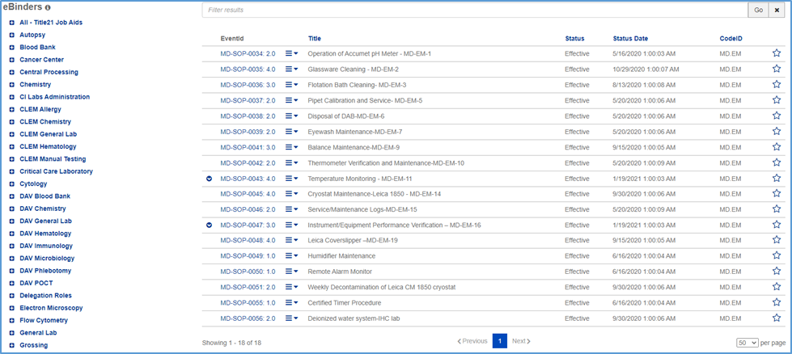

1. **Molecular IHC Procedure Manual**

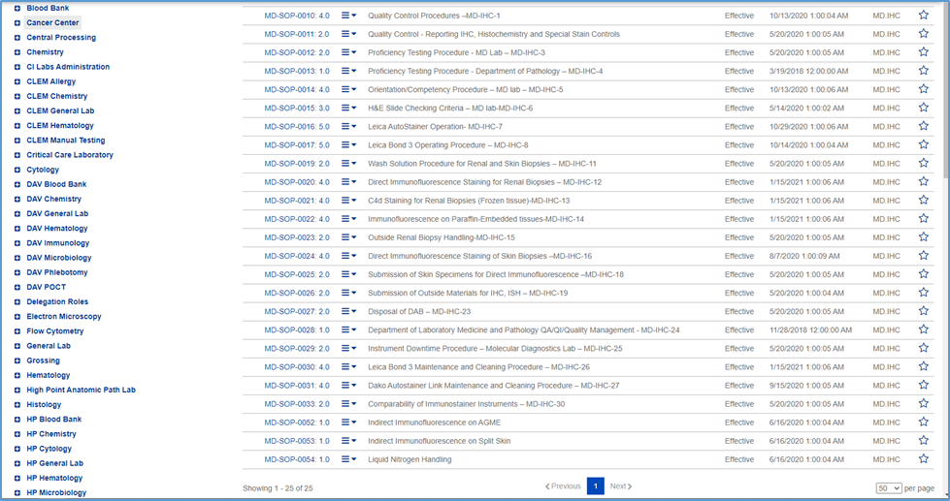

1. **Molecular Procedure Manual**

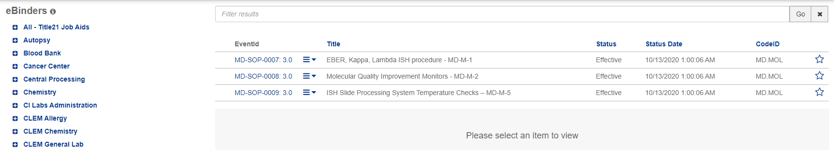

1. **Steroid Procedure Manual**

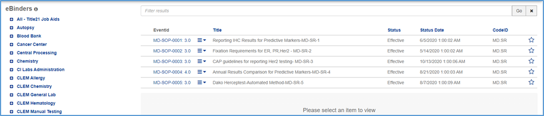

1. Read the applicable policies and procedures found in the **Lab Compliance eBinders** listed below:
2. **Policy**

LC-POL-0004: 3.0 Delegation of Duties in the Clinical Laboratory

LC-POL-0005: 1.0 Commitment to Quality Policy

LC-POL-0008: 2.0 Continuing Education Policy

LC-POL-0009: 1.0 Correction of Laboratory Records

LC-POL-0010: 1.0 Calling Critical and/or Corrected Values

LC-POL-0014: 2.0 Compliance Guidance on Laboratory Ordering Policy

LC-POL-0015: 1.0 Document Management Policy

LC-POL-0016: 2.0 Documentation of Foreign Equivalency for Laboratory Testing Personnel

LC-POL-0018: 1.0 Laboratory Equipment Maintenance Policy

LC-POL-0019: 1.0 Handling of Veterinary Samples

LC-POL-0021: 1.0 Laboratory Record Retention Policy

LC-POL-0023: 1.0 Limited Access to Clinical Laboratory Areas

LC-POL-0026: 1.0 Personnel File Requirements

LC-POL-0027: 1.0 Personal Electronic Devices and Internet Access

LC-POL-0031: 2.0 Quality Control (QC) Management Policy

LC-POL-0033: 2.0 Reflex Testing Policy

LC-POL-0036: 2.0 Pathology Laboratory Interim Self Inspection Procedure

LC-POL-0042: 1.0 Individual Quality Control Plan (IQCP) for the WFBMC Department of Pathology

LC-POL-0043: 1.0 Communication of Significant or Unexpected Findings

LC-POL-0047: 2.0 Critical Laboratory Values

LC-POL-0049: 1.0 List of Critical Laboratory Values

LC-POL-0050: 1.0 Reflex Tests List

1. **SOP**

LC-SOP-0001: 1.0 Method Validation Process NonWaived Testing

LC-SOP-0006: 1.0 Compliance with CAP Accreditation

LC-SOP-0011: 1.0 Customer Satisfaction Survey

LC-SOP-0020: 2.0 Laboratory Equipment Service Procedure

LC-SOP-0025: 1.0 Orientation and Competency Procedure

LC-SOP-0028: 3.0 CAPA Corrective Action Preventative Action

LC-SOP-0029: 2.0 Proficiency Testing Procedure

LC-SOP-0034: 1.0 Release of Laboratory Results to Patients

LC-SOP-0035: 1.0 Reporting Quality Issues in the Laboratroy

LC-SOP-0041: 1.0 Laboratory Safety Manual

LC-SOP-0045: 1.0 Retrospective Color Blind Testing of Laboratory Testing Personnel

LC-SOP-0046: 1.0 Staff Certification

LC-SOP-0047: 1.0 Title 21 Document Control

1. Read the policies and procedures found in the **Safety eBinders** listed below:
2. **Policy**

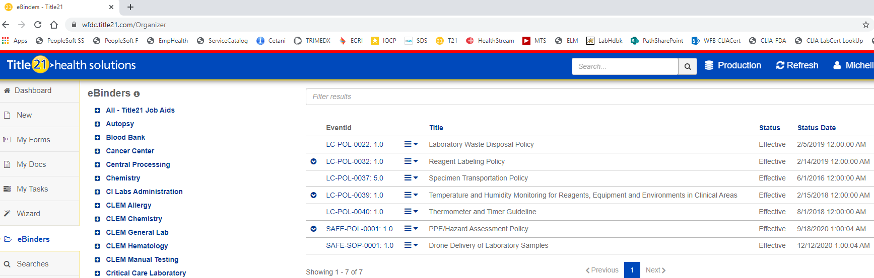

1. **SOP**

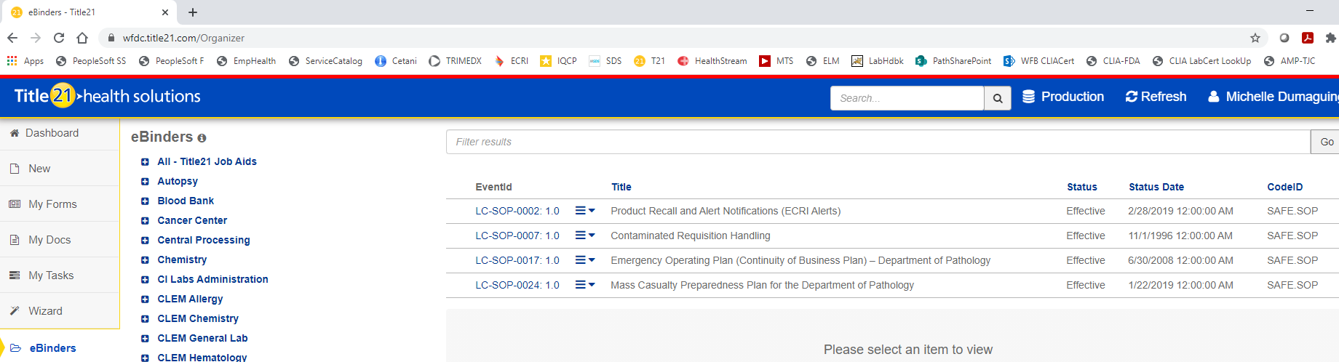

1. Log-in to MTS at <https://www.medtraining.org/ltac3/Secure/Login.aspx> and take the TEST to attest that you have reviewed applicable policies and procedures for the current year.