**Make sure you do the following before taking the test in MedTraining Solutions (MTS):**

1. Log in to the Department of Pathology document control system, Title 21. The link to access Title 21 is <https://wfdc.title21.com/Login/Login>
2. Read all the policies and procedures found in the Molecular Diagnostics IHC Electronic Binders (E-Binders) listed below:
3. Equipment Manual

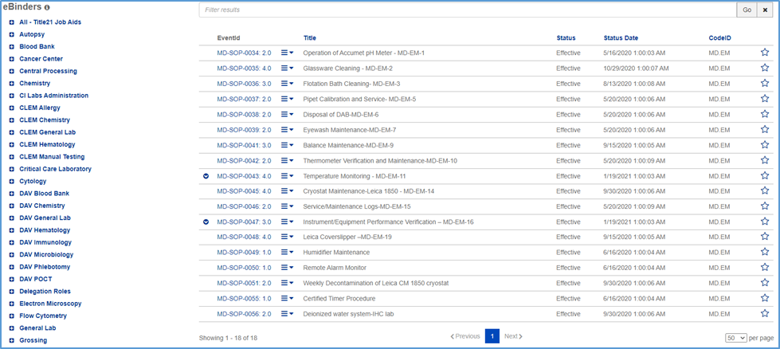

1. Molecular IHC Procedure Manual

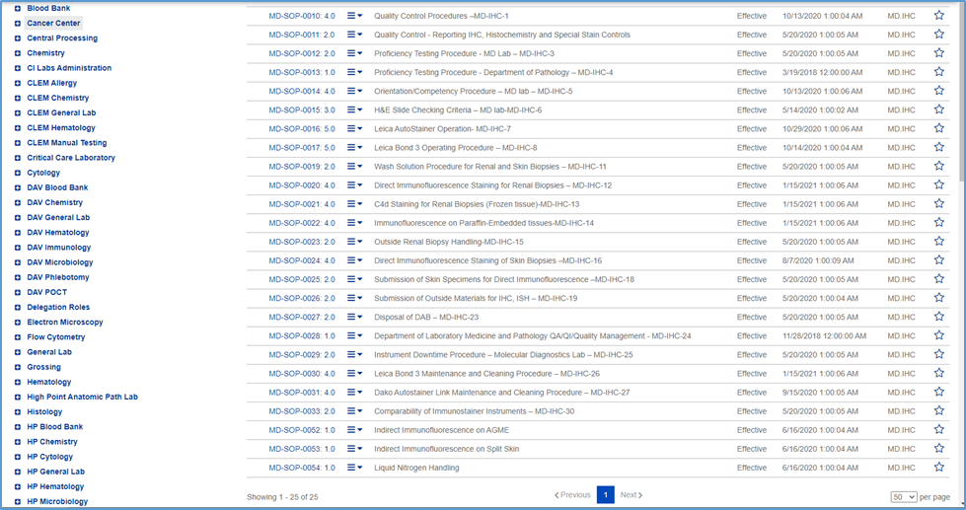

1. Molecular Procedure Manual

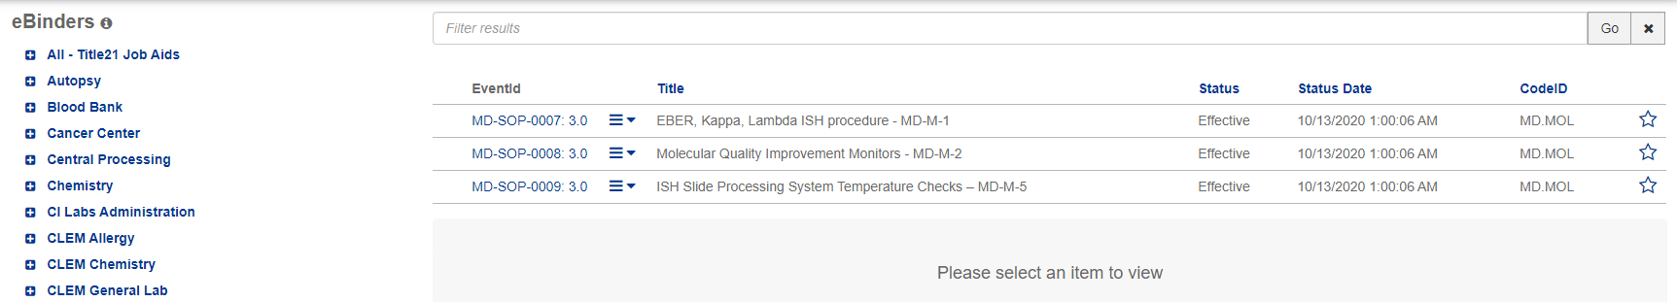

1. Steroid Procedure Manual

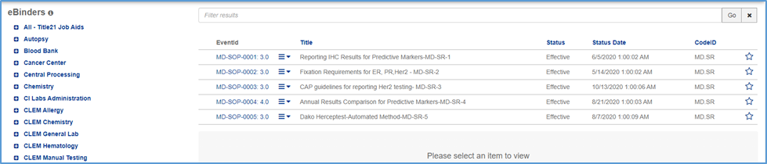

1. Read the applicable policies and procedures found in the Lab Compliance Electronic Binders (E-Binders) listed below:
2. Policy
3. SOP
4. Take the Test in MTS.