**STANDARDIZATION DOCUMENT FOR FREEZING OF CRYOPRESERVED PRODUCTS**

The Stem Cell Transplant and Cellular Therapy (SCTCT) Lab stores cryopreserved products in swing-arm closure canisters that are standard accessories with the MVE brand liquid nitrogen reservoirs. An empty canister is pictured below.

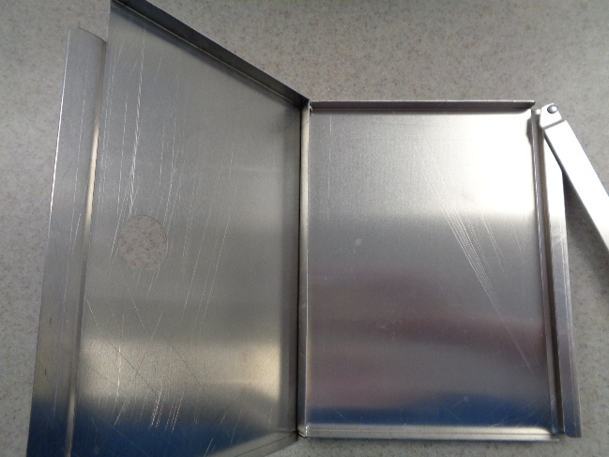

Product bags are frozen in a controlled-rate freezing chamber in presses that maintain uniform shape of the freezing bag during freezing and the bags are then transferred to liquid nitrogen storage in a canister.

With the recent increased number of broken bags, there are a number of policies about freezing and thawing that will be reiterated:

* View the bag at the time of placing it in the press to ensure no visible seeping leakage is occurring.
* Make sure the bag press is evenly distributing the cells throughout the freezing bag.
* Make at least 2 seals in the line going to the bag with the heat sealer
* Ensure seals are intact prior to placing the freezing bags in the bag press.
* When transferring product to the reservoir, use **extreme care**; products are extremely fragile.

In addition, the placement of the bags in the canisters will be standardized in an attempt to minimize errors that could lead to bag breakage. Miltenyi and Origen bags have almost identical dimensions and shape, so the photograph examples below apply to both bag types:

* Freezing bags should be placed in the canister with the shorter side towards the canister’s closing hinge; this leaves less bag surface area that could possibly come in contact with the hinge.
* There should be a little space between the freezing bag and each side of the canister prior to closing the canister. This ensures the canister’s hinged side does not puncture the bag.
* Close the canisters slowly and with care – Frozen product bags are **EXTREMLY FRAGILE!!**

Refer to the picture examples below:

These two bags are incorrectly stored in canisters because no space exists between the hinged edge of the canister and the freezing bag.

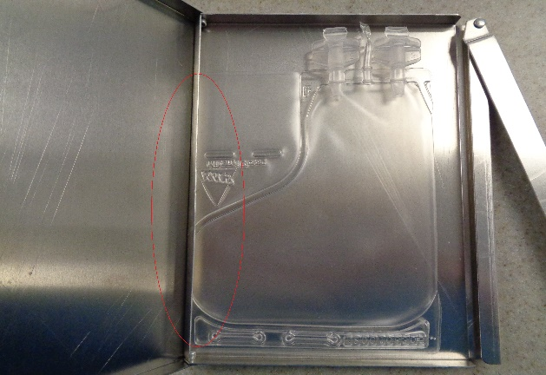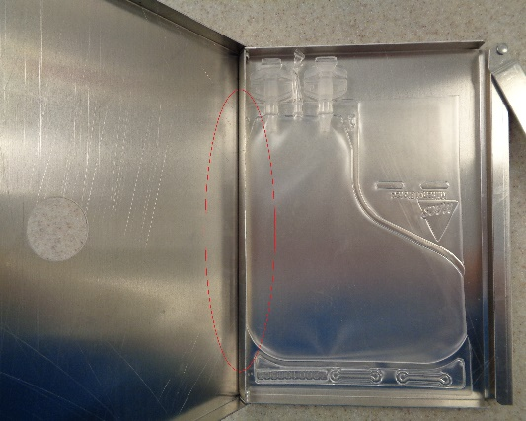

This bag is incorrectly placed in the canister because although there is space between the canister edges and the freezing bag, the long edge of the bag is on the hinged side of the canister.

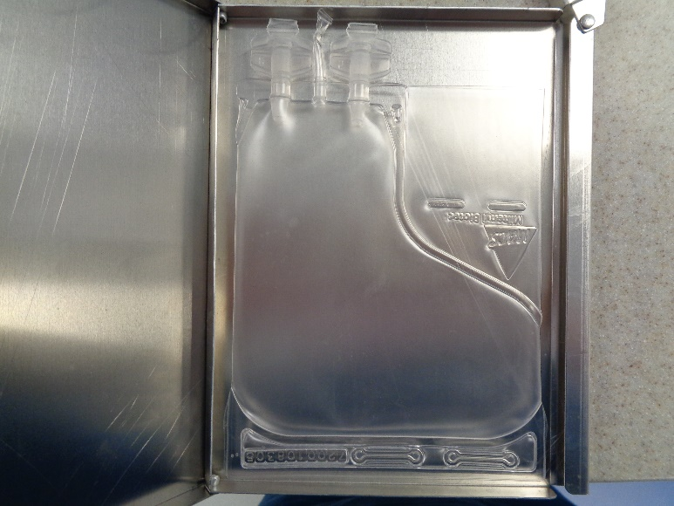

The bag below is correctly stored in the canister with the shorter edge of the freezing bag aligned with the hinged edge of the canister. There is space between the canister edge and the freezing bag.

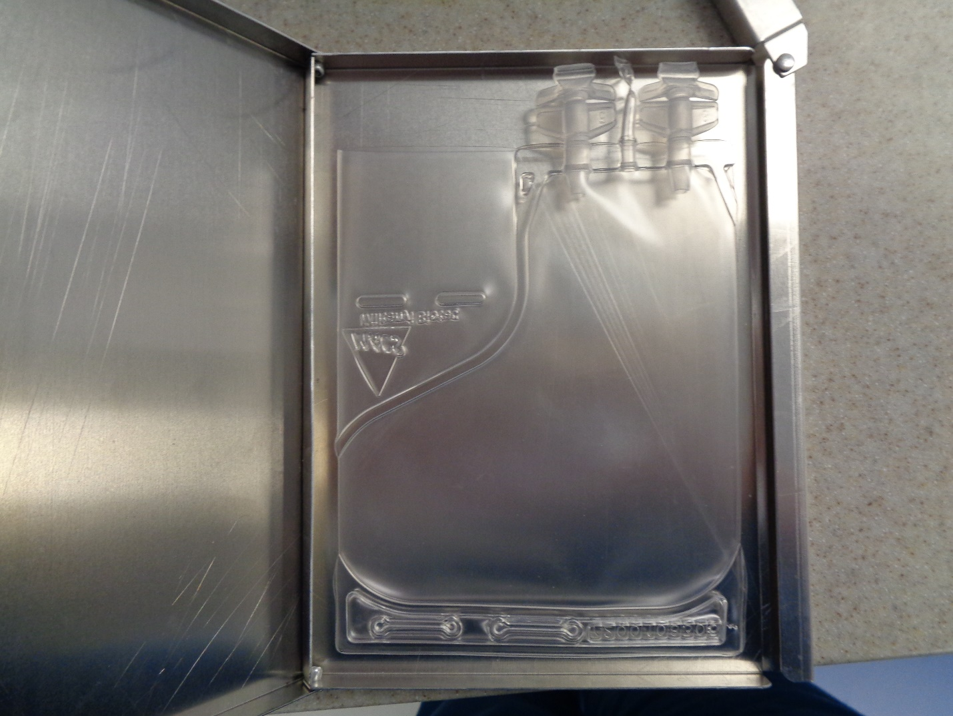

Product bags are frozen in a controlled-rate freezing chamber in presses that maintain uniform shape of the freezing bag during freezing and the bags are then transferred to liquid nitrogen storage in a canister. Products are flattened between two sides of a press prior to placement in the controlled-rate freezer. The presses are accessories supplied by the MVE brand liquid nitrogen reservoirs. The SCTCT Lab will freeze in these presses in a standardized way, as described below:

* View the bag at the time of placing it in the press to ensure no visible seeping leakage is occurring.
* Make sure the bag press is evenly distributing the cells throughout the freezing bag.
* Place freezing bags in the press so that they are not lined up seam to seam, that is like a mirror image, so that more even distribution can occur in the press; See image examples below.
* Always freeze 4 bags in a press; dummy bags are available in Refrigerator #1 if product bag number is not sufficient.
* When transferring product to the reservoir, use **extreme care**; products are extremely fragile.

Miltenyi and Origen bags have almost identical dimensions and shape, so the photograph examples below apply to both bag types:

Refer to the picture examples below:

These two bags are incorrectly placed in the press because they are lined up seam to seam.

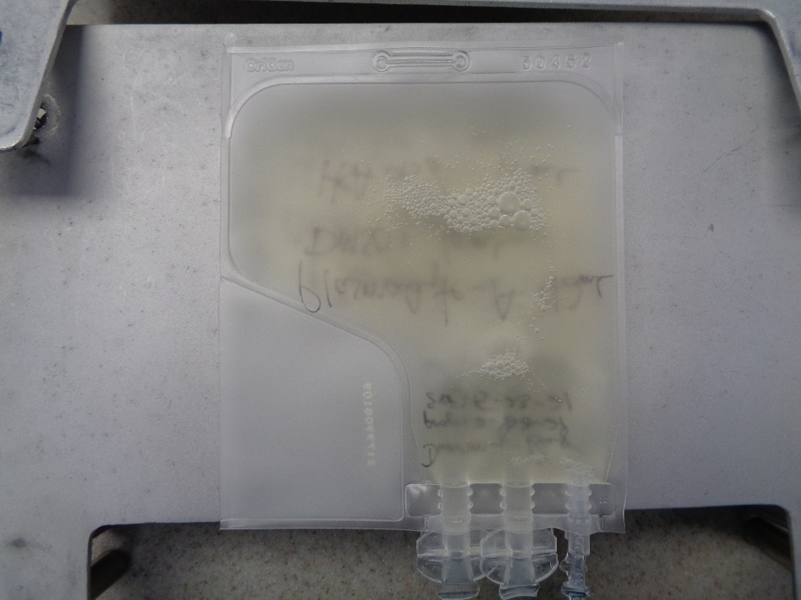

These bags are lined up correctly in the press, but only two bags are in the press, so this is also incorrect.

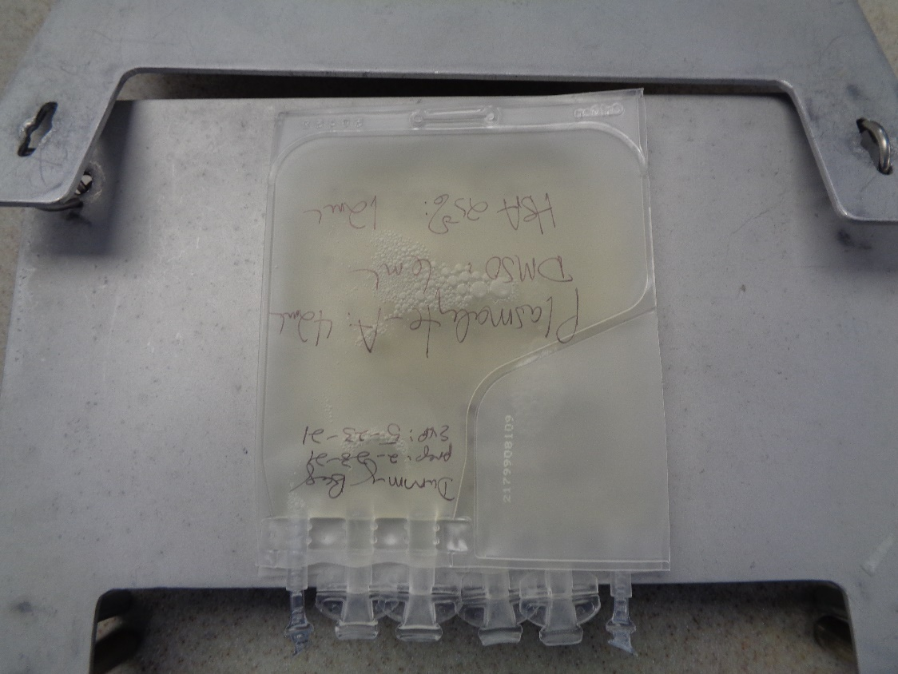

The bag below is correctly stored in the press with the freezing bags aligned in mirror image fashion and with 4 bags in the press.

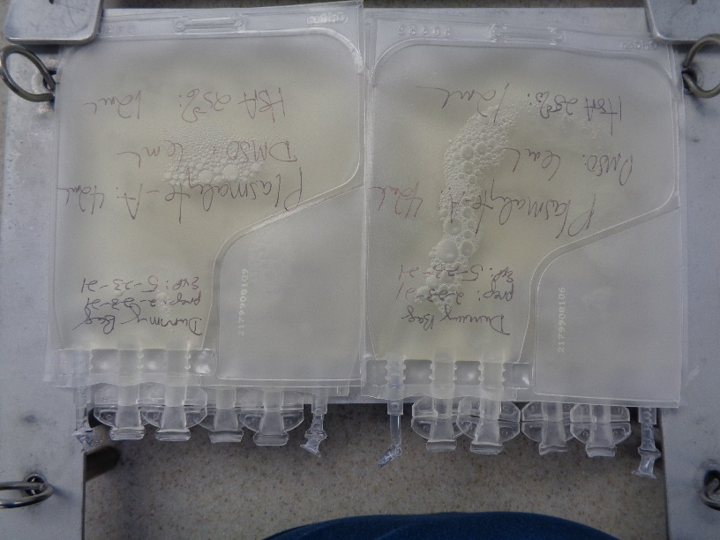

Finally, below is a picture of 4 aligned bags in a press that has been checked for even product distribution.

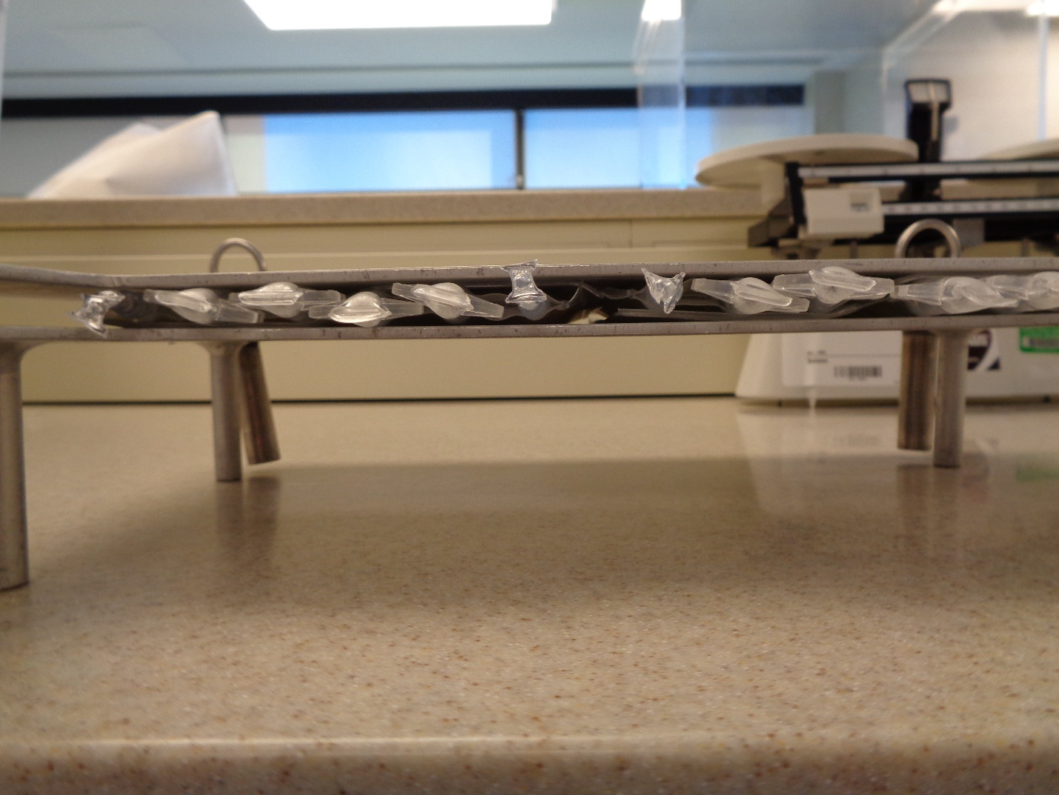

***I have read and understand the above information.***

Employee Signature:___________________________________________________

Date:___________________________

Manangement Signature:_______________________________________________

Date:___________________________