**Make sure you do the following before taking the TEST in MedTraining Solutions (MTS):**

1. Log in to the Department of Pathology document control system, Title 21. The link to access Title 21 is <https://wfdc.title21.com/Login/Login>.
2. The password is the one you log onto the system. The PIN number is a 5-digit number and one that you create.
3. Read all the policies and procedures that are within the **Outpatient Phlebotomy eBinders**:
4. **Forms**

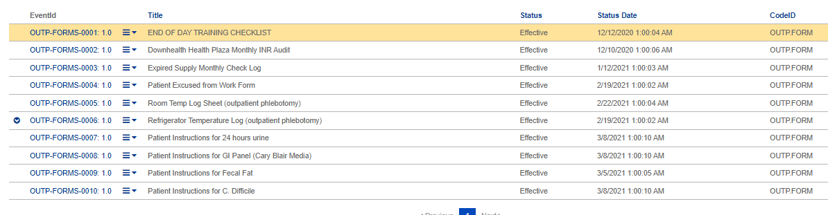

1. **Policy**



1. **SOP**

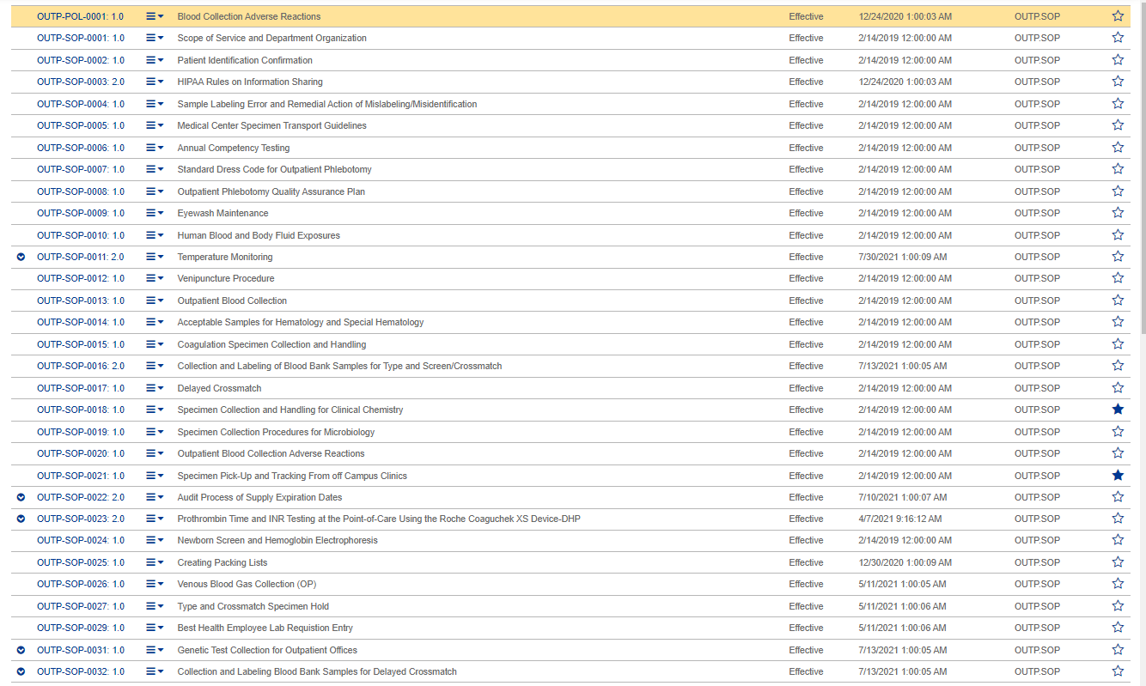



1. Read the applicable policies and procedures found in the **Lab Compliance eBinders** listed below:
2. **Policy**

LC-POL-0004: 3.0 Delegation of Duties in the Clinical Laboratory

LC-POL-0005: 1.0 Commitment to Quality Policy

LC-POL-0008: 2.0 Continuing Education Policy

LC-POL-0014: 2.0 Compliance Guidance on Laboratory Ordering Policy

LC-POL-0015: 1.0 Document Management Policy

LC-POL-0021: 1.0 Laboratory Record Retention Policy

LC-POL-0027: 1.0 Personal Electronic Devices and Internet Access

1. **SOP**

LC-SOP-0011: 1.0 Customer Satisfaction Survey

LC-SOP-0025: 1.0 Orientation and Competency Procedure

LC-SOP-0028: 3.0 CAPA Corrective Action Preventative Action

LC-SOP-0041: 1.0 Laboratory Safety Manual

LC-SOP-0046: 1.0 Staff Certification

LC-SOP-0047: 1.0 Title 21 Document Control

1. Read the policies and procedures found in the **Safety eBinders** listed below:
2. **Policy**

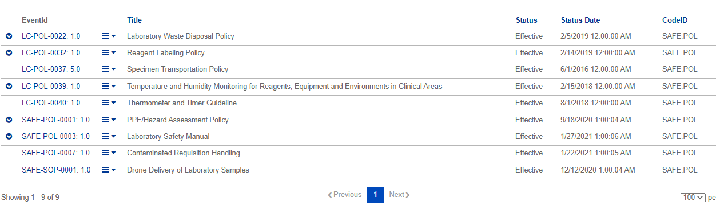

1. **SOP**

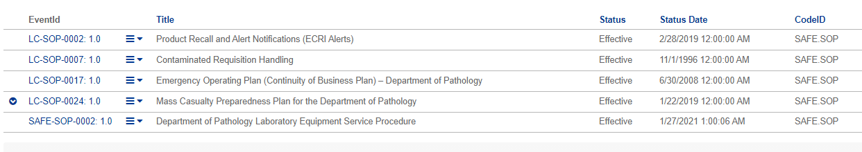

1. Log-in to MTS at <https://www.medtraining.org/ltac3/Secure/Login.aspx> and take the TEST to attest that you have reviewed applicable policies and procedures for the current year.