Applicable Laboratory(s)):

☒ North Carolina Baptist Hospital (NCBH)
☐ Lexington Medical Center (LMC)
☐ Davie Medical Center (DMC)
☐ Wilkes Medical Center (WMC)
☐ High Point Medical Center (HPMC)
☐ Westchester
☐ Clemmons

Policy Purpose

The purpose of this policy is to provide instructions regarding the receipt, storage, preparation, and administration of investigational cold stored platelets (CSP). This study is a phase 3, multicenter, international, randomized, partial blind, adaptive, non-inferiority, storage duration ranging trial in adult and pediatric patients undergoing cardiac surgery.

Scope

This policy applies to Blood Bank Staff and management.

Definitions

- Policy: As defined in the Policy on Creating and Amending Policy, a statement of principle that is developed for the purpose of guiding decisions and activities related to governance, administration, or management of care, treatment, services or other activities of WFBH. A policy may help to ensure compliance with applicable laws and regulations, promote one or more of the missions of WFBH, contain guidelines for governance, and set parameters within which faculty, staff, students, visitors and others are expected to operate.
- WFBH Lab System: Wake Forest Baptist Lab System is a health system that includes Wake Forest Baptist Medical Center and all affiliated organizations including Wake Forest University Health Sciences (WFUHS), North Carolina Baptist Hospital (NCBH), Lexington Medical Center (LMC), Davie Medical Center (DMC), Wilkes Medical Center (WMC), High Point Medical Center (HPMC), Lab at Westchester and Lab at Clemmons.
C. CSP: Cold Stored Platelet
D. uCCC: unblinded Clinical Coordination Center
E. EDC: Electronic Data Capture System
F. REDCap Cloud (RCC): EDC used for CHIPS

Policy Guidelines

- Study Platelets

- Cold Stored Platelets (CSP)
- Investigational study product (CSP) will be collected through apheresis collection by a US licensed or registered blood collection facility and contain between 200-425mL of apheresis platelets.
- Cold stored units will be tested for HIV (I/II), HCV, HBV, HTLV, WNV, T.cruzi, and babesia per FDA requirements.
- CSP will not be tested for bacteria since they will be placed in 1-6°C conditions within 8 hours of collection or within 24 hours for pathogen-reduced platelets.
- Due to short life of apheresis platelets, CSP must be ordered on-demand. uCCC will contact Blood bank staff to place an order for CSP if the study subject randomizes to CSP.
- CSP can be irradiated per standard SOP as required per patient
- Patients will be randomized at a 2:1 ratio to receive 4°C platelets (CSP) or 22°C platelets.
- Randomization may take place up to 30 days prior to initial transfusion once a potential study participant has been identified and has consented.
- Once a patient has randomized, unblinded study members will receive an email (sent to Blood Bank Staff) stating that the patient has been randomized.
- Blood Bank staff shall log onto the EDC to determine the assigned arm (4°C platelets “cold” vs. 22°C platelets “warm”).
- Randomized status should NOT be shared with the PI, study staff, or patient. Only the unblinded members (blood bank and uCCC staff) are privy to this information.
- With the exception of the blood bank staff or transfusionist who may become unblinded, all other hospital and study personnel will be blinded to the study platelet assignment (4°C or 22°C platelets) during the course of the study
k. The uCCC will review and confirm the use and inventory of the study platelets
throughout the study.
- The uCCC will arrange for investigational product supply based on participant randomization.
- Upon completion of the study, the uCCC will arrange for destruction or return of all investigational study platelets and obtain copies of the investigational supply and inventory records and documentation of destruction or disposal.
- uCCC Contact Information:

Name | Email | Phone
Unblinded CCC | CHIPS_unblinded@wustl.edu
Meghan Huff | meghanhuff@wustl.edu | 618-578-9309
Taegen Sullivan | taegen@tessaphamaceutics.com | 269-806-8579

2. Standard Room Temperature Platelets
- Standard room temperature platelets will come from general inventory.

B. Storage of CSP

- CSP shall be stored at 1-6°C on a flat, solid surface in a single layer with the ISBT label facing down.
  - Any temperature excursions shall be reported to the uCCC and affected CSP shall be quarantined until the uCCC notifies staff in writing that the CSP can be used.
- CSP should NOT be manipulated during storage (no agitation).
- At the beginning of the study, CSP will have an expiration of 7 days.
- The CSP expiry may change over time with a maximum of 21 days during the course of the study.
- Blood bank will be notified about any changes to records, shelf-life, and storage conditions that are adjusted during the trial. These changes will apply to units already in production and/or in inventory.
- CSP that are issued to the OR/ICU and not transfused may be returned to the blood bank if the unit(s) have not been out for more than 4 hours.
- CSP units that are returned within the 4 hours window may be placed back into inventory for future use.
- CSP units that are returned outside of the 4 hour window must be discarded.
- Disposition of units must be noted in both SCC and the EDC
- Time out of the refrigerator will be documented on the Accountability Log
Refer to Attachment 2: Accountability Log

C. Adverse Event Reporting

- All serious transfusion related events should be reported to the blood bank.
- All events involving 22°C platelets should follow SOP and blood bank will notify the blood supplier if applicable.
- All events involving 4°C platelets should follow SOP and be reported to the uCCC team who will notify the blood supplier if applicable.
- Any transfusion reaction reports should be uploaded to the EDC

Procedure

I. Order and Receipt of CSP

STEPS | INSTRUCTIONS
1.0 | Notification that a patient had been randomized will be sent to all blood bank staff. Add message to PCW: “CHIPS Protocol Patient” (see below)  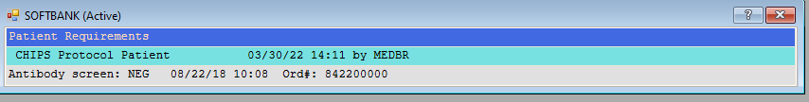
2.0 | Log in to EDC: REDCap Cloud to determine to which arm of the study the patient had been randomized (room temp or cold).  - Choose the Chilled Platelet Study  - Select Study Site: Wake Forest  - Select subjects from the left column  - Choose the subject  - Select the form “Unblinded Treatment Assignment” under the Blood Bank tab.
3.0 | If patient randomizes to RT 22°C platelets add comment to SCC (see below).  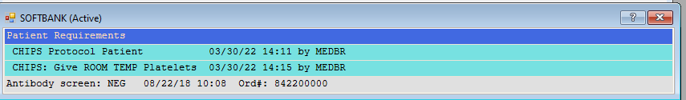
4.0 | If patient randomizes to cold stored platelets (CSP) add comment to SCC (see below). The uCCC will contact BB and facilitate ordering cold stored platelets.  - A total of 5 platelets will be obtained (from current stock or blood supplier) for each study participant that randomizes to CSP  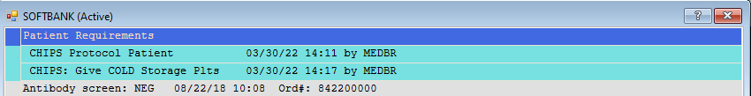
5.0 | Upon receipt of CSP: Outer shipping container should be examined for damage.
6.0 | If there is damage to the outer container, the inner box should be removed and examined for damage.
7.0 | Report any damage to the shipping system to CHIPS_unblinded@wustl.edu.
8.0 | Inspect product and compete packing slip (Attachment 1).
9.0 | uCCC staff shall be notified immediately if there is any damage to the CSP or if they arrive out of temperature (Refer to section B).
10.0 | Receive the units in the EDC and scan a copy of the packing slip to the unblinded coordinator.
11.0 | Receive the units in SCC.

II. Use and Issuing of Study Platelets
STEPS | INSTRUCTIONS
1.0 | Obtain ordered units from either 22°C or 4°C storage as indicated from randomization process.  - If 22°C platelets, select and issue per SOP, continue to step 5.  b. If 4°C platelets, continue to step 2.
2.0 | Observe units for signs of film or micro aggregate formation.  - CSP may develop a slight film during storage.  - To dissipate film, manually manipulate the bag in a see-saw motion, tilting each side up and down for 60 seconds prior to issuing the product.  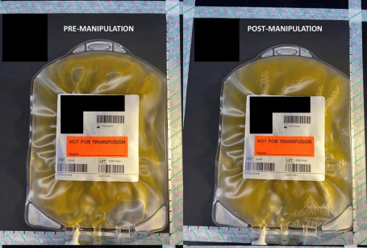  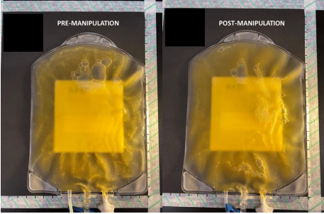
3.0 | Use blinding stickers to cover any potential unblinded information, such as the storage conditions.
4.0 | Change the expiration date of all CSP to the following day at 2359, unless the units expire earlier.  - This will ensure the clinical team cannot identify the platelet as a CSP based on expiration date.  - This will ensure unblinded information is not transferred into the EMR.  c. E code is not considered unblinded information as most people cannot identify  a component type based on this information.  - Create and apply updated ISBT label.
5.0 | Apply the “FOR INVESTIGATIONAL USE ONLY” sticker to all platelets including any 22°C platelets selected.  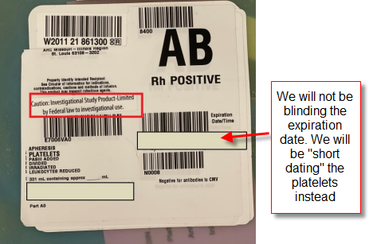  Note: Most CSP will come with the “FOR INVENSTIGATIONAL USE ONLY” wording incorporated into the ISBT label; this should be covered with a sticker as it could be unblinding if only some of the study platelets have the sticker.
6.0 | Issue platelets in SCC per SOP and place in standard RT cooler for transport to OR/ICU.
7.0 | Add a Note to tech in SCC indicating the date/time the first CSP unit is issued to the patient.  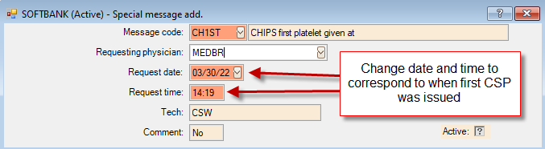  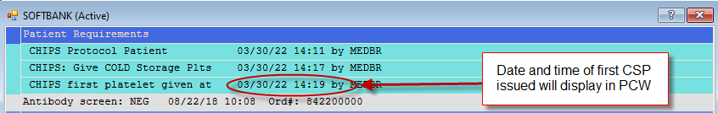
8.0 | Record all pertinent information on Accountability Log  Refer to Attachment 2: Accountability Log
9.0 | All platelets issued to study participants must be tracked in the EDC.  - Log into EDC and document issue date/time  - If 22°C platelets were issued, they must be entered into the EDC before documenting their issue date/time  c. There are two places in the EDC to track platelets:  - Platelet Tracker/Dashboard. This is where running inventory of CSP is maintained.  - Patient blood bank forms. This is where the treatment assignment, data for all platelets transfused for 72 hours from first study platelet, and transfusion reactions are uploaded.  Blinded team members will enter transfusion start/stop times and volumes for all blood products administered.
10.0 | Each study participant may receive up to 6 units in a 24-hour period.  If patient randomizes to CSP:  - The date/time of the first CSP unit issued will be documented SCC in the PCW.  - When more orders arrive for platelets, techs will check the Note to Tech to determine if more CSP can be issued (max of 6 in 24 hours).  - After time +24 hours after the first unit is issued, CSP shall no longer be selected or issued and 22°C platelets will be selected from general inventory  d. After 24 hours or 6 platelets (which ever comes first), blinding labels are no longer  needed.  If patient randomizes to 22°C platelets:  e. Blinding labels need to be on the first 6 platelets issued within 24 hours.  f. After 24 hours or 6 platelets (which ever comes first), blinding labels are no longer  needed.
11.0 | In the unlikely event that CSP platelets are administered for non-investigational purposes, the uCCC must be notified immediately.

III. Returning Study Platelets

- 22°C platelets that are issued and not transfused can be returned to inventory per SOP.
- Ensure removal of investigational study product sticker before return to regular inventory.
- 4°C platelets (CSP) may be returned to the blood bank if the unit(s) have not been out of the refrigerator for more than 4 hours. If acceptable, the units may be placed back into the refrigerator for use on other eligible study participants.
- Complete Attachment 2: Accountability Log
- Change expiration of platelet back to original (if applicable)
- In SCC: view inventory history report
- Original expiration will be displayed in the report.
- Change expiration. In SCC: Inventory > Edit > Unit
- Reprint label and re-label unit with original expiration date.

G. Shipping Systems

- CSP will be transported in containers provided by CHIPS that are validated to maintain temperature of product between 1-10°C for up to 48 hours.
- To ensure the platelets remained within temperature range, platelets will only be accepted and used in the study if the CSP arrives within 48 hours of packing.
- Tech receiving product will complete the packing form which will include the time of packaging.
Refer to Attachment 1: Clinical Supplies Distribution Request Form (CSDRF)
b. If CSP has been in transit for greater than 48 hours, staff will quarantine the platelets and contact the uCCC.
3. CSP may need to be shipped to another site depending on inventory and expiration.

- The shipping containers and cooling cassettes should be kept by the blood bank until needed to ship product to an alternate clinical site or until requested to ship back to the depot.
- 4 coolant cassettes are needed to ship out CSP
- 2 yellow coolant cassettes should be stored at 1-6°C
- 2 blue coolant cassettes should be stored at -20°C to be conditioned for next use.
- The coolant cassettes must be placed in the respective chambers (refrigerator/freezer) for a minimum of 24 hours prior to packing
- Shippers should be packed according to the pack-out schematic and procedure below:

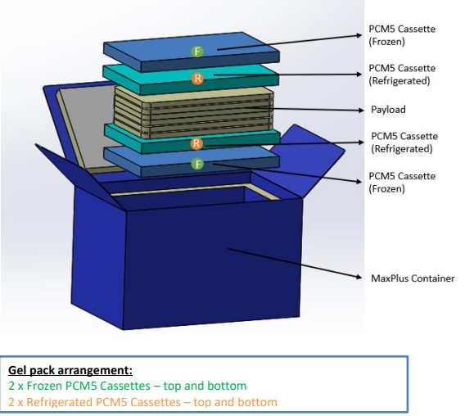

STEPS | INSTRUCTIONS
1.0 | Remove one PCM5 Cassette (blue) from the freezer and place in bottom of the shipper.
2.0 | Remove one PCM5 Cassette (yellow) and place directly on top of the frozen PCM5 Cassette.
3.0 | Load the payload (plts) into a liner bag and place it on top of the refrigerated PCM5 Cassette  Note: use adsorbent pads inside the leak proof liner bag at the top and bottom of the platelet unit stack. Lay the units flat inside the liner bag.
4.0 | Take the second refrigerated PCM5 Cassette (yellow) and place it directly on top of the liner bag containing the payload units.
5.0 | Lay the last PCM5 Cassette from the freezer (blue) on top of the refrigerated PCM5 Cassette and fill any remaining space with a bubble wrap filler material.  Note: the platelets should never come in direct contact with the frozen PCM5 Cassettes
6.0 | If packing less than maximum units, follow the same steps above but fill any remaining space with bubble wrap or similar dunnage material to avoid payload or coolant shifting during transit.
7.0 | Complete the Clinical Supplies Distriubution Request Form and place it in a zip top bag between the coolant cassettes and the lid of the box.
8.0 | Close the container lid and seal tightly with packing tape. The container is now ready for shipment.
9.0 | 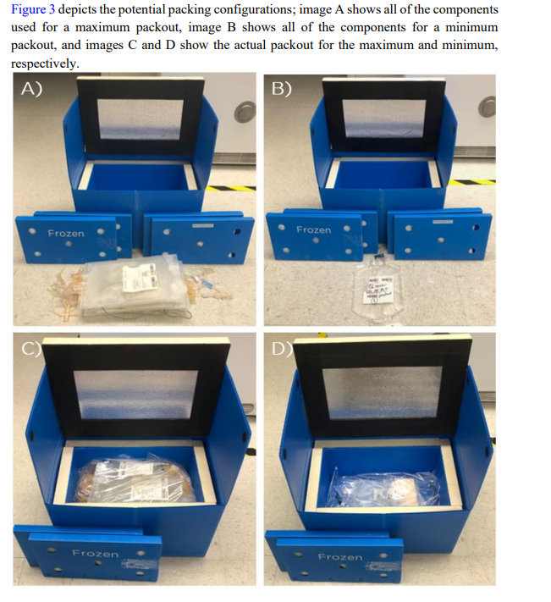

Literature References:

Related Policies/Procedures in Navex:

Attachments/Linked Documents in Title 21:

Revision Dates: Review Change Summary as Represented in Title 21.

