**Make sure you do the following before taking the TEST in MedTraining Solutions (MTS):**

1. Log in to the Department of Pathology document control system, Title 21. The link to access Title 21 is <https://wfdc.title21.com/Login/Login>
2. Read all the policies and procedures that are within the **Cytology eBinders**:
3. **Forms**

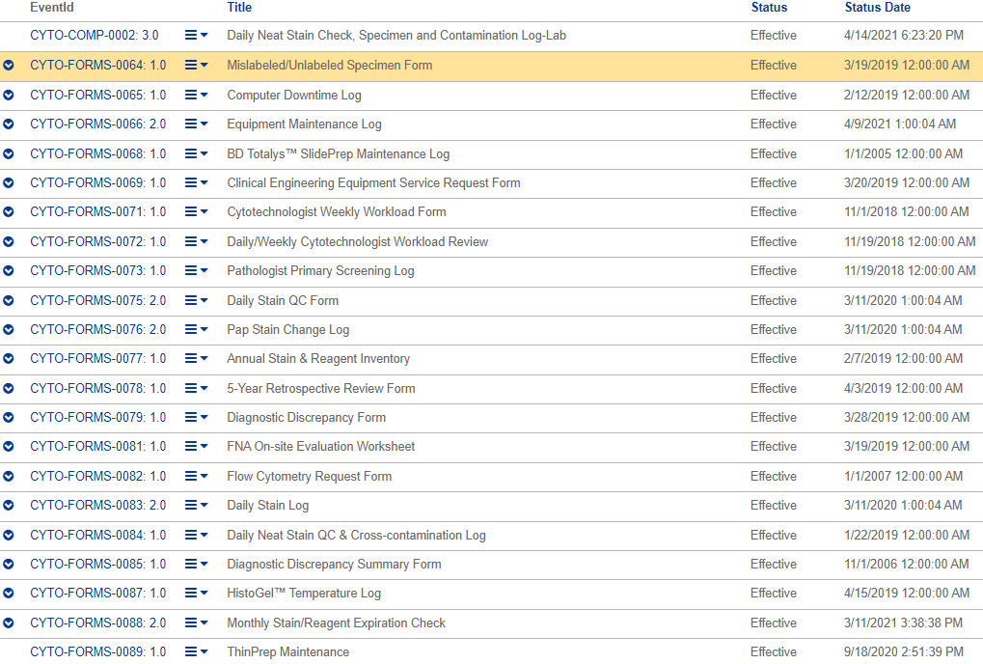

1. **Policy**

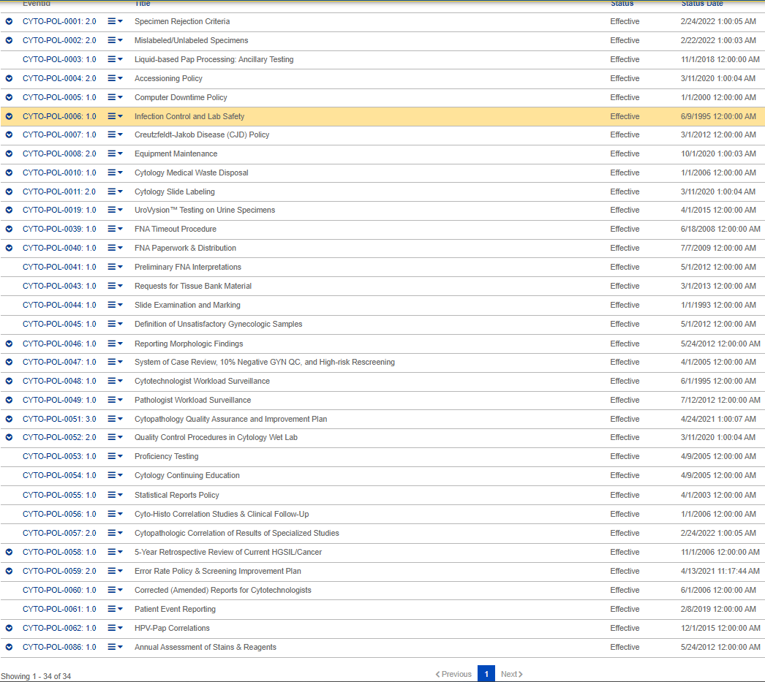

1. **SOP**

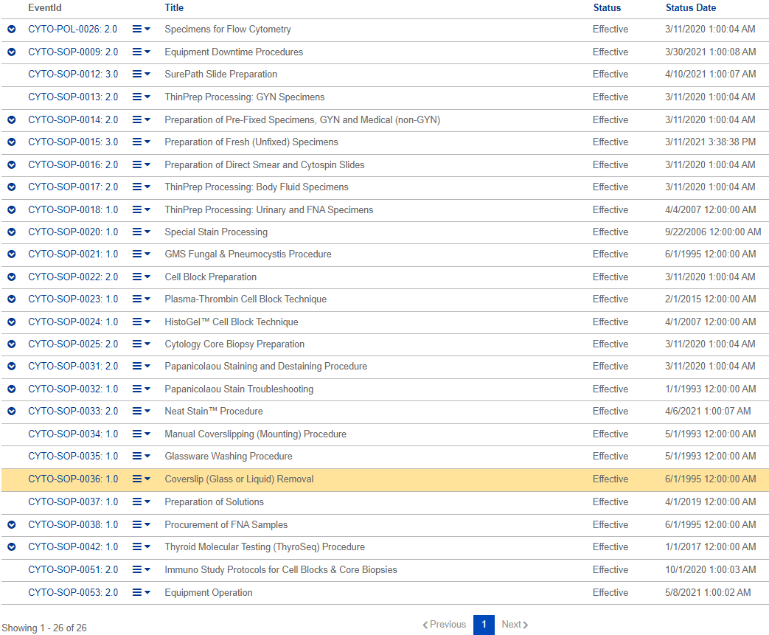

1. Read the applicable policies and procedures found in the **Quality eBinders** listed below:
2. **Policy**

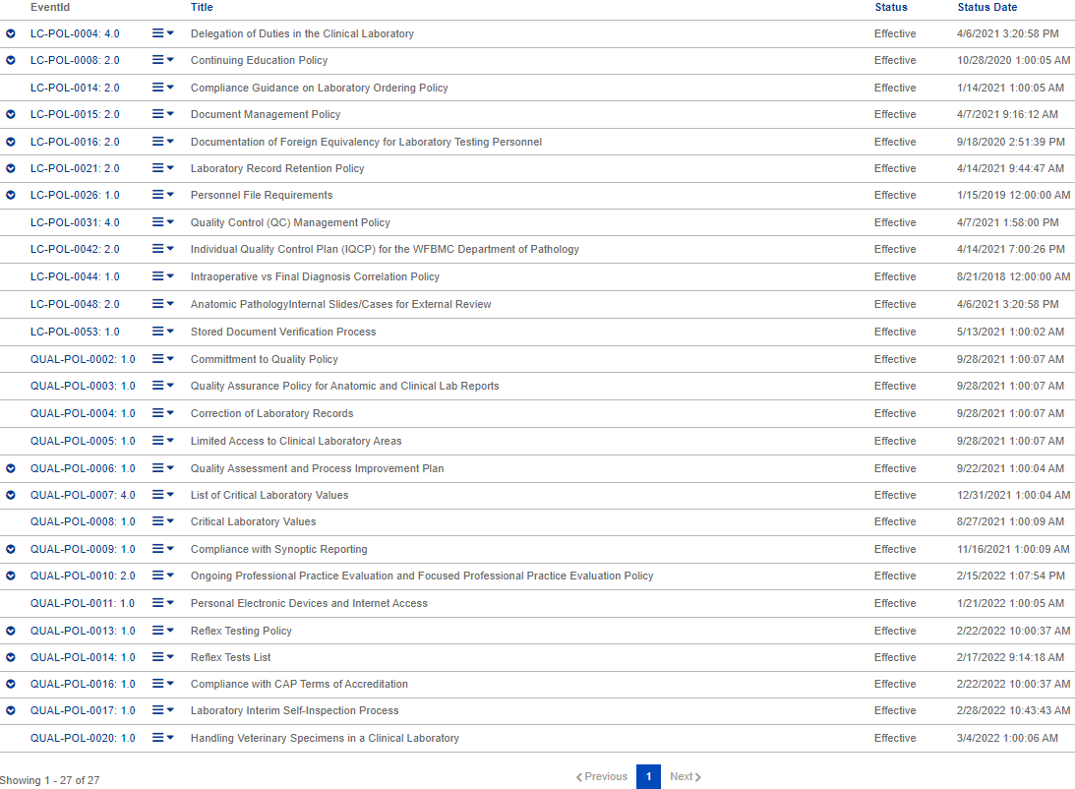

1. **SOP**

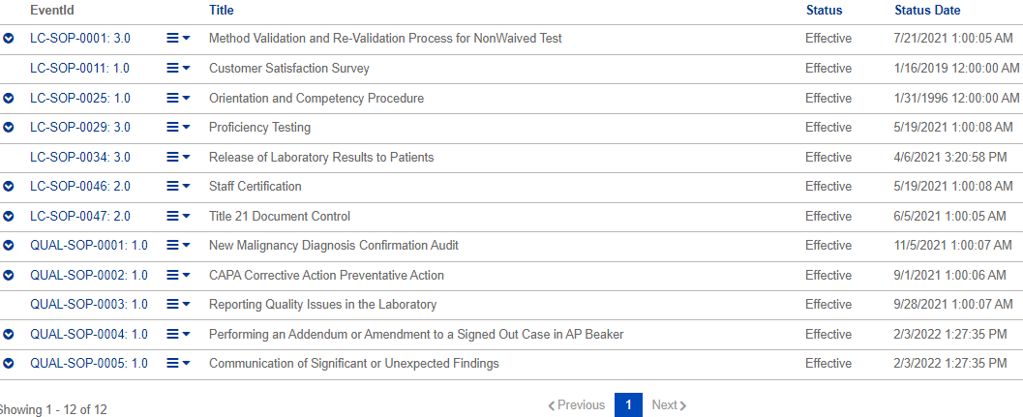

1. Read the policies and procedures found in the **Safety eBinders** listed below:
2. **Policy**

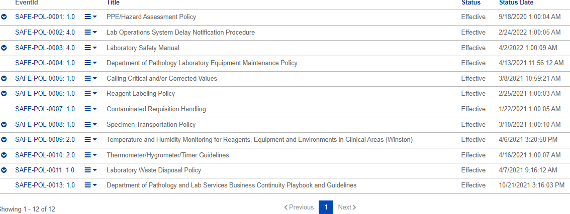

1. **SOP**

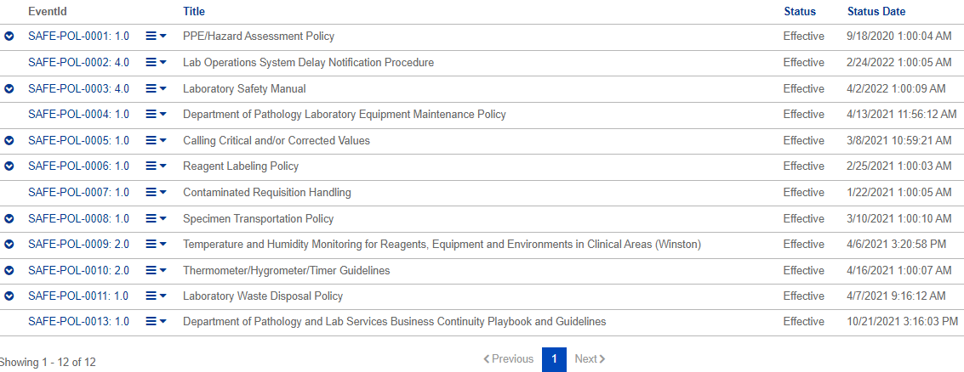

1. Log-in to MTS at <https://www.medtraining.org/ltac3/Secure/Login.aspx> and take the TEST to attest that you have reviewed applicable policies and procedures for the current year.