Applicable Laboratory(s)):

☒ North Carolina Baptist Hospital (NCBH)
☐ Lexington Medical Center (LMC)
☐ Davie Medical Center (DMC)
☐ Wilkes Medical Center (WMC)
☐ High Point Medical Center (HPMC)
☐ Westchester
☐ Clemmons

Procedure Statement

The purpose of this policy is list exceptions generated by SCC. Also when and which actions trigger each one.

Scope

Protocol owner/Implementer: Blood Bank Management
Protocol prepared by: Julie Jackson
Who performs protocol: Department staff/management

Definitions

- Policy: As defined in the Policy on Creating and Amending Policy, a statement of principle that is developed for the purpose of guiding decisions and activities related to governance, administration, or management of care, treatment, services or other activities of WFBH. A policy may help to ensure compliance with applicable laws and regulations, promote one or more of the missions of WFBH, contain guidelines for governance, and set parameters within which faculty, staff, students, visitors and others are expected to operate.
- WFBH Lab System: Wake Forest Baptist Lab System is a health system that includes Wake Forest Baptist Medical Center and all affiliated organizations including Wake Forest University Health Sciences (WFUHS), North Carolina Baptist Hospital (NCBH), Lexington Medical Center (LMC), Davie Medical Center (DMC), Wilkes Medical Center (WMC), High Point Medical Center (HPMC), Lab at Westchester and Lab at Clemmons.
- SCC: Soft Computer Consultants. The Blood Bank/Transfusion Services computer system for all sites of WFBH Lab System that have a Blood Bank/Transfusion Service.

Policy Guidelines

- Exceptions are generated when an action performed in SCC is outside of the normal procedure or abnormal results and needs an explanation as to the circumstances of the action. This includes, but is not limited to, Issuing products, Emergency issuing products, Selecting products, Resulting patient testing, etc…
- Examples would include:
- When a Rh positive red cell unit is issued to a Rh negative female under the age of 51 years old. The exception code ISABO (Issued with different ABORh) is triggered.
- When an Antibody ID is resulted as POS the exception code +ABI (Positive ABID) is triggered.
- When removing an antibody, antigen or special message in Patient > Edit the exception EPATD (Patient Demographic(s) changed) is triggered.
- When receiving in a non-leukoreduced product the exception NOLR (Non Leukoreduced Units Delivered) is triggered.
For full list of exceptions and their meaning refer to Attachment 1: SCC List of Exceptions
- Exceptions must be answered, they cannot be bypassed.
  - Canned comments are available that may be used. The F5 key will open the list of canned messages.
Refer to Attachment 2: SCC Canned Messages for Exceptions
  - If a canned comment that applies cannot be found, enter a free text reason.
- There are 4 colors associated with the exception boxes based on severity of the issue.
  - Priority 1 is red
  - Priority 2 is orange
  - Priority 3 is yellow
  - Priority 0 is green
- When an exception is triggered, there is information in the box pertaining to the issue.
  - In the following example, 3 units of whole blood were emergency issued to a patient that did not have a current ABO, RH or ABS completed. An electronic crossmatch could not be performed, and an immediate spin crossmatch was ordered but not resulted, per protocol for emergency release.
  - The exception XMNO (#1) was triggered. You can see the patient information (#2), unit information (#3), the initials of the tech (#4) issuing and the statement that the crossmatch is pending.
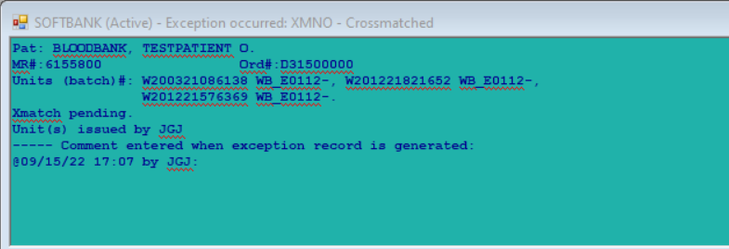
1

4

2

3

  - This next example is when 3 units were issued on a patient with antibodies and the units were not tested for the relative antigens.
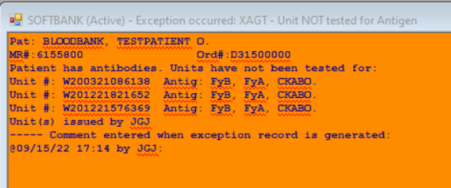

- Exceptions are reviewed by Blood Bank Management routinely.
  - Exceptions are reviewed in: Management > Exception Report
  - There are three options:
    - View- this is view only
    - Release- this is where management goes to review each individual exception and add their comments upon release of each exception
    - Report- exceptions can be printed. This function is used to pull information for audits based on the exception code
  - Each exception is opened by checking the box, it opens automatically
  - The reviewer sees exactly what the tech sees including the techs comment and why the exception was generated.
    - Below is an example of a positive ABID

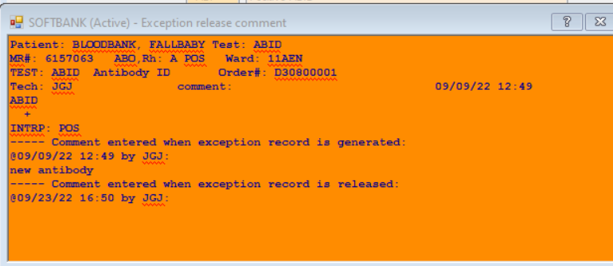
Management’s review comment area
The tech’s comment
The patient and the information that triggered the exception

  - The reviewer will enter comment after reviewing all information.
- Enter Ok if all is acceptable and no further explanation is needed
- Enter comment to explain further if needed

References

Related policies/procedures

Attachments/Linked documents (title 21)
Attachment 1: SCC List of Exceptions
Attachment 2: SCC Canned Messages for Exceptions

Revision Dates: Review Change Summary as represented in Title 21.

