This reason for this quick CE is two fold:

1. Many of you don’t know that Christina and Bettina are required to review **EVERY QA** exception that is answered in SCC. While doing so, it was noticed that the majority of QA failures for the “CKAB” code (seen in ALLO BMT transplant patients as a “fake antibody”) were not being answered correctly. This was concerning to us because this is our only means to confirm that we are giving these ALLO ABO mis-matched patients RBC’s that are the appropriate blood type. 18 of these exceptions were available to review for 1 recent month and only 5 of the exceptions were answered correctly. This QA failure will only stop you for an explanation when you’re issuing red cells – but ANY TIME you see the yellow <CKAB in the PCW – you are required to check for ALL the transfusion requirements (RBC’s, Plts, Plasma) to make sure the unit you’re getting ready to issue is the correct ABO.
2. Repeated instances where the historical ABO of a patient is being changed after a BMT recipient sero-converts. This is something that we NEVER want to do. Explanation below.

**Section #1: <CKAB Exception Code(when issuing red cells)**

**YOUR PATIENT/PATIENT PCW**

**The only information that is not clearly explained in the PCW is “what” the Note to Tech is for.**

**It is *crucial* that one always takes time to READ what the Note to Tech says.**

**In this patient’s case, the Note to Tech has been opened and reveals that the patient received an ALLO BMT that was a different ABO. (patient is A and received a B transplant) It is for this reason that all the other comments about transfusion requirements have been put in the PCW.**

**You see, when an individual receives a transplant with an ABO different than their own – they MUST receive red cell and plasma products that are ABO compatible with BOTH the DONOR and the RECIPIENT. Otherwise, if the incorrect ABO blood products are given the patient (recipient) may have a negative response.**

**So in this patient’s case:**

**Recipient type: A pos Donor Type: B pos**

***What RBC’s are compatible with both an A and a B person? O***

***What platelets are compatible with an A and a B person? AB / or washed B, A, or O***

***What plasma is compatible with an A and a B person? AB***

**Note to Tech**

**AT SELECTION**

**SCC will give you a flag – but here you only need to say YES or NO**

**AT ISSUE:**

**The same flag box appears. Here you say YES or NO like before.**

**BEFORE ISSUE COMPLETE**

**Once you answer YES to the flag above, the ORANGE QA exception box comes up. It is here that you must pause and check everything carefully. WHAT is the QA exception saying? Basically it’s saying that the patient has the “antibody” (fake antibody) CKAB and this unit is not screened for that antigen. This is intentionally put there to STOP you. Before you go further, you must verify that the unit you are getting ready to issue is, in fact, of the correct ABO type as stated in the PCW.**

**CORRECT WAY TO RESPOND:**

**F5, and select the canned comment PCWC. See translation in image below:**

**YOU’RE NOT DONE YET!!!**

**Before you finish – you must type in the ABO (and RH if specified) that the PCW states must be given – *and VERIFY* that the unit you’re getting ready to issue is the correct type!!**

**For this example we will type “O” because the PCW states the patient must receive O red cells.**

***

**Once you have confirmed the type of the unit and typed in the correct ABO, you can proceed to F12 and completion of the issue process.**

**SECTION #2**

**Same patient as before……. (Let’s *“PRETEND”* its been a year since we saw them last.)**

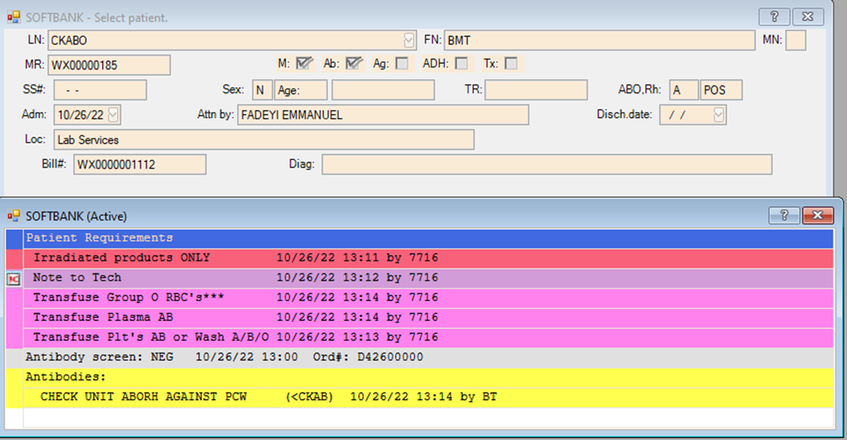

**Note the results of the ABO and the Flag box that comes up**

**Here the computer is wondering if you want to ignore the fact that the previous ABO result/interpretation is different than the current ABO result/interpretation. (Was A; now typing B) The correct response here is YES (which doesn’t seem right – but what comes next will) then F12**

**ONCE YOU HIT F12, THE FOLLOWING YELLOW QA FAILURE APPEARS: this QA failure is addressing the fact that the previous result and the current result are different.**

**The most appropriate way to answer this QA is to F5 and select either the code “*BMCV”* or *“BMT”*.**

**See below.**

**After you select the exception code, you F12, SCC asks if you want to SAVE the Exception Code. Say YES.**

**Once you say YES to the yellow box, a RED box comes up. Again, this QA is addressing the fact that the old type in the patient’s record and the current type are different. Answer the RED QA exception with the same canned comment (F5) you used before in the YELLOW one. F12 and again it asks if you want to SAVE the Exception Code. Say YES.**

**AFTER this F12, another “FLAG” comes up asking if you want to override the OLD ABO? *HERE YOU MUST SAY NO!!***

**To Explain: This Flag is asking DO YOU WANT TO TAKE THE NEW ABO AND PUT IT IN THE PLACE OF THE OLD ABO IN THE PERMANENT RECORD. *WE DON’T EVER WANT TO DO THIS!!!* SO WE WILL ALWAYS ANSWER “NO” TO OVERRIDE!!!**

**ONCE YOU ANSWER NO, THE RESULTING PROCESS WILL BE COMPLETE AND YOU CAN PROCEED AS USUAL.**