# Applicable Laboratory(s):

North Carolina Baptist Hospital (NCBH)

Lexington Medical Center (LMC)

Davie Medical Center (DMC)

Wilkes Medical Center (WMC)

High Point Medical Center (HPMC)

Westchester

Clemmons

# Purpose

The Be The Match Registry, operated by the National Marrow Donor Program (NMDP) is in

control of a worldwide internet-based database called the Center for International Blood and

Marrow Transplant Research (CIBMTR). This website facilitates international data collection

concerning bone marrow transplantation. The Stem Cell Transplant and Cellular Therapy (SCTCT) lab staff is responsible for completing the NMDP Forms 2006 as well as 770/772/773 in the CIBMTR in the Forms Net 3 section.

# Scope

i Procedure owner/Implementer: Christina Warren/Bettina Turner

ii. Procedure prepared by: Emily H. Wilson

iii. Who performs procedure: Department staff/management

# Definitions

1. Procedure: A process or method for accomplishing a specific task or objective.
2. WFBH Lab System: Wake Forest Baptist Lab System is a health system that includes Wake Forest Baptist Medical Center and all affiliated organizations including Wake Forest University Health Sciences (WFUHS), North Carolina Baptist Hospital (NCBH), Lexington Medical Center (LMC), Davie Medical Center (DMC), Wilkes Medical Center (WMC), High Point Medical Center (HPMC), Lab at Westchester and Lab at Clemmons.
3. NMDP: National Marrow Donor Program
4. CIBMTR: Center for International Blood and Marrow Transplant Research
5. FormsNet3: Section of database supported by the CIBMTR and accessed by SCTCT Lab staff.
6. CRID#: CIBMTR Recipient Identification Number
7. Form 2006: NMDP Product Data Form
8. Form 770/772/773: NMDP Product Analysis Form

# Supplies/Materials

A computer connected to the hospital network that has Google Chrome.

# PROTOCOLS

* Each staff member entering data into CIBMTR FormsNet3 has a user-set password and will be additionally identified by the Otka cloud system for increased security. (This is all established when you are first entered as a user of FormsNet3).
* Do not share your CIBMTR passwords with anyone
* Help for the CIBMTR website can be obtained at the NMDP Service Desk:

1-800-526-7809, ext. 3411 or (612)362-3411

* 700 Series Forms should be entered into CIBMTR website by 10AM the day following product collection.
* Staff should always use Google Chrome to enter FormsNet3.
* The data managers can provide SCTCT staff with a patient’s CIBMTR unique identifier, or CRID#.
* Always enter the year first when entering dates, then the month, then the day.

Example: 2018 09 01

* Do not use the ENTER key – this may not store information; use the TAB key after numbers are entered in a field.
* Enter product values in the 2006 form “at infusion time” – that is, the post processing values. If no processing occurred, enter initial counts.

# Procedure Guidelines

1. Open Google Chrome from the desktop.
2. Enter formsnet3.nmdp.org in the search bar.
3. Enter your username and password for BetheMatchClinical.org, which is set up for you by NMDP, Click Sign In.
   1. Another login screen will appear.

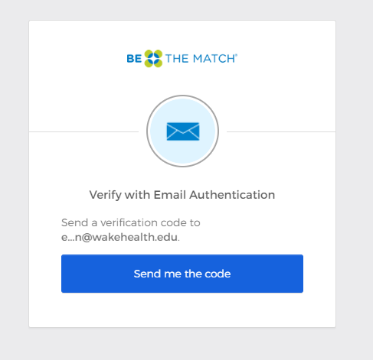

1. Click Send Me the Code, and an authentication code is immediately emailed to you.
2. Enter the authentication code in the Verification Code box and click Verify.
3. Click the Donor or Recipient Tab.

6.1 Click Recipient for 2006 Form

6.2 Click Donor for 700 Series Form

1. Enter the CRID# or Donor ID (with no spaces or dashes) in the search bar and click Search; A list of forms will appear

7.1 Example: 4230092(CRID) 900185437 (Donor ID)

7.2 The CRID# will be supplied to SCTCT staff by the data managers

8. Click on the Edit Form icon for the line containing the desired form.

8.1 Click on the Edit icon to edit.

8.2 Clicking on the Magnifying glass icon will only allow review of the form.

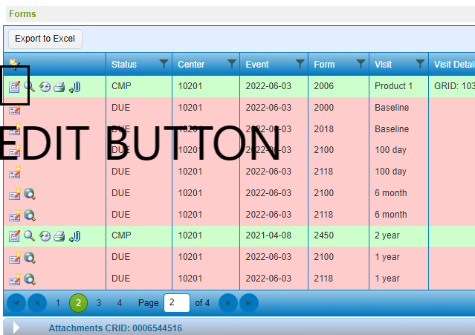

1. Complete all questions using the SCTCT lab patient chart as the source document.
   1. Refer to procedure attachments for line by line instructions and guidance on

completing the forms in FormsNet3.

9.2 Consult EPIC and the data managers if necessary for any information missing from

the SCTCT lab patient chart.

1. Click the Submit arrow when all questions have been completed.
   1. “Submit” does not appear until you hover over the arrow with the cursor, see below.
   2. Any incomplete questions will be noted with a red X symbol, .

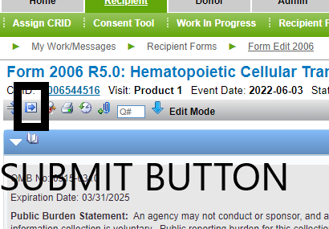

1. To enter another CRID or Donor ID, Click Recipient or Donor, then enter the new CRID or Donor ID.

12. Complete the CIBMTR Form 2006 Entry Log, SCT-FORMS-0330.

13. Have another technologist complete the checking column of the CIBMTR Form 2006

Entry Log.

14. Turn in the CIBMTR Form 2006 Entry Log to management for review.

EXPECTED OUTCOME RESULTS: Form 2006 or 700 Series Form is accepted into the

CIBMTR

ACCEPTABLE RANGES: Form 2006 or 700 Series Form is completed with no questions

remaining blank.

# Literature References: none

# Related Procedures/Policies in Navex: None

# Attachments/Linked Documents in Title 21:

Number by Number Instructions for Completing Form 2006

Number by Number Instructions for Completing Form 770

# Revision Dates: Review Change Summary as represented in Title 21.