# Applicable Laboratory(s):

North Carolina Baptist Hospital (NCBH)

Lexington Medical Center (LMC)

Davie Medical Center (DMC)

Wilkes Medical Center (WMC)

High Point Medical Center (HPMC)

Westchester

Clemmons

# Purpose

Maintaining a current list of all stored products makes retrieval of frozen products efficient.

The Stem Cell Transplant and Cellular Therapy (SCTCT) Lab uses Title21 software to maintain their electronic inventory. Each manual patient chart serves as the backup documentation of product location. This procedure describes placing products in and removing products from the Title21 electronic inventory.

# Scope

i Procedure owner/Implementer: Christina Warren

ii. Procedure prepared by: Emily H. Wilson

iii. Who performs procedure: Department staff/management

# Definitions

1. Procedure: A process or method for accomplishing a specific task or objective.
2. WFBH Lab System: Wake Forest Baptist Lab System is a health system that includes Wake Forest Baptist Medical Center and all affiliated organizations including Wake Forest University Health Sciences (WFUHS), North Carolina Baptist Hospital (NCBH), Lexington Medical Center (LMC), Davie Medical Center (DMC), Wilkes Medical Center (WMC), High Point Medical Center (HPMC), Lab at Westchester and Lab at Clemmons.

# C. IDM: Infectious Disease Marker

# D. HPC: Hematopoietic Progenitor Cell

# E. DLI: Donor Lymphocyte Infusion

# PROTOCOLS

# 1. Products should be stored in vapor phase if possible.

# 2. Storage of products in liquid phase must be approved by the medical director.

# 3. Products with known positive IDMs or IDMs that are not performed within 30 days of

# collection (HPC) or 7 days of collection (DLI) must be stored in the quarantine resesrvoir.

# 4. Quarantine is defined as storage in vapor phase of liquid nitrogen in the reservoir designated

# for quarantine products (reservoir #9). These products must be labeled with a biohazard

# legend.

# 5. Vials with known positive IDMs must be stored in vapor phase.

# Supplies/Materials

Chemical Risk Assessment: None

Biological Risk Assessment: Low

Protective Equipment: None

Supplies: None

Reagents: None

Equipment: Computer on medical center network

Specimen Requirements: n/a

**sections**

I. Entering Products

II. Deleting Products

III. Help Icon

# Procedure Guidelines

**I. Entering Products**

# A. Determine number of bags and vials to be stored and assign a freezer location.

# 1. When assigning locations:

# a). Reservoir #2 is for liquid phase storage only and should be avoided for regular

# storage.

# b). Vapor phase in Reservoirs #3 and 4 is in A and B canisters(C canisters are liquid

# phase and should not be used without medical director authorization).

# c). Vapor phase in Reservoirs # 5 – 9 is in canisters A through C. (D canisters are liquid

# phase and should not be used without medical director authorization).

# d). All canisters (A-D) in reservoirs #10 – 12 are vapor phase.

# e). Products bags with known positive IDMs must be stored in the known positive

# vapor phase storage areas (Reservoir #9)

# B. Update electronic cryoinventory to reflect the bags or vials you add to the freezer.

# 1. Click on the Title21 Icon on your computer desktop.



# 2. Click on the Freezers Icon at the top to open the inventory.

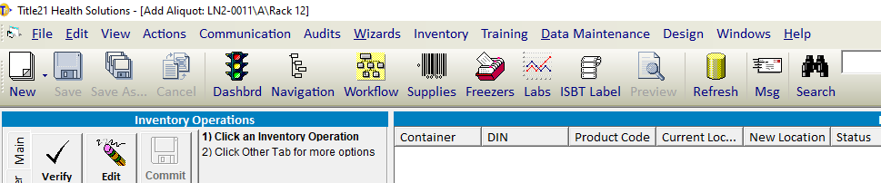

3. Expand a freezer on the left hand side to enable choice of a freezer space; the racks that are

completely filled are noted as 100%. Double click on an empty space to add new product.

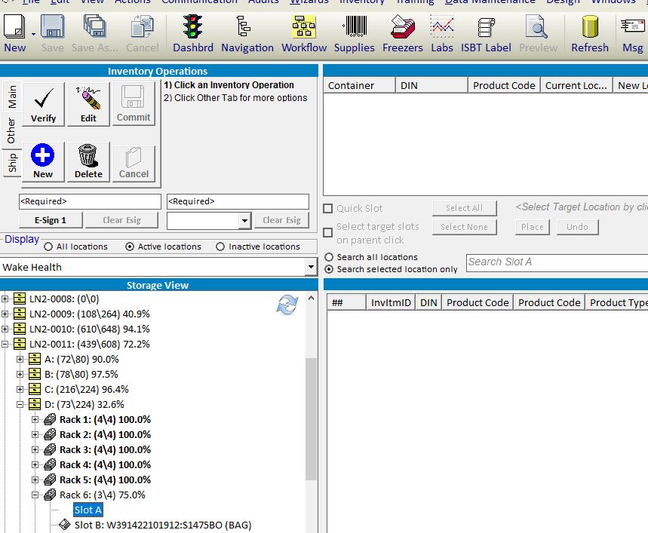

4. A window will appear to Add New Inventory. Enter at a minimum Recipient MRN, Recipient

Name, DIN, Product Code, Product Class, Product State, Collection Date, and Volume.

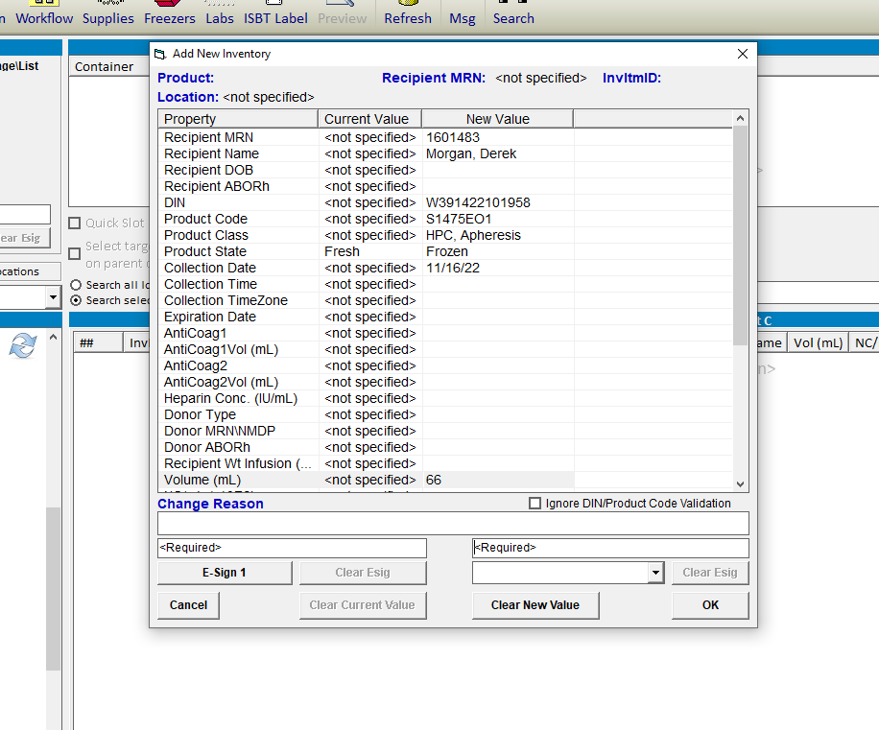

# 4.1 When entering a DIN, the check code is required. This is the code in the box to the right

# of the DIN# on the ISBT label.

4.2 Product code must have 8 characters, example: S1475A00

5. Click E-Sign 1 and enter Title21 password or PIN.

6. Have a second technologist E-Sign by choosing their name from the drop-down box on the

right and entering their password or PIN.

7. Product is now entered in the inventory; updates will not be reflected until you close and

reopen the Freezer icon.

**II. Deleting Products**

1. Highlight the product that you want to delete.

2. Click Delete in the top left corner (Make sure the Other Tab is highlighted to enable the

Delete Button).

3. Enter your password or PIN.

4. Deleted items are permanently deleted.

# 

# C:\Users\emwilson\Desktop\Delet Button.PNG

Other Tab

**III. HELP Icon**

1. Click the HELP Button at the top right of the Title21 Software and enter Inventory to see

additional HELP topics.

2. You must click the HELP Button again for the HELP topics to disappear.

3. This procedure may not be inclusive of all inventory tasks. Additional help can be received

from Title21 technical support at [support@title21.com](mailto:support@title21.com).

# Literature References: n/a

# Related Procedures/Policies in Navex: n/a

# Attachments/Linked Documents in Title 21: n/a

# Revision Dates: Review Change Summary as represented in Title 21.